Instruction

# Staff Instruction:

1. Login with staff credential

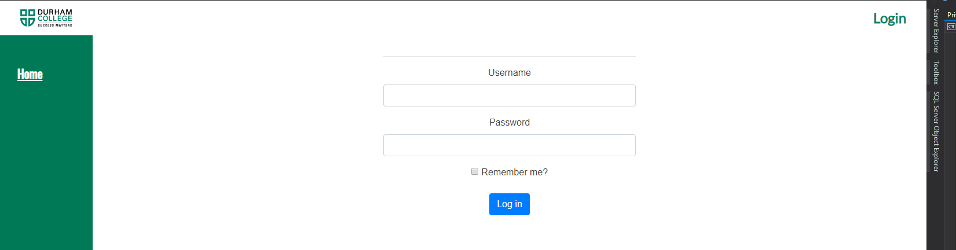

1. Navigate to Check In Tab

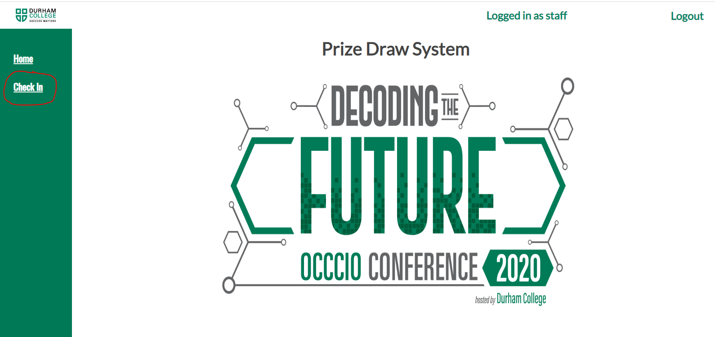

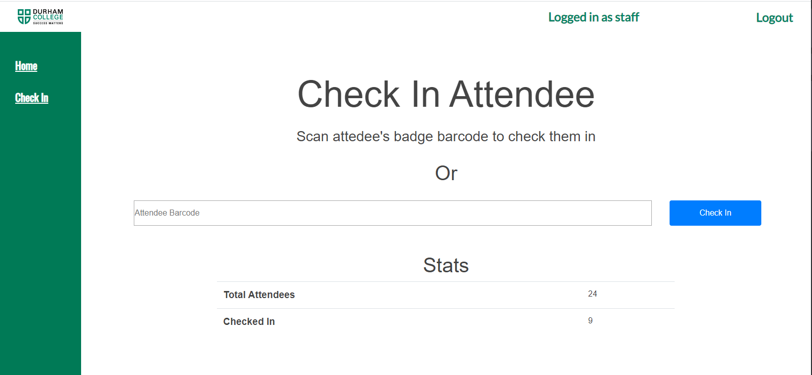

1. Begin Scanning