

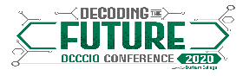

|  |
| --- |
| Jane Doe |
| Durham |
| Teacher |
| *1* |

|  |
| --- |
| «Next Record»John Doe |
| Durham |
| Teacher |
| *2* |

|  |
| --- |
| «Next Record»Cecilia P. |
| Durham |
| Sales |
| *29383439* |

|  |
| --- |
| «Next Record» |
|  |
|  |
|  |

|  |
| --- |
| «Next Record» |
|  |
|  |
|  |

|  |
| --- |
| «Next Record» |
|  |
|  |
|  |



