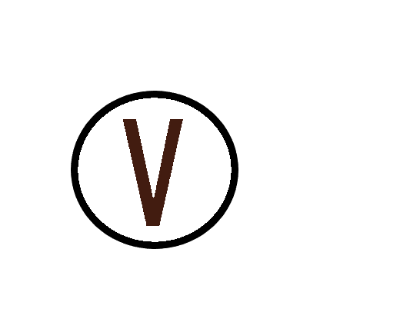



|  |
| --- |
| John Vendor |
| IBM |
| Sales |
| *87269796* |

|  |
| --- |
| «Next Record» |
|  |
|  |
|  |

|  |
| --- |
| «Next Record» |
|  |
|  |
|  |

|  |
| --- |
| «Next Record» |
|  |
|  |
|  |

|  |
| --- |
| «Next Record» |
|  |
|  |
|  |

|  |
| --- |
| «Next Record» |
|  |
|  |
|  |



