Instruction

# Vendor Instruction:

1. Login with vendor credential

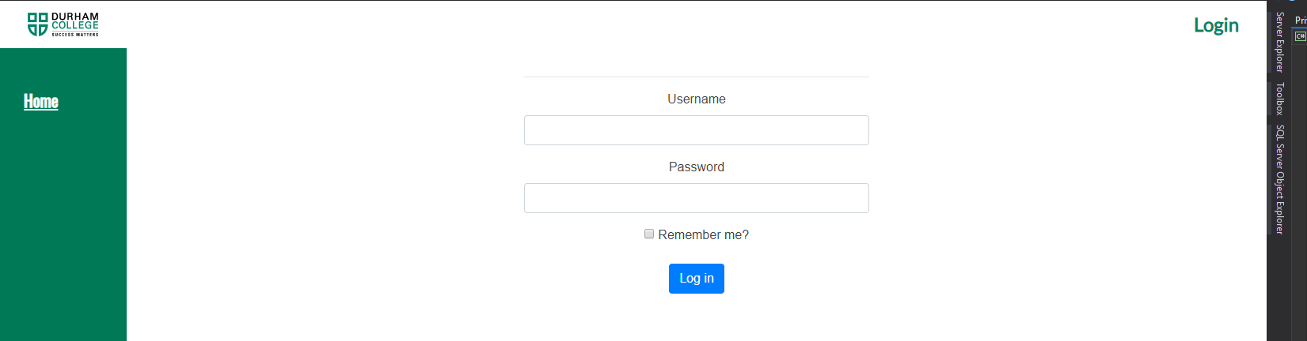

1. Navigate to Vendor Tab



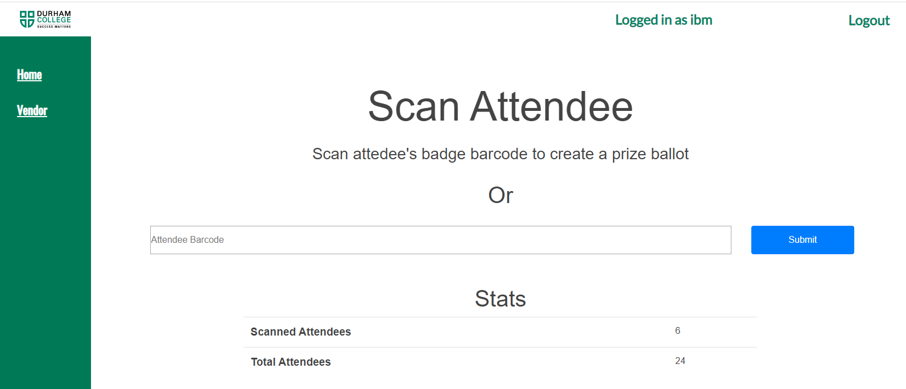

1. Begin Scanning