**Fundamentals of Computer Programming**

**Building a Programming Portfolio**

Week 3

*You should be able to complete the following programs by the end of the week. You should*

*keep the code somewhere safe, in an organised way. GitHub is ideal. Wherever you choose,*

*you should ensure that the work is safe and backed up.*

*Possible solutions will be uploaded to the main module GitHub repository every week. If you*

*follow that repo you should be able to receive notifications.*

1. Modify your greeting program so that if the user does not enter a name (i.e. they

just press enter), the program responds "Hello, Stranger!". Otherwise it should print

a greeting with their name as before.

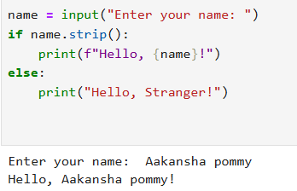

2. Write a program that simulates the way in which a user might choose a password.

The program should prompt for a new password, and then prompt again. If the two

passwords entered are the same the program should say "Password Set" or

similar, otherwise it should report an error.

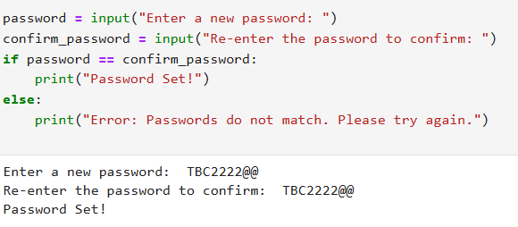

3. Modify your previous program so that the password must be between 8 and 12

characters (inclusive) long.

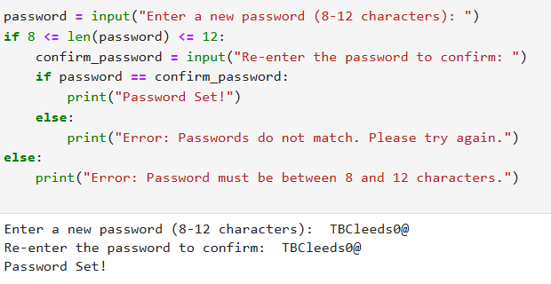

4. Modify your program again so that the chosen password cannot be one of a list of

common passwords, defined thus:

BAD_PASSWORDS = ['password', 'letmein', 'sesame', 'hello', 'justinbieber']

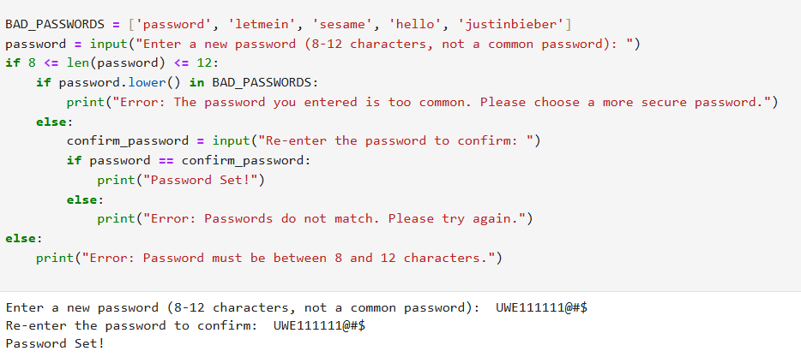

5. Modify your program a final time so that it executes until the user successfully

chooses a password. That is, if the password chosen fails any of the checks, the

program should return to asking for the password the first time.

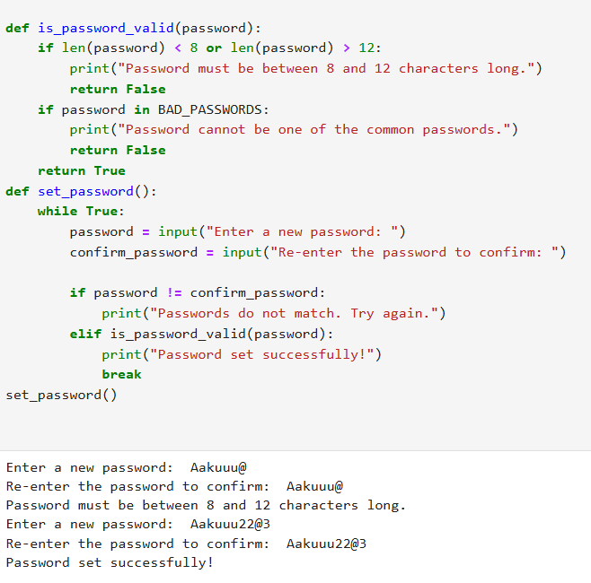

6. Write a program that displays the "Seven Times Table". That is, the result of

multiplying 7 by every number from 0 to 12 inclusive. The output might start:

0 x 7 = 0

1 x 7 = 7

2 x 7 = 14

and so on.

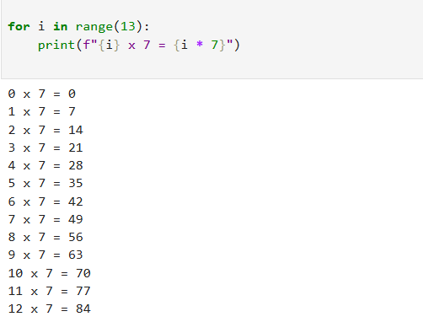

7. Modify your "Times Table" program so that the user enters the number of the table

they require. This number should be between 0 and 12 inclusive.

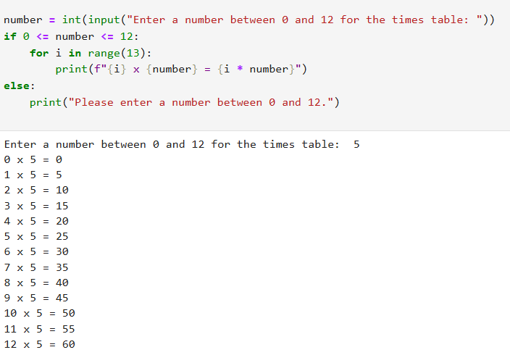

8. Modify the "Times Table" again so that the user still enters the number of the table,

but if this number is negative the table is printed *backwards*. So entering "-7"

would produce the Seven Times Table starting at "12 times" down to "0 times".

