**Fundamentals of Computer Programming**

**Building a Programming Portfolio**

Week 2

*You should be able to complete the following programs by the end of the week. You should*

*keep the code somewhere safe, in an organised way. GitHub is ideal. Wherever you choose,*

*you should ensure that the work is safe and backed up.*

*Possible solutions will be uploaded to the main module GitHub repository every week. If you*

*follow that repo you should be able to receive notifications.*

*In the following,* ***bold text*** *indicates where a user is typing.*

1. Last week you wrote a program that printed out a cheery greeting including your

name. Take a copy of it, and modify it so that the user enters their name at the

keyboard, and then receives a greeting. For example:

Hello, what is your name? **Mr Apricot**

Hello, Mr Apricot. Good to meet you!

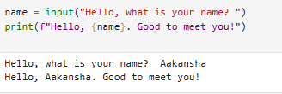

2. Write a program that prompts a user to enter a temperature in Celsius, and then

displays the corresponding temperature in Fahrenheit, like so:

Enter a temperature in Celsius: **32.5**

32.5C is equivalent to 90.5F.

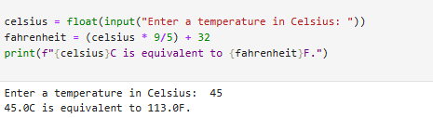

3. The Head of Computing at the University of Poppleton is tasked with dividing a

group of students into lab groups. A lab group is usually 24 students, but this is

sometimes varied to create groups of similar size. Write a program that prompts for

the number of students and group size, and then displays how many groups will be

needed and how many will be left over in a smaller group.

How many students? **113**

Required group size? **22**

There will be 5 groups with 3 students left over.

For bonus credit, see if you can fix the grammar in the output. So if there were 101

students in groups of 20 the output would be:

There will be 5 groups with 1 student left over.

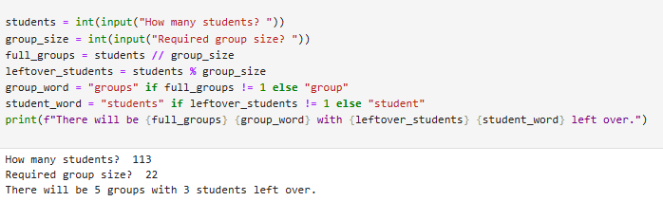

4. A kindly teacher wishes to distribute a tub of sweets between her pupils. She will

first count the sweets and then divide them according to how many pupils attend

that day. Write a program that will tell the teacher how many sweets to give to each

pupil, and how many she will have left over.

