**Fundamentals of Computer Programming**

**Building a Programming Portfolio**

Week 4

*You should be able to complete the following programs by the end of the week. You should*

*keep the code somewhere safe, in an organised way. GitHub is ideal. Wherever you choose,*

*you should ensure that the work is safe and backed up.*

*Possible solutions will be uploaded to the main module GitHub repository every week. If you*

*follow that repo you should be able to receive notifications.*

1. Functions are often used to validate input. Write a *function* that accepts a single

integer as a parameter and returns True if the integer is in the range 0 to 100

(inclusive), or False otherwise. Write a short program to test the function.

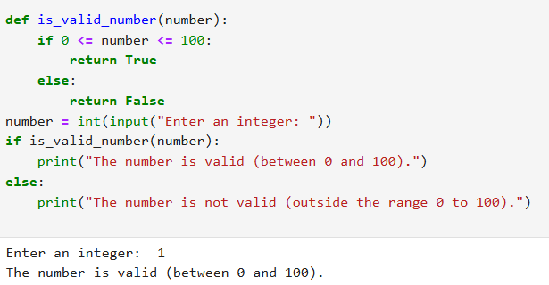

2. Write a function that has a single string as its parameter, and returns the number of

uppercase letters, and the number of lowercase letters in the string. Test the

function with a short program.

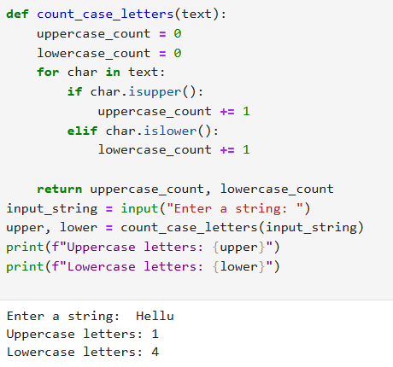

3. Modify your "greetings" program so that the first letter of the name entered is

always in uppercase with the rest in lowercase. This should happen even if the user

entered their name differently. So if the user entered arthur, ARTHUR, or even

arTHur the name should be displayed as Arthur.

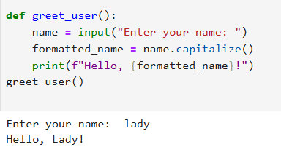

4. When processing data it is often useful to remove the last character from some

input (it is often a newline). Write and test a function that takes a string parameter

and returns it with the last character removed. (If the string contains one or fewer

characters, return it unchanged.)

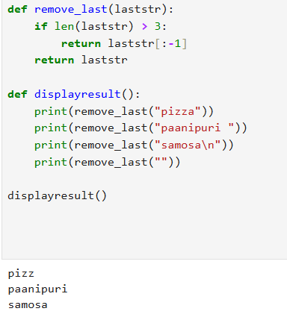

5. Write and test a function that converts a temperature measured in degrees

centigrade into the equivalent in fahrenheit, and another that does the reverse

conversion. Test both functions. (Google will find you the formulae).

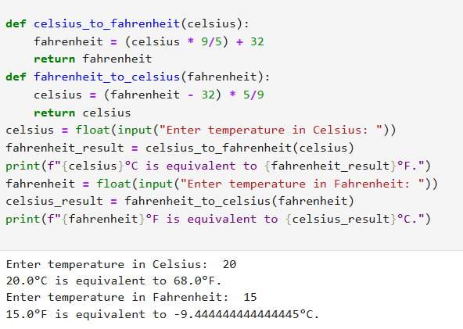

6. Write a program that takes a centigrade temperature and displays the equivalent in

fahrenheit. The input should be a number followed by a letter C. The output should

be in the same format.

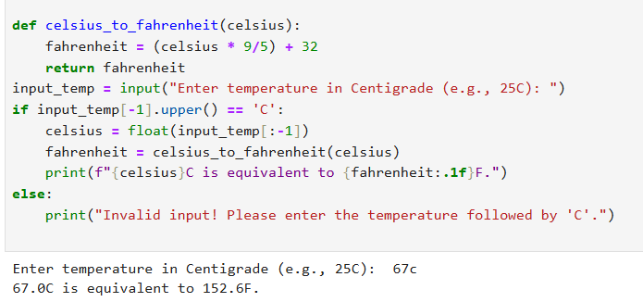

7. Write a program that reads 6 temperatures (in the same format as before), and

displays the maximum, minimum, and mean of the values.

*Hint: You should know there are built-in functions for max and min. If you hunt, you*

*might also find one for the mean.*

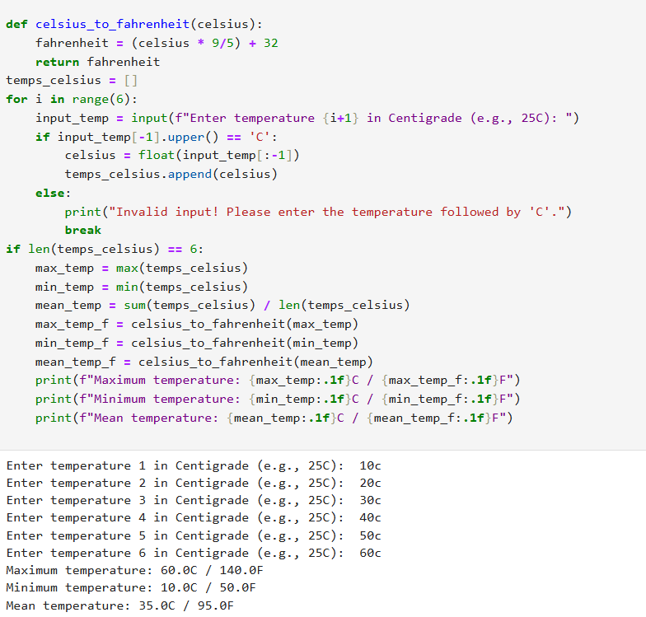

8. Modify the previous program so that it can process *any number* of values. The input

terminates when the user just pressed "Enter" at the prompt rather than entering a

value.

Programming Portfolio 04 V1.0 2022-08-10 AMJ

