**Fundamentals of Computer Programming**

**Building a Programming Portfolio**

Week 5

*You should be able to complete the following programs by the end of the week. By now you*

*should understand why you should be saving your work to GitHub or similar. Possible*

*solutions will be uploaded to the main module GitHub repository every week. If you follow*

*that repo you should be able to receive notifications.*

*After this week you should be able to run your programs from the command-line, without*

*having to use an IDE.*

*Note: Most of these programs process command-line arguments. In every case your program*

*should not crash if no arguments are provided. In most cases it should just exit with some*

*suitable error message.*

1. Using command-line arguments involves the sys module. Review the docs for this

module and using the information in there write a short program that when run

from the command-line reports what operating system platform is being used.

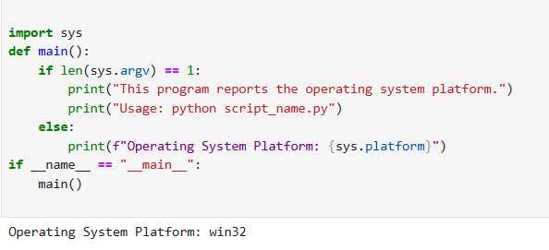

2. Write a program that, when run from the command line, reports how many

arguments were provided. (Remember that the program name itself is *not* an

argument).

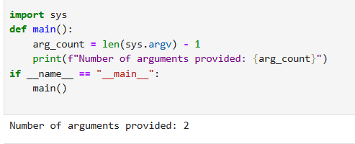

3. Write a program that takes a bunch of command-line arguments, and then prints

out the shortest. If there is more than one of the shortest length, any will do.

*Hint: Don't overthink this. A good way to find the shortest is just to sort them.*

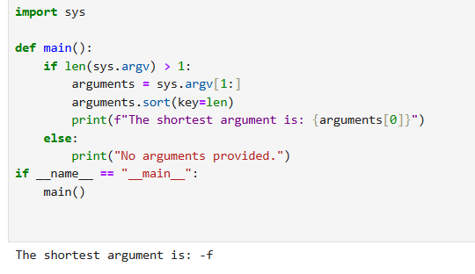

4. Write a program that takes a URL as a command-line argument and reports

whether or not there is a working website at that address.

*Hint: You need to get the HTTP response code.*

*Another Hint: StackOverflow is your friend.*

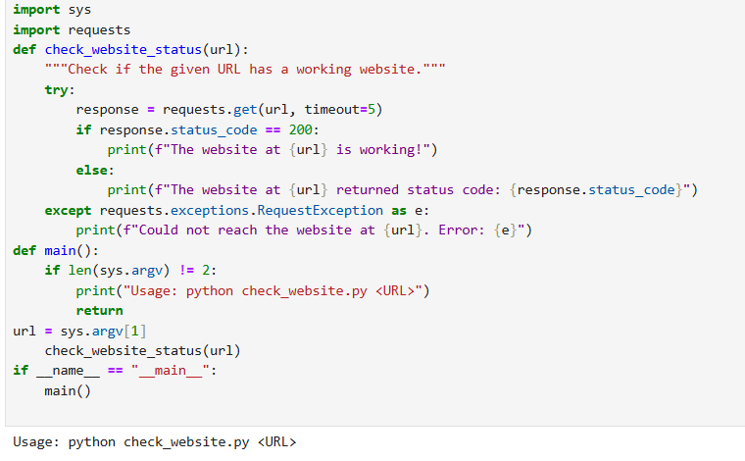

5. Last week you wrote a program that processed a collection of temperature readings

entered by the user and displayed the maximum, minimum, and mean. Create a

version of that program that takes the values from the command-line instead. Be

sure to handle the case where no arguments are provided!

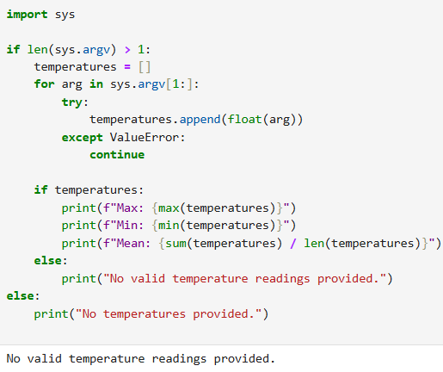

6. Write a program that takes the name of a file as a command-line argument, and

creates a backup copy of that file. The backup should contain an exact copy of the

contents of the original and should, obviously, have a different name.

*Hint: By now, you should be getting the idea that there is a built-in way to do the*

*heavy lifting here! Take a look at the "Brief Tour of the Standard Library" in the docs.*

Programming Portfolio 05 V1.0 2022-08-11 AMJ

