**Fundamentals of Computer Programming**

**Building a Programming Portfolio**

Week 6

*You should be able to complete the following programs by the end of the week. By now you*

*should understand why you should be saving your work to GitHub or similar. Possible*

*solutions will be uploaded to the main module GitHub repository every week. If you follow*

*that repo you should be able to receive notifications.*

*Note that as we have now seen many features of Python there are often multiple ways to*

*solve a problem. One lesson this week should be that a list can often be used in place of a*

*tuple, and vice versa. The aim is to go for the most obvious, and most clear, solution.*

1. Write a function that accepts a positive integer as a parameter and then returns a

representation of that number in binary (base 2).

*Hint: This is in many ways a trick question. Think!*

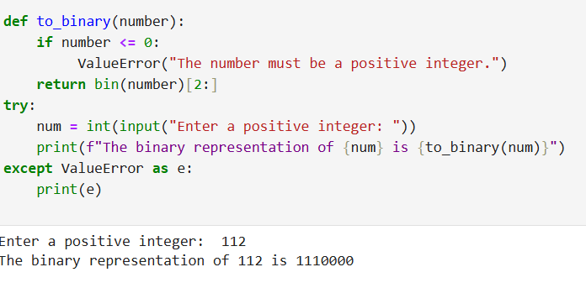

2. Write and test a function that takes an integer as its parameter and returns the

*factors* of that integer. (A factor is an integer which can be multiplied by another to

yield the original).

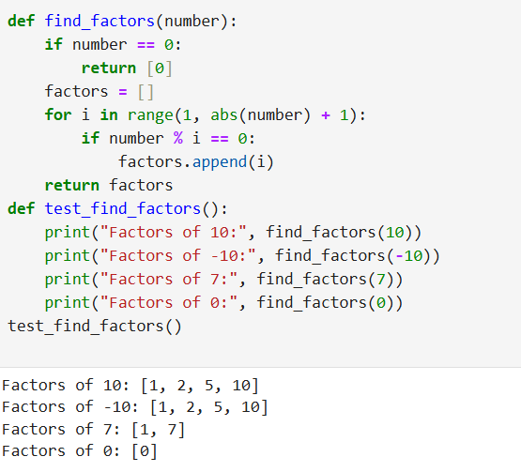

3. Write and test a function that determines if a given integer is a prime number. A

prime number is an integer greater than 1 that cannot be produced by multiplying

two other integers.

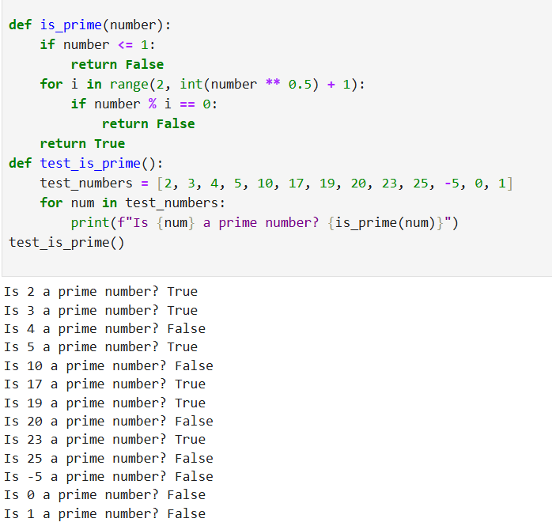

4. Computers are commonly used in encryption. A very simple form of encryption

(more accurately "obfuscation") would be to remove the spaces from a message

and reverse the resulting string. Write, and test, a function that takes a string

containing a message and "encrypts" it in this way.

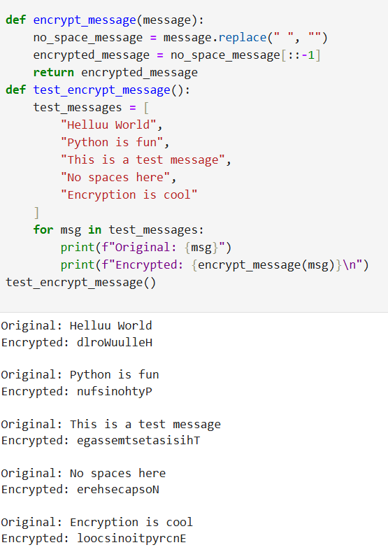

5. Another way to hide a message is to include the letters that make it up within

seemingly random text. The letters of the message might be every fifth character,

for example. Write and test a function that does such encryption. It should

randomly generate an interval (between 2 and 20), space the message out

accordingly, and should fill the gaps with random letters. The function should

return the encrypted message and the interval used.

For example, if the message is "send cheese", the random interval is 2, and for

clarity the random letters are not random:

send cheese

s e n d c h e e s e

sxyexynxydxy cxyhxyexyexysxye

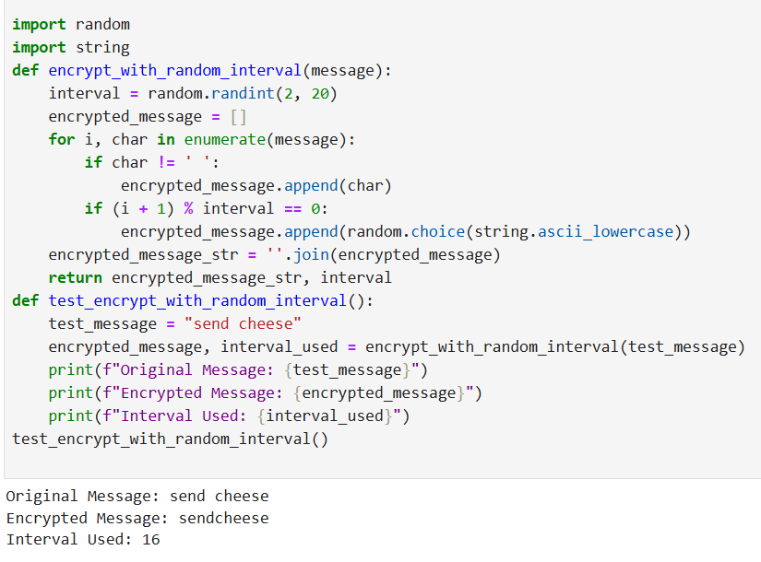

6. Write a program that decrypts messages encoded as above.

