Mobile – New algorithm

Mobile data will probably always be challenging.

Reasons are:

1. Constantly changing OS
2. Constantly changing Browsers
3. In-App activity
4. Rapid changing in security recommendations.

Despite this one by one, we progress in solving and adapting to this rapidly changing environment.

France

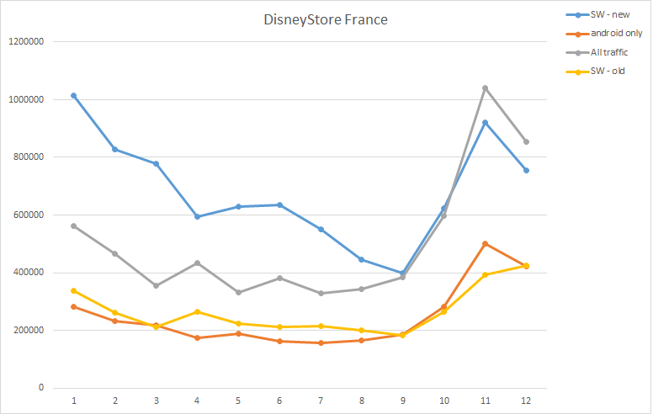

* Whenever iOS users and Android users act in an opposite ways we will see discrepancies in trends. It’s rarely happens, but as you can clearly see here, it does happen sometimes.
* Overestimation of data before Sep

Germany

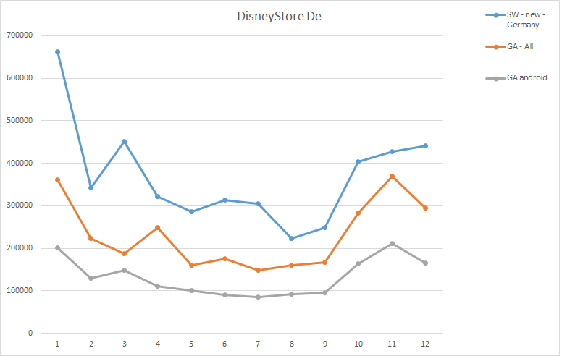

UK

