All pcs are connected to their own switch on FA0/1 , FA0/2 , FA0/3

IP Configuration

IT ADMIN PC 1

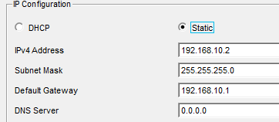

IT ADMIN PC 2
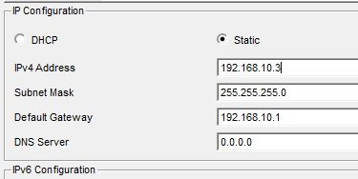

IT ADMIN PC 3
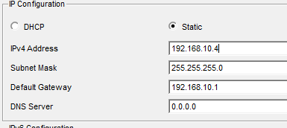

OPEN VAS SERVER
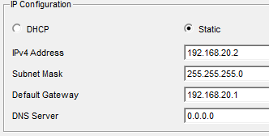

Solar Wind Server
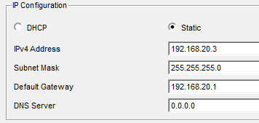

File Server
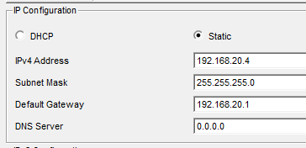

PC 12IT
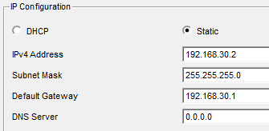

PC 13 IT
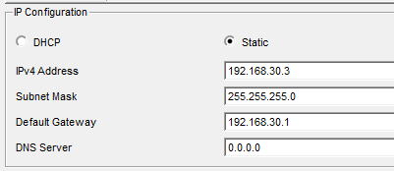

PC 14 IT
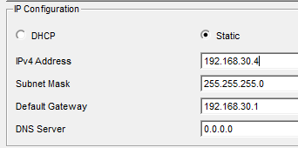

Engineers 1
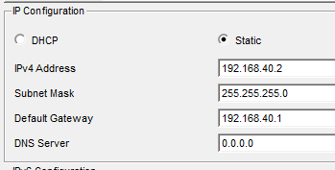

Engineers 2
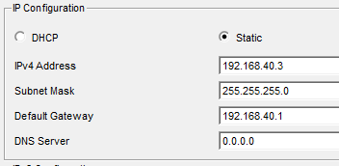

Engineers 3
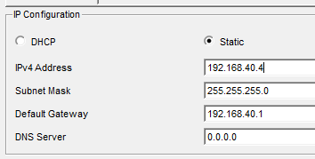

Construction 1
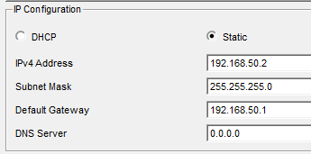

Construction 2
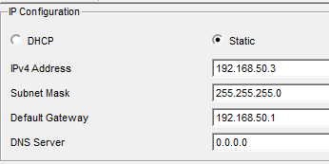

Construction 3
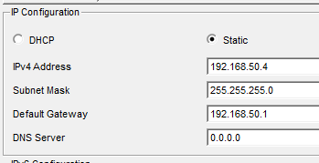

Admin 1
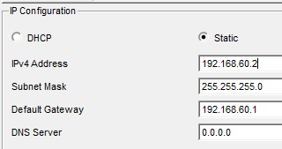

Admin 2
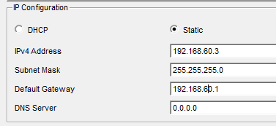

Admin 3
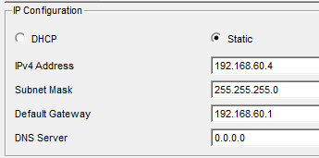

VLAN configuration

ACCESS-SW-MGMT
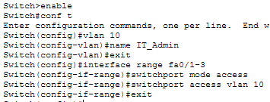

ACCESS-SW-SERCERS
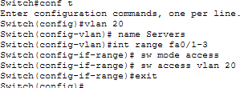

ACCESS-SW-IT
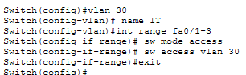

ACCESS-SW-ENGINEERING
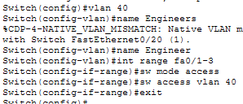

ACCESS-SW-CONSTRUCTION
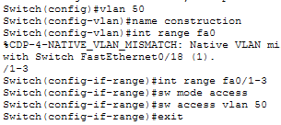

ACCESS-SW-ADMIN
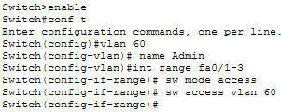

TRUNK CONFIGURATION

ACCESS-SW-MGMT
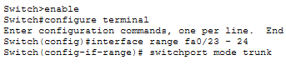
ACCESS-SW-SERCERS
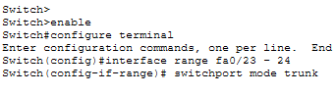
ACCESS-SW-IT
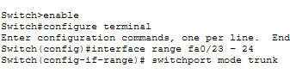
ACCESS-SW-ENGINEERING
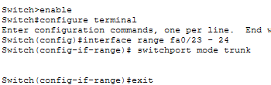

ACCESS-SW-CONSTRUCTION
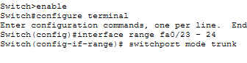
ACCESS-SW-ADMIN
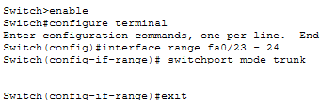

RUKAMCO-DIST 1
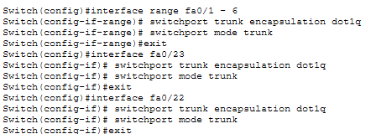
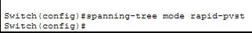

RUKAMCO-DIST 2
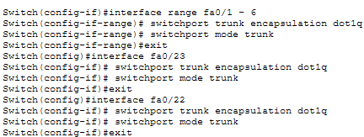
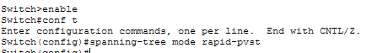

RUKAMCO-CORE

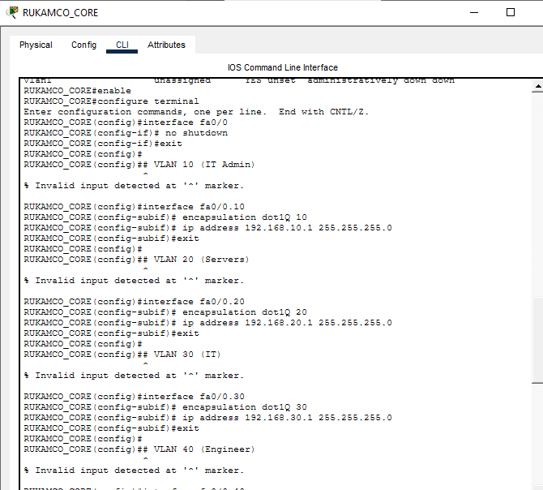
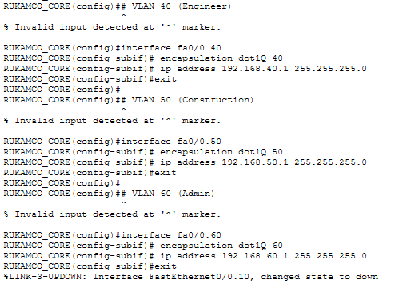
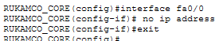

IT ADMIN(VLAN 10) TO VLAN 10 , 20 , 30 , 40 , 50, 60
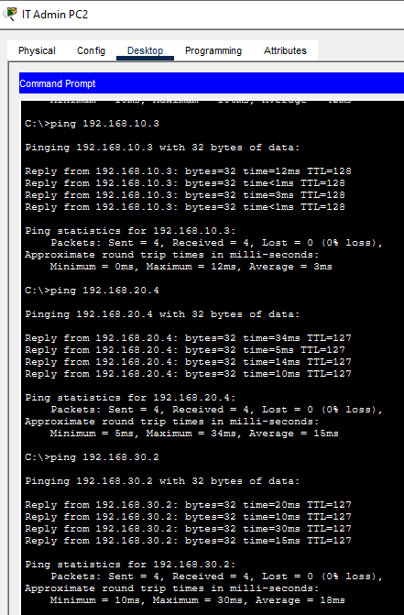
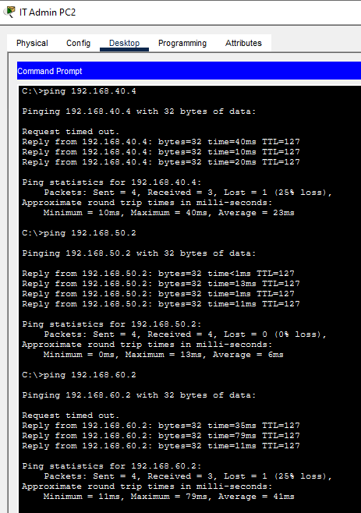

file server(VLAN 20) TO VLAN 10 , 20 , 30 , 40 , 50, 60
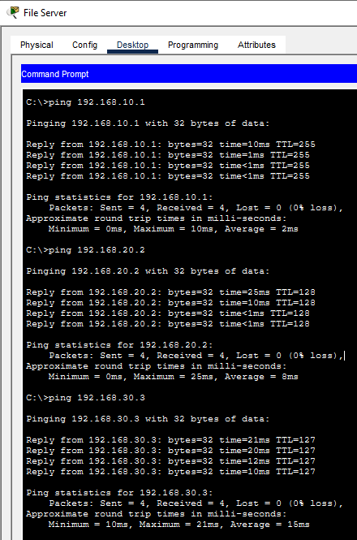
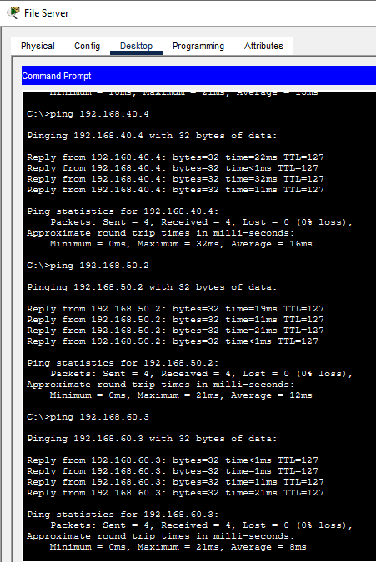

PC13IT(VLAN 30) TO VLAN 10 , 20 , 30 , 40 , 50, 60
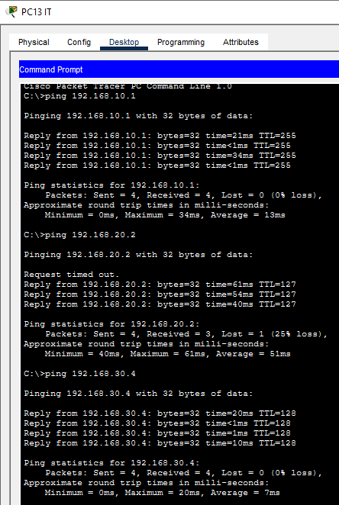
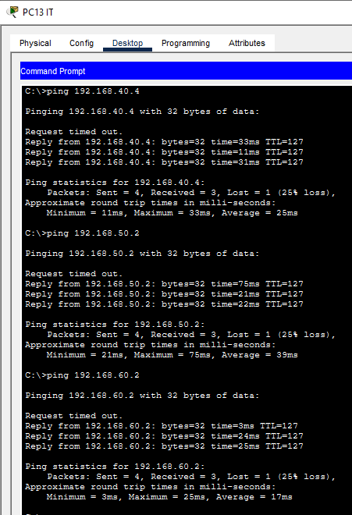

Engineer2(VLAN 40) TO VLAN 10 , 20 , 30 , 40 , 50, 60
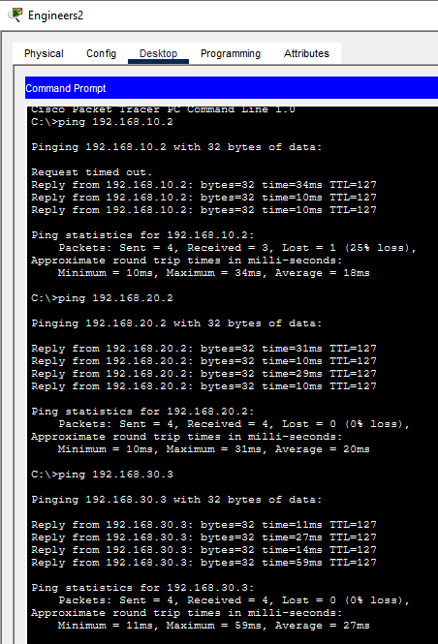
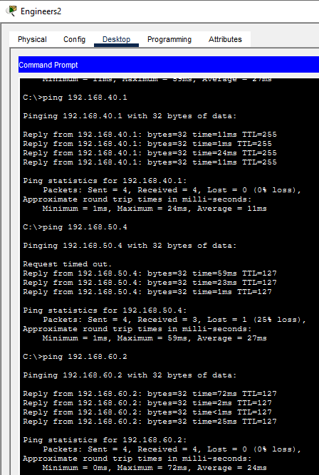

Constructor3(VLAN 50) TO VLAN 10 , 20 , 30 , 40 , 50, 60
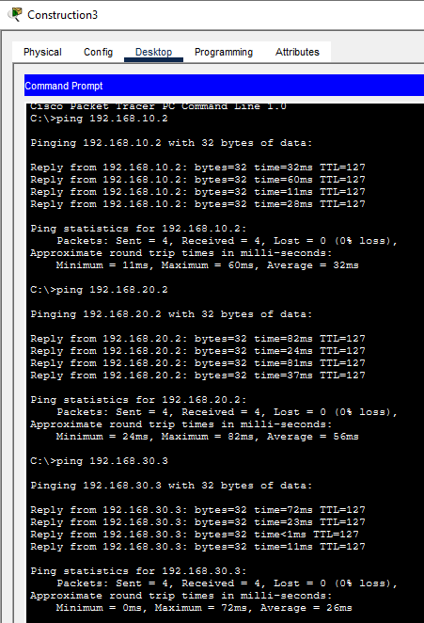
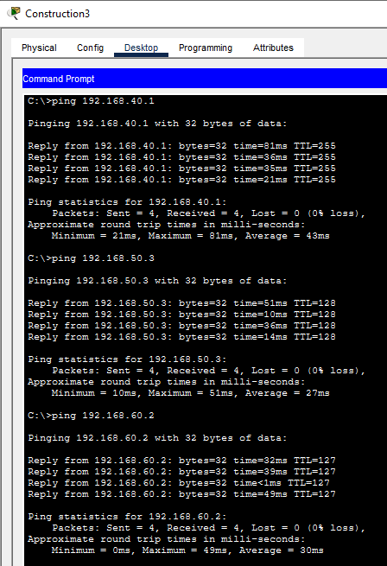

Admin1(VLAN 60) TO VLAN 10 , 20 , 30 , 40 , 50, 60

