

REPORT OF MODULE PROJECT

MAJOR OF COMPUTER ENGINEERING

STUDENT'S NAME : Muhammed Emir KAŞ
STUDENT'S NUMBER : 230201054

STUDENT'S NAME : Rohat Nur UZAN
STUDENT'S NUMBER : 230201071

STUDENT'S NAME : Yasemin YAVUZ
STUDENT'S NUMBER : 230201073

STUDENT'S NAME : Enes ERŞAN
STUDENT'S NUMBER : 240201014

STUDENT'S NAME : Fatma Zehra KEŞKEK
STUDENT'S NUMBER : 240201024

TABLE OF CONTENTS
- INTRODUCTION ….…………………………………………………………………………1
- TASK 1 : PROJECTILE MOTION .…………………………………………………………..2
Introduction ………………………………………………………………………..2
The Problem ……………………………………………………………………………….2
Physical Calculations ……………………………………………………………………...2
Algorithm ………………………………………………………………………………….4
Code …………………………………..…………………………………………………...6
Output ……………….………………………………………………………………..….10
- TASK 2 : COLLISIONS OF ASTEROIDS ……………..…………………………….……..11
Introduction ………………………………………………………………………11
The Problem ……………………………………………………………………………...11
Physical Calculations …………………………………………………………………….11
Algorithm ………………………………………………………………………………...13
Code …………………………………..………………………………………………….14
Output ……………….………………………………………………………………..….15
- TASK 3 : BALLISTIC PENDULUM ………………………………………………………..16
Introduction ………………………………………………………………………16
The Problem ……………………………………………………………………………...16
Physical Calculations …………………………………………………………………….16
Algorithm ………………………………………………………………………………...17
Code …………………………………..………………………………………………….18
Output ……………….………………………………………………………………..….19
- TASK 4 : SATELLITE MOTION SIMULATION ………………………………….……….20
Introduction ………………………………………………………………………20
The Problem ……………………………………………………………………………...20
Physical Calculations …………………………………………………………………….20
Algorithm ………………………………………………………………………………...22
Code …………………………………..………………………………………………….23
Output ……………….………………………………………………………………..….24
- COMBINATION OF CODES …………………………………………………………….…25
- MATLAB AND SIMULATION ……………………………………………………………..28
Projectile Motion ………………………………………………………………………...28
Collision of Asteroids ……………………………………………………………………32
Ballistic Pendulum ……………………………………………………………………….34
Satellite Motion …………………………………………………………………….…….36
- CONCLUSION ………………………………………………………………………………39

INTRODUCTION
This is a report sheet of first term module task of Sivas University of Science and Tech. Our team was assigned with calculating, coding, and simulating of four physic problems. The problems are named as in order of Projectile Motion, Collision of Asteroids, Ballistic Pendulum, and Satellite Motion Simulation. The problems were satisfied and simplified with using mathematical methods. In coding stage, c++ were chosen as programming language. Simplified equations were used as functions to get the required input values and come to output values. After coding stage whole tasks were combined in one file and editted to its final form. Finally whole tasks were simulated into graphics using matlab.

TASK 1 : PROJECTILE MOTION
Introduction
Basic definiton of projectile motion is representation of curved trajectorical motion of a particle or an object which is effected by gravitational acceleration. In most of calculations, air resistance or any external factor is ignored.
The Problem
The problem was computation of motion of a snowball with initial velocity of 7 m/s which is released from 14 m height with 40 degreed angle below. And to check if the object hits a man 1.9 m tall standing 4 m from the platform which the snowball falls.
Physical Calculations
The motion formulas can be inferred from kinematic formulas.
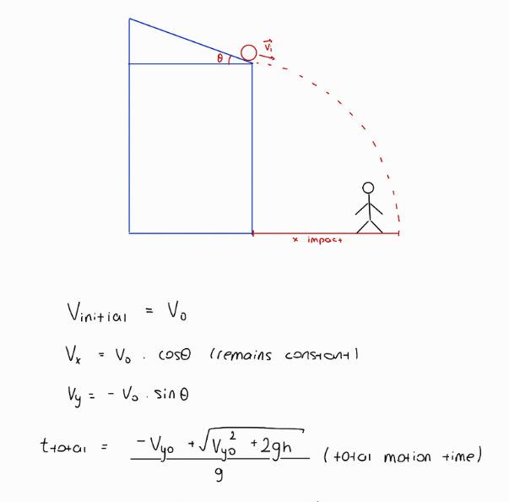
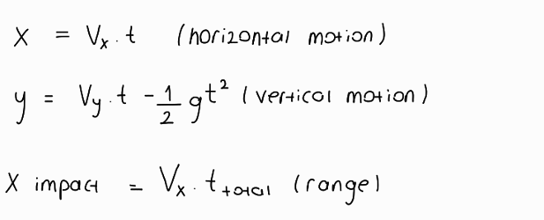
V0: Initial velocity of object
Vx: Component of velocity on x-axis
Vy Component of velocity on y-axis
θ: Angle of platform
x: X coordinate y: Y coordinate
t: Time g: Gravitational acceleration
ttotal: The time where y = 0
Fdrag: Resistance force of air p: Density of air
A: Crossec area of object V: Instantaneous velocity of object
ax: Acceleration on x-axis ay: Acceleration on y-axis
m: Mass of object

For the motion takes place in two dimensions, the process is divided into two perpendicular one dimensioned motion processes in order to simplify the calculations. On horizontal axis, for there is no acceleration acting on the object, action of the object is considered as uniform linear motion. On vertical axis, there is gravitational acceleration acts towards negative direction.
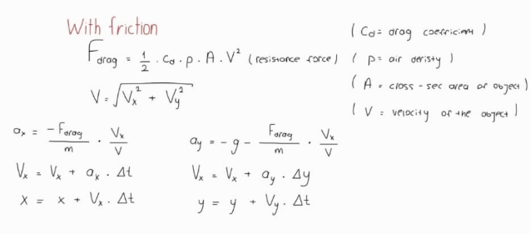
When it comes to make calculations with including air resistance, another acceleration value which is irrelated to gravity takes place on action. The air of environment creates a frictional force on object which is directly proportional to density of air, crosssec area of object, mass of the object and square of instantaneous speed of it. For acceleration changes the instantaneous speed and acceleration is directly proportional to square of speed, both acceleration and speed affect each other reciprocally during the motion.

Algorithm
Algorithm was created with taking kinematic formulas into consideration. Kinematic formulas make calculations with using time values. On preparation stage of algorithm, all the calculations were built top of changes over time. For each time value, system was encoded to give different x and y coordinates. The initial height, speed and acceleration are the coffecients of kinematic equations. Therefore, they are needed as inputs. The angle of platform is needed as input as well in order to divide velocity into its components to adapt velocity to kinematic formulas. If air resistance is included, mass and crossec area values have to be taken as well.

To check if the object hits the person who stands on the platform, height of person and horizontal location of person. Checking algorithm starts with determining the time when the object reaches horizontal location of the person. With using that specific time value, the vertical location is determined and checked if it is below the height of the person. Whole process can be summarized as:
Take height, initial velocity, angle of platform, as inputs
If air resistance is included take mass and crossec area of object too.
Check and print the location of projectile for each 0.1 seconds
Check if it hits the person which stands at stated location
Print results
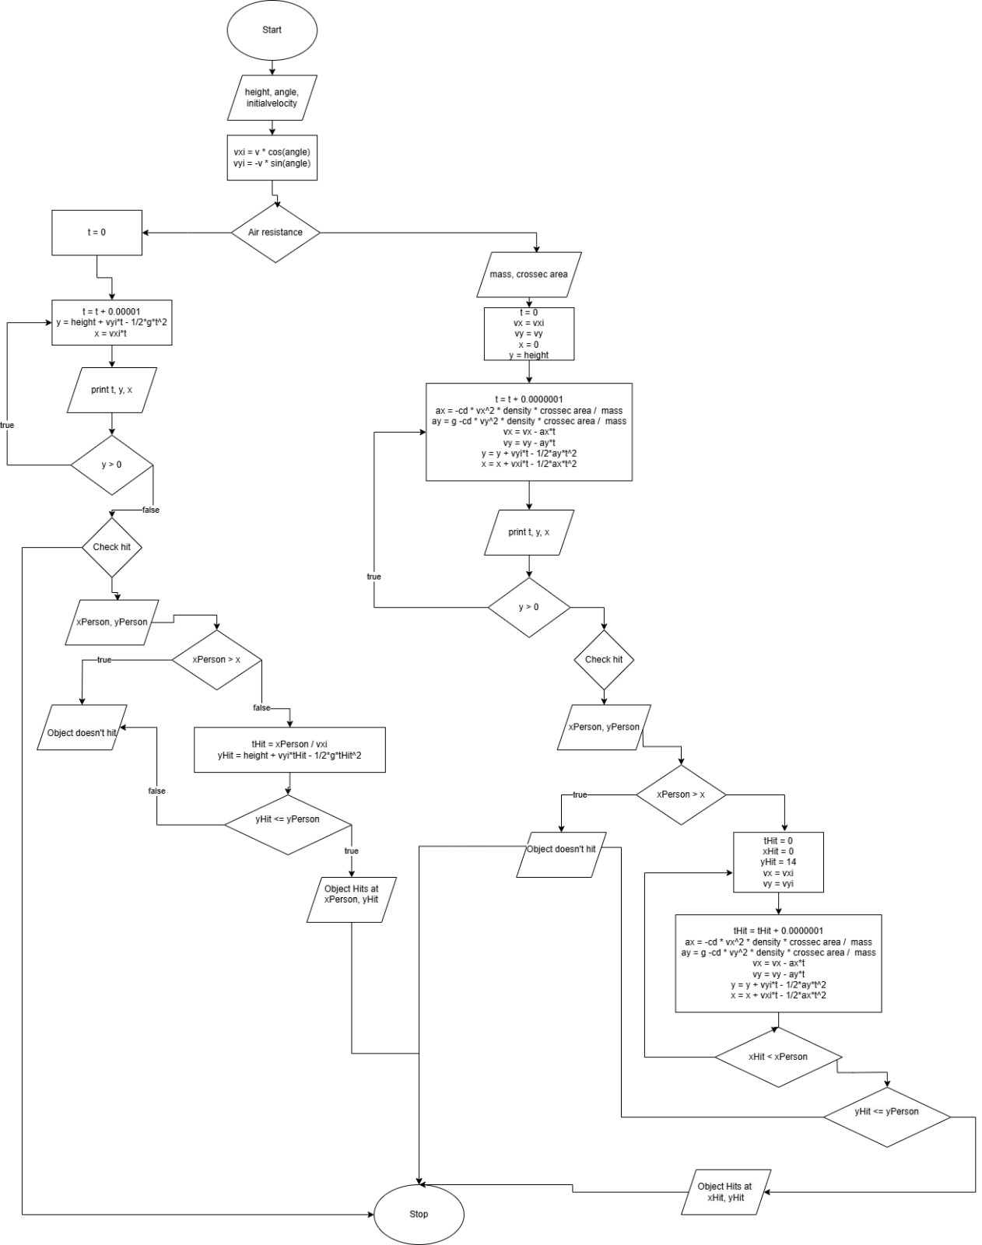

Code
Following the flowchart, the c++ code took its final form.
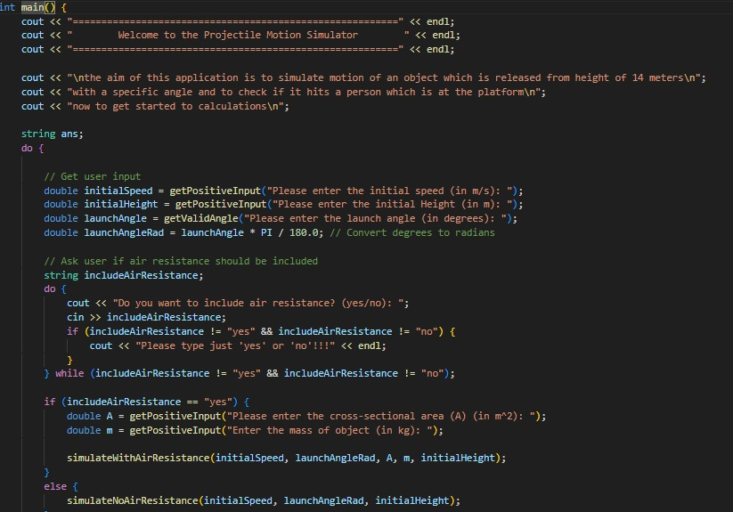User was asked for initial velocity of object, height and angle of the platform as input values.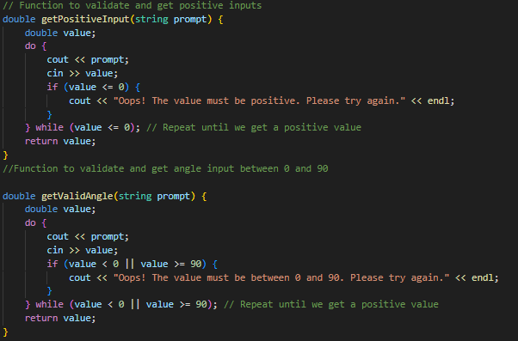

Input values were verified to be positive for scalar quantities and to be between 0 and 90 degrees for angles.

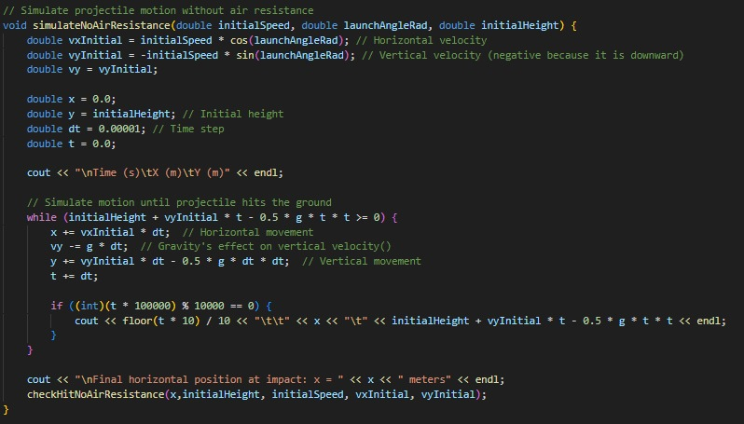

Physical calculations were encoded as functions and called during the process. The coordinates x and y are calculated for every 0.00001 seconds and printed every 0.1 seconds after.

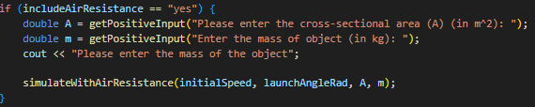

If air resistance is included, mass and crossec area of object are asked from the user and functions that work with air resistance are called for calculations.
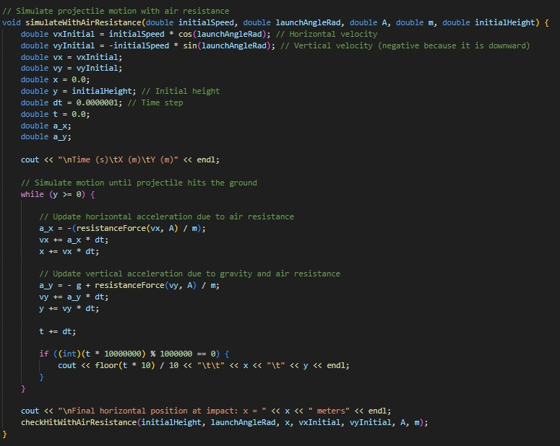Time intervals that had been set were narrowed down 0.0000001 seconds. Presence of air resistance, acceleration and velocity are changed in every time intervals and disposition is recalculated and added location values x and y and locations are printed every 0.1 seconds after. After all of these the range that projectile reach is printed to the text window.
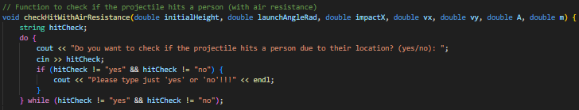After calculations the system asks user if they want to check whether the projectile hits the person at the platform or not. Based on answer, the system is directed to check functions.
The horizontal location and height of the person are determined by the user.
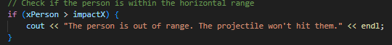At first, the computer checks whether the horizontal location of person is greater than range of motion for that means person is the out of the range. 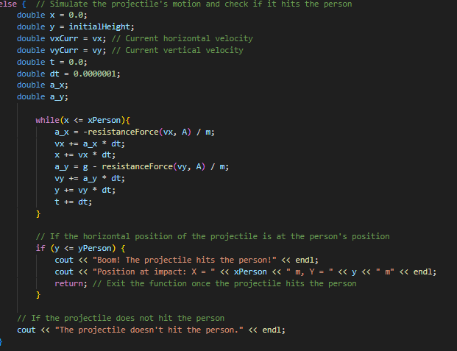Then system calculates how long it takes object to reach horizontal location of person and after that, it calculates the vertical location of object at this moment. That the vertical location of object is less than height of the person actually demonstrates that the projectile will hit the person. The location of ball where it hits the person is printed if height of the ball is smaller.
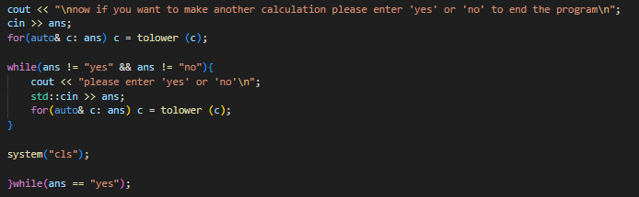The final step is to ask the user if they want to perform whole process again. As long as the answer is “yes”, program will reset itself and perform again.

Output
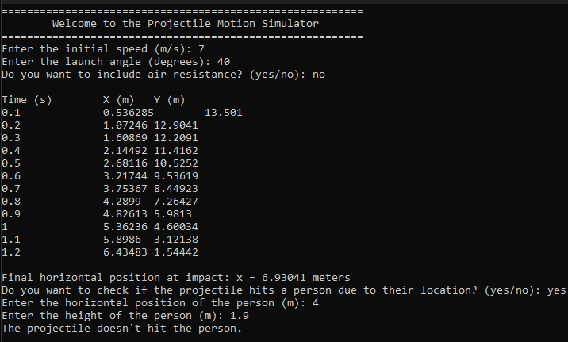

TASK 2 : COLLISIONS OF ASTEROIDS

Introduction
Collision of asteroids problemis related to linear momentum. Two asteriods create an angle among themselves after they collide. Due to this angle and collision event, their velocity undergo a change but their total momentum is always conserved if there is no external effect.

The problem
The problem was computation of final velocities of two asteroids with same mass after their collision. The first asteroid collides the second asteriod with 42 m/s initial velocity. The second asteroid, which was at rest, gains a momentum and velocity due to the collision. First asteroid produces angle of 25 degrees between its linear directions before and after collision. Second asteroid produces angle of 45 degrees between the initial and final linear directions of first asteroid. After calculation stage of velocities, finally, the fraction of energy loss at first asteroid during the process has to be calculated.

Physical Calculations
That momentum is always conserved was remarked before and with depending on conservation of momentum, calculations were made with following this law.

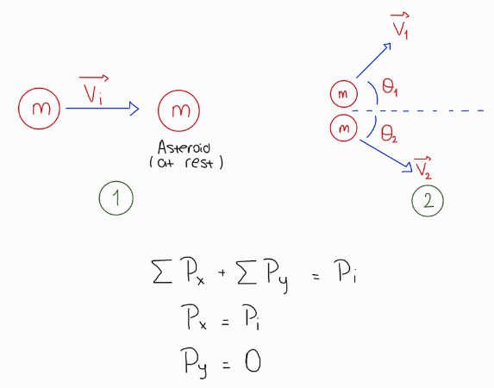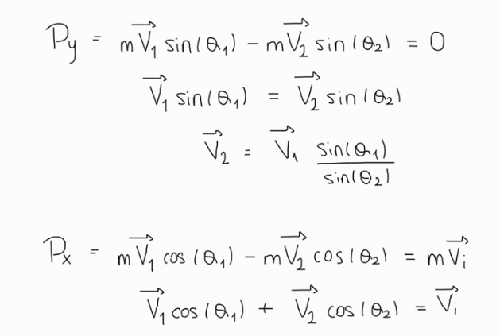
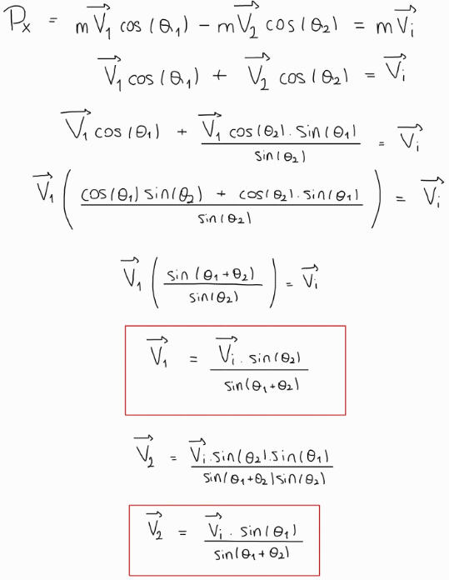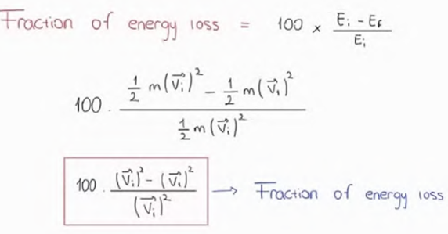

Pi: Initial momentum
Px: Final momentum on x-axis
Py: Final momentum on y-axis
Vi: Inıtial velocity of first asteroid
V1: Final velocity of first asteroid
V2: Final velocity of second asteroid
m: Mass of asteroids
θ1: The angle between initial direction and final direction of first asteroid
θ2: The angle between initial direction and final direction of second asteroid
Ei: Initial kinetic energy of first asteroid
E1: Final kinetic energy of first asteroid

After the editing stage at the equations, the formulas which express the final velocities and energy loss fraction were found.

Algorithm
To make these defined calculations, initial velocity and angles will be needed as inputs. After the process, computer will be asked to give final velocity values, and fraction of energy loss as output values. Prepared algorithm consists of three stages
Where the initial velocity and angles are taken as inputs.
Where final velocities and energy loss fraction are calculated.
Where the output values are printed.
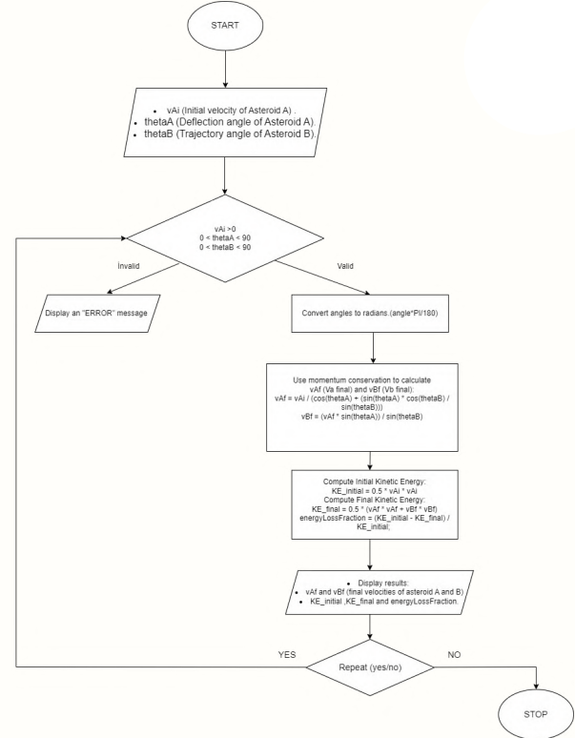
Functions that are used in second stage were designed based on remarked physical calculations. Program were designed to accept only positive values and acute angles as input values.

Code
C++ program was codified with following the flowchart.
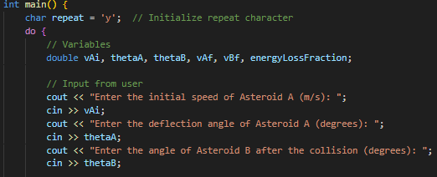 User was asked to enter initial velocity of first asteroids and two angles which is between initial direction of first asteroid and directions of two asteroids after collision.
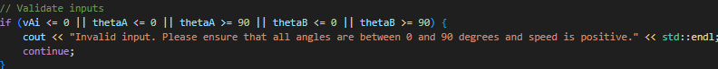To make calculations correctly, values are ensured to be positive for speed value and acute for angles.

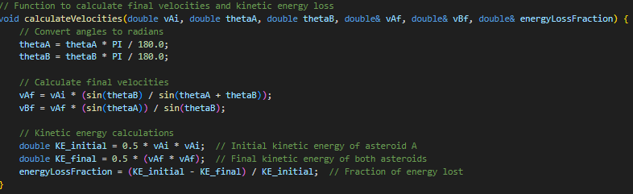Physical equations and formulas were encoded as auxilary functions.
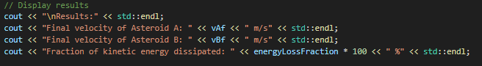Final velocity values and percent energy loss fraction were taken in the end of process and printed to the text window.
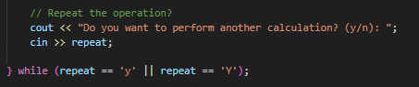

And finally the system asked the user if they wanted to make another calculation. The system was encoded to perform whole the process again and again as long as the answer is affirmative.

Output
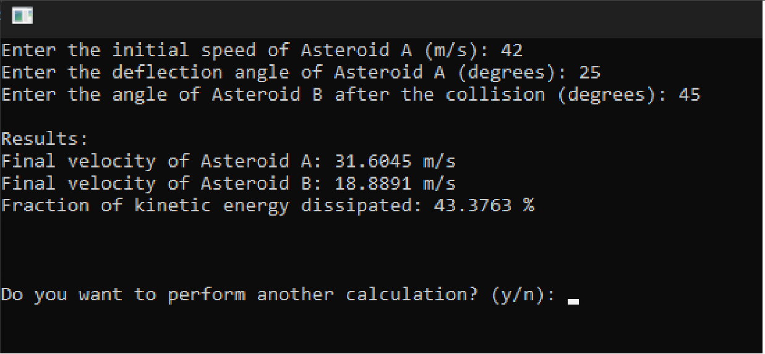

TASK 3 : BALLISTIC PENDULUM

Introduction
Ballistic pendulum is a device for measuring bullet’s momentum. The system works with the principle of conservation of momentum and mechanical energy. When the bullet hits the pendulum bob, it causes a levitation over pendulum. When calculations are made, the change over height levels is considered.

The Problem
12.0g bullet hits the bob of a pendulum with 380 m/s speed. The pendulum is 70 cm long and 6 kg. The problem is calculation of height of the pendulum where the bullet stops for a moment, the initial kinetic energy of bullet, and the kinetic energy at collision moment.

Physical Calculations
That conservation of momentum is what makes the basis of the calculations. At the moment, when bullet hits the pendulum, instantaneous momentum at that time and the initial momentum of pendulum were used. Additionally, the height that bullet causes can be considered as a conversion of kinetic energy to gravitational potential energy.
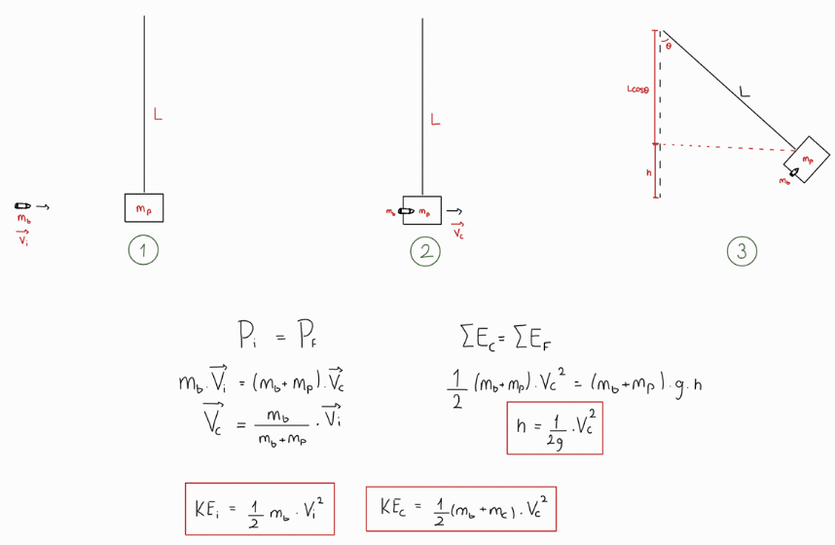
Pi: Initial momentum of bullet Pf: Momentum at collision
mb: Mass of bullet mp: Mass of pendulum
Vi: Initial speed of bullet Vc: Speed at collision
g: Gravitational acceleration h: Height that bullet causes
KEi: Initial kinetic energy of bullet
KEc: Kinetic energy at collision
Ef: Final mechanical energy
Ec: Mechanical energy at collision

For the kinetic energy will transform into sound, heat and deformation, Initial kinetic energy and the kinetic energy at collision take different values from each other. After a few settings on equations, formulas of height, initial kinetic energy, and kinetic energy at collision were created.

Algorithm
The algorithm starts with asking the user for speed of bullet, height of the pendulum, and the masses of pendulum and bullet as input values. Then kinetic energy values and change over height are calculated by the functions which is created following the physical equations. After calculation stage the results are printed on the screen.
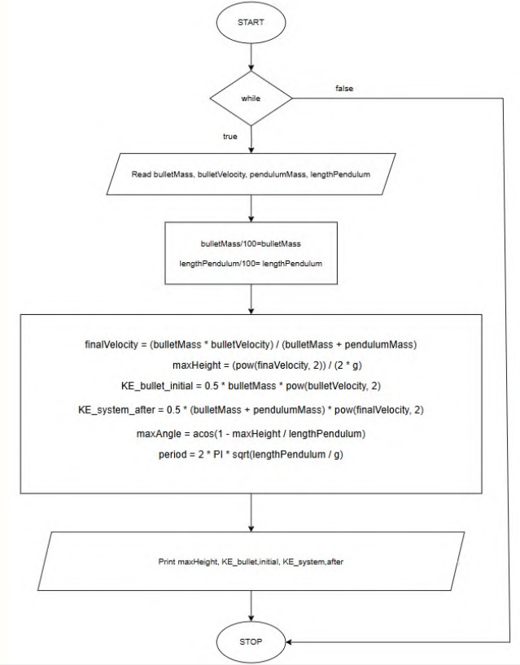
Calculations were designed based on physical calculations demonstrated.
Code
The basis of c++ code was created by the flowchart.
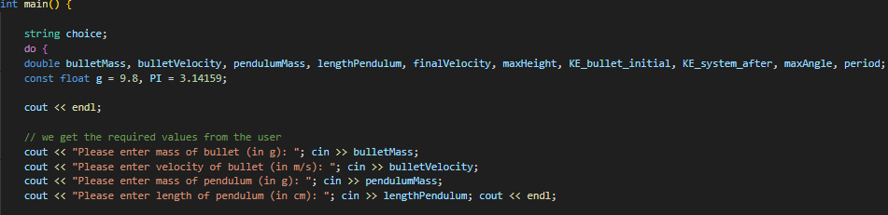Users were asked for height of the pendulum, speed of the bullet, and masses of bullet and pendulum as inputs.
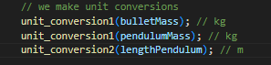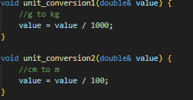
Units were converted into SI forms in order to get accurate results.
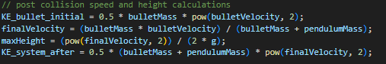
The physical formulas were integrated into assignment statements for output variables.

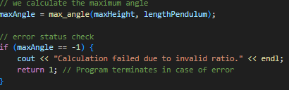

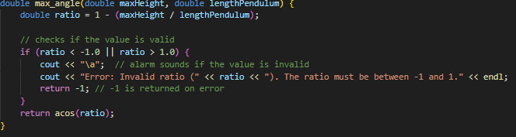
For unrealistic situations like to find cosine value greater than 1 or less than –1 an error message designed.
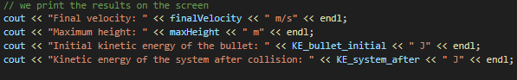The results that were taken printed out of text window.
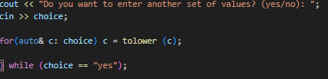
The final step is to ask the user whether they want to perform another process. As long as the answer is affirmative, the program will be repeated again and again.

Output
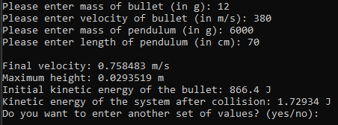

TASK 4 : SATELLITE MOTION SIMULATION

Introduction
In physics, acceleration is defined as change on linear velocity. It may not only affect velocity for value but also it may change the direction of velocity. Circular motion is an example for this kind of motion effected by acceleration. During the process, the value of velocity is always same but the direction of it is modified by acceleration. For that motion to be provided, acceleration has to be always perpendicular to the velocity. This perpendiuculation causes acceleration to be always towards to the center of trajectory of motion. The force that causes this acceleration is called centripedal force.
Based on law of gravity, two masses act pair of action reaction forces due to the mass values they have. This force is called gravitational force. In space, when celestial bodies act gravitational force on objects strong enough to prevent them to move away and not too strong to attract the objects to theirselves, gravitational force pretends like a centripedal force and makes the objects perform a circular motion around themselves.

The Problem
The problem was calculation of required velocity of a satellite which is 600 km away from Earth’s surface to revolve around the Earth. After calculation of velocity, the time that is taken during the revolution has to be calculated.

Physical Calculations
That gravitational force will act like the centripedal force was professed before. Both force has different formulas to be defined. Physical calculations were made with using the equation of both formula and mathematics.

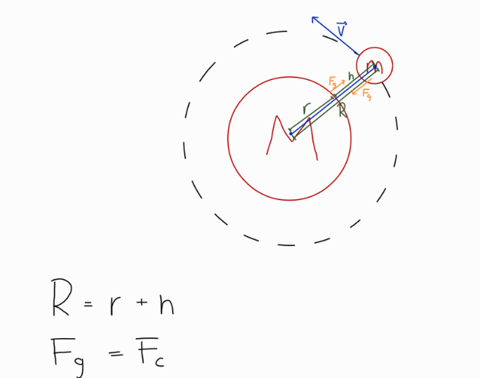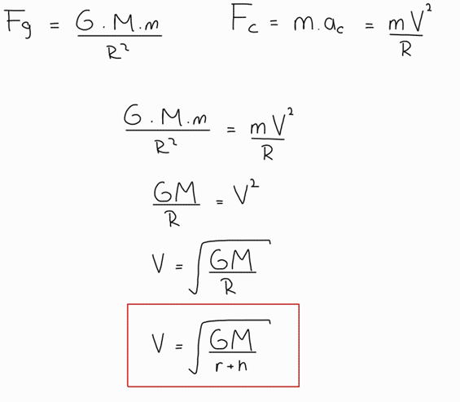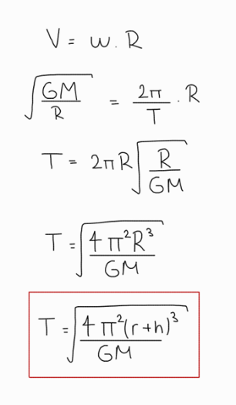
Fg: Gravitational force v: Velocity of the satellite
Fc: Centripedal force M: Mass of the orbit
T: Period of revolution m: Mass of the satellite
ω: Angular velocity of satellite
R: Distance between gravity center of orbit and satellite
r: Radius of orbit
h: Altitude of satellite from surface of orbit

In the end of the recoordination at the equations, period and velocity of revolution were finally able to be expressed as formulas theirselves.

Algorithm
To get the asked values, mass and radius of the orbit and the distance between orbit and satellite need to be known because the values are only changed by these three variables. Apart from this, G and pi are constants and they do not effect the needed values. Algorithm is prepared with three stages:
Where the mass, radius and distance are taken as inputs.
Where the orbital velocity and period are calculated
Where the final values are printed

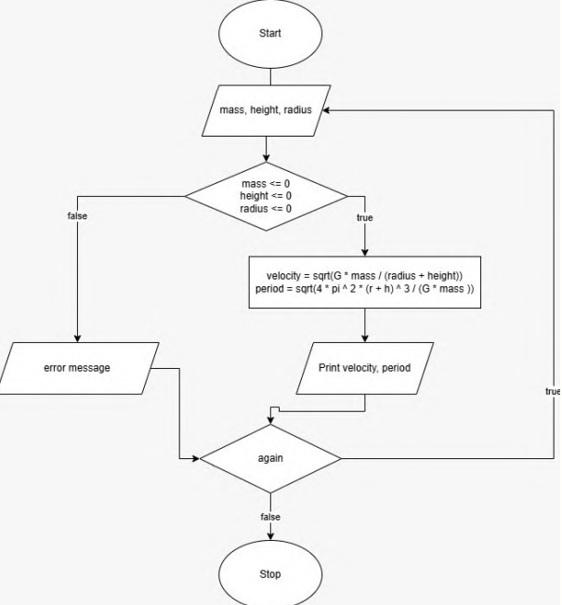
The system were designed to give an error message unless the mass, height and radius values are positive. Additionally, calculation functions were designed based on physical equations stated before.

Code
When the program being codified, flowchart was respected.
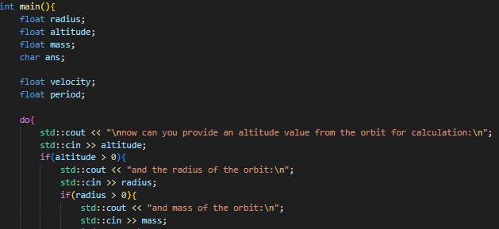The program was designed to ask the user for the mass of orbit at the center, radius of the orbit, and distance between orbit and the satellite as positive input values.
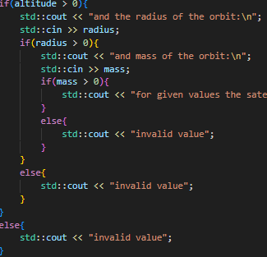
The system gives an error message if the input values are less than or equal to zero.

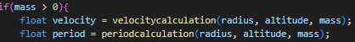
After the required values were provided, the system calls the functions to calculate orbital velocity and period.
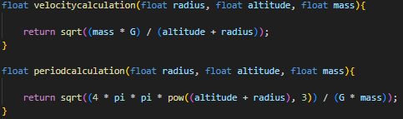
To build the functions, physical calculations were used.
Final values are printed to the text window in the end of the process and finally the system asks the user if they want to execute another calculation.
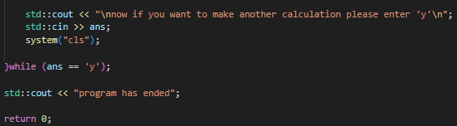Providing that the answer is confirmation, the program repeats itself one more time.

Output
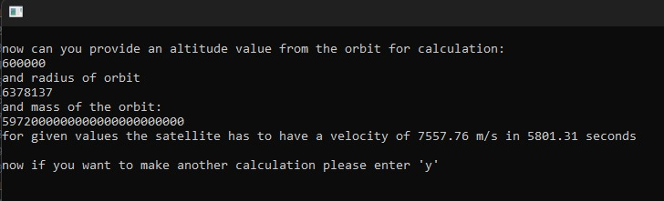

COMBINATION OF CODES
After dealing with the whole processes of tasks seperately, all c++ files were combined in one file.
Modifications
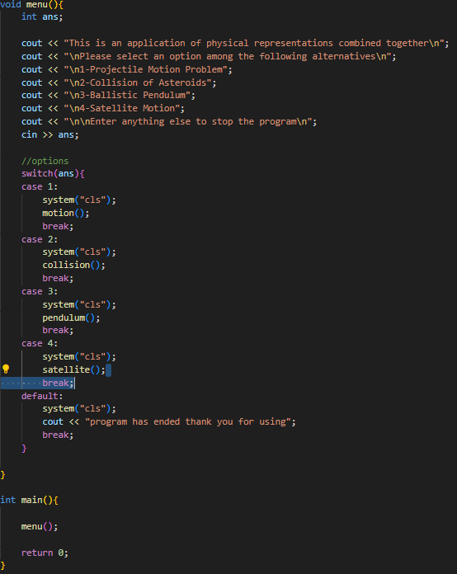
An interactive main menu was added to make transitions between tasks. The main statements were deleted from all tasks and they were renamed. The main menu works with a principle of function calling with using the function names of tasks. System asks to user which project they want to perform. If none of projects was selected, program stops itself.
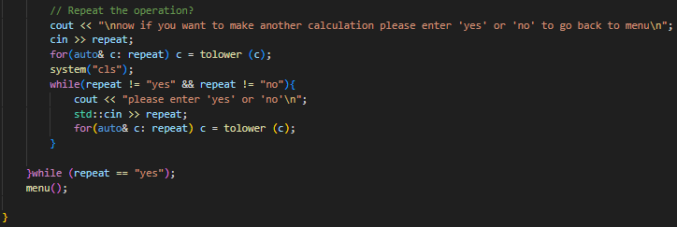It is possible to go back to main menu in the end of each task. Unlike it was in the seperate files, negative response directs the user to main menu instead of stopping the program.
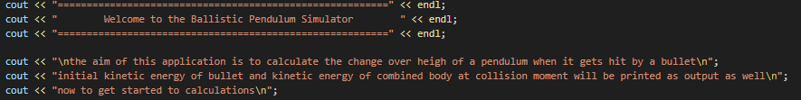An informative greeting message which explains what the program does and how it works was added in the beginning of each problems.
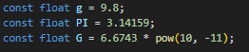
The constant values which are used in common were declared only once as global variable.
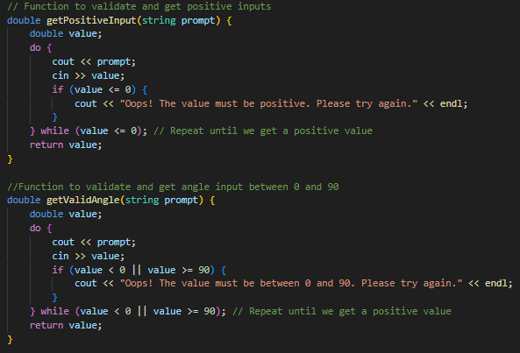
In order to validation of variables getValidAngle and GetPositiveInput functions were added. The functions were designed to ask values again and again as long as they are unacceptable.
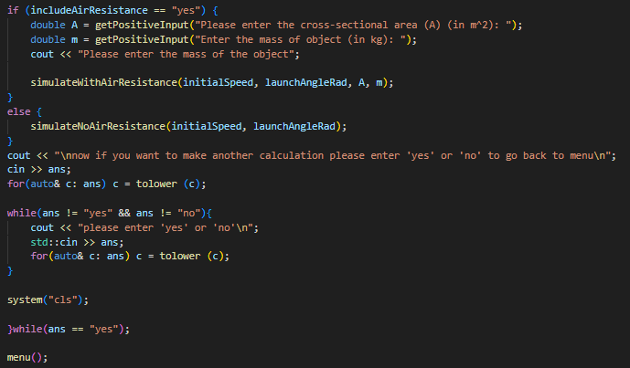All messages sent by compiler were edited to be closer to each other.

MATLAB AND SIMULATION
To observe what was done accurately, visualisation of codes was agreed upon and matlab was chosen to provide it. While C++ codes were being converted to matlab codes, the style and syntax of original codes were efforted to be kept as much as possible.

Projectile Motion
The graphs of first task were designed to demonstrate coordinates of x and y values on one single curve.

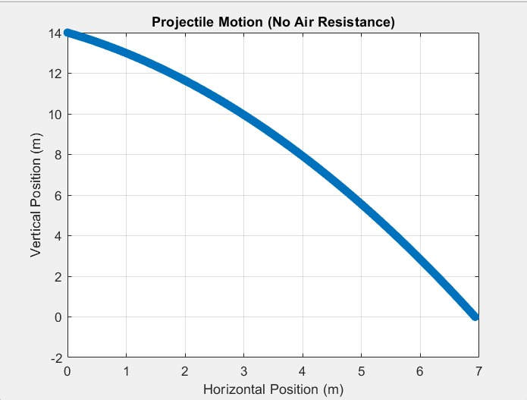

The coordinates x and y of curve represent the coordinate of object during the motion

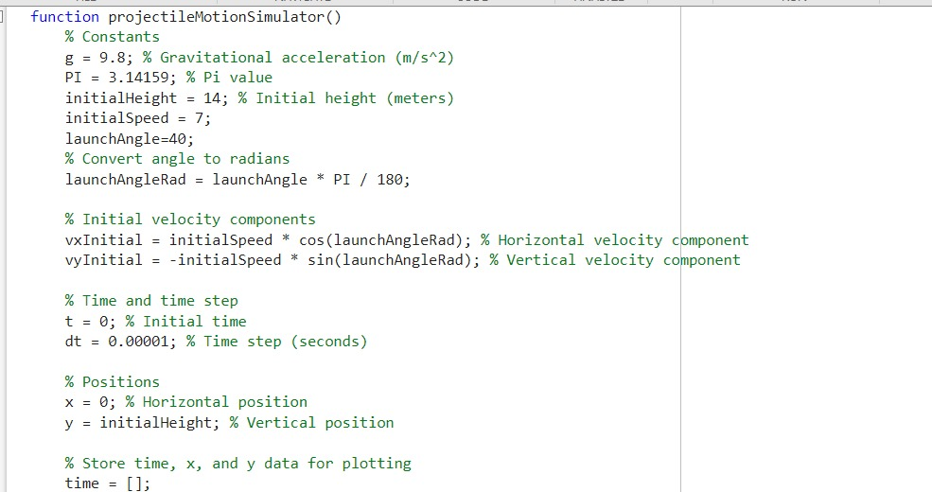The same algorithm that measures movement for each 0.00001 second was used.
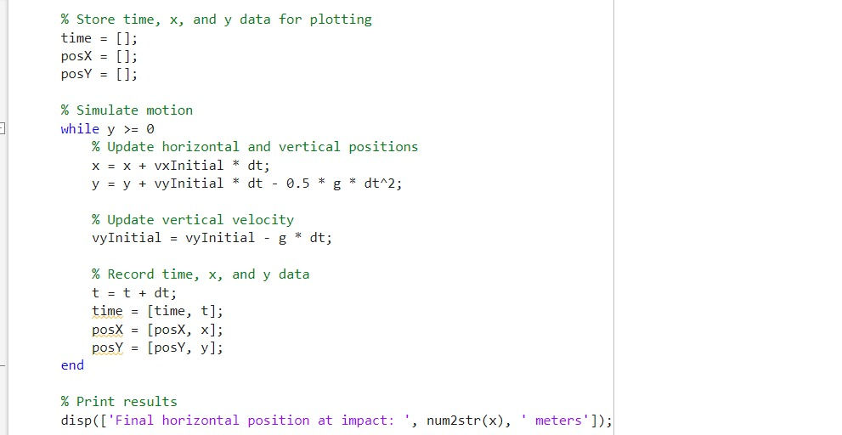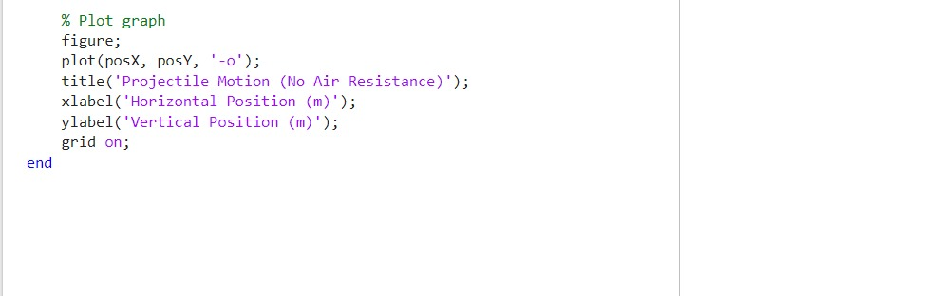

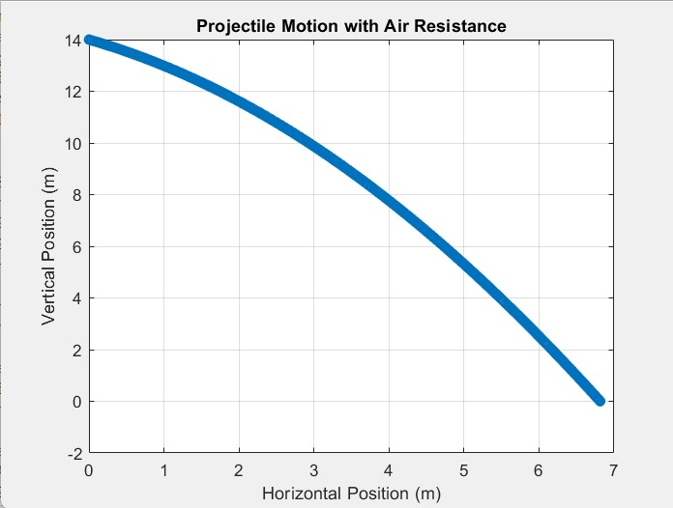
The difference between ranges of projectiles due to air resistance can be observed more explicitly on graphs.
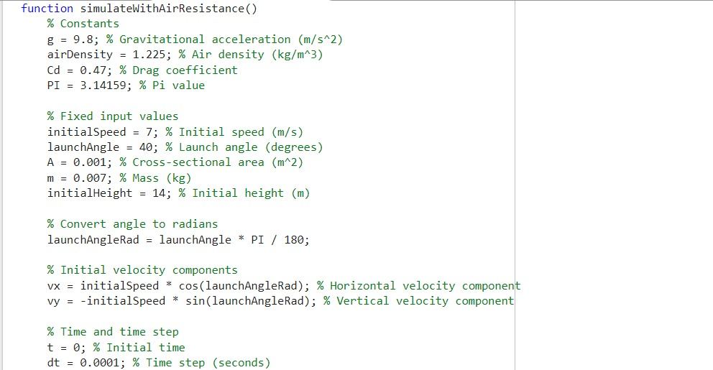When air resistance is included, algorithm changes the acceleration and velocity over the time. Disposition is modified based on velocity value and the process is repeated every 0.00001 seconds.
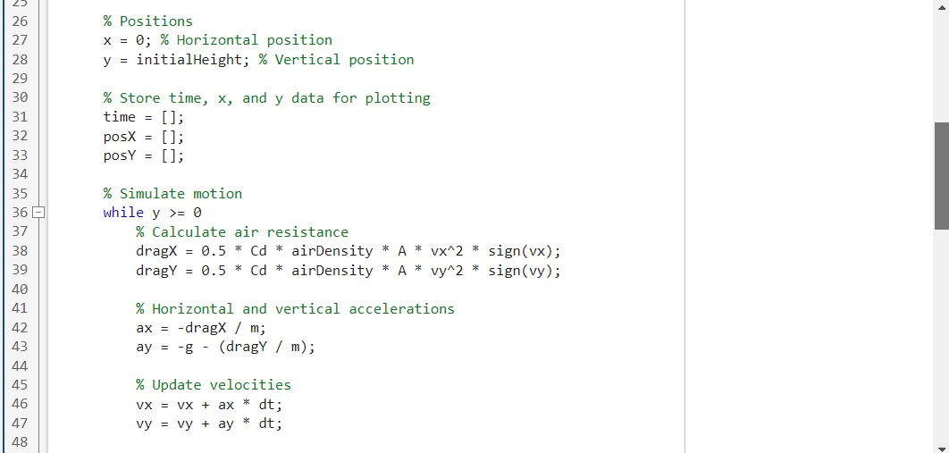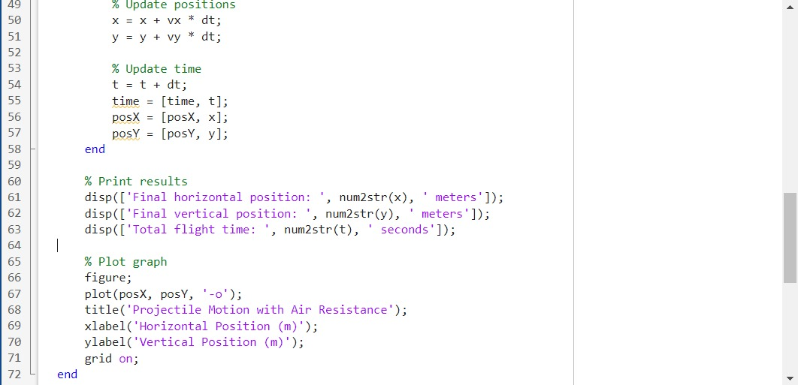
7 m/s speed, 40 degrees platform angle, 14 m platform height, 0.07 kg mass, and 0.01 m^2 crossec area were used as inputs for graphs to be drawn.

Collision of Asteroids
The graphs were created to compare the velocity values of asteroids clearly.
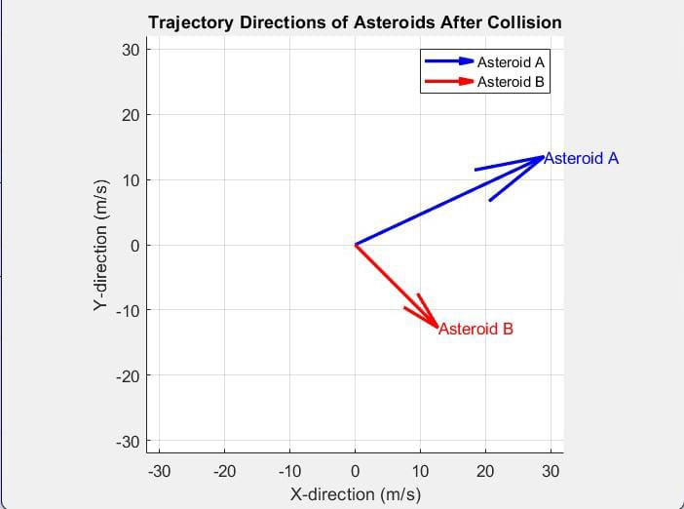The lengths of arrows represent velocity values of asteroids. The angle between x axis and arrows demonstrate the direction of them.
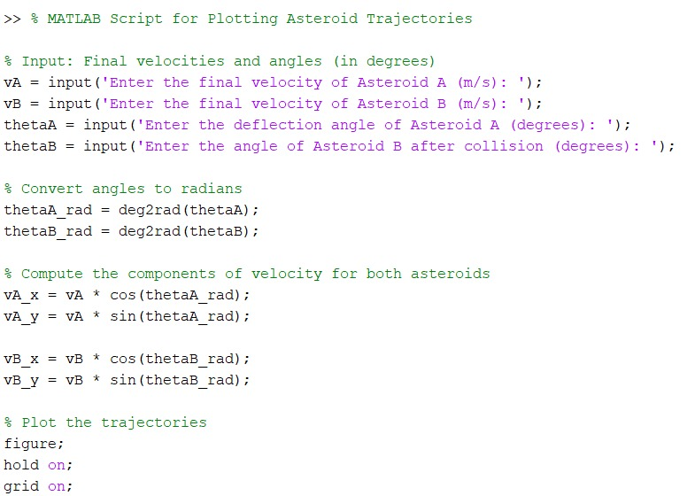
Graph function takes the velocities and angles as inputs instead of making a collision calculation.
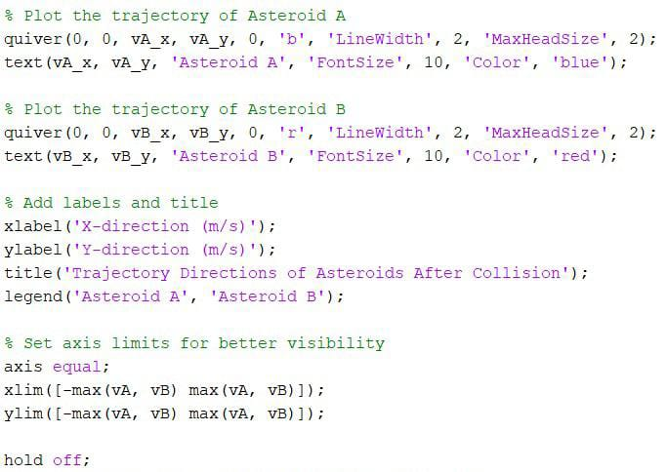
The velocity values that had taken from the c++ code of collision calculator. The input values were 42 m/s speed for first asteroid, 25 degrees direction to north of east for the first asteroid and 45 degrees direction south of east for the second asteroid.

Ballistic Pendulum
There are two graphs used to visualise pendulum.
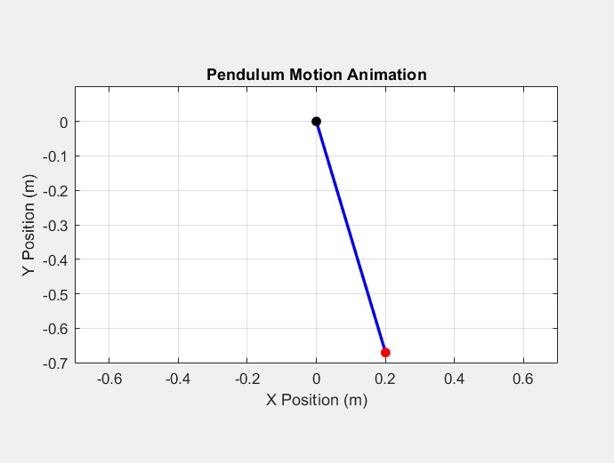
First graph simulates the collision moment of pendulum’s bob and the bullet.
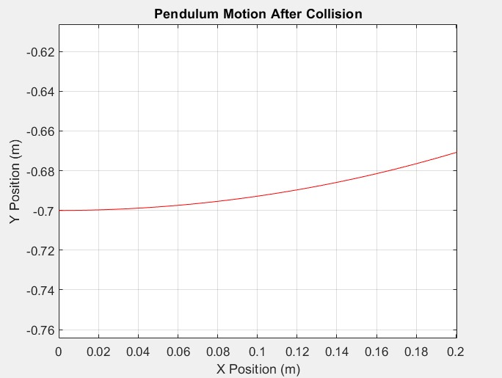
Second graph demonstrates the x and y values of pendulum after it gets hit by the bullet.
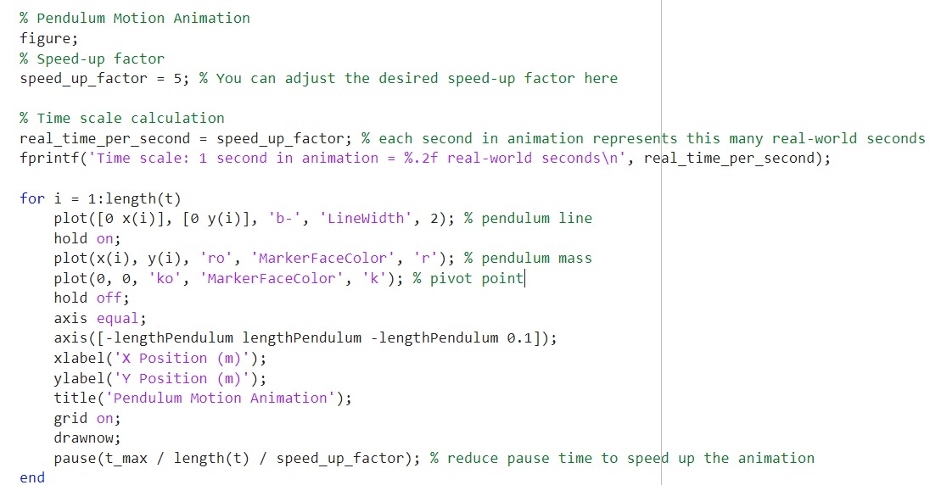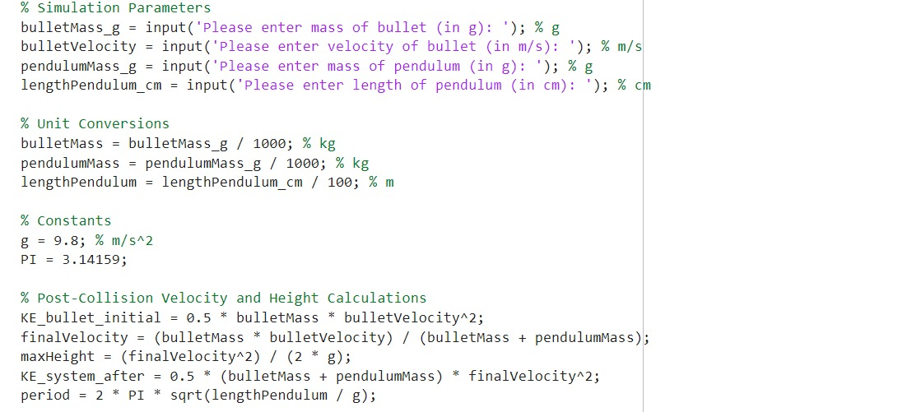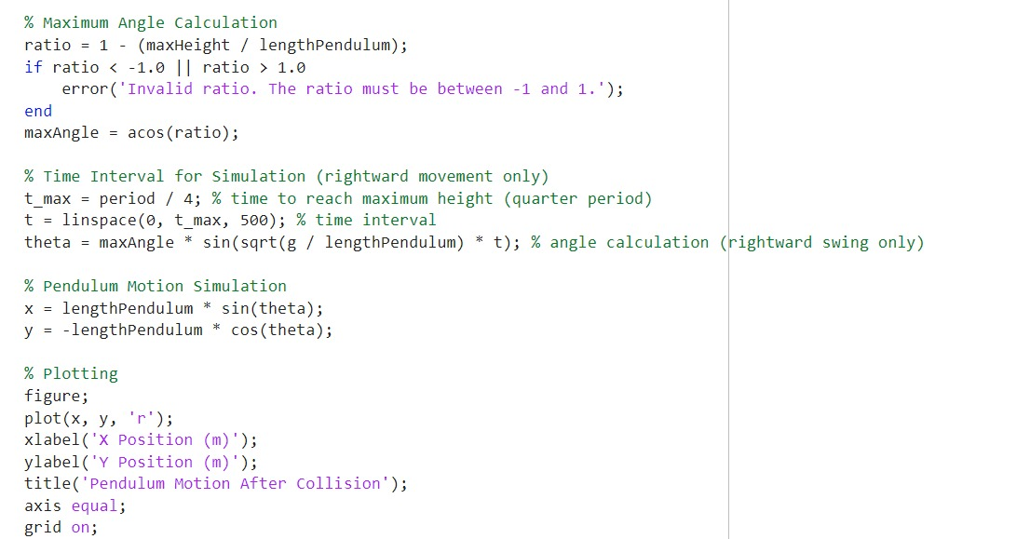
380 m/s speed, 12 g bullet mass, 70 cm pendulum length, and 6 kg pendulum mass were used as input values.

Satellite Motion
Instead of making a graph, trajectory simulation was used to simulate satellite motion.

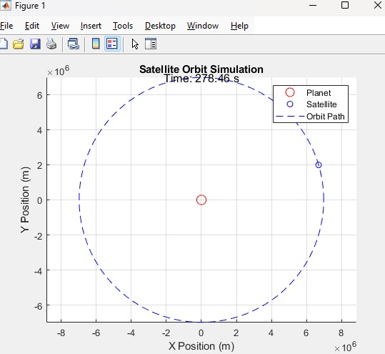

A table of x and y coordinates was used to display the location of satellite. Each interval represents 200000 meters in reality. The time value that is printed on screen is used to indicate the exact time of position of satellite.
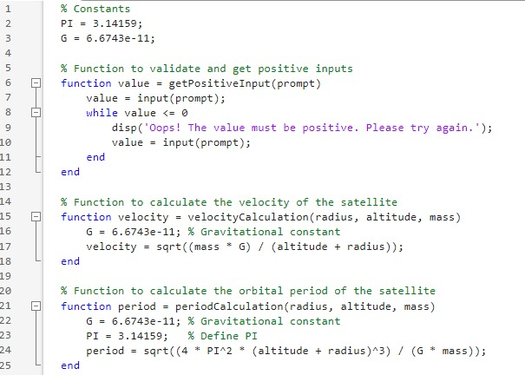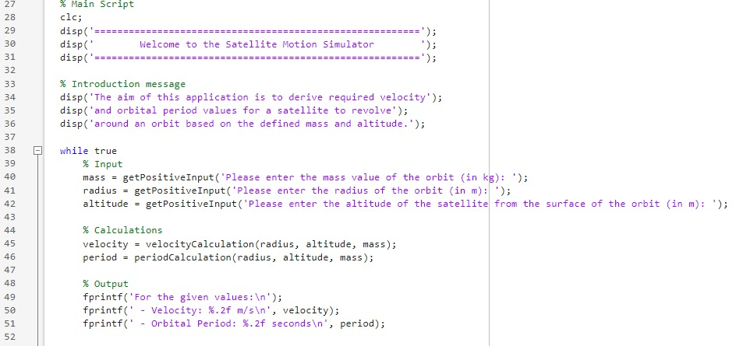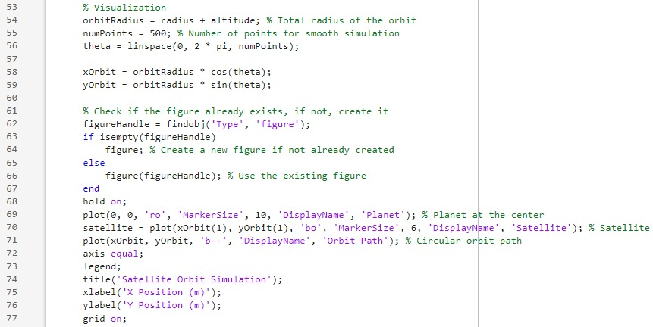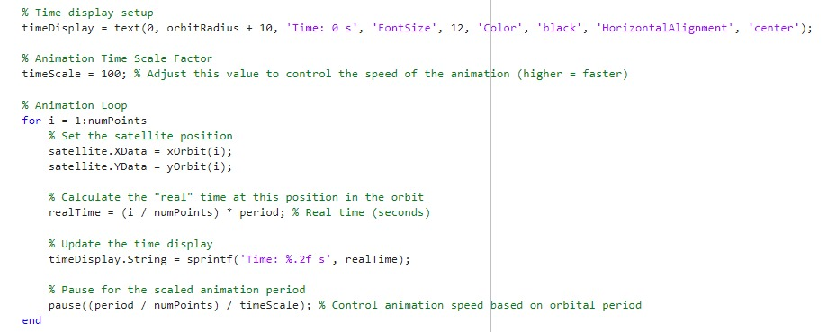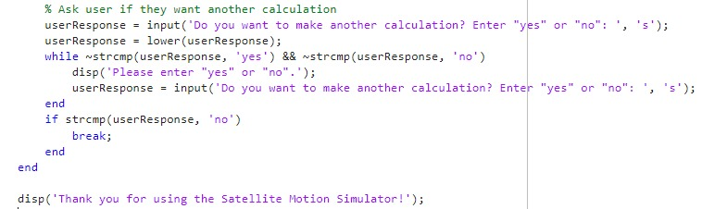
6378 km orbit radius, 600 km satellite altitude and 5.972 x 10^24 kg orbitt mass were used as inputs.

CONCLUSION
The report sheet shows the researching and problem solving stage of a modular project not only a specific one but also any. At first, the problems are taken into a consideration in point of what it means in reality and how scientists approach these given problems. Then the process is followed by a mathematical stage for satisfying the physical problems that was got from the researchments. After that, the process is worked with an algorithm which told the steps of a plan. The whole coding process was provided by C++ which is one of most worked programming languages. Coding stage enlightens about how a code line is used in real life other than academic. And finally all tasks were supported by a visual representation in order to bring solution algorithms closer to reality.

