AI & ML Internship — Elevate Labs
Task 2: Exploratory Data Analysis (EDA)
Titanic Dataset

1. Objective
Understand the Titanic passenger dataset using descriptive statistics and visualizations, in order to identify patterns, trends, anomalies, and feature-level relationships that influenced survival.

2. Tools Used
- Pandas — data loading, cleaning, and summary statistics
- NumPy — numeric operations
- Matplotlib & Seaborn — histograms, boxplots, heatmaps, pairplots, bar charts

3. Dataset Overview
The dataset contains 891 passenger records with 12 columns: PassengerId, Survived, Pclass, Name, Sex, Age, SibSp, Parch, Ticket, Fare, Cabin, and Embarked.
Column | Missing Count | Missing %
Age | 177 | 19.87%
Cabin | 687 | 77.10%
Embarked | 3 | 0.34%
All other columns | 0 | 0.00%

Cabin is too sparse to use directly without engineering (e.g. a 'has_cabin' flag or deck extraction). Age can be imputed using median or group-wise median by Pclass/Sex. Embarked's missingness is negligible and can be filled with the mode.

4. Summary Statistics
Feature | Mean | Median
Age | 29.7 yrs | 28.0 yrs
Fare | ₤31.29 | ₤16.38
Survived | 36.5% | —

Fare shows a large gap between mean and median, an early signal of right-skew confirmed later in the histogram and skewness check (skew ≈ 2.65).

5. Univariate Analysis

5.1 Histograms
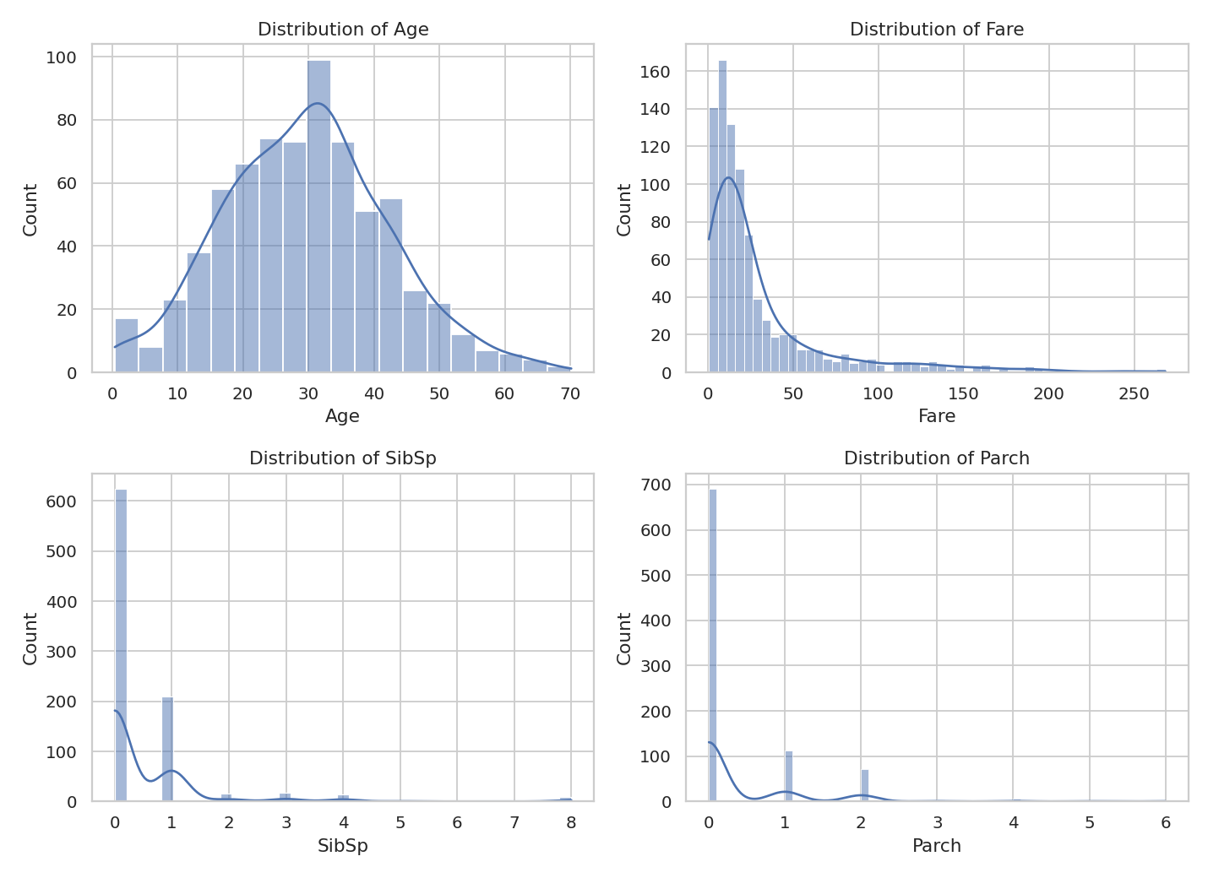
Figure 1 — Distributions of Age, Fare, SibSp, and Parch
Age is roughly bell-shaped and close to symmetric. Fare is heavily right-skewed with a long tail of high-paying passengers. SibSp and Parch are both dominated by zero (most passengers traveled alone).

5.2 Boxplots
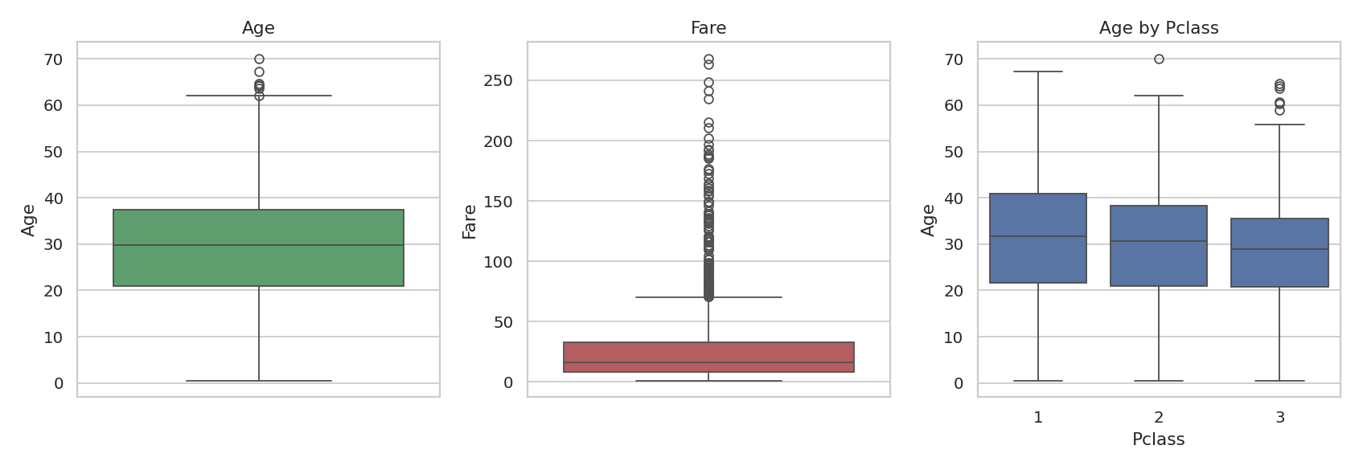
Figure 2 — Boxplots of Age, Fare, and Age by Passenger Class
Fare contains many high-value outliers, mostly first-class fares. Age has a small number of elderly outliers. Median age is broadly similar across classes, with 1st class skewing slightly older.

6. Multivariate Analysis

6.1 Correlation Matrix
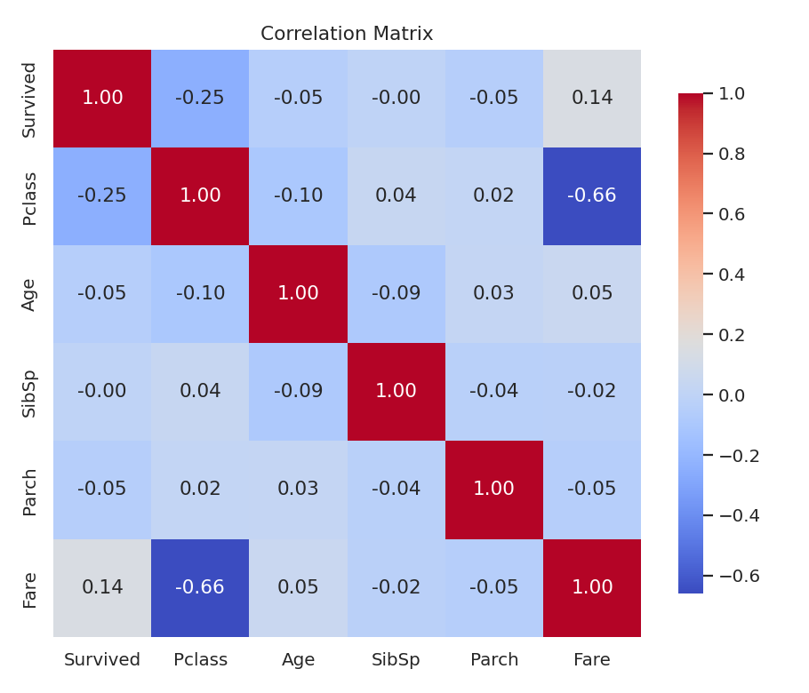
Figure 3 — Correlation matrix of numeric features
Pclass and Fare are strongly negatively correlated (≈ -0.66), which is expected since lower class numbers (1 = highest class) pay more. Pclass correlates negatively with Survived (≈ -0.25) and Fare correlates positively (≈ 0.15) — both consistent with wealthier, higher-class passengers surviving more often. No problematic multicollinearity is present among the independent predictors.

6.2 Pairplot

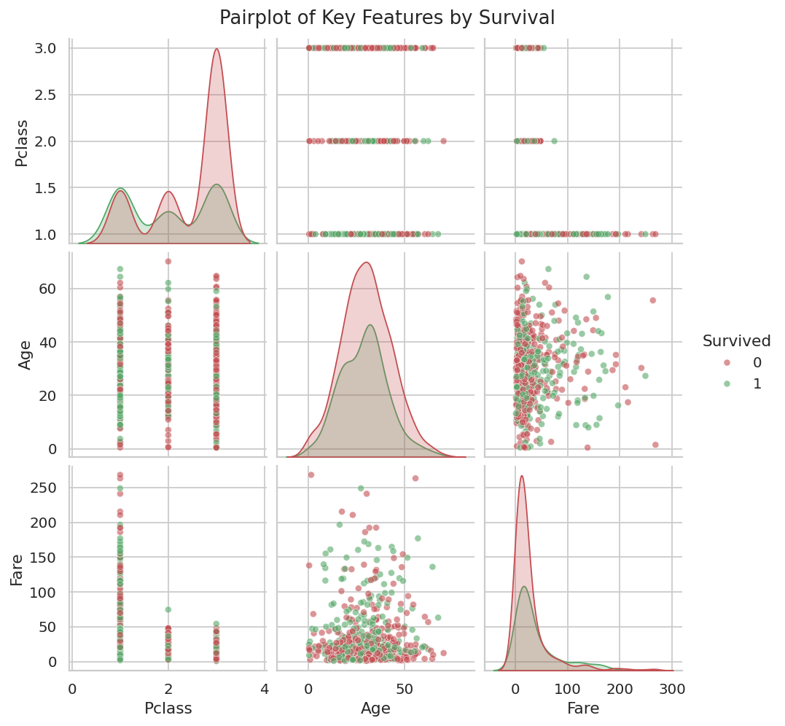
Figure 4 — Pairwise relationships between Survived, Pclass, Age, and Fare

7. Survival Rate by Category
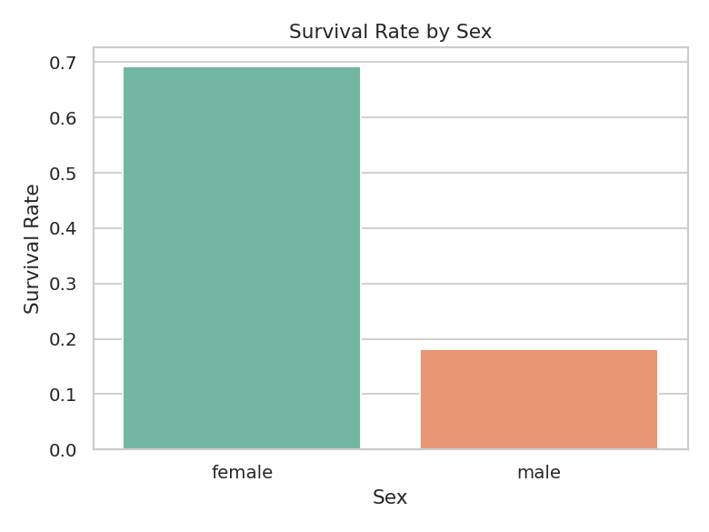
Figure 5 — Survival rate by sex
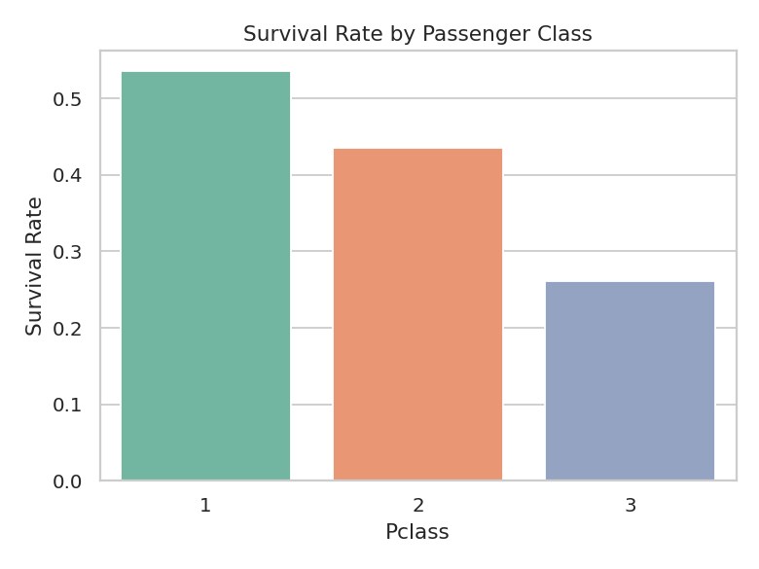
Figure 6 — Survival rate by passenger class
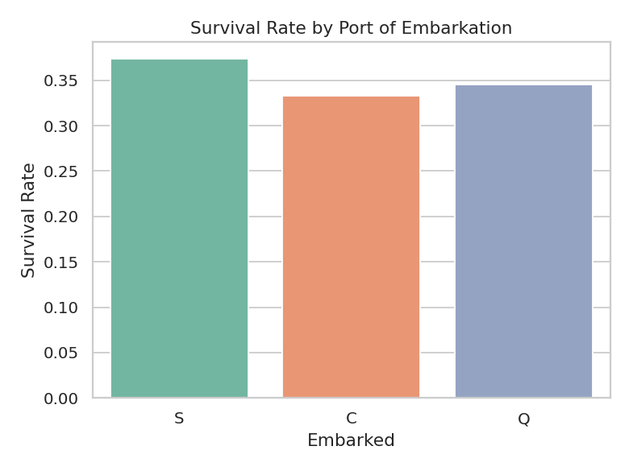
Figure 7 — Survival rate by port of embarkation
Sex is the strongest single predictor visible in the data: female passengers survived at a much higher rate than male passengers, consistent with a 'women and children first' evacuation protocol. Survival rate decreases steadily from 1st to 3rd class. Passengers who embarked at Cherbourg (C) show a somewhat higher survival rate, likely tied to the class mix boarding at that port.

8. Age and Fare in Relation to Survival
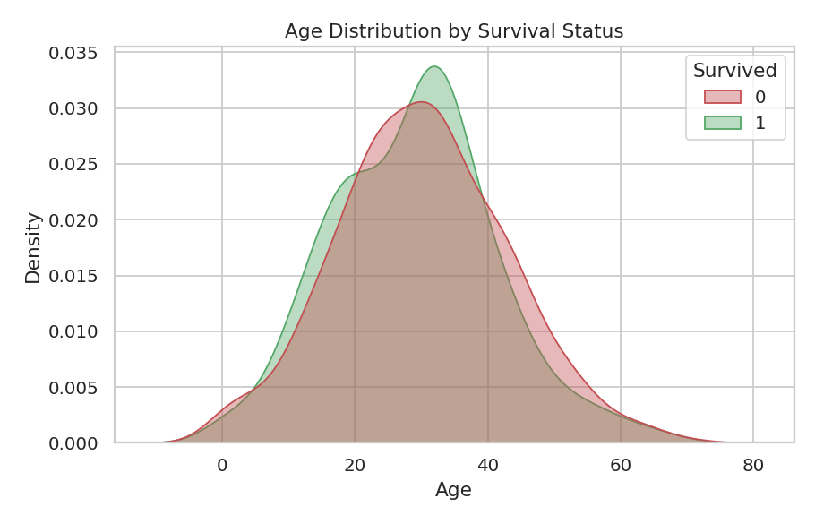
Figure 8 — Age distribution by survival status
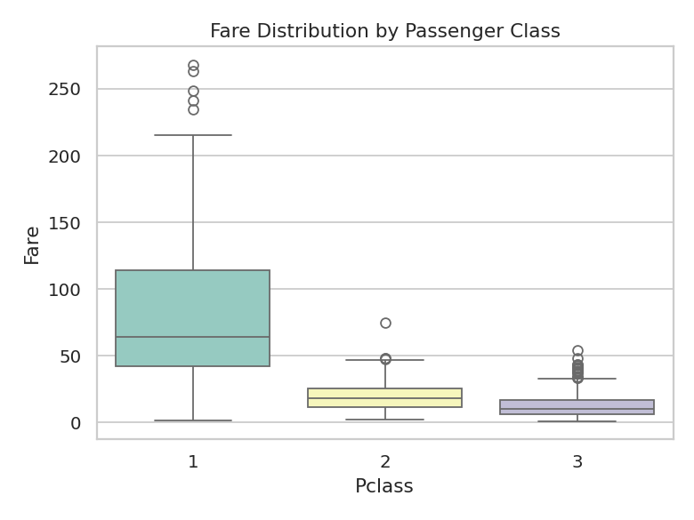
Figure 9 — Fare distribution by passenger class
Survivors and non-survivors show broadly similar age distributions, with a slightly higher survival density among very young children. Fare rises sharply with class, reinforcing Fare's role as a proxy for class and wealth in the survival relationship.

9. Key Feature-Level Inferences
- Sex is the strongest survival signal — being female roughly quadruples survival odds compared to being male.
- Passenger class strongly affects survival, likely reflecting cabin location, lifeboat access, and crew priority.
- Fare correlates with survival mainly through its relationship with class, not as an independent effect.
- Fare, SibSp, and Parch are right-skewed and should be transformed (e.g. log-transform) before use in distance-based models.
- Age has a mild influence, mostly favoring very young children.
- No problematic multicollinearity exists between independent predictors.
- Cabin requires special handling due to extreme sparsity (~77% missing).

10. Interview Questions — Answers
Q1. What is the purpose of EDA?
EDA is the process of investigating a dataset using statistics and visualizations before modeling, to understand its structure, spot missing values and outliers, examine relationships between variables, and form hypotheses about what drives the target variable.
Q2. How do boxplots help in understanding a dataset?
Boxplots summarize a numeric feature's distribution (median, quartiles, spread) in one compact view and make outliers easy to spot as points beyond the whiskers. They're also useful for comparing a feature's distribution across categories side by side.
Q3. What is correlation and why is it useful?
Correlation measures the strength and direction of the linear relationship between two numeric variables on a scale from -1 to 1. It helps identify which features move together, surface potential predictors of a target variable, and flag redundant features.
Q4. How do you detect skewness in data?
Skewness can be detected visually via a histogram or KDE plot (an asymmetric tail) or numerically using a skewness statistic — values near 0 indicate symmetry, positive values indicate a right tail, and negative values indicate a left tail.
Q5. What is multicollinearity?
Multicollinearity occurs when two or more independent variables are highly correlated with each other, making it difficult for a model to isolate each variable's individual effect on the target. It is typically detected using a correlation matrix or Variance Inflation Factor (VIF).
Q6. What tools do you use for EDA?
Pandas for data manipulation and summary statistics, Matplotlib and Seaborn for static visualizations, and Plotly for interactive visualizations, supported by NumPy and SciPy for numeric and statistical operations.

Q7. Can you explain a time when EDA helped you find a problem?
In this analysis, EDA revealed that Cabin was missing for about 77% of records — without catching this early, the column could have been fed into a model with poor or misleading imputation. EDA also revealed Fare's strong right-skew, which would distort distance-based models unless transformed.
Q8. What is the role of visualization in ML?
Visualization builds intuition about feature distributions and relationships, communicates findings to stakeholders, guides preprocessing decisions such as transformations and outlier handling, and helps validate model assumptions and diagnose errors after training.

11. Conclusion
This EDA confirms the well-known Titanic survival story: sex and passenger class were the dominant factors in who survived, with fare acting largely as a proxy for class. The dataset is clean enough for modeling after addressing Age imputation, Cabin sparsity, and Fare's skew, with no major multicollinearity concerns among the core numeric predictors.

