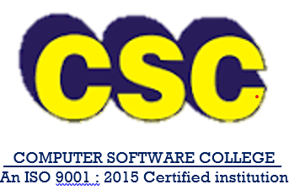
CSC COMPUTER EDUCATION
127,WEST RAJA STREET, NEAR S.S.K.V.SCHOOL
VENUS STUDIO UPSTAIRS, KANCHEEPURAM – 631502
Ph.8838404494 / 48657447

TO
The Centre Head
Chengalpattu

Respected Sir/Madam
Here with we are enclosing the Diploma Certificate as per your Certificate requisition slip.
S.NO | REG.NO | NAME | COURSE | FROM | TO
1 | 20315 | ABIRAMY.M | DCA | 04/02/2021 | 03/08/2021
2 | 20323 | NITHYA.S | DMO | 12/03/2021 | 11/05/2021
3 | 20321 | SIVA.M | TALLY | 16/03/2021 | 15//062021
4 | 20322 | RAJA.G | HDCA | 22/05/2021 | 21/05/2021
5 | 20328 | KAVITHA.C | ADPP | 06/06/2021 | 05/10/2021

Kindly acknowledge receipt
This is computer generated document and hence no signature required

For CSC COMPUTER EDUCATION

xxxxxxxxxx
(Manager)

