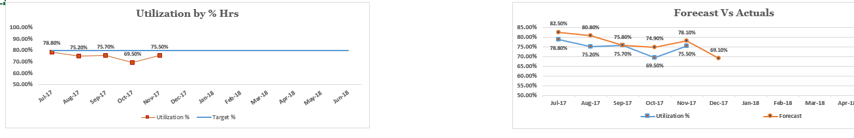

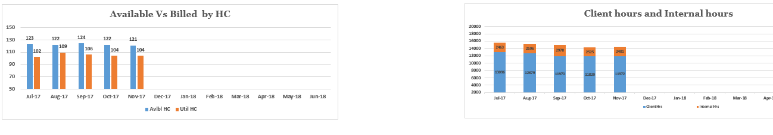

What is the utilization of xxx practice for the month of xxx-xx? –

Code: Avg({1<YYYYMM={">=$(=201708)<=$(=201710)"}>}[Utilization Percentage])

What is the forecast vs actuals for the practice xxx?

How many resources were utilized in the month of xxx? - Sum({$<YYYYMM={'201710'}>}[Utilization Head Count])

How many are in bench?

What is the total client hours billed as of date?

Provide me the list of top 3 months of utilization.

Which month had the highest utilization?

Which month had the lowest utilization?

What is the percentage of client billed hours on overall billed hours?