**Chapter three Theoretical background**

**3.1 Human brain anatomy and physiology:**

The brain is a complex organ that controls thought, memory, emotion, touch, motor skills, vision, breathing, temperature, hunger and every process that regulates our body. Together, the brain and spinal cord that extends from it make up the central nervous system, or CNS.

Weighing about 3 pounds in the average adult, the brain is about 60% fats. The remaining 40% is a combination of water, protein, carbohydrates and salts. The brain itself is a not a muscle. It contains blood vessels and nerves, including neurons and glial cells. The brain has three main parts: the cerebrum, cerebellum and brainstem. Cerebrum: is the largest part of the brain and is composed of right and left hemispheres. It performs higher functions like interpreting touch, vision and hearing, as well as speech, reasoning, emotions, learning, and fine control of movement.

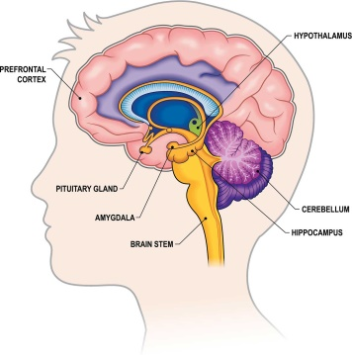

Fig 3.1: shows brain anatomy.

The brain sends and receives chemical and electrical signals throughout the body. Different signals control different processes, and your brain interprets each. Some make you feel tired, for example, while others make you feel pain. Some messages are kept within the brain, while others are relayed through the spine and across the body’s vast network of nerves to distant extremities. To do this, the central nervous system relies on billions of neurons. [3.1]

**3.2 The electroencephalogram:**

The electroencephalogram (EEG) is a recording of the electrical activity of the brain from the scalp. The recorded waveforms reflect the cortical electrical activity.

**Signal intensity:** EEG activity is quite small, measured in microvolts (µV).

**Signal frequency:** the main frequencies of the human EEG waves are:

1. **Delta:** has a frequency of 3 Hz or below. It tends to be the highest in amplitude and the slowest waves. It is normal as the dominant rhythm in infants up to one year and in stages 3 and 4 of sleep. It may occur focally with subcortical lesions and in general distribution with diffuse lesions, metabolic encephalopathy hydrocephalus or deep midline lesions. It is usually most prominent frontally in adults (e.g. FIRDA - Frontal Intermittent Rhythmic Delta) and posteriorly in children e.g. OIRDA - Occipital Intermittent Rhythmic Delta).
2. **Theta:** has a frequency of 3.5 to 7.5 Hz and is classified as "slow" activity. It is perfectly normal in children up to 13 years and in sleep but abnormal in awake adults. It can be seen as a manifestation of focal subcortical lesions; it can also be seen in generalized distribution in diffuse disorders such as metabolic encephalopathy or some instances of hydrocephalus.
3. **Alpha:** has a frequency between 7.5 and 13 Hz. Is usually best seen in the posterior regions of the head on each side, being higher in amplitude on the dominant side. It appears when closing the eyes and relaxing, and disappears when opening the eyes or alerting by any mechanism (thinking, calculating). It is the major rhythm seen in normal relaxed adults. It is present during most of life especially after the thirteenth year.
4. **Beta:** beta activity is "fast" activity. It has a frequency of 14 and greater Hz. It is usually seen on both sides in symmetrical distribution and is most evident frontally. It is accentuated by sedative-hypnotic drugs especially the benzodiazepines and the barbiturates. It may be absent or reduced in areas of cortical damage. It is generally regarded as a normal rhythm. It is the dominant rhythm in patients who are alert or anxious or have their eyes open.

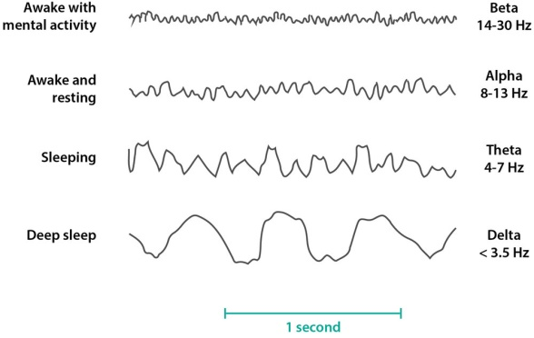

Fig 3.2: the main frequencies of the human EEG waves.

**Variables used in the classification of EEG activity:**

1. **Frequency:** refers to rhythmic repetitive activity (in Hz). The frequency of EEG activity can have different properties including:

Rhythmic. EEG activity consisting in waves of approximately constant frequency.

Arrhythmic. EEG activity in which no stable rhythms are present.

Dysrhythmic. Rhythms and/or patterns of EEG activity that characteristically appear in patient groups or rarely or seen in healthy subjects.

1. **Voltage:** refers to the average voltage or peak voltage of EEG activity. Values are dependent, in part, on the recording technique. Descriptive terms associated with EEG voltage include:
2. Attenuation (synonyms: suppression, depression). Reduction of amplitude of EEG activity resulting from decreased voltage. When activity is attenuated by stimulation, it is said to have been "blocked" or to show "blocking".
3. Hypersynchrony. Seen as an increase in voltage and regularity of rhythmic activity, or within the alpha, beta, or theta range. The term implies an increase in the number of neural elements contributing to the rhythm. (Note: term is used in interpretative sense but as a descriptor of change in the EEG).
4. Paroxysmal. Activity that emerges from background with a rapid onset, reaching (usually) quite high voltage and ending with an abrupt return to lower voltage activity. Though the term does not directly imply abnormality, much abnormal activity is paroxysmal.
5. **Morphology:** refers to the shape of the waveform. The shape of a wave or an EEG pattern is determined by the frequencies that combine to make up the waveform and by their phase and voltage relationships. Wave patterns can be described as being:
6. Monomorphic. Distinct EEG activity appearing to be composed of one dominant activity
7. Polymorphic. distinct EEG activity composed of multiple frequencies that combine to form a complex waveform.
8. Sinusoidal. Waves resembling sine waves. Monomorphic activity usually is sinusoidal.
9. Transient. An isolated wave or pattern that is distinctly different from background activity.

* Spike: a transient with a pointed peak and a duration from 20 to under 70 msec.
* Sharp wave: a transient with a pointed peak and duration of 70-200 msec.

1. **Synchrony:** refers to the simultaneous appearance of rhythmic or morphologically distinct patterns over different regions of the head, either on the same side (unilateral) or both sides (bilateral).
2. **Periodicity:** refers to the distribution of patterns or elements in time (e.g., the appearance of a particular EEG activity at more or less regular intervals). The activity may be generalized, focal or lateralized.[3.2]

**3.2.1 EEG abnormal conditions:**

Conditions that may be diagnosed with the aid of an EEG include:

* Sleep disorders (such as narcolepsy)
* Head injuries
* Brain infection
* Brain hemorrhage
* Alzheimer's disease
* Degeneration of brain tissue
* Metabolic conditions that affect brain tissue
* Hormonal conditions that affect brain tissue
* Certain disorders of the central nervous system
* Stroke
* Brain tumors
* Brain death.

Normal brain waves occur at a rate of up to 30 per second, but in someone with epilepsy, for example, the EEG may show bursts of abnormal discharges in the form of spikes and sharp wave patterns. Suspected epilepsy is the most common reason for an EEG.[3.3]

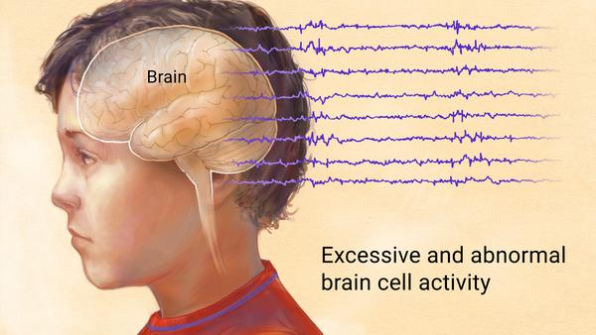

Fig 3.3: shows abnormal brain activity.

**3.3 Epilepsy:**

Epilepsy is a central nervous system (neurological) disorder in which brain activity becomes abnormal, causing seizures or periods of unusual behavior, sensations and sometimes loss of awareness. Anyone can develop epilepsy. Epilepsy affects both males and females of all races, ethnic backgrounds and ages. [3.4] An epileptic seizure is a transient occurrence of signs and/or symptoms due to abnormal excessive or synchronous neuronal activity in the brain. The definition of epilepsy requires the occurrence of at least one epileptic seizure.[3.5]

Seizure symptoms can vary widely. Some people with epilepsy simply stare blankly for a few seconds during a seizure, while others repeatedly twitch their arms or legs. Having a single seizure doesn't mean you have epilepsy. At least two seizures without a known trigger (unprovoked seizures) that happen at least 24 hours apart are generally required for an epilepsy diagnosis.[3.4]

Missed medication, lack of sleep, stress, alcohol, and menstruation are some of the most common triggers for epileptic seizures, but there are many more. Flashing lights can cause seizures in some people, but it’s much less frequent than you might imagine. In fact, only 3% of people with epilepsy are photosensitive (react to flashing lights). Other less common seizure triggers include: Herbal Medications and Supplements and Nutrient Deficiencies. [3.6]

Normal EEG can be distinguished from abnormal (epileptic seizure) EEG:

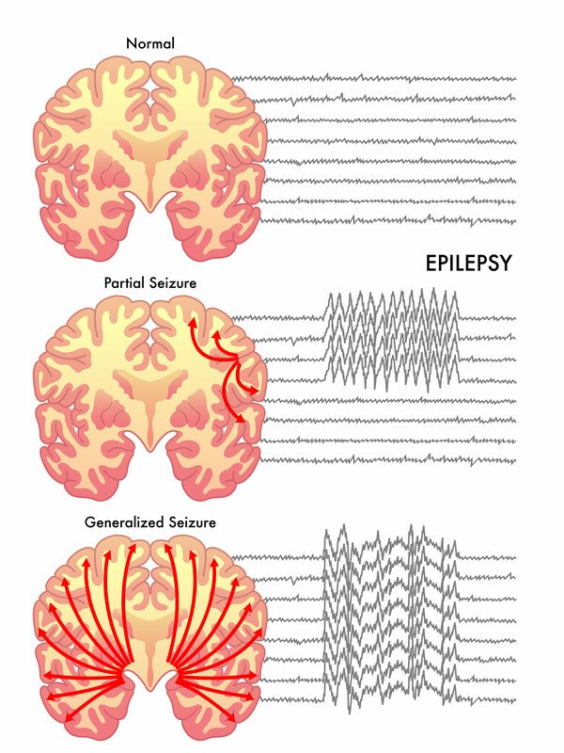

Fig 3.4: ​Comparing a normal EEG signal to an abnormal one.

EEG signals record the electrical activity of the brain using EEG electrodes placed on the scalp. They are noisy, have artifacts, and, above all, they are not the type of signals people are used to deal with (images, charts,...). Doctors, neuroscientists, and biomedical engineers usually receive training for years to understand and extract meaningful information from EEG data. Even in these cases, the raw recorded data needs to be processed before specialists look at it. Temporal and spatial filtering is usually applied, as well as artifact rejection procedures, even if the participant is still during recording. This processed EEG can then be visually inspected to detect anomalies (e.g. episode of epilepsy), changes in the mental state (e.g. sleep phases) or to study grand average responses of groups of people. Visual inspection is a long, expensive, and tedious process. It does not scale up well and cannot be transferred to Brain Computer Interface (BCI) applications. AI and machine learning tools are the perfect companion to automate, extend, and improve EEG data analysis. Indeed, BCI systems such as spellers or brain-controlled devices are based on decoding pipelines that use extensively different machine learning algorithms.[3.7]

**3.4 Artificial intelligence (AI):**

**Learning process:** Among the many interesting properties of a neural network is the ability of the network to learn from its environment and to improve its performance through learning. A neural network learns about its environment through an iterative process of adjustments applied to its synaptic weights and thresholds. We define learning in the context of neural networks as: a process by which the free parameters of a neural network are adapted through a continuing process of stimulation by the environment in which the network is embedded. The type of learning is determined by the manner in which the parameter changes take place.

**Supervised learning:** An essential ingredient of supervised is the availability of an external teacher, which is able to provide the neural network with a desired or target response. The network parameters are adjusted under the combined influence of the training vector and the error signal. This adjustment is carried out iteratively in a step-by-step fashion with the aim of eventually making the neural network emulate the teacher. This form of supervised learning is in fact an error-correction learning, which was already described.

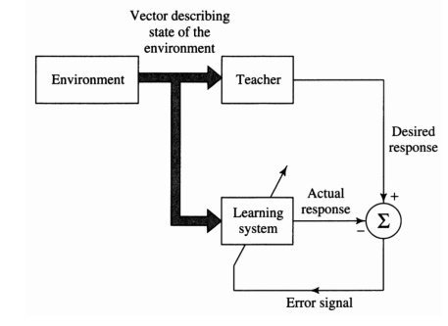

Fig 3.5: Supervised learning.

**Unsupervised learning:** In unsupervised or self-organized learning there is no external teacher to oversee the learning process. In other words, there are no specific samples of the function to be learned by the network. Rather, provision is made for a task-independent measure of the quality of representation that the network is required to learn and the free parameters of the network are optimized with respect to that measure. Once the network has become tuned to the statistical regularities of the input data, it develops the ability to form internal representations for encoding features of the input and thereby creates new classes automatically.

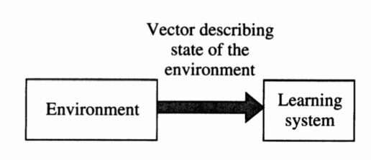

Fig 3.6: Unsupervised learning.

**Pattern recognition:** Pattern recognition is formally defined as the process whereby a received pattern/signal is assigned to one of a prescribed number of classes (categories). A neural network performs pattern recognition by first undergoing a training session, during which the network is repeatedly presented a set of input patterns along with the category to which each particular pattern belongs. Later, a new pattern is presented to the network that has not been seen before, but which belongs to the same population of patterns used to train the network. The network is able to identify the class of that particular pattern because of the information it has extracted from the training data. Pattern recognition performed by a neural network is statistical in nature, with the patterns being represented by points in a multidimensional decision space. The decision space is divided into regions, each one of which is associated with a class. The decision boundaries are determined by the training process. The construction of these boundaries is made statistical by the inherent variability that exists within and between classes.[3.9]

**3.4.1 AI models:**

**3.4.1.1 K-Nearest Neighbors (KNN):** is a machine learning algorithm used for classification and regression tasks. It is a non-parametric and lazy learning algorithm, meaning it does not make any assumptions about the underlying distribution of the data and does not have a separate training phase to build a model. In KNN, the class or value of an unknown instance is predicted by finding the k nearest instances (neighbors) in the training set based on a distance metric, and then taking a majority vote (in classification) or an average (in regression) of their labels or values. The choice of k is a hyperparameter that can be tuned to optimize performance. KNN is simple to implement and can be effective for low-dimensional data or when the decision boundary is nonlinear and complex. However, it can suffer from the curse of dimensionality and become computationally expensive as the number of features or instances grows. It also requires a distance metric that is appropriate for the data and may be sensitive to outliers or imbalanced classes.

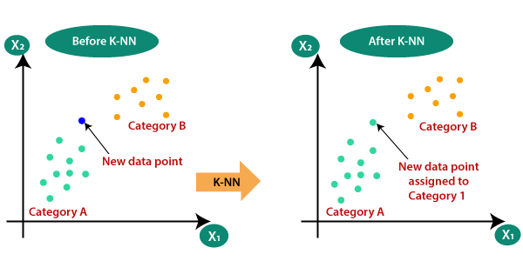

Fig 3.7: k-nearest-neighbor-algorithm-for-machine-learning

**3.4.1.2 Long Short-Term Memory (LSTM):** is a type of recurrent neural network (RNN) architecture that is designed to address the problem of vanishing gradients in traditional RNNs. LSTM networks are widely used for modeling sequential data, such as natural language, speech, and time series data. The key feature of LSTM is the presence of memory cells that are capable of storing information for a long time and selectively forgetting or updating that information. The memory cells are controlled by gates, which are layers of neural networks that control the flow of information into and out of the memory cells. The gates include an input gate, which decides which information to add to the memory cells, a forget gate, which decides which information to forget from the memory cells, and an output gate, which decides which information to output from the memory cells. LSTM has become popular in many applications due to its ability to capture long-term dependencies in sequential data and its ability to handle vanishing gradients, which can be a problem in traditional RNNs. LSTM has also been extended and modified in various ways to improve its performance, such as adding attention mechanisms, using multiple layers, and incorporating convolutional layers.

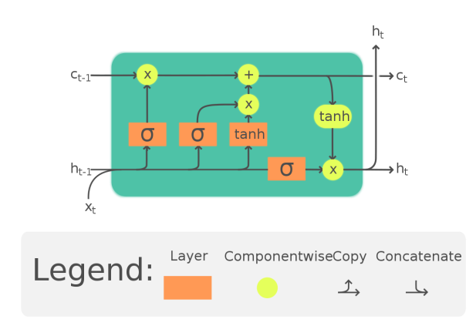

Fig 3.8: Long short term memory cell

**3.4.1.3 Support Vector Machine(SVM):** is a powerful and widely used supervised machine learning algorithm used for classification, regression, and outlier detection tasks. It is a parametric algorithm, meaning it builds a model based on training data that can be used to make predictions on new, unseen data. The core idea of SVM is to find the optimal hyperplane that separates the data into different classes or predicts the target value in the case of regression. The hyperplane is chosen to maximize the margin, which is the distance between the hyperplane and the closest data points from each class. The SVM algorithm can handle both linear and nonlinear boundaries by using different types of kernels, such as polynomial, radial basis function (RBF), and sigmoid. SVM is a versatile algorithm that can handle high-dimensional and complex data, and it is known for its ability to handle small and medium-sized datasets. It also has a strong theoretical foundation and is able to generalize well to new, unseen data. However, SVM can be computationally expensive, especially for large datasets, and requires careful tuning of the kernel and other hyperparameters to achieve optimal performance.

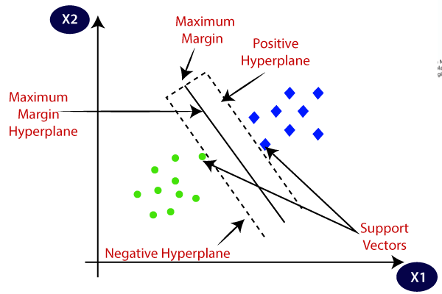

Fig 3.9: support vector machine algorithm

**3.4.1.4 “Artificial” neural networks (ANNs):** are inspired by the organic brain, translated to the computer. It’s not a perfect comparison, but there are neurons, activations, and lots of interconnectivity, even if the underlying processes are quite different.

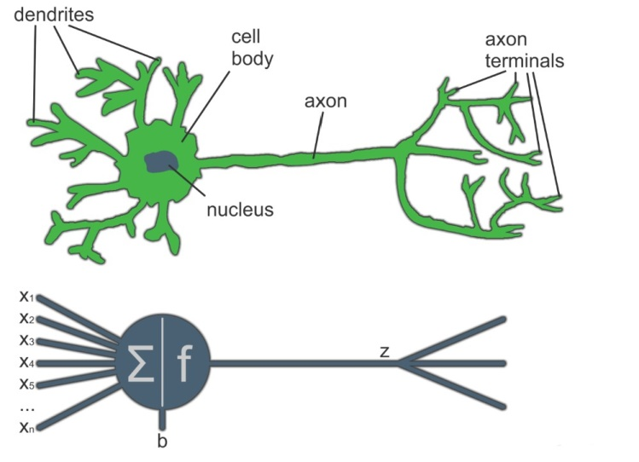

Fig 3.10: ​Comparing a biological neuron to an artificial neuron.

A single neuron by itself is relatively useless, but, when combined with hundreds or thousands (or many more) of other neurons, the interconnectivity produces relationships and results that frequently outperform any other machine learning methods.

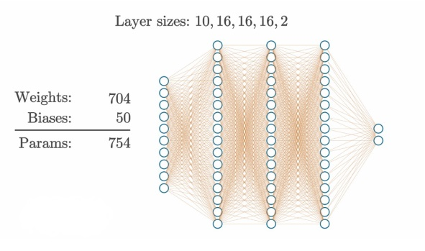

Fig 3.11:​ Example of a neural network with 3 hidden layers of 16 neurons each.

The above animation shows the examples of the model structures and the numbers of parameters the model has to learn to adjust in order to produce the desired outputs. The details of what is seen here are the subjects of future chapters. It might seem rather complicated when you look at it this way. Neural networks are considered to be “black boxes” in that we often have no idea why ​ they reach the conclusions they do. We do understand how ​ they do this, though.[3.8]

**3.4.2 Evaluation of neural network’s output:**

The evaluation of a neural network's output typically depends on the specific task and the type of data involved, one of the general approaches that can be used to evaluate the performance of a neural network is Confusion matrix: A confusion matrix is a table that shows the number of true positives, false positives, true negatives, and false negatives for a classification task. It can be used to calculate evaluation metrics such as accuracy, precision, recall, and F1 score. These metrics compare the predicted outputs with the true labels or categories and measure the performance of the model in terms of its ability to correctly classify the data.

**Accuracy:** Accuracy is the proportion of correctly classified instances, calculated as the number of true positives and true negatives divided by the total number of instances.

**Precision:** Precision is the proportion of true positives among the instances predicted as positive, calculated as the number of true positives divided by the sum of true positives and false positives.

**Recall:** Recall is the proportion of true positives among the instances that are actually positive, calculated as the number of true positives divided by the sum of true positives and false negatives.

**F1 score:** F1 score is the harmonic mean of precision and recall, calculated as 2 * (precision * recall) / (precision + recall).

These are just some of the many evaluation metrics used in machine learning. The choice of metric depends on the specific task and the desired performance criteria.

With the use of modern technologies such as machine learning, it is now possible to classify and predict epileptic seizures and therefore preventing diagnostic mistakes and accidental hazards. This research aims to design integrated AI software for both detection and prediction of epilepsy. The following chapter of this thesis illustrates the methodology applied to design the software.