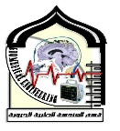**Sudan University of Science and Technology**

**College of Engineering**

**Biomedical Engineering Department**

Electroencephalogram based epileptic seizures detection and prediction via Machine/Deep learning approaches

A project Submitted in Partial Fulfilment for the Requirement of the Degree of B.Sc. (Honors) in Biomedical Engineering

Prepared By:

1. Afnan abubker Aljak Haroon
2. Ebaa Alfadil Abdalhai Ali
3. Rahaf Mohamed Mohieldeen Osman
4. Tmeem Abdullah Mohsen Ahmed

Supervisor:

Dr. Musab Alkhair

March 2023

**Declaration**

We, Afnan abubker Aljak Haroon, Ebaa Alfadil Abdalhai Ali, Rahaf Mohamed Mohieldeen Osman, and Tmeem Abdullah Mohsen Ahmed confirm that this presented work is our own, where all information had been derived from other projects listed in the references.

Afnan abubker Aljak Haroon

Ebaa Alfadil Abdalhai Ali

Rahaf Mohamed Mohieldeen Osman

Tmeem Abdullah Mohsen Ahmed

**Dedication**

We dedicate this work to our parents who supported us through this long journey, to our friends who without them we would not survived these years, to our families here and abroad encouraging us by every means possible and finally to whoever helped us wherever and whenever. Thank you all and may Allah reward you for what you have done for we can’t.

**Acknowledgment**

We are deeply grateful first to ALLAH for the strengths he has given us and his blessing in completing this thesis.Express our sincere appreciation and gratitude to our supervisor Dr.Musab Alkhair for being an ever-illuminating candle for Our project ,tremendously helpful and patient throughout this project.

All the thanks are also intended to our teacher and friend Eng. Hassan Tarig for his help and support to complete this project.

And finally, to the rest of my colleagues who helped us out through this project.

**Table of contents**

**Chapter One INTRODUCTION…………..…………………….. 1**

* 1. Human brain anatomy and physiology ……………….…………...1
  2. Electroencephalography (EEG)…………..………….…………….2

1. Definition………………………………………………………….2
2. Signal frequency…………………………………………………...2
3. Delta………………………………………………………...2
4. Theta………………………………………………………..2
5. Alpha……………………………………………………….3
6. Beta…………………………………………………………3
7. EEG abnormal conditions…………………………………………3
   1. Epilepsy……………………...………………..…….…...…....…...4
      1. General definition and etiology ………...………………………...4
      2. Epileptic seizures ………………………………………………...5
      3. The EEG in focal epilepsy………………………………………...6
      4. Seizure detection…………………………………………………..7
      5. Seizure prediction………………………………………………….7
   2. Problem statement ……..………………………..….….…………..8
   3. Objectives of the research…………………………………………8
8. General objective…………………………………………………..8
9. Specific objectives…………………………………………………8
10. Research Outlines………………………………………………….8

**Chapter Two LITERATURE REVIEW…..………...…………... 9**

1. General Review………………………………………..…..…….9
2. Classification ……………….………….……...………………...9
3. Prediction………...……………………………………………..13

**Chapter Three THEORITECAL BACKGROUND……….…......17**

1. Artificial intelligence (AI) …………...…………………………..17
2. Machine learning (ML)…………………………………………..17
3. Basic Concepts…………………………………………………...18
4. Learning process…………………………………………..18
5. Supervised learning………………………………………..18
6. Unsupervised learning…………………………………….19
7. Pattern recognition………………………………………...19
8. Deep learning (DL)………………………………………………20
9. AI models ………………..……………………………..………..20
10. K-Nearest Neighbors (KNN)……..……………………………...20
11. Long Short-Term Memory (LSTM) ……………………………..21
12. Support Vector Machine (SVM)……………………………..…..22
13. Artificial neural networks (ANNs)……………………………….23
14. Evaluation of neural network’s output ………..…………………24
15. Accuracy………………………………………………………….25
16. Precision………………………………………………………….25
17. Recall……………………………………………………………..25
18. F1 score…………………………………………………………..25

**Chapter Four MATERIALS AND METHODOLOGY ...….......26**

1. Classification Model ……………...……………………………..26
   * 1. EEG Database …....………………...……………….….………..26
     2. Preprocessing……………………..……………..……………….27
     3. Classification……………………………………………………..28
2. ANN……………………………………………………….28
3. LSTM……………………………………………………...28
4. KNN……………………………………………………….29
5. SVM……………………………………………………….30
6. LSVM……………………………………………………..31
   1. Materials and Methods for prediction………………………………31
      1. EEG Database ………………..............................……………….32
      2. Preprocessing………………………...…………………………..33
      3. Classification……………………………………………………..34
      4. Performance Evaluation………………………………………….35

**Chapter Five RESULTS AND DISCUSSION…….………….....38**

1. Result and Discussion for classification……...…………………..38
2. Metrics used to evaluate the classifiers…………………………..38
3. Performance measures……………………………………………39
4. Confusion matrix…………………………………………………39
5. Discussion………………………………………………………..42
6. Result and Discussion for prediction ………………..………......42
7. Discussion ………………………………………….……………44

**Chapter Six CONCLUSION…………………………………....46**

**REFERENCES………………………………………………………...48**

**List of Figures**

NO of figure Name of figure page

1. brain anatomy …………………...……………………….....1
2. the main frequencies of the human EEG waves …...…..………………………………………………………...…..3
3. Abnormal brain activity ……………………………….…...4
4. Comparing a normal EEG signal to an abnormal one ……………………………………………………...………...……6
5. Key components of AI ……………………………………17
6. Supervised learning………………………………………. 18
7. Unsupervised learning………………………….…………19
8. k-nearest-neighbor-algorithm-for-machine-learning…..….21
9. Long short-term memory cell……………………………..22
10. Support vector machine algorithm……………………...…23
11. Comparing a biological neuron to an artificial neuron……23
12. Example of an ANN with 3 hidden layers of 16 neurons each…………………………………………………………………..24
13. Proposed Model for machine learning techniques………...27
14. Proposed Model for deep learning techniques ……………27
15. Formula for LSTM ………………………………………..29
16. Set C – interictal hippocampal formation ………………...32
17. Set E – Signals of unhealthy person during a seizure …….32
18. Set A – Person not suffering from Epilepsy with open eye.33
19. Set D – interictal epileptogenic zone..…………………….33
20. Set B – Person not suffering from Epilepsy with closed eye………………………………………………………………..33
21. The definition of seizure prediction horizon (SPH) and seizure occurrence period (SOP) ………………………...…........36
22. The confusion matrix of SVM…………………………….39
23. The confusion matrix of KNN…………………………….40
24. The confusion matrix of LSVM…………………………...40
25. The confusion matrix of ANN…………………………….40
26. Comparison of the different Classification Techniques…...41
27. The workflow of the seizure classification and prediction..43

**List of Tables**

NO of table Name of table page

1. Summary of previous seizure detection studies……...……13
2. Summary of previous seizure prediction studies………….16
3. Describes the new label of data ………………...………...34
4. Data set description and number of cases in each class …………………………………..……..………………………....38
5. The sensors accuracy measurements……………...………38
6. Comparison of the different Classification Technique........41
7. Results before and after dropout technique ………..……..43
8. The comparison of the classification results of this work with other reported methods…………………………..………….45
9. The comparison of the results prediction of this work with other reported methods…………………………………………...45

**Abstract**

Electroencephalography (EEG) is commonly used in the diagnosis and management of epilepsy, a common neurological disease that affects more than 2 percent of the population globally. An imbalance in brain electrical activities causes unpredictable seizures, which eventually leads to epilepsy. During an epileptic seizure, there is a sudden burst of electrical activity in the brain that can be captured by EEG. This research study explores the use of electroencephalography (EEG) data from BONN University for detecting and predicting epileptic seizures using machine learning and deep learning approaches. The aim of this study is to develop an accurate and reliable seizure detection and prediction system that can aid in the early diagnosis and treatment of epilepsy. The research methodology includes classification using various machine learning and deep learning techniques to determine the best approach. The experimental results demonstrate the effectiveness of the proposed systems in detecting and predicting epileptic seizures with high accuracy and low false positive rates, however, the results show that the Artificial Neural Network (ANN) approach outperforms the Support Vector Machine, Linear Support Vector Machine and Long Short-Term Memory approaches in term of accuracy achieving 97.35%. As for prediction when ANN approach was applied to the EEG dataset the model achieved accuracy of 99%. This research can contribute towards the development of automated systems for epilepsy diagnosis and treatment, leading to improved patient outcomes and quality of life.

**المستخلص**

يستخدم تخطيط الكهربية الدماغية (EEG) عادة في تشخيص وإدارة مرض الصرع، وهو مرضٌ عصبيٌّ شائعٌ يؤثّر على أكثر من 2% من السكّان عالميًّا. يتسبب التوازن غير المتكافئ في الأنشطة الكهربائية للدماغ في نوبات صرع غير متوقعة، مما يؤدي في النهاية إلى الصرع. أثناء نوبة الصرع، يحدثُ انفجارٌ مفاجئٌ للنشاط الكهربائي في الدماغ يمكن التقاطُهُ بواسطةِ الكهربيةِ الدماغية (EEG). يستكشف هذا البحث استخدام بيانات التخطيط الكهربائي للدماغ (EEG) من جامعة بون للكشف عن نوبات الصرع وتنبؤها باستخدام تقنيات التعلم الآلي والتعلم العميق. هدف هذه الدراسة هو تطوير نظام دقيق وموثوق لكشف النوبات الصرعية وتنبؤها يمكن أن يساعد في التشخيص والعلاج المبكر لمرض الصرع. تتضمن منهجية البحث تصنيف باستخدام تقنيات التعلم الآلي والتعلم العميق المختلفة لتحديد النهج الأفضل. تظهر النتائج التجريبية فعالية الأنظمة المقترحة في الكشف عن النوبات الصرعية وتنبؤها بدقة عالية ومعدلات كاذبة منخفضة، ومع ذلك، تظهر النتائج أن نهج الشبكة العصبية الاصطناعية (ANN) يفوق نهج آلة الدعم النوعية(SVM)، آلة الدعم الخطي(LSVM) والذاكرة القصيرة الطويلة الأجل(LSTM) من حيث الدقة بتحقيق 97.35٪. أما بالنسبة للتنبؤ، عندما تم تطبيق نهج ANN على مجموعة بيانات EEG، حقق النموذج دقة تصل إلى 99%. يمكن أن تسهم هذه الدراسة في تطوير أنظمة آلية لتشخيص وعلاج الصرع، مما يؤدي إلى تحسين نتائج المرضى وجودة الحياة.

**List of abbreviations**

CNS central nervous system

|  |  |
| --- | --- |
| EEG  µs  Hz  ms | Electroencephalography  Microsecond  Hertz  milliseconds |
| CNN | Convolutional Neural Networks |
| RNN | Recurrent Neural Networks |
| DBN | Deep Belief Networks |
| AE | Autoencoders |
| LSTM | Long short-term memory |
| GSN | Generative adversarial networks |
| SVM | Support vector machine |
| MIN | Minimum |
| MAX | Maximum |
| SD | Standard Deviation |
| MLPNN | Multilayer perceptron neural network |
| RBFNN | Radial basis function neural network |
| CHB-MIT | Children’s Hospital Boston and the Massachusetts Institute of Technology |
| DWT | Discrete Wavelet Transform |
| RBF  UBonn | Radial basis function  Bonn University |
| GSO  S2I  1D | Gulfstandards organization  signal to image  one diminution |
| ReLU | Rectified Linear Unit |
| CAD | Computar-aided diagnosis |
| WT | Wavelet transform |
| GPU | Graphics processing unit |
|  |
|  |
| AI | Artificial intelligence |
| ML  DL | Machine learning  Deep Learning |
|  |  |
| KNNs | K-Nearest Neighbors |
| ANNs | Artificial neural networks |
| EEG  LSVM | Electrocardiography  Linear Support Vector Machine |
| EMG | Electromyography |
| sEEG | Scalp Electroencephalography |
| iEEG  IDEL | Intracranial Electroencephalography  Integrated Development and Learning Environment |
| TP  TN  FP  FN  FPR  TPR  SOP | True positive  True negative  False positive  False negative  False positive rate  True positive rate  Seizure occurrence period |
| SPH | Seizure prediction horizon |
|  |  |

**Chapter One Introduction**

1. **Human brain anatomy and physiology**

The brain is a complex organ that controls thought, memory, emotion, touch, motor skills, vision, breathing, temperature, hunger and every process that regulates our body. Together, the brain and spinal cord that extends from it make up the central nervous system, or CNS. Weighing about three pounds in the average adult, the brain is about 60% fats. The remaining 40% is a combination of water, protein, carbohydrates and salts. The brain itself is a not a muscle. It contains blood vessels and nerves, including neurons and glial cells. The brain has three main parts: the cerebrum, cerebellum and brainstem.

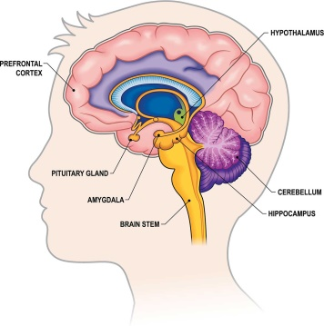

Figure 1-1: brain anatomy

The brain sends and receives chemical and electrical signals throughout the body. Different signals control different processes, and your brain interprets each. Some make you feel tired, for example, while others make you feel pain. Some messages are kept within the brain, while others are relayed through the spine and across the body’s vast network of nerves to distant extremities. To do this, the central nervous system relies on billions of neurons [1].

1. **Electroencephalography (EEG)**
2. **Definition**

Because epilepsy is fundamentally the result of abnormal neuronal discharges, EEG is the single most important investigative technique for the study of epilepsy. EEG consists in an electrophysiological recording of the brain’s electrical activity. The electroencephalogram (recorded signal) displays spatial and temporal voltage variations due to ionic currents flowing 3 within brain neurons. It is characterized by a high temporal resolution (order of µs), allowing the evaluation of dynamic cerebral functions. EEG displays neuronal electrical activity resulting from the summation of inhibitory and excitatory postsynaptic potentials of large group of neurons. It is considered to be mainly produced by pyramidal cortical neurons, which are arranged in parallel, perpendicularly to the surface of the brain, and have their cell bodies mainly in layers III and V of the cerebral cortex [2-3].

1. **Signal frequency**

The main frequencies of the human EEG waves are:

1. **Delta**

Has a frequency of 3 Hz or below. It tends to be the highest in amplitude and the slowest waves. It is normal as the dominant rhythm in infants up to one year and in stages 3 and 4 of sleep. It is usually most prominent frontally in adults and posteriorly in children.

1. **Theta**

Has a frequency of 3.5 to 7.5 Hz and is classified as "slow" activity. It is perfectly normal in children up to 13 years and in sleep but abnormal in awake adults. It can be seen as a manifestation of focal subcortical lesions; it can also be seen in generalized distribution in diffuse disorders such as metabolic encephalopathy or some instances of hydrocephalus.

1. **Alpha**

Has a frequency between 7.5 and 13 Hz. It is usually best seen in the posterior regions of the head on each side, being higher in amplitude on the dominant side. It appears when closing the eyes and relaxing, and disappears when opening the eyes or alerting by any mechanism (thinking, calculating). It is the major rhythm seen in normal relaxed adults. It is present during most of life especially after the thirteenth year.

1. **Beta**

Beta activity is "fast" activity. It has a frequency of 14 and greater Hz. It is usually seen on both sides in symmetrical distribution and is most evident frontally. It is accentuated by sedative-hypnotic drugs especially the benzodiazepines and the barbiturates. It may be absent or reduced in areas of cortical damage. It is generally regarded as a normal rhythm. It is the dominant rhythm in patients who are alert or anxious or have their eyes open [4].

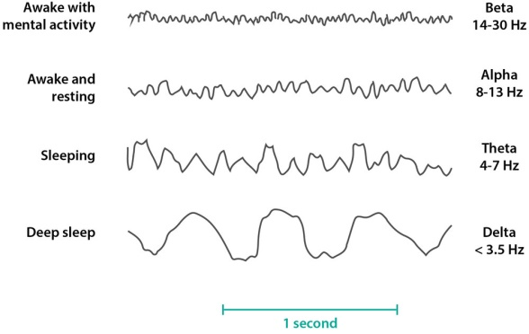

Figure 1-2: the main frequencies of the human EEG waves.

1. **EEG abnormal conditions**

Conditions that may be diagnosed with the aid of an EEG include:

• Sleep disorders (such as narcolepsy).

• Head injuries.

• Brain infection.

• Brain hemorrhage, tumors, or death.

• Alzheimer's disease.

• Degeneration of brain tissue.

• Metabolic, or Hormonal conditions that affect brain tissue.

• Certain disorders of the central nervous system.

• Stroke.

Normal brain waves occur at a rate of up to 30 per second, but in someone with epilepsy, for example, the EEG may show bursts of abnormal discharges in the form of spikes and sharp wave patterns. Suspected epilepsy is the most common reason for an EEG [5].

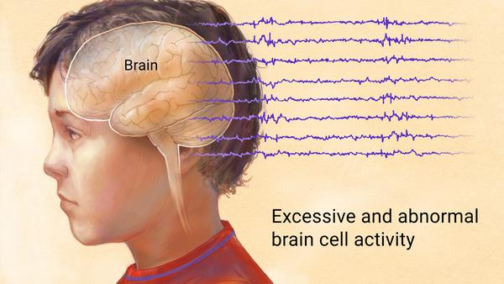

Figure 1-3: Abnormal brain activity

1. **Epilepsy**
2. **General definition and etiology**

Epilepsy is one of the most common neurological disorders affecting 70 million worldwide. It was first defined by Jackson in 1873 as “an occasional sudden and excessive discharge of grey matter”. This definition lasted for a long period of time, during which, investigations have given more insights into the characterization and mechanisms of this medical disorder on several levels. The fundamental elements of epilepsy are unprovoked, recurrent seizures resulting from abnormal excessive hyper synchronous neuronal discharges. Seizure manifestations vary greatly depending on the site, intensity and propagation of the seizure discharge.

In between seizures, brief (milliseconds (ms)) asymptomatic discharges called interictal epileptiform discharges (also known as spikes) may occur. Although epilepsy can appear at any age, its incidence is higher in children and elderly (after the age of 65). The main causes of epilepsy include genetic mutations, gliosis from acquired brain insults (hypoxia, ischemia/stroke, trauma, and infection), malformations of cortical development, vascular malformations, brain tumors and degenerative disorders [6-9].

1. **Epileptic seizures**

A seizure is defined as a transient disturbance of brain functions due to an abnormal electrical synchronization of groups of neurons. Epileptic seizures can be divided into two main categories: focal and generalized. Seizures are said to be focal when they start from a restricted area of the brain (thus in one hemisphere) while generalized seizures involved the whole of both hemispheres. Focal seizures can be further classified into frontal, temporal, insular, parietal, and occipital, depending on the lobe involved at seizure onset. In generalized seizures, there is impaired consciousness from the onset as the excessive electrical discharge is widespread from the beginning. With focal seizures, earliest symptoms depend on the lobe of seizure onset (ex. visual symptoms with occipital lobe seizures, sensory symptoms in parietal lobe seizures, motor symptoms in frontal lobe seizures etc.). Consciousness is frequently not impaired at the onset of a focal seizure but such impairment may occur as the discharge spreads to larger areas of the brain two and even manifest as bilateral tonic-clonic seizures if the discharge spreads to the whole brain [10-11].

1. **The EEG in focal epilepsy**

Patients with focal epilepsy exhibit focal epileptiform abnormalities. These are usually divided into a) ‘interictal’ discharges (‘spikes’) which are brief (20-200ms) asymptomatic paroxysmal EEG transients clearly distinguished from background; and b) ‘ictal’ discharges which are sudden focal rhythmic activity with characteristic pattern of evolution (with respect to amplitude, frequency and spatial distribution) lasting at least several seconds to minutes. These ictal discharges are generally associated with clinical seizure manifestations (electroclinical seizures) but can sometimes be clinically silent (electrical seizures). With a routine 30- minutes EEG, interictal spikes can be found in approximately 50% of epileptic patients (and in up to 84% by the third serial EEG) [12].

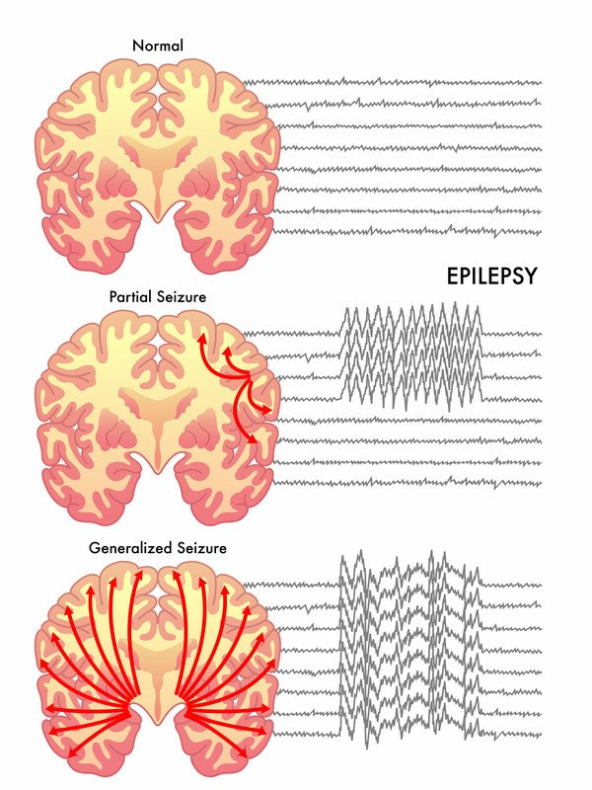

Figure 1-4: Comparing a normal EEG signal to an abnormal one

1. **Seizure detection**

Due to the time-limited observation period, the patient’s antiepileptic medication is sometimes reduced for facilitating the occurrence of epileptic events within the observation period, where the seizures may not be representative of natural conditions. In many cases, patients are asked to keep seizure diaries, as seizure monitoring is crucial for therapeutic decisions. Patient-reported seizure counts and measures derived from these reports, such as reduction in seizure frequency over a defined period, represent the primary endpoint for most clinical trials in epileptology [13-14].

However, it is well known that most epileptic seizure go unnoticed by the patients and their caregivers, which may affect treatment decisions. Seizure tracking is dependent on a subjective patient and family recall and may be influenced by the capacity of remembering details post seizure, by the level of awareness during the seizure and by the ability to identify seizures [15].

1. **Seizure prediction**

Besides seizure detection, accurately predicting seizures a few minutes before their onset would enable patients to take precautions against injury, and could open the door for development of treatments to prevent or control the incoming seizure. For instance, neurostimulation systems can act quickly as a way of suppressing a high portion of seizures. This prediction should have sufficient precision, specificity and sensitivity to minimize the interruptions on the patient’s life, having minimal unpredicted seizures and false alarms [16].

1. **Problem statement**

People who suffer from epilepsy cannot lead their normal lives because they may be exposed to a sudden seizure that endangers their lives, such as falling in a public place, their workplaces or while sleeping, and damage the parts of their body often leads to death, which makes their lifestyle limited. In this thesis we used Machine\Deep learning algorithms to improve the performance of EEG-based epileptic seizure detection and prediction.

1. **Objectives of the research**
   * 1. **General objective**

The general objective is to evaluate and achieve high performance of epileptic detection, prediction by applying Machine and deep learning techniques.

* + 1. **Specific objectives**

1. Achieve accurate classification for epileptic seizures.
2. Achieve high accuracy, less time predicting the occurrence of a seizure.
3. **Research Outlines**

This thesis consists of six chapters, chapter one includes a brief introduction. Chapter two includes a literature review. Chapter three includes the Theoretical background. Chapter four includes the Methodology. Chapter five includes the result and discussion. Finally, chapter six contains the conclusion and recommendation.

**Chapter Two Literature Review**

**General Review**

Epilepsy detection has been studied extensively since the 1970s. Early, statistical methods and classical machine learning techniques were used for Epilepsy classification. But due to the data complexity, the researchers started applying deep learning to this problem. Since 2016, many deep learning models such as Convolutional Neural Networks (CNN), Recurrent Neural Networks (RNN), Deep Belief Networks (DBN), Autoencoders (AE), Long short-term memory (LSTM), and generative adversarial networks (GAN) have been used to identify epilepsy.

**Classification**:

Classification of EEG signals into epileptic and nonepileptic involves extracting features from the EEG signals and using these features in training a machine learning model. In the literature, several feature extraction approaches and several classification methods are used. Several groups used the Discrete Wavelet Transform for feature extraction and then they applied different machine learning algorithms.

In 2017, Sandeep Kumar Satapathy and Alok Kumar Jagadev decided to use a semi-automatic tool in the framework of machine learning to understand the EEG signals and to predict epilepsy seizures. Using Bonn University—EEG Dataset, their primary focus was on two main techniques: ANN and SVM; for neural network approach probabilistic neural network, radial basis function neural networks, and recurrent neural networks are taken into consideration for empirical analysis on EEG signal to detect epilepsy seizure. Furthermore, for SVM, several kernel methods were studied such as linear, polynomial, and RBF during empirical analysis. With wavelet transform as the data analysis technique and some of the statistical features of many have been extracted from the signals such as Minimum (MIN), Maximum (MAX), MEAN, and Standard Deviation (SD), the efficiency of different machine learning techniques like MLPNN, RBFNN, RNN, PNN, and SVM have been compared, and concluded that SVM is the most efficient and powerful machine learning technique for the purpose of classification of the EEG signal with accuracy of 99.1% but extremely high detection time [17].

Later that year, another study done by Duo Chen et al. in the hope for developing a framework for automatically searching the adequate DWT settings to improve accuracy and to reduce computational cost of seizure detection, they developed a method to decompose EEG data into 7 commonly used wavelet families. The selection of frequency bands and features removed approximately 40% of redundancies. With two different datasets Bonn University and Children’s Hospital Boston and the Massachusetts Institute of Technology (CHB-MIT) EEG-Datasets, their proposed algorithm is constructed by two main selection blocks, a Wavelet-Level Selection (DWT coefficient features from several frequency bands construct the feature vector of one EEG signal segment) and a Band-Feature Selection. A SVM and RBF kernel was used as the classifier. To assess the performance of the approach, especially its ability to overcome individual difference, they used leave-one-subject-out cross-validation on MIT dataset which was a fair evaluation scheme to truly reveal the robustness of the classifier on overcoming the individual difference. Since UBonn dataset did not separate the data from different patients, 10-fold cross validation was used instead of leave-one-subject-out. On MIT dataset, decomposition level affects the accuracy substantially regardless of the mother wavelets. On UBonn dataset wavelets could achieve good accuracy (above 95%) at low decomposition level (less than two). UBonn dataset, compared with the results in MIT dataset, EEG segments in UBonn could be accurately classified at very low decomposition level, however, in other cases, including this work, these properties of wavelet do not matter at all. On dataset having complex EEG signals (contain hidden information distribution in several frequency bands), like MIT dataset, decomposition level influences accuracy substantially regardless of the mother wavelet and running the process is very time-consuming, especially when using various wavelet families and long-time continuous EEG segments [18].

Shuang X. Wang et al. on the other hand involved a novel random forest (RF) model combined with grid search optimization in the proposed automatic detection framework in 2019. The short-time Fourier transformation visualizes seizure features after normalization and used to conduct the time-frequency analysis of non-stationary EEG signals. The dimensionality of features is reduced through principal component analysis before feeding them into the classification model which was used to classify 500 samples of raw EEG data. In this study, the time-frequency analysis method is used to extract the time-frequency characteristics of EEG signals. At the same time, the statistical characteristics of EEG signals are extracted by statistical techniques, thus the best combination of feature extraction and feature classification is realized. Noninvasive EEG data was obtained at Bonn University from 25 patients with medically intractable partial epilepsy; the dataset was divided into five groups of ictal scalp EEG signals. And EEGLAB toolbox of Matlab was used to preprocess the cEEG. To ensure the credibility of the test results, they performed an arithmetic average processing. This paper uses the improved GSO to identify RF by computer. The GSO algorithm refers to meshing the variable regions, then traversing all the grid points, solving the objective function values satisfying the constraints, and selecting the optimal values. Although the proposed RF-GSO classification model has classification performance with accuracy of 96.7 the model had low sensitivity and specificity for multi-class [19].

Another approach done by Paschalis Bizopoulos et al. in 2020, beside the choice of the EEG epileptic seizure recognition dataset from University of California, Irvine for EEG classification, the implications of this study could be generalized in any kind of signal classification problem. Here we also refer to CNN as a neural network consisting of alternating convolutional layers each one followed by a Rectified Linear Unit (ReLU) and a max pooling layer and a fully connected layer. The input of CNN is converted to an image using learnable parameters. They restricted the output for the model to a 178 × 178 image to enable visual comparison. CNN DenseNet201 achieved the best accuracy of 85.3% with training time 70seconds/epoch on average. The two-layer CNN S2I achieved worse even compared with the 1D variants. Another outcome of these experiments is that increasing the depth of the base models did not increase the accuracy which is in line with previous results [20].

Table 2-1: Summary of previous seizure detection studies

|  |  |  |  |  |  |
| --- | --- | --- | --- | --- | --- |
| Year | Author | Feature | Classifier | Accuracy | Disadvantages |
| 2017 | Sandeep Kumar et al. | wavelet transform, MEAN, MIN, MAX and SD | SVM AND ANN | 99.1% | Extremely high detection time |
| 2017 | Duo Chen et al. | DWT | SVM | 95% | Decomposition level influences accuracy substantially and very time-consuming |
| 2019 | Shuang X. Wang et al. | short-time Fourier transformation | GSO | 96.7% | Low sensitivity and specificity |
| 2020 | Paschalis Bizopoulos et al. | - | CNN | 85.3% | Low accuracy |

**Prediction**

Until recently, the general belief in the medical community was that epileptic seizures could not be anticipated. Seizures were assumed to be abrupt transitions that occurred randomly over time. However, theories based on reports from clinical practice and scientific intuition, like the “reservoir theory” postulated by Lennox, existed and pointed out to the direction of seizure predictability. Various feelings of auras, that is, patients’ reports of sensations of an upcoming seizure, exist in the medical literature. Even though seizure detection and prediction is an ongoing research. So far, many different approaches using machine learning and deep learning have been tried by several researchers on seizure prediction [21].

In 2017, U. Rajendra Acharya et al. developed a computar-aided diagnosis (CAD) system to distinguish the class of EEG signals from Bonn University, Germany if normal, preictal, or seizure class using machine learning techniques. The EEG signals were normalized with Z-score normalization, zero mean and standard deviation of 1,then they were divided into 10 equal portions, nine out of ten were used to train the CNN while the one tenth was used to test the performance of the system. The model achieved 88.67% accuracy [22].

Thara D Ka, et al., in 2019 experienced epileptic seizure detection using LSTM approach on BONN university dataset resulting in 99.08% accuracy. Meanwhile seizure prediction was conducted using the same dataset by classifying preictal states of EEG from interictal and ictal states and the model could identify the pre-ictal state with the overall sensitivity: 89.21% and false prediction rate: 0.06 [23].

In this study, I Wijayanto, S Hadiyoso, S Aulia, and B S Atmojo in 2020 extracted the EEG signal pattern by using the Higuchi fractal dimension to classify the ictal and interictal conditions of EEG signals from Bonn University Dataset. The features were extracted from five EEG sub-bands, delta, theta, alpha, beta, and gamma band and fed to support vector machine model. The experiment shows that the use of HFD and the quadratic kernel is suitable for ictal detection with average accuracy of 91.1%. While the use of cubic kernel and HFD is suitable for detecting interictal conditions with average accuracy of 94.1% [24].

Meanwhile, in 2021, Adnan Salman offers a model based on a two-dimensional CNN, that provides a reliable strategy for both preprocessing and feature extraction. The model is used to categorize EEG signals from university of Bonn dataset into normal vs intericatl vs ictal instance, and in order to improve training and generalization accuracy, they adopted an augmentation technique to expand the size of the data set. This model achieved 97.8% accuracy [25].

In the research done by H O Lekshmy, Dhanyalaxmi Panickar and Sandhya Harikumar, they focused on the performance of various machine learning techniques (Logistic regression, Naive Bayes, Random Forest, and K- Nearest neighbor, Artificial neural network, Convolutional neural network, Long short term Memory technique and Auto Encoder) on EEG data to find the best algorithm that perform well on the Bonn university dataset as the primary dataset and CHB-MIT dataset to validate the results. The EEG signals shows different potential at different frequencies, so a conversion from the time- amplitude domain into the frequency-time domain was needed using Wavelet transform (WT). Random Forest classifier has performed remarkably well in terms of specificity, sensitivity and with 97%accracy. Among deep learning algorithms, LSTM is the best performing model with 98% accuracy. Random Forest is less computationally expensive when compare with the LSTM model. LSTM model performance can be effectively increased with the help of GPU acceleration. Random Forest supports variability of data, while LSTM is more suitable for time-series data. LSTM model has a provision for avoiding long dependencies this makes our predictions more accurate when compared with other models. The main problem with LSTM model is, it requires a large amount of data for training purposes [26].

Table 2-2: Summary of previous seizure prediction studies

|  |  |  |  |  |  |
| --- | --- | --- | --- | --- | --- |
| Year | Author | Feature | Classifier | Accuracy | Disadvantages |
| 2017 | U. Rajendra Acharya et al. | Z-score normalization, zero mean and standard deviation | CNN | 88.67% | Low accuracy |
| 2019 | Thara D Ka, et al. | - | LSTM | 89.21% | Low accuracy |
| 2020 | I Wijayanto et al. | - | HFD | 91.1% | Low accuracy |
| 2021 | Adnan Salman | - | CNN | 97.8% | Did not recognize the pre-ictal phase |
| 2022 | H O Lekshmy et al. | WT | LSTM | 98% | Requires a large amount of data |

**Chapter Three Theoretical Background**

1. **Artificial intelligence (AI)**

Artificial Intelligence refers to the ability of machines or computer programs to perform tasks that normally require human intelligence, such as perception, reasoning, learning, and problem-solving. AI has been a rapidly growing field over the past few decades, with applications in a wide range of industries, including healthcare, finance, transportation, manufacturing, and more. There are several different approaches to AI, including rule-based systems, expert systems, and machine learning.

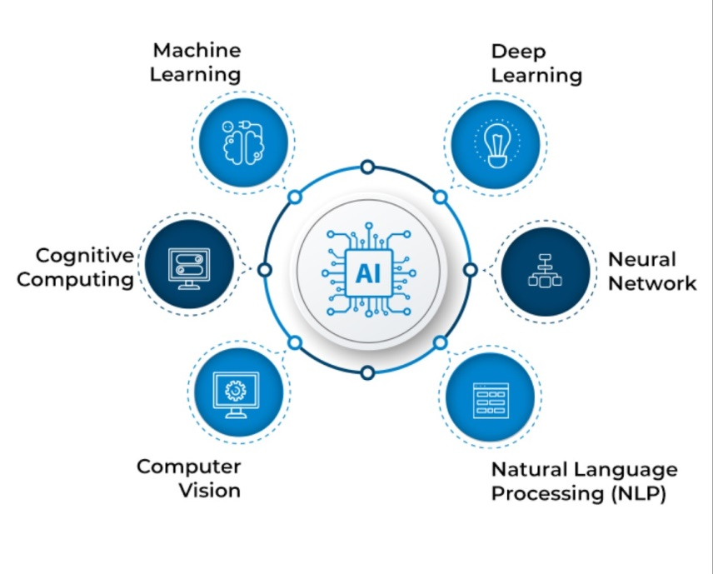

Figure 3-1: Key components of AI

1. **Machine learning (ML)**

Machine learning is a subset of AI that involves teaching computers to learn from data, without being explicitly programmed with rules. The goal of machine learning is to develop algorithms and models that can analyze and understand complex data, identify patterns and insights, and make predictions or decisions based on that data.

There are several different types of machine learning, including supervised learning, unsupervised learning, and reinforcement learning.

1. **Basic Concepts**

AI is a field which combines computer science and robust datasets, to enable problem solving. It has many features and properties, including:

1. **Learning process**

Among the many interesting properties of a neural network is the ability of the network to learn from its environment and to improve its performance through learning. A neural network learns about its environment through an iterative process of adjustments applied to its synaptic weights and thresholds. We define learning in the context of neural networks as: a process by which the free parameters of a neural network are adapted through a continuing process of stimulation by the environment in which the network is embedded. The type of learning is determined by the manner in which the parameter changes take place.

1. **Supervised learning**

An essential ingredient of supervised is the availability of an external teacher, which is able to provide the neural network with a desired or target response. The network parameters are adjusted under the combined influence of the training vector and the error signal. This adjustment is carried out iteratively in a step-by-step fashion with the aim of eventually making the neural network emulate the teacher.

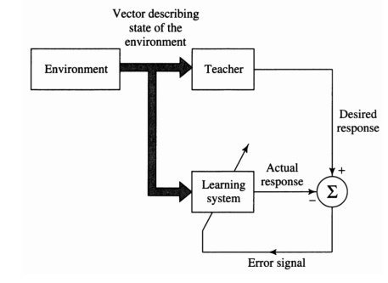

Figure 3-2: Supervised learning.

1. **Unsupervised learning**

In unsupervised or self-organized learning there is no external teacher to oversee the learning process. In other words, there are no specific samples of the function to be learned by the network. Rather, provision is made for a task-independent measure of the quality of representation that the network is required to learn and the free parameters of the network are optimized with respect to that measure. Once the network has become tuned to the statistical regularities of the input data, it develops the ability to form internal representations for encoding features of the input and thereby creates new classes automatically.

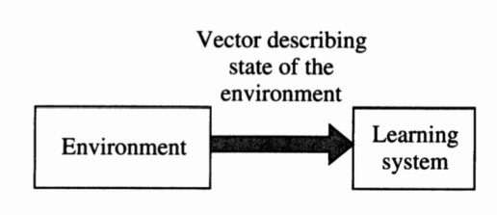

Figure 3-3: Unsupervised learning.

1. **Pattern recognition**

Pattern recognition is formally defined as the process whereby a received pattern/signal is assigned to one of a prescribed number of classes (categories). A neural network performs pattern recognition by first undergoing a training session, during which the network is repeatedly presented a set of input patterns along with the category to which each particular pattern belongs. Later, a new pattern is presented to the network that has not been seen before, but which belongs to the same population of patterns used to train the network. The network is able to identify the class of that particular pattern because of the information it has extracted from the training data [27].

1. **Deep learning (DL)**

DL is a subset of machine learning that uses neural networks to learn from large amounts of data. Neural networks are modeled after the structure of the human brain and consist of layers of interconnected nodes or neurons that process and transmit information. The term "deep" refers to the depth of the neural network, which can consist of dozens or even hundreds of layers. DL algorithms are able to automatically learn to extract relevant features and patterns from raw data, making them particularly useful for tasks like image and speech recognition. DL has achieved breakthroughs in a wide range of applications, including image and speech recognition, natural language processing, autonomous driving, and more. As DL continues to advance, researchers are exploring new architectures and techniques to improve the efficiency and accuracy of these models, while also working to address the ethical and social implications of their use.

1. **AI models**
2. **K-Nearest Neighbors (KNN)**

KNN is a ML algorithm used for classification and regression tasks. It is a non-parametric and lazy learning algorithm, meaning it does not make any assumptions about the underlying distribution of the data and does not have a separate training phase to build a model. In KNN, the class or value of an unknown instance is predicted by finding the k nearest instances (neighbors) in the training set based on a distance metric, and then taking a majority vote (in classification) or an average (in regression) of their labels or values. The choice of k is a hyper parameter that can be tuned to optimize performance. KNN is simple to implement and can be effective for low-dimensional data or when the decision boundary is nonlinear and complex.

However, it can suffer from the curse of dimensionality and become computationally expensive as the number of features or instances grows. It also requires a distance metric that is appropriate for the data and may be sensitive to outliers or imbalanced classes.

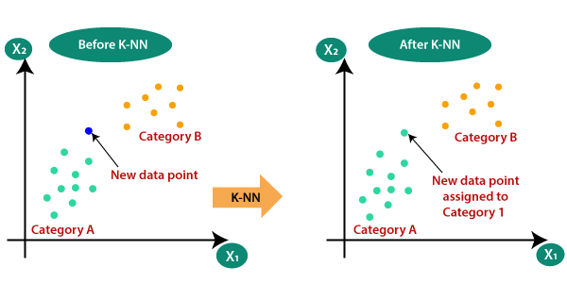

Figure 3-4: k-nearest-neighbor-algorithm-for-machine-learning

1. **Long Short-Term Memory (LSTM)**

LSTM is a type of RNN architecture that is designed to address the problem of vanishing gradients in traditional RNNs. LSTM networks are widely used for modeling sequential data, such as natural language, speech, and time series data. The key feature of LSTM is the presence of memory cells that are capable of storing information for a long time and selectively forgetting or updating that information. The memory cells are controlled by gates, which are layers of neural networks that control the flow of information into and out of the memory cells. The gates include an input gate, which decides which information to add to the memory cells, a forget gate, which decides which information to forget from the memory cells, and an output gate, which decides which information to output from the memory cells.

LSTM has become popular in many applications due to its ability to capture long-term dependencies in sequential data and its ability to handle vanishing gradients, which can be a problem in traditional RNNs. LSTM has also been extended and modified in various ways to improve its performance, such as adding attention mechanisms, using multiple layers, and incorporating convolutional layers.

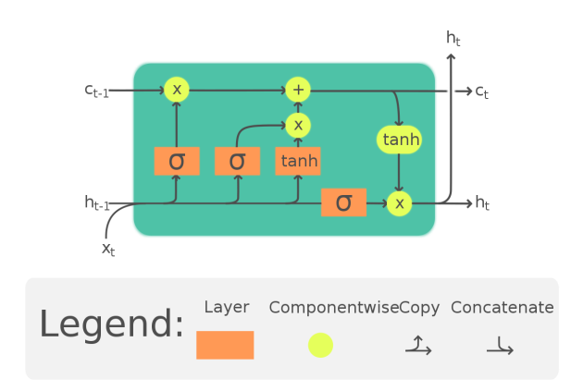

Figure 3-5: Long short-term memory cell

1. **Support Vector Machine (SVM)**

SVM is a powerful and widely used supervised ML algorithm used for classification, regression, and outlier detection tasks. It is a parametric algorithm, meaning it builds a model based on training data that can be used to make predictions on new, unseen data. The core idea of SVM is to find the optimal hyper plane that separates the data into different classes or predicts the target value in the case of regression. The hyper plane is chosen to maximize the margin, which is the distance between the hyper plane and the closest data points from each class. The SVM algorithm can handle both linear and nonlinear boundaries by using different types of kernels, such as polynomial, radial basis function (RBF), and sigmoid. SVM is a versatile algorithm that can handle high-dimensional and complex data.

SVM also has a strong theoretical foundation and is able to generalize well to new, unseen data. However, SVM can be computationally expensive, especially for large datasets, and requires careful tuning of the kernel and other hyper parameters to achieve optimal performance.

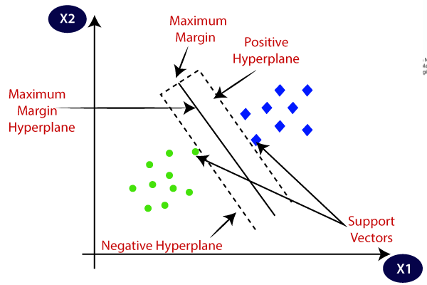

Figure 3-6: Support vector machine algorithm

1. **Artificial neural networks (ANNs)**

ANNs are inspired by the organic brain, translated to the computer. It’s not a perfect comparison, but there are neurons, activations, and lots of interconnectivity, even if the underlying processes are quite different.

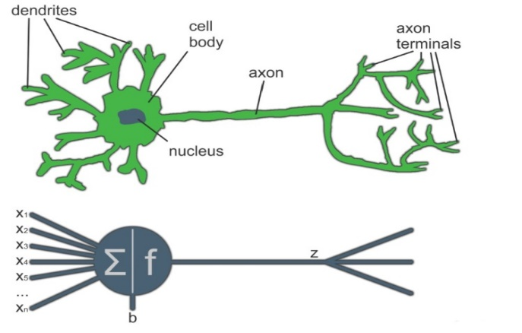

Figure 3-7: ​Comparing a biological neuron to an artificial neuron.

A single neuron by itself is relatively useless, but, when combined with hundreds or thousands of other neurons, the interconnectivity produces relationships and results that frequently outperform any other machine learning methods.

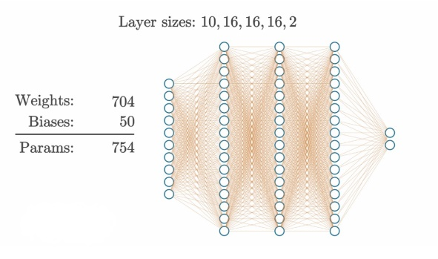

Fig 3-8:​ Example of an ANN with 3 hidden layers of 16 neurons each.

The above figure shows an ANN model structures and the numbers of parameters the model has. The details of what is seen here are the subjects of future chapters. It might seem rather complicated when you look at it this way. Neural networks are considered to be “black boxes” in that we often have no idea why ​ they reach the conclusions they do. We do understand how ​ they do this, though [28].

1. **Evaluation of neural network’s output**

The evaluation of an ANN output depends on the specific task and the type of data involved, one of the general approaches to be used to evaluate the performance is Confusion matrix: a table that shows the number of true positives, false positives, true negatives, and false negatives for a classification task. It used to calculate evaluation metrics such as accuracy, precision, recall, and F1 score; that compare the predicted outputs with the true labels and measure the performance of the model in terms of its ability to correctly classify the data.

1. **Accuracy**

Accuracy is the proportion of correctly classified instances, calculated as the number of true positives and true negatives divided by the total number of instances.

1. **Precision**

Precision is the proportion of true positives among the instances predicted as positive, calculated as the number of true positives divided by the sum of true positives and false positives.

1. **Recall**

Recall is the proportion of true positives among the instances that are actually positive, calculated as the number of true positives divided by the sum of true positives and false negatives.

1. **F1 score**

F1 score is the harmonic mean of precision and recall, calculated as

(3.1)

These are just some of the many evaluation metrics used in machine learning. The choice of metric depends on the specific task and the desired performance criteria.

With the use of modern technologies such as ML, it is now possible to classify and predict epileptic seizures and therefore preventing diagnostic mistakes and accidental hazards. This research aims to design integrated AI software for both detection and prediction of epilepsy.

**Chapter Four Materials and Methodology**

1. **Classification Model**

The purpose of our work is to compare a number of machine learning and deep learning techniques to find out which is more accurate in classifying EEG signals as an epileptic seizure or not an epileptic seizure. The proposed models were built in a Python 3.7 environment using Google colab using Keras-Tensorflow and sclearn Implementation.

**4.1.1 EEG Database**

In this study, a multi-channel scalp EEG database was used for the experiment. The EEG database we used is from Bonn University. The data be accessed at Github Repositarory. The unique dataset from the reference includes five special folders, every with one hundred files, with every record representing a single subject/person. Each record is a recording of mind interest for 23.6 seconds. The corresponding time-collection is sampled into 4097 records factors. Each records factor is the value of the EEG recording at a special factor in time. So, we've got general 500 people with each has 4097 records factors for 23.5 seconds. We divided and shuffled each 4097 records factors into 23 rows, every row includes 178 records factors for 1 second, and every records factor is the value of the EEG recording at a special factor in time. So now we've got 23 x 500 = 11500 portions of records(row), every records includes 178 records factors for 1 second(column), the closing column represents the label y {1,2,3,4,5}. The reaction variable is y in column 179, the Explanatory variables X1, X2, …, X178 y includes the class of the 178-dimensional enter vector.

Specifically y in {1, 2, 3, 4, 5}: 5 - eyes open, way after they had been recording the EEG sign of the mind the affected person had their eyes open, 4 - eyes closed, way after they had been recording the EEG sign the affected person had their eyes closed, 3 - Yes, they become aware of wherein the area of the tumor changed into within side the mind and recording the EEG interest from the wholesome mind place, 2 - They recorder the EEG from the place wherein the tumor changed into located ,1 - Recording of seizure interest. All of the cases in classes 2, 3, 4, and 5 have never had an epileptic seizure. Only class 1 has epileptic seizures. All of cases have an equal number of samples.

Figure 4-1: Proposed Model for machine learning techniques

Figure 4-2: Proposed Model for deep learning techniques

**4.1.2 Preprocessing**

This dataset is a pre-processed version of a very commonly used dataset featuring epileptic seizure detection. Biomedical indicators which include EEG have been infected through artifacts and noise, and accordingly a pre-processing step is wanted to smooth the data. Many sign-filtering algorithms were proposed to enhance the overall performance of fitness devices (EEG, ECG, EMG...) besieged through artifacts.

During the pre-processing of biomedical indicators, the maximum hard trouble is to extract excessive decision EEG indicators from noisy measurements and keep the EEG waveform sharpness.

**4.1.3 Classification**

The proposed models were built (ANN, KNN, SVM, LSVM and LSTM) and trained them to be ready to test any EEG signal.

**4.1.3.1 ANN**

ANNs are a network shape composed of a sequence of interconnected factors known as neurons, every of which has an enter and output and plays an exceedingly easy operation. Neural networks normally study their feature via learning process. Any ANN has an input, output and hidden layers, in our model we made two hidden layers. ANNs have the capacity to learn and model non-linear and complicated relationships that is clearly crucial due to the fact in real-life many of the relationships among inputs and outputs are non-linear in addition to complicated.

Formula for artificial neural network is: (Y=W1X1+W2X2+b) (4.1)

This summed function is applied over an Activation function. The output from this neuron is multiplied with the weight W3 and supplied as input to the output layer. To train a neural network to carry out a few task we have to modify the weights of every unit in the sort of manner that the error among the desired output and the real output is reduced.

**4.1.3.2 LSTM**

LSTM models are a subtype of RNNs. They are used to recognize patterns in data sequences. A unique structure lets in the LSTM version to determine whether or not to preserve preceding facts in short-time period reminiscence or discard it.

LSTM is unique form of recurrent neural community this is able to mastering long time dependencies in facts. This is accomplished due to the fact the habitual module of the version has a mixture of 4 layers interacting with every other. They're now no longer well-suitable for on-line mastering obligations which includes prediction or category obligations wherein the enter facts, isn't a sequence.

In LSTM we will have 3 gates: Input Gate, Forget Gate, Output Gate. Input Gate which tells us that what new information we’re going to store in the cell state. The forget gate which tells the information to throw away from the cell state. The output gate which is used to provide the activation to the final output of the LSTM block at timestamp ‘t’. Formula for LSTM is:

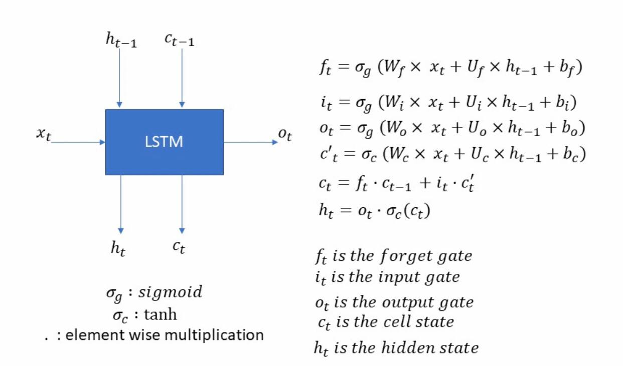

Figure 4-3: Formula for LSTM

**4.1.3.3 KNN**

KNN is a completely easy set of algorithms used to clear up classification problems. K stands for the number of neighbors in KNN. It does not work well with big dataset. In big datasets, the cost of calculating the distance between the new point and every current points are big which degrades the overall performance of the set of algorithms.

KNN does not work well with excessive dimensions due to the fact with big variety of dimensions it becomes difficult for the set of algorithm to calculate the space in every dimension. Need function scaling, we want to do feature scaling (standardization and normalization) earlier than making use of KNN set of rules to any dataset. If we do not do so, KNN can also additionally generate incorrect predictions. Sensitive to noisy statistics, lacking values and outliers: KNN is touchy to noise with inside the dataset. We want to manually impute lacking values and cast off outliers.

**Formula for KNN**

The k-nearest neighbor classifier essentially is predicated on a distance metric. The higher that metric displays label similarity the higher the categorized will be. The maximum not unusual place desire is the Minkowski distance:

(4-2)

**4.1.3.4 SVM**

SVM is a model that makes use of category algorithms for two-institution category problems create the great line or selection boundary which can segregate n-dimensional area into instructions in order that we are able to without problems positioned the brand-new records factor in the best class with inside the future, SVM set isn't always appropriate for big records sets. It does now no longer carry out thoroughly while the records set have extra noise. Formula for SVM:

SVM Lagrange problem

(4-3)

Minimizing w_2 corresponds to maximizing the margin. right here x1* and x2* are the closest factors inside the hyper planes of the 2 extraordinary instructions and w_2 is L2 norm of the load matrix. Here we see the very last shape of classifier hold in thoughts that is for ideal linear classification.

**4.1.3.5 LSVM**

Linear, SVM: Linear SVM is used for linearly separable records because of this that if a dataset may be labeled into lessons via way of means of the usage of a single instantly line, then such records, is called as linearly separable records and classifier is used referred to as Linear SVM classifier LSVM works via way of means of mapping records to a high-dimensional function area in order that records factors may be categorized even if the records aren't in any other case linearly separable. A separator among the types is found, and then the records are converted in any such manner that the separator may be drawn as a hyper plane.

Formula for LSVM: (4-4)

Where w is a vector regular to hyper plane and b is an offset. If the cost of w. x+b>0 then we are able to say it is a positive factor in any other case it is a negative factor. Now we need (w, b) such that the margin has a most distance.

We splat our dataset into training set and testing set at a ratio of 80%, 20% respectively. Binary classification was used to obtain that class 1 epileptic seizure otherwise 0.

**4.2 Materials and Methods for prediction**

This work used EEG recording data obtained from Bonn University, the same data used for classification [27].

**4.2.1. EEG Database**

In this study the epilepsy dataset from the University of Bonn was used. This dataset recorded from five patients and has five classes of EEG recording named Set A-E. Each set has 100 recordings with 23.6 seconds in length of brain signals. All EEG signals were recorded with the same 128- channel amplifier system. Set A and set B was recorded from healthy patients with eyes open and closed respectively, and marked as a normal condition. The electrodes used to record these sets were the scalp EEG method (sEEG). The other three series were recorded using the intracranial method (iEEG). EEG signals in Set C were recorded in the hippocampal formation of the brain, while set D was in the epileptogenic zone. These two groups are called the interictal condition. Set E, was recorded from patients in seizure condition and called as an ictal condition. Each set has 4097 samples, and is the sampling rate is 173.61 hertz. The data set is in text format, with 100 text files in each category. Figures below illustrate a representative sample for each group.

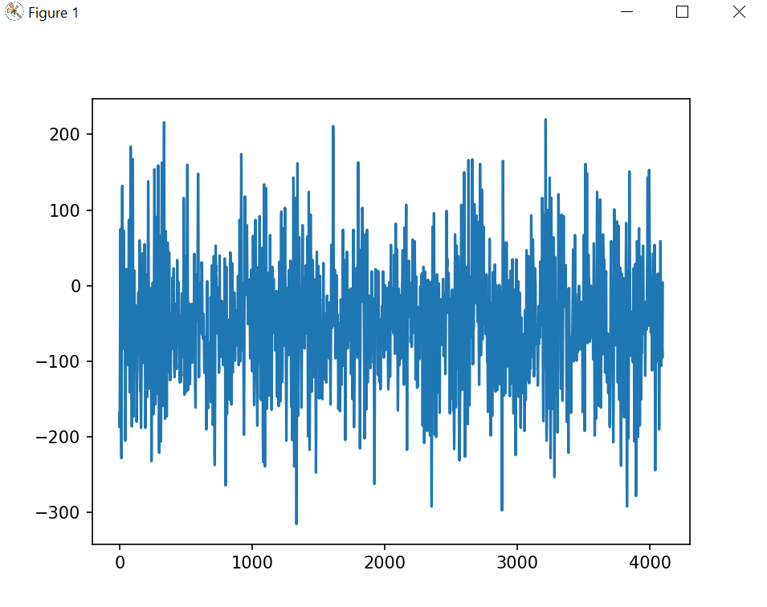

Figure 4-4: Set C – interictal hippocampal formation (C)

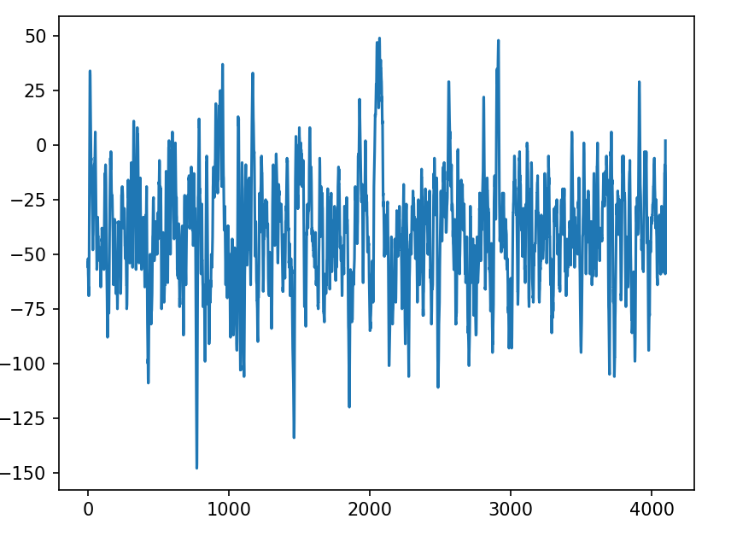

Figure 4-5: Set E – Signals of unhealthy person during a seizure

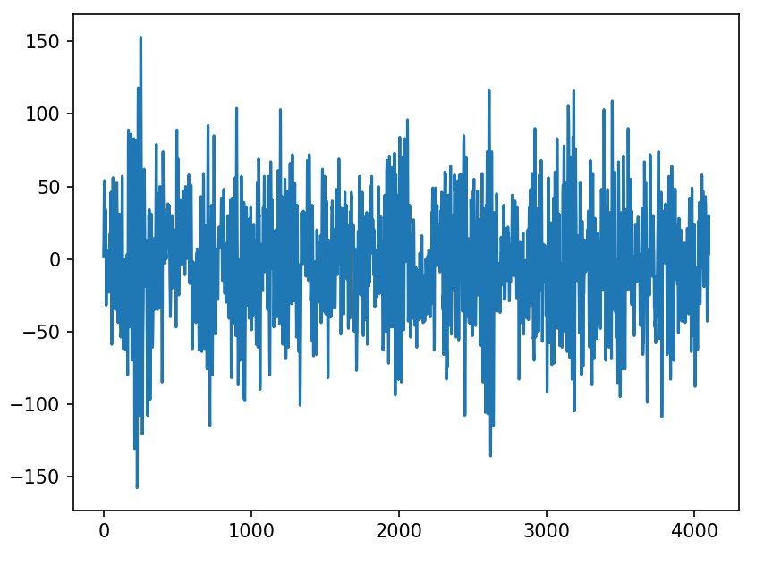

Figure 4-6: Set A – Person not suffering from Epilepsy with open eye

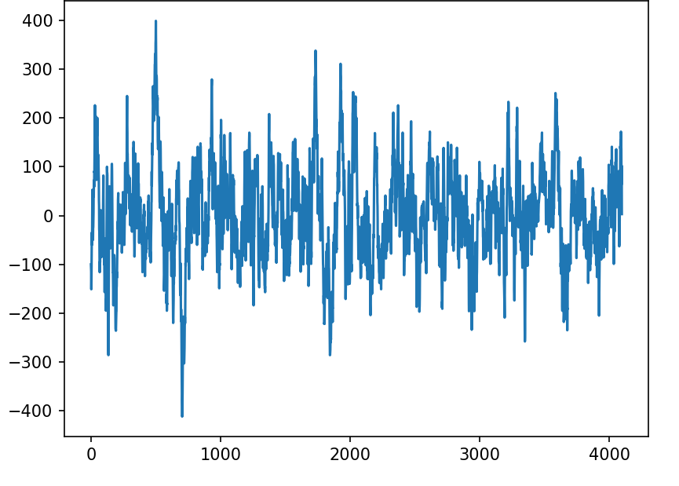

Figure 4-7: Set D – interictal epileptogenic zone

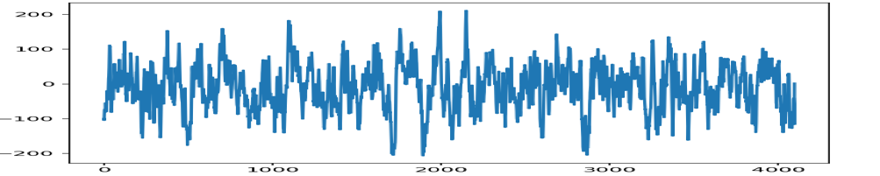

Figure 4-8: Set B – Person not suffering from Epilepsy with closed eye

**4.2.2. Preprocessing**

In this study the focus is on the pre-ictal condition so the binary classification method was used. The data has five class so we reduces the class to two class by grouped the data together as (A, B, C, E) and (D). In order to make a classification task the data was divided to pre ictal state (D) and other brain condition (A, B, C, E).

When the data was downloaded we found that it consist of five files each file has 100 files in excel sheet. In order to make the classification task easy all this files were combined in one file, to do that first when the signal was plotted in python IDEL we faced a problem because the arranged of data is inversed .the excel file contains (2 columns and 4097 rows) so if we want to plot the signals we must make every excel file contains (4097 columns and 2 rows) to all the excel files.

Instead of having 100 files to each file class every class was put together in one file so we have five files. The last step is to combined all the files together in one file contain all the data instead of five files. The last thing is to add a new column to the data set to make the classification easier and fast. The classes of data were renamed by give a number to each class. The details are in table 4-1.

Table 4-1: Describes the new label of data

|  |  |  |
| --- | --- | --- |
| Label | Class Name | New label |
| A | Healthy Open Eyes | 5 |
| B | Healthy closed Eyes | 4 |
| C | Inter-Ictal | 3 |
| D | Pre-Ictal | 1 |
| E | Ictal | 2 |

**4.2.3 Classification**

In this study ANN has been used as an epilepsy classifier. This was composed of a series of interconnected neurons, each of which has an input and output and performs a relatively simple operation. Neural networks generally learn their function through a learning process.

In general, ANN is comprised of network layers namely the input layer, hidden layer and output layer. For the data mining model, the input neurons determine all the input attribute values. In this model one input layer, two hidden layers and output layer have been used. Also Adam optimizer algorithm has been used. Adam is an adaptive learning rate optimization algorithm that’s been designed specifically for training deep neural networks. Used instead of the classical stochastic gradient descent procedure to update network weights iterative based in training data.

It uses the squared gradients to scale the learning rate and it takes advantage of momentum by using moving average of the gradient instead of gradient itself [29].

The network was developed using the Keras library for Python, and the Pandas library for manipulating the database in '.csv'. The database was divided into 70% for training and 30% for testing.

**4.2.4 Performance Evaluation**

Epileptic EEG signals can be divided into three stages, namely, interictal, preictal, and ictal. In our seizure prediction task, we mainly focused on the preictal periods. In order to evaluate the classification task some performance evaluation indexes were introduced. In this thesis, Accuracy, Precision, Recall, and F1-Score are used as the evaluation indexes for the model. In case of binary classification, the confusion matrix is a table with 4 different combinations of predicted and actual values. The elements of the matrix TP, TN, FP, and FN correspond to the True Positive, True Negative, False Positive, and False Negative counts, respectively, which were explained in previous section. In order to evaluate the prediction effect of system, some performance evaluation indexes were introduced. In this thesis sensitivity, false prediction rate (FPR) were used. FPR is the percentage of negative cases in the data that were mistakenly reported as positive. It is measured using the following formula:

(4-5)

Sensitivity or Recall or TPR (True Positive Rate) it measures the ability of the classifier to find all the positive samples. . It is measured using the following formula:

(4-6)

In real life, however, it is necessary to warn patients and doctors of an impending crisis so that doctors are prepared to adequately manage the episode. In order to evaluate the performance of the seizure prediction model, seizure occurrence period (SOP) and seizure prediction horizon (SPH) were introduced. SOP is defined as the time-period for predicting seizures, while SPH refers to the period between the alarm and the beginning of the SOP that is, the period of clinical intervention.

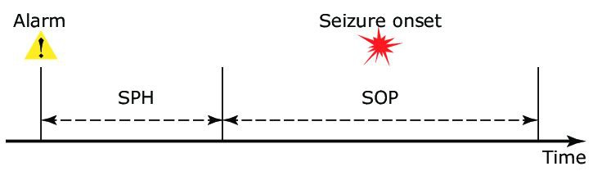

Figure 4-9: The definition of seizure prediction horizon (SPH) and seizure occurrence period (SOP)

For a correct prediction, a seizure onset must be after the SPH and within the SOP. If there is a seizure during SPH or no seizure in SOP, it is considered a false alarm.

In clinical practice, SOP should not be set for too long, otherwise it will increase patients' anxiety and cause mental stress. SPH conditions must allow physicians adequate time for clinical interventions [30].

According to the survey in [31], the optimal warning time is 3–5 minutes. Nesaei [32] proposed that SPH + SOP should be more than 10 minutes and less than 90 minutes to provide treatment for patients and avoid undesirable anxiety. Furthermore, the SOP in many seizure prediction studies is generally 30 minutes [31 - 34].

However, SOP and SPH are usually clinically unknown and researchers usually select values based on assumptions. Studies have shown that the electrical changes that occur in the brain before seizures are difficult to perceive with the naked eye. Due to the nature of the seizures, the time it takes for the seizure to start varies from a few minutes to several hours [35 - 37].

A seizure is correctly predicted if at least one sample segment inside the corresponding preictal interval is classified as positive. The metrics used to test the proposed approach are sensitivity and FPR with an SPH of 5 minutes and an SOP of 30 minutes.

EEG signal from the Bonn University database has five classes. The classes then grouped into two general conditions. The first is the preictal condition, which consists set (D), Set (A, B, C, and E) are grouped as other brain conditions. First our model was evaluated with standard metrics and then was compared with other works. Sensitivity and FPR are evaluated in this study for prediction task.

The proposed model was built in a Python 3.7 environment using Google colabm using Keras-Tensorflow and sclearn Implementation. The EEG segments from all patients were divided into a training set and a test set at a ratio of 7:3. The proposed seizure prediction method has been tested on Bonn University database.

**Chapter five Result and Discussion**

**5.1 Result and Discussion for classification**

In our work, five sets-explained in table5-1 each containing 100 single- channel EEG segments of 23.6-sec duration, were composed for the study. These segments were selected and cut out from continuous multichannel EEG recordings after visual inspection for artifacts.

Table 5-1: Data set description and number of cases in each class

|  |  |  |  |  |
| --- | --- | --- | --- | --- |
| **Classes** | **class description** | **patient state** | **Number of cases** | **Binary case** |
| **1** | Seizure activity recorded from epileptic patient | General epilepsy with seizure | 2300 | 2300 |
| **2** | EEG recorded from tumor region in epileptic patient | Partial epilepsy (no seizure) | 2300 | 9200 |
| **3** | EEG recorded from healthy area in epileptic patient | Partial epilepsy (no seizure) | 2300 |
| **4** | Eyes closed EEG recording | Healthy subject | 2300 |
| **5** | Eyes open EEG recording | Healthy subject | 2300 |

Results of using multiple classifiers to classify the epilepsy data set and the performance of the classifications are analyzed in the next section.

* + 1. **Metrics used to evaluate the classifiers**

Table 5-2: Classification outcomes

|  |  |  |
| --- | --- | --- |
| Acronym | Detection type | Real-world scenario |
| TP | True positive | A seizure detected correctly |
| FP | False positive | Falsely detected seizure |
| TN | True negative | A person who has no seizure diagnosed correctly |
| FN | False negative | A person who has a seizure and it is not detected |

* + 1. **Performance measures**

Accuracyis the fraction of predictions our model got right. It is measured using the following formula:

(5-1)

Precision, also known as positive predictive value which demonstrates how many from all the predicted positive classes are actually positive, calculated by the equation:

(5-2)

Recall, also known as sensitivity which explains from all the positive classes how many we predict correctly. Calculated by the equation:

(5-3)

F1-Score, also known as the harmonic mean of precision and recall. It combines precision and recall into a single number using the formula:

(5-4)

* + 1. **Confusion matrix:**

The below figures represents the confusion matrix of our models that shows the actual and predicted values from the classifiers by showing the number of(TP), (FP), (TN)and (FN).

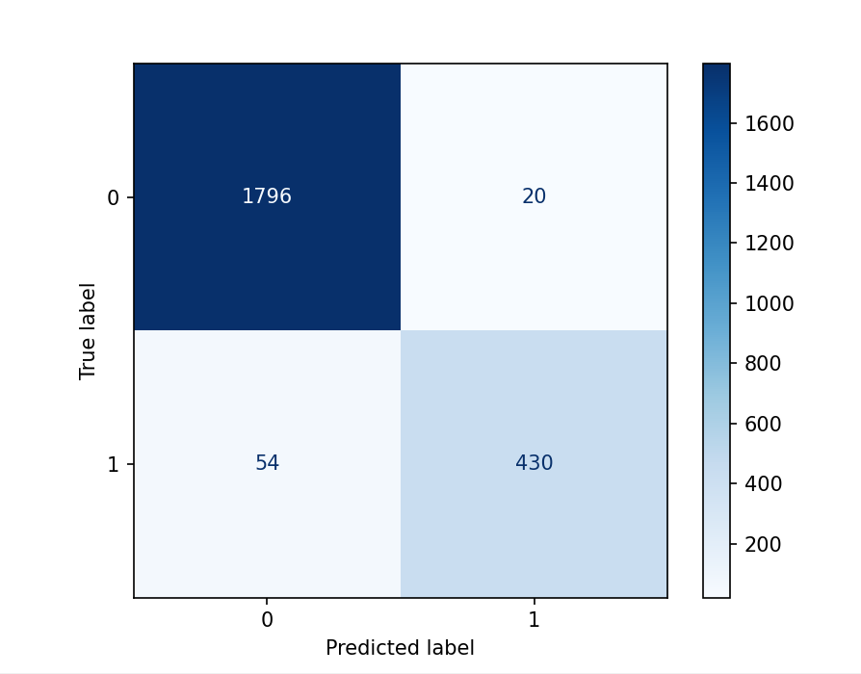

Figure 5-1: The confusion matrix of SVM

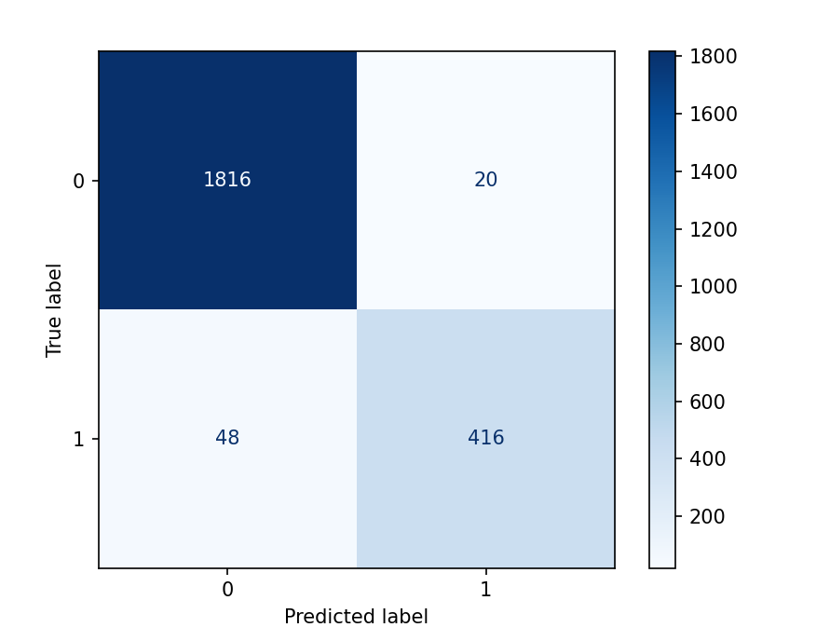

Figure 5-2: The confusion matrix of KNN

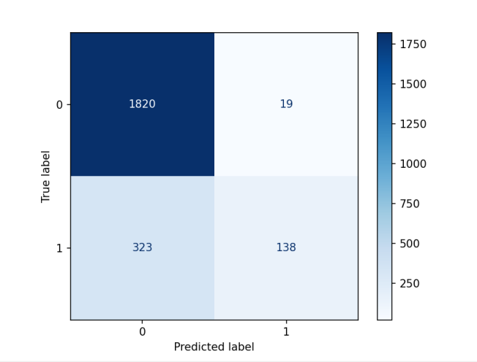

Figure 5-3: The confusion matrix of LSVM

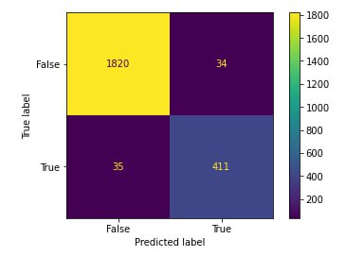

Figure 5-4: The confusion matrix of ANN

Table (5-3) and figure (5-5) illustrate the comparison between the different classification techniques with setting 80% of the dataset for raining and 20% for testing.

Table 5-3: Comparison of the different Classification Techniques

|  |  |  |  |  |  |
| --- | --- | --- | --- | --- | --- |
| Classification techniques | Accuracy | Recall | Precision | | F1 score |
| KNN | 93.43 | 67 | 99 | 80 | |
| SVM | 96.57 | 98 | 97 | 98 | |
| **ANN** | **97.35** | **93** | **93** | **93** | |
| LSTM | 96 | - | - | - | |
| Linear SVM | 86.78 | 31 | 97 | 47 | |

Figure 5-5: Comparison of the different Classification Techniques

* + 1. **Discussion:**

As shown in table (3) the ANN algorithm achieving accuracy of 97.35 shows the best result. While LSTM and SVM resulted in 96% accuracy with the SVM having the best F1 score. Finally, the KNN and Linear SVM had 93.4% and 86.7% respectively. Another outcome of these experiments is that we could not derive the confusion matrix for the LSTM approach and so could not determine its precision, recall and F1-score. But since our experiment is based on accuracy comparison it did not pose a problem. ANN are very time-consuming in the training process due to the high-dimensional input vector space [38].ANN-based detection scheme to reduce complexity and power consumption[39].ANN classification of EEG signals gives better results, and these results can also be used for the deduction of epileptic seizure[40].

* 1. **Result and Discussion for prediction:**

For the purpose of verifying the effectiveness of the proposed model, we conducted corresponding tests on the Bonne dataset.

The number of examples in this dataset is insufficient to build a comprehensive learning model. As a result, the model is likely to overfit. Through training the data, the model is likely to overfit, because the number of epilepsy signals was small, in order to improve training and generalization accuracy and to handle overfitting, dropout technique was used which is simply dropping the neurons in neural networks. During training a deep learning model, it drops some of its neurons and trains on rest. It updates the weights of only selected or activated neurons and others remain constant. For every new epoch again, it selects some nodes randomly based on the dropout ratio and keeps the rest of the neurons deactivated. It helps to create a more robust model that is able to perform well on unseen data.

The workflow of the seizure classification and prediction systems is shown in Figure (5-5). In our model, first, preprocessing the data was done by add new column and new label to make the classification task easier, second, the data was split by ratio of 7:3, for training and testing respectively, then ANN classifier with two hidden layers was applied and Adam optimizer was used. To evaluation the classification confusion matrix report was used and for prediction FPR and Sensitivity were used, According to Binder et al. [19], seizure prediction needs to find the preictal condition so we focus on it. Our model achieved accuracy by 98.2%. It can be seen that accuracy, precision, F1-score, sensitivity and FPR of our model were 95%, 93%,90%,87%,0.01 respectively ,which improved by using dropout technique. Table 5-4 showed that the result is better using dropout technique.

Figure 5-6: The workflow of the seizure classification and prediction.

Table 5-4: Results before and after dropout technique.

|  |  |  |  |  |  |
| --- | --- | --- | --- | --- | --- |
| Model | Accuracy | precision | F1**-**score | Sensitivity | FPR |
| Original data | 100% | 100% | 68% | 52% | 0.00 |
| **With dropout technique.** | **95%** | **93%** | **90%** | **87%** | **0.01** |

**5.3 Discussion:**

Information extracted from EEG signals in frequency and time (synchronization) domains has been used widely to classify and predict seizures. We proposed a model to classify and predict seizures using EEG dataset. Dropout technique showed a good result to overcome the overfitting problem. The results show that our model has better performance and it is more accurate in classification and prediction results.

The Bonne dataset used in this study has also been used for performance evaluation in other studies. In comparison to the state-of-the-art for classification task, Salman at [25] used a two-dimensional CNN and they achieved accuracy by 97.8%, and did not recognize the pre-ictal phase, also used a sliding window technique to overcome the problem of lack of data in compare we use dropout technique which provided a good accuracy in recognize pre-ictal phase. Wijayanto et al. [24] used support vector machine to classify the ictal and interictal conditions of EEG signals. They used two main scenarios to evaluate the detection system. The scenarios are based on the approach of seizure detection and prediction system. They achieved low accuracy between 91.1% - 88.7%to each scenario. The proposed model achieved better accuracy against the two scenarios. In comparison to the state-of-the-art for prediction task, D K Thara et al.[16] they used two layered bidirectional long short term memory and achieved sensitivity by 89.21% and FPR 0.06 per hour. H O Lekshmy et al.[19] they used different machine learning and deep learning techniques and they developed four neural networks (ANN, CNN, LSTM, Auto Encoder) for analyzing the Bonn dataset, and achieved sensitivity of (0.85 -0.97) and false positive rate of (0.87 - 0.92) in compare with all the models our result of sensitivity and FPR were better .

Table 5-5: The comparison of the classification results of this work with other reported methods

|  |  |  |  |  |
| --- | --- | --- | --- | --- |
| Year | Authors | Feature | Classifier | Accuracy |
| 2020 | Wijayanto | Higuchi fractal dimension | SVM | 91.1% - 88.7% |
| 2021 | Salman | - | CNN | 97.8 |
|  | **Our model** | - | **ANN** | **95%** |

Table (5-6): The comparison of the results prediction of this work with other reported methods

|  |  |  |  |  |  |
| --- | --- | --- | --- | --- | --- |
| Year | Authors | Feature | Classifier | Sensitivity (%) | FPR (h−1) |
| 2018 | D K Thara | **-** | Two layered stacked bidirectional LSTM | 89.21 | 0.06 |
| 2022 | H O Lekshmy | WT | ANN, CNN,LSTM, Auto Encoder | 0.85 -0.97 | 0.87 - 0.92 |
|  | **Proposed model** | - | **ANN** | **80%** | **0.01** |

**Chapter six Conclusion**

Epileptic seizures are currently one of the leading reasons for morbidity and mortality in the world. As much as 20% to 30% of epilepsy cases in the world may have been misdiagnosed. It is estimated that up to 70% of people living with epilepsy could live seizure- free if properly diagnosed. With the rise of epileptic seizures around the world and their effect on people's lives, it's more important than ever to get an accurate and timely diagnosis. So the fundamental goal of this thesis was to discover the best classification algorithm for epileptic seizures by compare a number of machine learning and deep learning techniques to find out which is more accurate in classifying EEG signals as an epileptic seizure or not an epileptic seizure. We found that a customized ANN with personalized cost function that learns from the imbalanced data and achieves high accuracy in automated seizure detection. ANN which is a deep learning technique is the best classifier with high accuracy of 97.35.

An effective seizure prediction method will not only help doctors diagnose and reduce the pain of patients; but can also help them avoid dangerous activities such as driving or swimming before the onset of seizures. Seizure prediction capability has been studied and improved over the last decades. A perfect prediction is not yet available, but with current prediction performance it appears possible to provide patients with a warning so they can take some precautions for their safety.

Also Epileptic seizure prediction is very useful to control seizures that are non-treatable with medicines or surgery. Predicting an epileptic seizure with an increased sensitivity and the low false positive rate remains a challenge due to multiple factors that include the lack of effective preprocessing of the EEG signals, class imbalance problem.

The proposed work showed its good generalization in working well with sensitivity and the false positive rate. This gives more patients the opportunity to possess a seizure prediction device that can help them have a more manageable life.

Deep learning techniques provide a way of extracting robust features and generate feature maps. It provides good accuracy results and accuracy is very important in case of health domain compared with machine learning techniques.

**References**

[1]. “Brain anatomy and how the brain works,” *Brain Anatomy and How the Brain Works | Johns Hopkins Medicine*, 14-Jul-2021. [Online]. Available: https://www.hopkinsmedicine.org/health/conditions-and-diseases/anatomy-of-the-brain. [Accessed: 14-Mar-2023].

[2]. S. Sanei, J. A. Chambers, S. Sanei, and J. A. Chambers, "Fundamentals of EEG Signal Processing," in EEG Signal Processing, pp. 35-125. ed: John Wiley & Sons Ltd, 2007.

[3]. P. Gloor, "Neuronal Generators and the Problem of Localization in Electroencephalography: Application of Volume Conductor Theory to Electroencephalography," Journal of Clinical Neurophysiology, vol. 2, 1985.

[4].*EEG*.[Online].Available:https://www.medicine.mcgill.ca/physio/vlab/biomed_signals/eeg_n.htm. [Accessed: 14-Mar-2023].

[5]. Department of Health & Human Services, “Eeg Test,” *Better Health Channel*, 12-Apr-2002.[Online].Available: https://www.betterhealth.vic.gov.au/health/conditionsandtreatments/eeg-test#conditions-diagnosed-by-eeg. [Accessed: 14-Mar-2023].

[6]. S. Wiebe, D. Bellhouse, C. Fallahay, and M. Eliasziw, "Burden of epilepsy: the Ontario  
Health Survey," The Canadian journal of neurological sciences, vol. 26, 1999.

[7]. R. S. Fisher, W. van Boas, W. Blume, C. Elger, P. Genton, P. Lee, and J. Engel, “Epileptic seizures and epilepsy: Definitions proposed by the International League Against Epilepsy (ILAE) and the International Bureau for Epilepsy (IBE),” *Epilepsia*, vol. 46, no. 4, pp. 470–472, 2005.

[8]. T. Blume Warren, O. Lüders Hans, E. Mizrahi, C. Tassinari, W. Van Emde Boas, and J.  
Engel, "Glossary of Descriptive Terminology for Ictal Semiology: Report of the ILAE  
Task Force on Classification and Terminology," Epilepsia, vol. 42, pp. 1212-1218, 2002.

[9]. L. Sörnmo and P. Laguna, Bioelectrical Signal Processing in Cardiac and Neurological  
Applications: Elsevier Academic Press, 2005.

[10]. J. J. Falco-Walter, I. E. Scheffer, and R. S. Fisher, "The new definition and classification  
of seizures and epilepsy," Epilepsy Research, vol. 139, pp. 73-79, 2018.

[11]. J. Engel, T. A. Pedley, and J. Aicardi, Epilepsy: A Comprehensive Textbook: Lippincott-  
Raven, 1998.

[12]. N. Foldvary, G. Klem, J. Hammel, W. Bingaman, I. Najm, and H. Lüders, "The localizing value of ictal EEG in focal epilepsy," Neurology, vol. 57, p. 2022, 2001.

[13]. Barbara Blachut, Christian Hoppe, Rainer Surges, Jutta Stahl, Christian E. Elger, and Christoph Helmstaedter. Counting seizures: The primary outcome measure in epileptology from the patients’ perspective. Seizure, 2015.

[14]. Christian E. Elger and Christian Hoppe. Diagnostic challenges in epilepsy: seizure underreporting and seizure detection. The Lancet Neurology, 2018.

[15]. A. Ulate-Campos, F. Coughlin, M. Gaínza-Lein, I. Sánchez Fernández, P. L. Pearl, and T. Loddenkemper. Automated seizure detection systems and their effectiveness for each type of seizure. Seizure, 2016.

[16]. R. S. Fisher, C. Acevedo, A. Arzimanoglou, A. Bogacz, J. H. Cross, C. E. Elger, J. Engel, L. Forsgren, J. A. French, M. Glynn, D. C. Hesdorffer, B. I. Lee, G. W. Mathern, S. L. Moshé, E. Perucca, I. E. Scheffer, T. Tomson, M. Watanabe, and S. Wiebe, “ILAE official report: A practical clinical definition of epilepsy,” *Epilepsia*, vol. 55, no. 4, pp. 475–482, 2014.

[17]. S. K. Satapathy, A. K. Jagadev, and S. Dehuri, “Weighted Majority Voting Based Ensemble of Classifiers Using Different Machine Learning Techniques for Classification of EEG Signal to Detect Epileptic Seizure,” Informatica, no. 41, pp. 99–110, Jan. 2017.

[18]. D. Chen, S. Wan, J. Xiang, and F. S. Bao, “A high-performance seizure detection algorithm based on discrete wavelet transform (DWT) and EEG,” *PLOS ONE*, vol. 12, no. 3, 2017.

[19]. X. Wang, G. Gong, N. Li, and S. Qiu, “Detection analysis of epileptic EEG using a novel random forest model combined with grid search optimization,” *Frontiers in Human Neuroscience*, vol. 13, 2019.

[20]. P. Bizopoulos, G. I. Lambrou, and D. Koutsouris, “Signal2Image modules in deep neural networks for EEG classification,” *2019 41st Annual International Conference of the IEEE Engineering in Medicine and Biology Society (EMBC)*, 2019.

[21]. L. D. Iasemidis, “Epileptic seizure prediction and Control,” *IEEE Transactions on Biomedical Engineering*, vol. 50, no. 5, pp. 549–558, 2003.

[22]. U. R. Acharya, S. L. Oh, Y. Hagiwara, J. H. Tan, and H. Adeli, “Deep convolutional neural network for the automated detection and diagnosis of seizure using EEG signals,” *Computers in Biology and Medicine*, vol. 100, pp. 270–278, 2018.

[23]. T. D.K., P. S. B.G., and F. Xiong, “Epileptic seizure detection and prediction using stacked bidirectional long short term memory,” *Pattern Recognition Letters*, vol. 128, pp. 529–535, 2019.

[24]. I. Wijayanto, S. Hadiyoso, S. Aulia, and B. S. Atmojo, “Detecting ictal and interictal condition of EEG signal using Higuchi fractal dimension and support vector machine,” *Journal of Physics: Conference Series*, vol. 1577, no. 1, p. 012016, 2020.

[25]. A. Salman, “Epilepsy detection from EEG data using 2D convolutional neural network,” *2021 6th International Conference on Communication, Image and Signal Processing (CCISP)*,pp 101-108, 2021.

[26]. H. O. Lekshmy, D. Panickar, and S. Harikumar, “Comparative analysis of multiple machine learning algorithms for epileptic seizure prediction,” *Journal of Physics: Conference Series*, vol. 2161, no. 1, p. 012055, 2022.

[27]. R. Andrzejak, K. Lehnertz, F. Mormann, C. Rieke, P. David, and C. Elger, “Indications of nonlinear deterministic and finite-dimensional structures in time series of brain electrical activity: dependence on recording region and brain state,” Physical Review, vol. 64, no. 6, 2001.

[28]. M. Hajek Neural Networks. University of KwaZulu-Natal, 2005.

[29]. Diederik P. Kingma and Jimmy Lei Ba. Adam : A method for stochastic optimization. 2014.

[30]. B. Sun, J.-J. Lv, L.-G. Rui, Y.-X. Yang, Y.-G. Chen, C. Ma, and Z.-K. Gao, “Seizure prediction in scalp EEG based channel attention dual-input convolutional neural network,” *Physica A: Statistical Mechanics and its Applications*, vol. 584, p. 126376, 2021.

[31]. Fourth International Workshop on Seizure Prediction. Available online: http: / /www .iwsp4.org /patients.htm [accessed on 14 Mar- 2023].

[32]. S. Nesaei and A. R. Sharafat, “Real‐time mining of epileptic seizure precursors via nonlinear mapping and dissimilarity features,” *IET Signal Processing*, vol. 9, no. 3, pp. 193–200, 2015.

[33]. N. D. Truong, A. D. Nguyen, L. Kuhlmann, M. R. Bonyadi, J. Yang, S. Ippolito, and O. Kavehei, “Convolutional neural networks for seizure prediction using intracranial and Scalp Electroencephalogram,” *Neural Networks*, vol. 105, pp. 104–111, 2018.

[34]. Z. Wang, J. Yang, H. Wu, J. Zhu, and M. Sawan, “Power efficient refined seizure prediction algorithm based on an enhanced benchmarking,” *Scientific Reports*, vol. 11, no. 1, 2021.

[35]. Z. Li, M. Fields, F. Panov, S. Ghatan, B. Yener, and L. Marcuse, “Deep learning of simultaneous intracranial and scalp EEG for prediction, detection, and lateralization of mesial temporal lobe seizures,” *Frontiers in Neurology*, vol. 12, 2021.

[36]. M. Bandarabadi, J. Rasekhi, C. A. Teixeira, M. R. Karami, and A. Dourado, “On the proper selection of preictal period for seizure prediction,” *Epilepsy & Behavior*, vol. 46, pp. 158–166, 2015.

[37]. D. K. Binder and S. R. Haut, “Toward new paradigms of seizure detection,” *Epilepsy & Behavior*, vol. 26, no. 3, pp. 247–252, 2013.

[38]. L. T. Xuyen, L. T. Thanh, D. V. Viet, T. Q. Long, N. L. Trung, and N. D. Thuan, “Deep learning for epileptic spike detection,” *VNU Journal of Science: Computer Science and Communication Engineering*, vol. 33, no. 2, 2018.

[39]. M. Saleheen, H. Alemzadeh, A. M. Cheriyan, Z. Kalbarczyk, and R. K. Iyer, “An efficient embedded hardware for high accuracy detection of epileptic seizures,” *2010 3rd International Conference on Biomedical Engineering and Informatics*, 2010.

[40]. M. K. Kiymik, A. Subasi, and H. R. Ozcalık, “Neural networks with periodogram and autoregressive spectral analysis methods in detection of epileptic seizure,” *Journal of Medical Systems*, vol. 28, no. 6, pp. 511–522, 2004.

Appendix

Prediction

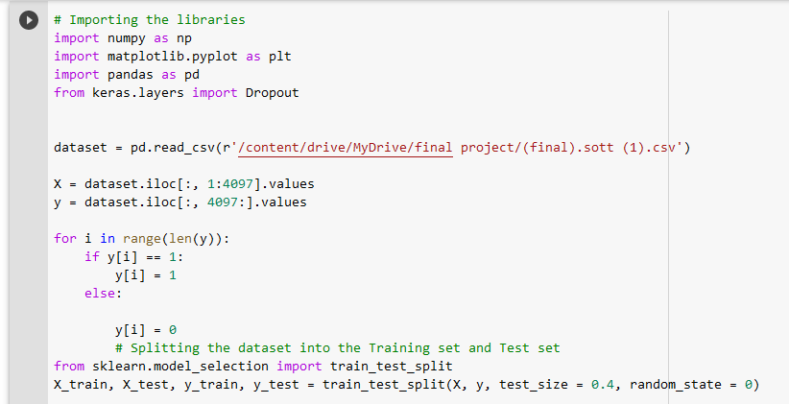

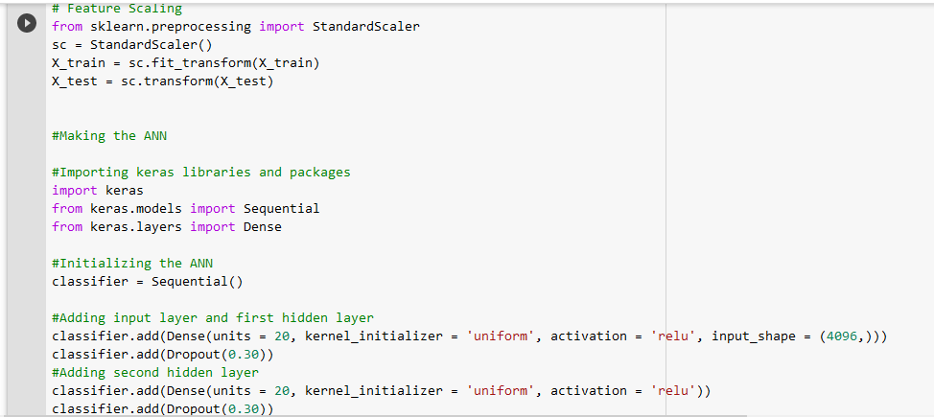

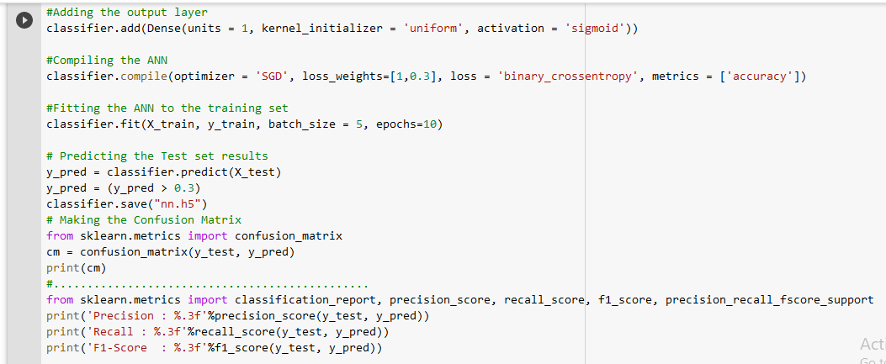

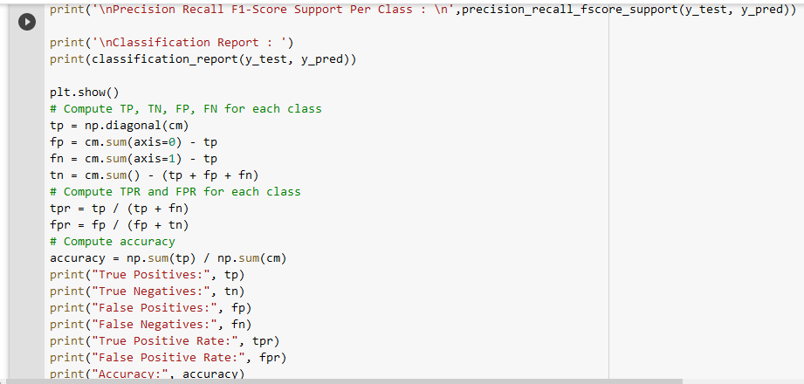

Classification

1-ANN

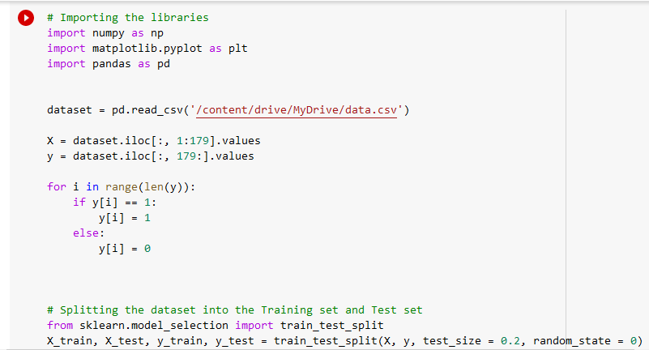

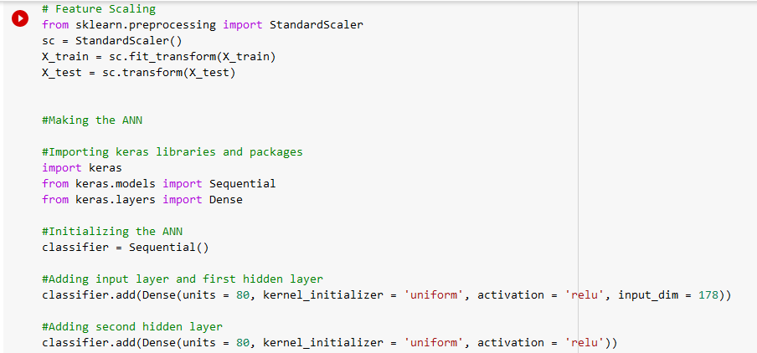

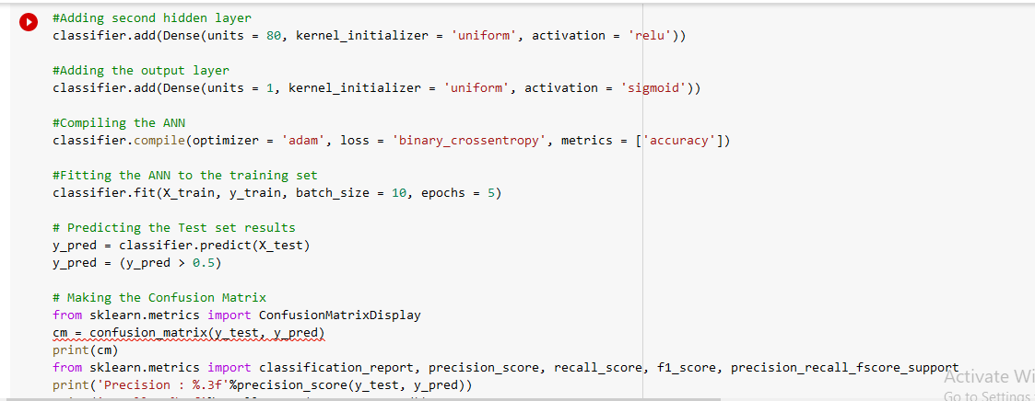

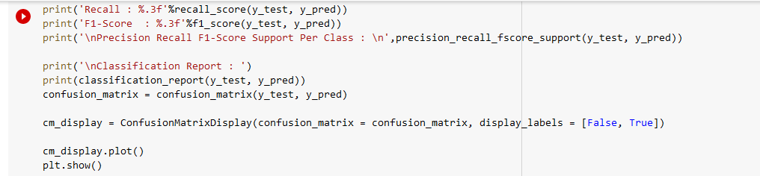

SVM

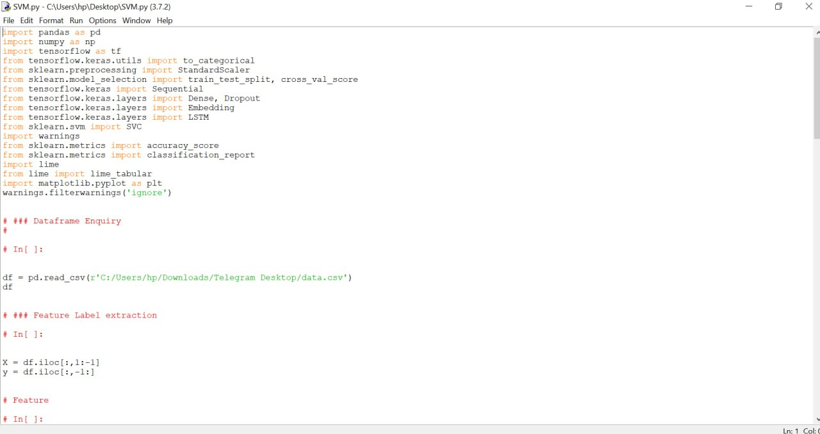

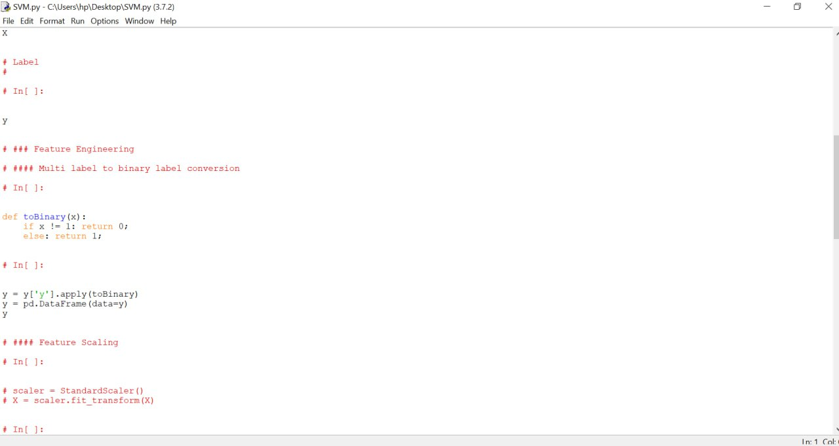

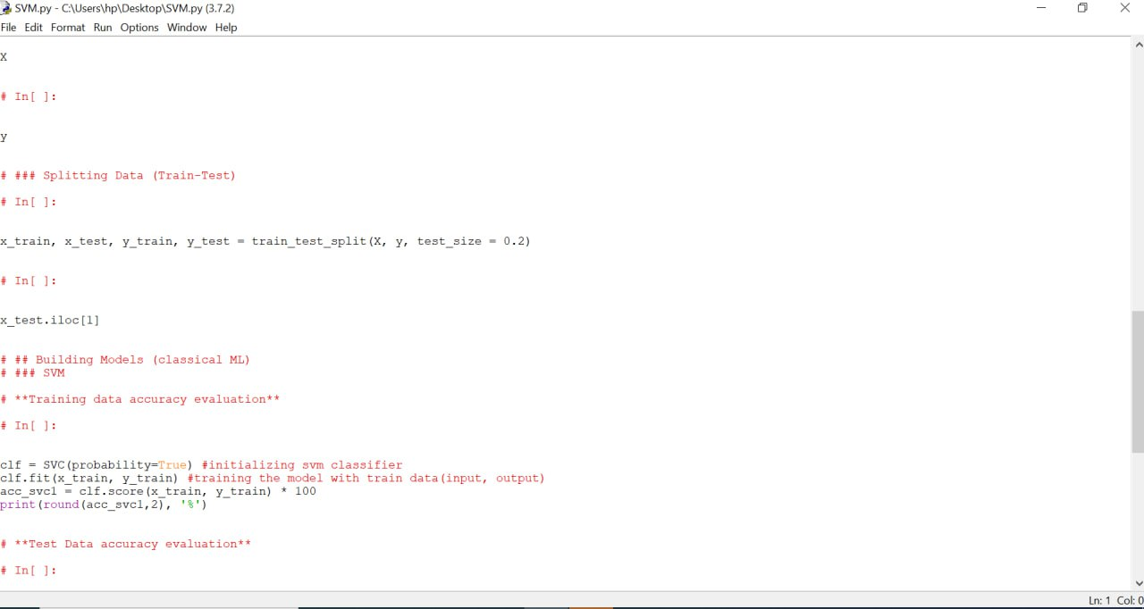

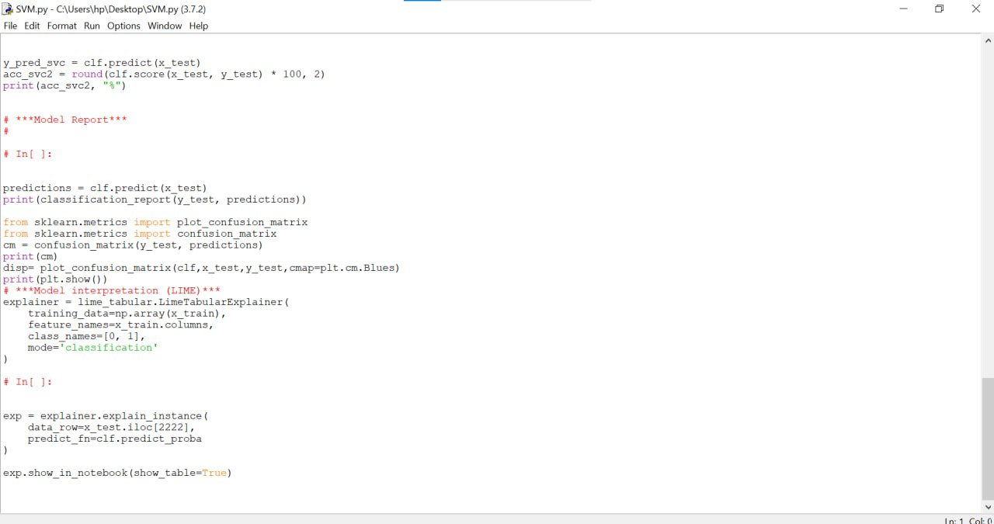

KNN

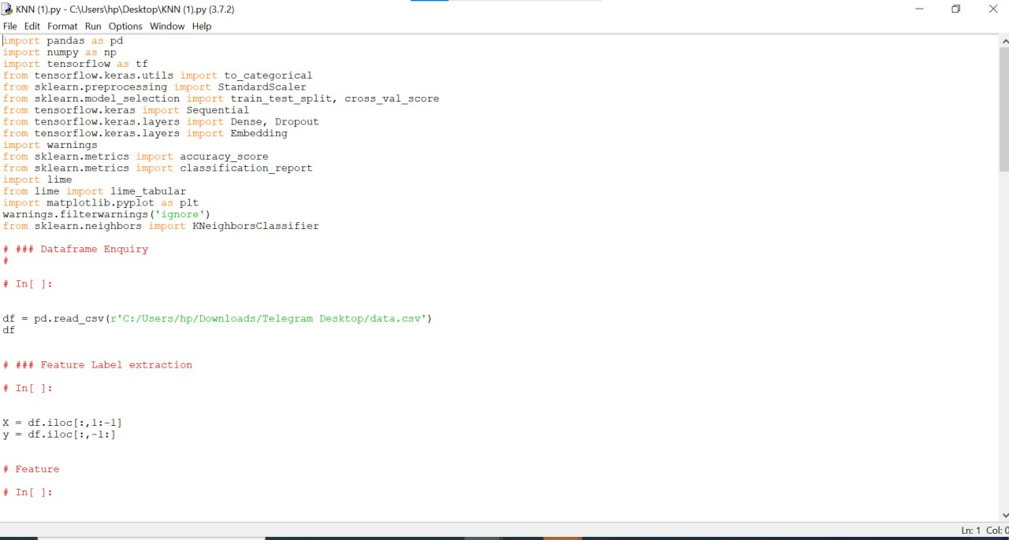

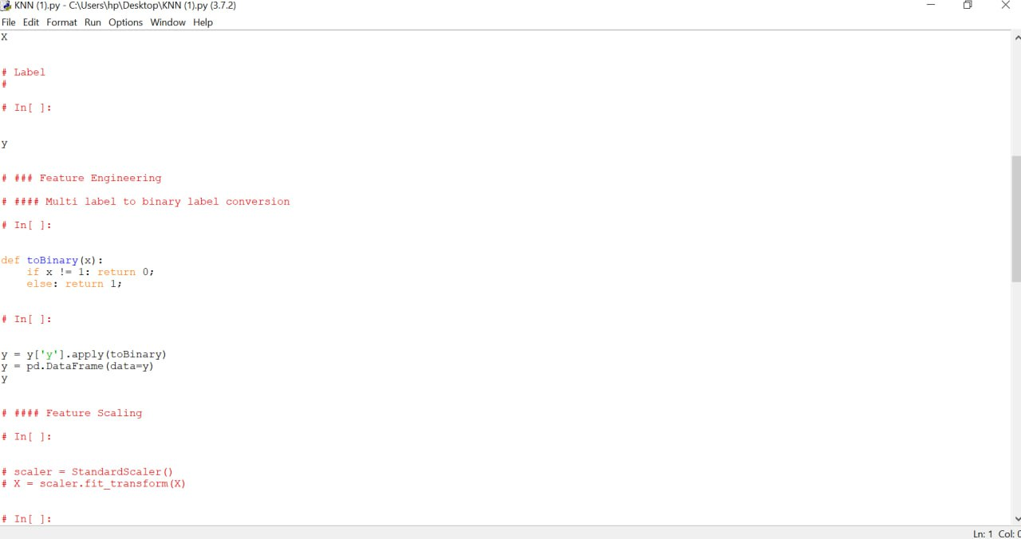

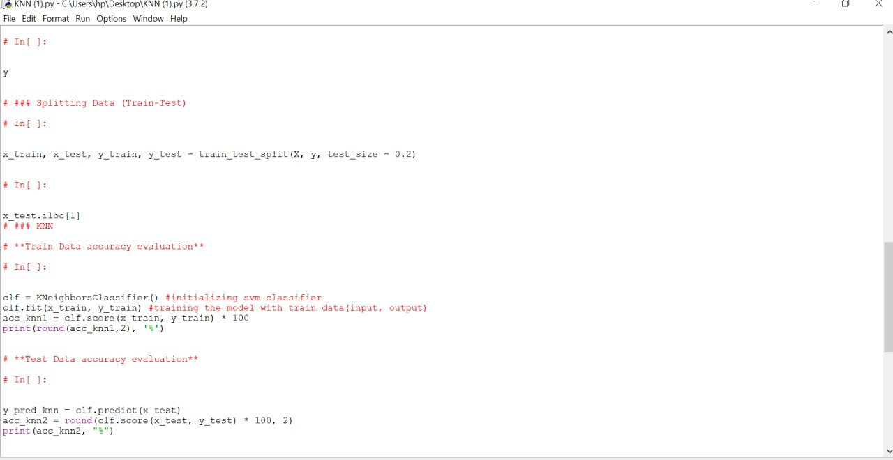

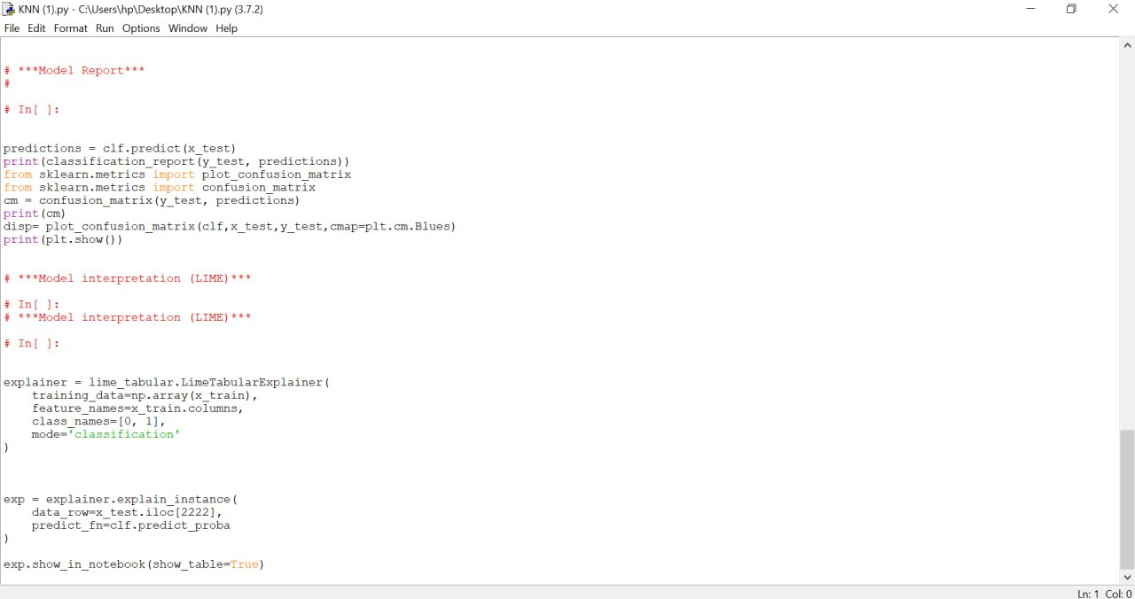

LSTM

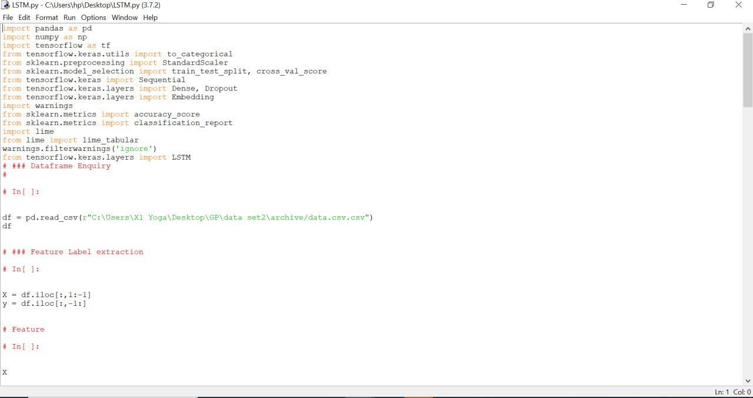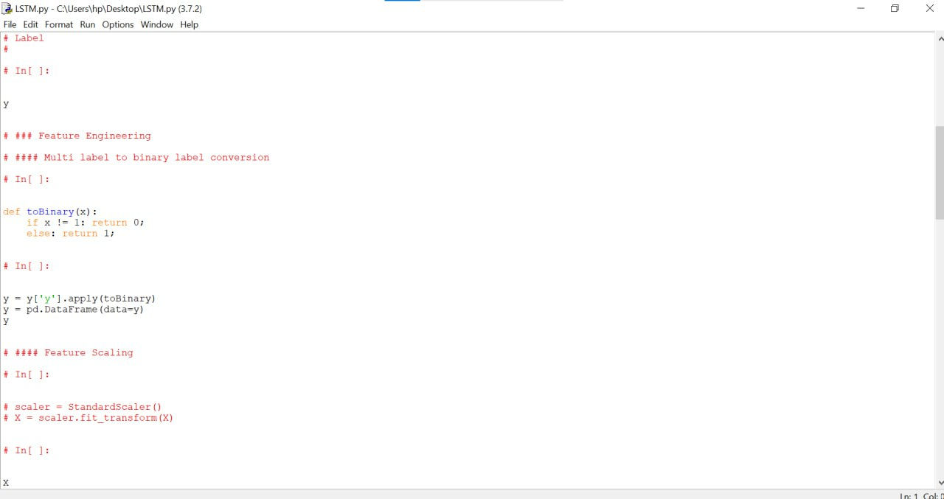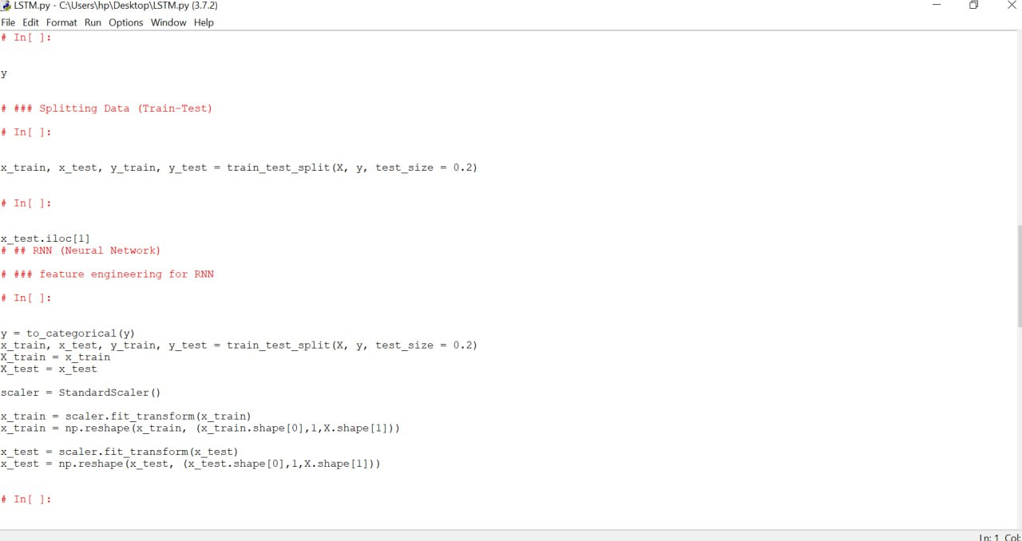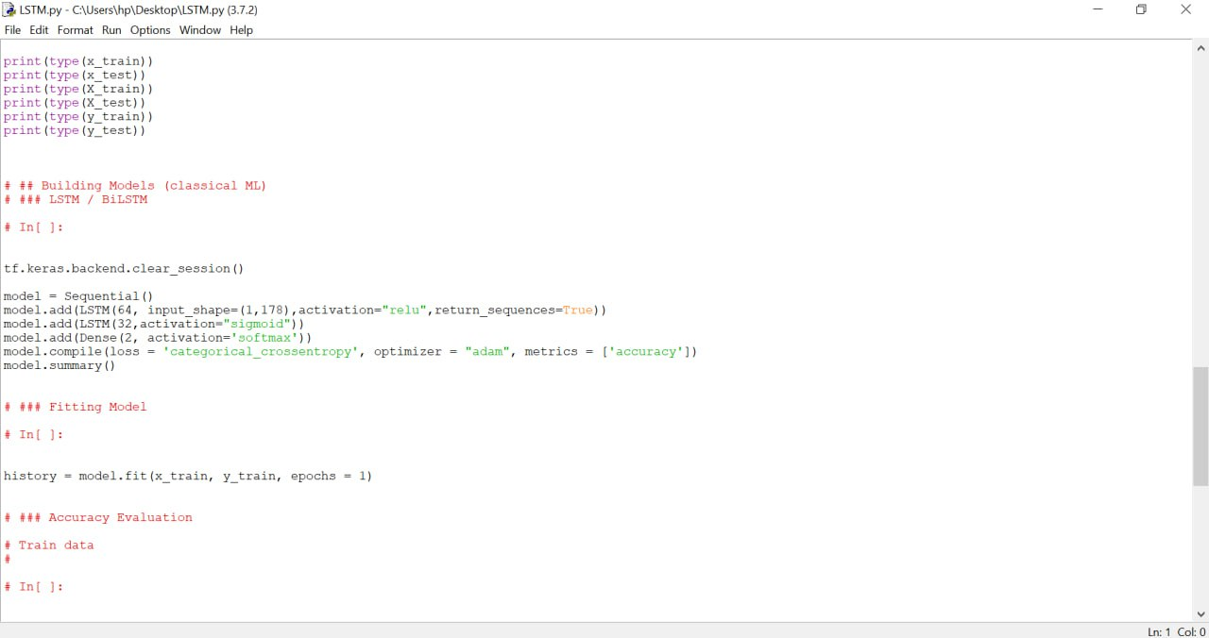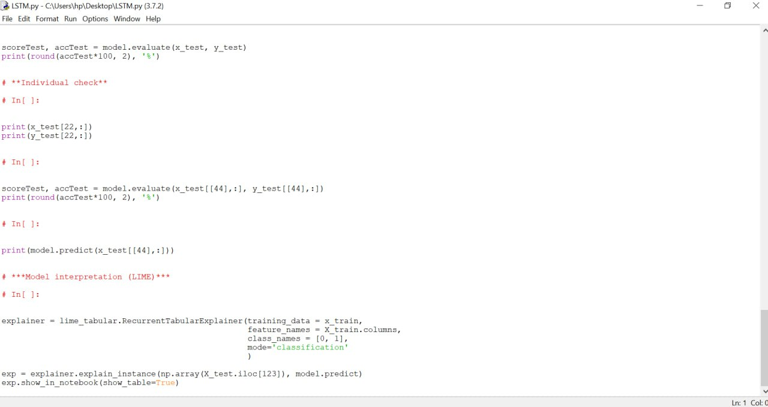

ISVM

