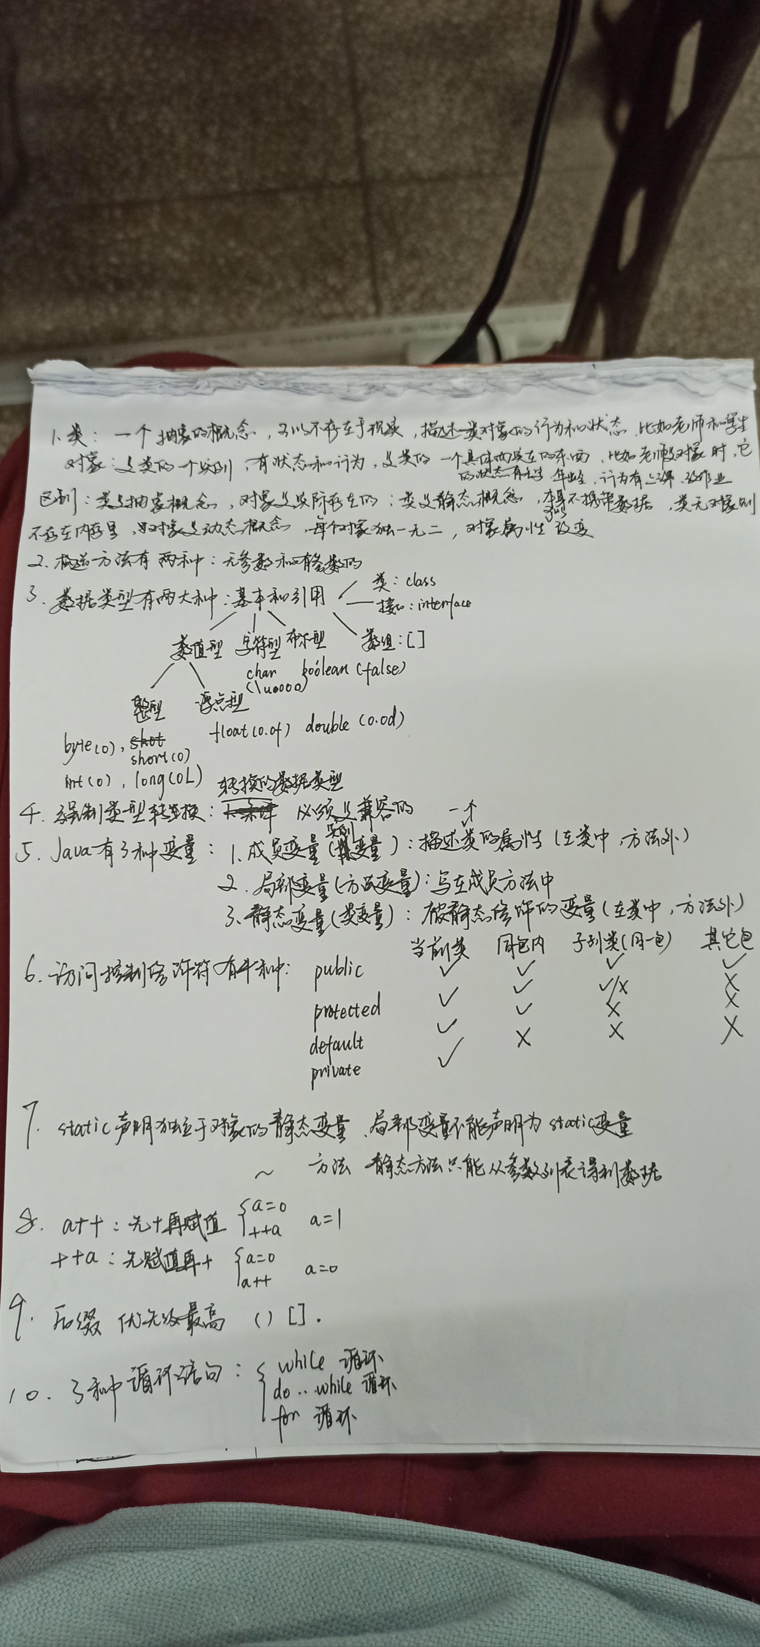
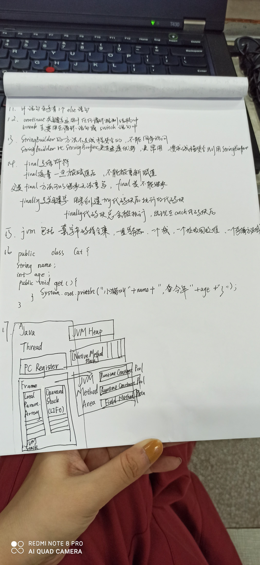
package zuyeyi
public abstract class vehicle{
static int speed;
public int size;
public void speedUp (){
System.out.println("加速");
}
public void speedDown (){
System.out.println("减速");
}
public static void main (String [] args){
Vehicle car = new Vehicle();
car.setSpeed(80);
car.setSize(1000);
}
}

package zuoyeer
public class Person{
private String name;
private int age;
private String gender;
public getName(){
return name;
}
public setName(String name){
this.name=name;
}
public getAge(){
return age;
}
public setAge(int age){
this.age=age;
}
public getGender(){
return gender;
}
public setGender(int age){
this.gender=gender;
}
public void show(){
System.out.println(this.name+","+this.age+","+this.gender);

}

packet com.homework;
public class Phone{
private float screenSize;
private String brand;
private String cpu;
private int memory;
public getScreenSize(){
return screenSize;
}
public setScreenSize(float screenSize){
this.screenSize=screenSize;
}
public getBrand(){
return age;
}
public setBrand(String brand){
this.brand=brand;
}
public getCpu(){
return cpu;
}
public setCpu(String cpu){
this.cpu=cpu;
}
public getMemory(){
return memory;
}
public setMemory(int memory){
this.memory=memory;
}
public static void main (String [] args){
Phone huawei = new Phone();
huawei.setScreenSize(6.7);
huawei.setBrand(huawei);
huawei.setCpu(qilin);
huawei.setMemory(128);
System.out.println("手机尺寸为"+huawei.screenSize);
System.out.println("手机品牌为"+huawei.brand);
System.out.println("手机cpu为"+huawei.cpu);
System.out.println("手机内存为"+huawei.memory);
}
}
2、使用文件流复制myfile.txt文件为myfile_cp.txt
package copyfile;

import java.io.FileInputStream;
import java.io.FileOutputStream;
import java.io.IOException;
import java.nio.channels.FileChannel;

public class CopyFileDemo3 {
public static void main(String[] args) throws IOException {
String fileSrc="C:/myfile.txt";
String fileDes="C:/myfile_cp.txt";
FileInputStream fi = null;
FileOutputStream fo = null;
FileChannel in = null;
FileChannel out = null;
try {
fi = new FileInputStream(fileSrc);
fo = new FileOutputStream(fileDes);
in = fi.getChannel();//得到对应的文件通道
out = fo.getChannel();//得到对应的文件通道
in.transferTo(0, in.size(), out);
} catch (IOException e) {
e.printStackTrace();
} finally {
try {
fi.close();
in.close();
fo.close();
out.close();
} catch (IOException e) {
e.printStackTrace();
}
}
System.out.println("C:/myfile文件夹文件复制成功");
}
}

