TOBB University of Economics and Technology
Department of Electrical and Electronics Engineering
ELE 224L – Electronic Circuits Laboratory
Experiment 4 – Preliminary Work: BJT Circuits
Name Surname
Student ID
Date

1 INTRODUCTION
1.1 Objective of the Experiment
The objective of this experiment is to investigate the current–voltage characteristics of the bipolar junction transistor (BJT) and to learn the DC biasing methods. The BC238A transistor is used to find the operating point of two biasing circuits, to see how the collector current depends on $V_{CE}$ and on the base drive, and to compare two biasing schemes in terms of their sensitivity to the current gain $β$. The ability to diagnose wrong measurements of $V_{CE}$ is also practised.
1.2 Benefits of the Experiment
The experiment shows how a BJT is analysed with the assumed-region method (assume active region, calculate, verify the assumption, switch to saturation if the assumption fails), why a bias circuit with an emitter resistor is preferred, and how measured voltages reveal wiring faults. It also trains the correct reading of a datasheet and the correct placement of a TO-92 transistor on a breadboard. These skills are directly used in the BJT amplifier experiment.
2 CALCULATIONS AND SIMULATIONS
2.1 BJT Properties
The parameters of the BC238A were taken from the datasheet of the BC237/238/239 family (Fairchild Semiconductor), and they are listed in Table 2.1.1. The current gain of the class A transistors is specified as $h_{FE}=120$–220 at $V_{CE}=5$ V and $I_{C}=2$ mA; the average value of 170 is used as $β$. The base–emitter turn-on voltage is typically 0.62 V (0.55–0.70 V) at the same bias. The collector–emitter saturation voltage is 0.2 V at most ($I_{C}=10$ mA, $I_{B}=0.5$ mA; typical 0.07 V), and 0.2 V is used as $V_{CE\left(sat\right)}$ in the calculations.
Table 2.1.1 BC238A parameters and TO-92 pin order from the datasheet
Parameter | Value | Condition
$β$ (class A, average) | 170 (range 120–220) | $V_{CE}$ = 5 V, $I_{C}$ = 2 mA
$V_{BE\left(on\right)}$ (typical) | 0.62 V (min 0.55 V, max 0.70 V) | $V_{CE}$ = 5 V, $I_{C}$ = 2 mA
$V_{CE\left(sat\right)}$ (maximum) | 0.2 V (typical 0.07 V) | $I_{C}$ = 10 mA, $I_{B}$ = 0.5 mA
Pin 1 / Pin 2 / Pin 3 | Collector / Base / Emitter | TO-92, flat face towards the viewer, leads down

The pin order is C–B–E for the Fairchild datasheet. Some other manufacturers use E–B–C for the same package, so the pin order of the physical part should be checked before the circuit is powered.
2.2 BJT Circuit 1 on the Breadboard
BJT circuit 1 (Figure 2.2.1) was drawn on the breadboard as shown in Figure 2.2.2. The transistor is placed with its three legs on three adjacent columns (collector on column 10, base on column 11, emitter on column 12). $R_{C}$ is connected between the collector column and a column that is wired to the $+V_{CC}$ rail, $R_{E}$ is connected between the emitter column and a column that is wired to the ground rail, and $R_{B}$ is connected between the base column and the $V_{BB}$ supply lead. The connections of the drawing were verified automatically against the circuit diagram.
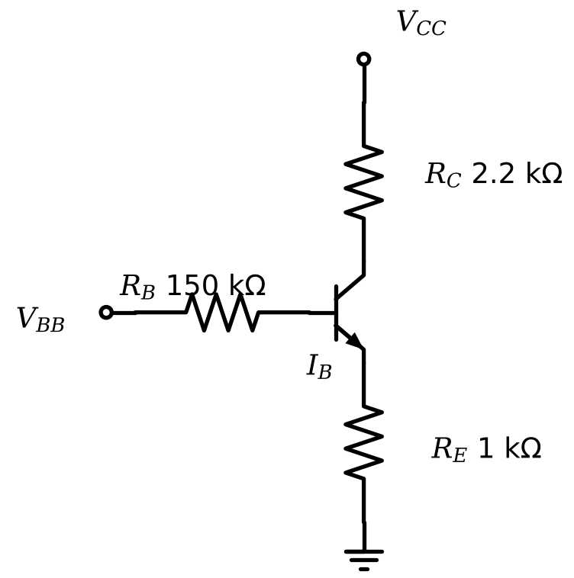
Figure 2.2.1 BJT circuit 1 of the experiment ($R_{B}$ = 150 k$Ω$, $R_{C}$ = 2.2 k$Ω$, $R_{E}$ = 1 k$Ω$).
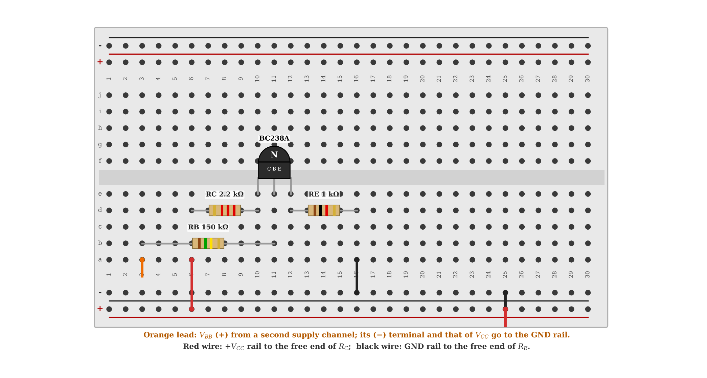
Figure 2.2.2 BJT circuit 1 drawn on the breadboard ($V_{BB}$, $V_{CC}$ and GND points are indicated).
2.3 Q-Point Calculations of BJT Circuit 1
The operating point of circuit 1 was calculated for $V_{BB}=1$, 2 and 5 V and for the $V_{CC}$ values of the experiment sheet with the model $β=170$, $V_{BE\left(on\right)}=0.62$ V, $V_{CE\left(sat\right)}=0.2$ V and no Early effect. The base-loop equation (2.1) gives the base current when the transistor is in the active region, and the remaining quantities follow from (2.2) and (2.3).
 | $$V_{BB}=I_{B}R_{B}+V_{BE\left(on\right)}+I_{E}R_{E}, I_{E}=\left(β+1\right)I_{B} ⇒ I_{B}=\frac{V_{BB}−V_{BE\left(on\right)}}{R_{B}+\left(β+1\right)R_{E}}$$ | (2.1)

 | $$I_{C}=βI_{B}, I_{E}=\left(β+1\right)I_{B}$$ | (2.2)

 | $$V_{CE}=V_{CC}−I_{C}R_{C}−I_{E}R_{E}$$ | (2.3)

The active-region assumption is verified by $V_{CE}≥V_{CE\left(sat\right)}$. If it fails, the transistor is in saturation: $V_{CE}=V_{CE\left(sat\right)}$, and $I_{B}$ and $I_{C}$ are found from the two loop equations given in (2.4); $I_{C}=βI_{B}$ no longer holds. If the supply is so small that even this solution gives $I_{C}≤0$, the collector current is practically zero and $V_{CE}=V_{CC}$.
 | $$\begin{matrix}\left(R_{B}+R_{E}\right)I_{B}+R_{E}I_{C} & =V_{BB}−V_{BE\left(on\right)} \\ R_{E}I_{B}+\left(R_{C}+R_{E}\right)I_{C} & =V_{CC}−V_{CE\left(sat\right)}\end{matrix}$$ | (2.4)

Sample calculation 1 (active region). For $V_{BB}=2$ V and $V_{CC}=10$ V: $I_{B}=\left(2−0.62\right)/\left(150\text{ k}Ω+171⋅1\text{ k}Ω\right)=4.299$ µA, $I_{C}=170⋅4.299 μ\text{A}=0.7308$ mA, $I_{E}=0.7351$ mA, and $V_{CE}=10−0.7308⋅2.2−0.7351⋅1=7.657$ V > $0.2$ V, so the assumption is valid. Sample calculation 2 (saturation). For $V_{BB}=5$ V and $V_{CC}=4$ V: the active-region result would be $V_{CE}=4−7.44<0.2$ V, so the transistor is in saturation, and (2.4) gives $I_{C}=1.181$ mA, $V_{CE}=0.2$ V. The other cells are calculated in the same way.
Table 2.3.1 Table 1 values for $V_{BB}$ = 1 V (calculation and SPICE)
$V_{CC}$ (V) | 0 | 0.2 | 0.5 | 1 | 2 | 4 | 6 | 8 | 10 | 15 | 20
$V_{CE}$ calc. (V) | 0 | 0.2 | 0.2 | 0.355 | 1.35 | 3.35 | 5.35 | 7.35 | 9.35 | 14.4 | 19.4
$I_{C}$ calc. (mA) | 0 | 0 | 0.093 | 0.201 | 0.201 | 0.201 | 0.201 | 0.201 | 0.201 | 0.201 | 0.201
$V_{CE}$ SPICE (V) | 0.0052 | 0.073 | 0.114 | 0.262 | 1.26 | 3.26 | 5.26 | 7.26 | 9.26 | 14.3 | 19.3
$I_{C}$ SPICE (mA) | −0.0028 | 0.039 | 0.12 | 0.23 | 0.231 | 0.231 | 0.231 | 0.231 | 0.231 | 0.231 | 0.231

Table 2.3.2 Table 1 values for $V_{BB}$ = 2 V (calculation and SPICE)
$V_{CC}$ (V) | 0 | 0.2 | 0.5 | 1 | 2 | 4 | 6 | 8 | 10 | 15 | 20
$V_{CE}$ calc. (V) | 0 | 0.2 | 0.2 | 0.2 | 0.2 | 1.66 | 3.66 | 5.66 | 7.66 | 12.7 | 17.7
$I_{C}$ calc. (mA) | 0 | 0 | 0.091 | 0.248 | 0.561 | 0.731 | 0.731 | 0.731 | 0.731 | 0.731 | 0.731
$V_{CE}$ SPICE (V) | 0.0088 | 0.05 | 0.076 | 0.101 | 0.146 | 1.61 | 3.61 | 5.61 | 7.61 | 12.6 | 17.6
$I_{C}$ SPICE (mA) | −0.0059 | 0.044 | 0.13 | 0.279 | 0.578 | 0.744 | 0.744 | 0.744 | 0.744 | 0.744 | 0.744

Table 2.3.3 Table 1 values for $V_{BB}$ = 5 V (calculation and SPICE)
$V_{CC}$ (V) | 0 | 0.2 | 0.5 | 1 | 2 | 4 | 6 | 8 | 10 | 15 | 20
$V_{CE}$ calc. (V) | 0 | 0.2 | 0.2 | 0.2 | 0.2 | 0.2 | 0.2 | 0.564 | 2.56 | 7.56 | 12.6
$I_{C}$ calc. (mA) | 0 | 0 | 0.085 | 0.241 | 0.555 | 1.18 | 1.81 | 2.32 | 2.32 | 2.32 | 2.32
$V_{CE}$ SPICE (V) | 0.012 | 0.033 | 0.05 | 0.067 | 0.088 | 0.117 | 0.149 | 0.571 | 2.57 | 7.57 | 12.6
$I_{C}$ SPICE (mA) | −0.013 | 0.043 | 0.132 | 0.283 | 0.59 | 1.21 | 1.82 | 2.32 | 2.32 | 2.32 | 2.32

The results are plotted in Figure 2.3.1. In the active region (large $V_{CC}$), $I_{C}$ is constant for a given $V_{BB}$ ($0.201$, $0.731$ and $2.32$ mA for $V_{BB}$ = 1, 2, 5 V) and $V_{CE}$ increases linearly with $V_{CC}$, since the model has no Early effect; the three horizontal lines are the output characteristics of the transistor for three different base currents ($I_{B}=1.18$, $4.30$ and $13.6$ µA). When $V_{CC}$ is decreased, the transistor enters the saturation region (the cells $V_{CC}≤6$ V for $V_{BB}=5$ V, ≤ $2$ V for $V_{BB}=2$ V and ≤ $0.5$ V for $V_{BB}=1$ V), where $V_{CE}$ is clamped at about 0.2 V and $I_{C}$ falls linearly with $V_{CC}$; this is the steep part of the characteristic. For $V_{CC}=0$, all currents are zero.
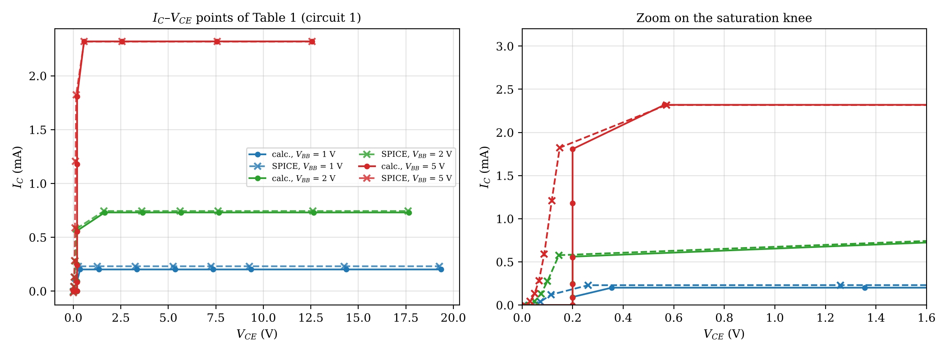
Figure 2.3.1 $I_{C}$–$V_{CE}$ points of Table 1 (calculation: circles; SPICE: crosses); right: zoom on the saturation region.
The SPICE results (BC238A model with $I_{S}$ fitted to $V_{BE}=0.62$ V at 2 mA, $β=170$, no Early effect; the model line is in Appendix A) are also given in the tables. In the active region, the largest difference in $V_{CE}$ is 0.0948 V ($V_{BB}$ = 1 V), 0.0432 V (2 V) and 0.00739 V (5 V), and the mean difference in $I_{C}$ is +14.6%, +1.8% and -0.1%, respectively. The difference is largest for $V_{BB}=1$ V because the real $V_{BE}$ depends logarithmically on the current: at $I_{C}≈0.2$ mA the real $V_{BE}$ is about 0.56 V, not 0.62 V, so the base current (which is proportional to $V_{BB}−V_{BE}$) is 15% larger than the calculated value. For $V_{BB}=5$ V, the term $V_{BB}−V_{BE}$ is large and the effect of the error in $V_{BE}$ disappears. In the saturation region, SPICE gives $V_{CE}$ between 0.03 and 0.15 V (it decreases with the base drive), whereas the model uses a constant 0.2 V; hence the saturation cells have a difference of up to 0.15 V in $V_{CE}$ and a few percent in $I_{C}$.
2.4 Biasing Circuit 1 (No Emitter Resistor)
The circuit in Figure 2.4.1 has no emitter resistor. For $V_{BB}=5$ V and $V_{CC}=12$ V, the base current is $I_{BQ}=\left(V_{BB}−V_{BE}\right)/R_{B}=\left(5−0.62\right)/150\text{ k}Ω=29.20$ µA, the collector current is $I_{CQ}=βI_{BQ}=4.964$ mA, and the collector–emitter voltage is $V_{CEQ}=V_{CC}−I_{CQ}R_{C}=12−4.964×2.2=1.079$ V, with $V_{BEQ}=0.62$ V. Since $V_{CEQ}>0.2$ V (and $V_{CEQ}>V_{BE}$, i.e., the collector junction is reverse biased), the active-region assumption is valid. The SPICE simulation gives $V_{BEQ}=0.6442$ V, $I_{BQ}=29.04$ µA, $I_{CQ}=4.937$ mA and $V_{CEQ}=1.140$ V; the differences from the calculation result from the dependence of $V_{BE}$ on the current ($V_{BE}=0.644$ V at 5 mA).
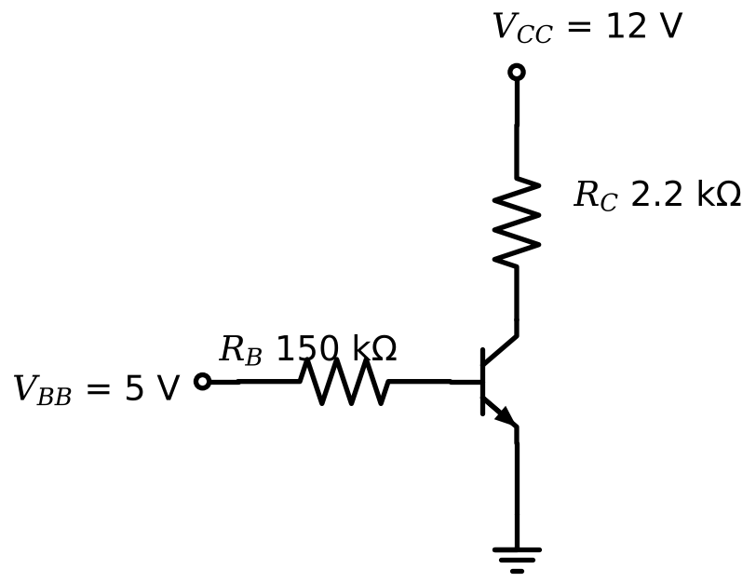
Figure 2.4.1 BJT biasing circuit 1 (no emitter resistor).
The operating point of this circuit is very sensitive to $β$, because $I_{C}=βI_{B}$ and $I_{B}$ is fixed by $V_{BB}$ and $R_{B}$. With the datasheet range of $β$ for the class A transistors, $I_{C}$ changes from 3.50 mA ($β=120$) to 5.36 (saturation limit) mA ($β=220$) in the active-region equations; for $β=220$, the active-region result would give $V_{CE}<0$, so the transistor actually saturates with $V_{CE}=0.2$ V and $I_{C}=5.36$ mA, and the amplifier would be unusable. This is shown in the left graph of Figure 2.5.2.
2.5 Biasing Circuit 2 (With Emitter Resistor)
The circuit in Figure 2.5.1 has $R_{B}=22$ k$Ω$, $R_{C}=1.2$ k$Ω$ and $R_{E}=1$ k$Ω$. The calculation with (2.1)–(2.3) for $V_{BB}=5$ V and $V_{CC}=12$ V gives $I_{BQ}=4.38/\left(22\text{ k}Ω+171\text{ k}Ω\right)=22.69$ µA, $I_{CQ}=3.858$ mA, $I_{EQ}=3.881$ mA, $V_{BEQ}=0.62$ V, and $V_{CEQ}=12−3.858×1.2−3.881×1=3.490$ V. The transistor is in the active region. The SPICE simulation gives $V_{BEQ}=0.6376$ V, $I_{BQ}=22.60$ µA, $I_{CQ}=3.843$ mA and $V_{CEQ}=3.524$ V.
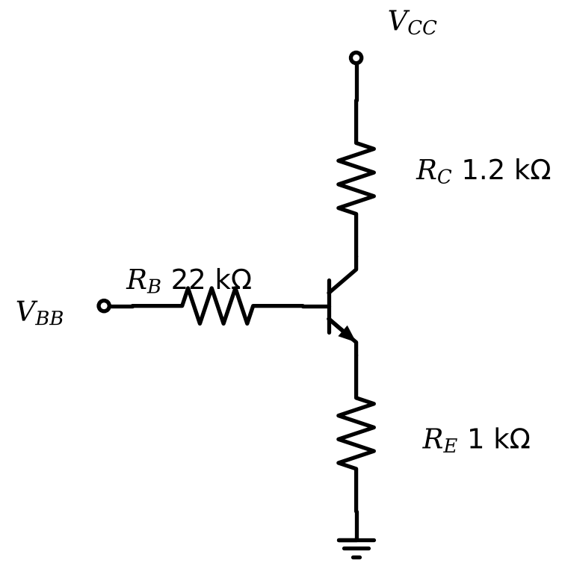
Figure 2.5.1 BJT biasing circuit 2 (with emitter resistor).
Table 2.5.1 Sensitivity of the two bias circuits to $β$ ($V_{BB}$ = 5 V, $V_{CC}$ = 12 V)
$β$ | Circuit 1: $I_{C}$ (mA) | Circuit 1: $V_{CE}$ (V) | Circuit 2: $I_{C}$ (mA) | Circuit 2: $V_{CE}$ (V)
120 | 3.50 | 4.29 | 3.68 | 3.88
170 | 4.96 | 1.08 | 3.86 | 3.49
220 | 5.36 | 0.200 (saturated) | 3.97 | 3.26

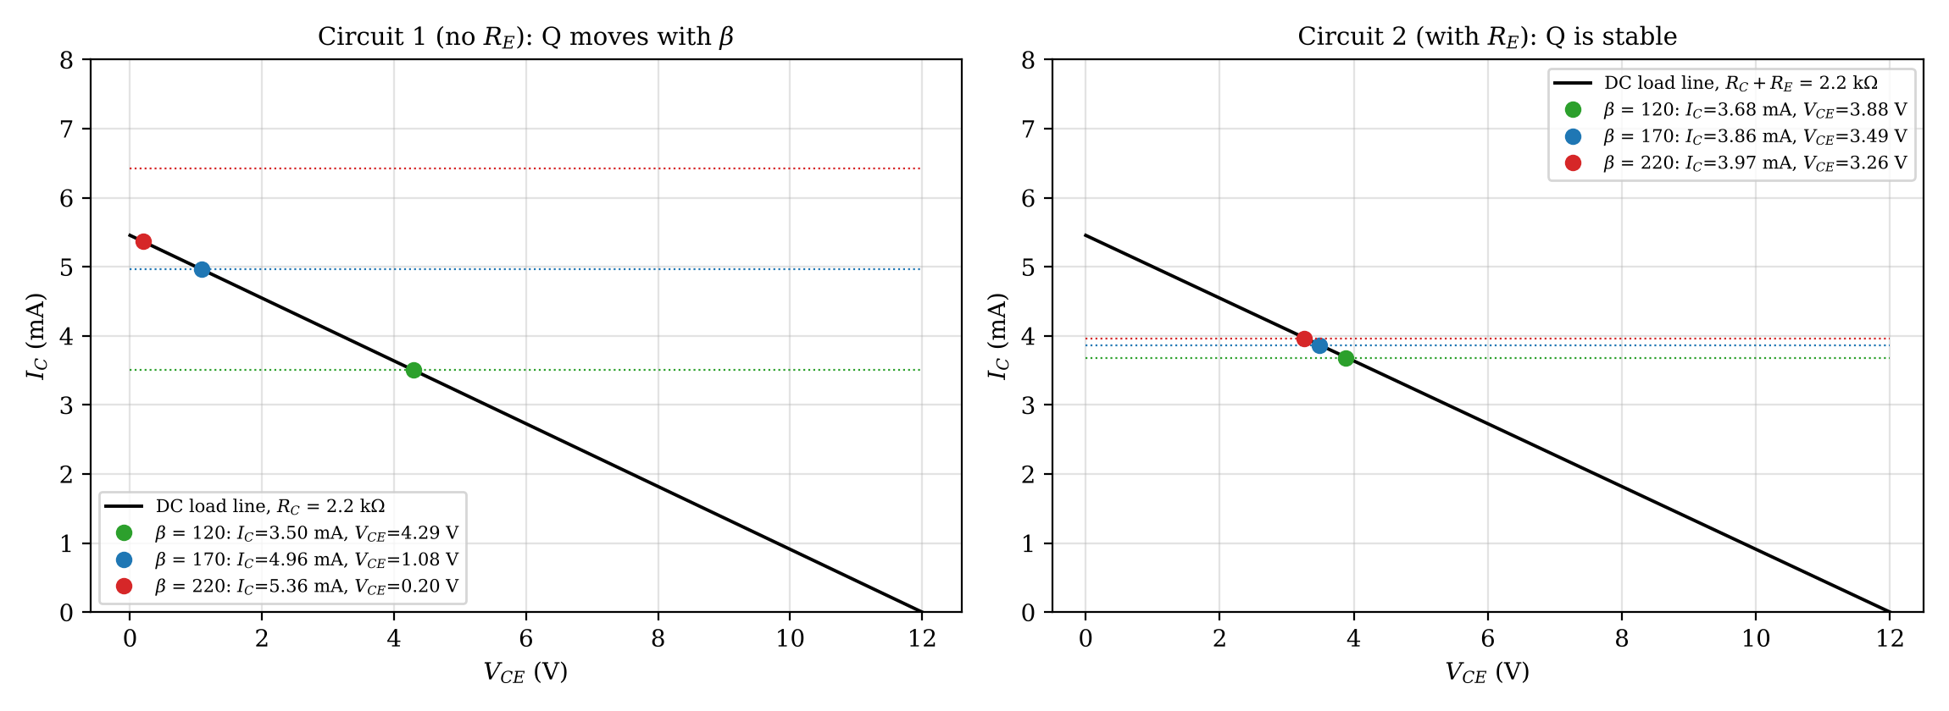
Figure 2.5.2 DC load lines and operating points of the two bias circuits for $β$ = 120, 170 and 220 (calculation).
In circuit 2, the emitter resistor provides negative feedback: if $I_{C}$ tries to increase, the voltage drop on $R_{E}$ increases, the base–emitter voltage decreases, and $I_{B}$ decreases. As Table 2.5.1 shows, a change of $β$ from 120 to 220 changes $I_{C}$ only from 3.68 to 3.97 mA (8%), whereas $I_{C}$ of circuit 1 changes by 37% and finally saturates. The operating point is stable because $\left(β+1\right)R_{E}=171$ k$Ω$ is large compared with $R_{B}$, so that $I_{C}≈\left(V_{BB}−V_{BE}\right)/R_{E}$ is almost independent of $β$.
2.6 Possible Reasons for Wrong $V_{CEQ}$ Readings
The reasons are listed item by item for biasing circuit 2 of Figure 2.5.1 (the correct value is $V_{CEQ}≈3.5$ V). The values in Table 2.6.1 were obtained from SPICE simulations of each fault.
Table 2.6.1 SPICE results of the fault conditions in BJT biasing circuit 2 ($V_{BB}$ = 5 V, $V_{CC}$ = 12 V)
Condition | $V_{CE}$ (V) | $V_{BE}$ (V) | $I_{C}$ (mA)
Normal operation (reference) | 3.52 | 0.638 | 3.84
$V_{BB}$ = 0 V (base supply missing) | 12.0 | 0 | 0
$R_{B}$ open (or base lead not inserted) | 12.0 | ≈ 0 (floating) | 0
Collector and emitter pins exchanged | 11.4 | 0.564 | 0.185
$R_{E}$ open (emitter floating) | 7.11 | 0.107 | 0
$R_{C}$ open (collector floating) | 0.0179 | 0.583 | 0
$V_{CC}$ = 0 V (collector supply missing) | 0.0107 | 0.576 | −0.0941
$R_{E}$ shorted by a wire | 0.121 | 0.668 | 9.90
$R_{C}$ = 12 k$Ω$ instead of 1.2 k$Ω$ | 0.0556 | 0.611 | 0.907
Collector–emitter short circuit | ≈ 0 | −0.455 | 5.45

If $V_{CEQ}$ is measured as 12 V, no current flows through $R_{C}$ and $R_{E}$ ($I_{C}≈0$), i.e., the transistor is in cut-off or the collector current path is broken. The possible reasons and the corresponding actions are:
• No base current: $V_{BB}$ is not applied or is 0 V (supply channel off, current limit at zero, ground wire not common). Action: measure $V_{B}$ with respect to ground; if it is 0 V, check the $V_{BB}$ channel and its wiring.
• Open $R_{B}$ or an unconnected base: a loose resistor leg, a hole in the wrong column, or a broken wire. Action: measure the voltage across $R_{B}$ (it should be about 0.5 V, i.e., $I_{B}R_{B}=22.7 μ\text{A}×22\text{ k}Ω$); if $V_{B}=V_{BB}$ and $V_{BE}≈0$, the base is connected but the emitter path is open; if the voltage at the base side is 0 V, the base is not connected.
• Transistor inserted incorrectly or damaged (open base–emitter junction): a wrong pin order places the base on a wrong column. Action: check the pin order of the part (C–B–E), measure $V_{BE}$ (it should be 0.6–0.7 V when the transistor conducts), and replace the transistor if the junction does not conduct.
• Exchanged collector and emitter pins: the transistor works in the inverse mode with a very small current gain, and $V_{CE}$ is close to 12 V (11.4 V in the simulation, with $V_{BE}≈0.56$ V and a small $I_{C}$). Action: exchange the two pins.
• A measurement error: the voltmeter is connected between $V_{CC}$ and a point instead of between collector and emitter, or $R_{E}$ is open (then $V_{CE}$ is not 12 V but 7.1 V in the simulation, and $V_{BE}≈0.1$ V, which distinguishes this case).
If $V_{CEQ}$ is measured as 0 V, the transistor is in deep saturation or there is a short circuit between the collector and the emitter. The possible reasons and the corresponding actions are:
• Excessive base drive or too large a collector resistor: $R_{E}$ shorted by a wire (0.121 V in the simulation, $I_{C}=9.9$ mA), or a wrong $R_{C}$ value such as 12 k$Ω$ (0.0556 V). Action: measure each resistor with an ohmmeter and compare with the colour code; remove the unintended wire.
• A short circuit between collector and emitter (a wire or a solder bridge on the breadboard, or a damaged transistor). In this case, $V_{BE}$ is typically negative or abnormal (−0.45 V in the simulation) and $I_{C}$ is about $V_{CC}/\left(R_{C}+R_{E}\right)=5.5$ mA. Action: remove the short, or replace the transistor if it is damaged.
• $V_{CC}$ is not applied (0 V): the supply channel is off or its wire is disconnected (0.0107 V in the simulation, with a small reverse current in $R_{C}$). Action: measure $V_{CC}$ at the top of $R_{C}$.
• $R_{C}$ is open or not connected to the collector: the collector floats and the forward-biased collector junction pulls it to the emitter voltage (0.0179 V in the simulation, $I_{C}=0$, $V_{BE}≈0.58$ V). Action: check the continuity of $R_{C}$ and the column of the collector.
• A measurement error, such as both probes on the same node or the ground lead of the voltmeter on a floating ground. Action: repeat the measurement with the probes directly on the collector and emitter pins.
In every case, the systematic approach is to measure $V_{B}$, $V_{E}$ and $V_{C}$ with respect to ground and to compare them with the expected values ($V_{B}≈4.50$ V, $V_{E}≈3.88$ V, $V_{C}≈7.37$ V) in order to find the first node where the measurement deviates.
3 CONCLUSIONS
The calculated and the simulated results of Table 1 agree well in the active region when the base drive is large ($V_{BB}=5$ V: the difference in $I_{C}$ is -0.1% and in $V_{CE}$ 0.00739 V), and the difference grows when the base drive is small ($V_{BB}=1$ V: +14.6% in $I_{C}$), because the constant $V_{BE\left(on\right)}=0.62$ V of the model is valid only near 2 mA. In the saturation region, the constant $V_{CE\left(sat\right)}=0.2$ V of the model is larger than the SPICE values (0.03–0.15 V), which is a limitation of the simple model rather than a calculation error. In the bias circuits, the circuit without $R_{E}$ has an operating point that depends strongly on $β$ (and even saturates for $β≥184$, which is inside the datasheet range of 120–220), whereas the circuit with $R_{E}$ changes its collector current by only about 8% over the same range, which is why emitter feedback is used in practical amplifiers. The fault analysis showed that $V_{CE}=12$ V and $V_{CE}=0$ V can each arise from several different faults, and that the additional measurements of $V_{BE}$ and the node voltages are necessary to separate them.
4 REFERENCES
1. Fairchild Semiconductor. (2002). BC237/238/239 NPN epitaxial silicon transistor [Data sheet, Rev. A2]. Retrieved October 11, 2026, from https://wmsc.lcsc.com/wmsc/upload/file/pdf/v2/lcsc/2309151357_onsemi-BC237_C3201628.pdf
2. Sedra, A. S., & Smith, K. C. (2014). Microelectronic circuits (7th ed.). New York: Oxford University Press.
3. ngspice. (n.d.). ngspice user manual. Retrieved October 11, 2026, from https://ngspice.sourceforge.io/docs.html
5 APPENDICES
5.1 Appendix A: SPICE Model and Netlists
The BC238A model was fitted to the datasheet typical values ($I_{S}$ for $V_{BE}=0.62$ V at 2 mA, $β_{F}=170$); $β_{R}=1$, $R_{B}=30 Ω$ and $R_{C}=1 Ω$ approximately reproduce the saturation voltages of the datasheet, and the Early voltage is infinite as required by the experiment sheet. The library model of the BC238 in another simulation program may differ slightly.
Code A.1 BJT model line used in the ngspice simulations
.model BC238A NPN(IS=7.7754e-14 BF=170 BR=1 RB=30 RC=1 CJE=8p CJC=3.5p TF=0.5n)

Netlist A.2 BJT circuit 1 ($V_{BB}$ = 5 V, $V_{CC}$ = 10 V)
Vbb vbb 0 DC 5
Vcc vcc 0 DC 10
RB vbb b 150000
RC vcc c 2200
RE e 0 1000
Q1 c b e BC238A
.model BC238A NPN(IS=7.7754e-14 BF=170 BR=1 RB=30 RC=1 CJE=8p CJC=3.5p TF=0.5n)

.op
.end

Netlist A.3 BJT biasing circuit 2
Vbb vbb 0 DC 5
Vcc vcc 0 DC 12
RB vbb b 22k
RC vcc c 1.2k
RE e 0 1k
Q1 c b e BC238A
.model BC238A NPN(IS=7.7754e-14 BF=170 BR=1 RB=30 RC=1 CJE=8p CJC=3.5p TF=0.5n)

.op
.end

