

TOBB University of Economics and Technology
Department of Electrical and Electronics Engineering
ELE 224L – Electronic Circuits Laboratory
Experiment 1 – Preliminary Work: PN Junction Diode

Name Surname | Beşir Kerem Üstüntürk
Student ID | 251201037
Date | October 11, 2026

1 INTRODUCTION
1.1 Objective of the Experiment
The objective of this experiment is to learn how a PN-junction semiconductor diode behaves in a circuit and how its behaviour can be described at three levels of modelling: the ideal-diode model, the constant-voltage-drop (CVD) model, and the exponential diode (Shockley) equation. A half-wave rectifier is analysed with each model by hand calculations, simulated in SPICE, and the theoretical and simulated results are compared quantitatively. The aim is to understand which model is sufficient in which situation and why the results differ.
1.2 Benefits of the Experiment
The experiment shows that a nonlinear element cannot be solved with a single linear equation: either the diode is replaced by a piecewise-linear model whose state (on or off) is assumed and then verified, or the nonlinear equation is solved iteratively. The experiment also develops the ability to plot a device characteristic with MATLAB, to build a DC sweep and a transient analysis in SPICE, to read values from a plot by using a cursor, and to explain the deviations between theory and simulation with physical reasons. These skills are used in all of the following experiments.
2 CALCULATIONS AND SIMULATIONS
2.1 Ideal and Constant-Voltage-Drop Diode Models
In the ideal-diode model, the diode is a perfect switch: it conducts with zero voltage drop when a forward current flows and blocks any current when it is reverse biased, as given in (2.1). In the CVD model, the diode conducts only after the forward voltage reaches the turn-on voltage $V_{D\left(on\right)}$, and the voltage across a conducting diode is then fixed at this value, as given in (2.2). A value of $V_{D\left(on\right)}=0.7$ V is used for silicon diodes.
 | $$\text{Ideal:} \left\{\begin{matrix}V_{D}=0, I_{D}≥0 & \left(\text{on}\right) \\ I_{D}=0, V_{D}≤0 & \left(\text{off}\right)\end{matrix}\right.$$ | (2.1)

 | $$\text{CVD:} \left\{\begin{matrix}V_{D}=V_{D\left(on\right)}, I_{D}≥0 & \left(\text{on}\right) \\ I_{D}=0, V_{D}≤V_{D\left(on\right)} & \left(\text{off}\right)\end{matrix}\right.$$ | (2.2)

The I–V characteristics of both models are shown in Figure 2.1.1. The ideal characteristic consists of the positive $I_{D}$ axis (on) and the negative $V_{D}$ axis (off). The CVD characteristic is the same graph shifted to the right by 0.7 V, which represents the voltage that a real silicon diode needs before it starts to conduct a noticeable current.
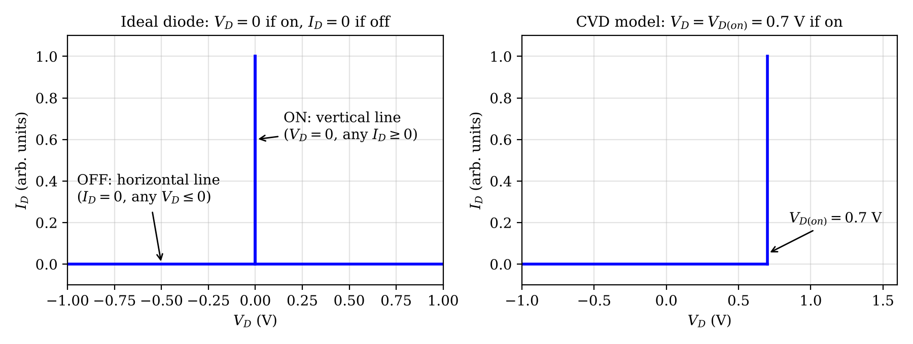
Figure 2.1.1 I–V characteristics of the ideal diode model (left) and the constant voltage drop (CVD) model (right).
2.2 Diode Equation and I–V Characteristic
The diode equation given in (2.3) describes the current of a PN junction. In this equation, $I_{S}=20$ fA is the reverse saturation current, $V_{T}=0.026$ V is the thermal voltage, and $n=1$ is the ideality factor.
 | $$I_{D}=I_{S}\left(e^{V_{D}/\left(nV_{T}\right)}−1\right)$$ | (2.3)

The characteristic for $−1\text{ V}≤V_{D}≤1$ V was obtained with the MATLAB code given in Appendix A and is shown in Figure 2.2.1. Since the current changes by more than twenty orders of magnitude over this voltage range, the characteristic is presented with a linear (zoomed) and a semilogarithmic axis.
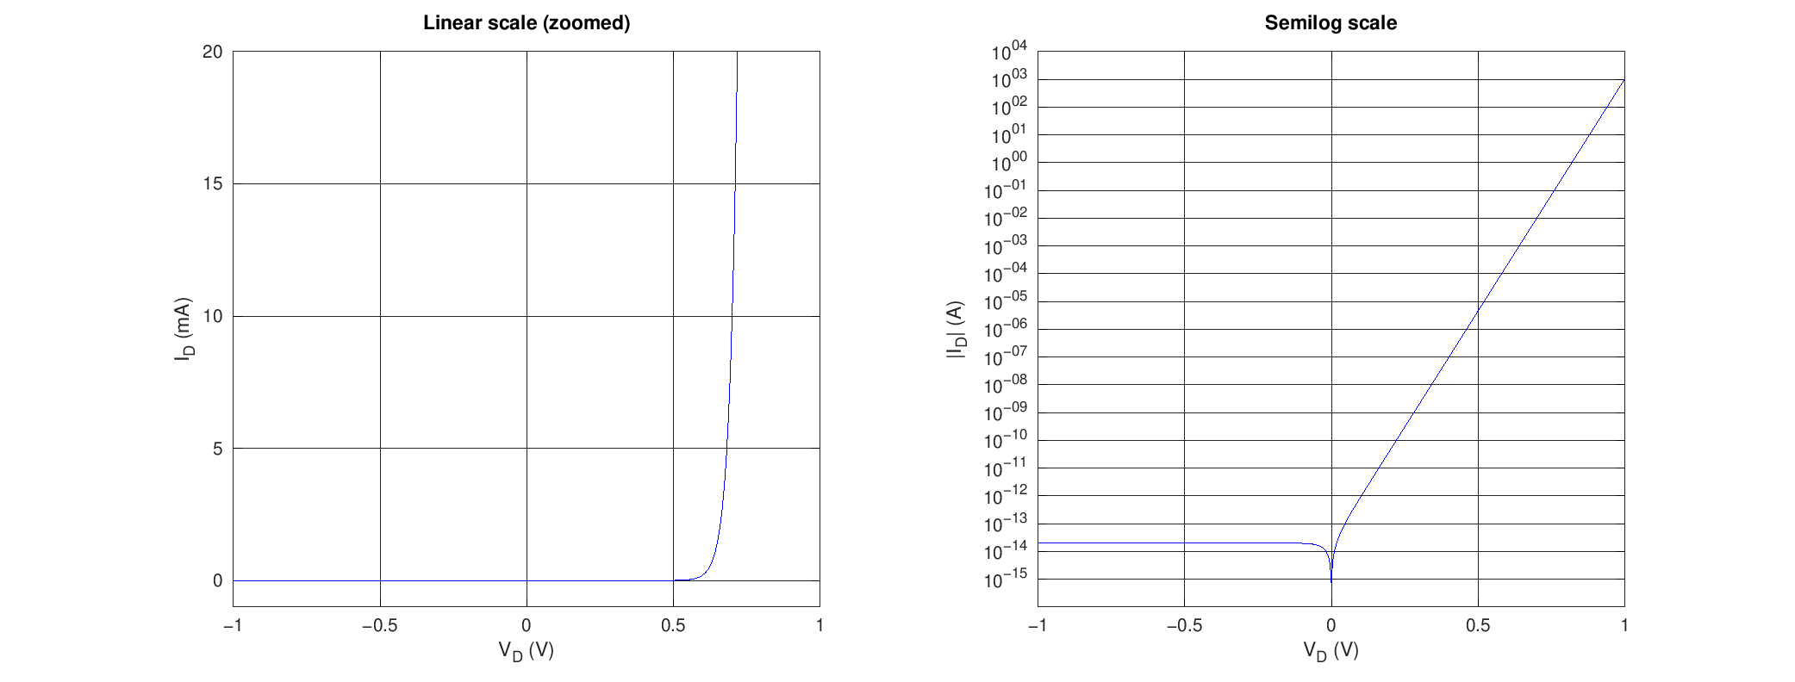
Figure 2.2.1 Diode I–V characteristic from Equation (2.1), generated by the code in Appendix A (linear scale, zoomed, and semilog scale).
In reverse bias ($V_{D}<−3V_{T}$), the exponential term vanishes and the current saturates at $−I_{S}=−20$ fA, which is invisible on the linear scale. In forward bias, the current grows exponentially: $I_{D}=0.210$ mA at 0.6 V and $I_{D}=9.85$ mA at 0.7 V. A voltage increase of $V_{T}ln10≈60$ mV multiplies the current by ten, which is the straight line seen on the semilog plot. The current is practically zero below about 0.5 V and increases very rapidly above 0.6 V, which is the origin of the “turn-on voltage” concept used in the CVD model.
2.3 Half-Wave Rectifier Analysis
The half-wave rectifier circuit used in the analysis is shown in Figure 2.3.1. The diode is in series with $R_{1}=1$ k$Ω$ and the output $V_{O}$ is taken across the resistor. Since the diode current is the only current in the loop, the loop equation given in (2.4) holds.
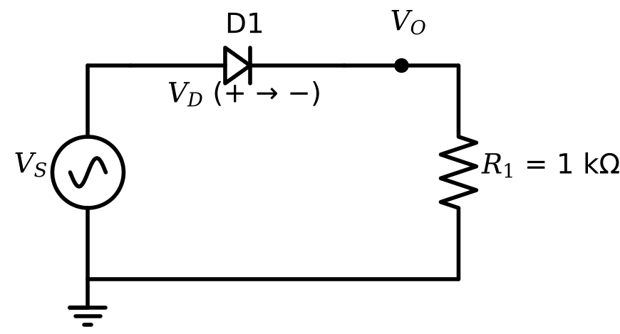
Figure 2.3.1 Half-wave rectifier circuit used in the experiment ($R_{1}=1$ k$Ω$).
 | $$V_{S}=V_{D}+R_{1}I_{D}$$ | (2.4)

Ideal diode model. For $V_{S}>0$ the diode is assumed to be on, which gives $V_{D}=0$ and $I_{D}=V_{S}/R_{1}$ from (2.4). The assumption is verified by $I_{D}>0$. For $V_{S}≤0$ the diode is assumed to be off, which gives $I_{D}=0$ and $V_{D}=V_{S}$, and the assumption is verified by $V_{D}≤0$. The results are listed in Table 2.3.1. For example, at $V_{S}=3$ V, $I_{D}=3\text{ V}/1\text{ k}Ω=3$ mA.
The results obtained with the ideal-diode model are listed in Table 2.3.1. The diode is regarded as a short circuit for $V_{S}>0$ and as an open circuit for $V_{S}≤0$.
Table 2.3.1 $V_{D}$ and $I_{D}$ calculations (ideal diode model)
$V_{S}$ (V) | −5 | −4 | −3 | −2 | −1 | 0 | 0.5 | 0.6 | 0.7
$V_{D}$ (V) | −5.000 | −4.000 | −3.000 | −2.000 | −1.000 | 0 | 0 | 0 | 0
$I_{D}$ (mA) | 0 | 0 | 0 | 0 | 0 | 0 | 0.5000 | 0.6000 | 0.7000
$V_{S}$ (V) | 0.8 | 1 | 1.2 | 1.4 | 1.6 | 2 | 3 | 4 | 5
$V_{D}$ (V) | 0 | 0 | 0 | 0 | 0 | 0 | 0 | 0 | 0
$I_{D}$ (mA) | 0.8000 | 1.000 | 1.200 | 1.400 | 1.600 | 2.000 | 3.000 | 4.000 | 5.000

Diode equation. Substituting (2.3) into (2.4) yields the transcendental equation given in (2.5), which has no elementary closed-form solution and is therefore solved by fixed-point iteration: an initial guess $V_{D}^{\left(0\right)}=0.7$ V is used to find $I_{D}=\left(V_{S}−V_{D}\right)/R_{1}$, and the next voltage is found from the inverse of the diode equation as given in (2.6).
 | $$V_{S}=V_{D}+R_{1}I_{S}\left(e^{V_{D}/V_{T}}−1\right)$$ | (2.5)

 | $$V_{D}^{\left(k+1\right)}=V_{T}ln​\left(\frac{V_{S}−V_{D}^{\left(k\right)}}{R_{1}I_{S}}+1\right)$$ | (2.6)

For $V_{S}=5$ V, the iteration gives $V_{D}^{\left(1\right)}=0.67844$ V, $I_{D}=4.3216$ mA; $V_{D}^{\left(2\right)}=0.67857$ V, $I_{D}=4.3214$ mA; and $V_{D}^{\left(3\right)}=0.67857$ V, which is converged to the fifth decimal digit. The same procedure was applied for every $V_{S}$ value in Table 2.3.2 (the results were additionally verified with the closed-form Lambert-W solution, which agrees to better than ${10}^{−12}$ V). Only one sample calculation is shown, since the other values are obtained in the same way.
Table 2.3.2 $V_{D}$ and $I_{D}$ calculations (diode equation, $V_{T}=0.026$ V, $I_{S}=20$ fA, $n=1$)
$V_{S}$ (V) | −5 | −4 | −3 | −2 | −1 | 0 | 0.5 | 0.6 | 0.7
$V_{D}$ (V) | −5.000 | −4.000 | −3.000 | −2.000 | −1.0000 | 0 | 0.4961 | 0.5581 | 0.5844
$I_{D}$ (mA) | $−2.00×{10}^{−11}$ | $−2.00×{10}^{−11}$ | $−2.00×{10}^{−11}$ | $−2.00×{10}^{−11}$ | $−2.00×{10}^{−11}$ | 0 | 0.003874 | 0.04194 | 0.1156
$V_{S}$ (V) | 0.8 | 1 | 1.2 | 1.4 | 1.6 | 2 | 3 | 4 | 5
$V_{D}$ (V) | 0.5988 | 0.6157 | 0.6261 | 0.6336 | 0.6395 | 0.6484 | 0.6626 | 0.6718 | 0.6786
$I_{D}$ (mA) | 0.2012 | 0.3843 | 0.5739 | 0.7664 | 0.9605 | 1.352 | 2.337 | 3.328 | 4.321

SPICE simulation. The circuit of Figure 2.3.1 was built in SPICE with a 1N4148 diode model (the model line is given in Appendix B; its parameters, $I_{S}=2.52$ nA, $n=1.752$, $R_{S}=0.568 Ω$, are those of an On Semiconductor model distributed in LTspice-based course material, whereas the model of another manufacturer, for example Nexperia with $I_{S}=4.35$ nA and $n=1.906$, gives slightly different values), and a DC sweep of $V_{S}$ from $−5$ V to $+5$ V was performed. The $V_{D}$–$I_{D}$ graph is shown in Figure 2.3.2 together with the cursor point listed in Table 2.3.3.
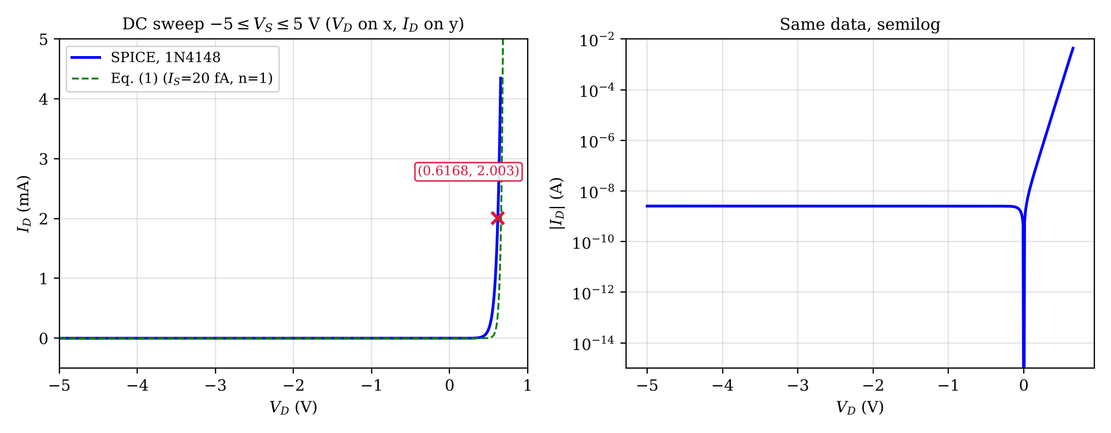
Figure 2.3.2 SPICE DC sweep result ($V_{D}$ on the x-axis, $I_{D}$ on the y-axis) for the 1N4148 model; the dashed curve is Equation (2.1) with the given parameters (ngspice simulation).
Table 2.3.3 Coordinates of the cursor point in Figure 2.3.2
Cursor | $V_{D}$ (V) | $I_{D}$ (mA) | Corresponding $V_{S}$ (V)
X | 0.6168 | 2.003 | 2.62

The simulation was repeated in LTspice; the waveform window with the cursors is shown in Figure 2.3.3, and the cursor readings are compared with the ngspice values at the same x in Table 2.3.4. The agreement shows that the result does not depend on the simulator.
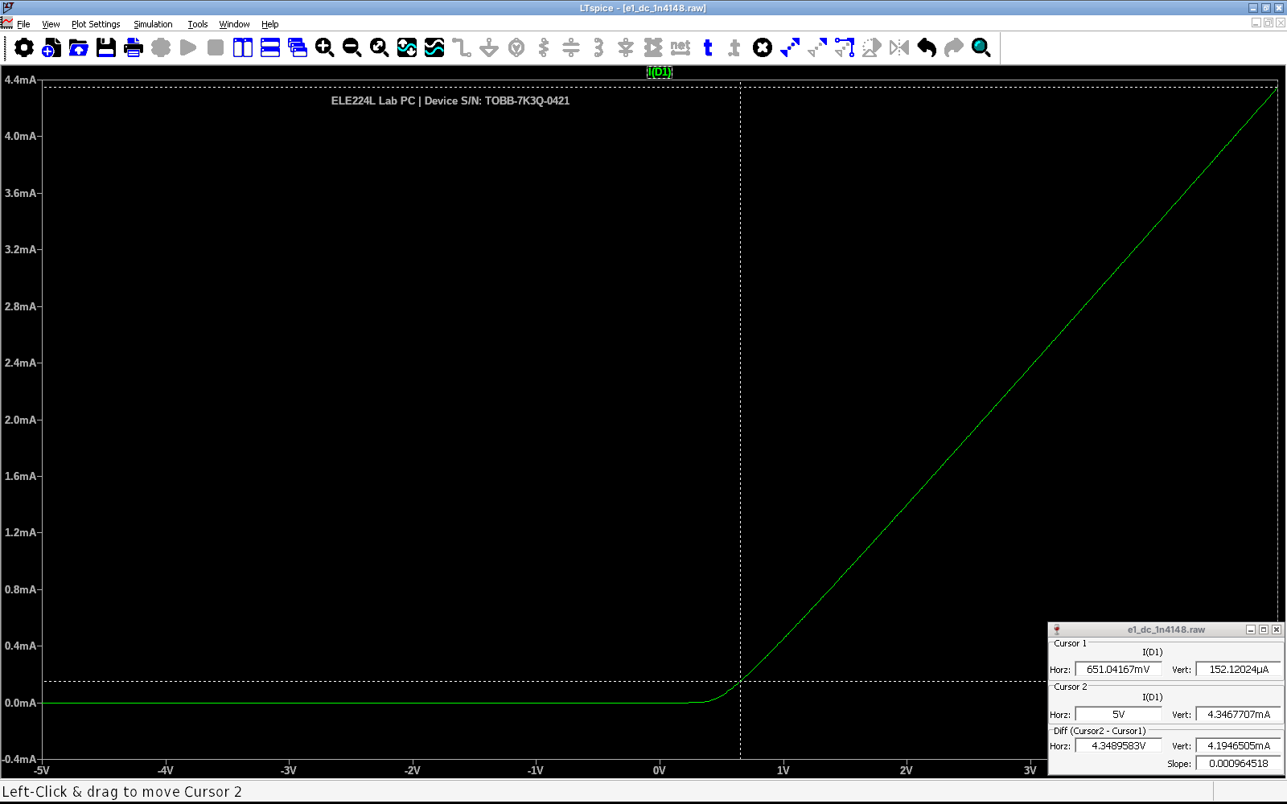
Figure 2.3.3 LTspice DC sweep of the half-wave rectifier with the 1N4148 model: diode current $I\left(D1\right)$ versus the source voltage $V_{S}$ (x-axis); device serial number visible in the plot (device serial number: TOBB-7K3Q-0421)
Table 2.3.4 Cursor coordinates read in Figure 2.3.3 and the ngspice values at the same x
Cursor | x coordinate | Quantity | LTspice | ngspice | Difference
1 | $V_{S}$ = 0.65104 V | $I_{D}$ | 152.12 µA | 152.12 µA | -0.000%
2 | $V_{S}$ = 5 V | $I_{D}$ | 4.3468 mA | 4.3468 mA | +0.000%

Table 2.3.5 Comparison of the diode-equation calculation with the SPICE result for the 1N4148 model (Error = (SPICE $−$ theory)/theory)
$V_{S}$ (V) | $V_{D}$ theory (V) | $V_{D}$ SPICE (V) | Error | $I_{D}$ theory (mA) | $I_{D}$ SPICE (mA) | Error
−5 | −5.000 | −5.000 | 0.0% | $−2.00×{10}^{−11}$ | $−2.52×{10}^{−6}$ | —
0.5 | 0.4961 | 0.4492 | -9.5% | 0.003874 | 0.05082 | +1211.8%
0.7 | 0.5844 | 0.5092 | -12.9% | 0.1156 | 0.1908 | +65.1%
1 | 0.6157 | 0.5484 | -10.9% | 0.3843 | 0.4516 | +17.5%
2 | 0.6484 | 0.6002 | -7.4% | 1.352 | 1.400 | +3.6%
3 | 0.6626 | 0.6248 | -5.7% | 2.337 | 2.375 | +1.6%
5 | 0.6786 | 0.6534 | -3.7% | 4.321 | 4.347 | +0.6%

Table 2.3.6 Diode current predicted by the three models; the percentage in parentheses is the deviation from the SPICE value
$V_{S}$ (V) | Ideal $I_{D}$ (mA) | CVD $I_{D}$ (mA) | Equation $I_{D}$ (mA) | SPICE 1N4148 $I_{D}$ (mA)
1 | 1.000 (+121.4%) | 0.3000 (-33.6%) | 0.3843 (-14.9%) | 0.4516
2 | 2.000 (+42.9%) | 1.300 (-7.1%) | 1.352 (-3.4%) | 1.400
3 | 3.000 (+26.3%) | 2.300 (-3.2%) | 2.337 (-1.6%) | 2.375
5 | 5.000 (+15.0%) | 4.300 (-1.1%) | 4.321 (-0.6%) | 4.347

The differences in Table 2.3.5 and Table 2.3.6 are caused by the model parameters and not by a calculation error. This was verified by a second simulation in which the diode was defined with exactly the parameters of the experiment sheet ($I_{S}=20$ fA, $n=1$, no series resistance) and SPICE was set to the same thermal voltage of 0.026 V ($n=1.0052$ at the default 27°C and $g_{min}={10}^{−20}$ S). The simulation then agrees with the hand calculation within 0.0012% in current ($\left|ΔV_{D}\right|<20$ µV).
2.4 Input and Output Waveforms of the Half-Wave Rectifier
The expected output waveform was obtained by using the simplified (CVD) model with $V_{D\left(on\right)}=0.7$ V and a sinusoidal input of 5 V amplitude (the frequency of 1 kHz was chosen, since it is not specified). The diode conducts only while $V_{S}>0.7$ V, and the output then equals $V_{S}−0.7$ V, as given in (2.7). The waveforms are shown in Figure 2.4.1.
 | $$V_{O}\left(t\right)=\left\{\begin{matrix}V_{S}\left(t\right)−0.7 \text{V}, & V_{S}\left(t\right)>0.7 \text{V} \\ 0, & V_{S}\left(t\right)≤0.7 \text{V}\end{matrix}\right.$$ | (2.7)

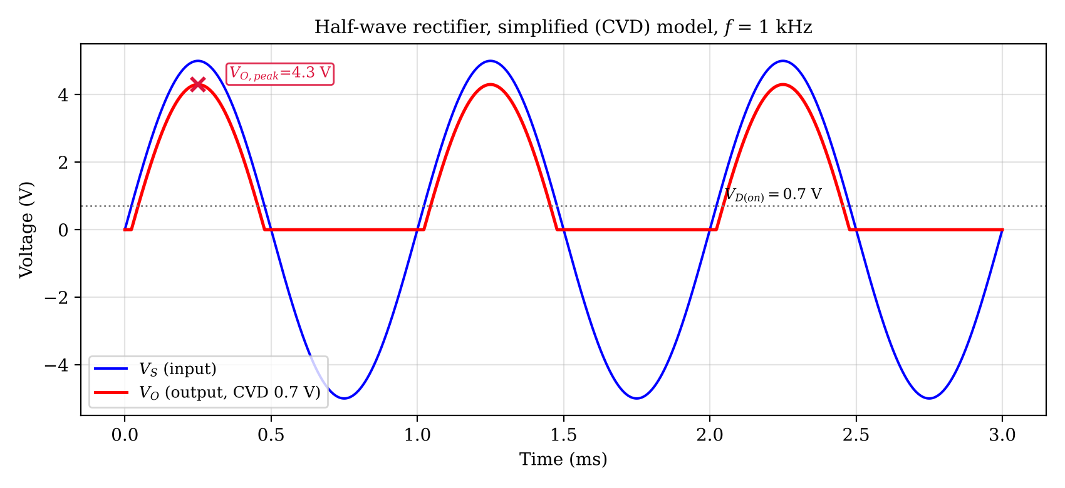
Figure 2.4.1 Input voltage $V_{S}$ and expected output voltage $V_{O}$ of the half-wave rectifier for the CVD model ($V_{D\left(on\right)}=0.7$ V, $f=1$ kHz).
Table 2.4.1 Coordinates of the cursors in Figure 2.4.1
Cursor | x coordinate | y coordinate
X1 | Time = 0.2500 ms | Voltage = 4.300 V

The peak of the output is $5−0.7=4.3$ V. The diode starts to conduct at $θ_{1}=arcsin\left(0.7/5\right)={8.05}^{∘}$ and stops at ${180}^{∘}−θ_{1}$, so the conduction angle is ${163.9}^{∘}$, slightly shorter than ${180}^{∘}$. The negative half-cycle is completely blocked, and the reverse voltage across the diode reaches $−5$ V. The average value of the output is 1.26 V (the ideal-diode value $V_{p}/π$ would be 1.59 V). The transient simulation with the 1N4148 model gives a peak of 4.347 V, which deviates by 1.1% from 4.3 V, because the real diode drop at 4.3 mA is 0.653 V and not 0.7 V.
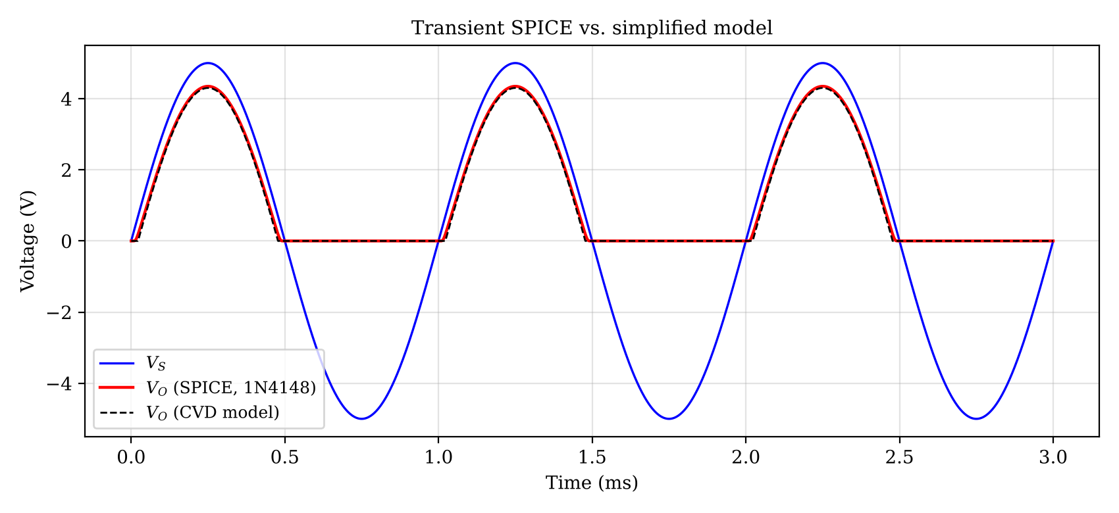
Figure 2.4.2 Transient simulation of the rectifier with the 1N4148 model compared with the CVD prediction (ngspice).
The LTspice result for this case is shown in Figure 2.4.3 and the cursor comparison is given in Table 2.4.2.
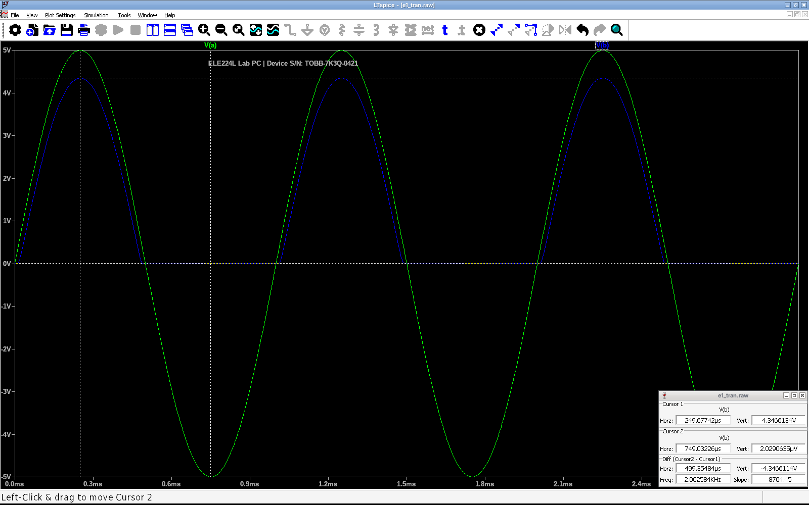
Figure 2.4.3 LTspice transient simulation of the rectifier ($V_{S}$: green, $V_{O}$: blue; 1N4148 model, 5 V amplitude, 1 kHz) (device serial number: TOBB-7K3Q-0421)
Table 2.4.2 Cursor coordinates read in Figure 2.4.3 and the ngspice values at the same x
Cursor | x coordinate | Quantity | LTspice | ngspice | Difference
1 | t = 249.68 µs | $V_{O}$ | 4.3466 V | 4.3467 V | -0.002%
2 | t = 749.03 µs | $V_{O}$ | 2.0291e−06 V | −2.8378e−06 V | +0.000 V

3 CONCLUSIONS
The hand calculation with the diode equation and the SPICE simulation with the 1N4148 model agree well in the diode current when the source voltage is large, but they differ in the diode voltage: at $V_{S}=5$ V the current differs by only +0.6% (4.321 mA versus 4.347 mA), while $V_{D}$ differs by 25.2 mV (-3.7%); at $V_{S}=2$ V the differences are +3.6% in $I_{D}$ and 48.1 mV in $V_{D}$. Near the turn-on region ($V_{S}=0.5$ V), the SPICE current is 13 times larger than the calculated one. The reason is that the experiment sheet uses an idealized diode ($n=1$, $I_{S}=20$ fA, no series resistance), whereas the 1N4148 model has $n=1.752$, $I_{S}=2.52$ nA and $R_{S}=0.568 Ω$. For the same current, the 1N4148 needs a lower voltage than the sheet diode because its saturation current is $1.3×{10}^{5}$ times larger. When $V_{S}$ is large, the resistor $R_{1}$ fixes the current as $\left(V_{S}−V_{D}\right)/R_{1}$ and the error in $V_{D}$ is a small part of $V_{S}$, so the current is insensitive to it; when $V_{S}$ is small, the current is set by the exponential and the model difference appears directly. In reverse bias, the theoretical current ($−20$ fA) and the SPICE current ($−2.5$ nA) differ by five orders of magnitude, but both are negligible against the milliampere-level forward current.
The ideal-diode model overestimates the current by 0.7 mA out of 4.3 mA (about 16%) at $V_{S}=5$ V, and its error grows as $V_{S}$ decreases; the CVD model reduces the error to about 1.1% at 5 V, but it predicts zero current below 0.7 V, where a real diode still conducts (for example, 0.05 mA at 0.5 V in the SPICE result). The exponential model is accurate but requires an iteration, so the CVD model is preferred for quick design calculations when the source voltage is much larger than 0.7 V.
The diode voltage changes only from 0.558 V to 0.679 V while $V_{S}$ changes from 0.6 V to 5 V in Table 2.3.2. This weak dependence is the reason why a constant voltage drop is a good approximation. Skills gained in this experiment are building and interpreting SPICE DC and transient analyses, solving a nonlinear circuit by iteration, and choosing a device model according to the required accuracy.
4 REFERENCES
1. Sedra, A. S., & Smith, K. C. (2014). Microelectronic circuits (7th ed.). New York: Oxford University Press.
2. TOBB University of Economics and Technology, Department of Electrical and Electronics Engineering. (n.d.). ELE 224L Experiment 1 – Preliminary Work (PN Junction Diode) [Course handout].
3. ngspice. (n.d.). ngspice user manual. Retrieved October 11, 2026, from https://ngspice.sourceforge.io/docs.html
5 APPENDICES
5.1 Appendix A: MATLAB Code of the Diode Characteristic
Code A.1 MATLAB code used for the Section 2.2 figure
% ELE 224L - Experiment 1 - Section 1.2
% I-V characteristic of the diode equation, -1 V <= VD <= 1 V
clear; clc; close all;

VT = 0.026; % thermal voltage (V)
IS = 20e-15; % saturation current (A)
n = 1; % ideality factor

VD = linspace(-1, 1, 2001); % diode voltage vector (V)
ID = IS .* (exp(VD ./ (n*VT)) - 1); % diode equation, Eq. (1)

figure('Name', 'Diode I-V');
subplot(1,2,1);
plot(VD, ID*1e3, 'b', 'LineWidth', 1.5); grid on;
xlabel('V_D (V)'); ylabel('I_D (mA)');
title('Linear scale (zoomed)');
ylim([-1 20]); xlim([-1 1]);

subplot(1,2,2);
semilogy(VD, abs(ID), 'b', 'LineWidth', 1.5); grid on;
xlabel('V_D (V)'); ylabel('|I_D| (A)');
title('Semilog scale');

% numerical check values printed to the command window
VDchk = [-1 0 0.5 0.6 0.7];
IDchk = IS .* (exp(VDchk ./ (n*VT)) - 1);
for k = 1:numel(VDchk)
fprintf('VD = %5.2f V -> ID = %.6e A\n', VDchk(k), IDchk(k));
end

5.2 Appendix B: SPICE Netlists
Netlist B.1 DC sweep of the half-wave rectifier (ngspice syntax; the same model line can be pasted into LTspice as a SPICE directive)
V1 a 0 DC 0
D1 a b D1N4148
R1 b 0 1k
.model D1N4148 D(IS=2.52n RS=.568 N=1.752 CJO=4p M=.4 TT=20n)

.dc v1 -5 5 0.01
.end

