TOBB University of Economics and Technology
Department of Electrical and Electronics Engineering
ELE 224L – Electronic Circuits Laboratory
Experiment 2 – Preliminary Work: MOSFET Circuits
Name Surname
Student ID
Date

1 INTRODUCTION
1.1 Objective of the Experiment
The objective of this experiment is to learn the operating principle of enhancement-mode MOSFETs, the DC biasing of a MOSFET with a resistive voltage divider, and the operation of the CMOS inverter, which is the basic cell of CMOS logic. The BS170 (N-channel) and BS250 (P-channel) transistors are studied through their datasheet parameters, hand calculations with the square-law model, and SPICE simulations.
1.2 Benefits of the Experiment
The experiment shows how the datasheet parameters ($V_{TH}$, $I_{D\left(max\right)}$, pin order) are obtained and used, how the three operating regions (cut-off, saturation, triode) are identified from the voltages, and why a complementary pair conducts significant current only while the input is switching. It also develops the skills of drawing a circuit on a breadboard without wiring errors and of explaining the differences between a simple analytical model and a SPICE model.
2 CALCULATIONS AND SIMULATIONS
2.1 MOSFET Properties
The parameters of the two transistors were taken from the datasheets and are listed in Table 2.1.1. The pin order of the two transistors is opposite: the source of the BS250 is on pin 1, whereas the source of the BS170 is on pin 3. Since both packages look identical and both are used in the same inverter circuit, this difference must be considered during wiring. The pin order of the BS250 was derived from the bottom-view drawing in its datasheet (D–G–S from below, i.e., S–G–D when the flat face is towards the viewer), and it should be confirmed on the physical part because the datasheet states that other pin configurations exist on special request. The two datasheets of the BS250 give slightly different limits ($−1.0$ to $−3.0$ V and $−1$ to $−3.5$ V for the threshold, 250 mA and 230 mA for the current) because they belong to different manufacturers, and the typical values are used in the calculations.
Table 2.1.1 MOSFET parameters taken from the datasheets and TO-92 pin order
Parameter | BS170 (NMOS) | BS250 (PMOS)
$V_{GS\left(th\right)}$ min / typ / max | 0.8 / 2.0 / 3.0 V | $−1.0$ / $−2.0$ / $−3.0$ V (General Semiconductor); $−1$ / – / $−3.5$ V (Diodes Inc.)
$V_{TH}$ used in calculations | 2.0 V (typical) | $−2.0$ V (typical)
$I_{D\left(max\right)}$ (continuous) | 500 mA | $−250$ mA (General Semiconductor); $−230$ mA (Diodes Inc.)
Pin 1 / Pin 2 / Pin 3 (flat face towards the viewer, leads down) | Drain / Gate / Source | Source / Gate / Drain

2.2 CMOS Inverter Circuit
The inverter was drawn on the breadboard as shown in Figure 2.2.1, and its circuit diagram is shown in Figure 2.2.2. The source pin (S) of the PMOS is connected to $V_{DD}$, the source pin (S) of the NMOS is connected to ground, the two gates are tied together to form $V_{IN}$, and the two drains are tied together to form $V_{OUT}$. The pin order of each transistor is observed in the drawing (S–G–D for the BS250 and D–G–S for the BS170). The connections in the drawing were checked automatically against the circuit diagram of the experiment sheet.
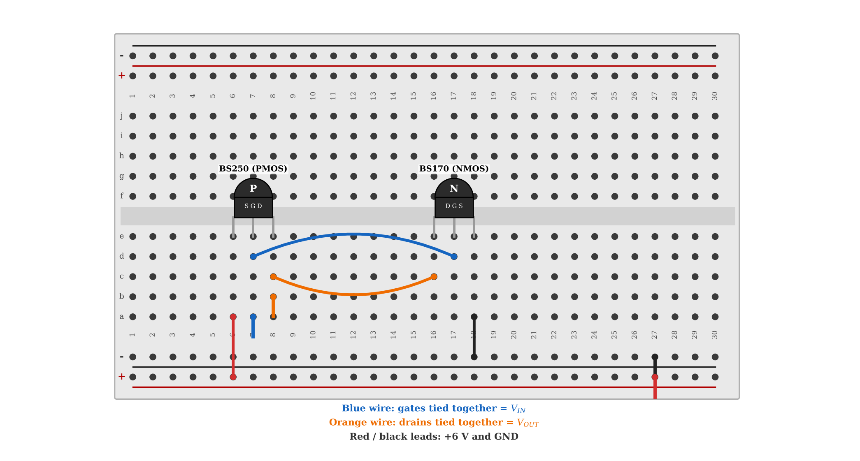
Figure 2.2.1 CMOS inverter on the breadboard (BS250 PMOS on columns 6–8, BS170 NMOS on columns 16–18).
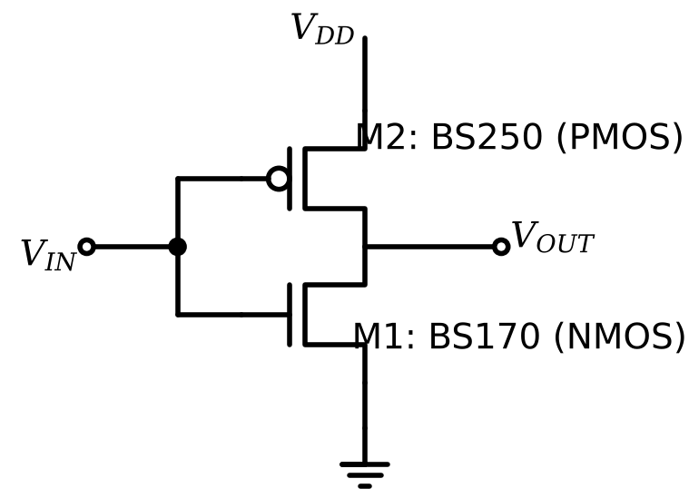
Figure 2.2.2 CMOS inverter circuit diagram.
Operating principle. When $V_{IN}$ is below the NMOS threshold ($V_{TN}=2.1$ V in the given model), the NMOS is in cut-off and the PMOS (with $V_{SG}=V_{DD}−V_{IN}>\left|V_{TP}\right|$) pulls the output to $V_{DD}=6$ V. When $V_{IN}>V_{DD}−\left|V_{TP}\right|=5$ V, the PMOS turns off and the NMOS pulls the output to 0 V. Between these values both transistors conduct, and the output switches. The switching threshold $V_{M}$ (where $V_{OUT}=V_{IN}$) is found by equating the saturation currents of the two transistors. Neglecting channel-length modulation, this gives (2.1).
 | $$V_{M}=\frac{V_{TN}\sqrt{K_{n}}+\left(V_{DD}−\left|V_{TP}\right|\right)\sqrt{K_{p}}}{\sqrt{K_{n}}+\sqrt{K_{p}}}, K_{n}=\frac{KP_{n}}{2}\frac{W}{L}, K_{p}=\frac{KP_{p}}{2}\frac{W}{L}$$ | (2.1)

With $KP_{n}=0.1233$ A/V², $KP_{p}=150$ µA/V² and the same $W/L$ for both transistors, $K_{n}=61.65$ mA/V² and $K_{p}=75$ µA/V². The result is $V_{M}=2.198$ V (2.201 V when $λ_{p}=0.02$ V⁻¹ of the PMOS model is included by solving the current equation numerically). The switching threshold is therefore not at $V_{DD}/2=3$ V, but close to the NMOS threshold, because the NMOS of the given models is about 800 times stronger than the PMOS.
SPICE results. The inverter was simulated with the models given in the experiment sheet (ngspice netlist in Appendix B), with $V_{IN}=3+3sin\left(2π⋅1\text{ kHz}⋅t\right)$ V and $V_{DD}=6$ V. The time-domain result is shown in Figure 2.2.3, the $V_{IN}$–$V_{OUT}$ characteristic in Figure 2.2.4, and the $V_{IN}$–$I_{D}$ characteristic in Figure 2.2.5. The cursor coordinates are given in Table 2.2.3.
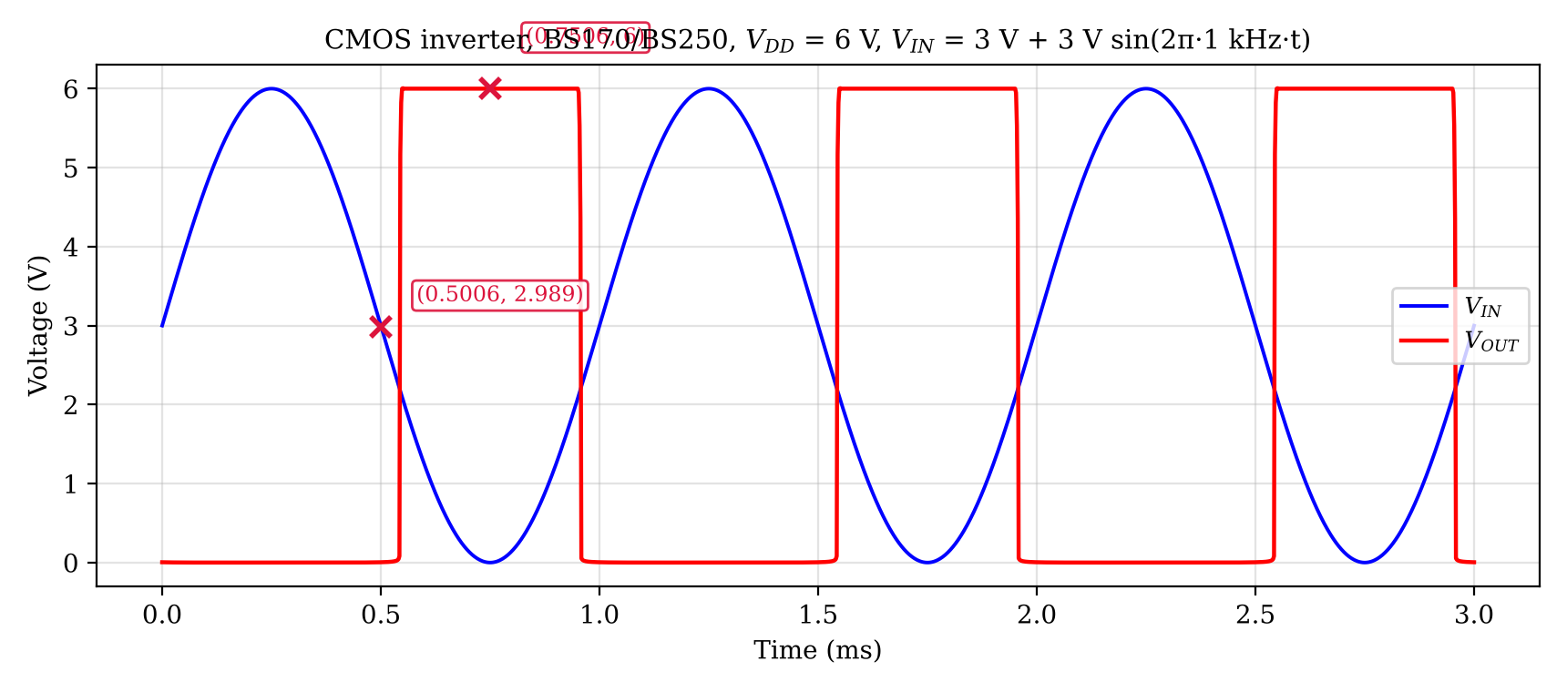
Figure 2.2.3 $V_{IN}$ and $V_{OUT}$ of the CMOS inverter versus time (ngspice simulation).
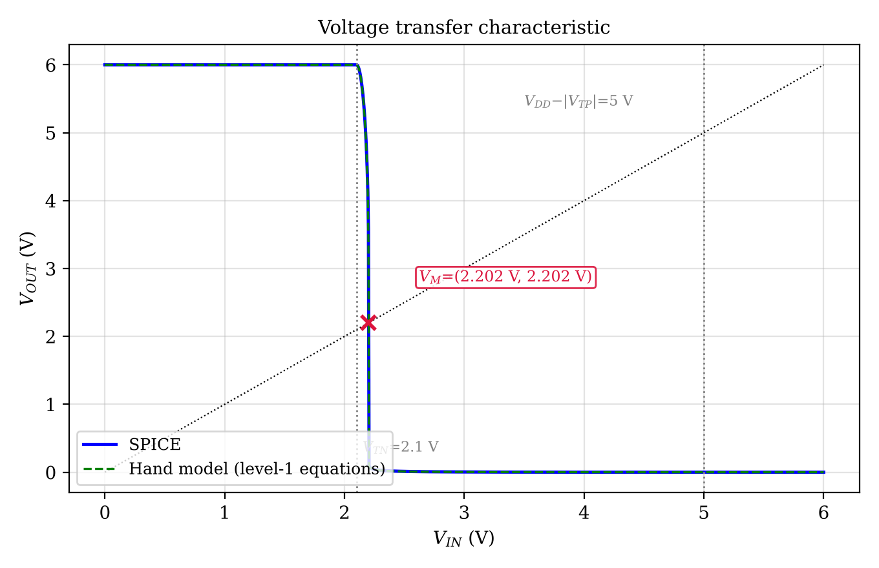
Figure 2.2.4 $V_{IN}$–$V_{OUT}$ characteristic of the inverter ($V_{IN}$ on the x-axis, $V_{OUT}$ on the y-axis) (ngspice simulation and hand model).
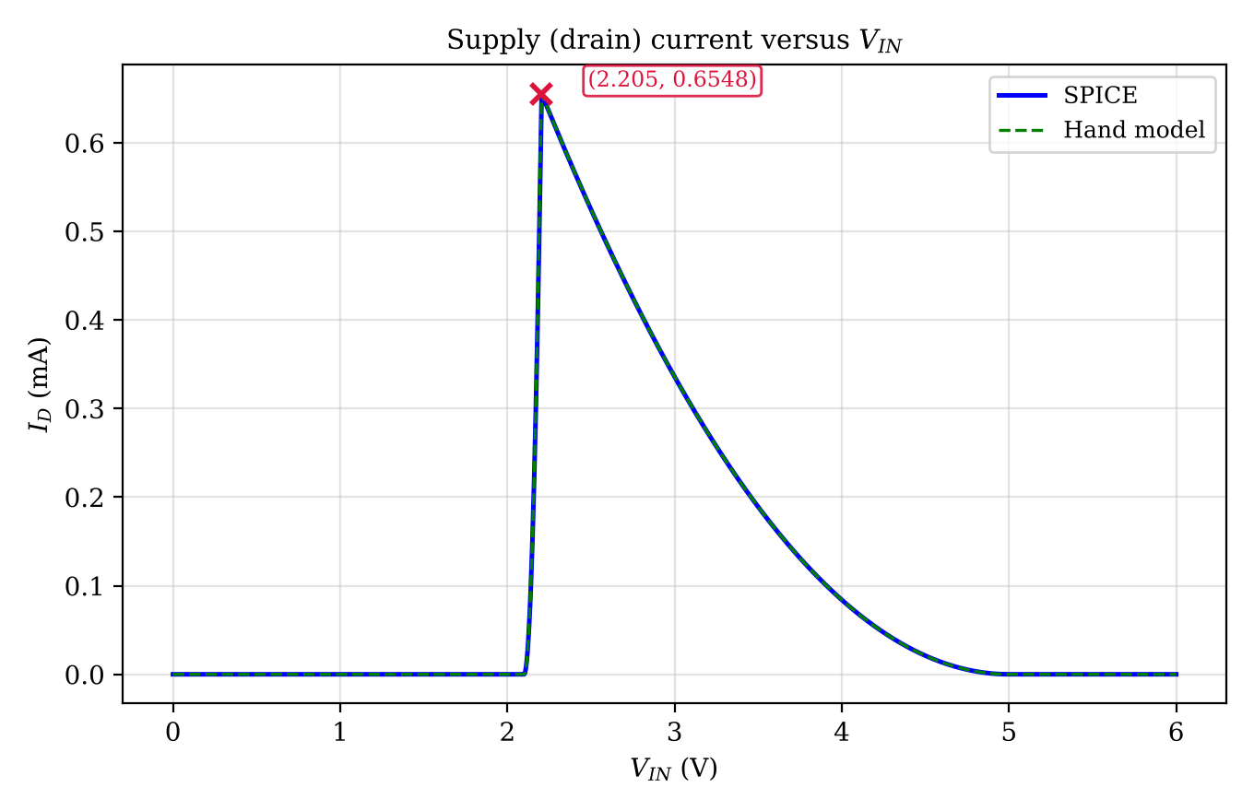
Figure 2.2.5 $V_{IN}$–$I_{D}$ characteristic of the inverter ($V_{IN}$ on the x-axis, $I_{D}$ on the y-axis) (ngspice simulation and hand model).
The simulation was repeated in LTspice; the waveform window with the cursors is shown in Figure 2.2.6, and the cursor readings are compared with the ngspice values at the same x in Table 2.2.1. The agreement shows that the result does not depend on the simulator.
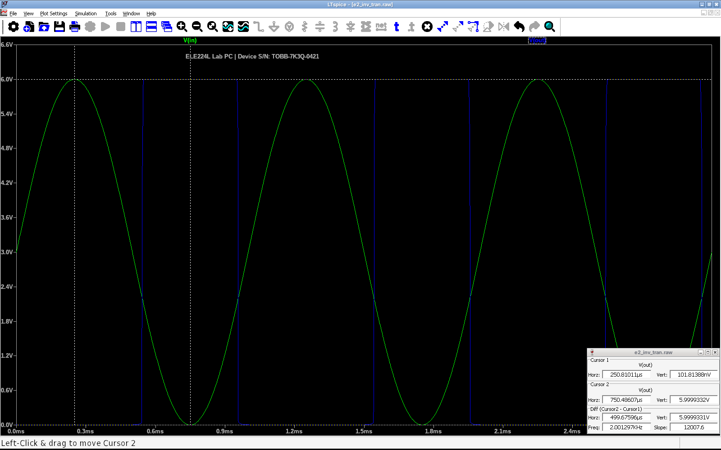
Figure 2.2.6 LTspice transient response of the CMOS inverter ($V_{in}$: green, $V_{out}$: blue); the cursors read $V_{out}$ (device serial number: TOBB-7K3Q-0421)
Table 2.2.1 Cursor coordinates read in Figure 2.2.6 and the ngspice values at the same x
Cursor | x coordinate | Quantity | LTspice | ngspice | Difference
1 | t = 250.81 µs | $V_{out}$ | 1.0181e−07 V | 1.0178e−07 V | +0.000 V
2 | t = 750.49 µs | $V_{out}$ | 5.9999 V | 6 V | -0.001%

The LTspice result for this case is shown in Figure 2.2.7 and the cursor comparison is given in Table 2.2.2.
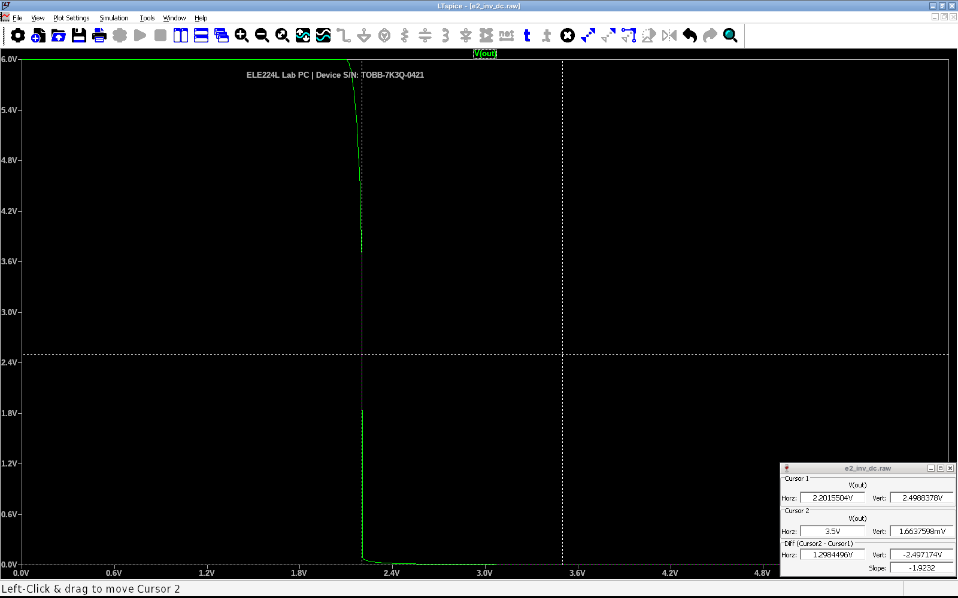
Figure 2.2.7 LTspice voltage transfer characteristic of the CMOS inverter (BS170/BS250): $V_{out}$ versus $V_{in}$ (device serial number: TOBB-7K3Q-0421)
Table 2.2.2 Cursor coordinates read in Figure 2.2.7 and the ngspice values at the same x
Cursor | x coordinate | Quantity | LTspice | ngspice | Difference
1 | $V_{in}$ = 2.2016 V | $V_{out}$ | 2.4988 V | 2.4994 V | -0.022%
2 | $V_{in}$ = 3.5 V | $V_{out}$ | 0.0016638 V | 0.0016638 V | -0.000%

Table 2.2.3 Cursor coordinates read from the simulation figures
Figure | Cursor | x | y
Figure 2.2.3 | X1 ($V_{IN}$) | 0.501 ms | 2.989 V
Figure 2.2.3 | X2 ($V_{OUT}$) | 0.751 ms | 6.000 V
Figure 2.2.4 | $V_{M}$ | 2.202 V ($V_{IN}$) | 2.202 V ($V_{OUT}$)
Figure 2.2.5 | peak $I_{D}$ | 2.205 V ($V_{IN}$) | 0.6548 mA

Table 2.2.4 Hand calculation (square-law model) versus SPICE for the CMOS inverter
$V_{IN}$ (V) | $V_{OUT}$ hand (V) | $V_{OUT}$ SPICE (V) | $I_{D}$ hand (mA) | $I_{D}$ SPICE (mA) | NMOS / PMOS region (hand)
0 | 6.000 | 6.000 | 0 | ≈0 | cut-off / triode
1.00 | 6.000 | 6.000 | 0 | ≈0 | cut-off / triode
2.00 | 6.000 | 6.000 | 0 | ≈0 | cut-off / triode
2.10 | 6.000 | 6.000 | 0 | ≈0 | cut-off / triode
2.15 | 5.616 | 5.620 | 0.1541 | 0.1526 | saturation / triode
2.20 | 3.374 | 3.581 | 0.6165 | 0.6048 | saturation / triode
2.30 | 0.02659 | 0.02856 | 0.6121 | 0.6118 | triode / saturation
2.50 | 0.01079 | 0.01238 | 0.5249 | 0.5247 | triode / saturation
3.00 | 0.003033 | 0.004044 | 0.3360 | 0.3359 | triode / saturation
4.00 | 3.586e−04 | 6.113e−04 | 0.08400 | 0.08400 | triode / saturation
5.00 | 0 | 1.161e−07 | 0 | 2.001e−05 | triode / cut-off
5.50 | 0 | 1.079e−07 | 0 | 2.001e−05 | triode / cut-off
6.00 | 0 | 1.018e−07 | 0 | 2.001e−05 | triode / cut-off

The behaviour in Figure 2.2.3 is explained as follows. While $V_{IN}$ is below about 2.1 V, the output is held at 6 V; while $V_{IN}$ is above about 2.3 V, the output is almost 0 V. Since the transition range is only about 0.2 V wide, the output is practically a square wave although the input is a sinusoid, and its transitions occur close to the lower part of the input swing (at about 2.2 V instead of 3 V), so the output stays low for more than half of the period. In Figure 2.2.5, the current is zero for $V_{IN}<2.1$ V (NMOS off) and for $V_{IN}>5$ V (PMOS off), and it is maximum (0.655 mA) at $V_{IN}≈2.21$ V, where both transistors conduct at the same time. The peak is determined by the weaker PMOS: the current that the PMOS can supply in saturation with $V_{SG}=3.79$ V is $K_{p}{\left(V_{SG}−\left|V_{TP}\right|\right)}^{2}≈0.586$ mA (about 6% more when its channel-length modulation is included). According to the hand model, the regions change at $V_{IN}=2.10$ V (NMOS turns on), 2.20 V (PMOS enters saturation), 2.20 V (NMOS enters triode), and 5.00 V (PMOS turns off).
2.3 MOSFET Bias (Common-Source) Circuit
The circuit of the experiment sheet consists of the divider $R_{G1}=33$ k$Ω$ and $R_{G2}=120$ k$Ω$ driving the gate of an NMOS whose source is grounded and whose drain is connected directly to $V_{2}=5$ V. Since the gate current of a MOSFET is zero, the divider is unloaded and the gate voltage is given by (2.2). The drain-source voltage is fixed by the supply, $V_{DS}=V_{2}=5$ V.
 | $$V_{GS}=V_{1} \frac{R_{G2}}{R_{G1}+R_{G2}}=\frac{120}{153}V_{1} ⇒ V_{1}=\frac{153}{120}V_{GS}=1.275 V_{GS}$$ | (2.2)

For a transistor in saturation, the square-law model of (2.3) is used with the given $K_{N}=72$ mA/V² and the typical datasheet threshold $V_{TH}=2.0$ V. This form of the model (with the factor 1/2) was chosen because it reproduces two independent datasheet values of the BS170: it gives $r_{DS\left(on\right)}=1/\left[K_{N}\left(V_{GS}−V_{TH}\right)\right]=1.74 Ω$ at $V_{GS}=10$ V (datasheet typical: 1.8 $Ω$) and $g_{m}=\sqrt{2K_{N}I_{D}}=190$ mS at $I_{D}=250$ mA (datasheet typical: 200 mS), whereas the form without the factor 1/2 would give 0.87 $Ω$ and 268 mS.
 | $$I_{D}=\frac{K_{N}}{2}{\left(V_{GS}−V_{TH}\right)}^{2} ⇔ V_{GS}=V_{TH}+\sqrt{\frac{2I_{D}}{K_{N}}}$$ | (2.3)

The saturation condition $V_{DS}≥V_{GS}−V_{TH}$ is checked for every column: since $V_{DS}=5$ V, it holds up to $V_{GS}=7$ V. As an example, for $I_{D}=10$ mA, $V_{GS}=2.0+\sqrt{2⋅10/72}=2.527$ V and $V_{1}=1.275×2.527=3.222$ V; for $V_{GS}=4$ V, $I_{D}=36⋅{\left(4−2\right)}^{2}=144$ mA. The other columns are calculated in the same way and are given in Table 2.3.1.
Table 2.3.1 Calculated values of the MOSFET bias circuit (square-law model, $K_{N}$ = 72 mA/V², $V_{TH}$ = 2.0 V)
$I_{D}$ (mA) | 0 | 1.00 | 10.0 | 50.0 | 100 | 36.00 | 144.0 | 324.0
$V_{GS}$ (V) | 0 | 2.167 | 2.527 | 3.179 | 3.667 | 3.000 | 4.000 | 5.000
$V_{DS}$ (V) | 5 | 5 | 5 | 5 | 5 | 5 | 5 | 5
$V_{1}$ (V) | 0 | 2.763 | 3.222 | 4.053 | 4.675 | 3.825 | 5.100 | 6.375

The three last columns ($V_{GS}=3$, 4 and 5 V) require attention: the calculated drain currents are 36 mA, 144 mA and 324 mA, and with $V_{DS}=5$ V the transistor would dissipate 0.18 W, 0.72 W and 1.62 W. The datasheet gives a total dissipation of 350 mW for the BS170, so the 144 mA and 324 mA points (and also 100 mA at 0.5 W) cannot be applied continuously on hardware, although they are harmless in a simulation. The cut-off column ($I_{D}=0$) is valid for any $V_{GS}≤V_{TH}$.
SPICE. The circuit was built with the BS170 model, $V_{1}$ was swept from 0 V to 12.75 V ($V_{GS}$ from 0 V to 10 V), and the $I_{D}$–$V_{GS}$ graph of Figure 2.3.1 was obtained. In the hand calculation, the $V_{1}$ values of Table 2.3.1 were applied to the SPICE circuit, and the results are compared in Table 2.3.4.
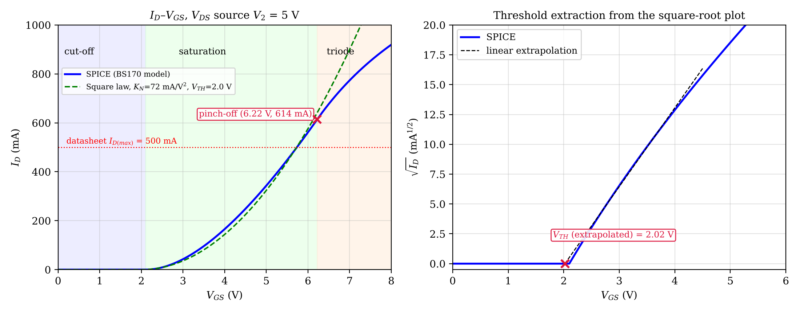
Figure 2.3.1 $I_{D}$–$V_{GS}$ characteristic of the BS170 circuit ($V_{GS}$ on the x-axis, $I_{D}$ on the y-axis) with the operating regions and the pinch-off point (left); square-root plot for the threshold voltage (right) (ngspice simulation).
Table 2.3.2 Coordinates of the cursors in Figure 2.3.1
Cursor | x coordinate | y coordinate
X1 | $V_{GS}$ = 6.219 V | $I_{D}$ = 613.5 mA
X2 | $V_{GS}$ = 2.021 V | $\sqrt{I_{D}}$ = 0 mA^1/2

The LTspice result for this case is shown in Figure 2.3.2 and the cursor comparison is given in Table 2.3.3.
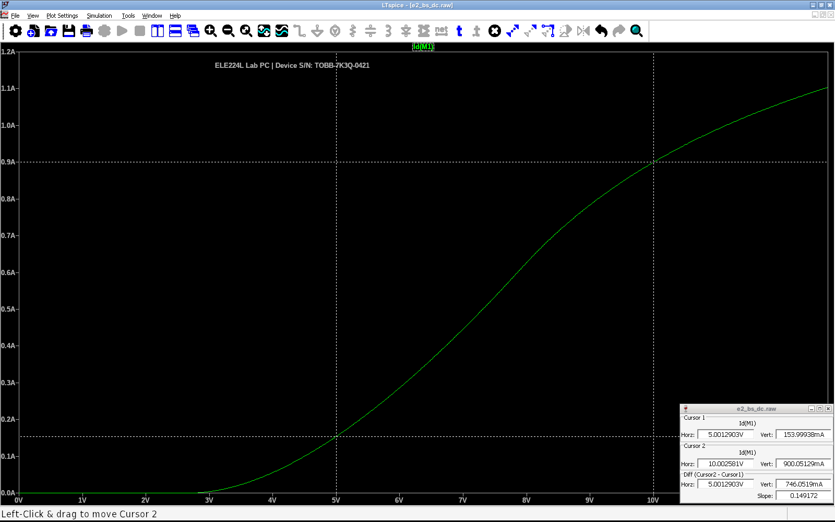
Figure 2.3.2 LTspice DC sweep of the BS170 bias circuit: drain current $I_{D}$ versus the source voltage $V_{1}$ of the gate divider (device serial number: TOBB-7K3Q-0421)
Table 2.3.3 Cursor coordinates read in Figure 2.3.2 and the ngspice values at the same x
Cursor | x coordinate | Quantity | LTspice | ngspice | Difference
1 | $V_{1}$ = 5.0013 V | $I_{D}$ | 154 mA | 154 mA | +0.000%
2 | $V_{1}$ = 10.0026 V | $I_{D}$ | 900.05 mA | 900.05 mA | -0.000%

Table 2.3.4 Hand calculation versus SPICE for the bias circuit (first rows: $V_{GS}$ in V required for the given $I_{D}$ in mA; last rows: $I_{D}$ in mA at the given $V_{GS}$)
Column | Hand | SPICE | Error
0 (given) | — | — | —
1.00 (given) | 2.167 | 2.229 | +2.9%
10.0 (given) | 2.527 | 2.518 | -0.3%
50.0 (given) | 3.179 | 3.079 | -3.1%
100 (given) | 3.667 | 3.531 | -3.7%
36.00 (from $V_{GS}$=3 V) | 36.00 | 42.76 | +18.8%
144.0 (from $V_{GS}$=4 V) | 144.0 | 165.7 | +15.1%
324.0 (from $V_{GS}$=5 V) | 324.0 | 343.4 | +6.0%

Operating regions and pinch-off. In Figure 2.3.1, the transistor is in cut-off for $V_{GS}<V_{TH}$ (the current is practically zero), in saturation (square-law region, $\sqrt{I_{D}}$ linear in $V_{GS}$) for larger $V_{GS}$, and in the triode region after the pinch-off point. The pinch-off point is the point at which $V_{DS}=V_{GS}−V_{TH}$ and the channel at the drain end is pinched off. With the ideal square-law model, it occurs at $V_{GS}=V_{DS}+V_{TH}=5+2.0=7.0$ V ($I_{D}=900$ mA). In the SPICE model, the drain and source series resistances ($R_{D}=1.436 Ω$, $R_{S}=1.572 Ω$) reduce the internal $V_{DS}$ and $V_{GS}$ at large currents, and the pinch-off occurs earlier: at $V_{GS}=6.22$ V and $I_{D}=614$ mA, which is marked in the figure. Both points are beyond the 500 mA datasheet limit, so they are not reachable in a hardware experiment. The threshold extracted from the square-root plot is 2.02 V, which agrees with the model parameter $V_{TO}=2.1$ V.
3 CONCLUSIONS
The datasheet reading showed that the BS170 and BS250 have opposite pin orders (D–G–S and S–G–D). If one of them is inserted with the pin pattern of the other, the gate stays on the middle pin but the source and the drain are exchanged, so the transistor does not work as intended (the body diode conducts). The switching threshold of the CMOS inverter was found as 2.202 V in SPICE and 2.201 V in the hand model, a difference of 0.7 mV, which is caused by the series resistances of the model and by the interpolation of the sweep. Outside the narrow transition region, the hand model and SPICE agree to within a few millivolts. Inside the transition region, a few millivolts of difference in $V_{IN}$ changes $V_{OUT}$ by volts (for example, at $V_{IN}=2.20$ V the hand model gives 3.37 V and SPICE 3.58 V), because the voltage gain is very high there; this is also the reason why the inverter works as a digital element.
In the bias circuit, the gate voltage required by SPICE for $I_{D}$ = 1, 10, 50 and 100 mA differs from the hand calculation by +2.9%, -0.3%, -3.1% and -3.7%, respectively, and the SPICE drain current at $V_{GS}$ = 3, 4 and 5 V is higher than the hand-calculated current by +18.8%, +15.1% and +6.0% (the difference in current is larger than the difference in voltage, since the current depends on the square of $V_{GS}−V_{TH}$). The reasons are the larger transconductance parameter of the SPICE model ($KP⋅W/L=123.3$ mA/V², i.e., 61.65 mA/V² in the $K/2$ form, against $K_{N}/2=36$ mA/V²), the different threshold ($V_{TO}=2.1$ V against 2.0 V), and the series resistances $R_{D}$ and $R_{S}$ of the model, which reduce the internal $V_{GS}$ at high currents. The datasheet range of $V_{GS\left(th\right)}=0.8$–3.0 V shows that the real bias point also changes strongly from device to device, so the gate voltage must be adjusted for each transistor in the laboratory. The experiment taught the use of datasheets, the identification of operating regions, and the comparison of an analytical model with a SPICE model.
4 REFERENCES
1. ON Semiconductor. (2017). BS170 small signal MOSFET 500 mA, 60 volts [Data sheet]. Retrieved October 11, 2026, from https://www.onsemi.com/download/data-sheet/pdf/bs170-d.pdf
2. General Semiconductor. (1999). BS250 DMOS transistor (P-channel) [Data sheet]. Retrieved October 11, 2026, from https://hippo.feld.cvut.cz/katalog/pdf/BS250.PDF
3. Diodes Incorporated. (2019). BS250P P-channel enhancement mode vertical DMOS FET [Data sheet]. Retrieved October 11, 2026, from https://www.diodes.com/assets/Datasheets/BS250P.pdf
4. Sedra, A. S., & Smith, K. C. (2014). Microelectronic circuits (7th ed.). New York: Oxford University Press.
5. ngspice. (n.d.). ngspice user manual. Retrieved October 11, 2026, from https://ngspice.sourceforge.io/docs.html
5 APPENDICES
5.1 Appendix A: Model Definitions
The model definitions of the experiment sheet were used. In the ngspice simulation, the parameters RG, RB, Rds and Tt, which are not available in the level-1 model of ngspice, were omitted; they have no effect on the DC results (RG is a gate series resistor without gate current, Rds = 120 M$Ω$ is practically an open circuit, and Tt only affects the bulk-diode charge).
Code A.1 Model lines used in the ngspice simulations
.model BS170 NMOS (VTO=2.1 RS=1.572 RD=1.436 KP=.1233 IS=5p)
.model BS250 PMOS (VTO=-1.0 KP=150u LAMBDA=0.02 RD=1 RS=1 IS=20n)

5.2 Appendix B: SPICE Netlists
Netlist B.1 CMOS inverter transient analysis
Vdd vdd 0 DC 6
Vin in 0 SIN(3 3 1k)
M1 out in 0 0 BS170 W=100u L=100u
M2 out in vdd vdd BS250 W=100u L=100u
.model BS170 NMOS (VTO=2.1 RS=1.572 RD=1.436 KP=.1233 IS=5p)
.model BS250 PMOS (VTO=-1.0 KP=150u LAMBDA=0.02 RD=1 RS=1 IS=20n)

.tran 2u 3m
.end

Netlist B.2 BS170 bias circuit DC sweep
V2 d 0 DC 5
V1 n1 0 DC 0
RG1 n1 g 33k
RG2 g 0 120k
M1 d g 0 0 BS170 W=100u L=100u
.model BS170 NMOS (VTO=2.1 RS=1.572 RD=1.436 KP=.1233 IS=5p)

.dc V1 0 12.75 0.005
.end

