TOBB University of Economics and Technology
Department of Electrical and Electronics Engineering
ELE 224L – Electronic Circuits Laboratory
Experiment 5 – Preliminary Work: BJT Amplifiers
Name Surname
Student ID
Date

1 INTRODUCTION
1.1 Objective of the Experiment
The objective of this experiment is to learn the operating principles of the common-emitter and the common-collector amplifiers, which are two of the three basic BJT amplifier configurations. For both circuits, the DC operating point, the small-signal voltage gain, the input and output resistances and the maximum output voltage swing are calculated and compared with SPICE simulations. The wiring of the circuits on a breadboard is also studied, including the detection of the errors in a given drawing.
1.2 Benefits of the Experiment
The experiment shows how a BJT amplifier is analysed in two steps (DC bias, then AC small signal), how the emitter bypass capacitor changes the gain by a factor of about 80, why the emitter follower has a gain close to but never above one, and how the exponential characteristic of the BJT limits the undistorted output amplitude. It also trains the checking of the capacitor impedances at the test frequency, the use of a THD criterion for distortion, and the reading and correcting of a breadboard drawing. These skills are required in all analog design work.
2 CALCULATIONS AND SIMULATIONS
2.1 BJT Amplifier Circuit Diagram and Breadboard
The parameters of the BC238A were taken from the datasheet (Fairchild BC237/238/239): $β=170$ (the average of the class A range of 120–220) and $V_{BE\left(on\right)}=0.62$ V (typical value at $I_{C}=2$ mA, $V_{CE}=5$ V). The Early voltage is neglected. These values are used in all calculations of this section.
Table 2.1.1 BJT parameters used in the calculations
Parameter | Value
$β$ (average) | 170
$V_{BE\left(on\right)}$ (typical) | 0.62 V

The connections of the given breadboard drawing (Figure 2.1.1) were read hole by hole, and the electrical nodes were extracted automatically and compared with the circuit diagram of the common-emitter amplifier (Figure 2.1.2). The comparison showed the four wiring errors and one missing element that are listed in Table 2.1.2 and marked in Figure 2.1.1. The values of the resistors read from the colour codes (5.6 k$Ω$, 120 k$Ω$, 1.8 k$Ω$, 39 k$Ω$, 15 k$Ω$) and the connections of the transistor ($C$ on column 18, $B$ on 19, $E$ on 20) are correct.
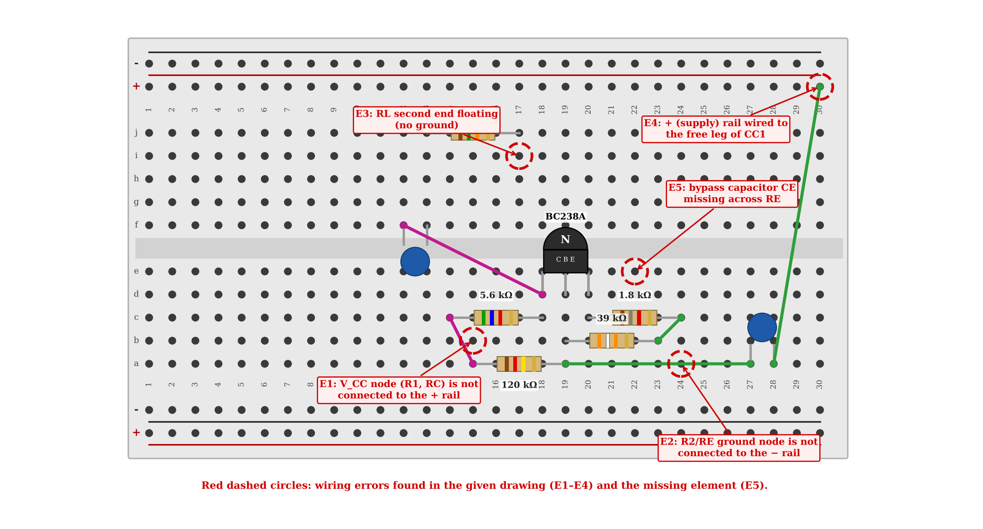
Figure 2.1.1 The given breadboard drawing of the common-emitter amplifier; the errors are marked with red dashed circles.
Table 2.1.2 Errors found in the given breadboard drawing and their corrections
No. | Error | Correction
E1 | The node where $R_{1}$ and $R_{C}$ meet (columns 14–15) is not connected to the + rail. | No supply voltage reaches the circuit; $V_{CC}$ must be wired to this node (red wire from the + rail to column 15).
E2 | The node where $R_{2}$ and $R_{E}$ meet (columns 23–24) is not connected to the − rail. | The circuit has no ground reference; a wire from this node to the − (GND) rail is required.
E3 | The second leg of $R_{L}$ (column 17, upper block) is not connected to anything. | The load is not grounded, so $C_{C2}$ and $R_{L}$ do not form a path to ground; $R_{L}$ must be wired to the GND rail.
E4 | The + (supply) rail is wired to the free leg of $C_{C1}$ (column 28). | The input coupling capacitor would be tied to the supply instead of the signal source; this wire must be removed and the function-generator output connected to $C_{C1}$ ($v_{i}$).
E5 | The emitter bypass capacitor $C_{E}$ is missing. | $C_{E}$ (22 nF) must be connected in parallel with $R_{E}$ (between the emitter column and the ground node).

The corrected drawing is shown in Figure 2.1.3. The names and values of the circuit elements are given in Table 2.1.3; the missing element is the bypass capacitor $C_{E}$ (drawn in red). The correctness of the corrected drawing was checked by the same automatic node extraction: the node lists of the drawing and of the circuit diagram are identical.
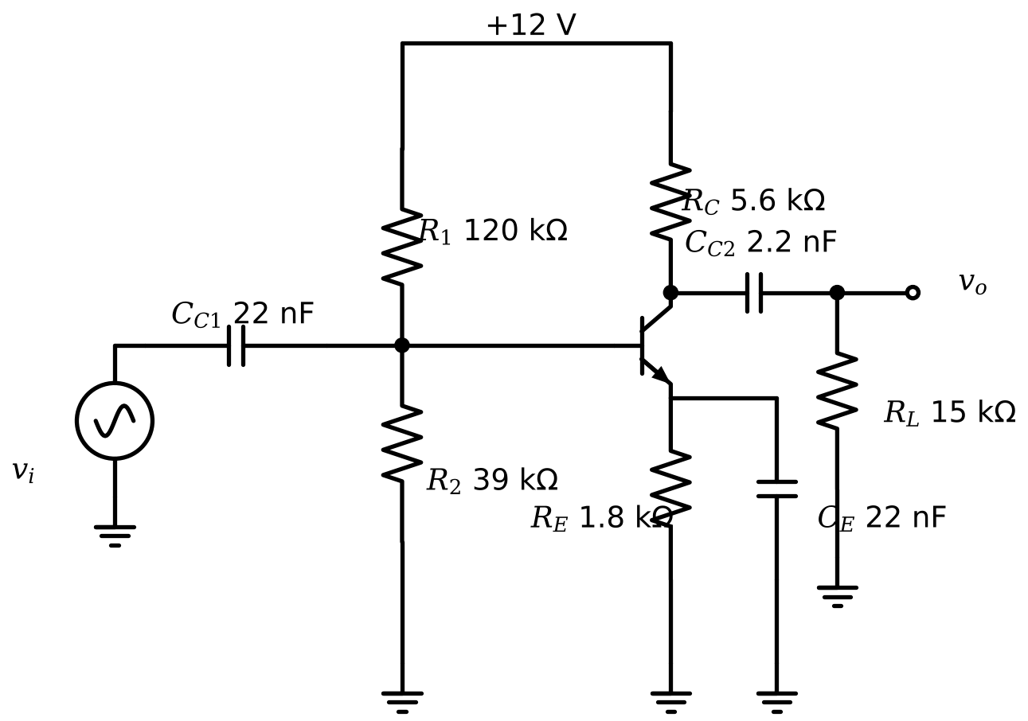
Figure 2.1.2 Common-emitter amplifier circuit diagram.
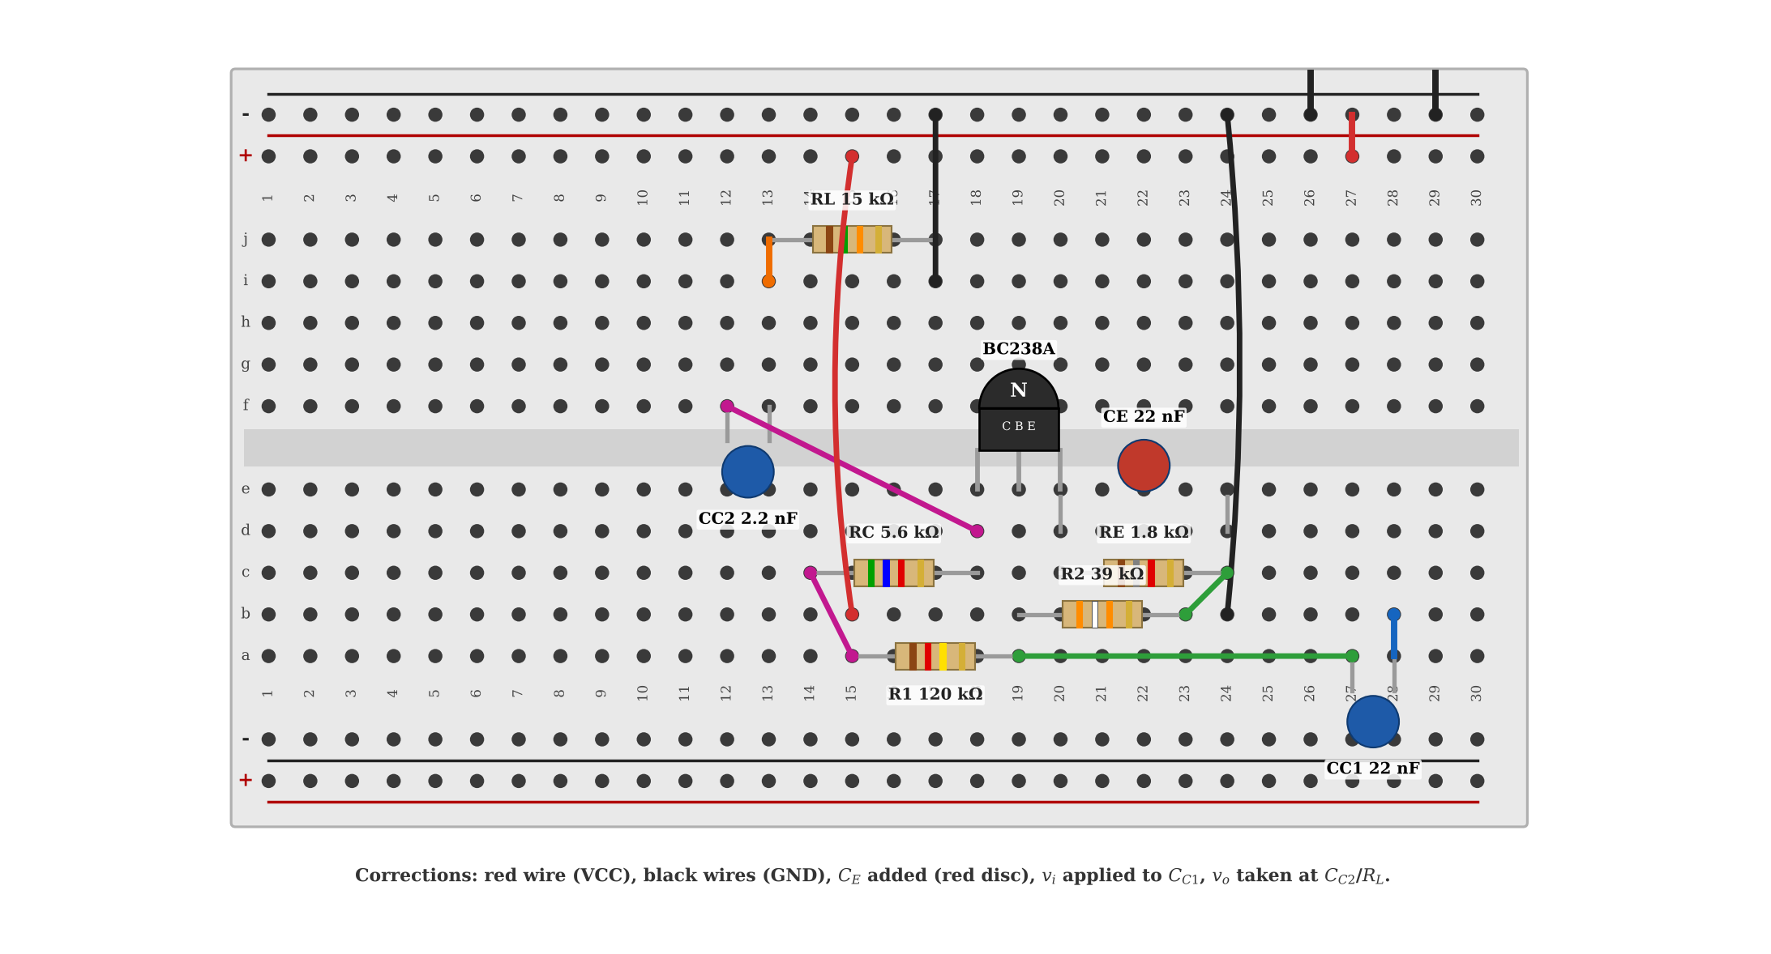
Figure 2.1.3 Corrected breadboard drawing of the common-emitter amplifier (with $C_{E}$ added).
Table 2.1.3 Names and values of the circuit elements of the common-emitter amplifier
Name | Value | Function
Q1 | BC238A (NPN) | Amplifying element
R1 | 120 k$Ω$ | Upper bias resistor (+$V_{CC}$ to base)
R2 | 39 k$Ω$ | Lower bias resistor (base to GND)
RC | 5.6 k$Ω$ | Collector resistor
RE | 1.8 k$Ω$ | Emitter resistor (DC stabilisation)
RL | 15 k$Ω$ | Load resistor
CC1 | 22 nF | Input coupling capacitor
CC2 | 2.2 nF | Output coupling capacitor
CE | 22 nF (missing) | Emitter bypass capacitor

The common-collector amplifier of the experiment sheet (Figure 2.1.4) was drawn on the breadboard as shown in Figure 2.1.5. The collector is wired directly to the + rail (there is no collector resistor), $R_{1}$ and $R_{2}$ form the base divider, the output is taken from the emitter through $C_{C2}$ and loaded by $R_{L}$, and the input is applied to the base through $C_{C1}$. The connections were verified automatically against the circuit diagram.
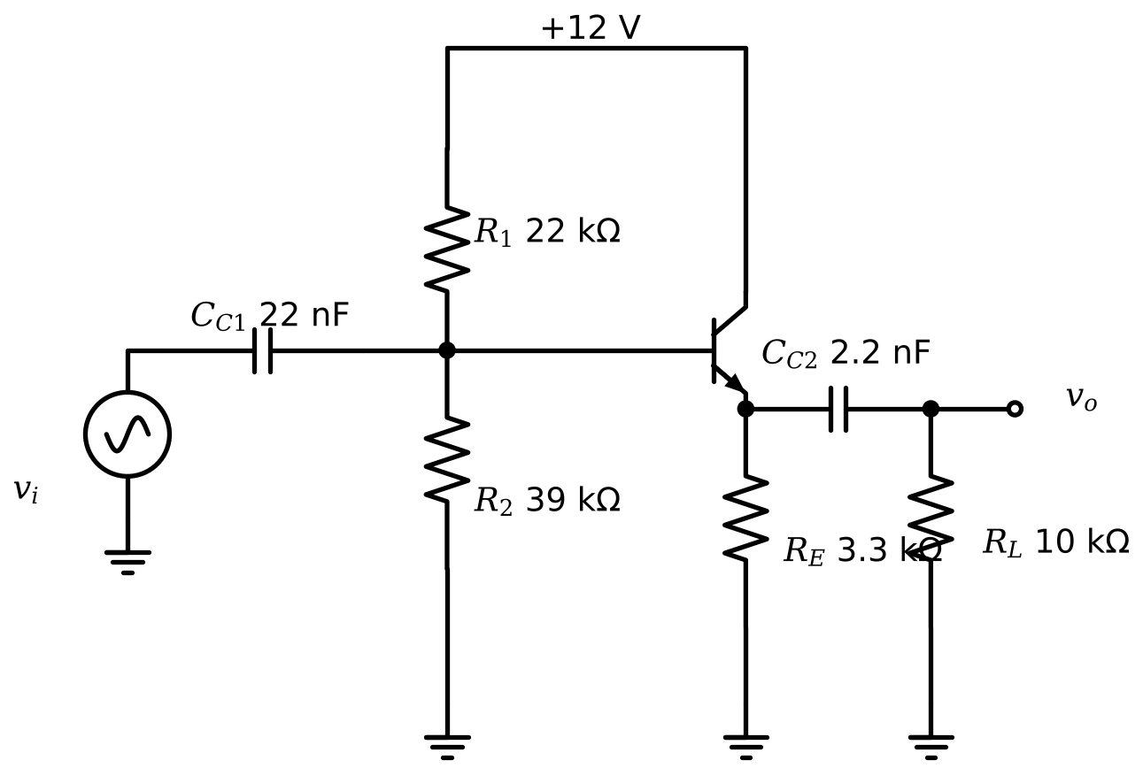
Figure 2.1.4 Common-collector amplifier circuit diagram.
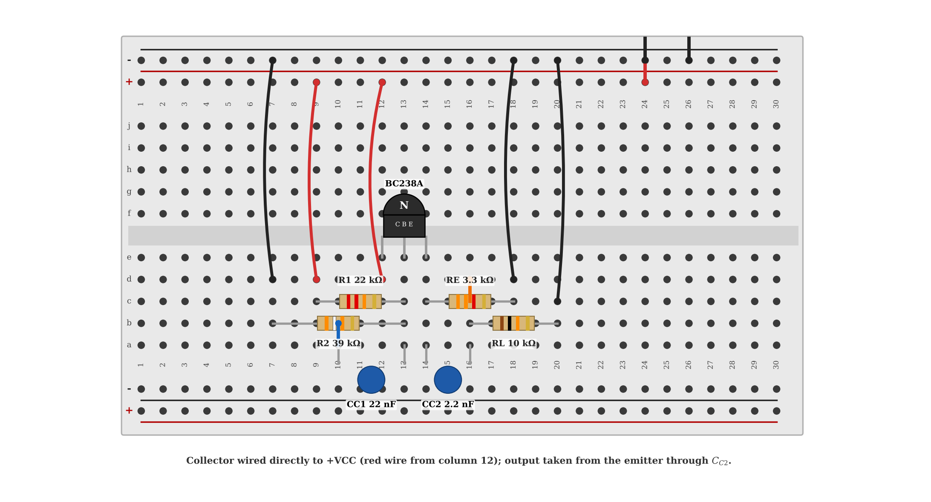
Figure 2.1.5 Common-collector amplifier on the breadboard.
2.2 Common-Emitter Amplifier Analysis
DC analysis. The capacitors are open circuits. The base divider is replaced by its Thévenin equivalent, $V_{TH}=V_{CC}R_{2}/\left(R_{1}+R_{2}\right)=2.943$ V and $R_{TH}=R_{1}∥R_{2}=29.43$ k$Ω$, and the base loop gives (2.1).
 | $$I_{B}=\frac{V_{TH}−V_{BE\left(on\right)}}{R_{TH}+\left(β+1\right)R_{E}}=\frac{2.9434−0.62}{29.434 \text{k}Ω+171⋅1.8 \text{k}Ω}=6.890 μ\text{A}$$ | (2.1)

Then $I_{C}=βI_{B}=1.171$ mA, $I_{E}=\left(β+1\right)I_{B}=1.178$ mA, and $V_{CE}=V_{CC}−I_{C}R_{C}−I_{E}R_{E}=12−1.171×5.6−1.178×1.8=3.321$ V. Since $V_{CE}>0.2$ V, the transistor is in the active region. The small-signal parameters are $g_{m}=I_{C}/V_{T}=45.05$ mS, $r_{π}=β/g_{m}=3.774$ k$Ω$ and $r_{e}=V_{T}/I_{E}=22.07 Ω$ (with $V_{T}=26$ mV).
AC analysis (mid-band). The coupling and bypass capacitors are short circuits and $V_{CC}$ is an AC ground. With $C_{E}$, the emitter is grounded and the gain is given by (2.2); without $C_{E}$, the emitter resistor produces negative feedback and the gain is given by (2.3), where $R_{L}′=R_{C}∥R_{L}=4.078$ k$Ω$. The output resistance (looking into the collector, $R_{L}$ excluded) is $R_{o}=R_{C}=5.6$ k$Ω$, and the input resistance is given by (2.4).
 | $$A_{V}=−g_{m}R_{L}′=−45.05 \text{mS}×4.078 \text{k}Ω=−183.7$$ | (2.2)

 | $$A_{V}=−\frac{βR_{L}′}{r_{π}+\left(β+1\right)R_{E}}=−\frac{170×4.078 \text{k}Ω}{3.774 \text{k}Ω+171×1.8 \text{k}Ω}=−2.225$$ | (2.3)

 | $$R_{i}=R_{1}∥R_{2}∥r_{π}=3.34 \text{k}Ω \left(\text{with }C_{E}\right), R_{i}=R_{1}∥R_{2}∥\left[r_{π}+\left(β+1\right)R_{E}\right]=26.89 \text{k}Ω \left(\text{without }C_{E}\right)$$ | (2.4)

Maximum output swing. The AC load line passes through the Q point with the slope $−1/R_{L}′$. With $C_{E}$, the collector voltage can increase by $I_{CQ}R_{L}′=4.776$ V before the transistor is cut off and decrease by $V_{CEQ}−V_{CE\left(sat\right)}=3.121$ V before it saturates, so that the symmetrical swing is limited by saturation: $V_{O,pp,max}=2×3.121=6.241$ V. Without $C_{E}$, the AC load seen by the emitter–collector path is $R_{L}′+R_{E}$, the collector current can decrease by $I_{CQ}$ or increase by $\left(V_{CEQ}−0.2\right)/\left(R_{L}′+R_{E}\right)=0.5309$ mA, and the output swing is $V_{O,pp,max}=2×0.5309 \text{mA}×R_{L}′=4.330$ V.
Table 2.2.1 Calculated values for the common-emitter amplifier circuit (the last two rows are additional)
 | With $C_{E}$ | Without $C_{E}$
$V_{BEQ}$ (V) | 0.62 | 0.62
$V_{CEQ}$ (V) | 3.321 | 3.321
$I_{BQ}$ (mA) | 0.006890 | 0.006890
$I_{CQ}$ (mA) | 1.171 | 1.171
$A_{V}=V_{o}/V_{i}$ (mid-band) | −183.7 | −2.225
$V_{O}$ (peak-to-peak, max.) (V) | 6.241 | 4.330
$R_{i}$ (k$Ω$) / $R_{o}$ (k$Ω$) | 3.34 / 5.6 | 26.9 / 5.6
$\left|A_{V}\right|$ at 100 kHz (phasor analysis) | 52.74 | 2.223

The mid-band gain assumes that $C_{E}$ is a perfect short circuit. At the test frequency of 100 kHz, the impedance of $C_{E}=22$ nF is $1/\left(2πfC_{E}\right)=72 Ω$, which is larger than $r_{e}=22.1 Ω$. The gain is then reduced to $\left|A_{V}\right|≈R_{L}′/\left(r_{e}+\left|Z_{E}\right|\right)$, and a complete phasor analysis (including $C_{C1}$, $C_{C2}$ and $C_{E}$) gives $\left|A_{V}\right|=52.7$ at 100 kHz instead of 184. A bypass capacitor of about 0.16 µF would be needed for 90% of the mid-band gain at 100 kHz. Without $C_{E}$, the gain is independent of frequency in this range (2.22).
SPICE. The circuit was built with the BC238A model (Appendix A). The DC and AC results are compared with the calculations in Table 2.2.2, the frequency response is shown in Figure 2.2.1. A sinusoidal input of 100 kHz with zero offset was applied, and the output was analysed with the total harmonic distortion (THD) obtained from the FFT of ten steady-state periods. The THD of the output as a function of the input amplitude is shown in Figure 2.2.4. An output waveform is called undistorted when THD ≤ $1\%$ (a THD of 5% is also given for reference), since the visual detection of the distortion of a sine wave is possible only above about 5%.
Table 2.2.2 Comparison of the calculation and SPICE for the common-emitter amplifier (Error = (SPICE $−$ calculation)/calculation)
Quantity | Calculation | SPICE | Error
$V_{BEQ}$ (V) | 0.62 | 0.6066 | -2.2%
$V_{CEQ}$ (V) | 3.321 | 3.270 | -1.5%
$I_{BQ}$ (µA) | 6.890 | 6.929 | +0.6%
$I_{CQ}$ (mA) | 1.171 | 1.178 | +0.6%
$\left|A_{V}\right|$ at 100 kHz, with $C_{E}$ | 52.74 | 52.75 | +0.0%
$\left|A_{V}\right|$ at 100 kHz, without $C_{E}$ | 2.223 | 2.223 | -0.0%
$\left|A_{V}\right|$ maximum of the curve, with $C_{E}$ (SPICE, at 1585 kHz) | 183.7 | 177.5 | -3.3%
$\left|A_{V}\right|$ mid-band, without $C_{E}$ | 2.225 | 2.201 | -1.1%
$R_{i}$ at 100 kHz, with $C_{E}$ (k$Ω$) | 10.72 | 9.879 | -7.8%
$R_{i}$ at 100 kHz, without $C_{E}$ (k$Ω$) | 26.89 | 26.65 | -0.9%

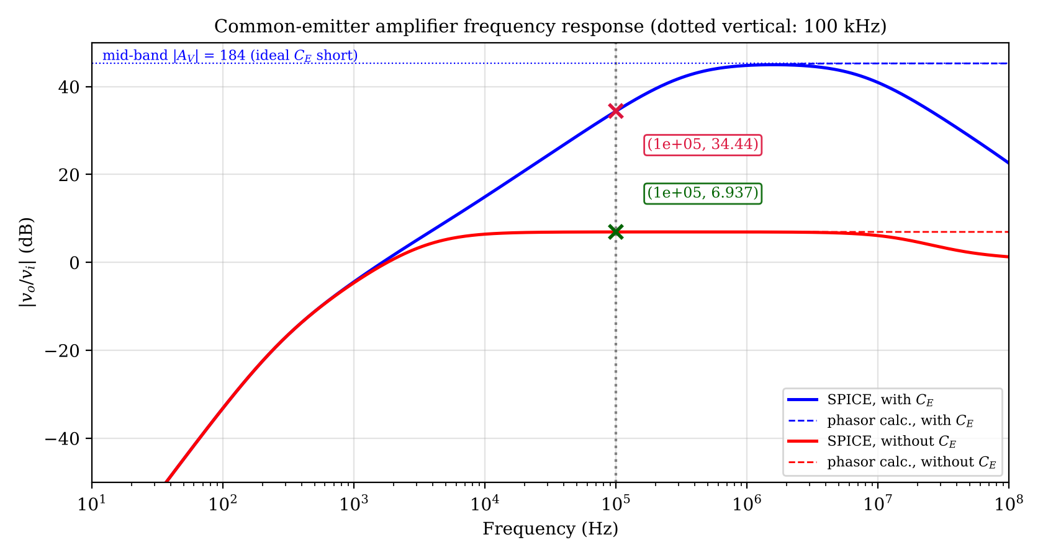
Figure 2.2.1 Frequency response of the common-emitter amplifier (SPICE and phasor calculation).
Table 2.2.3 Coordinates of the cursors in Figure 2.2.1
Cursor | x coordinate | y coordinate
X1 | Frequency = 1.000e+05 Hz | $\left|v_{o}/v_{i}\right|$ = 34.44 dB
X2 | Frequency = 1.000e+05 Hz | $\left|v_{o}/v_{i}\right|$ = 6.937 dB

The simulation was repeated in LTspice; the waveform window with the cursors is shown in Figure 2.2.2, and the cursor readings are compared with the ngspice values at the same x in Table 2.2.4. The agreement shows that the result does not depend on the simulator.
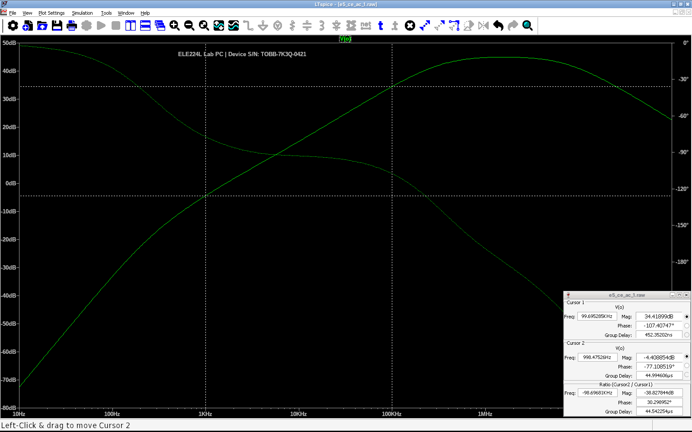
Figure 2.2.2 LTspice AC analysis of the common-emitter amplifier with the emitter bypass capacitor $C_{E}$ (device serial number: TOBB-7K3Q-0421)
Table 2.2.4 Cursor coordinates read in Figure 2.2.2 and the ngspice values at the same x
Cursor | x coordinate | Quantity | LTspice | ngspice | Difference
1 | f = 99.695 kHz | $\left|V_{O}\right|$ | 34.419 dB | 34.42 dB | -0.001 dB
1 | f = 99.695 kHz | $∠V_{O}$ | −107.41 ° | −107.39 ° | -0.022 °
2 | f = 998.48 Hz | $\left|V_{O}\right|$ | −4.4089 dB | −4.409 dB | +0.000 dB
2 | f = 998.48 Hz | $∠V_{O}$ | −77.109 ° | −77.108 ° | -0.001 °

The LTspice result for this case is shown in Figure 2.2.3 and the cursor comparison is given in Table 2.2.5.
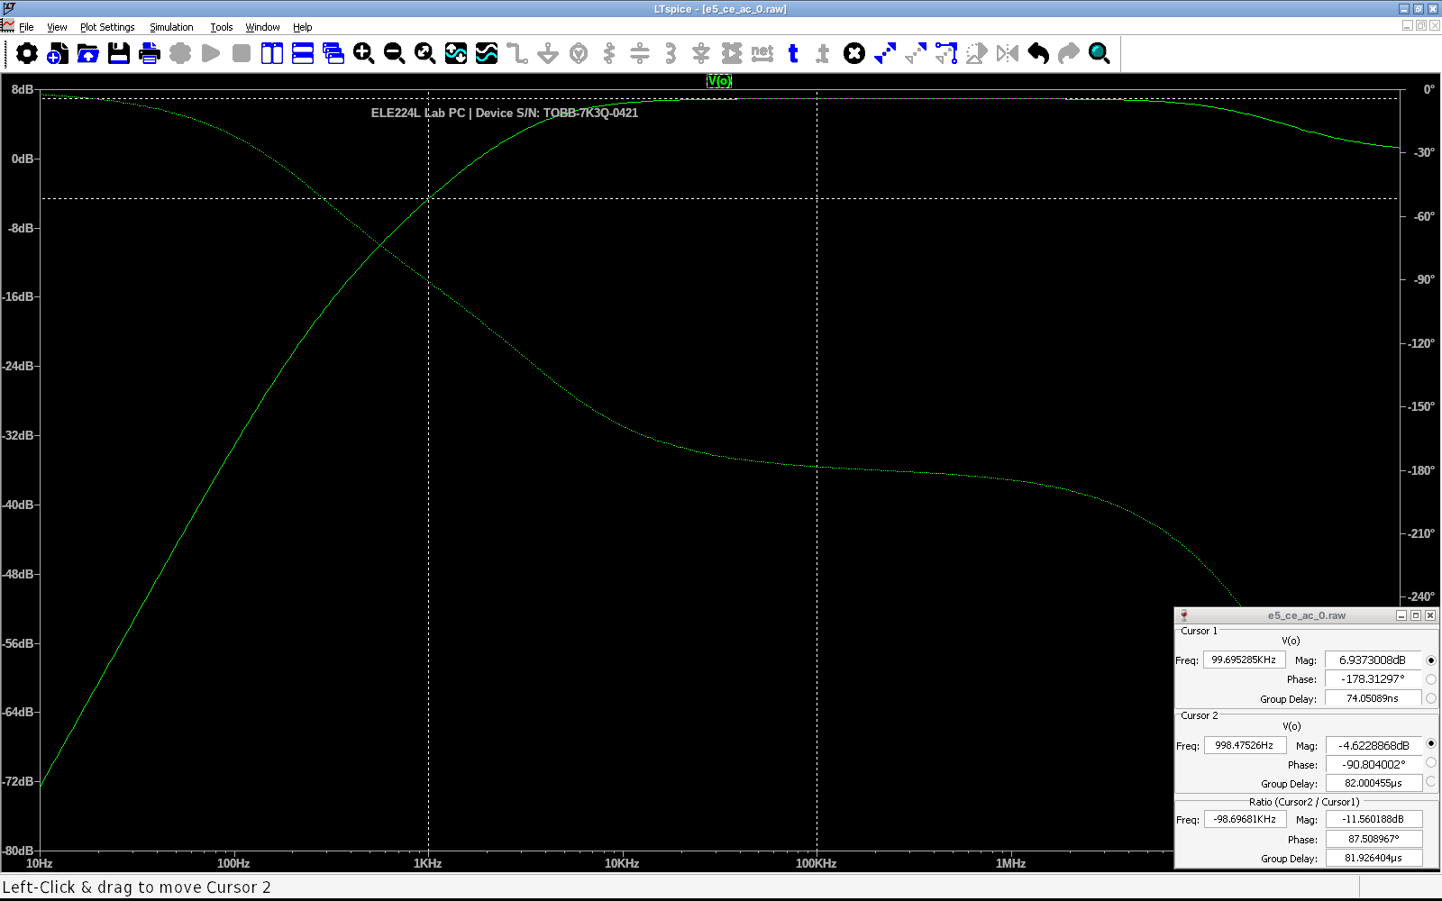
Figure 2.2.3 LTspice AC analysis of the common-emitter amplifier without $C_{E}$ (device serial number: TOBB-7K3Q-0421)
Table 2.2.5 Cursor coordinates read in Figure 2.2.3 and the ngspice values at the same x
Cursor | x coordinate | Quantity | LTspice | ngspice | Difference
1 | f = 99.695 kHz | $\left|V_{O}\right|$ | 6.9373 dB | 6.9374 dB | -0.000 dB
1 | f = 99.695 kHz | $∠V_{O}$ | −178.31 ° | −178.31 ° | -0.000 °
2 | f = 998.48 Hz | $\left|V_{O}\right|$ | −4.6229 dB | −4.623 dB | +0.000 dB
2 | f = 998.48 Hz | $∠V_{O}$ | −90.804 ° | −90.803 ° | -0.001 °

Highest undistorted amplitude. For the circuit with $C_{E}$, the THD reaches 1% at an input amplitude of 7.24 mV peak (14.5 mV peak-to-peak), at which the output is 0.764 V peak-to-peak (gain 52.7, equal to the phasor result); the THD reaches 5% at 69.5 mV peak-to-peak. For the circuit without $C_{E}$, the THD reaches 1% at 2.11 V peak-to-peak input (4.66 V peak-to-peak output) and 5% at 3.37 V peak-to-peak. The corresponding waveforms are shown in Figure 2.2.5 (with $C_{E}$) and Figure 2.2.6 (without $C_{E}$); the top panel of each figure shows the highest undistorted amplitude, and the other panels show a larger amplitude and an overdriven input.
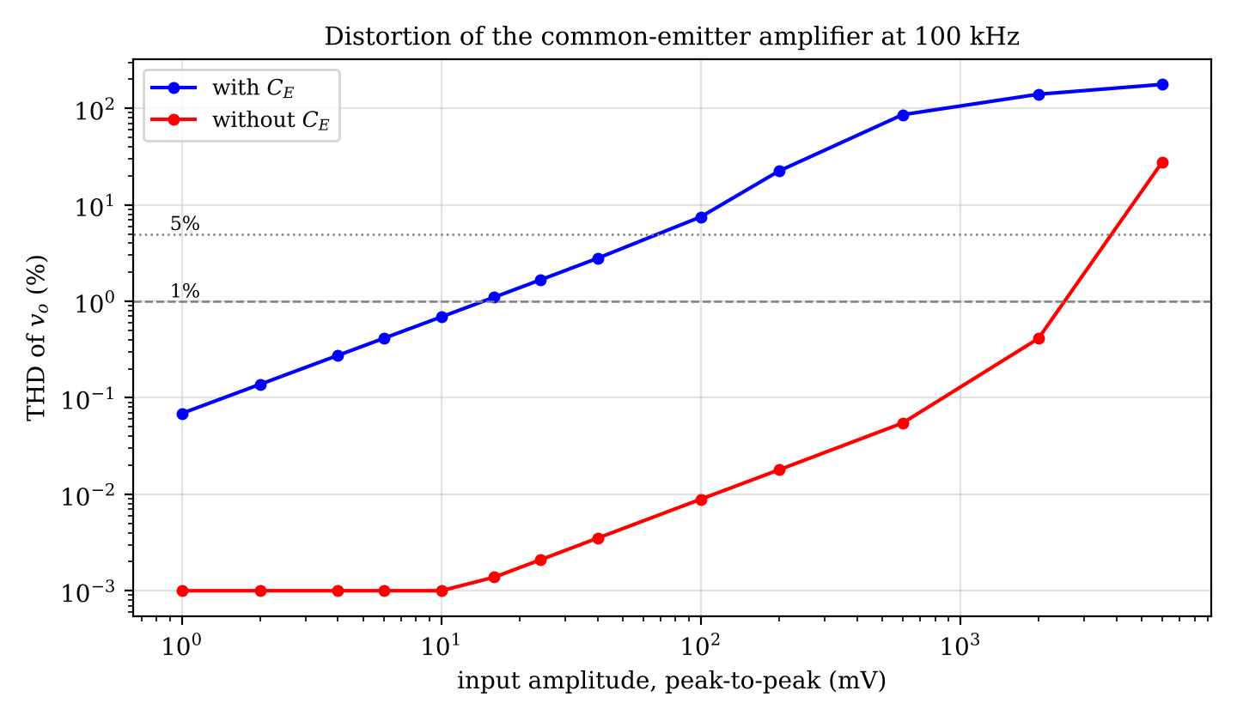
Figure 2.2.4 Total harmonic distortion of the output voltage versus input amplitude (SPICE, 100 kHz).
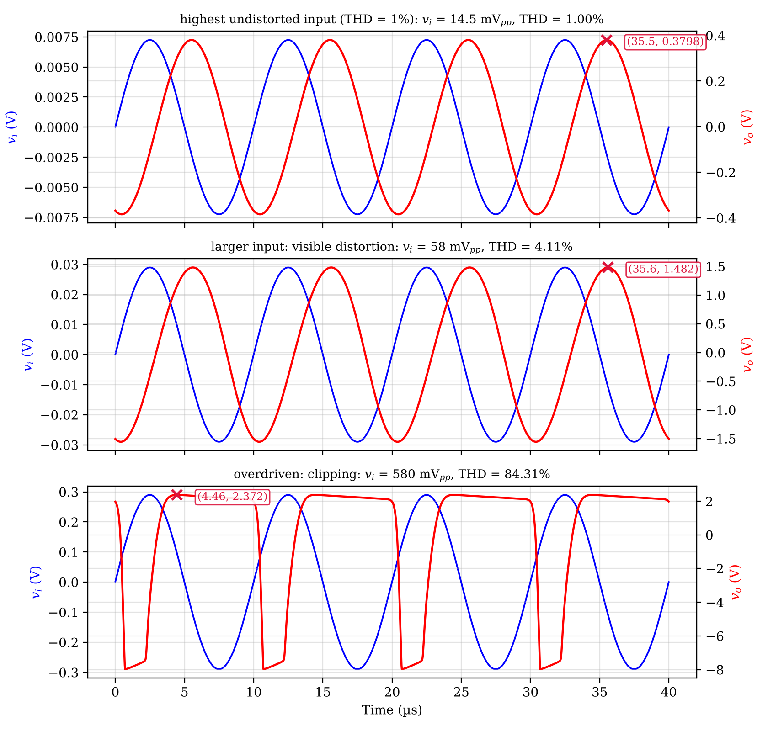
Figure 2.2.5 Input and output voltages of the circuit with $C_{E}$ at three input amplitudes (the output waveform is shown with its DC level removed).
Table 2.2.6 Coordinates of the cursors in Figure 2.2.5
Cursor | x coordinate | y coordinate
X1 | = 35.50 | $v_{o}$ = 0.3798 V
X2 | = 35.60 | $v_{o}$ = 1.482 V
X3 | = 4.460 | $v_{o}$ = 2.372 V

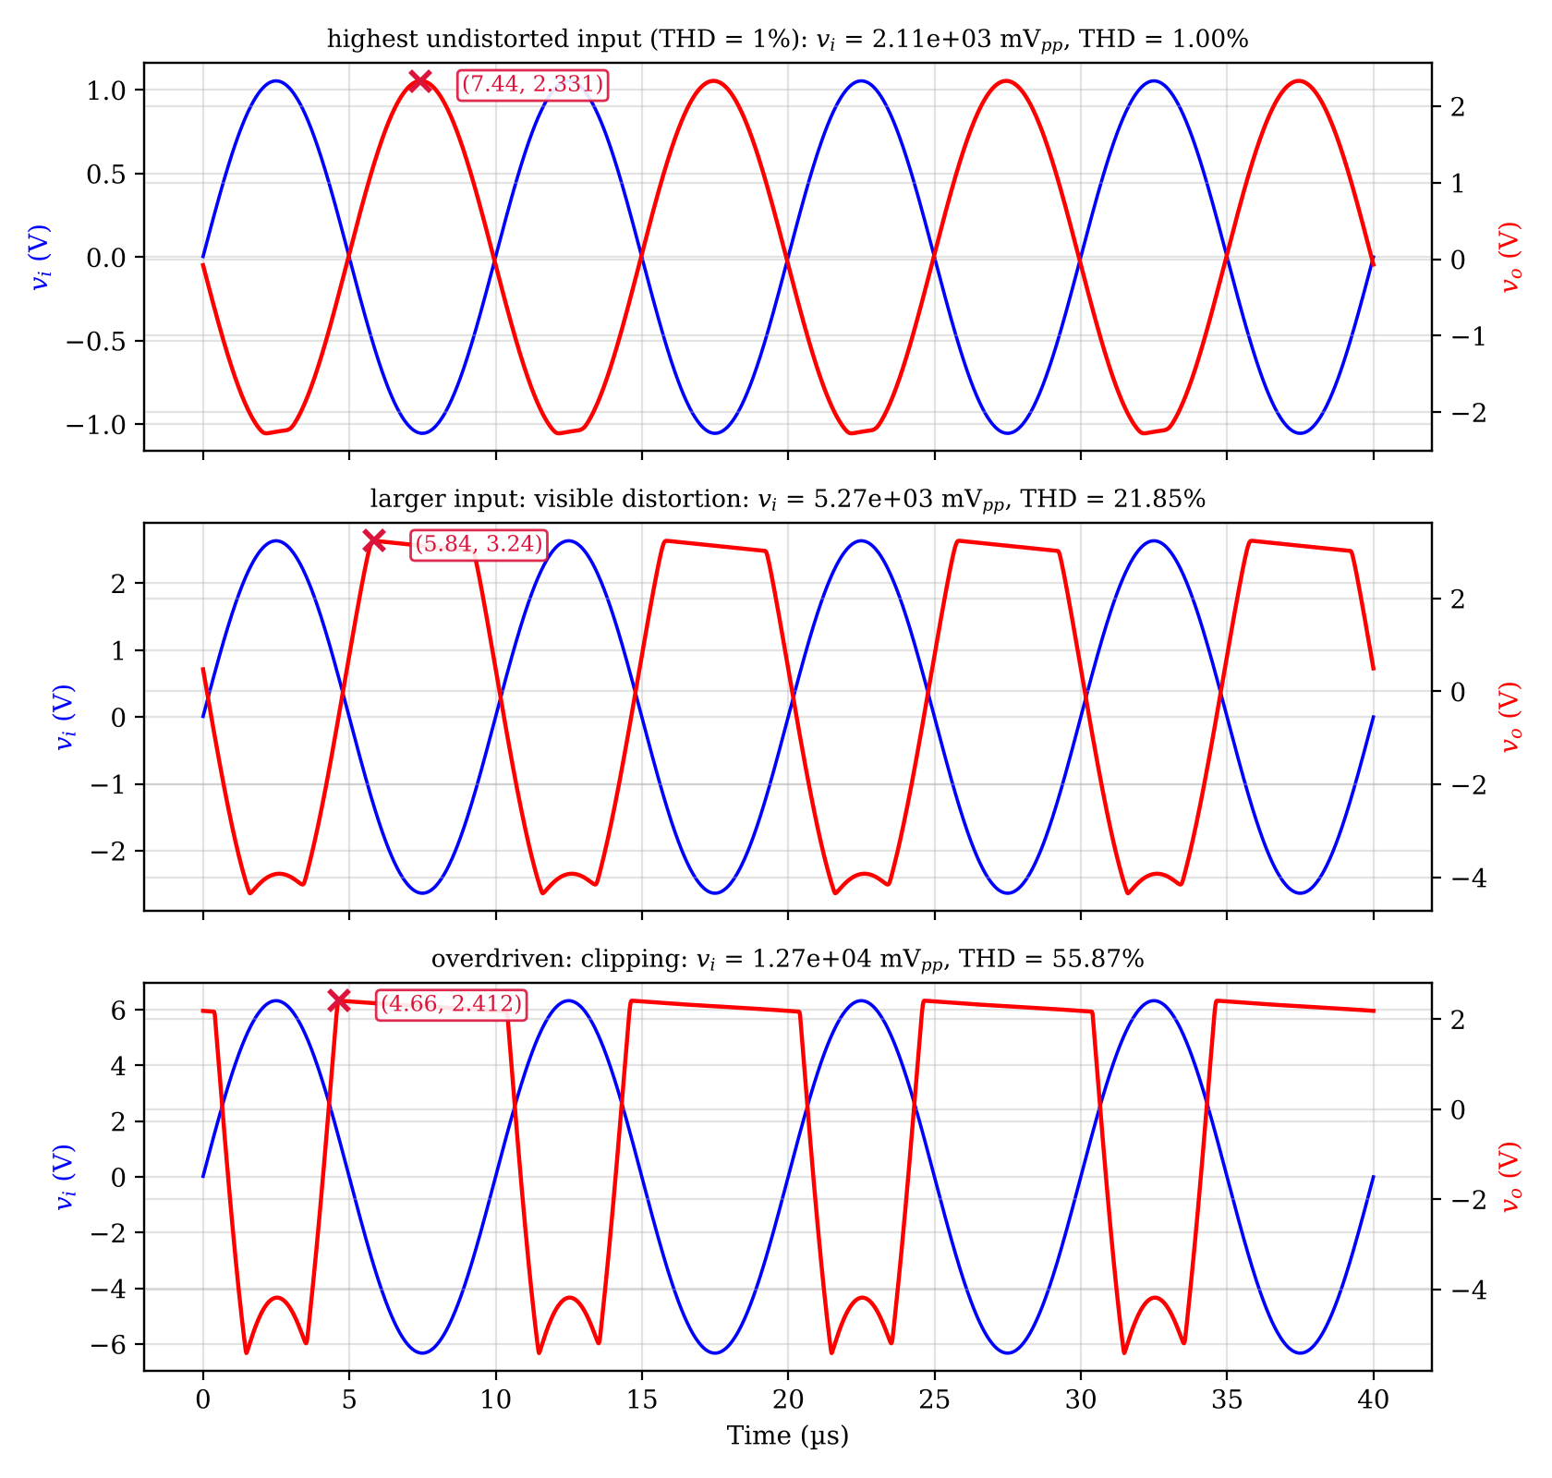
Figure 2.2.6 Input and output voltages of the circuit without $C_{E}$ at three input amplitudes.
Table 2.2.7 Coordinates of the cursors in Figure 2.2.6
Cursor | x coordinate | y coordinate
X1 | = 7.440 | $v_{o}$ = 2.331 V
X2 | = 5.840 | $v_{o}$ = 3.240 V
X3 | = 4.660 | $v_{o}$ = 2.412 V

The limits above are very different from the load-line limits of Table 2.2.1 (6.24 V and 4.33 V peak-to-peak). With $C_{E}$, the output is limited by the curvature of the exponential $I_{C}$–$V_{BE}$ characteristic, long before clipping: the second harmonic is approximately $v_{be}/\left(4V_{T}\right)$ of the fundamental for a bypassed emitter, so that a base–emitter signal of only a few millivolts already gives about 1% distortion. Without $C_{E}$, the emitter resistor linearizes the stage (the base–emitter signal is only a small fraction of $v_{i}$), so that the distortion starts only when the signal approaches the clipping level, at about the load-line value. When the input is increased much more, the output clips (with the coupling capacitor shifting the DC level, the clipped output swings 10.7 V peak-to-peak with $C_{E}$ and 7.82 V without $C_{E}$).
2.3 Common-Collector Amplifier Analysis
DC analysis. With $V_{TH}=12×39/61=7.672$ V and $R_{TH}=14.07$ k$Ω$, (2.5) gives the base current, and $V_{CE}=V_{CC}−I_{E}R_{E}$ because the collector is connected to $V_{CC}$.
 | $$I_{B}=\frac{V_{TH}−V_{BE\left(on\right)}}{R_{TH}+\left(β+1\right)R_{E}}=\frac{7.6721−0.62}{14.066 \text{k}Ω+171⋅3.3 \text{k}Ω}=12.193 μ\text{A}$$ | (2.5)

Then $I_{C}=2.073$ mA, $I_{E}=2.085$ mA, and $V_{CE}=12−2.085×3.3=5.119$ V (active region). The small-signal parameters are $g_{m}=79.72$ mS, $r_{π}=2.132$ k$Ω$ and $r_{e}=12.5 Ω$.
AC analysis. The AC load of the emitter is $R_{E}′=R_{E}∥R_{L}=2.481$ k$Ω$. The voltage gain, the input resistance and the output resistance (with an ideal source) are given by (2.6)–(2.8). The maximum symmetrical swing is limited by saturation on the positive side ($V_{CEQ}−0.2=4.919$ V) and by cut-off on the negative side ($I_{EQ}R_{E}′=5.173$ V), and $V_{O,pp,max}=2×4.919=9.839$ V.
 | $$A_{V}=\frac{\left(β+1\right)R_{E}′}{r_{π}+\left(β+1\right)R_{E}′}=\frac{171×2.481 \text{k}Ω}{2.132 \text{k}Ω+171×2.481 \text{k}Ω}=0.9950$$ | (2.6)

 | $$R_{i}=R_{1}∥R_{2}∥\left[r_{π}+\left(β+1\right)R_{E}′\right]=13.62 \text{k}Ω$$ | (2.7)

 | $$R_{o}=R_{E}∥\frac{r_{π}}{β+1}=12.42 Ω$$ | (2.8)

Table 2.3.1 Calculated values for the common-collector amplifier circuit
 | Calculated value
$V_{BEQ}$ (V) | 0.62
$V_{CEQ}$ (V) | 5.119
$I_{BQ}$ (mA) | 0.01219
$I_{CQ}$ (mA) | 2.073
$A_{V}=V_{o}/V_{i}$ | 0.9950
$V_{O}$ (peak-to-peak, max.) (V) | 9.839
$R_{i}$ (k$Ω$) / $R_{o}$ ($Ω$) (additional) | 13.6 / 12.4

Table 2.3.2 Comparison of the calculation and SPICE for the common-collector amplifier
Quantity | Calculation | SPICE | Error
$V_{BEQ}$ (V) | 0.62 | 0.6213 | +0.2%
$V_{CEQ}$ (V) | 5.119 | 5.121 | +0.0%
$I_{BQ}$ (µA) | 12.19 | 12.19 | -0.0%
$I_{EQ}$ (mA) | 2.085 | 2.085 | -0.0%
$A_{V}$ at 100 kHz | 0.9924 | 0.9923 | -0.0%
$R_{i}$ at 100 kHz (k$Ω$) | 13.62 | 13.62 | -0.0%
$R_{o}$ at 100 kHz ($Ω$) | 12.42 | 12.57 | +1.2%

The input and output voltage graphs of the common-collector amplifier (1 V peak, 100 kHz) are shown in Figure 2.3.1, and the frequency response is shown in Figure 2.3.2. The output follows the input with a gain of 0.9923 and without a phase shift (THD = 0.024%). The DC level of the output is removed by $C_{C2}$, and the transistor stays in the active region. When the input is increased to 8 V peak (Figure 2.3.4), the output clips at +6.57 V and −4.44 V (peak-to-peak 11.0 V), which is larger than the symmetrical load-line value of 9.84 V, because at large signals the base-current peaks charge $C_{C1}$ and shift the bias point to a larger swing.
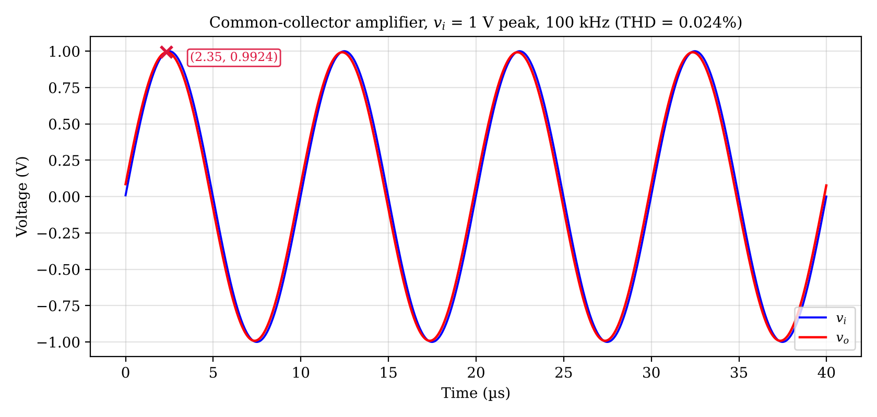
Figure 2.3.1 Input and output voltages of the common-collector amplifier (ngspice).
Table 2.3.3 Coordinates of the cursors in Figure 2.3.1
Cursor | x coordinate | y coordinate
X1 | Time = 2.350 µs | Voltage = 0.9924 V

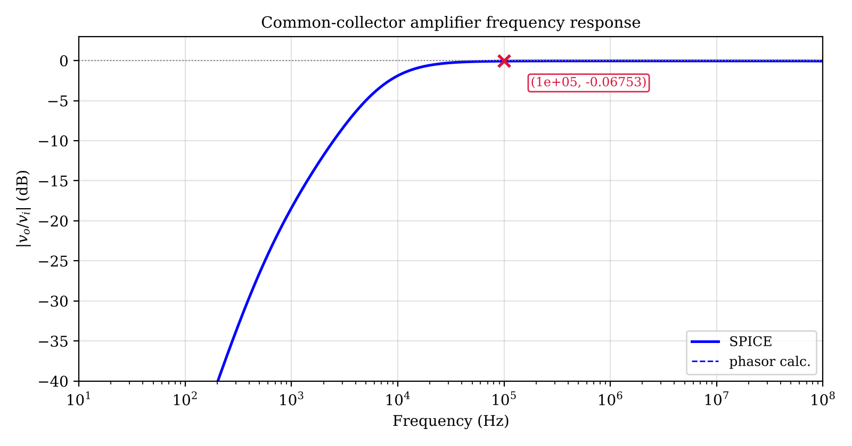
Figure 2.3.2 Frequency response of the common-collector amplifier.
Table 2.3.4 Coordinates of the cursors in Figure 2.3.2
Cursor | x coordinate | y coordinate
X1 | Frequency = 1.000e+05 Hz | $\left|v_{o}/v_{i}\right|$ = −0.06753 dB

The LTspice result for this case is shown in Figure 2.3.3 and the cursor comparison is given in Table 2.3.5.
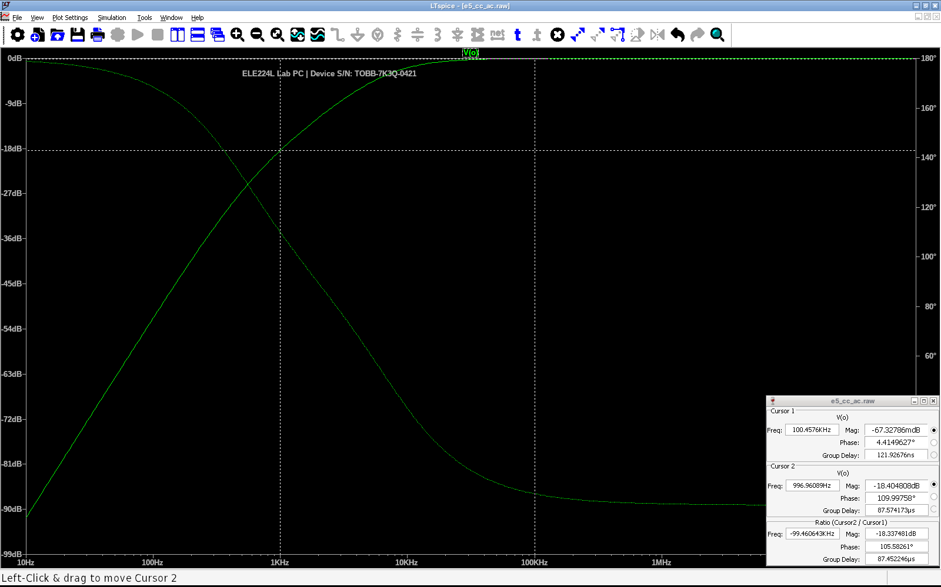
Figure 2.3.3 LTspice AC analysis of the common-collector (emitter-follower) amplifier (device serial number: TOBB-7K3Q-0421)
Table 2.3.5 Cursor coordinates read in Figure 2.3.3 and the ngspice values at the same x
Cursor | x coordinate | Quantity | LTspice | ngspice | Difference
1 | f = 100.458 kHz | $\left|V_{O}\right|$ | −0.067328 dB | −0.067329 dB | +0.000 dB
1 | f = 100.458 kHz | $∠V_{O}$ | 4.415 ° | 4.4153 ° | -0.000 °
2 | f = 996.96 Hz | $\left|V_{O}\right|$ | −18.405 dB | −18.405 dB | +0.001 dB
2 | f = 996.96 Hz | $∠V_{O}$ | 110 ° | 110 ° | -0.002 °

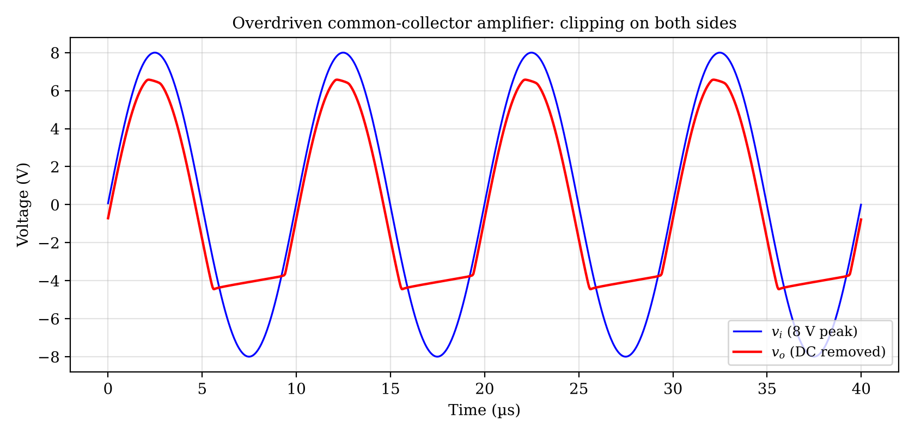
Figure 2.3.4 Overdriven common-collector amplifier (the output clips on both sides).
Is it possible to double the gain? No. From (2.6), $A_{V}=\frac{\left(β+1\right)R_{E}′}{r_{π}+\left(β+1\right)R_{E}′}$ is smaller than one for any finite $β$, because the denominator is larger than the numerator by $r_{π}$. The gain approaches one only when $\left(β+1\right)R_{E}′≫r_{π}$ (equivalently $R_{E}′≫r_{e}$), and it is already 0.9950. The largest possible improvement is therefore 0.5%, and a gain of about 2 cannot be obtained by changing the resistors or the bias. Physically, the output follows $v_{e}=v_{b}−V_{BE}$ with $V_{BE}$ almost constant, so that the emitter follower provides current gain ($β+1$) and impedance transformation, but not voltage gain. A voltage gain of 2 requires another configuration (for example, a common-emitter stage) or an additional gain stage.
2.4 Maximum Voltage Swing (Extra Points)
The voltage swing of the common-collector amplifier is limited by two boundaries of the AC load line: the saturation limit on the positive side, $V_{CEQ}−V_{CE\left(sat\right)}$, and the cut-off limit on the negative side, $I_{EQ}R_{E}′$. The largest symmetrical swing is obtained when the two limits are equal, i.e., when $V_{CEQ}=I_{EQ}R_{E}′$ with $V_{CEQ}=V_{CC}−I_{EQ}R_{E}$, which gives the optimum emitter current of (2.9).
 | $$I_{EQ,opt}=\frac{V_{CC}}{R_{E}+R_{E}′}=\frac{12}{3.300 \text{k}Ω+2.481 \text{k}Ω}=2.076 \text{mA}, V_{O,pp,max}≈2\left(V_{CC}−V_{CE\left(sat\right)}\right)\frac{R_{E}′}{R_{E}+R_{E}′}$$ | (2.9)

The designed circuit has $I_{EQ}=2.085$ mA and $V_{CEQ}=5.119$ V, which is almost exactly the optimum ($I_{EQ}R_{E}′=5.173$ V). The most important parameters for the swing are therefore (1) the bias resistors $R_{1}$, $R_{2}$ (the Q point), (2) the emitter and load resistors $R_{E}$, $R_{L}$ (the slope of the AC load line), (3) the supply voltage $V_{CC}$ (the available range) and (4) $V_{CE\left(sat\right)}$. The effects were investigated by SPICE simulations in which $R_{2}$ and $R_{L}$ were changed (Table 2.4.1, Figure 2.4.1); in each case, the DC values $V_{CEQ}$ and $I_{EQ}$ were found first, the two limits were calculated, and the largest output amplitude with THD ≤ $1\%$ was found by simulation.
Table 2.4.1 Effect of the bias resistor $R_{2}$ on the output swing of the common-collector amplifier ($R_{1}$ = 22 k$Ω$)
$R_{2}$ (k$Ω$) | $V_{CEQ}$ SPICE (V) | $I_{EQ}$ (mA) | Sat. limit (V) | Cut-off limit (V) | Load-line $V_{O,pp}$ (V) | SPICE $V_{O,pp}$, THD≤1% (V)
12.0 | 8.42 | 1.08 | 8.23 | 2.68 | 5.36 | 5.47
18.0 | 7.29 | 1.42 | 7.10 | 3.53 | 7.06 | 7.26
27.0 | 6.13 | 1.78 | 5.93 | 4.41 | 8.82 | 9.09
39.0 | 5.12 | 2.09 | 4.92 | 5.17 | 9.84 | 10.4
56.0 | 4.23 | 2.36 | 4.02 | 5.85 | 8.04 | 10.4
82.0 | 3.43 | 2.60 | 3.22 | 6.45 | 6.44 | 10.4
150 | 2.49 | 2.89 | 2.28 | 7.16 | 4.56 | 10.5

Table 2.4.2 Effect of the load resistor $R_{L}$ on the output swing ($R_{1}$ = 22 k$Ω$, $R_{2}$ = 39 k$Ω$)
$R_{L}$ (k$Ω$) | Sat. limit (V) | Cut-off limit (V) | Load-line $V_{O,pp}$ (V) | SPICE $V_{O,pp}$ (V)
1.00 | 4.92 | 1.60 | 3.20 | 3.06
2.20 | 4.92 | 2.75 | 5.50 | 5.55
4.70 | 4.92 | 4.04 | 8.08 | 8.28
10.0 | 4.92 | 5.17 | 9.84 | 10.4
22.0 | 4.92 | 5.98 | 9.84 | 11.3
47.0 | 4.92 | 6.43 | 9.84 | 11.7

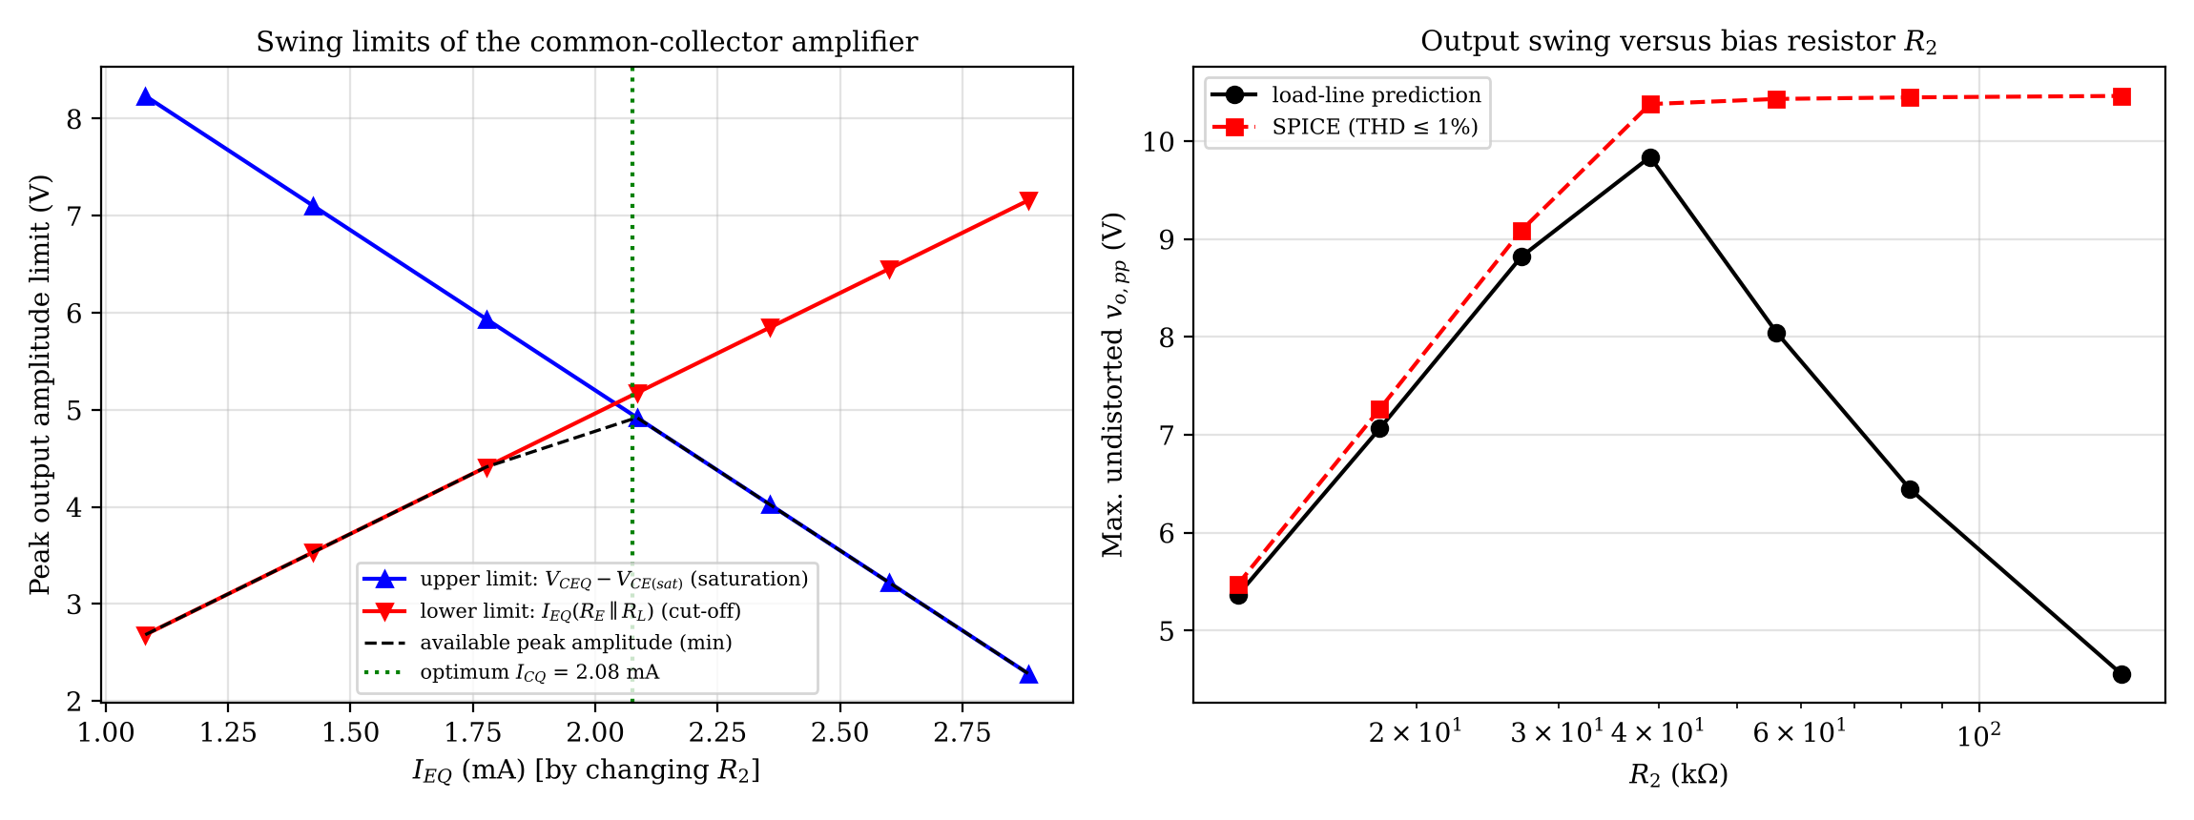
Figure 2.4.1 Swing limits and simulated swing of the common-collector amplifier versus the bias current (left) and $R_{2}$ (right).
The results show the following. (1) For a small bias current ($R_{2}≤27$ k$Ω$), the swing is limited by cut-off ($I_{EQ}R_{E}′$) and grows in proportion to $I_{EQ}$; the load-line prediction and the simulation agree within 4%. (2) Around the optimum bias ($R_{2}≈39$ k$Ω$), both limits are almost equal and the load-line swing is maximum (9.84 V). (3) For a larger bias current, the load line predicts a decrease of the swing since $V_{CEQ}$ becomes small (saturation limit), but the simulation shows a plateau of about 10.5 V peak-to-peak: with a large signal, the peaks of the base current charge the coupling capacitor $C_{C1}$ and lower the average base voltage (for $R_{2}=150$ k$Ω$ and a 4 V input, the average base voltage falls from 10.1 V to 8.7 V), which moves the bias point towards the centre of the available range automatically. (4) A larger load resistor increases the cut-off limit ($I_{EQ}R_{E}′$) until the saturation limit (4.92 V) takes over; for $R_{L}≥10$ k$Ω$, the swing no longer improves in the load-line prediction, and the simulation gives 11.7 V peak-to-peak for $R_{L}=47$ k$Ω$, close to the supply limit of 12 V. In summary, the swing is maximum when the Q point is at the middle of the AC load line, the load resistance is not small compared with $R_{E}$, and the supply voltage is as high as possible; $V_{CEQ}$ must be kept above $V_{CE\left(sat\right)}$ plus the half swing, and $V_{CE}$ must be monitored during the simulation to see on which side the clipping starts.
3 CONCLUSIONS
The comparison of the calculations and SPICE showed that the DC operating points agree within about 2% ($V_{CEQ}$: -1.5% for the common-emitter and +0.0% for the common-collector circuit), and that the voltage gains at 100 kHz agree within 0.1% (+0.0% and -0.0%) when the capacitor impedances are included in the calculation. The mid-band gain of the common-emitter amplifier with $C_{E}$ ($\left|A_{V}\right|=184$) is not reached at 100 kHz, since the 22 nF bypass capacitor has an impedance of 72 $Ω$ at this frequency, which is larger than $r_{e}=22.1 Ω$; the measured gain is 52.8, and the simulated maximum of the frequency response is 178 at 1585 kHz (-3.3% relative to the hand value) because the model parameters and the transistor capacitances differ from the ideal model. The input resistance with $C_{E}$ at 100 kHz is smaller in SPICE (9.88 versus 10.7 k$Ω$) because of the Miller effect of the collector capacitance, which is not included in the hand analysis.
The largest undistorted output of the common-emitter amplifier with $C_{E}$ is only 0.764 V peak-to-peak, which is limited by the exponential characteristic and not by clipping (the load-line value is 6.24 V); the emitter resistor increases the linear range by a factor of about 146 at the cost of the gain (2.22 instead of 52.7). The emitter follower has a gain of 0.995, a high input resistance (13.6 k$Ω$), a low output resistance (12.4 $Ω$) and a large swing (9.84 V peak-to-peak by the load line), and its gain cannot be doubled. The swing is maximum when the Q point is at the middle of the AC load line, which the given design nearly satisfies.
4 REFERENCES
1. Fairchild Semiconductor. (2002). BC237/238/239 NPN epitaxial silicon transistor [Data sheet, Rev. A2]. Retrieved October 11, 2026, from https://wmsc.lcsc.com/wmsc/upload/file/pdf/v2/lcsc/2309151357_onsemi-BC237_C3201628.pdf
2. Sedra, A. S., & Smith, K. C. (2014). Microelectronic circuits (7th ed.). New York: Oxford University Press.
3. ngspice. (n.d.). ngspice user manual. Retrieved October 11, 2026, from https://ngspice.sourceforge.io/docs.html
5 APPENDICES
5.1 Appendix A: SPICE Model and Netlists
Code A.1 BJT model line used in the ngspice simulations (see Experiment 4 for the fitting of the parameters)
.model BC238A NPN(IS=7.7754e-14 BF=170 BR=1 RB=30 RC=1 CJE=8p CJC=3.5p TF=0.5n)

Netlist A.2 Common-emitter amplifier with $C_{E}$ (AC analysis; the transient netlist differs only in the analysis command)
VCC vcc 0 DC 12
Vi in 0 DC 0 AC 1 SIN(0 0.001 100000)
Cc1 in b 22n
R1 vcc b 120k
R2 b 0 39k
RC vcc c 5.6k
Q1 c b e BC238A
RE e 0 1.8k
CE e 0 22n
Cc2 c o 2.2n
RL o 0 15k
.model BC238A NPN(IS=7.7754e-14 BF=170 BR=1 RB=30 RC=1 CJE=8p CJC=3.5p TF=0.5n)

.ac dec 60 10 100Meg
.end

Netlist A.3 Common-collector amplifier (AC analysis)
VCC vcc 0 DC 12
Vi in 0 DC 0 AC 1 SIN(0 0.001 100000)
Cc1 in b 22n
R1 vcc b 22000
R2 b 0 39000
Q1 vcc b e BC238A
RE e 0 3300
Cc2 e o 2.2n
RL o 0 10000
.model BC238A NPN(IS=7.7754e-14 BF=170 BR=1 RB=30 RC=1 CJE=8p CJC=3.5p TF=0.5n)

.ac dec 60 10 100Meg
.end

