TOBB University of Economics and Technology
Department of Electrical and Electronics Engineering
ELE 224L – Electronic Circuits Laboratory
Experiment 3 – Preliminary Work: MOSFET Amplifiers
Name Surname
Student ID
Date

1 INTRODUCTION
1.1 Objective of the Experiment
The objective of this experiment is to learn the operating principle of the MOSFET as an amplifying element in the common-source amplifier and as a matched current source in the current mirror. The DC operating point (Q point), the small-signal gain, and the input and output resistances of a common-source amplifier are calculated for the cases with and without a source bypass capacitor, and the current mirror is analysed for a range of input voltages, including the voltage at which it stops working.
1.2 Benefits of the Experiment
The experiment shows that an amplifier analysis consists of two separate steps (a DC bias analysis and a small-signal AC analysis), that a bypass capacitor changes the gain by a large factor, and that the capacitor values must be checked against the test frequency before a mid-band formula is used. It also shows how a current mirror copies a reference current and where this copying fails. These skills are required for the BJT amplifiers of the next experiments.
2 CALCULATIONS AND SIMULATIONS
2.1 Common-Source Amplifier Circuit
The amplifier circuit is shown in Figure 2.1.1. The values $V_{DD}=12$ V, $R_{1}=47$ k$Ω$, $R_{2}=33$ k$Ω$, $R_{D}=15$ k$Ω$, $R_{S}=10$ k$Ω$, $R_{L}=10$ k$Ω$, $C_{C1}=22$ nF, $C_{C2}=2.2$ nF and $C_{S}=22$ nF are used. The BS170 is modelled with the square-law equation $I_{D}=\left(K_{N}/2\right){\left(V_{GS}−V_{TH}\right)}^{2}$ with $K_{N}=72$ mA/V² and $V_{TH}=2.0$ V, and the channel-length modulation is neglected.
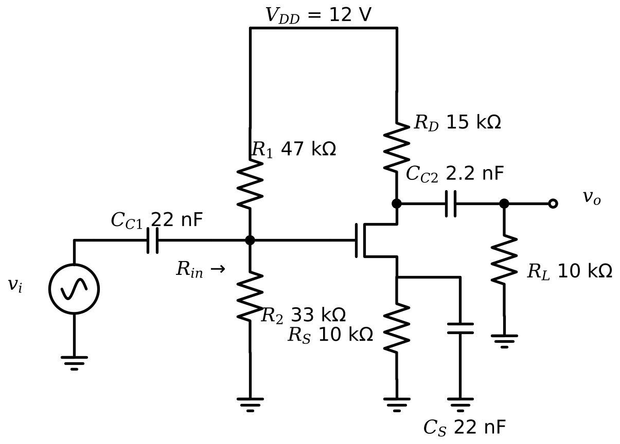
Figure 2.1.1 Common-source amplifier circuit analysed in the experiment.
DC analysis. All capacitors are open circuits for DC. The gate voltage is given by the divider, (2.1). The gate current is zero, so $V_{GS}=V_{G}−I_{D}R_{S}$. Substituting this into the square law and writing $V_{OV}=V_{GS}−V_{TH}$ gives the quadratic equation (2.2).
 | $$V_{G}=V_{DD}\frac{R_{2}}{R_{1}+R_{2}}=12⋅\frac{33}{80}=4.95 \text{V}$$ | (2.1)

 | $$\frac{K_{N}}{2}R_{S} V_{OV}^{2}+V_{OV}−\left(V_{G}−V_{TH}\right)=0 ⇒ 360 V_{OV}^{2}+V_{OV}−2.95=0$$ | (2.2)

The positive root is $V_{OV}=0.08914$ V, so $V_{GSQ}=2.0+0.08914=2.089$ V, $I_{DQ}=\left(72/2\right){\left(0.08914\right)}^{2}=0.2861$ mA, and $V_{DSQ}=V_{DD}−I_{DQ}\left(R_{D}+R_{S}\right)=12−0.2861×25=4.848$ V. Since $V_{DSQ}>V_{OV}$, the transistor is in saturation, which verifies the assumption. The transconductance is $g_{m}=K_{N}V_{OV}=6.418$ mS.
Small-signal analysis. For mid-band frequencies, the coupling capacitors are short circuits and the supply is an AC ground. With $C_{S}$ present, the source is at AC ground and the gain is given by (2.3). Without $C_{S}$, the source resistor produces local feedback, and the gain is given by (2.4). In both cases, $R_{in}=R_{1}∥R_{2}$ because the gate draws no current, and $R_{out}=R_{D}$ because the output resistance of the transistor is infinite in the model (the load $R_{L}$ is not included in $R_{out}$).
 | $$A_{V}=−g_{m}\left(R_{D}∥R_{L}\right)=−6.418 \text{mS}×6 \text{k}Ω=−38.51$$ | (2.3)

 | $$A_{V}=−\frac{g_{m}\left(R_{D}∥R_{L}\right)}{1+g_{m}R_{S}}=\frac{−38.51}{1+6.418×10}=−0.591$$ | (2.4)

 | $$R_{in}=R_{1}∥R_{2}=19.39 \text{k}Ω, R_{out}=R_{D}=15 \text{k}Ω$$ | (2.5)

Table 2.1.1 Calculated Q point, gain and resistances of the common-source amplifier
 | Circuit with $C_{S}$ | Circuit without $C_{S}$
$V_{GSQ}$ (V) | 2.089 | 2.089
$V_{DSQ}$ (V) | 4.848 | 4.848
$I_{DQ}$ (mA) | 0.2861 | 0.2861
$A_{V}=V_{o}/V_{i}$ (mid-band, $C_{S}$ ideal short) | −38.51 | −0.5908
$R_{in}$ (k$Ω$) | 19.39 | 19.39
$R_{out}$ (k$Ω$) | 15.00 | 15.00
$\left|A_{V}\right|$ at 10 kHz (phasor analysis) | 7.689 | 0.5671

The mid-band formulas assume that $C_{S}$ is a perfect short circuit. This assumption was checked for the test frequency of 10 kHz. At this frequency, the impedance of $C_{S}$ is $1/\left(2πfC_{S}\right)=723 Ω$, which is not small compared with $1/g_{m}=156 Ω$; the parallel combination of $R_{S}$ and $C_{S}$ is 722 $Ω$ in magnitude, and the gain is reduced by the factor $\left|1+g_{m}Z_{S}\right|$. A complete phasor analysis of the circuit (including $C_{C1}$, $C_{C2}$ and $C_{S}$) gives $\left|A_{V}\right|=7.69$ with $C_{S}$ and 0.567 without $C_{S}$ at 10 kHz, as listed in the last row of Table 2.1.1. For $\left|A_{V}\right|$ at 10 kHz to reach 90% of the mid-band value, $C_{S}$ would have to be about 0.28 µF.
SPICE. The circuit was built with the BS170 model. The Q point obtained from the DC analysis is compared with the calculation in Table 2.1.2. A sinusoidal input of 100 mV amplitude and 10 kHz was applied, and the time-domain graphs are shown in Figure 2.1.2 (with $C_{S}$) and Figure 2.1.3 (without $C_{S}$); more than two periods are visible. The transient amplitude ratio was measured in steady state. The frequency response obtained with an AC analysis is shown in Figure 2.1.4.
Table 2.1.2 Comparison of the calculation and SPICE for the common-source amplifier (Error = (SPICE $−$ calculation)/calculation)
Quantity | Calculation | SPICE | Error
$V_{GSQ}$ (V) | 2.089 | 2.168 | +3.8%
$V_{DSQ}$ (V) | 4.848 | 5.044 | +4.0%
$I_{DQ}$ (mA) | 0.2861 | 0.2782 | -2.7%
$\left|A_{V}\right|$ at 10 kHz, with $C_{S}$ | 7.689 | 7.748 | +0.8%
$\left|A_{V}\right|$ at 10 kHz, without $C_{S}$ | 0.5671 | 0.5690 | +0.3%
Mid-band $\left|A_{V}\right|$, with $C_{S}$ (SPICE at 1 MHz) | 38.51 | 48.97 | +27.2%
Mid-band $\left|A_{V}\right|$, without $C_{S}$ (SPICE at 1 MHz) | 0.5908 | 0.5927 | +0.3%
$R_{in}$ at 10 kHz (k$Ω$) | 19.39 | 19.40 | +0.07%
$R_{out}$ (k$Ω$) | 15.00 | 15.00 | -0.00%

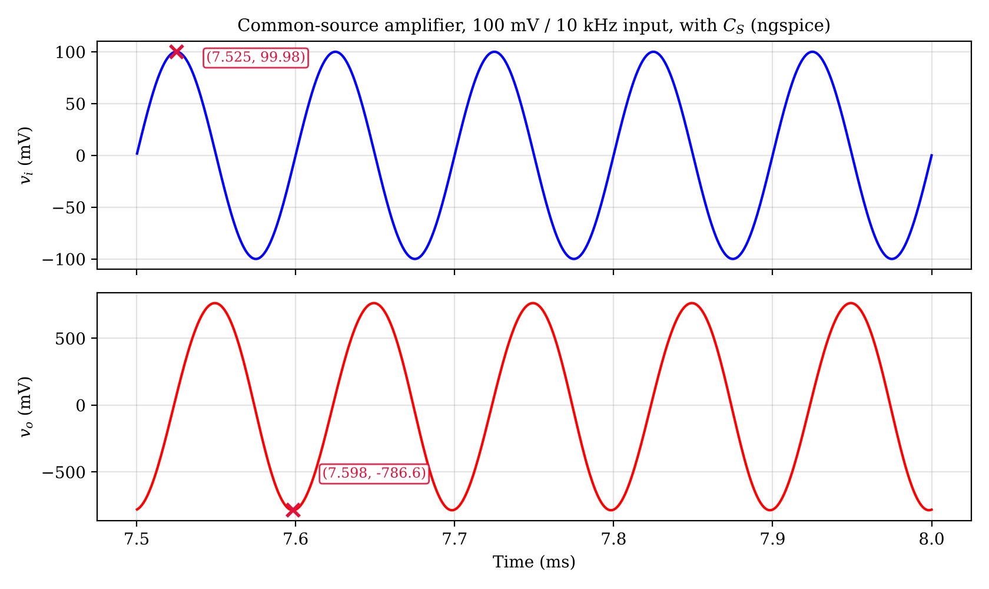
Figure 2.1.2 Input and output voltages of the common-source amplifier with $C_{S}$ (100 mV, 10 kHz; ngspice).
Table 2.1.3 Coordinates of the cursors in Figure 2.1.2
Cursor | x coordinate | y coordinate
X1 | = 7.525 | $v_{i}$ = 99.98 mV
X2 | Time = 7.598 ms | $v_{o}$ = −786.6 mV

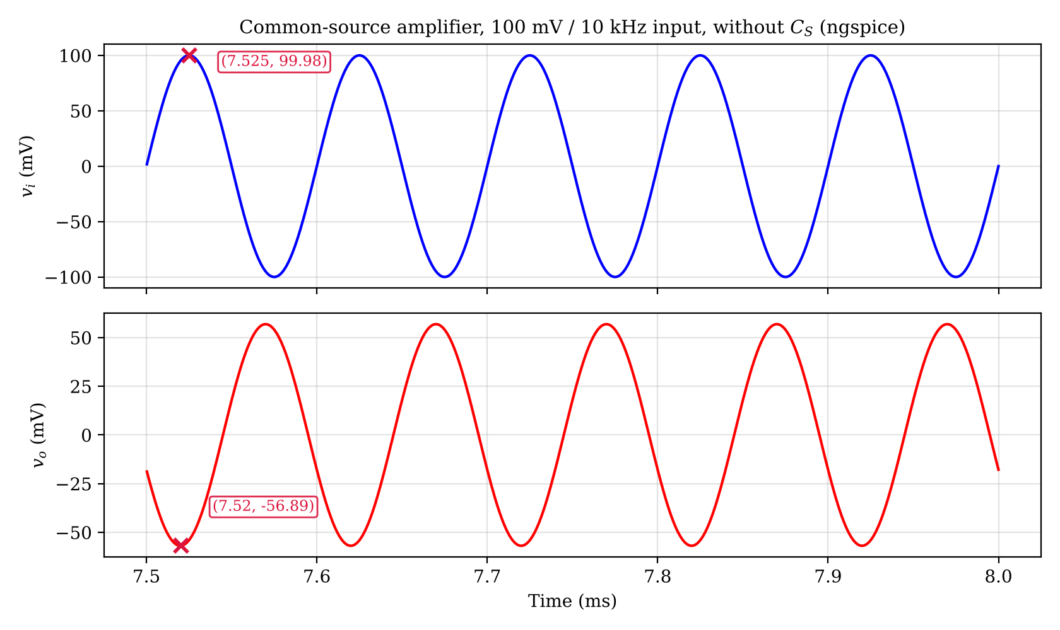
Figure 2.1.3 Input and output voltages of the common-source amplifier without $C_{S}$ (100 mV, 10 kHz; ngspice).
Table 2.1.4 Coordinates of the cursors in Figure 2.1.3
Cursor | x coordinate | y coordinate
X1 | = 7.525 | $v_{i}$ = 99.98 mV
X2 | Time = 7.520 ms | $v_{o}$ = −56.89 mV

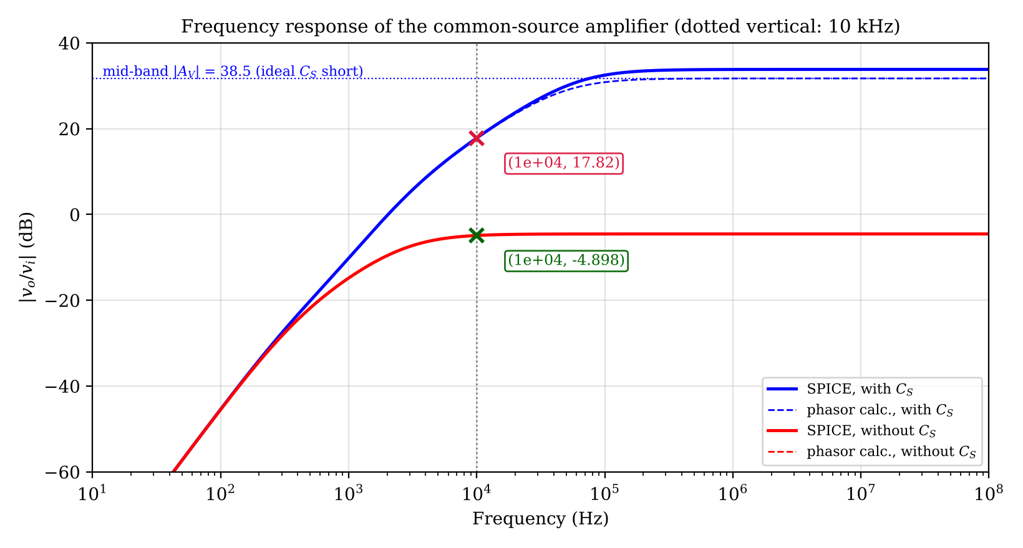
Figure 2.1.4 Frequency response of the amplifier: SPICE (solid) and the phasor calculation (dashed).
Table 2.1.5 Coordinates of the cursors in Figure 2.1.4
Cursor | x coordinate | y coordinate
X1 | Frequency = 1.000e+04 Hz | $\left|v_{o}/v_{i}\right|$ = 17.82 dB
X2 | Frequency = 1.000e+04 Hz | $\left|v_{o}/v_{i}\right|$ = −4.898 dB

Interpretation. The DC values of SPICE differ from the calculation by less than 5%, since the SPICE model has a larger transconductance parameter ($KP⋅W/L=123.3$ mA/V² against $K_{N}=72$ mA/V²), a slightly higher threshold (2.1 V against 2.0 V), and series resistances $R_{D}$ and $R_{S}$ of 1.4 and 1.6 $Ω$. At 10 kHz, the measured gain with $C_{S}$ is 7.75, which is far below the mid-band value 38.5 of the calculation, but it agrees with the phasor calculation (7.69) to 0.8%; the reason is that at this frequency the gain is determined by the impedance of $C_{S}$, $\left|A_{V}\right|≈R_{L}′/\left|Z_{S}\right|$, and not by $g_{m}$. The mid-band gain of SPICE (49.0) is 27% larger than the calculated mid-band gain since the SPICE transistor has a higher $g_{m}$ at the same current, and this difference is visible only above about 100 kHz in Figure 2.1.4. Without $C_{S}$, the gain is almost independent of $g_{m}$ because $g_{m}R_{S}≫1$, $A_{V}≈−R_{L}′/R_{S}=−0.6$, and the SPICE result agrees with the calculation within 0.3%.
2.2 Current Mirror Circuit
The current mirror is shown in Figure 2.2.1. The transistor M1 is diode connected (its gate and drain are tied), so it is always in saturation, and $V_{GS}$ is set by the reference current $I_{ref}$. Since M2 has the same $V_{GS}$ and is identical to M1, it carries the same current as long as it stays in saturation, i.e., as long as $V_{DS2}=V_{DD}−I_{out}R_{2}≥V_{OV}$. The reference current is found from the loop equation (2.6), which is solved for $I_{ref}$ by iteration (or as a quadratic in $V_{OV}$).
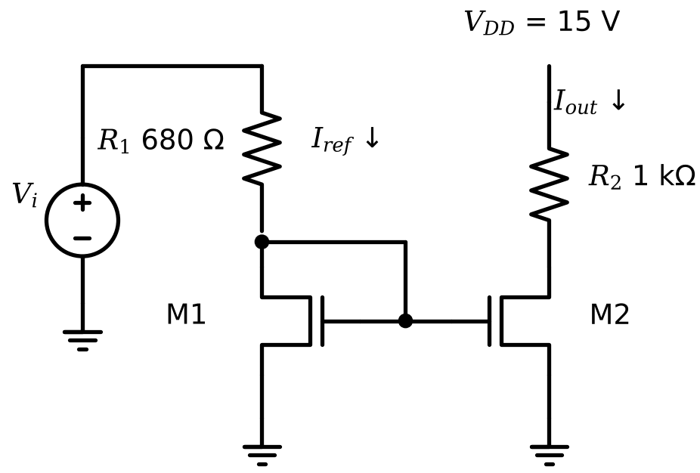
Figure 2.2.1 Current mirror circuit analysed in the experiment.
 | $$V_{i}=R_{1}I_{ref}+V_{TH}+\sqrt{\frac{2I_{ref}}{K_{N}}}$$ | (2.6)

For example, for $V_{i}=3$ V, $V_{i}−V_{TH}=1$ V gives the quadratic $24.48 V_{OV}^{2}+V_{OV}−1=0$ (with $V_{OV}$ in V and $R_{1}=0.68$ k$Ω$), and $V_{OV}=0.182$ V, $I_{ref}=36⋅{0.182}^{2}=1.20$ mA. Then $V_{DS2}=15−1.20×1=13.8$ V > $V_{OV}$, so M2 is in saturation and $I_{out}=I_{ref}=1.20$ mA. For $V_{i}=1$ V (below $V_{TH}$), M1 is off and both currents are zero. For $V_{i}=15$ V, $I_{ref}$ would be 18.08 mA and M2 would require $V_{DS2}=15−18.1<0$, which is impossible; M2 therefore leaves saturation, enters the triode region, and the solution of the triode current equation together with $V_{DS2}=15−I_{out}R_{2}$ gives $I_{out}=14.60$ mA. The hand-calculated and simulated values are given in Table 2.2.1.
Table 2.2.1 Reference and output currents of the current mirror: calculation and SPICE
$V_{i}$ (V) | $I_{ref}$ calc. (mA) | $I_{out}$ calc. (mA) | $I_{ref}$ SPICE (mA) | $I_{out}$ SPICE (mA) | M2 region (calc.)
1.00 | 0 | 0 | ≈ 0 | ≈ 0 | cut-off
3.00 | 1.202 | 1.202 | 1.122 | 1.122 | saturation
5.00 | 3.926 | 3.926 | 3.886 | 3.886 | saturation
8.00 | 8.125 | 8.125 | 8.124 | 8.124 | saturation
10.0 | 10.95 | 10.95 | 10.97 | 10.97 | saturation
12.0 | 13.80 | 13.80 | 13.83 | 13.83 | saturation
15.0 | 18.08 | 14.60 | 18.13 | 14.66 | triode

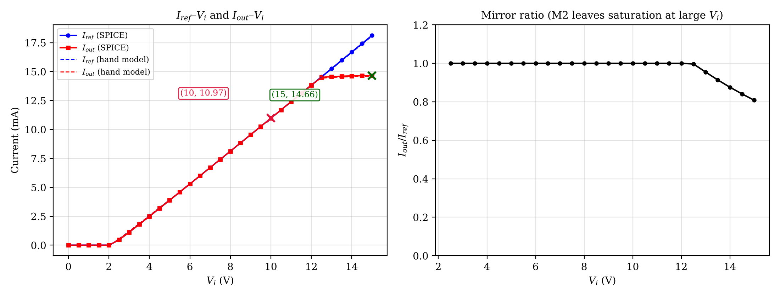
Figure 2.2.2 $I_{ref}$–$V_{i}$ and $I_{out}$–$V_{i}$ graphs of the current mirror ($V_{i}$ on the x-axis) with the mirror ratio (ngspice).
Table 2.2.2 Coordinates of the cursors in Figure 2.2.2
Cursor | x coordinate | y coordinate
X1 | $V_{i}$ = 10.00 V | Current = 10.97 mA
X2 | $V_{i}$ = 15.00 V | Current = 14.66 mA

The two currents are equal (within 0.1%) up to $V_{i}=12$ V. The SPICE and calculated reference currents agree within 1.0% for $V_{i}≥5$ V, whereas at 3 V the SPICE current is 6.6% lower than the calculated one; this larger difference is caused by the different transconductance and threshold of the SPICE model when $V_{OV}$ is small. For $V_{i}=15$ V, $I_{out}$ stays at about 14.7 mA while $I_{ref}$ continues to rise to 18.1 mA, because M2 enters the triode region (the calculation predicts this for $V_{i}>12.4$ V; in the 0.5 V steps of the SPICE sweep, the ratio $I_{out}/I_{ref}$ first falls below 0.99 at 13.0 V). The mirror therefore works as long as the load drop $I_{out}R_{2}$ leaves at least $V_{OV}$ across M2, i.e., $V_{DD}−I_{out}R_{2}≥V_{OV}$. In saturation, the equality of the currents also relies on the neglect of channel-length modulation, which is zero in the BS170 model.
3 CONCLUSIONS
The calculated Q point of the common-source amplifier ($V_{GSQ}=2.09$ V, $I_{DQ}=0.286$ mA, $V_{DSQ}=4.85$ V) agrees with SPICE within about 4%, with the differences caused by the model parameters. The most important result is that the mid-band gain formulas cannot be applied at 10 kHz with the given capacitor values: the bypass capacitor of 22 nF is too small, and the measured gain with $C_{S}$ is 7.75 instead of 38.5. A bypass capacitor of at least about 0.28 µF would be required for this test frequency, or the test frequency should be raised above about 100 kHz. Without the bypass capacitor, the gain is small (−0.591) but stable, since it depends only on the resistor ratio. The analysis also gave $R_{in}=19.39$ k$Ω$ (set by the bias divider) and $R_{out}=15$ k$Ω$ (set by $R_{D}$); the SPICE values agree within 0.1%.
In the current mirror, the output current follows the reference current until the output transistor loses saturation at about 12–13 V; the experiment taught the limit of the mirror (compliance voltage), the use of a diode-connected transistor as a bias generator, and the difference between an ideal copy and the real behaviour. The unexpected results above were explained by checking the capacitor impedances and the model parameters, which is a skill required in the remaining experiments.
4 REFERENCES
1. Sedra, A. S., & Smith, K. C. (2014). Microelectronic circuits (7th ed.). New York: Oxford University Press.
2. ON Semiconductor. (2017). BS170 small signal MOSFET 500 mA, 60 volts [Data sheet]. Retrieved October 11, 2026, from https://www.onsemi.com/download/data-sheet/pdf/bs170-d.pdf
3. ngspice. (n.d.). ngspice user manual. Retrieved October 11, 2026, from https://ngspice.sourceforge.io/docs.html
5 APPENDICES
5.1 Appendix A: SPICE Netlists
Netlist A.1 Common-source amplifier with $C_{S}$ (transient)
VDD vdd 0 DC 12
Vi in 0 DC 0 AC 1 SIN(0 0.1 10k)
Cc1 in g 22n
R1 vdd g 47k
R2 g 0 33k
M1 d g s 0 BS170 W=100u L=100u
RD vdd d 15k
RS s 0 10k
CS s 0 22n
Cc2 d o 2.2n
RL o 0 10k

.model BS170 NMOS (VTO=2.1 RS=1.572 RD=1.436 KP=.1233 IS=5p)

.tran 2u 8m 0 1u
.end

Netlist A.2 Current mirror (DC sweep)
VDD vdd 0 DC 15
Vi vi 0 DC 0
R1 vi d1 680
M1 d1 d1 0 0 BS170 W=100u L=100u
M2 d2 d1 0 0 BS170 W=100u L=100u
R2 vdd d2 1k
.model BS170 NMOS (VTO=2.1 RS=1.572 RD=1.436 KP=.1233 IS=5p)

.dc Vi 0 15 0.5
.end

