Heroes of Pymoli Sales Analysis

1. Players aged 20-24 are more likely to purchase more than one item in game than other age groups; and players aged 40+ are more self-controlled on spending

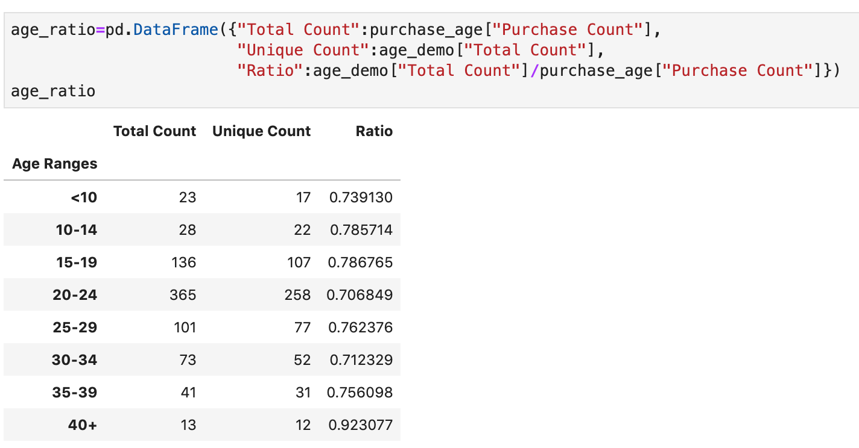

1. Female players are more likely to purchase more than one item and tend to spend more than male players

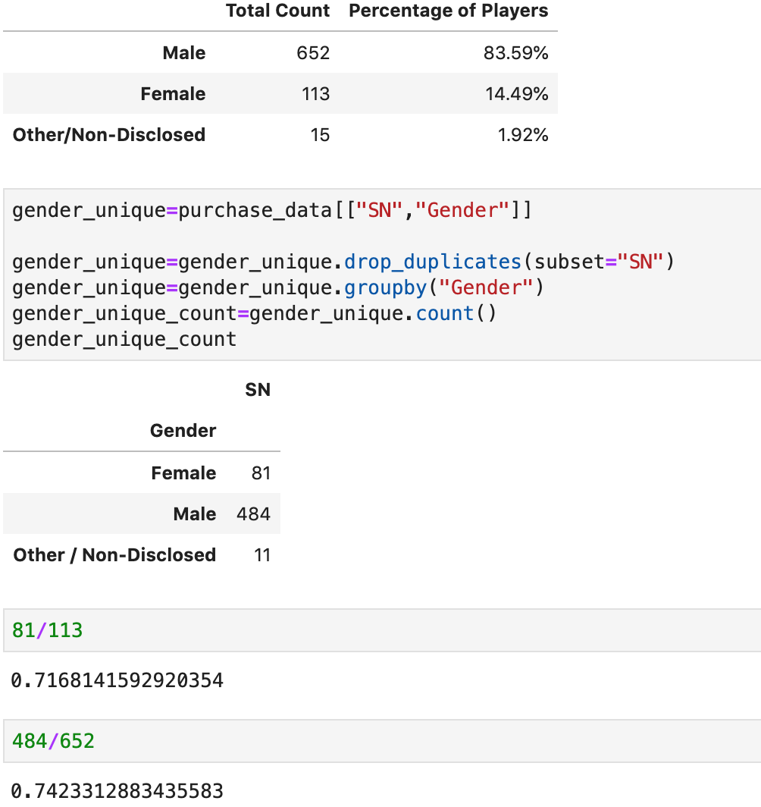

1. Item price doesn’t seem to have significant impact on popularity. Oathbreaker, Last Hope of the Breaking Storm is currently the most popular and most profitable item

