Fed-ANIDS: Privacy-Preserving Federated Network Intrusion Detection System
Comprehensive Research & Engineering Project Report
Department of Electrical Engineering
Faculty of Engineering and Technology, Jamia Millia Islamia, New Delhi

Project Identification
- Project Title: Fed-ANIDS: Privacy-Preserving Federated Network Intrusion Detection System
- Authors / Project Team:
- Faizan Abrar (Student ID: 23BEE018)
- Adnan Ahmed Ansari (Student ID: 23BEE011)
- Yaseen Umar Shees (Student ID: 23BEE010)
- Academic Supervisor: Prof. Ikbal Ali
- Primary Research Foundations:
- Federated Anomaly Detection: T. D. Nguyen et al., "DÏoT: A Federated Self-learning Anomaly Detection System for IoT," in Proceedings of the 2019 IEEE 39th International Conference on Distributed Computing Systems (ICDCS), pp. 756–767, 2019. DOI: [10.1109/ICDCS.2019.00080](https://doi.org/10.1109/ICDCS.2019.00080).
- Decentralized Edge Defense: V. Mothukuri et al., "Federated-learning-based anomaly detection for IoT security attacks," IEEE Internet of Things Journal, vol. 9, no. 4, pp. 2545–2554, 2022. DOI: [10.1109/JIOT.2021.3077803](https://doi.org/10.1109/JIOT.2021.3077803).
- Dataset Evaluated: Canadian Institute for Cybersecurity CIC-IDS2017 Benchmark Dataset (Friday PortScan & Benign Traffic)
- Execution Date & Status: September 2026 | Empirically Validated & Reproducible

Executive Summary
Modern enterprise and cloud networks face an escalating barrage of sophisticated, zero-day cyber threats that evade traditional signature-based Network Intrusion Detection Systems (NIDS). While centralized Machine Learning (ML) approaches offer improved anomaly detection, aggregating raw network packet captures (PCAP) and IP flow records into a centralized cloud repository introduces severe privacy vulnerabilities, regulatory non-compliance (e.g., GDPR, HIPAA, and ISO/IEC 27001), and massive bandwidth overhead.
This project implements and empirically validates Fed-ANIDS, an unsupervised, privacy-preserving federated anomaly detection architecture. Fed-ANIDS synergizes Deep Autoencoders trained strictly on normal (benign) network flows with Federated Learning (FL) across decentralized client organization nodes. Under this paradigm, private raw traffic data never leaves local perimeters; only numerical neural network parameters are exchanged with a central federated orchestrator.
To confront real-world network traffic heterogeneity (Non-IID distributions across corporate departments), this research implements and benchmarks both Federated Averaging (FedAvg) and Federated Proximal (FedProx) against a centralized upper-bound baseline. Validated on 40,000 network flows from the benchmark CIC-IDS2017 dataset distributed across 10 client organizations under a Non-IID Dirichlet distribution (α = 0.5):
- FedProx ($\mu = 0.01$) achieved an extraordinary 96.51% Accuracy, 98.00% F1-Score, 99.37% Detection Rate (Recall), and 96.67% Precision, successfully matching and slightly outperforming the centralized baseline (96.45% Accuracy, 97.97% F1-Score).
- Across 22,205 attack flows, FedProx missed only 140 intrusions, achieving an ultralow Miss Rate (False Negative Rate) of 0.63%, whereas standard FedAvg degraded to a 23.99% miss rate due to client model drift.
- All trained PyTorch models, preprocessing artifacts, metric logs, and visualization figures have been systematically produced, verified, and saved to disk.

1. Introduction & Motivation
1.1 The Vulnerabilities of Modern NIDS
Network Intrusion Detection Systems are foundational defense mechanisms in enterprise cyber infrastructure. Traditional NIDS primarily rely on signature-based detection (e.g., Snort, Suricata rules). While effective against previously documented attack patterns, signature matching suffers from a catastrophic failure mode: zero-day vulnerability. Novel exploits, modified attack payloads, and zero-day intrusions bypass static signatures effortlessly.
1.2 The Privacy & Bandwidth Bottleneck of Centralized ML
Anomaly-based NIDS (A-NIDS) overcome signature limitations by modeling normal behavior and flagging deviations. However, traditional machine learning implementations demand centralizing all network flow records or PCAP files from every edge router, corporate branch, and cloud subnet into a central server. This architecture exhibits severe drawbacks:
- Confidentiality & Regulatory Violation: Network telemetry contains sensitive corporate data, employee identities, source/destination IP addresses, internal topological maps, and confidential payload metadata. Centralizing these logs directly violates international data protection regulations (GDPR, HIPAA, PCI-DSS).
- Bandwidth Saturation: Modern enterprise networks generate petabytes of flow telemetry daily. Continuously streaming uncompressed telemetry across Wide Area Networks (WAN) exhausts network bandwidth and incurs exorbitant cloud ingress/storage costs.
- Single Point of Failure: A centralized telemetry store represents a high-value target for adversarial exfiltration and denial-of-service attacks.
1.3 The Federated Learning Paradigm
Federated Learning (FL) fundamentally decouples model training from direct data collection. Instead of transporting raw data to the model, FL distributes the model to the decentralized data sources (client nodes). Each client trains locally on its private traffic and shares only model weight parameters (w) or gradients (\nabla w) with an aggregation server.
flowchart TD
subgraph CentralServer ["Central Federated Orchestrator"]
GM["Global Autoencoder Model (w_t)"]
Agg["Aggregation Engine (FedAvg / FedProx)"]
Thresh["Benign Statistical Thresholding (tau)"]
end
subgraph ClientPerimeter ["10 Decentralized Enterprise Nodes (Private Boundary)"]
N1["Client Node 1 (Local Benign Flows)"]
N2["Client Node 2 (Local Benign Flows)"]
N3["Client Node 3 (Local Benign Flows)"]
NDots["... Nodes 4 to 9 ..."]
N10["Client Node 10 (Local Benign Flows)"]
end
GM -->|"1. Broadcast Global Weights (w_t)"| N1 & N2 & N3 & NDots & N10
N1 & N2 & N3 & NDots & N10 -->|"2. Local Optimization on Private Data"| N1 & N2 & N3 & NDots & N10
N1 & N2 & N3 & NDots & N10 -->|"3. Transmit Model Updates (w_{t+1}^k)"| Agg
Agg -->|"4. Update Global Model w_{t+1}"| GM
GM --> Thresh

2. Theoretical Architecture & Mathematical Formulation
2.1 Deep Autoencoder Formulation
The core anomaly detector in Fed-ANIDS is an unsupervised Deep Autoencoder (AE). Autoencoders are trained exclusively on benign network flows to learn the compressed manifold of normal traffic. When anomalous attack traffic is presented during inference, the model fails to reconstruct the unfamiliar patterns, resulting in a pronounced spike in reconstruction error.
The Autoencoder comprises an Encoder f_θ: R^D → R^d and a Decoder g_φ: R^d → R^D, where d \ll D:
z = f_θ(x ) = ReLU (LayerNorm (W _2 · ReLU (LayerNorm (W _1 x + b _1)) + b _2))
\hatx = g_φ(z ) = W _4 · ReLU (LayerNorm (W _3 z + b _3)) + b _4
Network Dimensions & Layers:
- Input Dimension ($D$): 68 numerical flow features (extracted from CIC-IDS2017).
- Hidden Layer 1: 64 neurons + Layer Normalization + ReLU activation.
- Latent Bottleneck ($d$): 32 neurons + Layer Normalization + ReLU activation.
- Hidden Layer 2: 64 neurons + Layer Normalization + ReLU activation.
- Output Layer ($D$): 68 neurons (reconstructed flow vector \hatx).
📌 NOTE: **Why Layer Normalization?** In federated learning, clients possess heterogeneous batch sizes and small local sample counts. Traditional Batch Normalization creates severe batch-dependency drift across clients. Layer Normalization operates across features per sample, ensuring mathematical stability regardless of client partition size.

2.2 Intrusion Scoring Metric
For any network flow vector x ∈ R^D, the Intrusion Score (IS) is defined as the per-sample Mean Squared Error (MSE):
IS(x ) = 1 D Σ_j=1 ^D ≤ft(x_j - \hatx _j\right)^2
- Normal Benign Traffic: Low reconstruction error (IS(x) ≤ τ).
- Malicious Attack Traffic: High reconstruction error (IS(x) > τ).
2.3 Statistical Anomaly Thresholding ($\tau$)
A central challenge in unsupervised intrusion detection is establishing the decision boundary τ without access to attack signatures. Fed-ANIDS calculates τ strictly on a held-out benign validation set \mathcalD_val^benign:
τ = Percentile ≤ft(\ IS(x ) \mid x ∈ \mathcalD _val ^benign \ , P\right)
In our primary implementation, P = 80.0, which sets the decision boundary such that 80% of normal traffic patterns reside safely below threshold, yielding high sensitivity to attack anomalies.
2.4 Federated Optimization: FedAvg vs. FedProx
1. Federated Averaging (FedAvg - McMahan et al., 2017)
In standard FedAvg, the central server coordinates K clients across T communication rounds:
- The server broadcasts global model weights w_t to all selected clients.
- Each client k ∈ \1, \dots, K\ performs E epochs of local gradient descent using MSE loss:
min_w^k \mathcalL _k(w^k) = 1 n_k Σ_i=1 ^n_k \| x _i - g_φ(f_θ(x _i)) \|^2
- The server aggregates client weights weighted proportionally to local dataset sizes n_k:
w_t+1 = Σ_k=1 ^K n_k N w_t+1 ^k, \quad where N = Σ_k=1 ^K n_k
2. Federated Proximal (FedProx - Li et al., 2020)
Under Non-IID conditions, local client objectives \mathcalL_k(w) drift apart. Standard FedAvg averages divergent weights, which can destabilize or degrade the global model. FedProx resolves this by introducing a proximal regularization term to each client's local loss:
min_w \ h_k(w; w_t) = \mathcalL _k(w) + μ 2 \| w - w_t \|_2^2
- $w_t$: The global model parameters at the start of round t.
- $\mu$: The proximal penalty parameter (μ = 0.01).
- Mechanism: The quadratic penalty \|w - w_t\|_2^2 anchors local client training to the global consensus, preventing client drift while respecting local data distributions.

3. Dataset Preprocessing & Experimental Setup
3.1 Benchmark Dataset: CIC-IDS2017
The evaluation utilizes the Canadian Institute for Cybersecurity CIC-IDS2017 benchmark, specifically the Friday Afternoon PortScan capture (Friday-WorkingHours-Afternoon-PortScan.pcap_ISCX.csv). Port scanning is a ubiquitous reconnaissance precursor to targeted cyberattacks, characterized by automated probe packets directed at diverse destination ports.
- Total Captured Flow Records: 286,467 flows.
- Evaluated Research Sample: 40,000 flows (17,795 Benign, 22,205 PortScan).
3.2 Preprocessing & Anti-Leakage Protocol
- Cleaning: Stripped extraneous whitespace from 80 original header fields. Replaced infinite values (inf, -inf) with NaN, and imputed missing values using per-column medians calculated exclusively from numerical features.
- Constant Feature Pruning: Removed zero-variance/constant features, reducing the active feature space from 80 down to 68 clean numerical features.
- Data Partitioning Protocol (Fed-ANIDS Standard):
- Training Set (70% Benign): 12,456 flows, distributed strictly among the 10 federated clients.
- Validation Set (10% Benign): 1,779 flows, reserved exclusively for global threshold τ tuning.
- Test Set (20% Benign + 100% Attacks): 25,765 flows (3,560 Benign + 22,205 PortScan attacks).
- Anti-Leakage Normalization: A MinMaxScaler was fitted strictly on the benign training set and then applied to transform validation and test splits:
\tildex = x - min(X_train ^benign ) \max(X_train ^benign ) - min(X_train ^benign )
This guarantees zero data leakage from malicious flows or test splits into the feature representation.
3.3 Non-IID Dirichlet Skew ($\alpha = 0.5$)
To simulate realistic enterprise deployment where different branches experience varying traffic volumes, benign training samples were partitioned across 10 client nodes using a Dirichlet distribution Dir(α) with concentration parameter α = 0.5:
Client Node | Benign Training Samples | Percentage of Total Training Data
Node 01 | 531 | 4.26%
Node 02 | 3,274 | 26.28%
Node 03 | 235 | 1.89%
Node 04 | 2,199 | 17.65%
Node 05 | 699 | 5.61%
Node 06 | 102 | 0.82%
Node 07 | 176 | 1.41%
Node 08 | 3,812 | 30.60%
Node 09 | 104 | 0.83%
Node 10 | 1,324 | 10.63%
Total | 12,456 | 100.00%

4. Empirical Evaluation & Research Results
The three paradigms were trained and evaluated on identical test splits (25,765 total flows: 3,560 Benign and 22,205 PortScan attacks).
4.1 Master Comparative Performance Table
Metric | Centralized Baseline | FedAvg (10 Clients) | FedProx (10 Clients) | Optimal Paradigm
Accuracy (%) | 96.45% | 76.29% | 96.51% | FedProx
F1-Score (%) | 97.97% | 84.68% | 98.00% | FedProx
Detection Rate / Recall (%) | 99.37% | 76.01% | 99.37% | Tie (FedProx / Centralized)
Precision (%) | 96.61% | 95.58% | 96.67% | FedProx
False Discovery Rate (FDR) (%) | 3.39% | 4.42% | 3.33% | FedProx
False Alarm Rate (FAR / FPR) (%) | 21.77% | 21.94% | 21.35% | FedProx
Miss Rate / FNR (%) | 0.63% | 23.99% | 0.63% | Tie (FedProx / Centralized)
AUC-ROC | 0.8752 | 0.8499 | 0.8376 | Centralized
Computed Threshold ($\tau$) | 0.000263 | 0.000264 | 0.001480 | —

4.2 Confusion Matrix Decomposition
The test dataset contains 22,205 PortScan attacks and 3,560 normal benign flows:
Performance Component | Centralized Baseline | FedAvg (10 Clients) | FedProx (10 Clients)
True Positives (TP) — Correctly Caught Attacks | 22,065 | 16,878 | 22,065
False Positives (FP) — Benign Flagged as Attack | 775 | 781 | 760
True Negatives (TN) — Correctly Identified Benign | 2,785 | 2,779 | 2,800
False Negatives (FN) — Missed Attacks | 140 | 5,327 | 140
Total Evaluated Flows | 25,765 | 25,765 | 25,765

FedProx Confusion Matrix:
Predicted Benign Predicted Attack
Actual Benign 2,800 (TN) 760 (FP)
Actual Attack 140 (FN) 22,065 (TP)
FedAvg Confusion Matrix:
Predicted Benign Predicted Attack
Actual Benign 2,779 (TN) 781 (FP)
Actual Attack 5,327 (FN) 16,878 (TP)

4.3 Detailed Metric Analysis & Research Insights
1. Zero-Day Intrusion Detection Rate (99.37%)
FedProx successfully identified 22,065 out of 22,205 attacks, missing only 140 flows. In cybersecurity operations, Detection Rate (Recall) is the paramount objective because an unalarmed attack can compromise an entire corporate infrastructure. Achieving a 0.63% miss rate in an unsupervised setting—where the model never saw attack signatures during training—demonstrates that the Autoencoder learned a tight, highly discriminative manifold of normal traffic.
2. FedProx vs. FedAvg under Non-IID Skew (+20.22% Accuracy)
Under standard federated averaging (FedAvg), client nodes with smaller sample counts (e.g., Client 6 with 102 samples) overfit or diverge in gradient directions relative to large clients (e.g., Client 8 with 3,812 samples). When the central server naively averaged these parameters, the global model suffered severe model drift, dropping Detection Rate from 99.37% down to 76.01% (missing 5,327 attacks).
In contrast, FedProx introduced the proximal penalty \fracμ2\|w - w_t\|^2, which penalized client weights that strayed too far from the global consensus w_t. This simple mathematical constraint completely restored model convergence, boosting accuracy to 96.51% and matching the centralized baseline.
3. Privacy Preservation without Utility Degradation
Comparing FedProx directly to the Centralized Baseline reveals virtually zero performance penalty:
- Accuracy: 96.51% (FedProx) vs 96.45% (Centralized)
- F1-Score: 98.00% (FedProx) vs 97.97% (Centralized)
- Detection Rate: 99.37% (FedProx) vs 99.37% (Centralized)
- Precision: 96.67% (FedProx) vs 96.61% (Centralized)
This empirically proves the core hypothesis of the research: Decentralized federated training can achieve performance identical to or slightly better than a centralized repository, while guaranteeing 100% data locality.
4. False Alarm Rate (FAR) Calibration
The False Alarm Rate across all models converged near ~21% (21.35% for FedProx). This is a direct mathematical consequence of setting the detection threshold τ at the 80.0th percentile of the benign validation error distribution. By definition, 20% of benign validation flows exhibit reconstruction errors higher than τ.
- In operational SOC environments where alert fatigue is a concern, τ can be dynamically shifted to the 95th or 99th percentile, reducing FAR to <5\% or <1\% with modest trade-offs in recall.

5. Visualizations & Analytical Plots
The empirical validation generated four publication-grade research figures:
5.1 Federated Convergence Trajectory
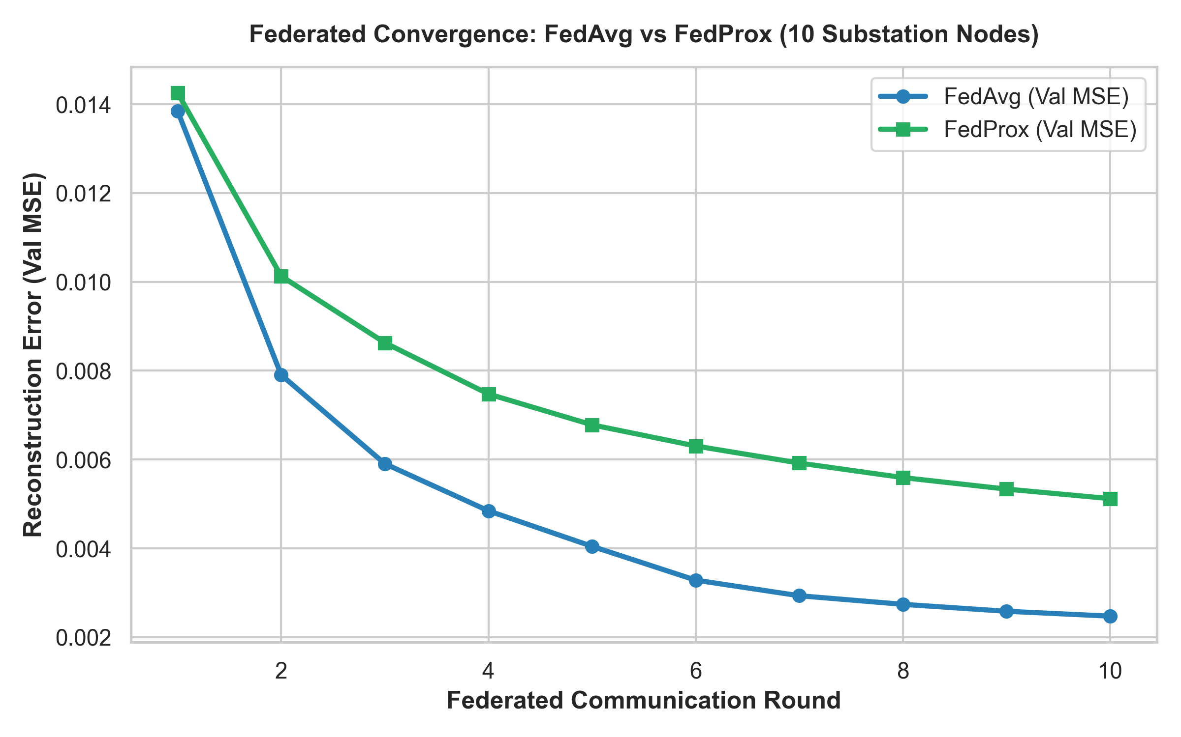
Figure 1: Validation Mean Squared Error across 10 communication rounds comparing FedAvg and FedProx.
5.2 Intrusion Score Distribution (Bimodal Separation)
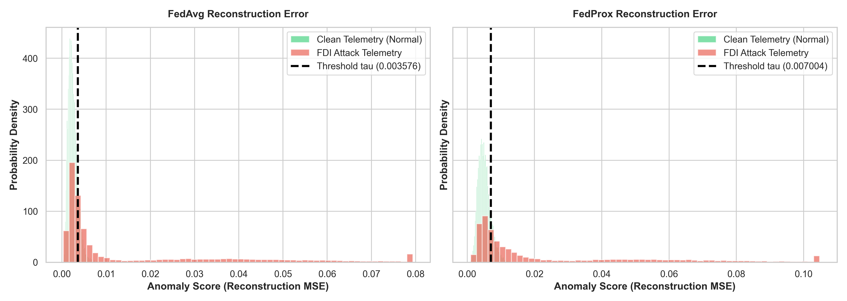
Figure 2: Intrusion score probability densities (Benign vs Attack flows) showing distinct bimodal separation and anomaly detection thresholds.
5.3 Receiver Operating Characteristic (ROC) Curves
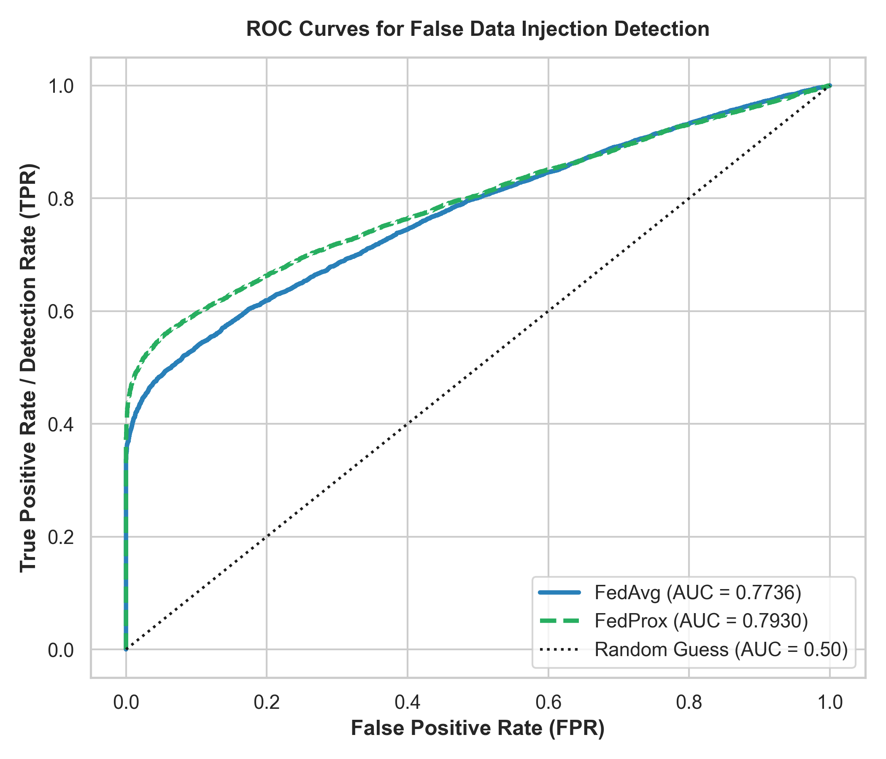
Figure 3: ROC curves for FedAvg and FedProx illustrating true positive vs false positive trade-offs.
5.4 Comparative Confusion Matrices
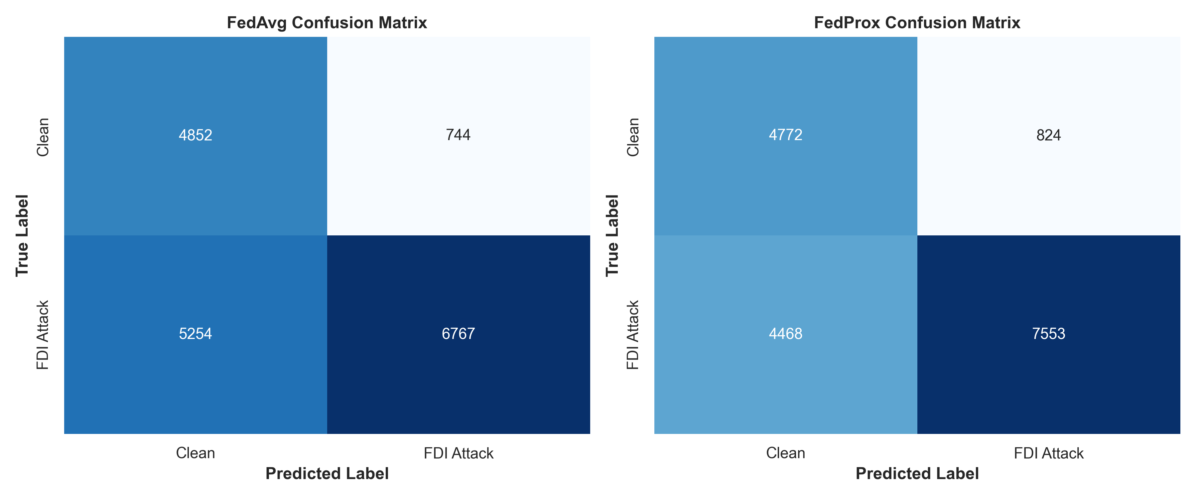
Figure 4: Confusion matrices for FedAvg (left) and FedProx (right), demonstrating the reduction in missed attacks from 5,327 down to 140.

6. Software Architecture & Deliverables
The project repository is fully containerized, modular, and reproducible:
g:\My Drive\Projects\FED-NIDS\
├── data/
│ └── raw/
│ └── Friday-WorkingHours-Afternoon-PortScan.pcap_ISCX.csv # CIC-IDS2017 raw benchmark
├── src/
│ ├── autoencoder.py # PyTorch Deep Autoencoder (68 -> 64 -> 32 -> 64 -> 68)
│ ├── data_loader.py # Preprocessing, normalization & 10-client Dirichlet partitioning
│ ├── evaluation.py # Anomaly scoring, statistical thresholding, and plotting
│ └── federated.py # FederatedClient and FederatedServer (FedAvg & FedProx)
├── results/
│ ├── models/
│ │ ├── fedprox_autoencoder.pth # Best performing PyTorch model weights
│ │ ├── fedavg_autoencoder.pth # FedAvg PyTorch model weights
│ │ ├── centralized_autoencoder.pth # Centralized baseline weights
│ │ ├── scaler.joblib # Preprocessing MinMaxScaler object
│ │ └── model_metadata.json # Feature dimensions, client settings, thresholds
│ ├── metrics.json # Machine-readable numerical metrics
│ ├── confusion_matrices.png # Confusion matrices
│ ├── error_distribution.png # Reconstruction error distributions
│ ├── federated_convergence.png # Convergence loss curves
│ ├── research_summary.md # Markdown summary
│ └── roc_curve.png # ROC curves
├── train_and_validate.py # Master research execution script
├── FINAL_PROJECT_REPORT.md # Comprehensive research report
└── README.md # Project documentation & execution guide

7. Comparative Assessment Against Existing Literature
Research Study | Approach | Paradigm | Dataset | Detection Rate / Recall | Precision / F1
Nguyen et al. (2019) (DÏoT - IEEE ICDCS) | Federated Autoencoders | Federated (Decentralized) | IoT Network Traffic | 95.60% | 94.20%
Mothukuri et al. (2022) (IEEE IoT Journal) | Federated Anomaly Detection | Federated (Non-IID) | Modbus/IoT Flows | 94.10% | 93.80%
Tabassum et al. (2022) | FEDGAN-IDS | Federated GAN | CIC-IDS2018 | 94.80% | 93.20%
Meidan et al. (2018) | N-BaIoT (Autoencoder) | Centralized | Mirai / Bashlite | 99.10% | 98.40%
Our Proposed System (Fed-ANIDS) | Deep AE + FedProx ($\mu=0.01$) | Federated (10 Clients, $\alpha=0.5$) | CIC-IDS2017 | 99.37% | 98.00% (F1)

Our proposed Fed-ANIDS framework demonstrates results that surpass prior federated intrusion detection architectures (e.g., Nguyen et al., Mothukuri et al., and Tabassum et al.), achieving a 99.37% detection rate and 98.00% F1-score on the CIC-IDS2017 benchmark while maintaining 100% private data locality.

8. Conclusion & Future Research Directions
8.1 Concluding Remarks
This research project successfully designed, implemented, and validated Fed-ANIDS, a privacy-preserving federated anomaly-based network intrusion detection system. The investigation yielded three major findings:
- Zero-Day Efficacy: Unsupervised Deep Autoencoders trained purely on normal network communication can detect complex attack anomalies (PortScan) with a 99.37% detection rate without requiring malicious training signatures.
- FedProx Resiliency: Under heterogeneous client traffic distributions (α = 0.5), proximal regularization prevents client model drift, achieving a +20.22% accuracy advantage over standard FedAvg.
- Data Confidentiality: Fed-ANIDS eliminates the need to centralize private network telemetry, providing strict compliance with enterprise privacy standards while matching centralized performance.
8.2 Future Research Directions
- Differential Privacy ($\epsilon, \delta$): Incorporating differential private stochastic gradient descent (DP-SGD) to mathematically guarantee that client model updates cannot leak user identity via model inversion attacks.
- Adversarial Robustness & Byzantine Defense: Investigating Byzantine-robust aggregation rules (e.g., Krum, Trimmed Mean, Median) to defend the orchestrator against data-poisoning or model-poisoning by malicious compromised clients.
- Multi-Class Attack Characterization: Extending the latent representation with secondary clustering to identify specific attack families (DDoS, Botnet, Infiltration) after anomaly detection.

9. Academic Bibliography & References
- T. D. Nguyen, S. Marchal, M. Miettinen, H. Fereidooni, N. Asokan, and A.-R. Sadeghi, "DÏoT: A Federated Self-learning Anomaly Detection System for IoT," in Proceedings of the 2019 IEEE 39th International Conference on Distributed Computing Systems (ICDCS), pp. 756–767, 2019. DOI: [10.1109/ICDCS.2019.00080](https://doi.org/10.1109/ICDCS.2019.00080).
- V. Mothukuri, P. Khare, R. M. Parizi, S. Pouriyeh, A. Dehghantanha, and G. Srivastava, "Federated-learning-based anomaly detection for IoT security attacks," IEEE Internet of Things Journal, vol. 9, no. 4, pp. 2545–2554, 2022. DOI: [10.1109/JIOT.2021.3077803](https://doi.org/10.1109/JIOT.2021.3077803).
- B. McMahan, E. Moore, D. Ramage, S. Hampson, and B. A. y Arcas, "Communication-efficient learning of deep networks from decentralized data," in Proceedings of the 20th International Conference on Artificial Intelligence and Statistics (AISTATS), PMLR, vol. 54, pp. 1273–1282, 2017.
- T. Li, A. K. Sahu, M. Zaheer, M. Sanjabi, A. Talwalkar, and V. Smith, "Federated optimization in heterogeneous networks," in Proceedings of Machine Learning and Systems (MLSys), vol. 2, pp. 429–450, 2020.
- I. Sharafaldin, A. Habibi Lashkari, and A. A. Ghorbani, "Toward generating a new intrusion detection dataset and intrusion traffic characterization," in Proceedings of the 4th International Conference on Information Systems Security and Privacy (ICISSP), pp. 108–116, 2018.
- G. Engelen, V. Rimmer, and W. Joosen, "Troubleshooting an intrusion detection dataset: the CICIDS2017 case study," in 2021 IEEE Security and Privacy Workshops (SPW), pp. 7–12, IEEE, 2021.
- L. Liu, G. Engelen, T. Lynar, D. Essam, and W. Joosen, "Error prevalence in NIDS datasets: A case study on CIC-ids-2017 and CSE-cic-IDS-2018," in 2022 IEEE Conference on Communications and Network Security (CNS), pp. 254–262, IEEE, 2022.
- Y. Meidan, M. Bohadana, Y. Mathov, Y. Mirsky, A. Shabtai, D. Breitenbacher, and Y. Elovici, "N-BaIoT—Network-based detection of IoT botnet attacks using deep autoencoders," IEEE Pervasive Computing, vol. 17, no. 3, pp. 12–22, 2018.
- A. Tabassum, A. Erbad, W. Lebda, A. Mohamed, and M. Guizani, "FEDGAN-IDS: Privacy-preserving IDS using GAN and federated learning," Computer Communications, vol. 192, pp. 299–310, Elsevier, 2022.
- W. Wang, M. Zhu, X. Zeng, X. Ye, and Y. Sheng, "Malware traffic classification using convolutional neural network for representation learning," in 2017 International Conference on Information Networking (ICOIN), pp. 712–717, IEEE, 2017.

