CS3212 計算機網路概論
Lab 1
- Description
Write a program (using Dev-C++) which can count the number of hyperlinks of a given web page. The main objective is to practice socket programming and try to use HTTP protocol.

- Requirements
  - Input: The users enter the URL of the desired web page without “http://”.
  - Output: Print all hyperlinks and the number of hyperlinks. Note that only <a href=“xxx”> should be counted while <link href=“xxx”> shouldn’t.

- Example
9 hyperlinks in http://can.cs.nthu.edu.tw/index.html
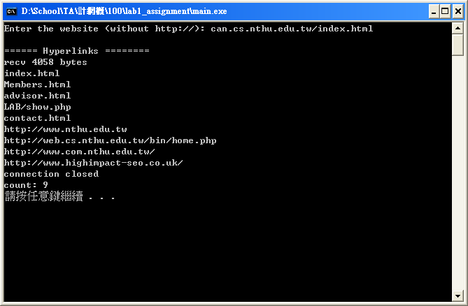
- Hint
  - Refer to the “winsock tutorial” document for information about Dev-C++ and socket programming.
  - Divide the URL into a host name and a path
- www.cs.nthu.edu.tw
- /index.html
  - Get the source code of a web page
- Send a request to the server (GET xxx …\r\n\r\n)
- Receive responses from the server (you may need to receive more than one responses)
  - Count the number of hyperlinks
- <a href="xxxx">
- Use strtok() to tokenize the source code by space characters (" \t\n")
- If the string starts with "href" and the previous token ends with "a", then you find a hyperlink

- Submission
  - Please provide a readme.txt to show what functionalities your homework have.
- For example, is it able to be compiled? Does it meet all requirements?
- If you can run your program, please provide a screenshot to show how it works just like the examples in this document.
  - Compress the related files into 學號_作業_版本.rar (ex: 9762516_lab1_v1.rar)
  - Upload the compressed file to iLMS

