Sun-Earth-Moon程序文档

- 程序说明
该程序是一个简单的太阳、地球和月亮的旋转系统。基于VS2005开发平台，使用C++和OpenGL编写。
该程序使用了OpenGL基本的坐标变换功能，实现球体的公转和自转。加入了光照和纹理，使其场景真实。另外，用户可以和场景进行简单的交互，方向键可以控制场景的坐标旋转，鼠标可以点击太阳、地球和月亮，变换其渲染模式（无纹理渲染和有纹理渲染），并且窗口标题会提示当前点击的对象。

- 程序结构
源程序分为一头文件Utility.h和一源文件Sun-Earth-Moon.cpp，头文件的功能是提供一些基本的绘图函数。下图是程序功能函数的调用流程结构图。
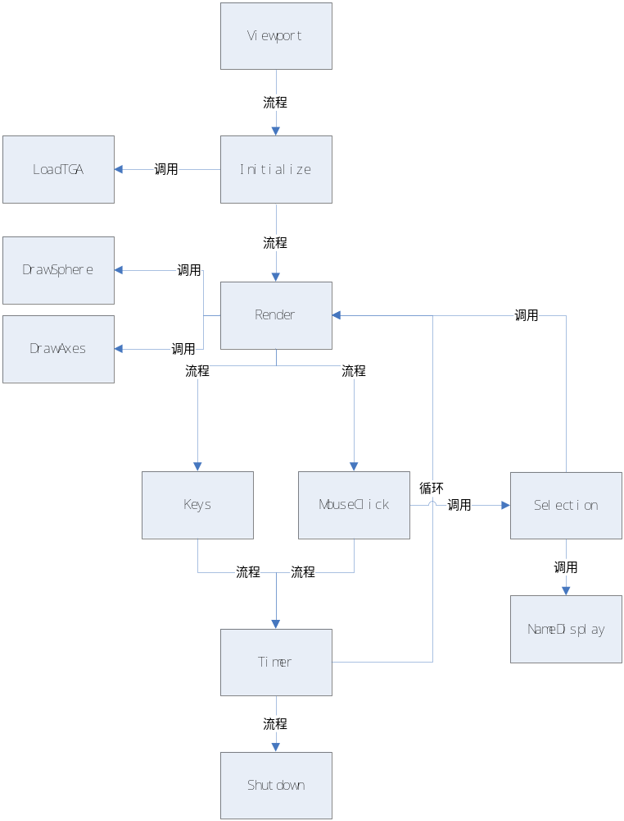
图 程序功能函数调用流程图

Viewport函数，用于控制视口的透视效果，如角度、纵横比例及最近和最远的裁减空间，并且保证窗口大小改变时，渲染对象能够保持相对的大小比例。
Initialize函数，用于对渲染进行初始化，包括设置深度检测、物体正反面、光照、材质、纹理等。其中纹理的读取是通过调用LoadTGA函数实现。
LoadTGA函数，用于对本地的纹理图片进行读取操作。
Render函数，进行实质的渲染操作，例如坐标的变换、纹理贴图等，球体的绘制通过调用DrawSphere实现，可视化坐标轴的绘制通过调用DrawAxes实现。
DrawSphere函数，绘制球体。
DrawAxes函数，绘制可视化坐标轴。
Keys函数，用于键盘上方向键控制的处理。
MouseClick函数，处理鼠标点击的动作，通过调用Selection函数来进行对象选取的操作。
Selection函数，处理对象选取的动作，对于当前鼠标点击的对象，使用一个全局变量进行标识，并通过调用Render函数再次渲染，该全局变量在Render函数中来确定当前状态采用无纹理渲染还是有纹理渲染。Selection函数同时调用NameDisplay函数，来处理窗口标题的信息。
NameDisplay函数，点击对象后更新窗口标题的信息，显示当前点击的对象名称。
Timer函数，控制渲染速度，即隔多长时间渲染一帧。
Shutdown函数，当窗口关闭时，释放纹理对象。

- 源程序代码
Utility.h
#include <stdio.h>

#define GL_CLAMP_TO_EDGE 0x812F
#define GL_MULTISAMPLE 0x809D

// 定义targa图片的头信息
#pragma pack(1)
typedef struct
{
GLbyte identsize;
GLbyte colorMapType;
GLbyte imageType;
unsigned short colorMapStart;
unsigned short colorMapLength;
unsigned char colorMapBits;
unsigned short xstart;
unsigned short ystart;
unsigned short width;
unsigned short height;
GLbyte bits;
GLbyte descriptor;
} TGAHEADER;
#pragma pack(8)

// 读取targa图片
GLbyte *LoadTGA(const char *szFileName, GLint *iWidth, GLint *iHeight, GLint *iComponents, GLenum *eFormat)
{
FILE *pFile;
TGAHEADER tgaHeader;
unsigned long lImageSize;
short sDepth;
GLbyte *pBits = NULL;

*iWidth = 0;
*iHeight = 0;
*eFormat = GL_BGR_EXT;
*iComponents = GL_RGB8;

pFile = fopen(szFileName, "rb");
if(pFile == NULL)
return NULL;

fread(&tgaHeader, 18, 1, pFile);

*iWidth = tgaHeader.width;
*iHeight = tgaHeader.height;
sDepth = tgaHeader.bits / 8;

if(tgaHeader.bits != 8 && tgaHeader.bits != 24 && tgaHeader.bits != 32)
return NULL;

lImageSize = tgaHeader.width * tgaHeader.height * sDepth;

pBits = (GLbyte*)malloc(lImageSize * sizeof(GLbyte));
if(pBits == NULL)
return NULL;

if(fread(pBits, lImageSize, 1, pFile) != 1)
{
free(pBits);
return NULL;
}

switch(sDepth)
{
case 3:
*eFormat = GL_BGR_EXT;
*iComponents = GL_RGB8;
break;
case 4:
*eFormat = GL_BGRA_EXT;
*iComponents = GL_RGBA8;
break;
case 1:
*eFormat = GL_LUMINANCE;
*iComponents = GL_LUMINANCE8;
break;
};

fclose(pFile);

return pBits;
}

// 画球体
void DrawSphere(GLfloat fRadius, GLint iSlices, GLint iStacks)
{
GLfloat drho = (GLfloat)(3.141592653589) / (GLfloat) iStacks;
GLfloat dtheta = 2.0f * (GLfloat)(3.141592653589) / (GLfloat) iSlices;
GLfloat ds = 1.0f / (GLfloat) iSlices;
GLfloat dt = 1.0f / (GLfloat) iStacks;
GLfloat t = 1.0f;
GLfloat s = 0.0f;
GLint i, j;

for (i = 0; i < iStacks; i++)
{
GLfloat rho = (GLfloat)i * drho;
GLfloat srho = (GLfloat)(sin(rho));
GLfloat crho = (GLfloat)(cos(rho));
GLfloat srhodrho = (GLfloat)(sin(rho + drho));
GLfloat crhodrho = (GLfloat)(cos(rho + drho));

glBegin(GL_TRIANGLE_STRIP);
s = 0.0f;
for ( j = 0; j <= iSlices; j++)
{
GLfloat theta = (j == iSlices) ? 0.0f : j * dtheta;
GLfloat stheta = (GLfloat)(-sin(theta));
GLfloat ctheta = (GLfloat)(cos(theta));

GLfloat x = stheta * srho;
GLfloat y = ctheta * srho;
GLfloat z = crho;

glTexCoord2f(s, t);
glNormal3f(x, y, z);
glVertex3f(x * fRadius, y * fRadius, z * fRadius);

x = stheta * srhodrho;
y = ctheta * srhodrho;
z = crhodrho;
glTexCoord2f(s, t - dt);
s += ds;
glNormal3f(x, y, z);
glVertex3f(x * fRadius, y * fRadius, z * fRadius);
}
glEnd();

t -= dt;
}
}

// 画坐标轴
void DrawAxes(void)
{
GLUquadricObj *pObj;

float fAxisRadius = 2.5f;
float fAxisHeight = 25.0f;
float fArrowRadius = 3.0f;
float fArrowHeight = 5.0f;

pObj = gluNewQuadric();
gluQuadricDrawStyle(pObj, GLU_FILL);
gluQuadricNormals(pObj, GLU_SMOOTH);
gluQuadricOrientation(pObj, GLU_OUTSIDE);
gluQuadricTexture(pObj, GLU_FALSE);

// 画Z轴
glColor3f(0.0f, 0.0f, 1.0f);
gluCylinder(pObj, fAxisRadius, fAxisRadius, fAxisHeight, 10, 1);
glPushMatrix();
glTranslatef(0.0f, 0.0f, 25.0f);
gluCylinder(pObj, fArrowRadius, 0.0f, fArrowHeight, 10, 1);
glRotatef(180.0f, 1.0f, 0.0f, 0.0f);
gluDisk(pObj, fAxisRadius, fArrowRadius, 10, 1);
glPopMatrix();

// 画X轴
glColor3f(1.0f, 0.0f, 0.0f);
glPushMatrix();
glRotatef(90.0f, 0.0f, 1.0f, 0.0f);
gluCylinder(pObj, fAxisRadius, fAxisRadius, fAxisHeight, 10, 1);
glPushMatrix();
glTranslatef(0.0f, 0.0f, 25.0f);
gluCylinder(pObj, fArrowRadius, 0.0f, fArrowHeight, 10, 1);
glRotatef(180.0f, 0.0f, 1.0f, 0.0f);
gluDisk(pObj, fAxisRadius, fArrowRadius, 10, 1);
glPopMatrix();
glPopMatrix();

// 画Y轴
glColor3f(0.0f, 1.0f, 0.0f);
glPushMatrix();
glRotatef(-90.0f, 1.0f, 0.0f, 0.0f);
gluCylinder(pObj, fAxisRadius, fAxisRadius, fAxisHeight, 10, 1);
glPushMatrix();
glTranslatef(0.0f, 0.0f, 25.0f);
gluCylinder(pObj, fArrowRadius, 0.0f, fArrowHeight, 10, 1);
glRotatef(180.0f, 1.0f, 0.0f, 0.0f);
gluDisk(pObj, fAxisRadius, fArrowRadius, 10, 1);
glPopMatrix();
glPopMatrix();

glColor3f(1.0f, 1.0f, 1.0f);
gluSphere(pObj, 4.0f, 15, 15);

gluDeleteQuadric(pObj);
}

Sun-Earth-Moon.cpp
#include <windows.h>
#include <math.h>
#include <gl/gl.h>
#include <gl/glu.h>
#include <gl/glut.h>
#include "Utility.h"

// 键盘控制旋转变量
static float xRot = 0.0f;
static float yRot = 0.0f;

// 光照属性参数
float whiteLight[] = { 0.2f, 0.2f, 0.2f, 1.0f };
float sourceLight[] = { 1.f, 1.0f, 1.0f, 1.0f };
float specularLight[] = { 1.0f, 1.0f, 1.0f, 1.0f };
float lightPos[] = { 0.0f, 0.0f, 0.0f, 1.0f };

//纹理参数
#define SUN_TEXTURE 0
#define EARTH_TEXTURE 1
#define MOON_TEXTURE 2
#define NUM_TEXTURES 3
GLuint textureObjects[NUM_TEXTURES];
const char *TextureFiles[] = {"sun.tga", "earth.tga", "moon.tga"};

// 选择参数
int selectedSun = 0;
int selectedEarth = 0;
int selectedMoon = 0;

#define SUN 4
#define EARTH 5
#define MOON 6

// 渲染场景
void Render(void)
{
// 太阳、地球和月亮的自转变量
static float fMoonRot = 0.0f;
static float fEarthRot = 0.0f;
static float fSunRot = 0.0f;

// 地球和月亮的公转变量
static float fMoonRev = 0.0f;
static float fEarthRev = 0.0f;

// 清除场景
glClear(GL_COLOR_BUFFER_BIT | GL_DEPTH_BUFFER_BIT);

// 保存当前模型坐标
glMatrixMode(GL_MODELVIEW);
glPushMatrix();

// 将整个场景朝前（z轴）移动个单位
glTranslatef(0.0f, 0.0f, -400.0f);

// 初始化names stack，用于选取动作
glInitNames();
glPushName(0);

// 更新当前键盘控制的旋转
glRotatef(xRot, 1.0f, 0.0f, 0.0f);
glRotatef(yRot, 0.0f, 1.0f, 0.0f);

// 画太阳，包括自转运动
glPushMatrix();
glDisable(GL_LIGHTING);

// 若点击太阳，则使用纹理，以下类似代码功能相同
if(selectedSun == SUN)
{
glEnable(GL_TEXTURE_2D);
glColor3ub(255,255,255);
glBindTexture(GL_TEXTURE_2D, textureObjects[SUN_TEXTURE]);
}
// 若再次点击太阳，则不使用纹理，以下类似代码功能相同
else
{
glDisable(GL_TEXTURE_2D);
glColor3ub(255, 255, 0);
}
glRotatef(-90.0f, 1.0f, 0.0f, 0.0f);
glRotatef(fSunRot, 0.0f, 0.0f, 1.0f);
glLoadName(SUN);
DrawSphere(70.0f,100, 50);
glEnable(GL_LIGHTING);
glPopMatrix();

// 更新太阳的自转变量
fSunRot -= 1.0f;
if(fSunRot < -360.0f)
fSunRot = 0.0f;

// 定位光源
glLightfv(GL_LIGHT0,GL_POSITION,lightPos);

// 画地球，包括公转和自转运动
if(selectedEarth == EARTH)
{
glEnable(GL_TEXTURE_2D);
glColor3ub(255,255,255);
glBindTexture(GL_TEXTURE_2D, textureObjects[EARTH_TEXTURE]);
}
else
{
glDisable(GL_TEXTURE_2D);
glColor3ub(0,0,255);
}
glRotatef(fEarthRev, 0.0f, 1.0f, 0.0f);
glTranslatef(200.0f,0.0f,0.0f);
glPushMatrix();
glRotatef(-90.0f, 1.0f, 0.0f, 0.0f);
glRotatef(fEarthRot, 0.0f, 0.0f, 1.0f);
glLoadName(EARTH);
DrawSphere(20.0f,100, 50);
glPopMatrix();

// 更新地球的公转变量
fEarthRev += 1.0f;
if(fEarthRev > 360.0f)
fEarthRev = 0.0f;

// 更新地球的自转变量
fEarthRot += 5.0f;
if(fEarthRot > 360.0f)
fEarthRot = 0.0f;

// 画月球，包括公转和自转运动
if(selectedMoon == MOON)
{
glEnable(GL_TEXTURE_2D);
glColor3ub(255,255,255);
glBindTexture(GL_TEXTURE_2D, textureObjects[MOON_TEXTURE]);
}
else
{
glDisable(GL_TEXTURE_2D);
glColor3ub(200,200,200);
}
glRotatef(fMoonRev,0.0f, 1.0f, 0.0f);
glTranslatef(40.0f, 0.0f, 0.0f);
glPushMatrix();
glRotatef(-90.0f, 1.0f, 0.0f, 0.0f);
glRotatef(fMoonRot, 0.0f, 0.0f, 1.0f);
glLoadName(MOON);
DrawSphere(5.0f,100, 50);
glPopMatrix();

// 更新月球的公转变量
fMoonRev+= 5.0f;
if(fMoonRev > 360.0f)
fMoonRev = 0.0f;

// 更新月球的自转变量
fMoonRot -= 10.0f;
if(fMoonRot < -360.0f)
fMoonRot = 0.0f;

// 恢复模型坐标
glPopMatrix();

glPushMatrix();

glDisable(GL_TEXTURE_2D);
glDisable(GL_LIGHTING);

// 移动场景，使坐标轴与整个场景的位置匹配
glTranslatef(0.0f, 0.0f, -400.0f);
glTranslatef(0.0f, -200.0f, 0.0f);
glTranslatef(-250.0f, 0.0f, 0.0f);

// 更新当前键盘控制的旋转
glRotatef(xRot, 1.0f, 0.0f, 0.0f);
glRotatef(yRot, 0.0f, 1.0f, 0.0f);

// 画坐标轴
DrawAxes();

glPopMatrix();

// 显示图像
glutSwapBuffers();
}

// 在窗口上显示鼠标选取的对象名称
void NameDisplay(int id)
{
switch(id)
{
case SUN:
glutSetWindowTitle("太阳被选取！");
break;

case EARTH:
glutSetWindowTitle("地球被选取！");
break;

case MOON:
glutSetWindowTitle("月球被选取！");
break;

default:
glutSetWindowTitle("什么也没有选取！");
break;
}
}

// 处理选取动作
#define BUFFER_LENGTH 64
void Selection(int xPos, int yPos)
{
float fAspect;

// 定义selection buffer
static GLuint selectBuff[BUFFER_LENGTH];

// 定义鼠标点击的标识及用于选取动作的视口
int hits, viewport[4];

// 获取selection buffer
glSelectBuffer(BUFFER_LENGTH, selectBuff);

// 获取用于选取动作的视口
glGetIntegerv(GL_VIEWPORT, viewport);

// 转换到透视坐标，并存储当前状态
glMatrixMode(GL_PROJECTION);
glPushMatrix();

// 调整到选取模式进行渲染
glRenderMode(GL_SELECT);

// 确定鼠标周围的裁减空间
glLoadIdentity();
gluPickMatrix(xPos, viewport[3] - yPos + viewport[1], 2,2, viewport);

// 设置选取渲染得窗口属性
fAspect = (float)viewport[2] / (float)viewport[3];
gluPerspective(60.0f, fAspect, 1.0, 1000.0);

// 进行渲染
Render();

hits = glRenderMode(GL_RENDER);

GLuint nErr = glGetError();

// 若有鼠标点击动作，则进行处理
if(hits == 1)
{
NameDisplay(selectBuff[3]);
if(selectedSun == selectBuff[3])
selectedSun = 0;
else if(selectBuff[3] == SUN)
selectedSun = selectBuff[3];

else if(selectedEarth == selectBuff[3])
selectedEarth = 0;
else if(selectBuff[3] == EARTH)
selectedEarth = selectBuff[3];

else if(selectedMoon == selectBuff[3])
selectedMoon = 0;
else if(selectBuff[3] == MOON)
selectedMoon = selectBuff[3];
}

else
glutSetWindowTitle("什么也没有选取！");

// 恢复透视坐标
glMatrixMode(GL_PROJECTION);
glPopMatrix();

// 回到模型坐标
glMatrixMode(GL_MODELVIEW);
}

// 初始化
void Initialize()
{
int i;

// 设置深度检测、正反面及取消内面的计算
glEnable(GL_DEPTH_TEST);
glFrontFace(GL_CCW);
glEnable(GL_CULL_FACE);

// 启动光照
glEnable(GL_LIGHTING);

// 设置光源的属性，如环境光照、漫射光照及光源位置的参数
glLightModelfv(GL_LIGHT_MODEL_AMBIENT,whiteLight);
glLightfv(GL_LIGHT0,GL_DIFFUSE,sourceLight);
glLightfv(GL_LIGHT0,GL_POSITION,lightPos);
glEnable(GL_LIGHT0);

// 光照下的材质颜色属性
glEnable(GL_COLOR_MATERIAL);
glColorMaterial(GL_FRONT, GL_AMBIENT_AND_DIFFUSE);
glMaterialfv(GL_FRONT, GL_SPECULAR, specularLight);
glMateriali(GL_FRONT, GL_SHININESS, 128);

// 设置纹理
glEnable(GL_TEXTURE_2D);
glGenTextures(NUM_TEXTURES, textureObjects);
glTexEnvi(GL_TEXTURE_ENV, GL_TEXTURE_ENV_MODE, GL_MODULATE);

for(i = 0; i < NUM_TEXTURES; i++)
{
GLbyte *pBytes;
GLint iWidth, iHeight, iComponents;
GLenum eFormat;

glBindTexture(GL_TEXTURE_2D, textureObjects[i]);

// 读取纹理图片
pBytes = LoadTGA(TextureFiles[i], &iWidth, &iHeight, &iComponents, &eFormat);
gluBuild2DMipmaps(GL_TEXTURE_2D, iComponents, iWidth, iHeight, eFormat, GL_UNSIGNED_BYTE, pBytes);

free(pBytes);

glTexParameteri(GL_TEXTURE_2D, GL_TEXTURE_MAG_FILTER, GL_LINEAR);
glTexParameteri(GL_TEXTURE_2D, GL_TEXTURE_MIN_FILTER, GL_LINEAR_MIPMAP_LINEAR);
glTexParameteri(GL_TEXTURE_2D, GL_TEXTURE_WRAP_S, GL_CLAMP_TO_EDGE);
glTexParameteri(GL_TEXTURE_2D, GL_TEXTURE_WRAP_T, GL_CLAMP_TO_EDGE);
}

// 设置背景颜色
glClearColor(0.0f, 0.0f, 0.0f, 1.0f );

glEnable(GL_MULTISAMPLE);
}

// 渲染更新时间间隔
void Timer(int value)
{
glutPostRedisplay();
glutTimerFunc(50, Timer, 1);
}

// 键盘控制
void Keys(int key, int x, int y)
{
if(key == GLUT_KEY_UP)
xRot-= 5.0f;

if(key == GLUT_KEY_DOWN)
xRot += 5.0f;

if(key == GLUT_KEY_LEFT)
yRot -= 5.0f;

if(key == GLUT_KEY_RIGHT)
yRot += 5.0f;

if(key > 356.0f)
xRot = 0.0f;

if(key < -1.0f)
xRot = 355.0f;

if(key > 356.0f)
yRot = 0.0f;

if(key < -1.0f)
yRot = 355.0f;

glutPostRedisplay();
}

// 处理鼠标动作
void MouseClick(int button, int state, int x, int y)
{
if(button == GLUT_LEFT_BUTTON && state == GLUT_DOWN)
Selection(x, y);
}

// 关闭资源
void Shutdown(void)
{
// 删除textureObjects对象
glDeleteTextures(NUM_TEXTURES, textureObjects);
}

// 视口属性
void Viewport(int w, int h)
{
float fAspect;

// 防止除数为
if(h == 0)
h = 1;

// 建立相对于窗口的视口
glViewport(0, 0, w, h);

// 计算窗口纵横比
fAspect = (float)w/(float)h;

// 转换到透视坐标
glMatrixMode(GL_PROJECTION);
glLoadIdentity();

// 设置视口属性，度角，可视的最近和最远位置
gluPerspective(60.0f, fAspect, 1.0, 1000.0);

// 恢复到模型坐标
glMatrixMode(GL_MODELVIEW);
glLoadIdentity();
}

// 主函数
int main(int argc, char* argv[])
{
glutInit(&argc, argv);
glutInitDisplayMode(GLUT_DOUBLE | GLUT_RGB | GLUT_DEPTH | GLUT_MULTISAMPLE);
glutInitWindowSize(1024, 768);
glutCreateWindow("太阳-地球-月亮");
glutReshapeFunc(Viewport);
glutSpecialFunc(Keys);
glutMouseFunc(MouseClick);
glutDisplayFunc(Render);
glutTimerFunc(50, Timer, 1);
Initialize();
glutMainLoop();
Shutdown();

return 0;
}

周一舟
200620603011
2009.7.6

