**Toka FadlHosny AboZiethar.**

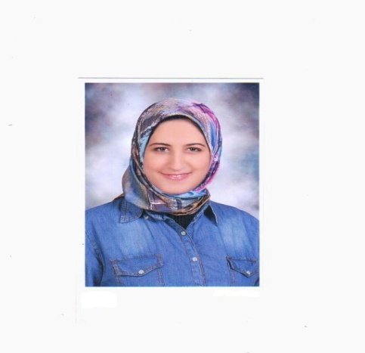

Glal qretum ST. ,Damnhour, ElBehera,Egypt.  
c: (+2) 01113255188.  
toka.fadlaz@gmail.com.  
  
Fresh graduate from the faculty of pharmacy of Alexandria university, I have good working skills since I have good laboratory grades.  
also, I have work experience in a pharmacy in my town ,since last September.  
  
**professional experience & trainings**- Working at dr. Doaa Sabry pharmacy since September 2015 .  
-trained at dr. Hany Tawfeeq pharmacy for 1 month - July 2015- .

**Skills   
communication skills :**-fast learner.   
-good team worker.  
-good listener.  
-good time management.   
- good multi_ tasking .

**computer skills :**- good dealing with Microsoft office

**Languages:**- Arabic ( mother language)   
- English ( excellent )

**School Experience**  
 Attended BioVision Alexandria Conference (April 11_ April 13) 2016.-

- Attended a workshop of the DAAD organization April 2015 .  
-member of Human Resources committee of pharmacy eagles club since 2015.  
 -member of Social committee of pharmacy eagles club since 2014.   
- Vice president of change generation project –one of the biggest projects of eagles club – since 2014.   
- member of Social committee of Active Hands club before emerging into Eagles club .  
-was an organizer in the e'agl el kheir ( charity project) in the university under the authority of the students Union among other projects ( the day of Orphans and others ) .  
   
**Interest & Hobbies** Swimming, cycling, walking, learning languages, reading books, running.

**Personal Data**

-Date of Birth: 8th of March 1994.

- Gender : Female

- Mob. No. : 01113255188.

- Marital Status: Single.

- Nationality: Egyptian.

- Email:tota.fadlaz@gmail.com .

- Address: Glal Qertum ST. , damnhour , El-Behera .

- Home town: Damnhour, El-Beheira Governorate, Egypt.