

|  |
| --- |
| cine |
| 11/01/18 17:20 |
| **Author:** John Doe  **File name:** cine.vp  **Version** 1.0 |

|  |
| --- |
| Site Map |
|  |

|  |
| --- |
|  |

01. Site Map / cine 

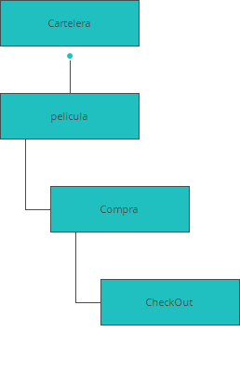

|  |
| --- |
| Screens |
|  |

|  |
| --- |
|  |

02. Screens / cine 

Cartelera

|  |
| --- |
|  |

Interactions

|  |  |
| --- | --- |
| 1 | **on Click:** goes to 'Cartelera' 🡪 |
| 2 | **on Click:** goes to 'pelicula' with effect: fade 🡪 |

02. Screens / cine 

pelicula

|  |
| --- |
|  |

Interactions

|  |  |
| --- | --- |
| 3 | **on Click:** goes to 'Cartelera' 🡪 |

02. Screens / cine 

Compra

|  |
| --- |
|  |

Interactions

|  |  |
| --- | --- |
| 5 | **on Click:** goes to 'CheckOut' with effect: slide up 🡪 |

02. Screens / cine 

CheckOut

|  |
| --- |
|  |