VeShare: A D2D Infrastructure for Real-Time Social-Enabled Vehicle Networks

In this paper author is describing concept to enable device to device communication between vehicles sensors and cellular networks. In this paper to achieve high and reliable communication author is separating control plane and data plane. Control plane take decisions to assign vehicles to same SVN (social enabled vehicle networks) with common interest and data plane simply forward data between SVN and vehicles.

Common interest includes topic such as Road Condition, Safety and Entertainment. In VeShare application vehicles send their locations details to SVN and other vehicle obtained details about traffic from SVN and by getting details drivers will be aware of each moving vehicles and drivers take timely action of stopping vehicles.

In existing technique if one driver suddenly stop vehicle then other vehicle comings from behind may get collided but in VeShare all vehicle get information from SVN/base stations about other vehicles and take timely action.

To provide security to vehicles location we will encrypt data and send to base station and other genuine vehicles may obtained data from base station and then decrypt the data to get locations.

To implement this project we design two applications

1. Base station: Responsible to receive encrypted data and send that data information back to other vehicles upon requested.
2. Simulation: In this module we create s simulator to design group of vehicles and each vehicle register their interest with SVN and report their encrypted data to base station. If two vehicles comes closer then base station inform them to stop. While crossing vehicle will inform to base station and base station reports to other vehicle to stop till the vehicle crossed the road.

As extension work to achieve faster data transmission we have implemented multithreading concept where each request will be handled by separate thread. So here work is distributed between multiple threads and communication will be faster.

Screen shots

First double click on ‘run.bat’ file from ‘Basestation’ folder to get below screen

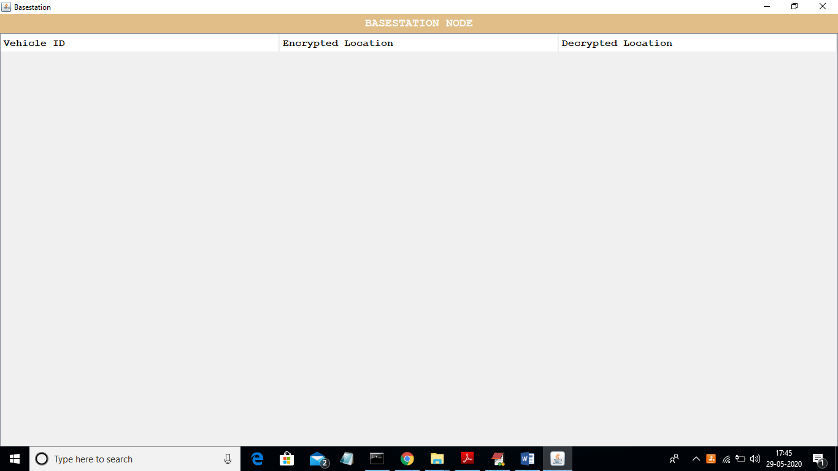

Basestation will receive encrypted location details of each vehicle and display in the table. For understanding purpose I am displaying decrypted data also in beside column.

Now double click on ‘run.bat’ file from ‘Simulation’ folder to get below screen

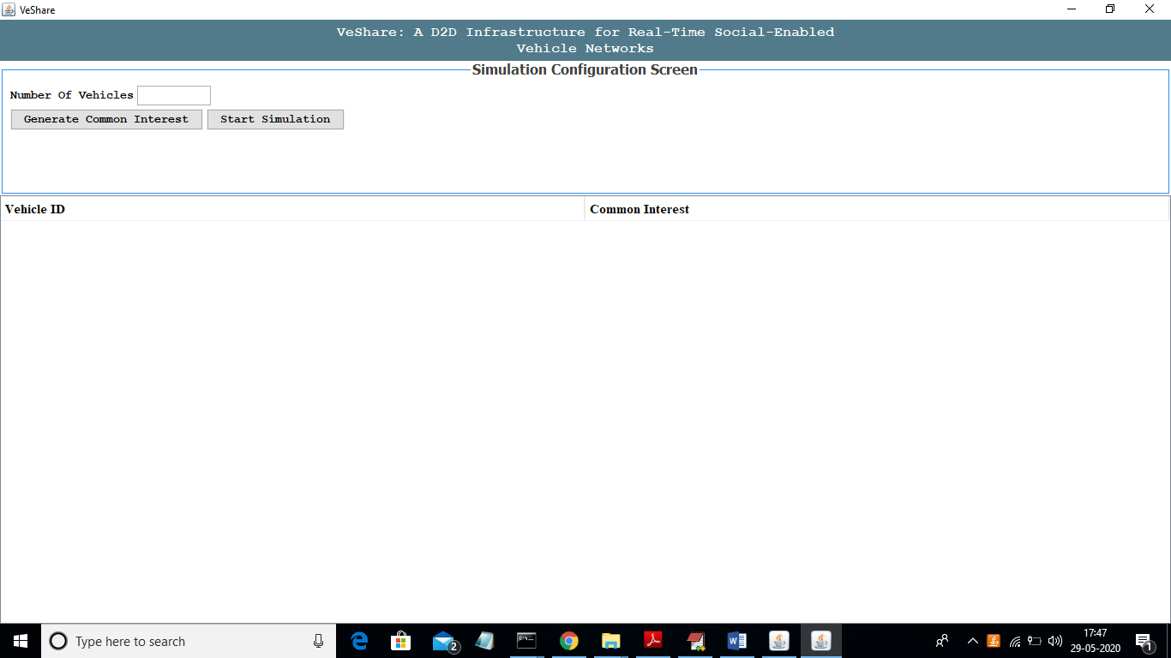

In above screen in the text field enter number of vehicles and then click on ‘Generate Common Interest’ button to assign each vehicle with random common interest

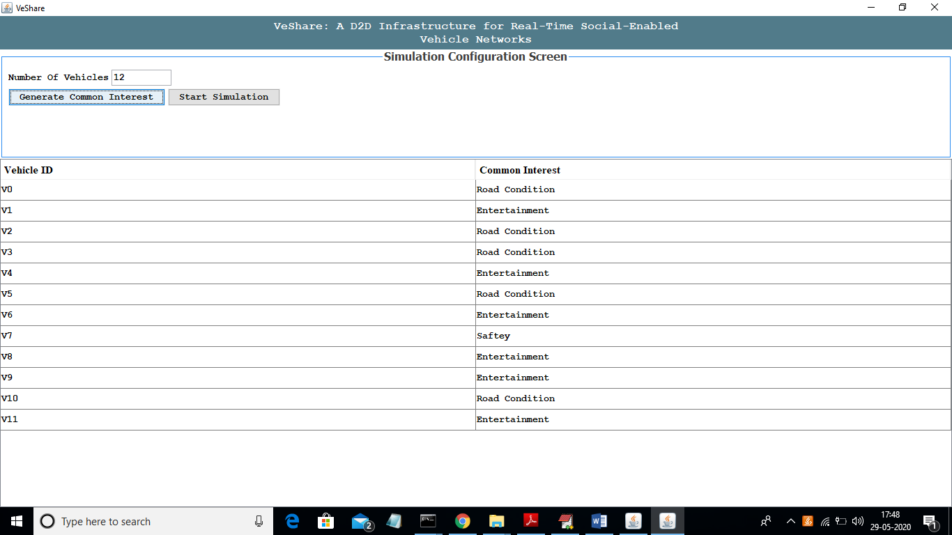

In above screen I entered number of vehicles as 12 and then click on ‘Generate Common Interest’ button to get common interest to each vehicle. Now click on ‘Start Simulation’ button to get below screen

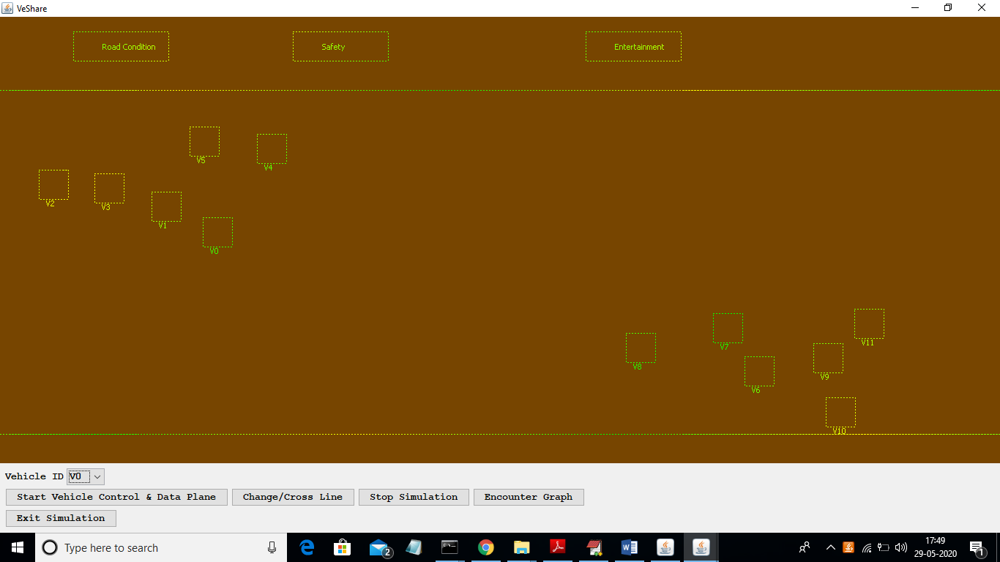

In above screen I am display half vehicles as moving to right side and other half moving to left side and while moving each vehicle will report their movement to their appropriate common interest SVN such as Road Condition or safety or entertainment. Now to start movement click on ‘Start Vehicle Control & Data Plane’ button to allow control plane to take decision and data plane to send data.

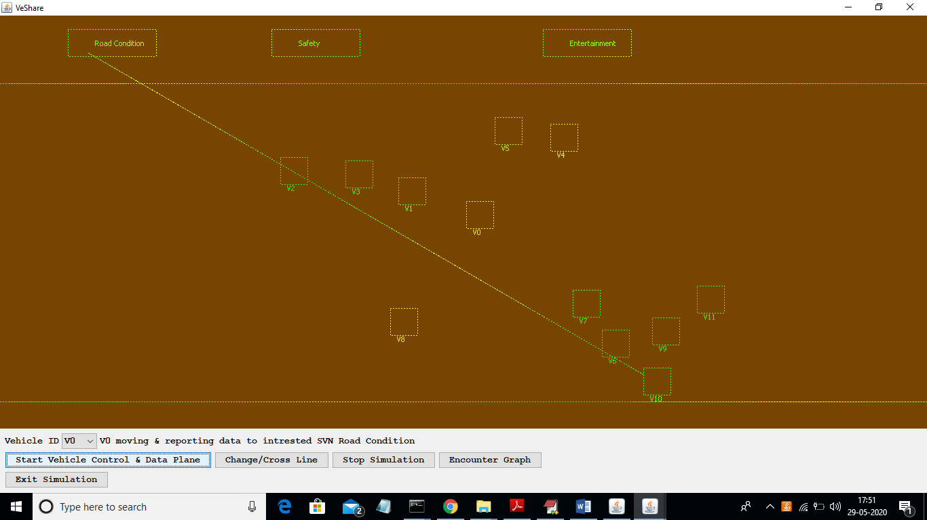

In above screen we can see each vehicles start movement and while moving they report data to appropriate SVN and cross line select any vehicle id from drop down box and then that vehicle crossed and move towards opposite direction.

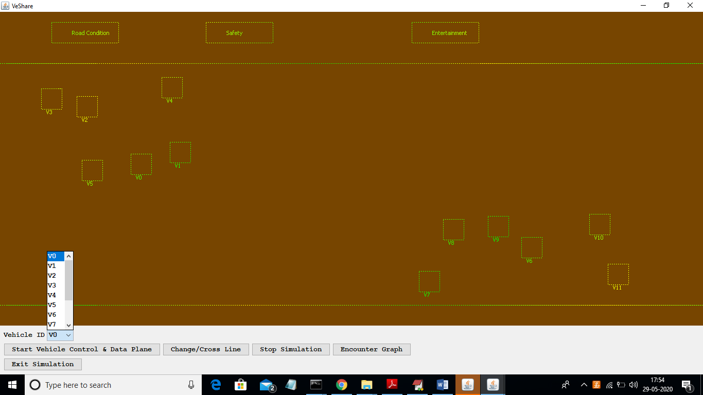

In above screen from drop down box I am selecting vehicle 0 and its moving towards right direction but when I click on ‘Change/Cross Line’ then it will cross road and start moving towards left. While crossing road base station will inform other vehicles to stop till this vehicle cross the road.

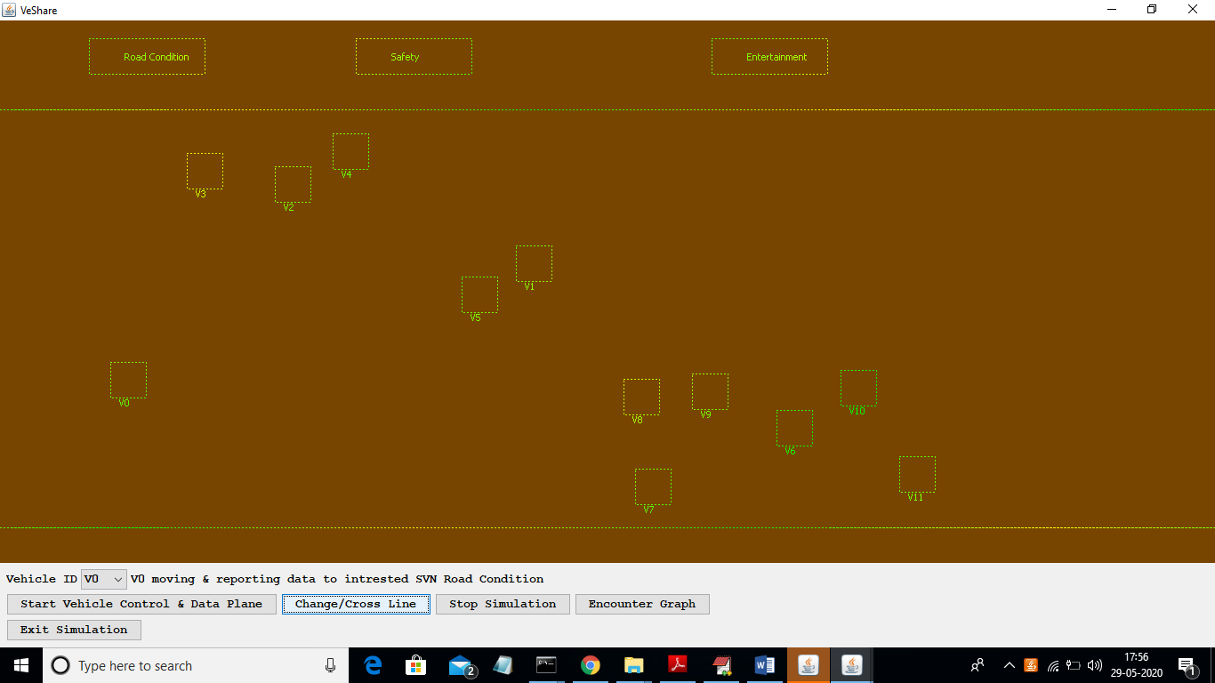

In above screen V0 vehicle starts moving towards left after clicking on ‘Change/Cross line’ button. To stop simulation click on ‘Stop Simulation’ button

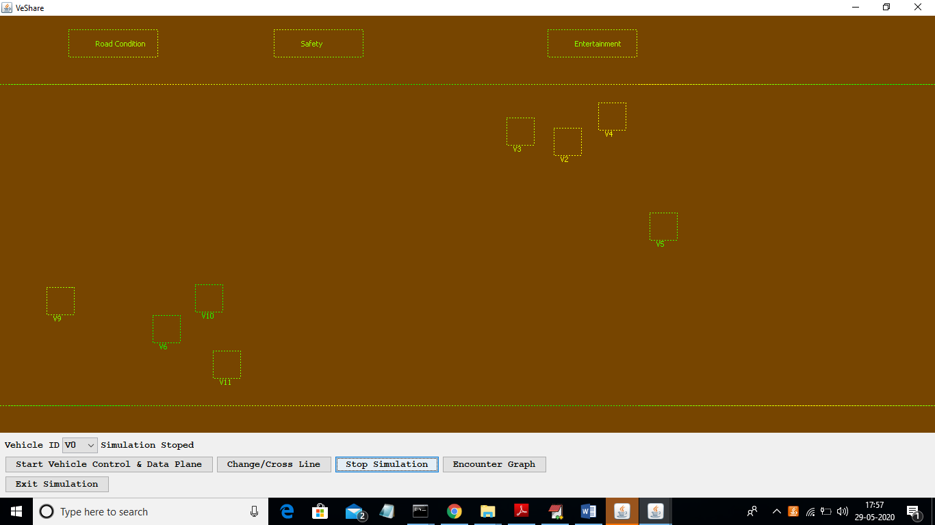

In above screen vehicles stop movement and now click on ‘Encounter Graph’ button to get below graph

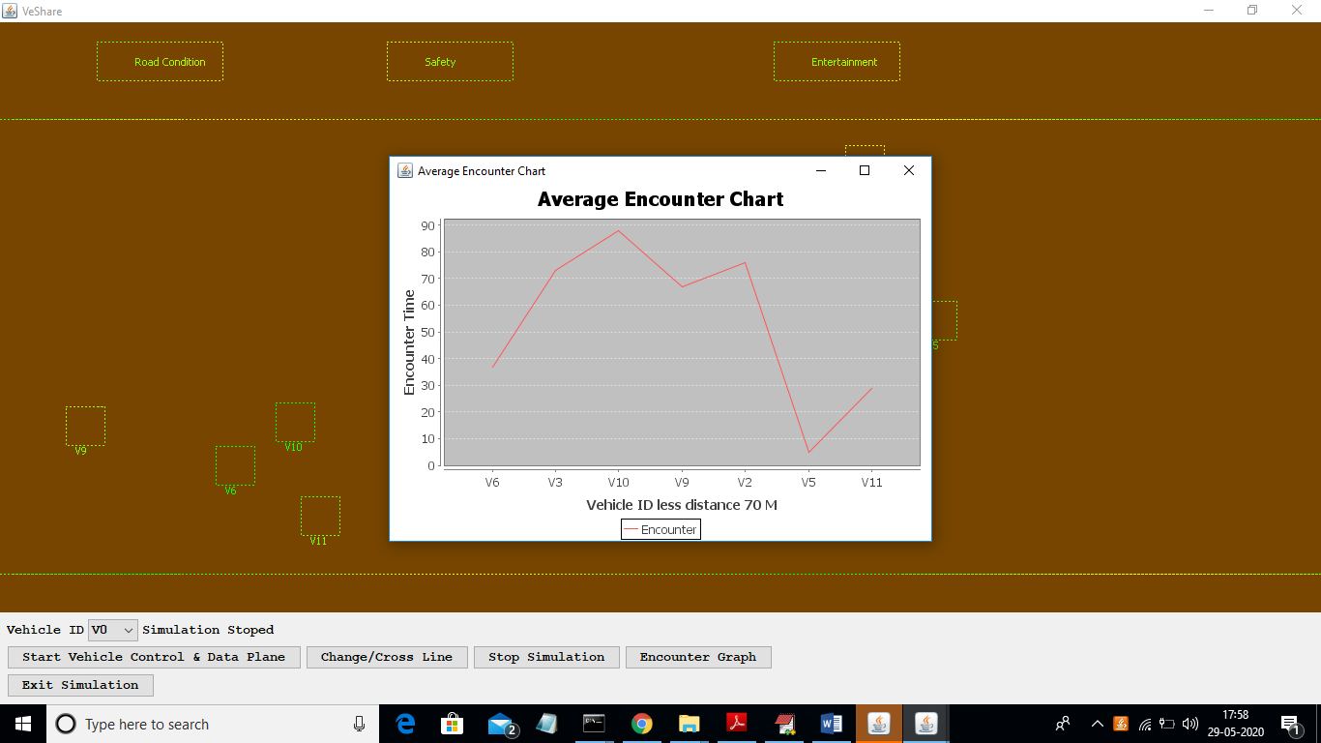

In above graph x-axis represents vehicle id with distance less than 70 meters and y-axis represents count of how many time that vehicle has encounter with other vehicle with close distance. Here base station will inform to vehicles if they are coming too close with other vehicles to stop to avoid accident. In above graph for each vehicle we are display number of close encounter of each vehicle. In below base station screen we can see each vehicle location details in encrypted and decrypted format

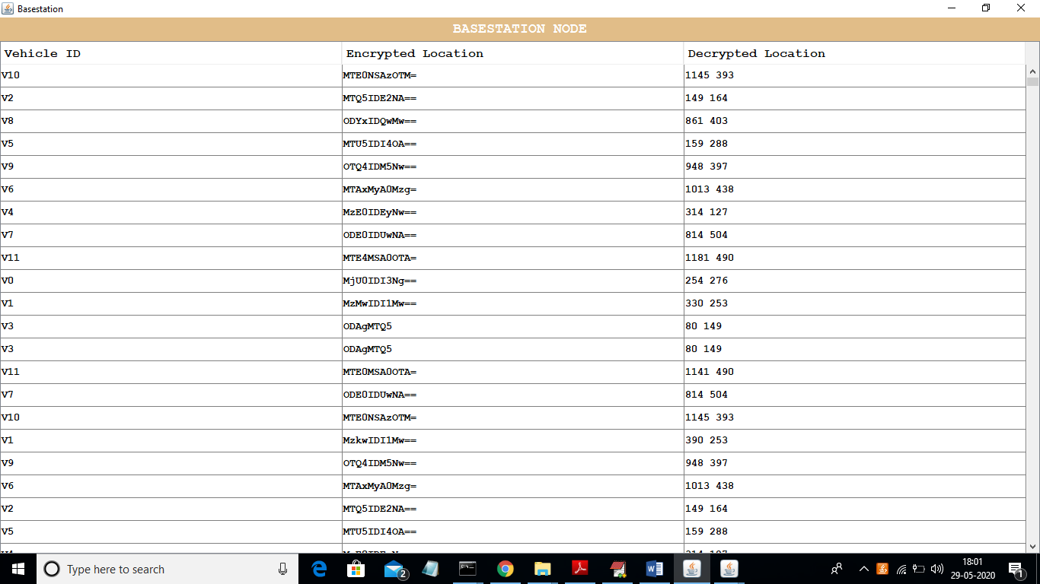

In above screen decrypted column we have vehicle X and Y location separated with space, in first column we can see vehicle id and in second column we can see encrypted data.