***Python Tutorial***

-Aditya Yadav

*Table of Contents*

----------------------------------------------------------------------

Title PageNo.

----------------------------------------------------------------------

*\*Python Basic Tutorial\**

1. Python - Introduction ------------------------------- 4
2. Python - Home ------------------------------- 5
3. Python - Overview ------------------------------- 7
4. Python - Environment Setup ------------------------------- 9
5. Python - Basic Syntax ------------------------------- 11
6. Python - Variable Types ------------------------------- 14
7. Python - Basic Operators ------------------------------- 18
8. Python - Decision Making ------------------------------- 28
9. Python - Loops ------------------------------- 29
10. Python - Numbers ------------------------------- 31
11. Python - Strings ------------------------------- 36
12. Python - Lists ------------------------------- 47
13. Python - Tuples ------------------------------- 52
14. Python - Dictionary ------------------------------- 57
15. Python - Date & Time ------------------------------- 61
16. Python - Functions ------------------------------- 70
17. Python - Modules ------------------------------- 78
18. Python - Files I/O ------------------------------- 84
19. Python - Exceptions ------------------------------- 97

*\*Python Advanced Tutorial\**

1. Python - Classes/Objects ----------------------- 109
2. Python - Reg Expressions ----------------------- 123
3. Python - CGI Programming ----------------------- 144
4. Python - Database Access ----------------------- 164
5. Python - Networking ----------------------- 177
6. Python - Sending Email ----------------------- 184
7. Python - Multithreading ----------------------- 189
8. Python - XML Processing ----------------------- 199
9. Python - GUI Programming ----------------------- 208
10. Python - Further Extensions ----------------------- 218

*\*Python Useful Resources\**

1. Python - Interview Questions and Answers ------- 230

***Python***

**Introduction:**

Python is one the best programming languages currently and will be for a long time. Why, you ask?... Because of its simplicity. It’s easy to understand, read and write. There are many libraries available for you to do many interesting tasks such as web development using flask, django… along with machine learning using scikit-learn, tensorflow, keras, pytorch, etc. Are few to name.

Whether you are a beginner to programming or shifting towards the dynamics of python, it’s not an issue because python is sweet and simple and has an open heart and it welcomes everyone who wants to enter into its world.

There is nothing that cannot be done by python i mean literally everything from web development to machine learning to deep learning to almost everything else (p.s.: Android development is not included here.)

If you are a beginner, you might have doubts on selecting IDE as well. As of now I will suggest to use IDLE for beginning and later on switch to PyCharm or VsStudio for project level work.

***Python Basic Tutorial***

**=>Python - Home:**

Python is a general-purpose interpreted, interactive, object-oriented, and high-level programming language. It was created by Guido van Rossum .

## Characteristics of Python

Following are important characteristics of Python Programming −

* It supports functional and structured programming methods as well as OOP.
* It can be used as a scripting language or can be compiled to byte-code for building large applications.
* It provides very high-level dynamic data types and supports dynamic type checking.
* It supports automatic garbage collection.
* It can be easily integrated with C, C++, COM, ActiveX, CORBA, and Java.

## Applications of Python

As mentioned before, Python is one of the most widely used languages over the web. I'm going to list few of them here:

* Easy-to-learn − Python has few keywords, simple structure, and a clearly defined syntax. This allows the student to pick up the language quickly.
* Easy-to-read − Python code is more clearly defined and visible to the eyes.
* Easy-to-maintain − Python's source code is fairly easy-to-maintain.
* A broad standard library − Python's bulk of the library is very portable and cross-platform compatible on UNIX, Windows, and Macintosh.
* Interactive Mode − Python has support for an interactive mode which allows interactive testing and debugging of snippets of code.
* Portable − Python can run on a wide variety of hardware platforms and has the same interface on all platforms.
* Extendable − You can add low-level modules to the Python interpreter. These modules enable programmers to add to or customize their tools to be more efficient.
* Databases − Python provides interfaces to all major commercial databases.
* GUI Programming − Python supports GUI applications that can be created and ported to many system calls, libraries and windows systems, such as Windows MFC, Macintosh, and the X Window system of Unix.
* Scalable − Python provides a better structure and support for large programs than shell scripting.

## Prerequisites

You should have a basic understanding of Computer Programming terminologies. A basic understanding of any of the programming languages is a plus.

**=>Python - Overview:**

Python is a high-level, interpreted, interactive and object-oriented scripting language. Python is designed to be highly readable. It uses English words frequently whereas other languages use punctuation, and it has fewer syntactic constructions than other languages.

* Python is Interpreted − Python is processed at runtime by the interpreter. You do not need to compile your program before executing it. This is similar to PERL and PHP.
* Python is Interactive − You can actually sit at a Python prompt and interact with the interpreter directly to write your programs.
* Python is Object-Oriented − Python supports Object-Oriented style or technique of programming that encapsulates code within objects.
* Python is a Beginner's Language − Python is a great language for the beginner-level programmers and supports the development of a wide range of applications from simple text processing to WWW browsers to games.

## History of Python

Python was developed by Guido van Rossum in the late eighties and early nineties at the National Research Institute for Mathematics and Computer Science in the Netherlands.

Python is derived from many other languages, including ABC, Modula-3, C, C++, Algol-68, SmallTalk, and Unix shell and other scripting languages.

Python is copyrighted. Like Perl, Python source code is now available under the GNU General Public License (GPL).

Python is now maintained by a core development team at the institute, although Guido van Rossum still holds a vital role in directing its progress.

## Python Features

Python's features include −

* Easy-to-learn − Python has few keywords, simple structure, and a clearly defined syntax. This allows the student to pick up the language quickly.
* Easy-to-read − Python code is more clearly defined and visible to the eyes.
* Easy-to-maintain − Python's source code is fairly easy-to-maintain.
* A broad standard library − Python's bulk of the library is very portable and cross-platform compatible on UNIX, Windows, and Macintosh.
* Interactive Mode − Python has support for an interactive mode which allows interactive testing and debugging of snippets of code.
* Portable − Python can run on a wide variety of hardware platforms and has the same interface on all platforms.
* Extendable − You can add low-level modules to the Python interpreter. These modules enable programmers to add to or customize their tools to be more efficient.
* Databases − Python provides interfaces to all major commercial databases.
* GUI Programming − Python supports GUI applications that can be created and ported to many system calls, libraries and windows systems, such as Windows MFC, Macintosh, and the X Window system of Unix.
* Scalable − Python provides a better structure and support for large programs than shell scripting.

Apart from the above-mentioned features, Python has a big list of good features, few are listed below −

* It supports functional and structured programming methods as well as OOP.
* It can be used as a scripting language or can be compiled to byte-code for building large applications.
* It provides very high-level dynamic data types and supports dynamic type checking.
* It supports automatic garbage collection.
* It can be easily integrated with C, C++, COM, ActiveX, CORBA, and Java.

**=>Python - Environment Setup:**

## Installing Python

Installing python is the first task at hand which is as simple as the language itself. Simply search for a python executable file as this link “<https://www.python.org/downloads/windows/>” for windows… you can find downloadable files for other unix as well. There are other ways such as using pip or conda but this is the easiest as you will need to download pip and conda first if you use those means.

Here is a quick overview of installing Python on various platforms −

### Unix and Linux Installation

* Open a Web browser and go to <https://www.python.org/downloads/>.
* Follow the link to download zipped source code available for Unix/Linux.
* Download and extract files.
* Editing the *Modules/Setup* file if you want to customize some options.
* run ./configure script
* make
* make install

This installs Python at standard location */usr/local/bin* and its libraries at */usr/local/lib/pythonXX* where XX is the version of Python.

### Windows Installation

* Open a Web browser and go to <https://www.python.org/downloads/>.
* Follow the link for the Windows installer *python-XYZ.msi* file where XYZ is the version you need to install.
* To use this installer *python-XYZ.msi*, the Windows system must support Microsoft Installer 2.0. Save the installer file to your local machine and then run it to find out if your machine supports MSI.
* Run the downloaded file. This brings up the Python install wizard, which is really easy to use. Just accept the default settings, wait until the install is finished, and you are done.

## Setting up PATH

Programs and other executable files can be in many directories, so operating systems provide a search path that lists the directories that the OS searches for executables.

The path is stored in an environment variable, which is a named string maintained by the operating system. This variable contains information available to the command shell and other programs.

The path variable is named as PATH in Unix or Path in Windows (Unix is case sensitive; Windows is not).

In Mac OS, the installer handles the path details. To invoke the Python interpreter from any particular directory, you must add the Python directory to your path.

## Setting path at Unix/Linux

To add the Python directory to the path for a particular session in Unix −

* In the csh shell − type setenv PATH "$PATH:/usr/local/bin/python" and press Enter.
* In the bash shell (Linux) − type export PATH="$PATH:/usr/local/bin/python" and press Enter.
* In the sh or ksh shell − type PATH="$PATH:/usr/local/bin/python" and press Enter.
* Note − /usr/local/bin/python is the path of the Python directory

## Setting path at Windows

To add the Python directory to the path for a particular session in Windows −

At the command prompt − type path %path%;C:\Python and press Enter.

Note − C:\Python is the path of the Python directory

## Running Python

=>You can start Python from Unix, DOS, or any other system that provides you a command-line interpreter or shell window.

=>Enter python the command line.

=>Start coding right away in the interactive interpreter.



or



or



**=>Python - Basic Syntax:**

The Python language has many similarities to Perl, C, and Java. However, there are some definite differences between the languages.

## First Python Program

Let us execute programs in different modes of programming.

### Interactive Mode Programming

Invoking the interpreter without passing a script file as a parameter brings up the following prompt −

Simply type “python” on your cmd and then write code as shown in the image below.

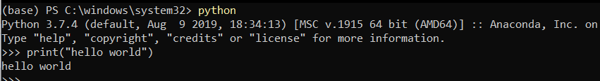

### Script Mode Programming

In this case we simply create a script with python commands and run the script.

Let us write a simple Python program in a script. Python files have extension .py. Type the following source code in a test.py file −



We assume that you have a Python interpreter set in the PATH variable. Now, try to run this program as follows −



This produces the following result −



## Reserved Words

The following list shows the Python keywords. These are reserved words and you cannot use them as constant or variable or any other identifier names. All the Python keywords contain lowercase letters only.

|  |  |  |
| --- | --- | --- |
| and | exec | not |
| assert | finally | or |
| break | for | pass |
| class | from | print |
| continue | global | raise |
| def | if | return |
| del | import | try |
| elif | in | while |
| else | is | with |
| except | lambda | yield |

## Lines and Indentation

Python provides no braces to indicate blocks of code for class and function definitions or flow control. Blocks of code are denoted by line indentation, which is rigidly enforced.

The number of spaces in the indentation is variable, but all statements within the block must be indented the same amount. For example −

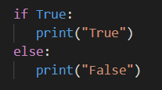

## Multi-Line Statements

Statements in Python typically end with a new line. Python does, however, allow the use of the line continuation character (\) to denote that the line should continue. For example −

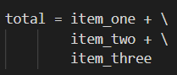

## Comments in Python

A hash sign (#) that is not inside a string literal begins a comment. All characters after the # and up to the end of the physical line are part of the comment and the Python interpreter ignores them as shown below.



**=>Python - Variable Types:**

Variables are nothing but reserved memory locations to store values. This means that when you create a variable you reserve some space in memory.

## Assigning Values to Variables

Python variables do not need explicit declaration to reserve memory space. The declaration happens automatically when you assign a value to a variable. The equal sign (=) is used to assign values to variables.

The operand to the left of the = operator is the name of the variable and the operand to the right of the = operator is the value stored in the variable. For example −

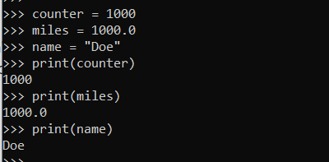

## Multiple Assignment

Python allows you to assign a single value to several variables simultaneously. For example −

a = b = c = 1

## Standard Data Types

The data stored in memory can be of many types. For example, a person's age is stored as a numeric value and his or her address is stored as alphanumeric characters. Python has various standard data types that are used to define the operations possible on them and the storage method for each of them.

Python has five standard data types −

* Numbers
* String
* List
* Tuple
* Dictionary

## Python Strings

Strings in Python are identified as a contiguous set of characters represented in the quotation marks. Python allows for either pairs of single or double quotes. Subsets of strings can be taken using the slice operator ([ ] and [:] ) with indexes starting at 0 in the beginning of the string and working their way from -1 at the end.

The plus (+) sign is the string concatenation operator and the asterisk (*) is the repetition operator. For example −

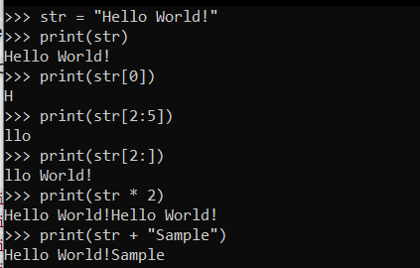

## Python Lists

Lists are the most versatile of Python's compound data types. A list contains items separated by commas and enclosed within square brackets ([]). To some extent, lists are similar to arrays in C. One difference between them is that all the items belonging to a list can be of different data types.

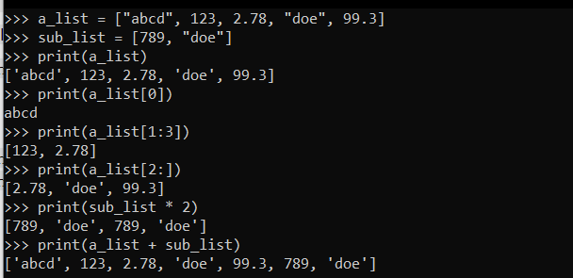

## Python Tuples

A tuple is another sequence data type that is similar to the list. A tuple consists of a number of values separated by commas. Unlike lists, however, tuples are enclosed within parentheses.

The main differences between lists and tuples are: Lists are enclosed in brackets ( [ ] ) and their elements and size can be changed, while tuples are enclosed in parentheses ( ( ) ) and cannot be updated. Tuples can be thought of as read-only lists. For example −

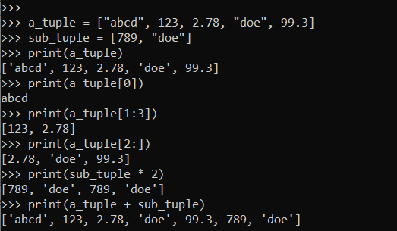

## Python Dictionary

Python's dictionaries are a kind of hash table type. They work like associative arrays or hashes found in Perl and consist of key-value pairs. A dictionary key can be almost any Python type, but are usually numbers or strings. Values, on the other hand, can be any arbitrary Python object.

Dictionaries are enclosed by curly braces ({ }) and values can be assigned and accessed using square braces ([]). For example −

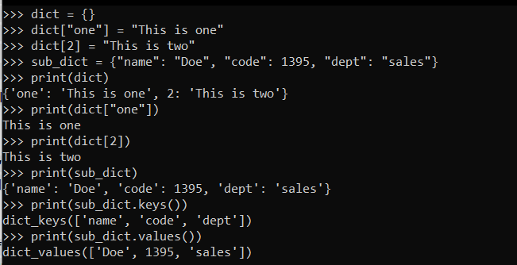

Dictionaries have no concept of order among elements. It is incorrect to say that the elements are "out of order"; they are simply unordered.

**=>Python - Basic Operators:**

Python language supports the following types of operators.

* Arithmetic Operators
* Comparison (Relational) Operators
* Assignment Operators
* Logical Operators
* Bitwise Operators
* Membership Operators
* Identity Operators

Let us have a look at all operators one by one.

## Python Arithmetic Operators

Assume variable a holds 10 and variable b holds 20, then −

|  |  |  |
| --- | --- | --- |
| Operator | Description | Example |
| + Addition | Adds values on either side of the operator. | a + b = 30 |
| - Subtraction | Subtracts right hand operand from left hand operand. | a – b = -10 |
| * Multiplication | Multiplies values on either side of the operator | a * b = 200 |
| / Division | Divides left hand operand by right hand operand | b / a = 2 |
| % Modulus | Divides left hand operand by right hand operand and returns remainder | b % a = 0 |
| ** Exponent | Performs exponential (power) calculation on operators | a**b =10 to the power 20 |
| // | Floor Division - The division of operands where the result is the quotient in which the digits after the decimal point are removed. But if one of the operands is negative, the result is floored, i.e., rounded away from zero (towards negative infinity) − | 9//2 = 4 and 9.0//2.0 = 4.0, -11//3 = -4, -11.0//3 = -4.0 |

## 

## Python Comparison Operators

These operators compare the values on either side of them and decide the relation among them. They are also called Relational operators.

Assume variable a holds 10 and variable b holds 20, then −

|  |  |  |
| --- | --- | --- |
| Operator | Description | Example |
| == | If the values of two operands are equal, then the condition becomes true. | (a == b) is not true. |
| != | If values of two operands are not equal, then the condition becomes true. | (a != b) is true. |
| <> | If values of two operands are not equal, then the condition becomes true. | (a <> b) is true. This is similar to != operator. |
| > | If the value of the left operand is greater than the value of the right operand, then the condition becomes true. | (a > b) is not true. |
| < | If the value of the left operand is less than the value of the right operand, then the condition becomes true. | (a < b) is true. |
| >= | If the value of the left operand is greater than or equal to the value of the right operand, then the condition becomes true. | (a >= b) is not true. |
| <= | If the value of the left operand is less than or equal to the value of the right operand, then the condition becomes true. | (a <= b) is true. |

## 

## Python Assignment Operators

Assume variable a holds 10 and variable b holds 20, then −

|  |  |  |
| --- | --- | --- |
| Operator | Description | Example |
| = | Assigns values from right side operands to left side operand | c = a + b assigns value of a + b into c |
| += Add AND | It adds right operand to the left operand and assign the result to left operand | c += a is equivalent to c = c + a |
| -= Subtract AND | It subtracts right operand from the left operand and assign the result to left operand | c -= a is equivalent to c = c - a |
| *= Multiply AND | It multiplies right operand with the left operand and assign the result to left operand | c *= a is equivalent to c = c * a |
| /= Divide AND | It divides left operand with the right operand and assign the result to left operand | c /= a is equivalent to c = c / a |
| %= Modulus AND | It takes modulus using two operands and assign the result to left operand | c %= a is equivalent to c = c % a |
| **= Exponent AND | Performs exponential (power) calculation on operators and assign value to the left operand | c **= a is equivalent to c = c ** a |
| //= Floor Division | It performs floor division on operators and assign value to the left operand | c //= a is equivalent to c = c // a |

## 

## Python Bitwise Operators

Bitwise operator works on bits and performs bit by bit operation. Assume if a = 60; and b = 13; Now in the binary format their values will be 0011 1100 and 0000 1101 respectively. Following table lists out the bitwise operators supported by Python language with an example each in those, we use the above two variables (a and b) as operands −

a = 0011 1100

b = 0000 1101

-----------------

a&b = 0000 1100

a|b = 0011 1101

a^b = 0011 0001

~a = 1100 0011

There are following Bitwise operators supported by Python language

|  |  |  |
| --- | --- | --- |
| Operator | Description | Example |
| & Binary AND | Operator copies a bit to the result if it exists in both operands | (a & b) (means 0000 1100) |
| | Binary OR | It copies a bit if it exists in either operand. | (a | b) = 61 (means 0011 1101) |
| ^ Binary XOR | It copies the bit if it is set in one operand but not both. | (a ^ b) = 49 (means 0011 0001) |
| ~ Binary Ones Complement | It is unary and has the effect of 'flipping' bits. | (~a ) = -61 (means 1100 0011 in 2's complement form due to a signed binary number. |
| << Binary Left Shift | The left operands value is moved left by the number of bits specified by the right operand. | a << 2 = 240 (means 1111 0000) |
| >> Binary Right Shift | The left operands value is moved right by the number of bits specified by the right operand. | a >> 2 = 15 (means 0000 1111) |

## Python Logical Operators

There are following logical operators supported by Python language. Assume variable a holds 10 and variable b holds 20 then

|  |  |  |
| --- | --- | --- |
| Operator | Description | Example |
| and Logical AND | If both the operands are true then condition becomes true. | (a and b) is true. |
| or Logical OR | If any of the two operands are non-zero then the condition becomes true. | (a or b) is true. |
| not Logical NOT | Used to reverse the logical state of its operand. | Not(a and b) is false. |

## Python Membership Operators

Python’s membership operators test for membership in a sequence, such as strings, lists, or tuples. There are two membership operators as explained below −

|  |  |  |
| --- | --- | --- |
| Operator | Description | Example |
| in | Evaluates to true if it finds a variable in the specified sequence and false otherwise. | x in y, here in results in a 1 if x is a member of sequence y. |
| not in | Evaluates to true if it does not finds a variable in the specified sequence and false otherwise. | x not in y, here not in results in a 1 if x is not a member of sequence y. |

## Python Identity Operators

Identity operators compare the memory locations of two objects. There are two Identity operators explained below −

|  |  |  |
| --- | --- | --- |
| Operator | Description | Example |
| is | Evaluates to true if the variables on either side of the operator point to the same object and false otherwise. | x is y, here it results in 1 if id(x) equals id(y). |
| is not | Evaluates to false if the variables on either side of the operator point to the same object and true otherwise. | x is not y, here is not results in 1 if id(x) is not equal to id(y). |

## Python Operators Precedence

The following table lists all operators from highest precedence to lowest.

|  |  |
| --- | --- |
| Sr.No. | Operator & Description |
| 1 | **, - Exponentiation (raise to the power) |
| 2 | ~ + - , - Complement, unary plus and minus (method names for the last two are +@ and -@) |
| 3 | * / % // - Multiply, divide, modulo and floor division |
| 4 | + - , - Addition and subtraction |
| 5 | >> << - Right and left bitwise shift |
| 6 | & - Bitwise 'AND' |
| 7 | ^ | - Bitwise exclusive `OR' and regular `OR' |
| 8 | <= < > >= - Comparison operators |
| 9 | <> == != - Equality operators |
| 10 | = %= /= //= -= += *= **= - Assignment operators |
| 11 | is is not - Identity operators |
| 12 | in not in - Membership operators |
| 13 | not or and - Logical operators |

**=>Python - Decision Making:**

Decision making is anticipation of conditions occurring while execution of the program and specifying actions taken according to the conditions.

Python programming language assumes any non-zero and non-null values as TRUE, and if it is either zero or null, then it is assumed as FALSE value.

The Python programming language provides the following types of decision making statements.

1. if statements

An if statement consists of a boolean expression followed by one or more statements.

1. if...else statements

An if statement can be followed by an optional else statement, which executes when the boolean expression is FALSE.

1. nested if statements

You can use one if or else if statement inside another if or else if statement(s).

Here is an example of a one-line if clause −

#!/usr/bin/python

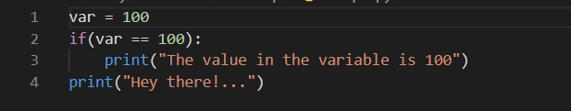

When the above code is executed, it produces the following result −

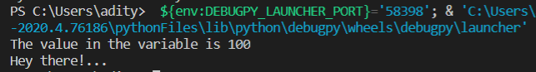

**=>Python - Loops:**

In general, statements are executed sequentially: The first statement in a function is executed first, followed by the second, and so on. There may be a situation when you need to execute a block of code several number of times.

A loop statement allows us to execute a statement or group of statements multiple times.

Python programming language provides the following types of loops to handle looping requirements.

|  |  |
| --- | --- |
| **Sr.No.** | **Loop Type & Description** |
| 1 | [while loop](https://www.tutorialspoint.com/python/python_while_loop.htm)  Repeats a statement or group of statements while a given condition is TRUE. It tests the condition before executing the loop body. |
| 2 | [for loop](https://www.tutorialspoint.com/python/python_for_loop.htm)  Executes a sequence of statements multiple times and abbreviates the code that manages the loop variable. |
| 3 | [nested loops](https://www.tutorialspoint.com/python/python_nested_loops.htm)  You can use one or more loops inside any another while, for or do..while loop. |

## Loop Control Statements

Loop control statements change execution from its normal sequence. When execution leaves a scope, all automatic objects that were created in that scope are destroyed.

Let us go through the loop control statements briefly

|  |  |
| --- | --- |
| **Sr.No.** | **Control Statement & Description** |
| 1 | [break statement](https://www.tutorialspoint.com/python/python_break_statement.htm)  Terminates the loop statement and transfers execution to the statement immediately following the loop. |
| 2 | [continue statement](https://www.tutorialspoint.com/python/python_continue_statement.htm)  Causes the loop to skip the remainder of its body and immediately retest its condition prior to reiterating. |
| 3 | [pass statement](https://www.tutorialspoint.com/python/python_pass_statement.htm)  The pass statement in Python is used when a statement is required syntactically but you do not want any command or code to execute. |

See an example:

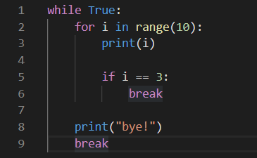

The output obtained is-

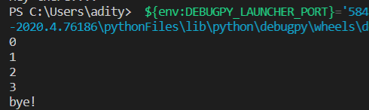

**=>Python - Numbers:**

Number data types store numeric values. They are immutable data types, meaning that changing the value of a number data type results in a newly allocated object.

Number objects are created when you assign a value to them. For example −

var1 = 1

var2 = 10

You can also delete the reference to a number object by using the del statement. The syntax of the del statement is −

del var1[,var2[,var3[....,varN]]]]

You can delete a single object or multiple objects by using the del statement. For example −

del var

del var_a, var_b

Python supports four different numerical types −

* int (signed integers) − They are often called just integers or ints, are positive or negative whole numbers with no decimal point.
* long (long integers ) − Also called longs, they are integers of unlimited size, written like integers and followed by an uppercase or lowercase L.
* float (floating point real values) − Also called floats, they represent real numbers and are written with a decimal point dividing the integer and fractional parts. Floats may also be in scientific notation, with E or e indicating the power of 10 (2.5e2 = 2.5 x 102 = 250).
* complex (complex numbers) − are of the form a + bJ, where a and b are floats and J (or j) represents the square root of -1 (which is an imaginary number). The real part of the number is a, and the imaginary part is b. Complex numbers are not used much in Python programming.

### Examples

Here are some examples of numbers

|  |  |  |  |
| --- | --- | --- | --- |
| int | long | float | complex |
| 10 | 51924361L | 0.0 | 3.14j |
| 100 | -0x19323L | 15.20 | 45.j |
| -786 | 0122L | -21.9 | 9.322e-36j |
| 080 | 0xDEFABCECBDAECBFBAEL | 32.3+e18 | .876j |
| -0490 | 535633629843L | -90. | -.6545+0J |
| -0x260 | -052318172735L | -32.54e100 | 3e+26J |
| 0x69 | -4721885298529L | 70.2-E12 | 4.53e-7j |

## Number Type Conversion

Python allows user inter-convert numbers.

* Type int(x) to convert x to a plain integer.
* Type long(x) to convert x to a long integer.
* Type float(x) to convert x to a floating-point number.
* Type complex(x) to convert x to a complex number with real part x and imaginary part zero.
* Type complex(x, y) to convert x and y to a complex number with real part x and imaginary part y. x and y are numeric expressions

## Mathematical Functions

Python includes the following functions that perform mathematical calculations.

|  |  |
| --- | --- |
| Sr.No. | Function & Returns ( description ) |
| 1 | [abs(x)](https://www.tutorialspoint.com/python/number_abs.htm) :: The absolute value of x: the (positive) distance between x and zero. |
| 2 | [ceil(x)](https://www.tutorialspoint.com/python/number_ceil.htm) :: The ceiling of x: the smallest integer not less than x |
| 3 | [cmp(x, y)](https://www.tutorialspoint.com/python/number_cmp.htm) :: -1 if x < y, 0 if x == y, or 1 if x > y |
| 4 | [exp(x)](https://www.tutorialspoint.com/python/number_exp.htm) :: The exponential of x: ex |
| 5 | [fabs(x)](https://www.tutorialspoint.com/python/number_fabs.htm) :: The absolute value of x. |
| 6 | [floor(x)](https://www.tutorialspoint.com/python/number_floor.htm) :: The floor of x: the largest integer not greater than x |
| 7 | [log(x)](https://www.tutorialspoint.com/python/number_log.htm) :: The natural logarithm of x, for x> 0 |
| 8 | [log10(x)](https://www.tutorialspoint.com/python/number_log10.htm) :: The base-10 logarithm of x for x> 0. |
| 9 | [max(x1, x2,...)](https://www.tutorialspoint.com/python/number_max.htm) :: The largest of its arguments: the value closest to positive infinity |
| 10 | [min(x1, x2,...)](https://www.tutorialspoint.com/python/number_min.htm) :: The smallest of its arguments: the value closest to negative infinity |
| 11 | [modf(x)](https://www.tutorialspoint.com/python/number_modf.htm) :: The fractional and integer parts of x in a two-item tuple. Both parts have the same sign as x. The integer part is returned as a float. |
| 12 | [pow(x, y)](https://www.tutorialspoint.com/python/number_pow.htm) :: The value of x**y. |
| 13 | [round(x [,n])](https://www.tutorialspoint.com/python/number_round.htm) :: x rounded to n digits from the decimal point. Python rounds away from zero as a tie-breaker: round(0.5) is 1.0 and round(-0.5) is -1.0. |
| 14 | [sqrt(x)](https://www.tutorialspoint.com/python/number_sqrt.htm) :: The square root of x for x > 0 |

## Random Number Functions

Random numbers are used for games, simulations, testing, security, and privacy applications. Python includes the following functions that are commonly used.

|  |  |
| --- | --- |
| Sr.No. | Function & Description |
| 1 | [choice(seq)](https://www.tutorialspoint.com/python/number_choice.htm) :: A random item from a list, tuple, or string. |
| 2 | [randrange ([start,] stop [,step])](https://www.tutorialspoint.com/python/number_randrange.htm) :: A randomly selected element from range(start, stop, step) |
| 3 | [random()](https://www.tutorialspoint.com/python/number_random.htm) :: A random float r, such that 0 is less than or equal to r and r is less than 1 |
| 4 | [seed([x])](https://www.tutorialspoint.com/python/number_seed.htm) :: Sets the integer starting value used in generating random numbers. Call this function before calling any other random module function. Returns None. |
| 5 | [shuffle(lst)](https://www.tutorialspoint.com/python/number_shuffle.htm) :: Randomizes the items of a list in place. Returns None. |
| 6 | [uniform(x, y)](https://www.tutorialspoint.com/python/number_uniform.htm) :: A random float r, such that x is less than or equal to r and r is less than y |

## Trigonometric Functions

Python includes the following functions that perform trigonometric calculations.

|  |  |
| --- | --- |
| Sr.No. | Function & Description |
| 1 | [acos(x)](https://www.tutorialspoint.com/python/number_acos.htm) :: Return the arc cosine of x, in radians. |
| 2 | [asin(x)](https://www.tutorialspoint.com/python/number_asin.htm) :: Return the arc sine of x, in radians. |
| 3 | [atan(x)](https://www.tutorialspoint.com/python/number_atan.htm) :: Return the arc tangent of x, in radians. |
| 4 | [atan2(y, x)](https://www.tutorialspoint.com/python/number_atan2.htm) :: Return atan(y / x), in radians. |
| 5 | [cos(x)](https://www.tutorialspoint.com/python/number_cos.htm) :: Return the cosine of x radians. |
| 6 | [hypot(x, y)](https://www.tutorialspoint.com/python/number_hypot.htm) :: Return the Euclidean norm, sqrt(x*x + y*y). |
| 7 | [sin(x)](https://www.tutorialspoint.com/python/number_sin.htm) :: Return the sine of x radians. |
| 8 | [tan(x)](https://www.tutorialspoint.com/python/number_tan.htm) :: Return the tangent of x radians. |
| 9 | [degrees(x)](https://www.tutorialspoint.com/python/number_degrees.htm) :: Converts angle x from radians to degrees. |
| 10 | [radians(x)](https://www.tutorialspoint.com/python/number_radians.htm) :: Converts angle x from degrees to radians. |

## Mathematical Constants

The module also defines two mathematical constants −

|  |  |
| --- | --- |
| Sr.No. | Constants & Description |
| 1 | pi :: The mathematical constant pi. |
| 2 | e :: The mathematical constant e. |

**=>Python - Strings:**

Strings are amongst the most popular types in Python. We can create them simply by enclosing characters in quotes. Python treats single quotes the same as double quotes. Creating strings is as simple as assigning a value to a variable. For example −



## Accessing Values in Strings

Python does not support a character type; these are treated as strings of length one, thus also considered a substring.

To access substrings, use the square brackets for slicing along with the index or indices to obtain your substring. For example −

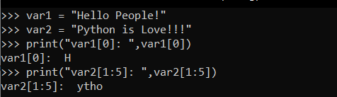

## Updating Strings

You can "update" an existing string by (re)assigning a variable to another string. The new value can be related to its previous value or to a completely different string altogether. For example −

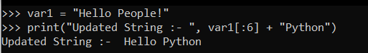

## Escape Characters

Following table is a list of escape or non-printable characters that can be represented with backslash notation.

An escape character gets interpreted; in a single quoted as well as double quoted strings.

|  |  |  |
| --- | --- | --- |
| Backslash notation | Hexadecimal character | Description |
| \a | 0x07 | Bell or alert |
| \b | 0x08 | Backspace |
| \cx |  | Control-x |
| \C-x |  | Control-x |
| \e | 0x1b | Escape |
| \f | 0x0c | Form Feed |
| \M-\C-x |  | Meta-Control-x |
| \n | 0x0a | Newline |
| \nnn |  | Octal notation, where n is in the range 0.7 |
| \r | 0x0d | Carriage return |
| \s | 0x20 | Space |
| \t | 0x09 | Tab |
| \v | 0x0b | Vertical tab |
| \x |  | Character x |
| \xnn |  | Hexadecimal notation, where n is in the range 0.9, a.f, or A.F |

## String Special Operators

Assume string variable a holds 'Hello' and variable b holds 'Python', then −

|  |  |  |
| --- | --- | --- |
| Operator | Description | Example |
| + | Concatenation - Adds values on either side of the operator | a + b will give HelloPython |
| * | Repetition - Creates new strings, concatenating multiple copies of the same string | a*2 will give -HelloHello |
| [] | Slice - Gives the character from the given index | a[1] will give e |
| [ : ] | Range Slice - Gives the characters from the given range | a[1:4] will give ell |
| in | Membership - Returns true if a character exists in the given string | H in a will give 1 |
| not in | Membership - Returns true if a character does not exist in the given string | M not in a will give 1 |
| r/R | Raw String - Suppresses actual meaning of Escape characters. The syntax for raw strings is exactly the same as for normal strings with the exception of the raw string operator, the letter "r," which precedes the quotation marks. The "r" can be lowercase (r) or uppercase (R) and must be placed immediately preceding the first quote mark. | print r'\n' prints \n and print R'\n'prints \n |
| % | Format - Performs String formatting | See at next section |

## String Formatting Operator

One of Python's coolest features is the string format operator %. This operator is unique to strings and makes up for the pack of having functions from C's printf() family. Following is a simple example -



Here is the list of complete set of symbols which can be used along with % −

|  |  |
| --- | --- |
| Format Symbol | Conversion |
| %c | character |
| %s | string conversion via str() prior to formatting |
| %i | signed decimal integer |
| %d | signed decimal integer |
| %u | unsigned decimal integer |
| %o | octal integer |
| %x | hexadecimal integer (lowercase letters) |
| %X | hexadecimal integer (UPPERcase letters) |
| %e | exponential notation (with lowercase 'e') |
| %E | exponential notation (with UPPERcase 'E') |
| %f | floating point real number |
| %g | the shorter of %f and %e |
| %G | the shorter of %f and %E |

Other supported symbols and functionality are listed in the following table −

|  |  |
| --- | --- |
| Symbol | Functionality |
| * | argument specifies width or precision |
| - | left justification |
| + | display the sign |
| <sp> | leave a blank space before a positive number |
| # | add the octal leading zero ( '0' ) or hexadecimal leading '0x' or '0X', depending on whether 'x' or 'X' were used. |
| 0 | pad from left with zeros (instead of spaces) |
| % | '%%' leaves you with a single literal '%' |
| (var) | mapping variable (dictionary arguments) |
| m.n. | m is the minimum total width and n is the number of digits to display after the decimal point (if appl.) |

## Triple Quotes

Python's triple quotes comes to the rescue by allowing strings to span multiple lines, including verbatim NEWLINEs, TABs, and any other special characters.

The syntax for triple quotes consists of three consecutive single or double quotes.

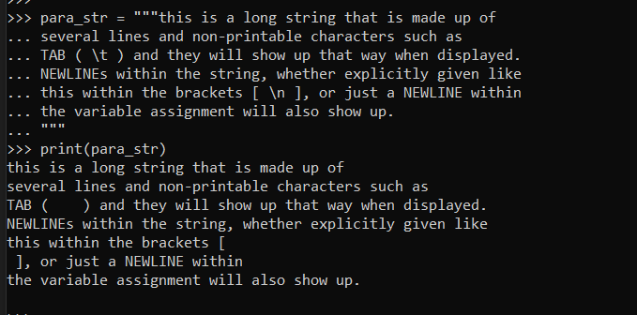

Raw strings do not treat the backslash as a special character at all. Every character you put into a raw string stays the way you wrote it −



Now let's make use of raw string. We would put expression in r'expression' as follows −



## Unicode String

Normal strings in Python are stored internally as 8-bit ASCII, while Unicode strings are stored as 16-bit Unicode. This allows for a more varied set of characters, including special characters from most languages in the world. I'll restrict my treatment of Unicode strings to the following −



As you can see, Unicode strings use the prefix u, just as raw strings use the prefix r.

## Built-in String Methods

Python includes the following built-in methods to manipulate strings −

|  |  |
| --- | --- |
| Sr.No. | Methods with Description |
| 1 | [capitalize()](https://www.tutorialspoint.com/python/string_capitalize.htm) :: Capitalizes first letter of string |
| 2 | [center(width, fillchar)](https://www.tutorialspoint.com/python/string_center.htm) :: Returns a space-padded string with the original string centered to a total of width columns. |
| 3 | [count(str, beg= 0,end=len(string))](https://www.tutorialspoint.com/python/string_count.htm) :: Counts how many times str occurs in string or in a substring of string if starting index beg and ending index end are given. |
| 4 | [decode(encoding='UTF-8',errors='strict')](https://www.tutorialspoint.com/python/string_decode.htm) :: Decodes the string using the codec registered for encoding. encoding defaults to the default string encoding. |
| 5 | [encode(encoding='UTF-8',errors='strict')](https://www.tutorialspoint.com/python/string_encode.htm) :: Returns encoded string version of string; on error, default is to raise a ValueError unless errors is given with 'ignore' or 'replace'. |
| 6 | [endswith(suffix, beg=0, end=len(string))](https://www.tutorialspoint.com/python/string_endswith.htm) :: Determines if string or a substring of string (if starting index beg and ending index end are given) ends with suffix; returns true if so and false otherwise. |
| 7 | [expandtabs(tabsize=8)](https://www.tutorialspoint.com/python/string_expandtabs.htm) :: Expands tabs in string to multiple spaces; defaults to 8 spaces per tab if tabsize not provided. |
| 8 | [find(str, beg=0 end=len(string))](https://www.tutorialspoint.com/python/string_find.htm) :: Determine if str occurs in string or in a substring of string if starting index beg and ending index end are given returns index if found and -1 otherwise. |
| 9 | [index(str, beg=0, end=len(string))](https://www.tutorialspoint.com/python/string_index.htm) :: Same as find(), but raises an exception if str not found. |
| 10 | [isalnum()](https://www.tutorialspoint.com/python/string_isalnum.htm) :: Returns true if string has at least 1 character and all characters are alphanumeric and false otherwise. |
| 11 | [isalpha()](https://www.tutorialspoint.com/python/string_isalpha.htm) :: Returns true if string has at least 1 character and all characters are alphabetic and false otherwise. |
| 12 | [isdigit()](https://www.tutorialspoint.com/python/string_isdigit.htm) :: Returns true if string contains only digits and false otherwise. |
| 13 | [islower()](https://www.tutorialspoint.com/python/string_islower.htm) :: Returns true if string has at least 1 cased character and all cased characters are in lowercase and false otherwise. |
| 14 | [isnumeric()](https://www.tutorialspoint.com/python/string_isnumeric.htm) :: Returns true if a unicode string contains only numeric characters and false otherwise. |
| 15 | [isspace()](https://www.tutorialspoint.com/python/string_isspace.htm) :: Returns true if string contains only whitespace characters and false otherwise. |
| 16 | [istitle()](https://www.tutorialspoint.com/python/string_istitle.htm) :: Returns true if string is properly "titlecased" and false otherwise. |
| 17 | [isupper()](https://www.tutorialspoint.com/python/string_isupper.htm) :: Returns true if string has at least one cased character and all cased characters are in uppercase and false otherwise. |
| 18 | [join(seq)](https://www.tutorialspoint.com/python/string_join.htm) :: Merges (concatenates) the string representations of elements in sequence seq into a string, with separator string. |
| 19 | [len(string)](https://www.tutorialspoint.com/python/string_len.htm) :: Returns the length of the string |
| 20 | [ljust(width[, fillchar])](https://www.tutorialspoint.com/python/string_ljust.htm) :: Returns a space-padded string with the original string left-justified to a total of width columns. |
| 21 | [lower()](https://www.tutorialspoint.com/python/string_lower.htm) :: Converts all uppercase letters in string to lowercase. |
| 22 | [lstrip()](https://www.tutorialspoint.com/python/string_lstrip.htm) :: Removes all leading whitespace in string. |
| 23 | [maketrans()](https://www.tutorialspoint.com/python/string_maketrans.htm) :: Returns a translation table to be used in translate function. |
| 24 | [max(str)](https://www.tutorialspoint.com/python/string_max.htm) :: Returns the max alphabetical character from the string str. |
| 25 | [min(str)](https://www.tutorialspoint.com/python/string_min.htm) :: Returns the min alphabetical character from the string str. |
| 26 | [replace(old, new [, max])](https://www.tutorialspoint.com/python/string_replace.htm) :: Replaces all occurrences of old in string with new or at most max occurrences if max given. |
| 27 | [rfind(str, beg=0,end=len(string))](https://www.tutorialspoint.com/python/string_rfind.htm) :: Same as find(), but search backwards in string. |
| 28 | [rindex( str, beg=0, end=len(string))](https://www.tutorialspoint.com/python/string_rindex.htm) :: Same as index(), but search backwards in string. |
| 29 | [rjust(width,[, fillchar])](https://www.tutorialspoint.com/python/string_rjust.htm) :: Returns a space-padded string with the original string right-justified to a total of width columns. |
| 30 | [rstrip()](https://www.tutorialspoint.com/python/string_rstrip.htm) :: Removes all trailing whitespace of string. |
| 31 | [split(str="", num=string.count(str))](https://www.tutorialspoint.com/python/string_split.htm) :: Splits string according to delimiter str (space if not provided) and returns list of substrings; split into at most num substrings if given. |
| 32 | [splitlines( num=string.count('\n'))](https://www.tutorialspoint.com/python/string_splitlines.htm) :: Splits string at all (or num) NEWLINEs and returns a list of each line with NEWLINEs removed. |
| 33 | [startswith(str, beg=0,end=len(string))](https://www.tutorialspoint.com/python/string_startswith.htm) :: Determines if string or a substring of string (if starting index beg and ending index end are given) starts with substring str; returns true if so and false otherwise. |
| 34 | [strip([chars])](https://www.tutorialspoint.com/python/string_strip.htm) :: Performs both lstrip() and rstrip() on string. |
| 35 | [swapcase()](https://www.tutorialspoint.com/python/string_swapcase.htm) :: Inverts case for all letters in string. |
| 36 | [title()](https://www.tutorialspoint.com/python/string_title.htm) :: Returns "titlecased" version of string, that is, all words begin with uppercase and the rest are lowercase. |
| 37 | [translate(table, deletechars="")](https://www.tutorialspoint.com/python/string_translate.htm) :: Translates string according to translation table str(256 chars), removing those in the del string. |
| 38 | [upper()](https://www.tutorialspoint.com/python/string_upper.htm) :: Converts lowercase letters in string to uppercase. |
| 39 | [zfill (width)](https://www.tutorialspoint.com/python/string_zfill.htm) :: Returns original string leftpadded with zeros to a total of width characters; intended for numbers, zfill() retains any sign given (less one zero). |
| 40 | [isdecimal()](https://www.tutorialspoint.com/python/string_isdecimal.htm) :: Returns true if a unicode string contains only decimal characters and false otherwise. |

**=>Python - Lists:**

The most basic data structure in Python is the sequence. Each element of a sequence is assigned a number - its position or index. The first index is zero, the second index is one, and so forth. List is one of the most common one.The list is a most versatile data type available in Python which can be written as a list of comma-separated values (items) between square brackets. Important thing about a list is that items in a list need not be of the same type.

Creating a list is as simple as putting different comma-separated values between square brackets. For example −

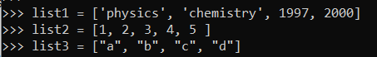

Similar to string indices, list indices start at 0, and lists can be sliced, concatenated and so on.

## Accessing Values in Lists

To access values in lists, use the square brackets for slicing along with the index or indices to obtain value available at that index. For example −

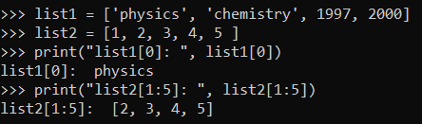

## Updating Lists

You can update single or multiple elements of lists by giving the slice on the left-hand side of the assignment operator, and you can add to elements in a list with the append() method. For example −

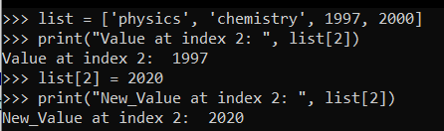

## Delete List Elements

To remove a list element, you can use either the del statement if you know exactly which element(s) you are deleting or the remove() method if you do not know. For example −

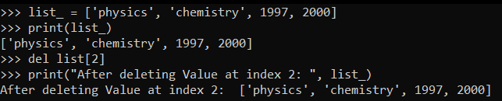

## Basic List Operations

Lists respond to the + and * operators much like strings; they mean concatenation and repetition here too, except that the result is a new list, not a string.

In fact, lists respond to all of the general sequence operations we used on strings in the prior chapter.

|  |  |  |
| --- | --- | --- |
| Python Expression | Results | Description |
| len([1, 2, 3]) | 3 | Length |
| [1, 2, 3] + [4, 5, 6] | [1, 2, 3, 4, 5, 6] | Concatenation |
| ['Hi!'] * 4 | ['Hi!', 'Hi!', 'Hi!', 'Hi!'] | Repetition |
| 3 in [1, 2, 3] | True | Membership |
| for x in [1, 2, 3]: print x, | 1 2 3 | Iteration |

## 

## Indexing, Slicing, and Matrixes

Because lists are sequences, indexing and slicing work the same way for lists as they do for strings.

Assuming following input −

L = ['spam', 'Spam', 'SPAM!']

|  |  |  |
| --- | --- | --- |
| Python Expression | Results | Description |
| L[2] | SPAM! | Offsets start at zero |
| L[-2] | Spam | Negative: count from the right |
| L[1:] | ['Spam', 'SPAM!'] | Slicing fetches sections |

## 

## Built-in List Functions & Methods

Python includes the following list functions −

|  |  |
| --- | --- |
| Sr.No. | Function with Description |
| 1 | [cmp(list1, list2)](https://www.tutorialspoint.com/python/list_cmp.htm) :: Compares elements of both lists. |
| 2 | [len(list)](https://www.tutorialspoint.com/python/list_len.htm) :: Gives the total length of the list. |
| 3 | [max(list)](https://www.tutorialspoint.com/python/list_max.htm) :: Returns item from the list with max value. |
| 4 | [min(list)](https://www.tutorialspoint.com/python/list_min.htm) :: Returns item from the list with min value. |
| 5 | [list(seq)](https://www.tutorialspoint.com/python/list_list.htm) :: Converts a tuple into list. |

Python includes following list methods

|  |  |
| --- | --- |
| Sr.No. | Methods with Description |
| 1 | [list.append(obj)](https://www.tutorialspoint.com/python/list_append.htm) :: Appends object obj to list |
| 2 | [list.count(obj)](https://www.tutorialspoint.com/python/list_count.htm) :: Returns count of how many times obj occurs in list |
| 3 | [list.extend(seq)](https://www.tutorialspoint.com/python/list_extend.htm) :: Appends the contents of seq to list |
| 4 | [list.index(obj)](https://www.tutorialspoint.com/python/list_index.htm) :: Returns the lowest index in list that obj appears |
| 5 | [list.insert(index, obj)](https://www.tutorialspoint.com/python/list_insert.htm) :: Inserts object obj into list at offset index |
| 6 | [list.pop(obj=list[-1])](https://www.tutorialspoint.com/python/list_pop.htm) :: Removes and returns last object or obj from list |
| 7 | [list.remove(obj)](https://www.tutorialspoint.com/python/list_remove.htm) :: Removes object obj from list |
| 8 | [list.reverse()](https://www.tutorialspoint.com/python/list_reverse.htm) :: Reverses objects of list in place |
| 9 | [list.sort([func])](https://www.tutorialspoint.com/python/list_sort.htm) :: Sorts objects of list, use compare func if given |

**=>Python - Tuples:**

A tuple is an immutable sequence of Python objects. Tuples are sequences, just like lists. The differences between tuples and lists are, the tuples cannot be changed unlike lists and tuples use parentheses, whereas lists use square brackets.

Creating a tuple is as simple as putting different comma-separated values. Optionally you can put these comma-separated values between parentheses also. For example −

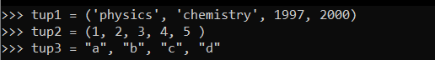

The empty tuple is written as two parentheses containing nothing −



To write a tuple containing a single value you have to include a comma, even though there is only one value −



Like string indices, tuple indices start at 0, and they can be sliced, concatenated, and so on.

## Accessing Values in Tuples

To access values in tuple, use the square brackets for slicing along with the index or indices to obtain values available at that index. For example −

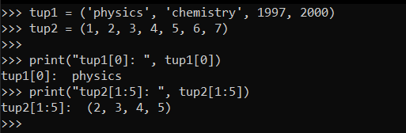

## Updating Tuples

Tuples are immutable which means you cannot update or change the values of tuple elements. You are able to take portions of existing tuples to create new tuples as the following example demonstrates −

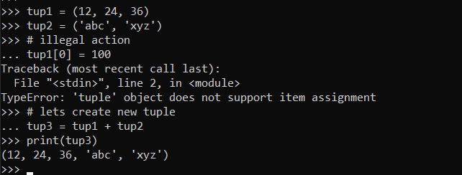

## Delete Tuple Elements

Removing individual tuple elements is not possible. There is, of course, nothing wrong with putting together another tuple with the undesired elements discarded.

To explicitly remove an entire tuple, just use the del statement. For example −

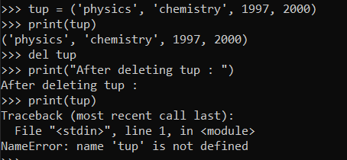

## Basic Tuples Operations

Tuples respond to the + and * operators much like strings; they mean concatenation and repetition here too, except that the result is a new tuple, not a string.

In fact, tuples respond to all of the general sequence operations we used on strings in the prior chapter −

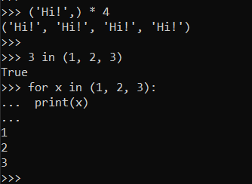

|  |  |  |
| --- | --- | --- |
| Python Expression | Results | Description |
| len((1, 2, 3)) | 3 | Length |
| (1, 2, 3) + (4, 5, 6) | (1, 2, 3, 4, 5, 6) | Concatenation |
| ('Hi!',) * 4 | ('Hi!', 'Hi!', 'Hi!', 'Hi!') | Repetition |
| 3 in (1, 2, 3) | True | Membership |
| for x in (1, 2, 3): print x, | 1 2 3 | Iteration |

## Indexing, Slicing, and Matrixes

Because tuples are sequences, indexing and slicing work the same way for tuples as they do for strings. Assuming following input −

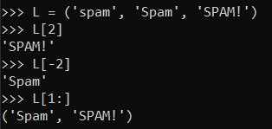

|  |  |  |
| --- | --- | --- |
| Python Expression | Results | Description |
| L[2] | 'SPAM!' | Offsets start at zero |
| L[-2] | 'Spam' | Negative: count from the right |
| L[1:] | ['Spam', 'SPAM!'] | Slicing fetches sections |

## No Enclosing Delimiters

Any set of multiple objects, comma-separated, written without identifying symbols, i.e., brackets for lists, parentheses for tuples, etc., default to tuples, as indicated in these short examples −

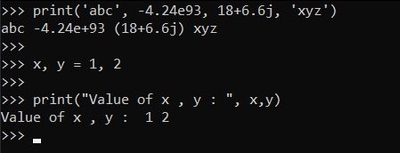

## Built-in Tuple Functions

Python includes the following tuple functions −

|  |  |
| --- | --- |
| Sr.No. | Function with Description |
| 1 | [cmp(tuple1, tuple2)](https://www.tutorialspoint.com/python/tuple_cmp.htm) :: Compares elements of both tuples. |
| 2 | [len(tuple)](https://www.tutorialspoint.com/python/tuple_len.htm) :: Gives the total length of the tuple. |
| 3 | [max(tuple)](https://www.tutorialspoint.com/python/tuple_max.htm) :: Returns item from the tuple with max value. |
| 4 | [min(tuple)](https://www.tutorialspoint.com/python/tuple_min.htm) :: Returns item from the tuple with min value. |
| 5 | [tuple(seq)](https://www.tutorialspoint.com/python/tuple_tuple.htm) :: Converts a list into tuple. |

**=>Python - Dictionary:**

Each key is separated from its value by a colon (:), the items are separated by commas, and the whole thing is enclosed in curly braces. An empty dictionary without any items is written with just two curly braces, like this: {}.

Keys are unique within a dictionary while values may not be. The values of a dictionary can be of any type, but the keys must be of an immutable data type such as strings, numbers, or tuples.

## Accessing Values in Dictionary

To access dictionary elements, you can use the familiar square brackets along with the key to obtain its value. Following is a simple example −

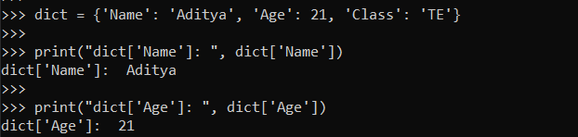

If we attempt to access a data item with a key, which is not part of the dictionary, we get an error as follows −

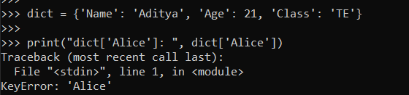

## Updating Dictionary

You can update a dictionary by adding a new entry or a key-value pair, modifying an existing entry, or deleting an existing entry as shown below in the simple example −

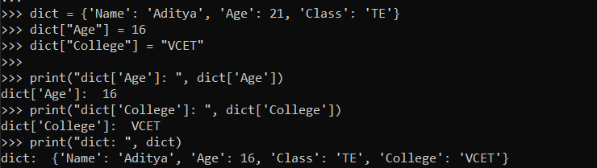

## Delete Dictionary Elements

You can either remove individual dictionary elements or clear the entire contents of a dictionary. You can also delete the entire dictionary in a single operation.

To explicitly remove an entire dictionary, just use the del statement. Following is a simple example −

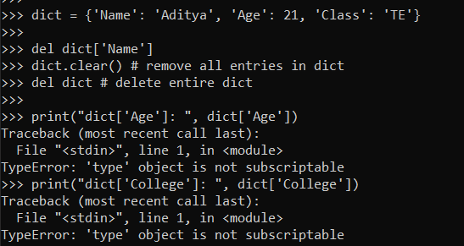

## Properties of Dictionary Keys

Dictionary values have no restrictions. They can be any arbitrary Python object, either standard objects or user-defined objects. However, the same is not true for the keys.

There are two important points to remember about dictionary keys −

(a) More than one entry per key not allowed. Which means no duplicate key is allowed. When duplicate keys are encountered during assignment, the last assignment wins. For example −

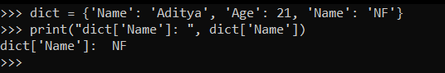

(b) Keys must be immutable. Which means you can use strings, numbers or tuples as dictionary keys but something like ['key'] is not allowed. Following is a simple example −

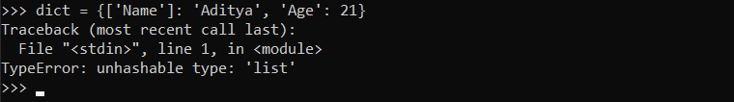

## Built-in Dictionary Functions & Methods

Python includes the following dictionary functions −

|  |  |
| --- | --- |
| Sr.No. | Function with Description |
| 1 | [cmp(dict1, dict2)](https://www.tutorialspoint.com/python/dictionary_cmp.htm) :: Compares elements of both dict. |
| 2 | [len(dict)](https://www.tutorialspoint.com/python/dictionary_len.htm) :: Gives the total length of the dictionary. This would be equal to the number of items in the dictionary. |
| 3 | [str(dict)](https://www.tutorialspoint.com/python/dictionary_str.htm) :: Produces a printable string representation of a dictionary |
| 4 | [type(variable)](https://www.tutorialspoint.com/python/dictionary_type.htm) :: Returns the type of the passed variable. If the passed variable is a dictionary, then it would return a dictionary type. |

Python includes following dictionary methods −

|  |  |
| --- | --- |
| Sr.No. | Methods with Description |
| 1 | [dict.clear()](https://www.tutorialspoint.com/python/dictionary_clear.htm) :: Removes all elements of dictionary *dict* |
| 2 | [dict.copy()](https://www.tutorialspoint.com/python/dictionary_copy.htm) :: Returns a shallow copy of dictionary *dict* |
| 3 | [dict.fromkeys()](https://www.tutorialspoint.com/python/dictionary_fromkeys.htm) :: Create a new dictionary with keys from seq and values *set* to *value*. |
| 4 | [dict.get(key, default=None)](https://www.tutorialspoint.com/python/dictionary_get.htm) :: For *key* key, returns value or default if key not in dictionary |
| 5 | [dict.has_key(key)](https://www.tutorialspoint.com/python/dictionary_has_key.htm) :: Returns *true* if key in dictionary *dict*, *false* otherwise |
| 6 | [dict.items()](https://www.tutorialspoint.com/python/dictionary_items.htm) :: Returns a list of *dicts* (key, value) tuple pairs |
| 7 | [dict.keys()](https://www.tutorialspoint.com/python/dictionary_keys.htm) :: Returns list of dictionary dict's keys |
| 8 | [dict.setdefault(key, default=None)](https://www.tutorialspoint.com/python/dictionary_setdefault.htm) :: Similar to get(), but will set dict[key]=default if *key* is not already in dict |
| 9 | [dict.update(dict2)](https://www.tutorialspoint.com/python/dictionary_update.htm) :: Adds dictionary *dict2*'s key-values pairs to *dict* |
| 10 | [dict.values()](https://www.tutorialspoint.com/python/dictionary_values.htm) :: Returns list of dictionary *dict*'s values |

**=>Python - Date & Time:**

A Python program can handle date and time in several ways. Converting between date formats is a common chore for computers. Python's time and calendar modules help track dates and times.

## What is Tick?

Time intervals are floating-point numbers in units of seconds. Particular instants in time are expressed in seconds since 12:00am, January 1, 1970(epoch).

There is a popular time module available in Python which provides functions for working with times, and for converting between representations. The function *time.time()* returns the current system time in ticks since 12:00am, January 1, 1970(epoch).

## Example

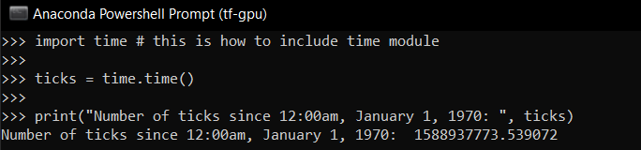

Date arithmetic is easy to do with ticks. However, dates before the epoch cannot be represented in this form. Dates in the far future also cannot be represented this way - the cutoff point is sometime in 2038 for UNIX and Windows.

## What is TimeTuple?

Many of Python's time functions handle time as a tuple of 9 numbers, as shown below −

|  |  |  |
| --- | --- | --- |
| Index | Field | Values |
| 0 | 4-digit year | 2020 |
| 1 | Month | 1 to 12 |
| 2 | Day | 1 to 31 |
| 3 | Hour | 0 to 23 |
| 4 | Minute | 0 to 59 |
| 5 | Second | 0 to 61 (60 or 61 are leap-seconds) |
| 6 | Day of Week | 0 to 6 (0 is Monday) |
| 7 | Day of year | 1 to 366 (Julian day) |
| 8 | Daylight savings | -1, 0, 1, -1 means library determines DST |

The above tuple is equivalent to struct_time structure. This structure has following attributes −

|  |  |  |
| --- | --- | --- |
| Index | Attributes | Values |
| 0 | tm_year | 2020 |
| 1 | tm_mon | 1 to 12 |
| 2 | tm_mday | 1 to 31 |
| 3 | tm_hour | 0 to 23 |
| 4 | tm_min | 0 to 59 |
| 5 | tm_sec | 0 to 61 (60 or 61 are leap-seconds) |
| 6 | tm_wday | 0 to 6 (0 is Monday) |
| 7 | tm_yday | 1 to 366 (Julian day) |
| 8 | tm_isdst | -1, 0, 1, -1 means library determines DST |

## Getting current time

To translate a time instant from a *seconds since the epoch* floating-point value into a time-tuple, pass the floating-point value to a function (e.g., localtime) that returns a time-tuple with all nine items valid.

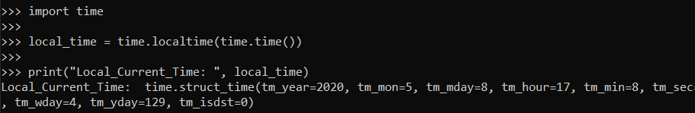

## Getting formatted time

You can format any time as per your requirement, but simple method to get time in readable format is asctime() −

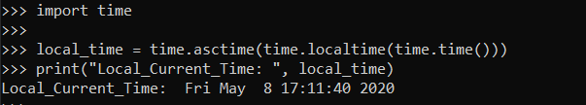

## Getting calendar for a month

The calendar module gives a wide range of methods to play with yearly and monthly calendars. Here, we print a calendar for a given month ( Apr 2020 ) −

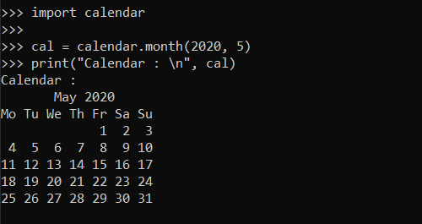

## The Time Module

There is a popular time module available in Python which provides functions for working with times and for converting between representations. Here is the list of all available methods −

|  |  |
| --- | --- |
| Sr.No. | Function with Description |
| 1 | [time.altzone](https://www.tutorialspoint.com/python/time_altzone.htm)  The offset of the local DST timezone, in seconds west of UTC, if one is defined. This is negative if the local DST timezone is east of UTC (as in Western Europe, including the UK). Only use this if daylight is nonzero. |
| 2 | [time.asctime([tupletime])](https://www.tutorialspoint.com/python/time_asctime.htm)  Accepts a time-tuple and returns a readable 24-character string such as 'Tue Dec 11 18:07:14 2008'. |
| 3 | [time.clock( )](https://www.tutorialspoint.com/python/time_clock.htm)  Returns the current CPU time as a floating-point number of seconds. To measure computational costs of different approaches, the value of time.clock is more useful than that of time.time(). |
| 4 | [time.ctime([secs])](https://www.tutorialspoint.com/python/time_ctime.htm)  Like asctime(localtime(secs)) and without arguments is like asctime( ) |
| 5 | [time.gmtime([secs])](https://www.tutorialspoint.com/python/time_gmtime.htm)  Accepts an instant expressed in seconds since the epoch and returns a time-tuple t with the UTC time. Note : t.tm_isdst is always 0 |
| 6 | [time.localtime([secs])](https://www.tutorialspoint.com/python/time_localtime.htm)  Accepts an instant expressed in seconds since the epoch and returns a time-tuple t with the local time (t.tm_isdst is 0 or 1, depending on whether DST applies to instant secs by local rules). |
| 7 | [time.mktime(tupletime)](https://www.tutorialspoint.com/python/time_mktime.htm)  Accepts an instant expressed as a time-tuple in local time and returns a floating-point value with the instant expressed in seconds since the epoch. |
| 8 | [time.sleep(secs)](https://www.tutorialspoint.com/python/time_sleep.htm)  Suspends the calling thread for secs seconds. |
| 9 | [time.strftime(fmt[,tupletime])](https://www.tutorialspoint.com/python/time_strftime.htm)  Accepts an instant expressed as a time-tuple in local time and returns a string representing the instant as specified by string fmt. |
| 10 | [time.strptime(str,fmt='%a %b %d %H:%M:%S %Y')](https://www.tutorialspoint.com/python/time_strptime.htm)  Parses str according to format string fmt and returns the instant in time-tuple format. |
| 11 | [time.time( )](https://www.tutorialspoint.com/python/time_time.htm)  Returns the current time instant, a floating-point number of seconds since the epoch. |
| 12 | [time.tzset()](https://www.tutorialspoint.com/python/time_tzset.htm)  Resets the time conversion rules used by the library routines. The environment variable TZ specifies how this is done. |

Let us go through the functions briefly −

There are following two important attributes available with time module −

|  |  |
| --- | --- |
| Sr.No. | Attribute with Description |
| 1 | time.timezone  Attribute time.timezone is the offset in seconds of the local time zone (without DST) from UTC (>0 in the Americas; <=0 in most of Europe, Asia, Africa). |
| 2 | time.tzname  Attribute time.tzname is a pair of locale-dependent strings, which are the names of the local time zone without and with DST, respectively. |

## The Calendar Module

The calendar module supplies calendar-related functions, including functions to print a text calendar for a given month or year.

By default, the calendar takes Monday as the first day of the week and Sunday as the last one. To change this, call calendar.setfirstweekday() function.

Here is a list of functions available with the *calendar* module −

|  |  |
| --- | --- |
| Sr.No. | Function with Description |
| 1 | calendar.calendar(year,w=2,l=1,c=6)  Returns a multiline string with a calendar for year year formatted into three columns separated by c spaces. w is the width in characters of each date; each line has length 21*w+18+2*c. l is the number of lines for each week. |
| 2 | calendar.firstweekday( )  Returns the current setting for the weekday that starts each week. By default, when the calendar is first imported, this is 0, meaning Monday. |
| 3 | calendar.isleap(year)  Returns True if year is a leap year; otherwise, False. |
| 4 | calendar.leapdays(y1,y2)  Returns the total number of leap days in the years within range(y1,y2). |
| 5 | calendar.month(year,month,w=2,l=1)  Returns a multiline string with a calendar for month month of year year, one line per week plus two header lines. w is the width in characters of each date; each line has length 7*w+6. l is the number of lines for each week. |
| 6 | calendar.monthcalendar(year,month)  Returns a list of lists of ints. Each sublist denotes a week. Days outside month month of year are set to 0; days within the month are set to their day-of-month, 1 and up. |
| 7 | calendar.monthrange(year,month)  Returns two integers. The first one is the code of the weekday for the first day of the month month in year; the second one is the number of days in the month. Weekday codes are 0 (Monday) to 6 (Sunday); month numbers are 1 to 12. |
| 8 | calendar.prcal(year,w=2,l=1,c=6)  Like print calendar.calendar(year,w,l,c). |
| 9 | calendar.prmonth(year,month,w=2,l=1)  Like print calendar.month(year,month,w,l). |
| 10 | calendar.setfirstweekday(weekday)  Set the first day of each week to weekday code weekday. Weekday codes are 0 (Monday) to 6 (Sunday). |
| 11 | calendar.timegm(tupletime)  The inverse of time.gmtime: accepts a time instant in time-tuple form and returns the same instant as a floating-point number of seconds since the epoch. |
| 12 | calendar.weekday(year,month,day)  Returns the weekday code for the given date. Weekday codes are 0 (Monday) to 6 (Sunday); month numbers are 1 (January) to 12 (December). |

**=>Python - Functions:**

A function is a block of organized, reusable code that is used to perform a single, related action. Functions provide better modularity for your application and a high degree of code reusing.

As you already know, Python gives you many built-in functions like print(), etc. but you can also create your own functions. These functions are called *user-defined functions.*

## Defining a Function

You can define functions to provide the required functionality. Here are simple rules to define a function in Python.

* Function blocks begin with the keyword def followed by the function name and parentheses ( ( ) ).
* Any input parameters or arguments should be placed within these parentheses. You can also define parameters inside these parentheses.
* The first statement of a function can be an optional statement - the documentation string of the function or *docstring*.
* The code block within every function starts with a colon (:) and is indented.
* The statement return [expression] exits a function, optionally passing back an expression to the caller. A return statement with no arguments is the same as return None.

## Syntax

**def** function_name(parameters):

Statement

…………..

…………..

return expression

By default, parameters have a positional behavior and you need to inform them in the same order that they were defined.

## Example

The following function takes a string as input parameter and prints it on standard screen.

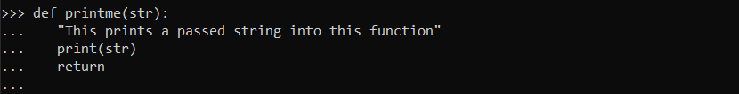

## Calling a Function

Defining a function only gives it a name, specifies the parameters that are to be included in the function and structures the blocks of code.

Once the basic structure of a function is finalized, you can execute it by calling it from another function or directly from the Python prompt. Following is the example to call printme() function −

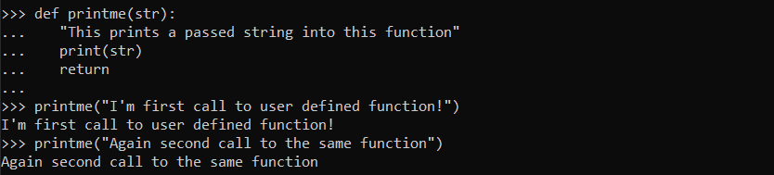

## Pass by reference vs value

All parameters (arguments) in the Python language are passed by reference. It means if you change what a parameter refers to within a function, the change also reflects back in the calling function. For example −

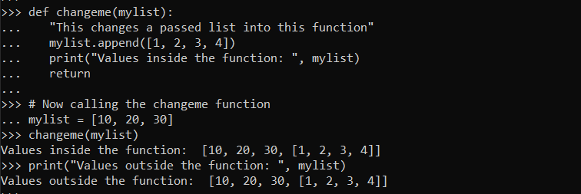

There is one more example where argument is being passed by reference and the reference is being overwritten inside the called function.

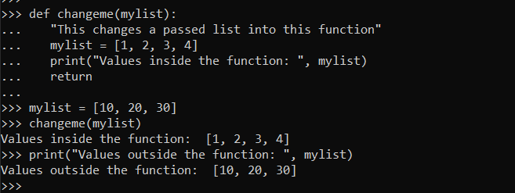

## Function Arguments

You can call a function by using the following types of formal arguments −

* Required arguments
* Keyword arguments
* Default arguments
* Variable-length arguments

## Required arguments

Required arguments are the arguments passed to a function in correct positional order. Here, the number of arguments in the function call should match exactly with the function definition.

To call the function *printme()*, you definitely need to pass one argument, otherwise it gives a syntax error as follows −

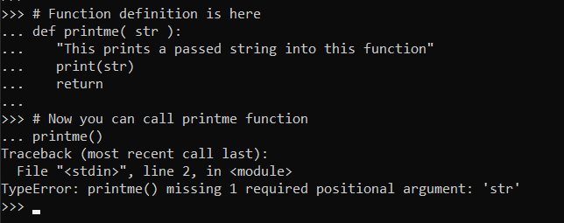

## Keyword arguments

Keyword arguments are related to the function calls. When you use keyword arguments in a function call, the caller identifies the arguments by the parameter name.

This allows you to skip arguments or place them out of order because the Python interpreter is able to use the keywords provided to match the values with parameters. You can also make keyword calls to the *printme()* function in the following ways −

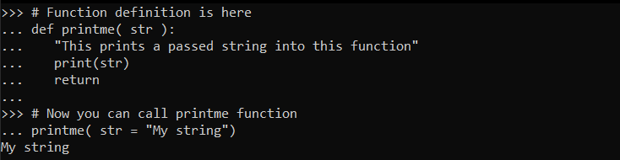

The following example gives a more clear picture. Note that the order of parameters does not matter.

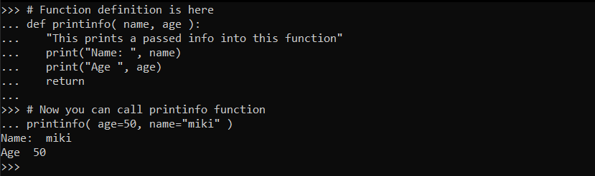

## Default arguments

A default argument is an argument that assumes a default value if a value is not provided in the function call for that argument. The following example gives an idea on default arguments, it prints default age if it is not passed −

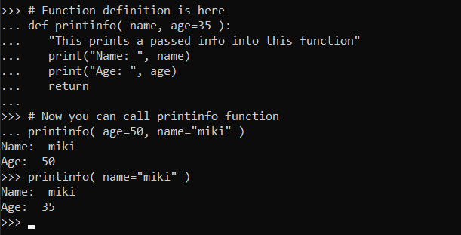

## Variable-length arguments

You may need to process a function for more arguments than you specified while defining the function. These arguments are called *variable-length* arguments and are not named in the function definition, unlike required and default arguments.

Syntax for a function with non-keyword variable arguments is this −

**def function_name([formal_args,] *var_args_tuple):**

**Statement**

**…………..**

**…………..**

**return expression**

An asterisk (*) is placed before the variable name that holds the values of all non keyword variable arguments. This tuple remains empty if no additional arguments are specified during the function call. Following is a simple example −

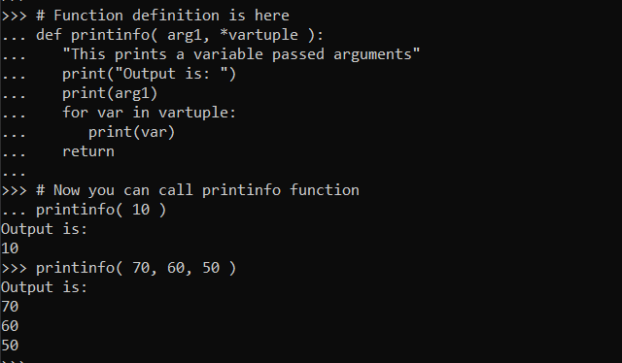

## The *Lambda* Functions

These functions are called anonymous because they are not declared in the standard manner by using the *def* keyword. You can use the *lambda* keyword to create small anonymous functions.

* Lambda forms can take any number of arguments but return just one value in the form of an expression. They cannot contain commands or multiple expressions.
* An anonymous function cannot be a direct call to print because lambda requires an expression
* Lambda functions have their own local namespace and cannot access variables other than those in their parameter list and those in the global namespace.
* Although it appears that lambda's are a one-line version of a function, they are not equivalent to inline statements in C or C++, whose purpose is by passing function stack allocation during invocation for performance reasons.

## Syntax

The syntax of *lambda* functions contains only a single statement, which is as follows −

**lambda** [arg1 [,arg2,.....argn]]:expression

Following is the example to show how *lambda* form of function works −

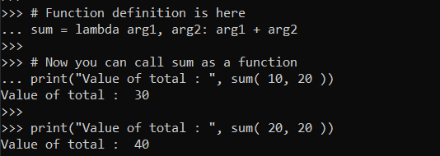

## The *return* Statement

The statement return [expression] exits a function, optionally passing back an expression to the caller. A return statement with no arguments is the same as return None.

All the above examples are not returning any value. You can return a value from a function as follows −

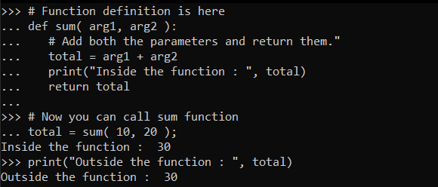

## Scope of Variables

All variables in a program may not be accessible at all locations in that program. This depends on where you have declared a variable.

The scope of a variable determines the portion of the program where you can access a particular identifier. There are two basic scopes of variables in Python −

* Global variables
* Local variables

## Global vs. Local variables

Variables that are defined inside a function body have a local scope, and those defined outside have a global scope.

This means that local variables can be accessed only inside the function in which they are declared, whereas global variables can be accessed throughout the program body by all functions. When you call a function, the variables declared inside it are brought into scope. Following is a simple example −

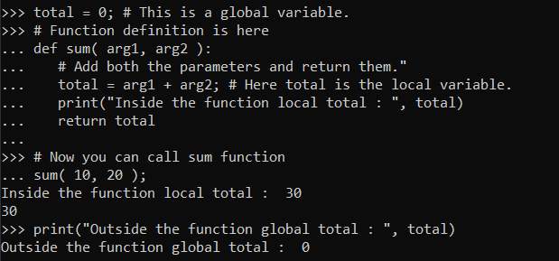

**=>Python - Modules:**

A module allows you to logically organize your Python code. Grouping related code into a module makes the code easier to understand and use. A module is a Python object with arbitrarily named attributes that you can bind and reference.

Simply, a module is a file consisting of Python code. A module can define functions, classes and variables. A module can also include runnable code.

## Example

The Python code for a module named *aname* normally resides in a file named *aname.py*. Here's an example of a simple module, sample.py

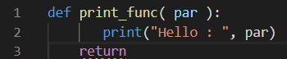

## The *import* Statement

You can use any Python source file as a module by executing an import statement in some other Python source file. The *import* has the following syntax −

**import** module1[, module2[,... moduleN]

When the interpreter encounters an import statement, it imports the module if the module is present in the search path. A search path is a list of directories that the interpreter searches before importing a module. For example, to import the module support.py, you need to put the following command at the top of the script −

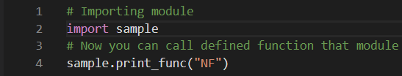

When the above code is executed, it produces the following result −



A module is loaded only once, regardless of the number of times it is imported. This prevents the module execution from happening over and over again if multiple imports occur.

## The *from...import* Statement

Python from statement lets you import specific attributes from a module into the current namespace. The *from...import* has the following syntax −

**from** modname **import** name1[, name2[, ... nameN]]

For example, to import the function fibonacci from the module fib, use the following statement −

**from** fib **import** fibonacci

This statement does not import the entire module fib into the current namespace; it just introduces the item fibonacci from the module fib into the global symbol table of the importing module.

## The *from...import \** Statement

It is also possible to import all names from a module into the current namespace by using the following import statement −

**from** modname **import** *

This provides an easy way to import all the items from a module into the current namespace; however, this statement should be used sparingly.

## Locating Modules

When you import a module, the Python interpreter searches for the module in the following sequences −

* The current directory.
* If the module isn't found, Python then searches each directory in the shell variable PYTHONPATH.
* If all else fails, Python checks the default path. On UNIX, this default path is normally /usr/local/lib/python/.

The module search path is stored in the system module sys as the sys.path variable. The sys.path variable contains the current directory, PYTHONPATH, and the installation-dependent default.

## The *PYTHONPATH* Variable

The PYTHONPATH is an environment variable, consisting of a list of directories. The syntax of PYTHONPATH is the same as that of the shell variable PATH.

Here is a typical PYTHONPATH from a Windows system −

**set PYTHONPATH** = c:\python20\lib;

And here is a typical PYTHONPATH from a UNIX system −

**set PYTHONPATH** = /usr/local/lib/python

## Namespaces and Scoping

Variables are names (identifiers) that map to objects. A *namespace* is a dictionary of variable names (keys) and their corresponding objects (values).

A Python statement can access variables in a *local namespace* and in the *global namespace*. If a local and a global variable have the same name, the local variable shadows the global variable.

Each function has its own local namespace. Class methods follow the same scoping rule as ordinary functions.

Python makes educated guesses on whether variables are local or global. It assumes that any variable assigned a value in a function is local.

Therefore, in order to assign a value to a global variable within a function, you must first use the global statement.

The statement *global VarName* tells Python that VarName is a global variable. Python stops searching the local namespace for the variable.

For example, we define a variable *Money* in the global namespace. Within the function *Money*, we assign *Money* a value, therefore Python assumes *Money* as a local variable. However, we assessed the value of the local variable *Money* before setting it, so an UnboundLocalError is the result. Uncommenting the global statement fixes the problem.

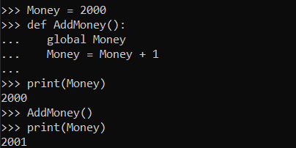

## The dir( ) Function

The dir() built-in function returns a sorted list of strings containing the names defined by a module.

The list contains the names of all the modules, variables and functions that are defined in a module. Following is a simple example −

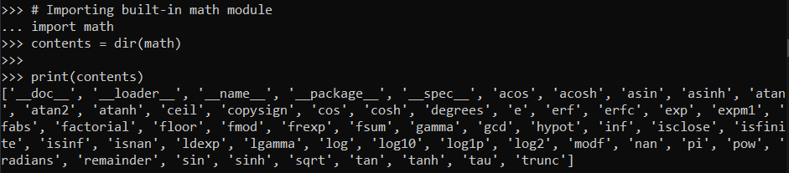

Here, the special string variable *__name__* is the module's name, and *__file__* is the filename from which the module was loaded.

## The *globals()* and *locals()* Functions

The *globals()* and *locals()* functions can be used to return the names in the global and local namespaces depending on the location from where they are called.

If locals() is called from within a function, it will return all the names that can be accessed locally from that function.

If globals() is called from within a function, it will return all the names that can be accessed globally from that function.

The return type of both these functions is a dictionary. Therefore, names can be extracted using the keys() function.

## The *reload()* Function

When the module is imported into a script, the code in the top-level portion of a module is executed only once.

Therefore, if you want to re execute the top-level code in a module, you can use the *reload()* function. The reload() function imports a previously imported module again. The syntax of the reload() function is this −

**reload**(module_name)

Here, *module_name* is the name of the module you want to reload and not the string containing the module name. For example, to reload *hello* module, do the following −

**reload**(hello)

## Packages in Python

A package is a hierarchical file directory structure that defines a single Python application environment that consists of modules and subpackages and sub-subpackages, and so on.

Consider a file *Pots.py* available in the Phone directory. This file has following line of source code −

**def** Pots():

print "I'm Pots Phone"

Similar way, we have another two files having different functions with the same name as above −

* *Phone/Isdn.py* file having function Isdn()
* *Phone/G3.py* file having function G3()

Now, create one more file __init__.py in *Phone* directory −

* Phone/__init__.py

To make all of your functions available when you've imported Phone, you need to put explicit import statements in __init__.py as follows −

**from** Pots **import** Pots

**from** Isdn **import** Isdn

**from** G3 **import** G3

After you add these lines to __init__.py, you have all of these classes available when you import the Phone package.

# Now import your Phone Package.

**import** Phone

Phone.Pots()

Phone.Isdn()

Phone.G3()

When the above code is executed, it produces the following result −

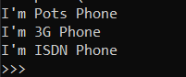

In the above example, we have taken examples of a single function in each file, but you can keep multiple functions in your files. You can also define different Python classes in those files and then you can create your packages out of those classes.

**=>Python - Files I/O:**

Just like in C and Java programming, we can handle input and output in python as well. This is one of the easiest things to do in python.Also file handling is quite simple in python as well. Let’s look at them...

## Printing to the Screen

The simplest way to produce output is using the *print* statement where you can pass zero or more expressions separated by commas. This function converts the expressions you pass into a string and writes the result to standard output as follows −

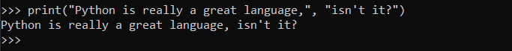

## Keyboard Reading Input

Python provides two built-in functions to read a line of text from standard input, which by default comes from the keyboard. These functions are −

* Raw_input (python--version--2.x)
* input

## The *raw_input* Function(python--version--2.x)

The *raw_input([prompt])* function reads one line from standard input and returns it as a string (removing the trailing newline).

str = **raw_input**("Enter your input: ")

**print** "Received input is : ", str

This prompts you to enter any string and it would display the same string on the screen. When I typed "Hello Python!", its output is like this −



## The *input* Function

The *input([prompt])* function is equivalent to raw_input, except that it assumes the input is a valid Python expression and returns the evaluated result to you.

str = **input**("Enter your input: ")

**print** "Received input is : ", str

This would produce the following result against the entered input −



## Opening and Closing Files

Until now, you have been reading and writing to the standard input and output. Now, we will see how to use actual data files.

Python provides basic functions and methods necessary to manipulate files by default. You can do most of the file manipulation using a file object.

## The *open* Function

Before you can read or write a file, you have to open it using Python's built-in *open()* function. This function creates a file object, which would be utilized to call other support methods associated with it.

### Syntax

file**_**object = **open**(file_name [, access_mode][, buffering])

Here are parameter details −

* file_name − The file_name argument is a string value that contains the name of the file that you want to access.
* access_mode − The access_mode determines the mode in which the file has to be opened, i.e., read, write, append, etc. A complete list of possible values is given below in the table. This is an optional parameter and the default file access mode is read (r).
* buffering − If the buffering value is set to 0, no buffering takes place. If the buffering value is 1, line buffering is performed while accessing a file. If you specify the buffering value as an integer greater than 1, then buffering action is performed with the indicated buffer size. If negative, the buffer size is the system default(default behavior).

Here is a list of the different modes of opening a file −

|  |  |
| --- | --- |
| Sr.No. | Modes & Description |
| 1 | r  Opens a file for reading only. The file pointer is placed at the beginning of the file. This is the default mode. |
| 2 | rb  Opens a file for reading only in binary format. The file pointer is placed at the beginning of the file. This is the default mode. |
| 3 | r+  Opens a file for both reading and writing. The file pointer placed at the beginning of the file. |
| 4 | rb+  Opens a file for both reading and writing in binary format. The file pointer placed at the beginning of the file. |
| 5 | w  Opens a file for writing only. Overwrites the file if the file exists. If the file does not exist, create a new file for writing. |
| 6 | wb  Opens a file for writing only in binary format. Overwrites the file if the file exists. If the file does not exist, create a new file for writing. |
| 7 | w+  Opens a file for both writing and reading. Overwrites the existing file if the file exists. If the file does not exist, create a new file for reading and writing. |
| 8 | wb+  Opens a file for both writing and reading in binary format. Overwrites the existing file if the file exists. If the file does not exist, create a new file for reading and writing. |
| 9 | a  Opens a file for appending. The file pointer is at the end of the file if the file exists. That is, the file is in the append mode. If the file does not exist, it creates a new file for writing. |
| 10 | ab  Opens a file for appending in binary format. The file pointer is at the end of the file if the file exists. That is, the file is in the append mode. If the file does not exist, it creates a new file for writing. |
| 11 | a+  Opens a file for both appending and reading. The file pointer is at the end of the file if the file exists. The file opens in the append mode. If the file does not exist, it creates a new file for reading and writing. |
| 12 | ab+  Opens a file for both appending and reading in binary format. The file pointer is at the end of the file if the file exists. The file opens in the append mode. If the file does not exist, it creates a new file for reading and writing. |

## The *file* Object Attributes

Once a file is opened and you have one *file* object, you can get various information related to that file.

Here is a list of all attributes related to file object −

|  |  |
| --- | --- |
| Sr.No. | Attribute & Description |
| 1 | file.closed  Returns true if file is closed, false otherwise. |
| 2 | file.mode  Returns access mode with which file was opened. |
| 3 | file.name  Returns name of the file. |
| 4 | file.softspace  Returns false if space explicitly required with print, true otherwise. |

### Example

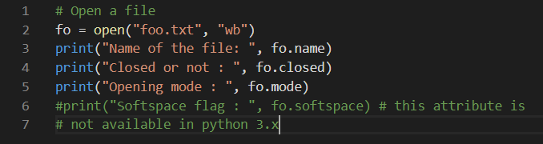

This produces the following result −



## The *close()* Method

The close() method of a *file* object flushes any unwritten information and closes the file object, after which no more writing can be done.

Python automatically closes a file when the reference object of a file is reassigned to another file. It is a good practice to use the close() method to close a file.

### Syntax

fileObject.**close**()

### Example

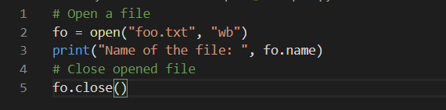

This produces the following result −



## Reading and Writing Files

The *file* object provides a set of access methods to make our lives easier. We would see how to use *read()* and *write()* methods to read and write files.

## The *write()* Method

The *write()* method writes any string to an open file. It is important to note that Python strings can have binary data and not just text.

The write() method does not add a newline character ('\n') to the end of the string −

### Syntax

fileObject.**write**(string)

Here, the passed parameter is the content to be written into the opened file.

### Example

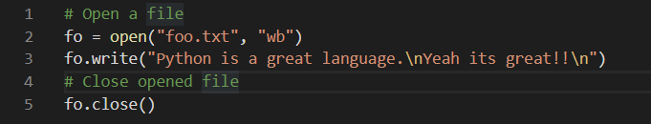

The above method would create a foo.txt file and would write given content in that file and finally it would close that file. If you would open this file, it would have the following content.

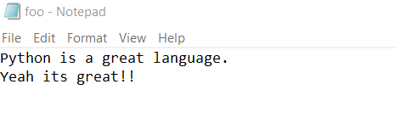

## The *read()* Method

The *read()* method reads a string from an open file. It is important to note that Python strings can have binary data. apart from text data.

### Syntax

fileObject.**read**([count])

Here, the passed parameter is the number of bytes to be read from the opened file. This method starts reading from the beginning of the file and if *count* is missing, then it tries to read as much as possible, maybe until the end of file.

### Example

Let's take a file *foo.txt*, which we created above.

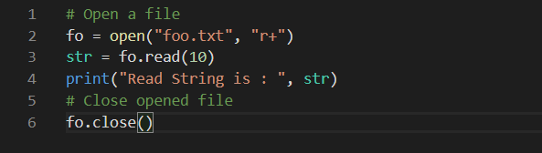

This produces the following result −

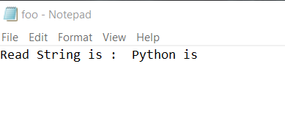

## File Positions

The *tell()* method tells you the current position within the file; in other words, the next read or write will occur at that many bytes from the beginning of the file.

The *seek(offset[, from])* method changes the current file position. The *offset* argument indicates the number of bytes to be moved. The *from* argument specifies the reference position from where the bytes are to be moved.

If *from* is set to 0, it means use the beginning of the file as the reference position and 1 means use the current position as the reference position and if it is set to 2 then the end of the file would be taken as the reference position.

### Example

Let us take a file *foo.txt*, which we created above.

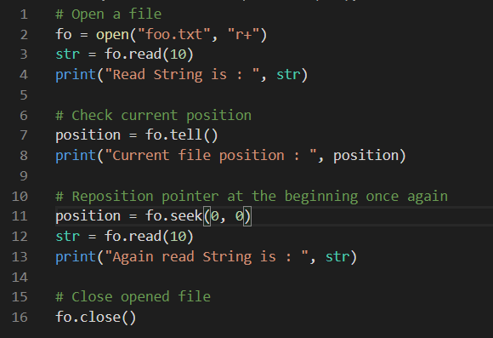

This produces the following result −

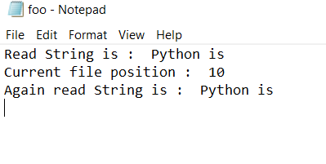

## Renaming and Deleting Files

Python os module provides methods that help you perform file-processing operations, such as renaming and deleting files.

To use this module you need to import it first and then you can call any related functions.

## The rename() Method

The *rename()* method takes two arguments, the current filename and the new filename.

### Syntax

os.**rename**(current_file_name, new_file_name)

### Example

Following is the example to rename an existing file *test1.txt* −

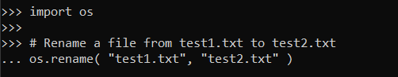

## The *remove()* Method

You can use the *remove()* method to delete files by supplying the name of the file to be deleted as the argument.

### Syntax

os.**remove**(file_name)

### Example

Following is the example to delete an existing file *test2.txt* −

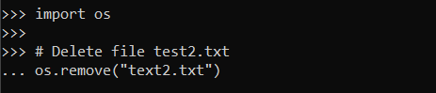

## Directories in Python

All files are contained within various directories, and Python has no problem handling these too. The os module has several methods that help you create, remove, and change directories.

## The *mkdir()* Method

You can use the *mkdir()* method of the os module to create directories in the current directory. You need to supply an argument to this method which contains the name of the directory to be created.

### Syntax

os.**mkdir**("newdir")

### Example

Following is the example to create a directory *test* in the current directory −

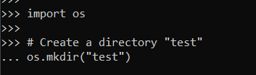

## The *chdir()* Method

You can use the *chdir()* method to change the current directory. The chdir() method takes an argument, which is the name of the directory that you want to make the current directory.

### Syntax

os.**chdir**("newdir")

### Example

Following is the example to go into "/home/newdir" directory −

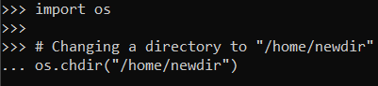

## The *getcwd()* Method

The *getcwd()* method displays the current working directory.

### Syntax

os.**getcwd**()

### Example

Following is the example to give current directory −

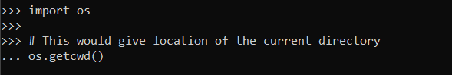

## The *rmdir()* Method

The *rmdir()* method deletes the directory, which is passed as an argument in the method.

Before removing a directory, all the contents in it should be removed.

### Syntax

os.**rmdir**('dirname')

### Example

Following is the example to remove the "/tmp/test" directory. It is required to give a fully qualified name of the directory, otherwise it would search for that directory in the current directory.

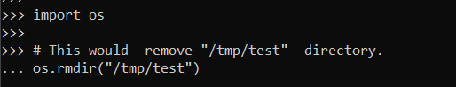

**=>Python - Exceptions:**

Python provides two very important features to handle any unexpected error in your Python programs and to add debugging capabilities in them −

* Exception Handling − This would be covered in this tutorial. Here is a list standard Exceptions available in Python: [Standard Exceptions](https://www.tutorialspoint.com/python/standard_exceptions.htm).
* Assertions − This would be covered in [Assertions in Python](https://www.tutorialspoint.com/python/assertions_in_python.htm) tutorial.

List of Standard Exceptions −

|  |  |
| --- | --- |
| Sr.No. | Exception Name & Description |
| 1 | Exception :: Base class for all exceptions |
| 2 | StopIteration :: Raised when the next() method of an iterator does not point to any object. |
| 3 | SystemExit :: Raised by the sys.exit() function. |
| 4 | StandardError :: Base class for all built-in exceptions except StopIteration and SystemExit. |
| 5 | ArithmeticError :: Base class for all errors that occur for numeric calculation. |
| 6 | OverflowError :: Raised when a calculation exceeds maximum limit for a numeric type. |
| 7 | FloatingPointError :: Raised when a floating point calculation fails. |
| 8 | ZeroDivisionError  Raised when division or modulo by zero takes place for all numeric types. |
| 9 | AssertionError  Raised in case of failure of the Assert statement. |
| 10 | AttributeError  Raised in case of failure of attribute reference or assignment. |
| 11 | EOFError  Raised when there is no input from either the raw_input() or input() function and the end of file is reached. |
| 12 | ImportError :: Raised when an import statement fails. |
| 13 | KeyboardInterrupt  Raised when the user interrupts program execution, usually by pressing Ctrl+c. |
| 14 | LookupError :: Base class for all lookup errors. |
| 15 | IndexError :: Raised when an index is not found in a sequence. |
| 16 | KeyError  Raised when the specified key is not found in the dictionary. |
| 17 | NameError  Raised when an identifier is not found in the local or global namespace. |
| 18 | UnboundLocalError  Raised when trying to access a local variable in a function or method but no value has been assigned to it. |
| 19 | EnvironmentError  Base class for all exceptions that occur outside the Python environment. |
| 20 | IOError  Raised when an input/ output operation fails, such as the print statement or the open() function when trying to open a file that does not exist. |
| 21 | IOError  Raised for operating system-related errors. |
| 22 | SyntaxError  Raised when there is an error in Python syntax. |
| 23 | IndentationError  Raised when indentation is not specified properly. |
| 24 | SystemError  Raised when the interpreter finds an internal problem, but when this error is encountered the Python interpreter does not exit. |
| 25 | SystemExit  Raised when Python interpreter is quit by using the sys.exit() function. If not handled in the code, causes the interpreter to exit. |
| 26 | TypeError  Raised when an operation or function is attempted that is invalid for the specified data type. |
| 27 | ValueError  Raised when the built-in function for a data type has the valid type of arguments, but the arguments have invalid values specified. |
| 28 | RuntimeError  Raised when a generated error does not fall into any category. |
| 29 | NotImplementedError  Raised when an abstract method that needs to be implemented in an inherited class is not actually implemented. |

### Assertions in Python

An assertion is a sanity-check that you can turn on or turn off when you are done with your testing of the program.

The easiest way to think of an assertion is to liken it to a raise-if statement (or to be more accurate, a raise-if-not statement). An expression is tested, and if the result comes up false, an exception is raised.

Assertions are carried out by the assert statement, the newest keyword to Python, introduced in version 1.5.

Programmers often place assertions at the start of a function to check for valid input, and after a function call to check for valid output.

### The *assert* Statement

When it encounters an assert statement, Python evaluates the accompanying expression, which is hopefully true. If the expression is false, Python raises an *AssertionError* exception.

The syntax for assert is −

**assert** Expression[, Arguments]

If the assertion fails, Python uses ArgumentExpression as the argument for the AssertionError. AssertionError exceptions can be caught and handled like any other exception using the try-except statement, but if not handled, they will terminate the program and produce a traceback.

### Example

Here is a function that converts a temperature from degrees Kelvin to degrees Fahrenheit. Since zero degrees Kelvin is as cold as it gets, the function bails out if it sees a negative temperature −

#!/usr/bin/python

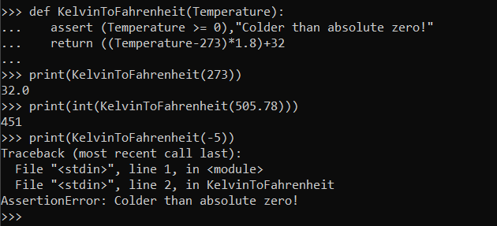

## What is Exception?

An exception is an event, which occurs during the execution of a program that disrupts the normal flow of the program's instructions. In general, when a Python script encounters a situation that it cannot cope with, it raises an exception. An exception is a Python object that represents an error.

When a Python script raises an exception, it must either handle the exception immediately otherwise it terminates and quits.

## Handling an exception

If you have some *suspicious* code that may raise an exception, you can defend your program by placing the suspicious code in a try: block. After the try: block, include an except: statement, followed by a block of code which handles the problem as elegantly as possible.

### Syntax

Here is simple syntax of *try....except...else* blocks −

**try**:

You do your operations here;

......................

**except** *ExceptionI*:

If there is ExceptionI, then execute this block.

**except** *ExceptionII*:

If there is ExceptionII, then execute this block.

......................

**else**:

If there is no exception then execute this block.

Here are few important points about the above-mentioned syntax −

* A single try statement can have multiple except statements. This is useful when the try block contains statements that may throw different types of exceptions.
* You can also provide a generic except clause, which handles any exception.
* After the except clause(s), you can include an else-clause. The code in the else-block executes if the code in the try: block does not raise an exception.
* The else-block is a good place for code that does not need the try: block's protection.

### Example

This example opens a file, writes content in the, file and comes out gracefully because there is no problem at all −

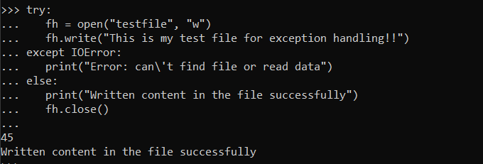

### Example

This example tries to open a file where you do not have write permission, so it raises an exception −

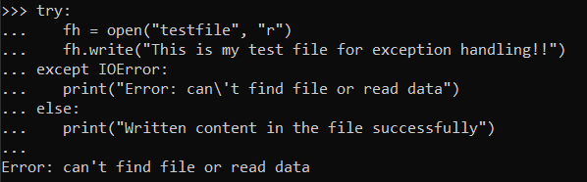

## The *except* Clause with No Exceptions

You can also use the except statement with no exceptions defined as follows −

**try**:

“‘You do your operations here”’

......................

**except**:

“‘If there is any exception, then execute this block.’’’

......................

**else**:

‘’’If there is no exception then execute this block’’’

This kind of a try-except statement catches all the exceptions that occur. Using this kind of try-except statement is not considered a good programming practice though, because it catches all exceptions but does not make the programmer identify the root cause of the problem that may occur.

## The *except* Clause with Multiple Exceptions

You can also use the same *except* statement to handle multiple exceptions as follows −

**try**:

“‘You do your operations here’’’

......................

**except**(Exception1[, Exception2[,...ExceptionN]]]):

‘’’If there is any exception from the given exception list,

then execute this block’’’

......................

**else**:

‘’’If there is no exception then execute this block’’’

## The try-finally Clause

You can use a finally: block along with a try: block. The finally block is a place to put any code that must execute, whether the try-block raised an exception or not. The syntax of the try-finally statement is this −

**try**:

‘’’You do your operations here’’’

......................

‘’’Due to any exception, this may be skipped’’’

**finally**:

‘’’This would always be executed’’’

......................

You cannot use *else* clauses along with a finally clause.

### Example

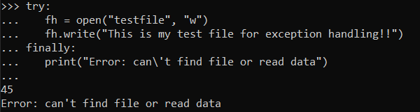

Same example can be written more cleanly as follows −

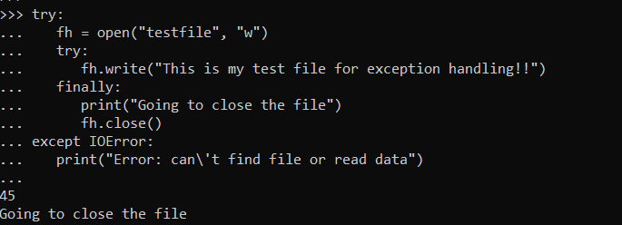

When an exception is thrown in the *try* block, the execution immediately passes to the *finally* block. After all the statements in the *finally* block are executed, the exception is raised again and is handled in the *except* statements if present in the next higher layer of the *try-except* statement.

## Argument of an Exception

An exception can have an *argument*, which is a value that gives additional information about the problem. The contents of the argument vary by exception. You capture an exception's argument by supplying a variable in the except clause as follows −

**try**:

‘’’ You do your operations here’’’

......................

**except** *ExceptionType, Argument*:

‘’’You can print the value of Argument here…’’’

If you write the code to handle a single exception, you can have a variable follow the name of the exception in the except statement. If you are trapping multiple exceptions, you can have a variable follow the tuple of the exception.

This variable receives the value of the exception mostly containing the cause of the exception. The variable can receive a single value or multiple values in the form of a tuple. This tuple usually contains the error string, the error number, and an error location.

### Example

Following is an example for a single exception −

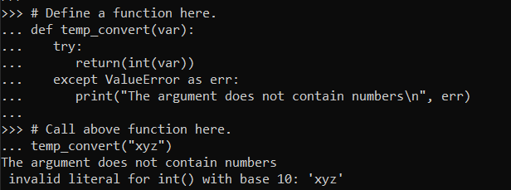

## Raising an Exceptions

You can raise exceptions in several ways by using the raise statement. The general syntax for the raise statement is as follows.

### Syntax

**raise** [Exception [, args [, traceback]]]

Here, *Exception* is the type of exception (for example, NameError) and *argument* is a value for the exception argument. The argument is optional; if not supplied, the exception argument is None.

The final argument, traceback, is also optional (and rarely used in practice), and if present, is the traceback object used for the exception.

### Example

An exception can be a string, a class or an object. Most of the exceptions that the Python core raises are classes, with an argument that is an instance of the class. Defining new exceptions is quite easy and can be done as follows −

**def** functionName( level ):

**if** level < 1:

**raise** "Invalid level!", level

# The code below to this would not be executed

# if we raise the exception

Note: In order to catch an exception, an "except" clause must refer to the same exception thrown either class object or simple string. For example, to capture above exception, we must write the except clause as follows −

**try**:

‘’’Business Logic here…’’’

**except** "Invalid level!":

‘’’Exception handling here…’’’

**else**:

‘’’Rest of the code here…’’’

## User-Defined Exceptions

Python also allows you to create your own exceptions by deriving classes from the standard built-in exceptions.

Here is an example related to *RuntimeError*. Here, a class is created that is subclassed from *RuntimeError*. This is useful when you need to display more specific information when an exception is caught.

In the try block, the user-defined exception is raised and caught in the except block. The variable e is used to create an instance of the class *Networkerror*.

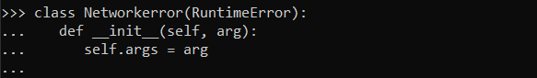

So once you defined above class, you can raise the exception as follows −

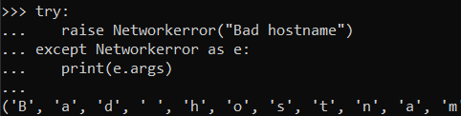

**============================================**

***Python Advanced Tutorial***

**=>Python - Classes/Objects:**

Python has been an object-oriented language since it existed. Because of this, creating and using classes and objects are downright easy. This chapter helps you become an expert in using Python's object-oriented programming support.

If you do not have any previous experience with object-oriented (OO) programming, you may want to consult an introductory course on it or at least a tutorial of some sort so that you have a grasp of the basic concepts.

However, here is small introduction of Object-Oriented Programming (OOP) to bring you at speed −

## Overview of OOP Terminology

* Class − A user-defined prototype for an object that defines a set of attributes that characterize any object of the class. The attributes are data members (class variables and instance variables) and methods, accessed via dot notation.
* Class variable − A variable that is shared by all instances of a class. Class variables are defined within a class but outside any of the class's methods. Class variables are not used as frequently as instance variables are.
* Data member − A class variable or instance variable that holds data associated with a class and its objects.
* Function overloading − The assignment of more than one behavior to a particular function. The operation performed varies by the types of objects or arguments involved.
* Instance variable − A variable that is defined inside a method and belongs only to the current instance of a class.
* Inheritance − The transfer of the characteristics of a class to other classes that are derived from it.
* Instance − An individual object of a certain class. An object obj that belongs to a class Circle, for example, is an instance of the class Circle.
* Instantiation − The creation of an instance of a class.
* Method − A special kind of function that is defined in a class definition.
* Object − A unique instance of a data structure that's defined by its class. An object comprises both data members (class variables and instance variables) and methods.
* Operator overloading − The assignment of more than one function to a particular operator.

## Creating Classes

The *class* statement creates a new class definition. The name of the class immediately follows the keyword *class* followed by a colon as follows −

**class** ClassName:

‘’'Optional class documentation string'’’

Class_Suite

* The class has a documentation string, which can be accessed via *ClassName.__doc__*.
* The *class_suite* consists of all the component statements defining class members, data attributes and functions.

### Example

Following is the example of a simple Python class −

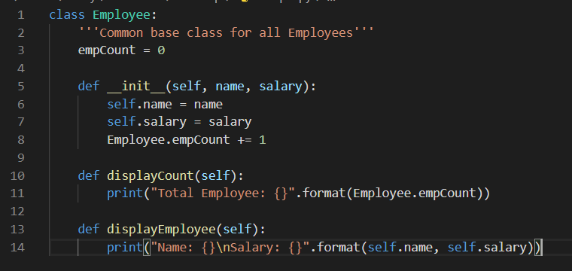

* The empCount is a class variable whose value is shared among all instances of this class. This can be accessed as *Employee.empCount* from inside the class or outside the class.
* The first method *__init__()* is a special method, which is called a class constructor or initialization method that Python calls when you create a new instance of this class.
* You declare other class methods like normal functions with the exception that the first argument to each method is *self*. Python adds the *self* argument to the list for you; you do not need to include it when you call the methods.

## Creating Instance Objects

To create instances of a class, you call the class using the class name and pass in whatever arguments its *__init__* method accepts.

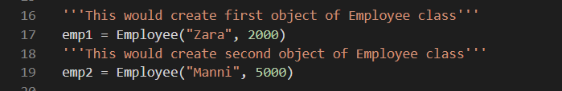

## Accessing Attributes

You access the object's attributes using the dot operator with object. Class variable would be accessed using class name as follows −

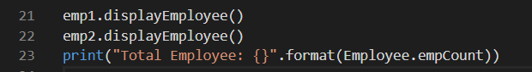

Now, putting all the concepts together −

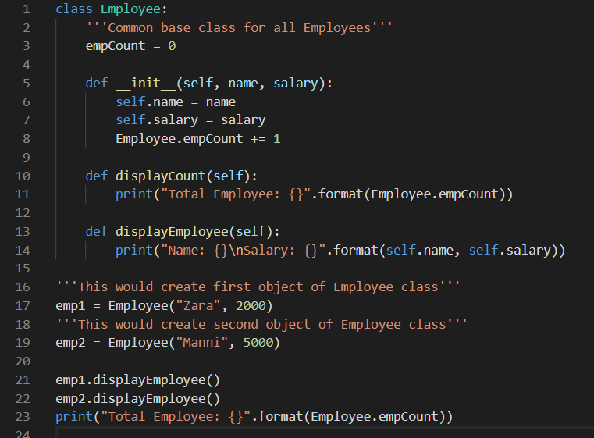

When the above code is executed, it produces the following result −

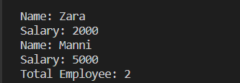

You can add, remove, or modify attributes of classes and objects at any time −

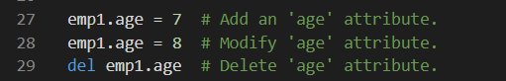

Instead of using the normal statements to access attributes, you can use the following functions −

* The getattr(obj, name[, default]) − to access the attribute of object.
* The hasattr(obj,name) − to check if an attribute exists or not.
* The setattr(obj,name,value) − to set an attribute. If attribute does not exist, then it would be created.
* The delattr(obj, name) − to delete an attribute.

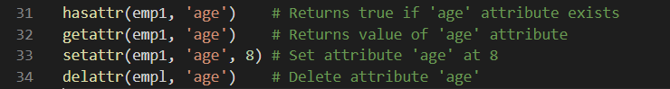

## Built-In Class Attributes

Every Python class keeps following built-in attributes and they can be accessed using dot operator like any other attribute −

* __dict__ − Dictionary containing the class's namespace.
* __doc__ − Class documentation string or none, if undefined.
* __name__ − Class name.
* __module__ − Module name in which the class is defined. This attribute is "__main__" in interactive mode.
* __bases__ − A possibly empty tuple containing the base classes, in the order of their occurrence in the base class list.

For the above class let us try to access all these attributes −

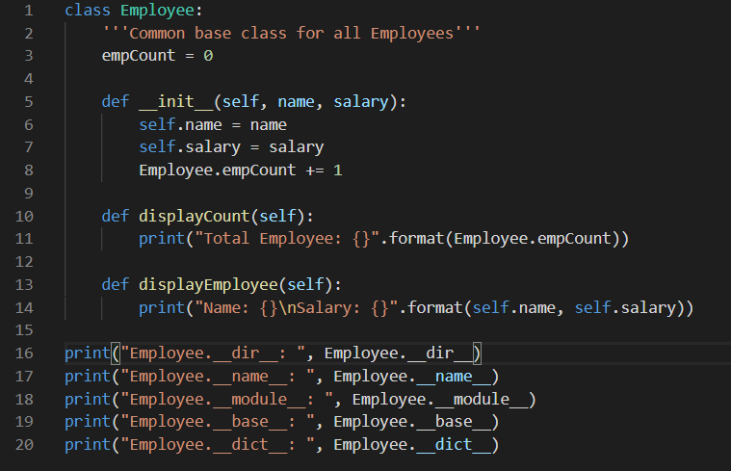

When the above code is executed, it produces the following result −

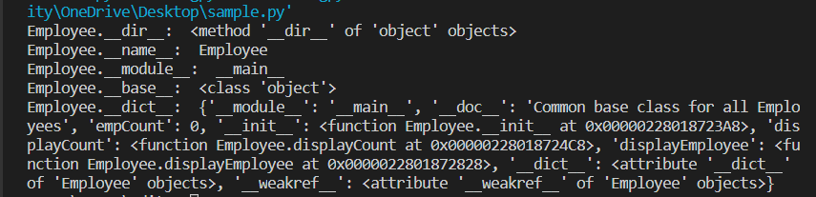

## Destroying Objects (Garbage Collection)

Python deletes unneeded objects (built-in types or class instances) automatically to free the memory space. The process by which Python periodically reclaims blocks of memory that no longer are in use is termed Garbage Collection.

Python's garbage collector runs during program execution and is triggered when an object's reference count reaches zero. An object's reference count changes as the number of aliases that point to it changes.

An object's reference count increases when it is assigned a new name or placed in a container (list, tuple, or dictionary). The object's reference count decreases when it's deleted with *del*, its reference is reassigned, or its reference goes out of scope. When an object's reference count reaches zero, Python collects it automatically.

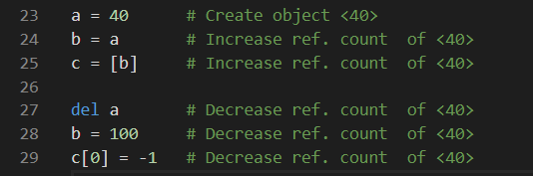

You normally will not notice when the garbage collector destroys an orphaned instance and reclaims its space. But a class can implement the special method *__del__()*, called a destructor, that is invoked when the instance is about to be destroyed. This method might be used to clean up any non memory resources used by an instance.

### Example

This __del__() destructor prints the class name of an instance that is about to be destroyed −

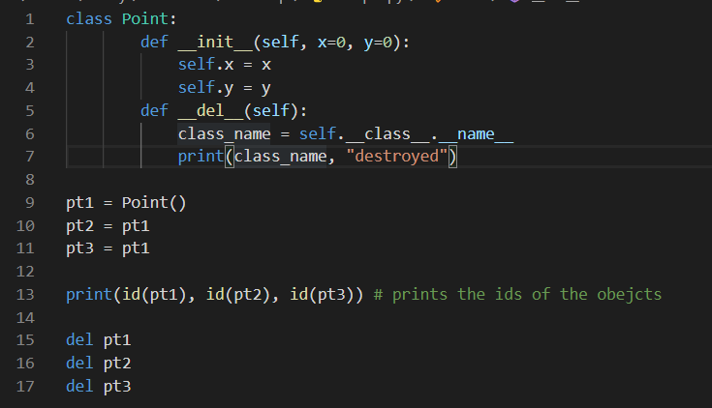

When the above code is executed, it produces following result −

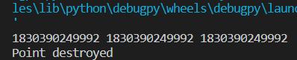

Note − Ideally, you should define your classes in separate files, then you should import them in your main program file using *import* statements.

## Class Inheritance

Instead of starting from scratch, you can create a class by deriving it from a preexisting class by listing the parent class in parentheses after the new class name.

The child class inherits the attributes of its parent class, and you can use those attributes as if they were defined in the child class. A child class can also override data members and methods from the parent.

### Syntax

Derived classes are declared much like their parent class; however, a list of base classes to inherit from is given after the class name −

**class** SubClassName (ParentClass1[, ParentClass2, ...]):

'’’Optional class documentation string’’'

class_suite

### Example

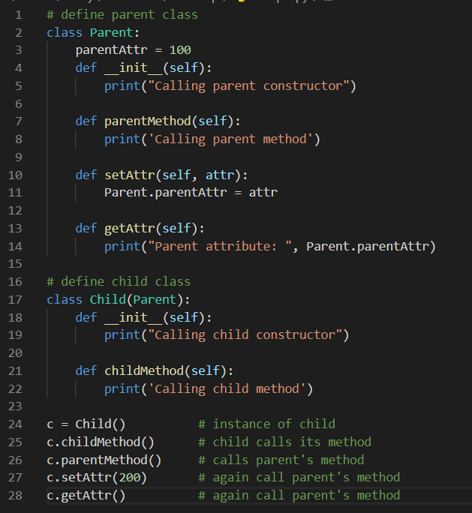

When the above code is executed, it produces the following result −

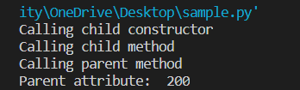

Similar way, you can drive a class from multiple parent classes as follows −

**class** A: # define your class A

**.............**

**class** B: # define your class B

**............**

**class** C(A, B): # subclass of A and B

**............**

You can use issubclass() or isinstance() functions to check a relationship between two classes and instances.

* The issubclass(sub, sup) boolean function returns true if the given subclass sub is indeed a subclass of the superclass sup.
* The isinstance(obj, Class) boolean function returns true if *obj* is an instance of class *Class* or is an instance of a subclass of Class

## Overriding Methods

You can always override your parent class methods. One reason for overriding parent's methods is because you may want special or different functionality in your subclass.

### Example

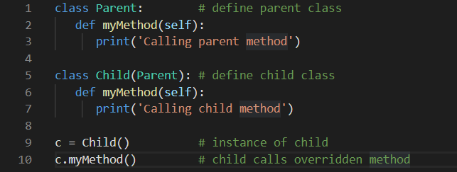

When the above code is executed, it produces the following result −



## Base Overloading Methods

Following table lists some generic functionality that you can override in your own classes −

|  |  |
| --- | --- |
| Sr.No. | Method, Description & Sample Call |
| 1 | __init__ ( self [,args...] )  Constructor (with any optional arguments)  Sample Call : *obj = className(args)* |
| 2 | __del__( self )  Destructor, deletes an object  Sample Call : *del obj* |
| 3 | __repr__( self )  Evaluable string representation  Sample Call : *repr(obj)* |
| 4 | __str__( self )  Printable string representation  Sample Call : *str(obj)* |
| 5 | __cmp__ ( self, x )  Object comparison  Sample Call : *cmp(obj, x)* |

## Overloading Operators

Suppose you have created a Vector class to represent two-dimensional vectors, what happens when you use the plus operator to add them? Most likely Python will yell at you.

You could, however, define the *__add__* method in your class to perform vector addition and then the plus operator would behave as per expectation −

### Example

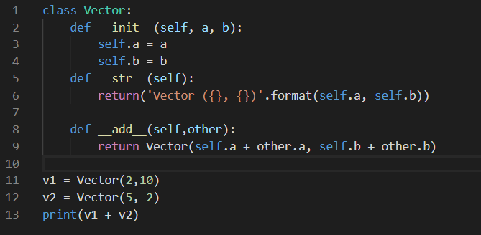

When the above code is executed, it produces the following result −



## Data Hiding

An object's attributes may or may not be visible outside the class definition. You need to name attributes with a double underscore prefix, and those attributes then are not directly visible to outsiders.

### Example

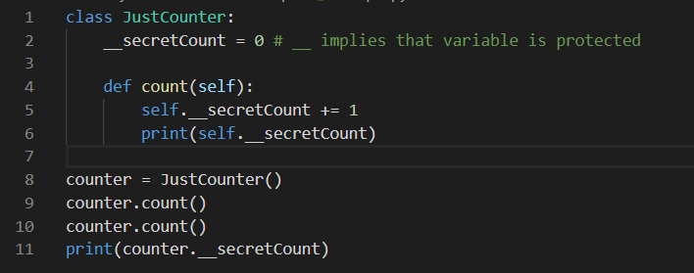

When the above code is executed, it produces the following result −

As you can see we can see the output for two expressions but the third expression throws error because we try to access a highly protected class variable.

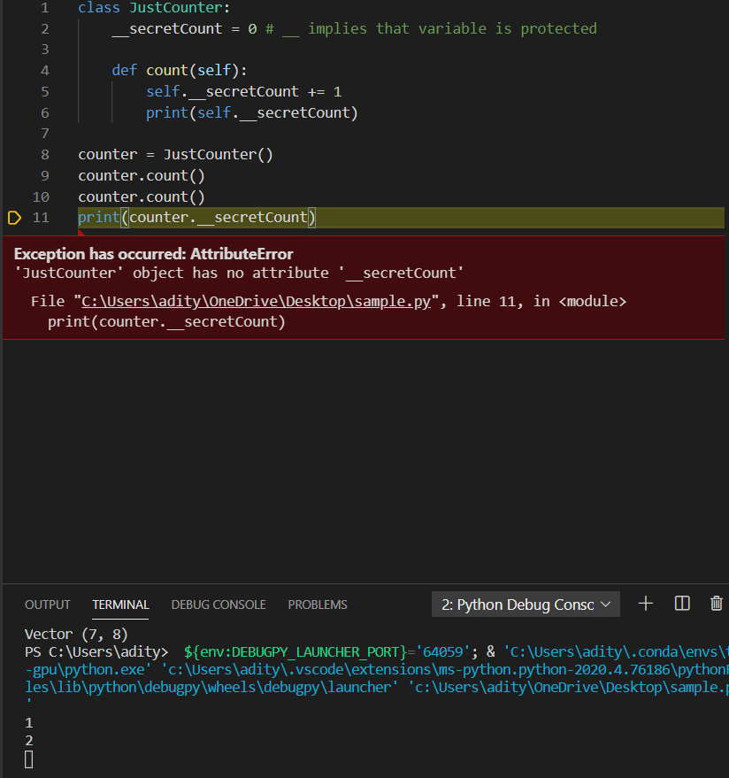

Python protects those members by internally changing the name to include the class name. You can access such attributes as *object._className__attrName*. If you would replace your last line as following, then it works for you −

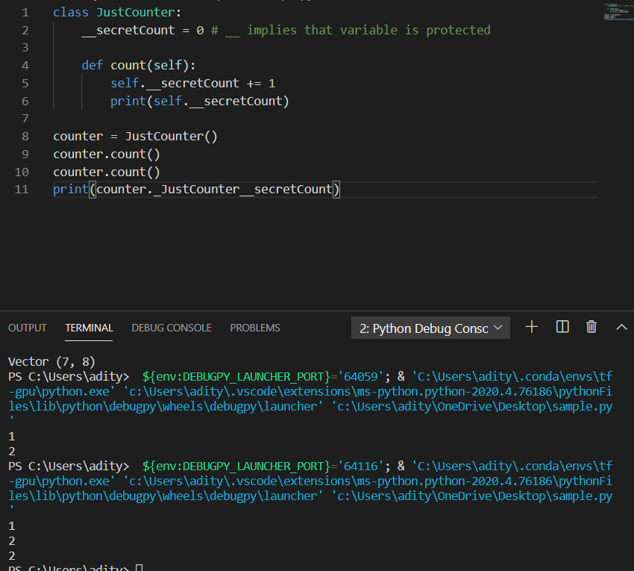

**=>Python - Reg Expressions:**

A *regular expression* is a special sequence of characters that helps you match or find other strings or sets of strings, using a specialized syntax held in a pattern. Regular expressions are widely used in the UNIX world.

The Python module provides full support for Perl-like regular expressions in Python. The re module raises the exception re.error if an error occurs while compiling or using a regular expression.

We would cover two important functions, which would be used to handle regular expressions. But a small thing first: There are various characters, which would have special meaning when they are used in regular expression. To avoid any confusion while dealing with regular expressions, we would use Raw Strings as r'expression'.

Firstly you would need to import the module of regular_expression as:

**import** re

## The *match* Function

This function attempts to match RE *pattern* to *string* with optional *flags*.

Here is the syntax for this function −

re.**match**(pattern, string, flags=0)

Here is the description of the parameters −

|  |  |
| --- | --- |
| Sr.No. | Parameter & Description |
| 1 | Pattern :: This is the regular expression to be matched. |
| 2 | string ::  This is the string, which would be searched to match the pattern at the beginning of the string. |
| 3 | flags  You can specify different flags using bitwise OR (|). These are modifiers, which are listed in the table below. |

The *re.match* function returns a match object on success, None on failure. We use*group(num)* or *groups()* function of the matched object to get a matched expression.

|  |  |
| --- | --- |
| Sr.No. | Match Object Method & Description |
| 1 | group(num=0)  This method returns entire match (or specific subgroup num) |
| 2 | groups()  This method returns all matching subgroups in a tuple (empty if there weren't any) |

### Example

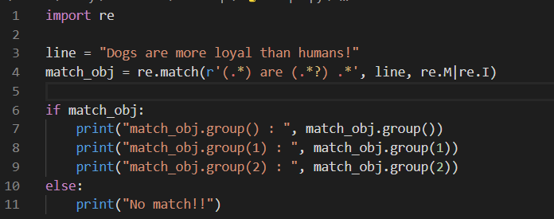

When the above code is executed, it produces following result −

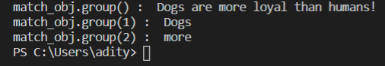

## The *search* Function

This function searches for the first occurrence of RE *pattern* within a string with optional *flags*.

Here is the syntax for this function −

re.**search**(pattern, string, flags=0)

Here is the description of the parameters −

|  |  |
| --- | --- |
| Sr.No. | Parameter & Description |
| 1 | pattern  This is the regular expression to be matched. |
| 2 | string  This is the string, which would be searched to match the pattern anywhere in the string. |
| 3 | flags  You can specify different flags using bitwise OR (|). These are modifiers, which are listed in the table below. |

The *re.search* function returns a match object on success, none on failure. We use *group(num)* or *groups()* function of the match object to get a matched expression.

|  |  |
| --- | --- |
| Sr.No. | Match Object Methods & Description |
| 1 | group(num=0)  This method returns entire match (or specific subgroup num) |
| 2 | groups()  This method returns all matching subgroups in a tuple (empty if there weren't any) |

### Example

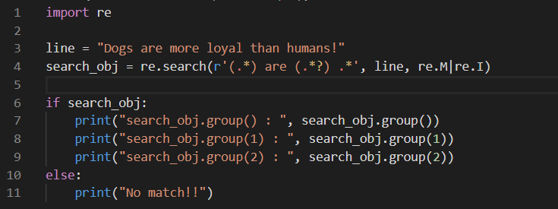

When the above code is executed, it produces following result −



## Matching Versus Searching

Python offers two different primitive operations based on regular expressions: match checks for a match only at the beginning of the string, while search checks for a match anywhere in the string (this is what Perl does by default).

### Example

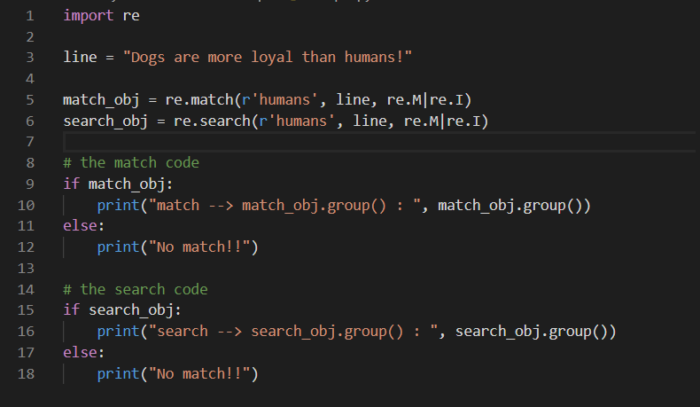

When the above code is executed, it produces the following result −



## Search and Replace(i.e. Substitute)

One of the most important re methods that use regular expressions is sub.

### Syntax

re.**sub**(pattern, repl, string, max=0)

This method replaces all occurrences of the RE *pattern* in *string* with *repl*, substituting all occurrences unless *max* provided. This method returns a modified string.

### Example

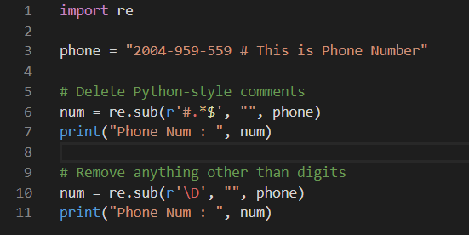

When the above code is executed, it produces the following result −



## Regular Expression Modifiers: Option Flags

Regular expression literals may include an optional modifier to control various aspects of matching. The modifiers are specified as an optional flag. You can provide multiple modifiers using exclusive OR (|), as shown previously and may be represented by one of these −

|  |  |
| --- | --- |
| Sr.No. | Modifier & Description |
| 1 | re.I  Performs case-insensitive matching. |
| 2 | re.L  Interprets words according to the current locale. This interpretation affects the alphabetic group (\w and \W), as well as word boundary behavior(\b and \B). |
| 3 | re.M  Makes $ match the end of a line (not just the end of the string) and makes ^ match the start of any line (not just the start of the string). |
| 4 | re.S  Makes a period (dot) match any character, including a newline. |
| 5 | re.U  Interprets letters according to the Unicode character set. This flag affects the behavior of \w, \W, \b, \B. |
| 6 | re.X  Permits "cuter" regular expression syntax. It ignores whitespace (except inside a set [] or when escaped by a backslash) and treats unescaped # as a comment marker. |

## Regular Expression Patterns

Except for control characters, (+ ? . * ^ $ ( ) [ ] { } | \), all characters match themselves. You can escape a control character by preceding it with a backslash.

Following table lists the regular expression syntax that is available in Python −

|  |  |
| --- | --- |
| Sr.No. | Pattern & Description |
| 1 | ^  Matches beginning of line. |
| 2 | $  Matches end of line. |
| 3 | .  Matches any single character except newline. Using m option allows it to match newline as well. |
| 4 | [...]  Matches any single character in brackets. |
| 5 | [^...]  Matches any single character not in brackets |
| 6 | re*  Matches 0 or more occurrences of preceding expression. |
| 7 | re+  Matches 1 or more occurrence of preceding expression. |
| 8 | re?  Matches 0 or 1 occurrence of preceding expression. |
| 9 | re{ n}  Matches exactly n number of occurrences of preceding expression. |
| 10 | re{ n,}  Matches n or more occurrences of preceding expression. |
| 11 | re{ n, m}  Matches at least n and at most m occurrences of preceding expression. |
| 12 | a| b  Matches either a or b. |
| 13 | (re)  Groups regular expressions and remembers matched text. |
| 14 | (?imx)  Temporarily toggles on i, m, or x options within a regular expression. If in parentheses, only that area is affected. |
| 15 | (?-imx)  Temporarily toggles off i, m, or x options within a regular expression. If in parentheses, only that area is affected. |
| 16 | (?: re)  Groups regular expressions without remembering matched text. |
| 17 | (?imx: re)  Temporarily toggles on i, m, or x options within parentheses. |
| 18 | (?-imx: re)  Temporarily toggles off i, m, or x options within parentheses. |
| 19 | (?#...)  Comment. |
| 20 | (?= re)  Specifies position using a pattern. Doesn't have a range. |
| 21 | (?! re)  Specifies position using pattern negation. Doesn't have a range. |
| 22 | (?> re)  Matches independent pattern without backtracking. |
| 23 | \w  Matches word characters. |
| 24 | \W  Matches non-word characters. |
| 25 | \s  Matches whitespace. Equivalent to [\t\n\r\f]. |
| 26 | \S  Matches non-whitespace. |
| 27 | \d  Matches digits. Equivalent to [0-9]. |
| 28 | \D  Matches non-digits. |
| 29 | \A  Matches beginning of string. |
| 30 | \Z  Matches end of string. If a newline exists, it matches just before the newline. |
| 31 | \z  Matches end of string. |
| 32 | \G  Match point where last match finished. |
| 33 | \b  Matches word boundaries when outside brackets. Matches backspace (0x08) when inside brackets. |
| 34 | \B  Matches nonword boundaries. |
| 35 | \n, \t, etc.  Matches newlines, carriage returns, tabs, etc. |
| 36 | \1...\9  Matches nth grouped subexpression. |
| 37 | \10  Matches nth grouped subexpression if it matches already. Otherwise refers to the octal representation of a character code. |

## Regular Expression Examples

### Literal characters

|  |  |
| --- | --- |
| Sr.No. | Example & Description |
| 1 | python  Match "python". |

## Character classes

|  |  |
| --- | --- |
| Sr.No. | Example & Description |
| 1 | [Pp]ython  Match "Python" or "python" |
| 2 | rub[ye]  Match "ruby" or "rube" |
| 3 | [aeiou]  Match any one lowercase vowel |
| 4 | [0-9]  Match any digit; same as [0123456789] |
| 5 | [a-z]  Match any lowercase ASCII letter |
| 6 | [A-Z]  Match any uppercase ASCII letter |
| 7 | [a-zA-Z0-9]  Match any of the above |
| 8 | [^aeiou]  Match anything other than a lowercase vowel |
| 9 | [^0-9]  Match anything other than a digit |

## Special Character Classes

|  |  |
| --- | --- |
| Sr.No. | Example & Description |
| 1 | .  Match any character except newline |
| 2 | \d  Match a digit: [0-9] |
| 3 | \D  Match a non-digit: [^0-9] |
| 4 | \s  Match a whitespace character: [ \t\r\n\f] |
| 5 | \S  Match non whitespace: [^ \t\r\n\f] |
| 6 | \w  Match a single word character: [A-Za-z0-9_] |
| 7 | \W  Match a non-word character: [^A-Za-z0-9_] |

## Repetition Cases

|  |  |
| --- | --- |
| Sr.No. | Example & Description |
| 1 | ruby?  Match "rub" or "ruby": the y is optional |
| 2 | ruby*  Match "rub" plus 0 or more ys |
| 3 | ruby+  Match "rub" plus 1 or more ys |
| 4 | \d{3}  Match exactly 3 digits |
| 5 | \d{3,}  Match 3 or more digits |
| 6 | \d{3,5}  Match 3, 4, or 5 digits |

## Non-Greedy repetition

This matches the smallest number of repetitions −

|  |  |
| --- | --- |
| Sr.No. | Example & Description |
| 1 | <.*>  Greedy repetition: matches "<python>perl>" |
| 2 | <.*?>  Non-greedy: matches "<python>" in "<python>perl>" |

## Grouping with Parentheses

|  |  |
| --- | --- |
| Sr.No. | Example & Description |
| 1 | \D\d+  No group: + repeats \d |
| 2 | (\D\d)+  Grouped: + repeats \D\d pair |
| 3 | ([Pp]ython(, )?)+  Match "Python", "Python, python, python", etc. |

## Backreferences

This matches a previously matched group again −

|  |  |
| --- | --- |
| Sr.No. | Example & Description |
| 1 | ([Pp])ython&\1ails  Match python&pails or Python&Pails |
| 2 | (['"])[^\1]*\1  Single or double-quoted string. \1 matches whatever the 1st group matched. \2 matches whatever the 2nd group matched, etc. |

## Alternatives

|  |  |
| --- | --- |
| Sr.No. | Example & Description |
| 1 | Python|perl  Match "python" or "perl" |
| 2 | rub(y|le))  Match "ruby" or "ruble" |
| 3 | Python(!+|\?)  "Python" followed by one or more ! or one ? |

## Anchors

This needs to specify match position.

|  |  |
| --- | --- |
| Sr.No. | Example & Description |
| 1 | ^Python  Match "Python" at the start of a string or internal line |
| 2 | Python$  Match "Python" at the end of a string or line |
| 3 | \APython  Match "Python" at the start of a string |
| 4 | Python\Z  Match "Python" at the end of a string |
| 5 | \bPython\b  Match "Python" at a word boundary |
| 6 | \brub\B  \B is nonword boundary: match "rub" in "rube" and "ruby" but not alone |
| 7 | Python(?=!)  Match "Python", if followed by an exclamation point. |
| 8 | Python(?!!)  Match "Python", if not followed by an exclamation point. |

## Special Syntax with Parentheses

|  |  |
| --- | --- |
| Sr.No. | Example & Description |
| 1 | R(?#comment)  Matches "R". All the rest is a comment |
| 2 | R(?i)uby  Case-insensitive while matching "uby" |
| 3 | R(?i:uby)  Same as above |
| 4 | rub(?:y|le))  Group only without creating \1 backreference |

**=>Python - CGI Programming:**

The Common Gateway Interface, or CGI, is a set of standards that define how information is exchanged between the web server and a custom script. The CGI specs are currently maintained by the NCSA.

## What is CGI?

* The Common Gateway Interface, or CGI, is a standard for external gateway programs to interface with information servers such as HTTP servers.
* The current version is CGI/1.1 and CGI/1.2 is under progress.

## Web Browsing

To understand the concept of CGI, let us see what happens when we click a hyperlink to browse a particular web page or URL.

* Your browser contacts the HTTP web server and demands for the URL, i.e., filename.
* Web Server parses the URL and looks for the filename. If it finds that file then sends it back to the browser, otherwise sends an error message indicating that you requested a wrong file.
* Web browser takes response from the web server and displays either the received file or error message.

However, it is possible to set up the HTTP server so that whenever a file in a certain directory is requested that file is not sent back; instead it is executed as a program, and whatever that program outputs is sent back for your browser to display. This function is called the Common Gateway Interface or CGI and the programs are called CGI scripts. These CGI programs can be a Python Script, PERL Script, Shell Script, C or C++ program, etc.

## CGI Architecture Diagram

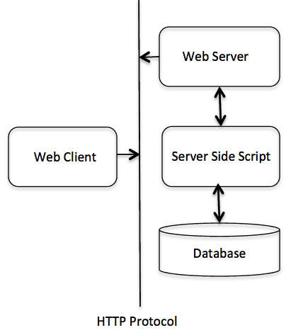

## Web Server Support and Configuration

Before you proceed with CGI Programming, make sure that your Web Server supports CGI and it is configured to handle CGI Programs. All the CGI Programs to be executed by the HTTP server are kept in a pre-configured directory. This directory is called CGI Directory and by convention it is named as /var/www/cgi-bin. By convention, CGI files have extension as. cgi, but you can keep your files with python extension .py as well.

By default, the Linux server is configured to run only the scripts in the cgi-bin directory in /var/www. If you want to specify any other directory to run your CGI scripts, comment the following lines in the httpd.conf file −

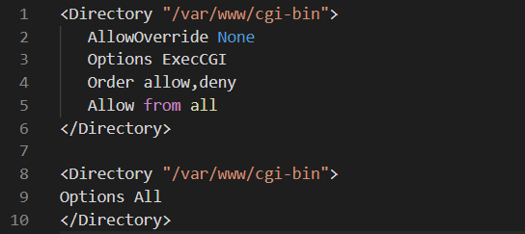

Here, we assume that you have Web Server up and running successfully and you are able to run any other CGI program like Perl or Shell, etc.

## First CGI Program

Here is a simple link, which is linked to a CGI script called [hello.py](https://www.tutorialspoint.com/cgi-bin/hello.py). This file is kept in /var/www/cgi-bin directory and it has the following content. Before running your CGI program, make sure you have changed the mode of file using chmod 755 hello.py UNIX command to make the file executable.

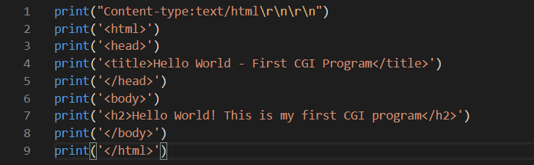

If you click hello.py, then this produces the following output −

|  |
| --- |
| Hello World! This is my first CGI program |

This hello.py script is a simple Python script, which writes its output on STDOUT file, i.e., screen. There is one important and extra feature available which is the first line to be printed Content-type:text/html\r\n\r\n. This line is sent back to the browser and it specifies the content type to be displayed on the browser screen.

By now you must have understood the basic concept of CGI and you can write many complicated CGI programs using Python. This script can interact with any other external system also to exchange information such as RDBMS.

## HTTP Header

The line Content-type:text/html\r\n\r\n is part of the HTTP header which is sent to the browser to understand the content. All the HTTP header will be in the following form −

**HTTP Field Name**: Field Content

For Example

**Content-type**: text/html\r\n\r\n

There are few other important HTTP headers, which you will use frequently in your CGI Programming.

|  |  |
| --- | --- |
| Sr.No. | Header & Description |
| 1 | Content-type:  A MIME string defining the format of the file being returned. Example is Content-type:text/html |
| 2 | Expires: Date  The date the information becomes invalid. It is used by the browser to decide when a page needs to be refreshed. A valid date string is in the format 01 Jan 1998 12:00:00 GMT. |
| 3 | Location: URL  The URL that is returned instead of the URL requested. You can use this field to redirect a request to any file. |
| 4 | Last-modified: Date  The date of last modification of the resource. |
| 5 | Content-length: N  The length, in bytes, of the data being returned. The browser uses this value to report the estimated download time for a file. |
| 6 | Set-Cookie: String  Set the cookie passed through the *string* |

## CGI Environment Variables

All the CGI programs have access to the following environment variables. These variables play an important role while writing any CGI program.

|  |  |
| --- | --- |
| Sr.No. | Variable Name & Description |
| 1 | CONTENT_TYPE  The data type of the content. Used when the client is sending attached content to the server. For example, file upload. |
| 2 | CONTENT_LENGTH  The length of the query information. It is available only for POST requests. |
| 3 | HTTP_COOKIE  Returns the set cookies in the form of key & value pair. |
| 4 | HTTP_USER_AGENT  The User-Agent request-header field contains information about the user agent originating the request. It is the name of the web browser. |
| 5 | PATH_INFO  The path for the CGI script. |
| 6 | QUERY_STRING  The URL-encoded information that is sent with GET method request. |
| 7 | REMOTE_ADDR  The IP address of the remote host making the request. This is useful logging or for authentication. |
| 8 | REMOTE_HOST  The fully qualified name of the host making the request. If this information is not available, then REMOTE_ADDR can be used to get an IR address. |
| 9 | REQUEST_METHOD  The method used to make the request. The most common methods are GET and POST. |
| 10 | SCRIPT_FILENAME  The full path to the CGI script. |
| 11 | SCRIPT_NAME  The name of the CGI script. |
| 12 | SERVER_NAME  The server's hostname or IP Address |
| 13 | SERVER_SOFTWARE  The name and version of the software the server is running. |

Here is a small CGI program to list out all the CGI variables. Click this link to see the result [Get Environment](http://www.tutorialspoint.com/cgi-bin/get_env.py)

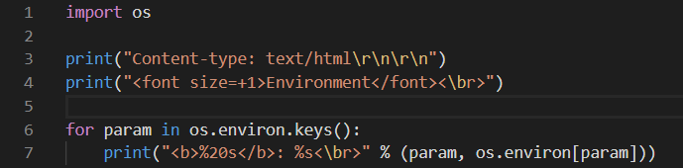

## GET and POST Methods

You must have come across many situations when you need to pass some information from your browser to web server and ultimately to your CGI Program. Most frequently, browsers use two methods two pass this information to the web server. These methods are GET Method and POST Method.

## Passing Information using GET method

The GET method sends the encoded user information appended to the page request. The page and the encoded information are separated by the ? character as follows −

**http://www.test.com/cgi-bin/hello.py?key1=value1&key2=value2**

The GET method is the default method to pass information from browser to web server and it produces a long string that appears in your browser's Location:box. Never use the GET method if you have a password or other sensitive information to pass to the server. The GET method has size limitation: only 1024 characters can be sent in a request string. The GET method sends information using QUERY_STRING header and will be accessible in your CGI Program through QUERY_STRING environment variable.

You can pass information by simply concatenating key and value pairs along with any URL or you can use HTML <FORM> tags to pass information using the GET method.

## Simple URL Example:Get Method

Here is a simple URL, which passes two values to hello_get.py program using the GET method.

[/cgi-bin/hello_get.py?first_name=ZARA&last_name=ALI](https://www.tutorialspoint.com/cgi-bin/hello_get.py?first_name=ZARA&last_name=ALI)

Below is hello_get.py script to handle input given by web browser. We are going to use cgi module, which makes it very easy to access passed information −

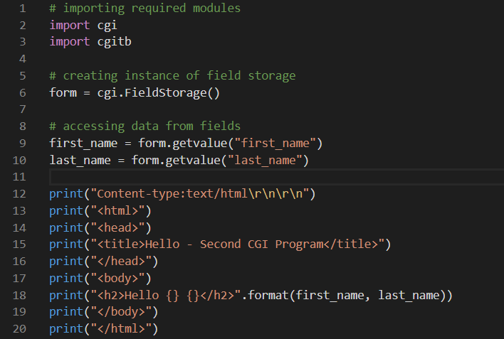

This would generate the following result −

|  |
| --- |
| Hello ADITYA YADAV |

## Simple FORM Example:GET Method

This example passes two values using HTML FORM and submit button. We use the same CGI script hello_get.py to handle this input.

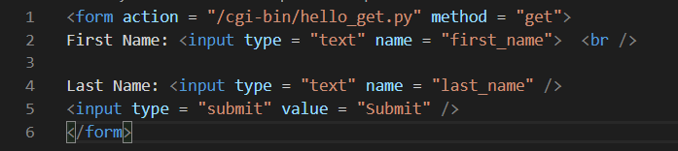

Here is the actual output of the above form, you enter First and Last Name and then click submit button to see the result.

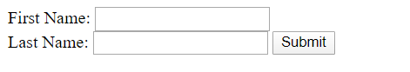

## Passing Information Using POST Method

A generally more reliable method of passing information to a CGI program is the POST method. This packages the information in exactly the same way as GET methods, but instead of sending it as a text string after a ? in the URL it sends it as a separate message. This message comes into the CGI script in the form of the standard input.

Below is the same hello_get.py script which handles GET as well as POST method.



Let us take again the same example as above which passes two values using HTML FORM and submit button. We use the same CGI script hello_get.py to handle this input.

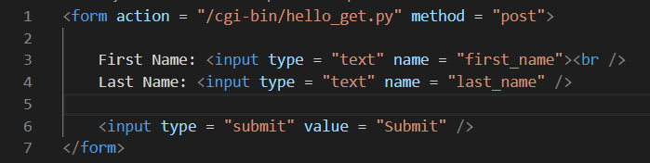

Here is the actual output of the above form. You enter First and Last Name and then click the submit button to see the result.



## Passing Checkbox Data to CGI Program

Checkboxes are used when more than one option is required to be selected.

Here is example HTML code for a form with two checkboxes −

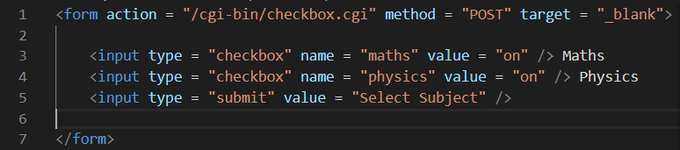

The result of this code is the following form −

Maths Physics

Below is a checkbox.cgi script to handle input given by the web browser for the checkbox button.

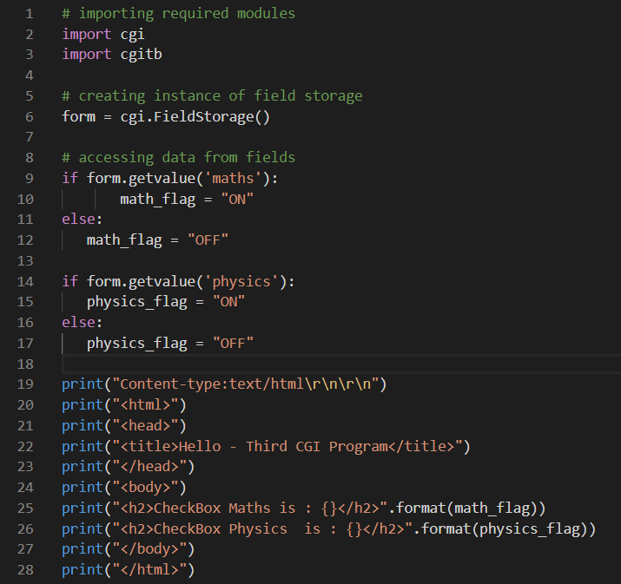

## Passing Radio Button Data to CGI Program

Radio Buttons are used when only one option is required to be selected.

Here is example HTML code for a form with two radio buttons −

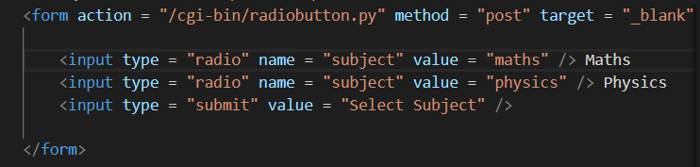

The result of this code is the following form −

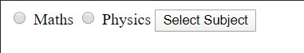

Below is radiobutton.py script to handle input given by web browser for radio button −

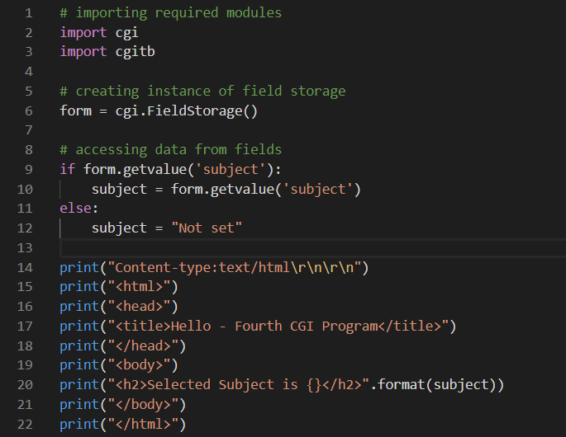

## Passing Textarea Data to CGI Program

TEXTAREA element is used when multiline text has to be passed to the CGI Program.

Here is example HTML code for a form with a TEXTAREA box −

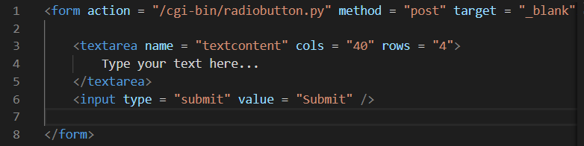

The result of this code is the following form −

Below is textarea.cgi script to handle input given by web browser −

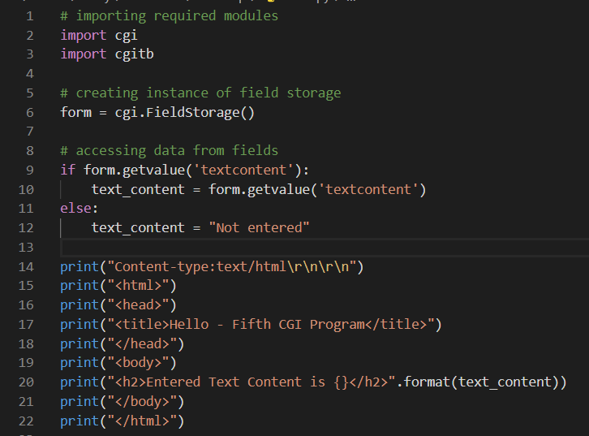

## Passing Drop Down Box Data to CGI Program

Drop Down Box is used when we have many options available but only one or two will be selected.

Here is example HTML code for a form with one drop down box −

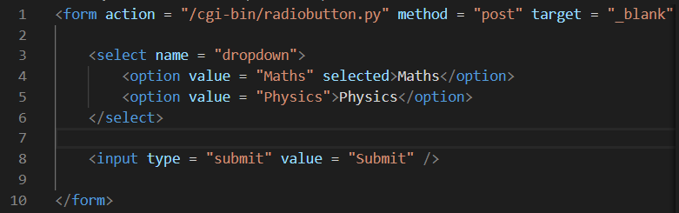

The result of this code is the following form −

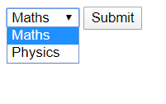

Below is dropdown.py script to handle input given by web browser.

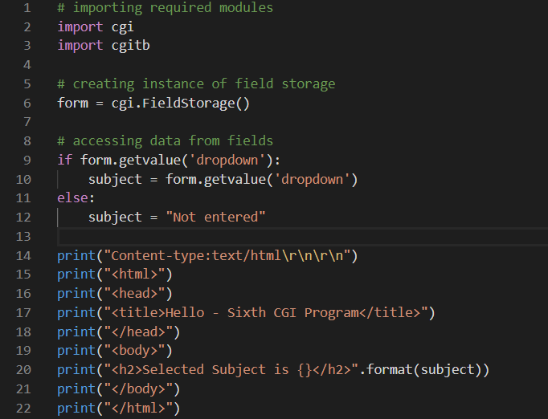

## Using Cookies in CGI

HTTP protocol is a stateless protocol. For a commercial website, it is required to maintain session information among different pages. For example, one user registration ends after completing many pages. How to maintain user's session information across all the web pages?

In many situations, using cookies is the most efficient method of remembering and tracking preferences, purchases, commissions, and other information required for better visitor experience or site statistics.

## How It Works?

Your server sends some data to the visitor's browser in the form of a cookie. The browser may accept the cookie. If it does, it is stored as a plain text record on the visitor's hard drive. Now, when the visitor arrives at another page on your site, the cookie is available for retrieval. Once retrieved, your server knows/remembers what was stored.

Cookies are a plain text data record of 5 variable-length fields −

* Expires − The date the cookie will expire. If this is blank, the cookie will expire when the visitor quits the browser.
* Domain − The domain name of your site.
* Path − The path to the directory or web page that sets the cookie. This may be blank if you want to retrieve the cookie from any directory or page.
* Secure − If this field contains the word "secure", then the cookie may only be retrieved with a secure server. If this field is blank, no such restriction exists.
* Name=Value − Cookies are set and retrieved in the form of key and value pairs.

## Setting up Cookies

It is very easy to send cookies to the browser. These cookies are sent along with the HTTP Header before the Content-type field. Assuming you want to set UserID and Password as cookies. Setting the cookies is done as follows −

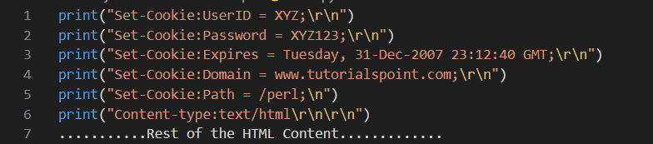

From this example, you must have understood how to set cookies. We use the Set-Cookie HTTP header to set cookies.

It is optional to set cookies attributes like Expires, Domain, and Path. It is notable that cookies are set before sending the magic line "Content-type:text/html\r\n\r\n.

## Retrieving Cookies

It is very easy to retrieve all the set cookies. Cookies are stored in CGI environment variable HTTP_COOKIE and they will have following form −

**key1** = value1;**key2** = value2;**key3** = value3....

Here is an example of how to retrieve cookies.

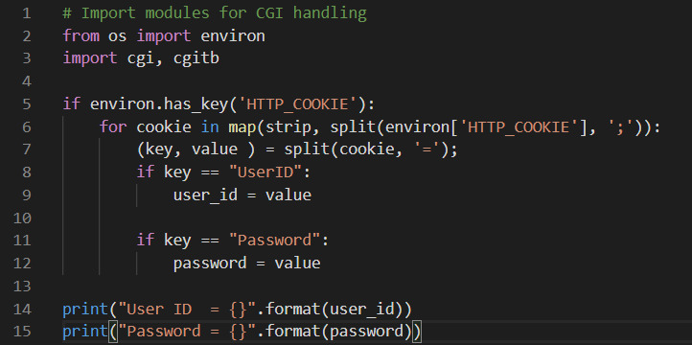

This produces the following result for the cookies set by above script −

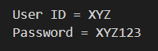

## File Upload Example

To upload a file, the HTML form must have the enctype attribute set to multipart/form-data. The input tag with the file type creates a "Browse" button.

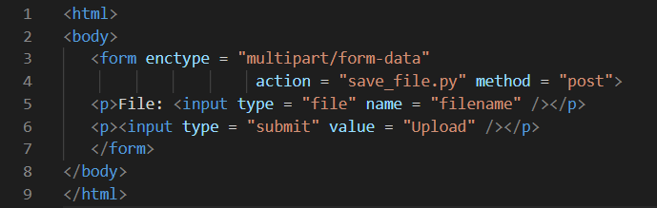

The result of this code is the following form −

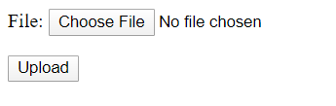

Above example has been disabled intentionally to save people uploading files on our server, but you can try the above code with your server.

Here is the script save_file.py to handle file upload −

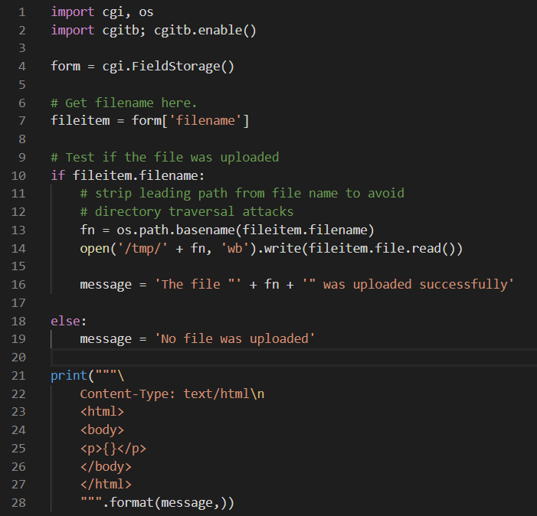

If you run the above script on Unix/Linux, then you need to take care of replacing file separator as follows, otherwise on your windows machine above open() statement should work fine.

fn = **os.path.basename**(fileitem.filename.**replace**("\\", "/" ))

## How To Raise a "File Download" Dialog Box?

Sometimes, it is desired that you want to give an option where a user can click a link and it will pop up a "File Download" dialogue box to the user instead of displaying actual content. This is very easy and can be achieved through HTTP header. This HTTP header is different from the header mentioned in the previous section.

For example, if you want make a FileName file downloadable from a given link, then its syntax is as follows −

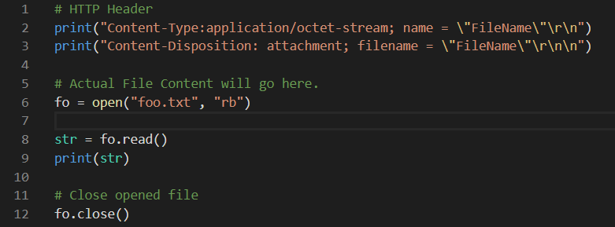

**=>Python - Database Access:**

The Python standard for database interfaces is the Python DB-API. Most Python database interfaces adhere to this standard.

You can choose the right database for your application. Python Database API supports a wide range of database servers such as −

* GadFly
* mSQL
* MySQL
* PostgreSQL
* Microsoft SQL Server 2000
* Informix
* Interbase
* Oracle
* Sybase

Here is the list of available Python database interfaces: [Python Database Interfaces and APIs](http://wiki.python.org/moin/DatabaseInterfaces). You must download a separate DB API module for each database you need to access. For example, if you need to access an Oracle database as well as a MySQL database, you must download both the Oracle and the MySQL database modules.

The DB API provides a minimal standard for working with databases using Python structures and syntax wherever possible. This API includes the following −

* Importing the API module.
* Acquiring a connection with the database.
* Issuing SQL statements and stored procedures.
* Closing the connection

We would learn all the concepts using MySQL, so let us talk about the MySQLdb module.

## What is MySQLdb?

MySQLdb is an interface for connecting to a MySQL database server from Python. It implements the Python Database API v2.0 and is built on top of the MySQL C API.

## How do I Install MySQLdb?

Before proceeding, you make sure you have MySQLdb installed on your machine. Just type the following in your Python script and execute it −



If it produces the following result, then it means MySQLdb module is not installed −

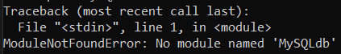

To install MySQLdb module, use the following command −

For Ubuntu, use the following command -

**$ sudo apt-get install python-pip python-dev libmysqlclient-dev**

For Fedora, use the following command -

**$ sudo dnf install python python-devel mysql-devel redhat-rpm-config gcc**

For Python command prompt, use the following command -

**pip install MySQL-python**

## Database Connection

Before connecting to a MySQL database, make sure of the followings −

* You have created a database TESTDB.
* You have created a table EMPLOYEE in TESTDB.
* This table has fields FIRST_NAME, LAST_NAME, AGE, SEX and INCOME.
* User ID "testuser" and password "test123" are set to access TESTDB.
* Python module MySQLdb is installed properly on your machine.
* You have gone through MySQL tutorial to understand [MySQL Basics.](https://www.tutorialspoint.com/mysql/index.htm)

### Example

Following is the example of connecting with MySQL database "TESTDB"

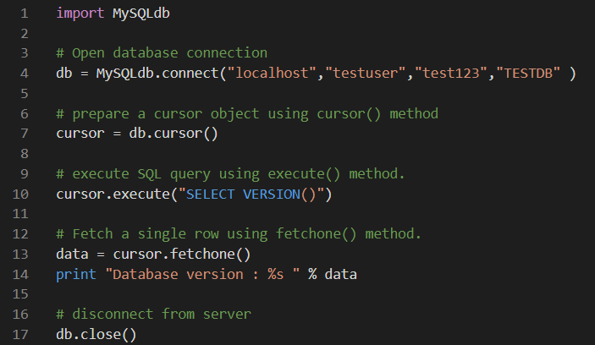

While running this script, it is producing the following result in my Linux machine.



If a connection is established with the datasource, then a Connection Object is returned and saved into db for further use, otherwise db is set to None. Next, db object is used to create a cursor object, which in turn is used to execute SQL queries. Finally, before coming out, it ensures that database connection is closed and resources are released.

## Creating Database Table

Once a database connection is established, we are ready to create tables or records into the database tables using the execute method of the created cursor.

### Example

Let us create Database table EMPLOYEE −

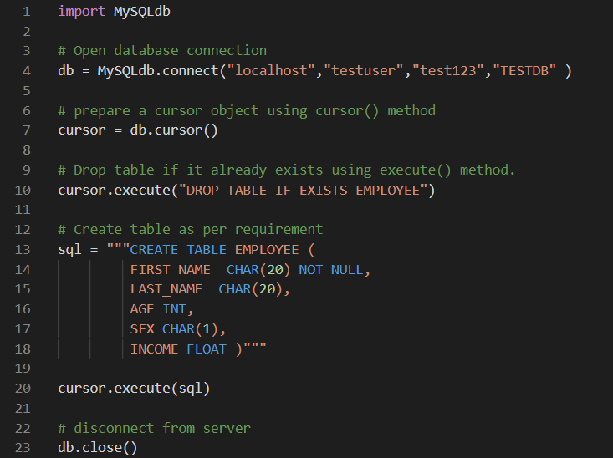

## INSERT Operation

It is required when you want to create your records into a database table.

### Example

The following example, executes SQL *INSERT* statement to create a record into EMPLOYEE table −

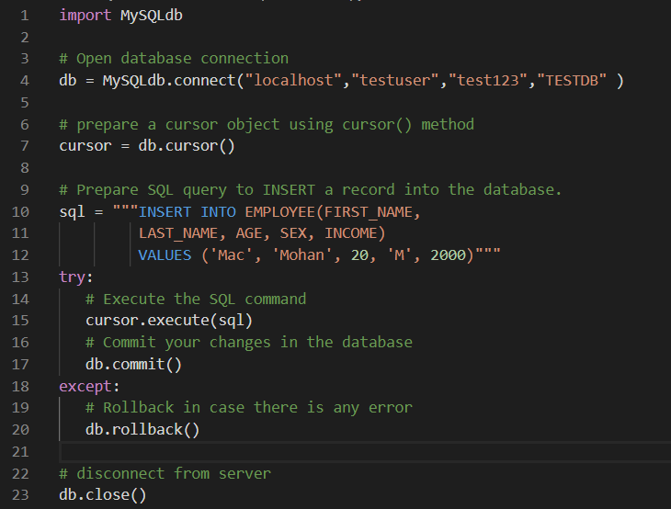

Above example can be written as follows to create SQL queries dynamically −

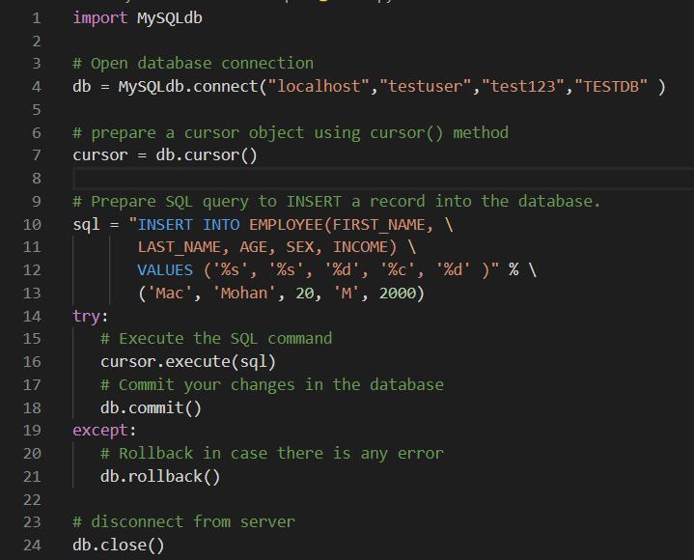

### Example

Following code segment is another form of execution where you can pass parameters directly −

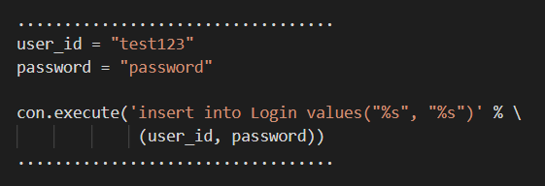

## READ Operation

READ Operation on any database means to fetch some useful information from the database.

Once our database connection is established, you are ready to make a query into this database. You can use either fetchone() method to fetch a single record or fetchall() method to fetch multiple values from a database table.

* fetchone() − It fetches the next row of a query result set. A result set is an object that is returned when a cursor object is used to query a table.
* fetchall() − It fetches all the rows in a result set. If some rows have already been extracted from the result set, then it retrieves the remaining rows from the result set.
* rowcount − This is a read-only attribute and returns the number of rows that were affected by an execute() method.

### Example

The following procedure queries all the records from EMPLOYEE table having salary more than 1000 −

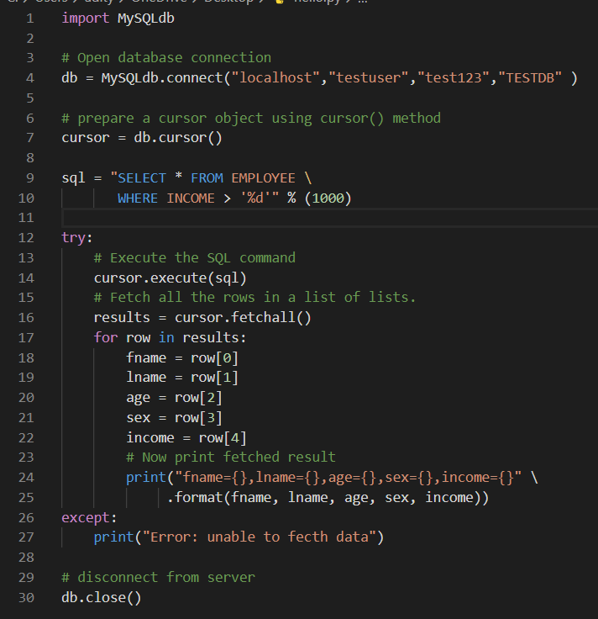

This will produce the following result −



## Update Operation

UPDATE_Operation on any database means to update one or more records, which are already available in the database.

The following procedure updates all the records having SEX as 'M'. Here, we increase the AGE of all the males by one year.

### Example

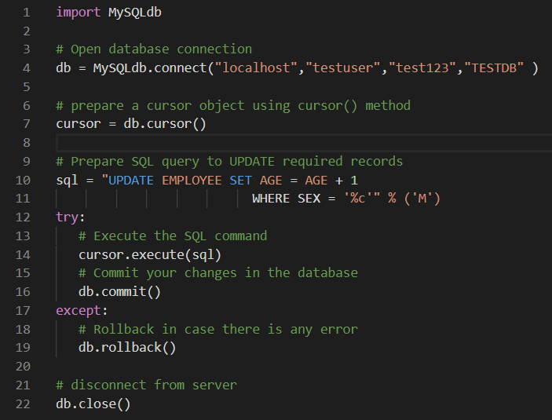

## DELETE Operation

DELETE operation is required when you want to delete some records from your database. Following is the procedure to delete all the records from EMPLOYEE where AGE is more than 20 −

### Example

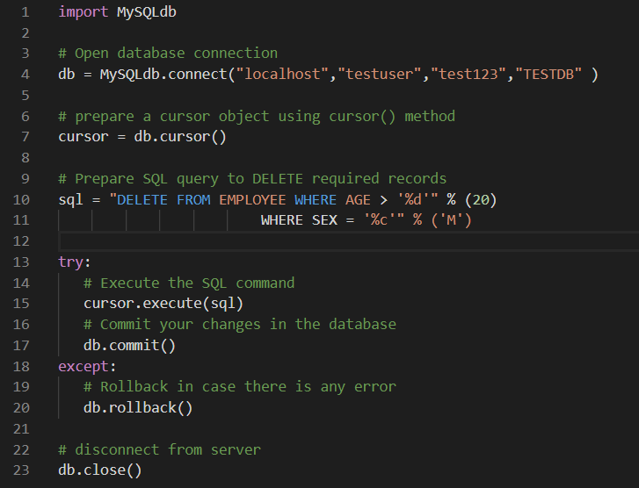

## Performing Transactions

Transactions are a mechanism that ensures data consistency. Transactions have the following four properties −

* Atomicity − Either a transaction completes or nothing happens at all.
* Consistency − A transaction must start in a consistent state and leave the system in a consistent state.
* Isolation − Intermediate results of a transaction are not visible outside the current transaction.
* Durability − Once a transaction was committed, the effects are persistent, even after a system failure.

The Python DB API 2.0 provides two methods to either *commit* or *rollback* a transaction.

### Example

You already know how to implement transactions. Here is again similar example −

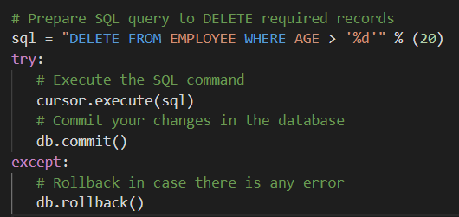

## COMMIT Operation

Commit is the operation, which gives a green signal to the database to finalize the changes, and after this operation, no change can be reverted back.

Here is a simple example to call commit method.



## ROLLBACK Operation

If you are not satisfied with one or more of the changes and you want to revert back those changes completely, then use rollback() method.

Here is a simple example to call rollback() method.



## Disconnecting Database

To disconnect Database connection, use close() method.



If the connection to a database is closed by the user with the close() method, any outstanding transactions are rolled back by the DB. However, instead of depending on any of DB lower level implementation details, your application would be better off calling commit or rollback explicitly.

## Handling Errors

There are many sources of errors. A few examples are a syntax error in an executed SQL statement, a connection failure, or calling the fetch method for an already canceled or finished statement handle.

The DB API defines a number of errors that must exist in each database module. The following table lists these exceptions.

|  |  |
| --- | --- |
| **Sr.No.** | **Exception & Description** |
| 1 | Warning  Used for non-fatal issues. Must subclass StandardError. |
| 2 | Error  Base class for errors. Must subclass StandardError. |
| 3 | InterfaceError  Used for errors in the database module, not the database itself. Must subclass Error. |
| 4 | DatabaseError  Used for errors in the database. Must subclass Error. |
| 5 | DataError  Subclass of DatabaseError that refers to errors in the data. |
| 6 | OperationalError  Subclass of DatabaseError that refers to errors such as the loss of a connection to the database. These errors are generally outside of the control of the Python scripter. |
| 7 | IntegrityError  Subclass of DatabaseError for situations that would damage the relational integrity, such as uniqueness constraints or foreign keys. |
| 8 | InternalError  Subclass of DatabaseError that refers to errors internal to the database module, such as a cursor no longer being active. |
| 9 | ProgrammingError  Subclass of DatabaseError that refers to errors such as a bad table name and other things that can safely be blamed on you. |
| 10 | NotSupportedError  Subclass of DatabaseError that refers to trying to call unsupported functionality. |

**=>Python - Networking:**

Python provides two levels of access to network services. At a low level, you can access the basic socket support in the underlying operating system, which allows you to implement clients and servers for both connection-oriented and connectionless protocols.

Python also has libraries that provide higher-level access to specific application-level network protocols, such as FTP, HTTP, and so on.

This chapter gives you understanding on the most famous concept in Networking - Socket Programming.

## What are Sockets?

Sockets are the endpoints of a bidirectional communications channel. Sockets may communicate within a process, between processes on the same machine, or between processes on different continents.

Sockets may be implemented over a number of different channel types: Unix domain sockets, TCP, UDP, and so on. The *socket* library provides specific classes for handling the common transports as well as a generic interface for handling the rest.

Sockets have their own vocabulary −

|  |  |
| --- | --- |
| **Sr.No.** | **Term & Description** |
| 1 | Domain  The family of protocols that is used as the transport mechanism. These values are constants such as AF_INET, PF_INET, PF_UNIX, PF_X25, and so on. |
| 2 | type  The type of communications between the two endpoints, typically SOCK_STREAM for connection-oriented protocols and SOCK_DGRAM for connectionless protocols. |
| 3 | protocol  Typically zero, this may be used to identify a variant of a protocol within a domain and type. |
| 4 | hostname  The identifier of a network interface −   * A string, which can be a host name, a dotted-quad address, or an IPV6 address in colon (and possibly dot) notation * A string "<broadcast>", which specifies an INADDR_BROADCAST address. * A zero-length string, which specifies INADDR_ANY, or * An Integer, interpreted as a binary address in host byte order. |
| 5 | port  Each server listens for clients calling on one or more ports. A port may be a Fixnum port number, a string containing a port number, or the name of a service. |

## The *socket* Module

To create a socket, you must use the *socket.socket()* function available in *socket* module, which has the general syntax −



Here is the description of the parameters −

* socket_family − This is either AF_UNIX or AF_INET, as explained earlier.
* socket_type − This is either SOCK_STREAM or SOCK_DGRAM.
* protocol − This is usually left out, defaulting to 0.

Once you have a socket object, then you can use required functions to create your client or server program. Following is the list of functions required −

## Server Socket Methods

|  |  |
| --- | --- |
| **Sr.No.** | **Method & Description** |
| 1 | s.bind()  This method binds the address (hostname, port number pair) to the socket. |
| 2 | s.listen()  This method sets up and starts a TCP listener. |
| 3 | s.accept()  This passively accepts TCP client connection, waiting until connection arrives (blocking). |

## Client Socket Methods

|  |  |
| --- | --- |
| **Sr.No.** | **Method & Description** |
| 1 | s.connect()  This method actively initiates TCP server connection. |

## General Socket Methods

|  |  |
| --- | --- |
| **Sr.No.** | **Method & Description** |
| 1 | s.recv()  This method receives TCP message |
| 2 | s.send()  This method transmits TCP message |
| 3 | s.recvfrom()  This method receives UDP message |
| 4 | s.sendto()  This method transmits UDP message |
| 5 | s.close()  This method closes socket |
| 6 | socket.gethostname()  Returns the hostname. |

## A Simple Server

To write Internet servers, we use the socket function available in the socket module to create a socket object. A socket object is then used to call other functions to set up a socket server.

Now call bind(hostname, port) function to specify a *port* for your service on the given host.

Next, call the *accept* method of the returned object. This method waits until a client connects to the port you specified, and then returns a *connection* object that represents the connection to that client.

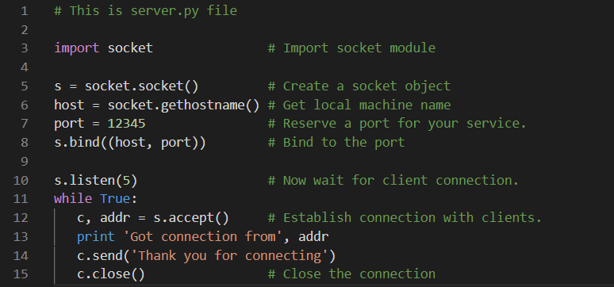

## A Simple Client

Let us write a very simple client program which opens a connection to a given port 12345 and given host. This is very simple to create a socket client using Python's *socket* module function.

The socket.connect(hostname, port ) opens a TCP connection to *hostname* on the *port*. Once you have a socket open, you can read from it like any IO object. When done, remember to close it, as you would close a file.

The following code is a very simple client that connects to a given host and port, reads any available data from the socket, and then exits −

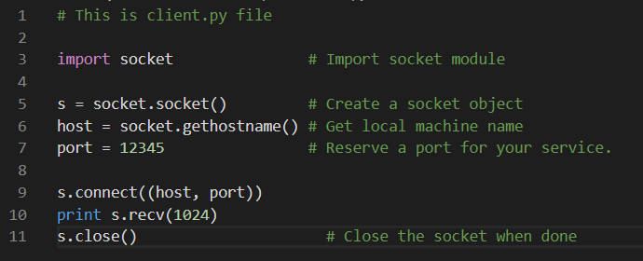

Now run this server.py in background and then run above client.py to see the result.

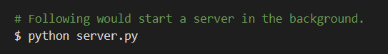

&



This would produce following result −

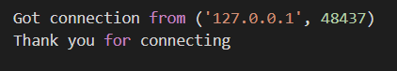

## Python Internet modules

A list of some important modules in Python Network/Internet programming.

|  |  |  |  |
| --- | --- | --- | --- |
| **Protocol** | **Common function** | **Port No** | **Python module** |
| HTTP | Web pages | 80 | httplib, urllib, xmlrpclib |
| NNTP | Usenet news | 119 | nntplib |
| FTP | File transfers | 20 | ftplib, urllib |
| SMTP | Sending email | 25 | smtplib |
| POP3 | Fetching email | 110 | poplib |
| IMAP4 | Fetching email | 143 | imaplib |
| Telnet | Command lines | 23 | telnetlib |
| Gopher | Document transfers | 70 | gopherlib, urllib |

You should check all the libraries mentioned above to work with FTP, SMTP, POP, and IMAP protocols.

**=>Python - Sending Email:**

Simple Mail Transfer Protocol (SMTP) is a protocol, which handles sending e-mail and routing email between mail servers.

Python provides smtplib module, which defines an SMTP client session object that can be used to send mail to any Internet machine with an SMTP or ESMTP listener daemon.

Here is a simple syntax to create one SMTP object, which can later be used to send an email −

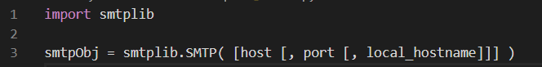

Here is the detail of the parameters −

* host − This is the host running your SMTP server. You can specify the IP address of the host or a domain name like tutorialspoint.com. This is an optional argument.
* port − If you are providing *host* argument, then you need to specify a port, where SMTP server is listening. Usually this port would be 25.
* local_hostname − If your SMTP server is running on your local machine, then you can specify just *localhost* as of this option.

An SMTP object has an instance method called sendmail, which is typically used to do the work of mailing a message. It takes three parameters −

* The *sender* − A string with the address of the sender.
* The *receivers* − A list of strings, one for each recipient.
* The *message* − A message as a string formatted as specified in the various RFCs.

## Example

Here is a simple way to send one email using Python script. Try it once −

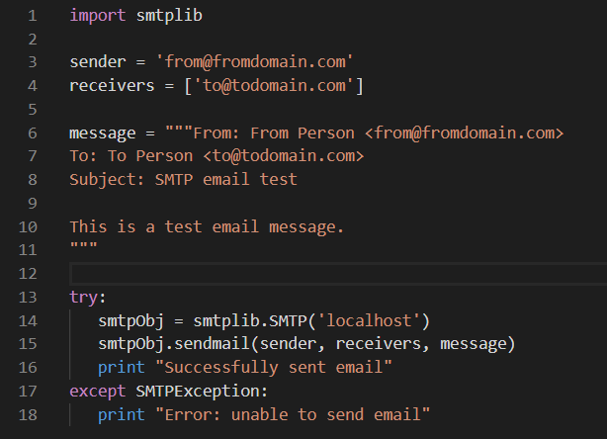

Here, you have placed a basic email in a message, using a triple quote, taking care to format the headers correctly. An email requires a From, To, and Subject header, separated from the body of the e-mail with a blank line.

To send the mail you use *smtpObj* to connect to the SMTP server on the local machine and then use the *sendmail* method along with the message, the from address, and the destination address as parameters (even though the from and to addresses are within the email itself, these aren't always used to route mail).

If you are not running an SMTP server on your local machine, you can use *smtplib* client to communicate with a remote SMTP server. Unless you are using a webmail service (such as Hotmail or Yahoo! Mail), your e-mail provider must have provided you with outgoing mail server details that you can supply them, as follows −



## Sending an HTML email using Python

When you send a text message using Python, then all the content is treated as simple text. Even if you include HTML tags in a text message, it is displayed as simple text and HTML tags will not be formatted according to HTML syntax. But Python provides an option to send an HTML message as an actual HTML message.

While sending an e-mail message, you can specify a Mime version, content type and character set to send an HTML email.

### Example

Following is the example to send HTML content as an e-mail. Try it once −

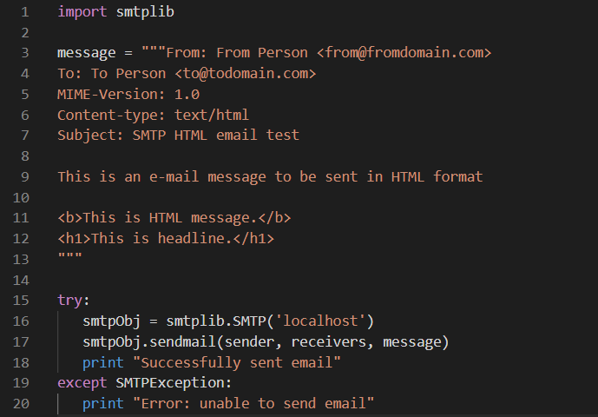

## Sending Attachments as an E-mail

To send an email with mixed content requires to set Content-type header to multipart/mixed. Then, text and attachment sections can be specified within boundaries.

A boundary is started with two hyphens followed by a unique number, which cannot appear in the message part of the e-mail. A final boundary denoting the e-mail's final section must also end with two hyphens.

Attached files should be encoded with the pack("m") function to have base64 encoding before transmission.

### Example

Following is the example, which sends a file /tmp/test.txt as an attachment:: −

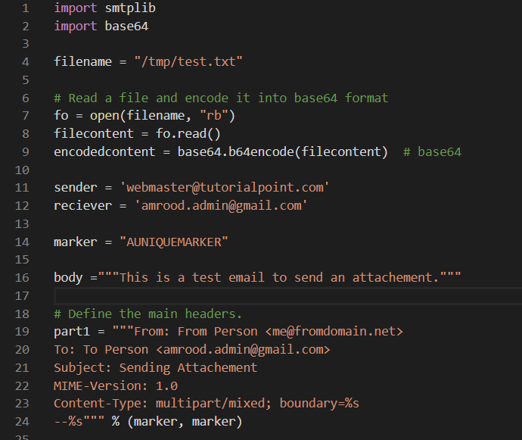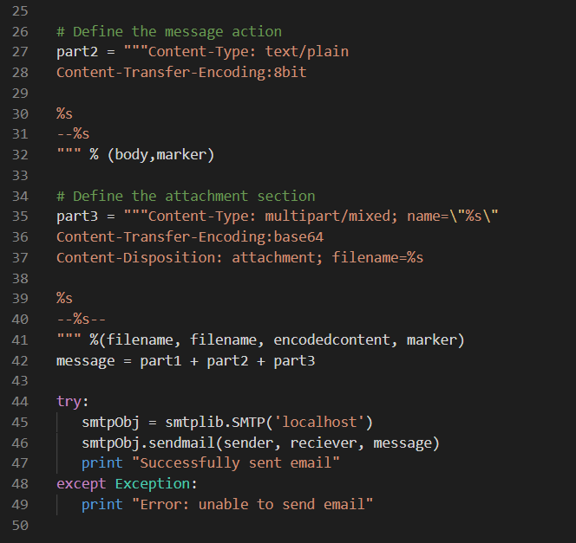

**=>Python - Multithreading:**

Note: For python3.x module is named as “threading”

Running several threads is similar to running several different programs concurrently, but with the following benefits −

* Multiple threads within a process share the same data space with the main thread and can therefore share information or communicate with each other more easily than if they were separate processes.
* Threads are sometimes called light-weight processes and they do not require much memory overhead; they are cheaper than processes.

A thread has a beginning, an execution sequence, and a conclusion. It has an instruction pointer that keeps track of where within its context it is currently running.

* It can be preempted (interrupted)
* It can temporarily be put on hold (also known as sleeping) while other threads are running - this is called yielding.

## Starting a New Thread:

To spawn another thread, you need to call following method available in *thread* module −



This method call enables a fast and efficient way to create new threads in both Linux and Windows.

The method call returns immediately and the child thread starts and calls function with the passed list of *args*. When the function returns, the thread terminates.

Here, *args* is a tuple of arguments; use an empty tuple to call function without passing any arguments. *kwargs* is an optional dictionary of keyword arguments.

### Example

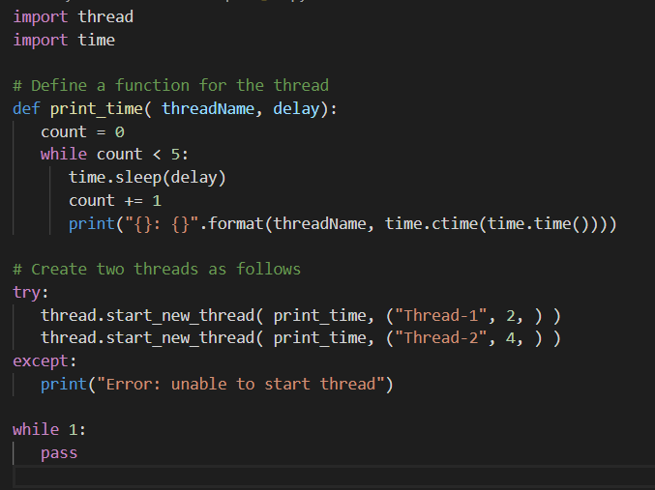

When the above code is executed, it produces the following result −

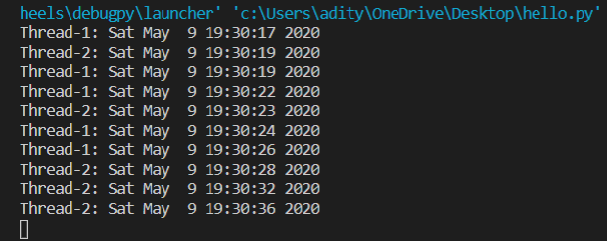

Although it is very effective for low-level threading, the *thread* module is very limited compared to the newer threading module.

## The *Threading* Module

The newer threading module included with Python 2.4 provides much more powerful, high-level support for threads than the thread module discussed in the previous section.

The *threading* module exposes all the methods of the *thread* module and provides some additional methods −

* threading.activeCount() − Returns the number of thread objects that are active.
* threading.currentThread() − Returns the number of thread objects in the caller's thread control.
* threading.enumerate() − Returns a list of all thread objects that are currently active.

In addition to the methods, the threading module has the *Thread* class that implements threading. The methods provided by the *Thread* class are as follows −

* run() − The run() method is the entry point for a thread.
* start() − The start() method starts a thread by calling the run method.
* join([time]) − The join() waits for threads to terminate.
* isAlive() − The isAlive() method checks whether a thread is still executing.
* getName() − The getName() method returns the name of a thread.
* setName() − The setName() method sets the name of a thread.

## Creating Thread Using *Threading* Module

To implement a new thread using the threading module, you have to do the following −

* Define a new subclass of the *Thread* class.
* Override the *__init__(self [,args])* method to add additional arguments.
* Then, override the run(self [,args]) method to implement what the thread should do when started.

Once you have created the new *Thread* subclass, you can create an instance of it and then start a new thread by invoking the *start()*, which in turn calls *run()* method.

### Example

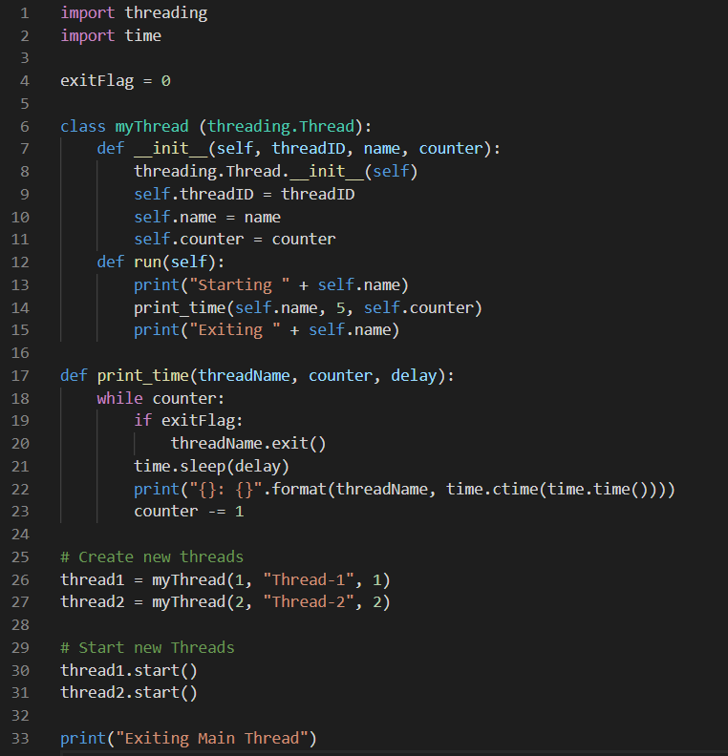

When the above code is executed, it produces the following result −

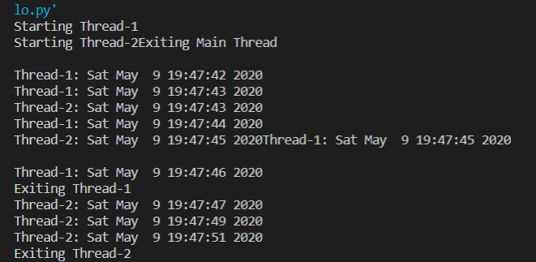

## Synchronizing Threads

The threading module provided with Python includes a simple-to-implement locking mechanism that allows you to synchronize threads. A new lock is created by calling the *Lock()* method, which returns the new lock.

The *acquire(blocking)* method of the new lock object is used to force threads to run synchronously. The optional *blocking* parameter enables you to control whether the thread waits to acquire the lock.

If *blocking* is set to 0, the thread returns immediately with a 0 value if the lock cannot be acquired and with a 1 if the lock was acquired. If blocking is set to 1, the thread blocks and waits for the lock to be released.

The *release()* method of the new lock object is used to release the lock when it is no longer required.

### Example

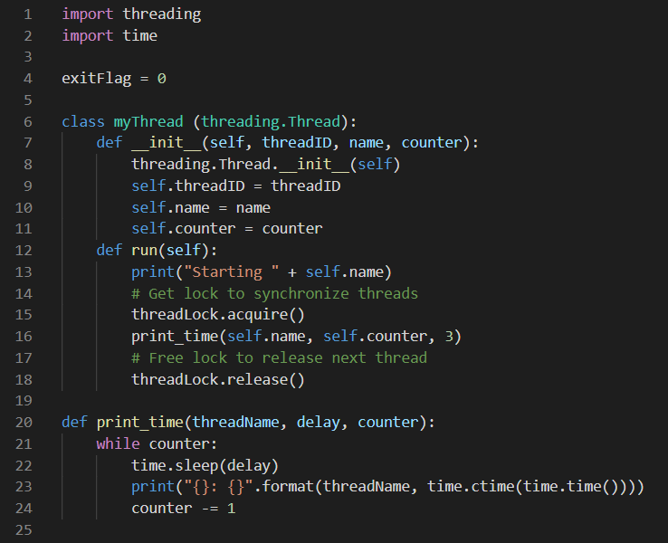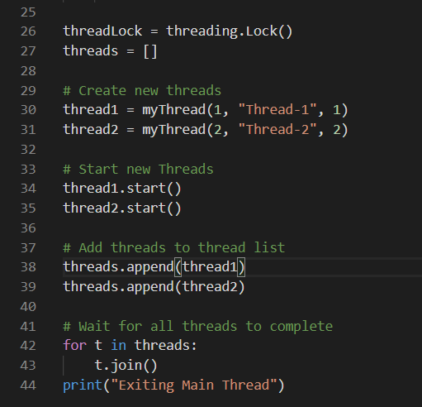

When the above code is executed, it produces the following result −

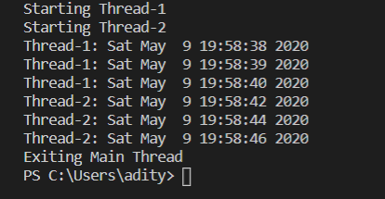

## Multithreaded Priority Queue

The *Queue* module allows you to create a new queue object that can hold a specific number of items. There are following methods to control the Queue −

* get() − The get() removes and returns an item from the queue.
* put() − The put adds an item to a queue.
* qsize() − The qsize() returns the number of items that are currently in the queue.
* empty() − The empty( ) returns True if the queue is empty; otherwise, False.
* full() − the full() returns True if the queue is full; otherwise, False.

### Example

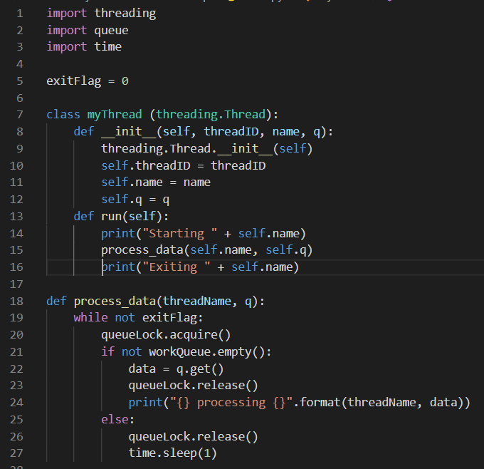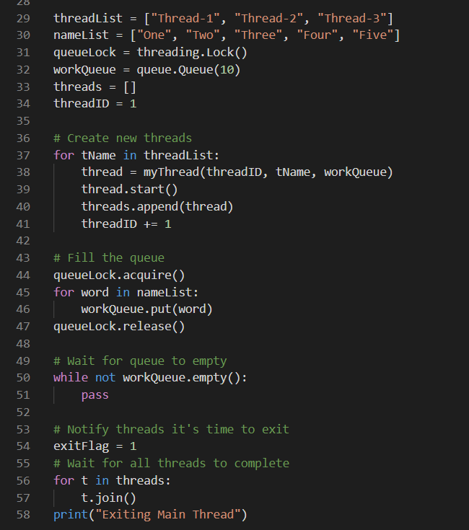

When the above code is executed, it produces the following result −

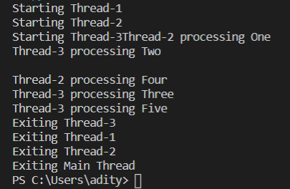

**=>Python - XML Processing:**

XML is a portable, open source language that allows programmers to develop applications that can be read by other applications, regardless of operating system and/or developmental language.

## What is XML?

The Extensible Markup Language (XML) is a markup language much like HTML or SGML. This is recommended by the World Wide Web Consortium and available as an open standard.

XML is extremely useful for keeping track of small to medium amounts of data without requiring a SQL-based backbone.

## XML Parser Architectures and APIs

The Python standard library provides a minimal but useful set of interfaces to work with XML.

The two most basic and broadly used APIs to XML data are the SAX and DOM interfaces.

* Simple API for XML (SAX) − Here, you register callbacks for events of interest and then let the parser proceed through the document. This is useful when your documents are large or you have memory limitations, it parses the file as it reads it from disk and the entire file is never stored in memory.
* Document Object Model (DOM) API − This is a World Wide Web Consortium recommendation wherein the entire file is read into memory and stored in a hierarchical (tree-based) form to represent all the features of an XML document.

SAX obviously cannot process information as fast as DOM can when working with large files. On the other hand, using DOM exclusively can really kill your resources, especially if used on a lot of small files.

SAX is read-only, while DOM allows changes to the XML file. Since these two different APIs literally complement each other, there is no reason why you cannot use them both for large projects.

For all our XML code examples, let's use a simple XML file *movies.xml* as an input −

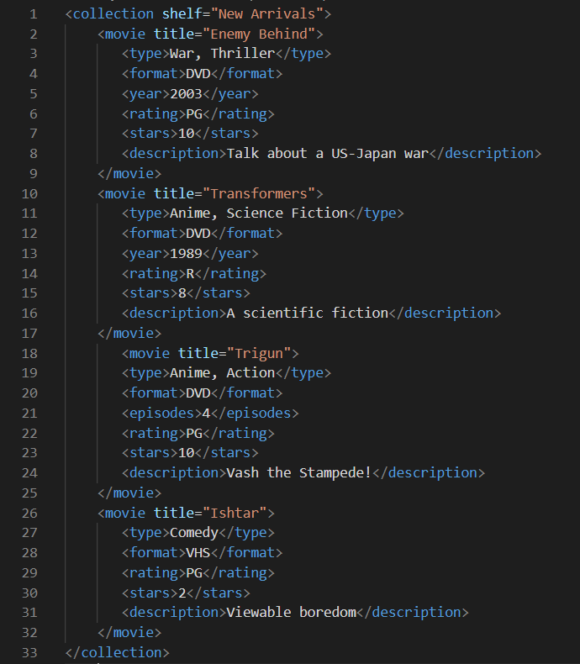

## Parsing XML with SAX APIs

SAX is a standard interface for event-driven XML parsing. Parsing XML with SAX generally requires you to create your own ContentHandler by subclassing xml.sax.ContentHandler.

Your *ContentHandler* handles the particular tags and attributes of your flavor(s) of XML. A ContentHandler object provides methods to handle various parsing events. Its owning parser calls ContentHandler methods as it parses the XML file.

The methods *startDocument* and *endDocument* are called at the start and the end of the XML file. The method *characters(text)* is passed character data of the XML file via the parameter text.

The ContentHandler is called at the start and end of each element. If the parser is not in namespace mode, the methods *startElement(tag, attributes)* and *endElement(tag)* are called; otherwise, the corresponding methods *startElementNS* and *endElementNS* are called. Here, tag is the element tag, and attributes is an Attributes object.

Here are other important methods to understand before proceeding −

## The *make_parser* Method

Following method creates a new parser object and returns it. The parser object created will be of the first parser type the system finds.

**xml.sax.make_parser( [**parser_list**] )**

Here is the detail of the parameters −

* parser_list − The optional argument consisting of a list of parsers to use which must all implement the make_parser method.

## The *parse* Method

Following method creates a SAX parser and uses it to parse a document.

**xml.sax.parse(** xml_file**,** contenthandler**[,** errorhandler**])**

Here is the detail of the parameters −

* xml_file − This is the name of the XML file to read from.
* contenthandler − This must be a ContentHandler object.
* errorhandler − If specified, errorhandler must be a SAX ErrorHandler object.

## The *parseString* Method

There is one more method to create a SAX parser and to parse the specified XML string.

**xml.sax.parseString(**xmlstring**,** contenthandler**[,** errorhandler**])**

Here is the detail of the parameters −

* xmlstring − This is the name of the XML string to read from.
* contenthandler − This must be a ContentHandler object.
* errorhandler − If specified, errorhandler must be a SAX ErrorHandler object.

### Example

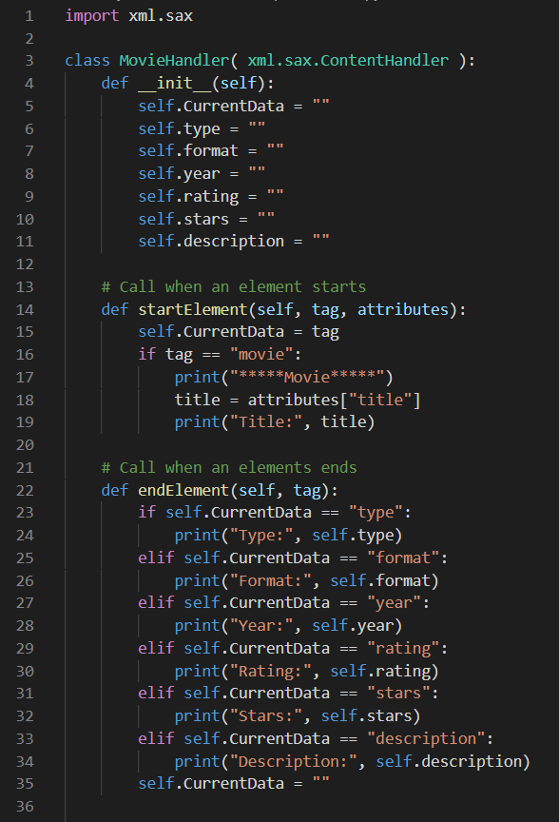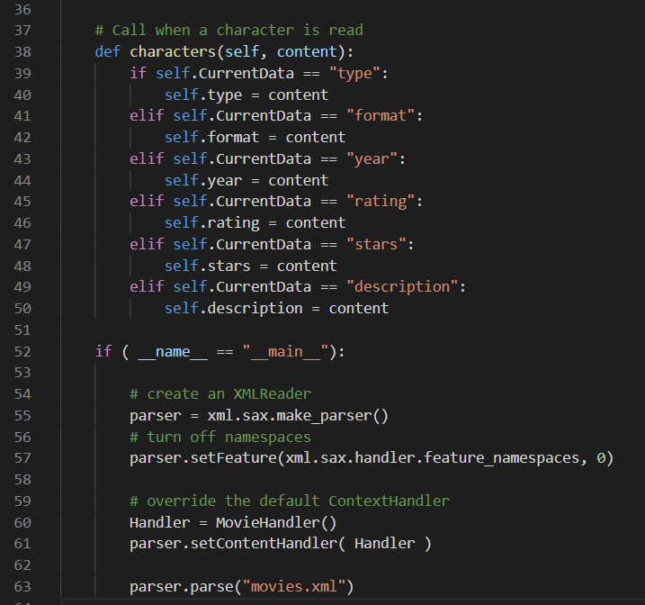

This would produce following result −

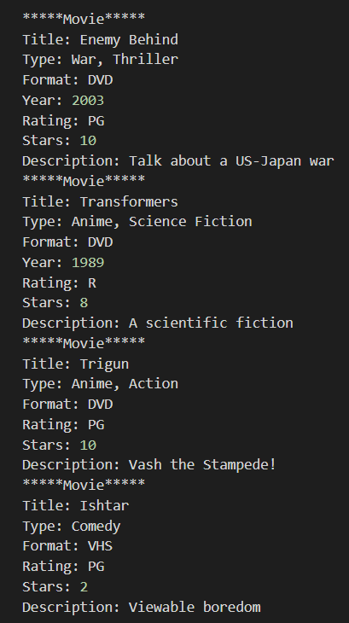

For a complete detail on SAX API documentation, please refer to standard [Python SAX APIs](http://docs.python.org/library/xml.sax.html).

## Parsing XML with DOM APIs

The Document Object Model ("DOM") is a cross-language API from the World Wide Web Consortium (W3C) for accessing and modifying XML documents.

The DOM is extremely useful for random-access applications. SAX only allows you a view of one bit of the document at a time. If you are looking at one SAX element, you have no access to another.

Here is the easiest way to quickly load an XML document and to create a minidom object using the xml.dom module. The minidom object provides a simple parser method that quickly creates a DOM tree from the XML file.

The sample phrase calls the parse( file [,parser] ) function of the minidom object to parse the XML file designated by file into a DOM tree object.

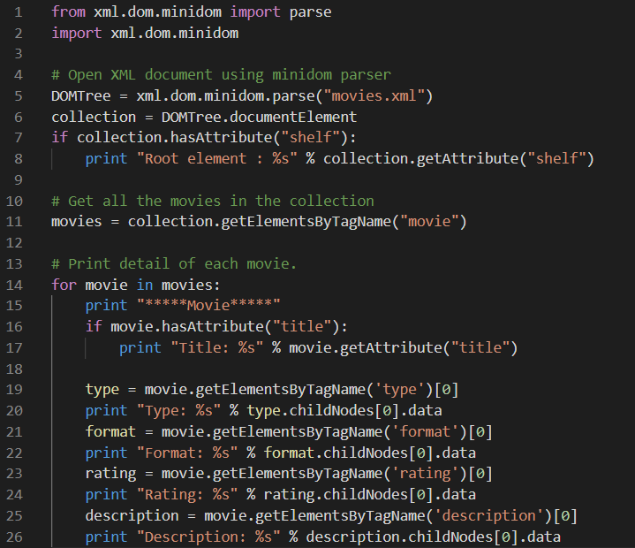

This would produce the following result −

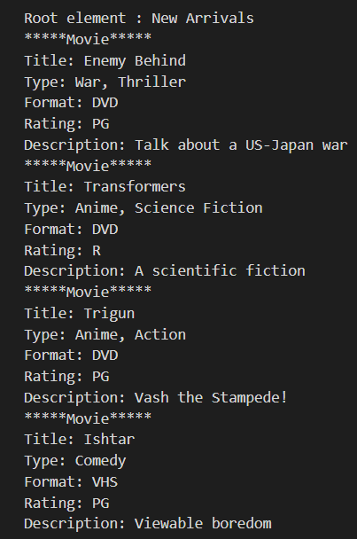

**=>Python - GUI Programming:**

Python provides various options for developing graphical user interfaces (GUIs). Most important are listed below.

* Tkinter − Tkinter is the Python interface to the Tk GUI toolkit shipped with Python. We would look at this option in this documentation.
* wxPython − This is an open-source Python interface for wxWindows [http://wxpython.org](http://wxpython.org/).
* JPython − JPython is a Python port for Java which gives Python scripts seamless access to Java class libraries on the local machine [http://www.jython.org](http://www.jython.org/).

There are many other interfaces available, which you can find on the net.

## Tkinter Programming

Tkinter is the standard GUI library for Python. Python when combined with Tkinter provides a fast and easy way to create GUI applications. Tkinter provides a powerful object-oriented interface to the Tk GUI toolkit.

Creating a GUI application using Tkinter is an easy task. All you need to do is perform the following steps −

* Import the *Tkinter* module.
* Create the GUI application main window.
* Add one or more of the above-mentioned widgets to the GUI application.
* Enter the main event loop to take action against each event triggered by the user.

## Example

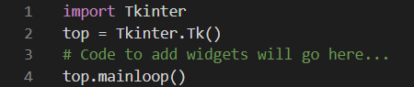

This would create a following window −



## Tkinter Widgets

Tkinter provides various controls, such as buttons, labels and text boxes used in a GUI application. These controls are commonly called widgets.

There are currently 15 types of widgets in Tkinter. We present these widgets as well as a brief description in the following table −

|  |  |
| --- | --- |
| **Sr.No.** | **Operator & Description** |
| 1 | [Button](https://www.tutorialspoint.com/python/tk_button.htm)  The Button widget is used to display buttons in your application. |
| 2 | [Canvas](https://www.tutorialspoint.com/python/tk_canvas.htm)  The Canvas widget is used to draw shapes, such as lines, ovals, polygons and rectangles, in your application. |
| 3 | [Checkbutton](https://www.tutorialspoint.com/python/tk_checkbutton.htm)  The Checkbutton widget is used to display a number of options as checkboxes. The user can select multiple options at a time. |
| 4 | [Entry](https://www.tutorialspoint.com/python/tk_entry.htm)  The Entry widget is used to display a single-line text field for accepting values from a user. |
| 5 | [Frame](https://www.tutorialspoint.com/python/tk_frame.htm)  The Frame widget is used as a container widget to organize other widgets. |
| 6 | [Label](https://www.tutorialspoint.com/python/tk_label.htm)  The Label widget is used to provide a single-line caption for other widgets. It can also contain images. |
| 7 | [Listbox](https://www.tutorialspoint.com/python/tk_listbox.htm)  The Listbox widget is used to provide a list of options to a user. |
| 8 | [Menubutton](https://www.tutorialspoint.com/python/tk_menubutton.htm)  The Menu-Button widget is used to display menus in your application. |
| 9 | [Menu](https://www.tutorialspoint.com/python/tk_menu.htm)  The Menu widget is used to provide various commands to a user. These commands are contained inside Menubutton. |
| 10 | [Message](https://www.tutorialspoint.com/python/tk_message.htm)  The Message widget is used to display multiline text fields for accepting values from a user. |
| 11 | [Radiobutton](https://www.tutorialspoint.com/python/tk_radiobutton.htm)  The Radiobutton widget is used to display a number of options as radio buttons. The user can select only one option at a time. |
| 12 | [Scale](https://www.tutorialspoint.com/python/tk_scale.htm)  The Scale widget is used to provide a slider widget. |
| 13 | [Scrollbar](https://www.tutorialspoint.com/python/tk_scrollbar.htm)  The Scrollbar widget is used to add scrolling capability to various widgets, such as list boxes. |
| 14 | [Text](https://www.tutorialspoint.com/python/tk_text.htm)  The Text widget is used to display text in multiple lines. |
| 15 | [Toplevel](https://www.tutorialspoint.com/python/tk_toplevel.htm)  The Toplevel widget is used to provide a separate window container. |
| 16 | [Spinbox](https://www.tutorialspoint.com/python/tk_spinbox.htm)  The Spinbox widget is a variant of the standard Tkinter Entry widget, which can be used to select from a fixed number of values. |
| 17 | [PanedWindow](https://www.tutorialspoint.com/python/tk_panedwindow.htm)  A PanedWindow is a container widget that may contain any number of panes, arranged horizontally or vertically. |
| 18 | [LabelFrame](https://www.tutorialspoint.com/python/tk_labelframe.htm)  A labelframe is a simple container widget. Its primary purpose is to act as a spacer or container for complex window layouts. |
| 19 | [tkMessageBox](https://www.tutorialspoint.com/python/tk_messagebox.htm)  This module is used to display message boxes in your applications. |

## Standard attributes

Let us take a look at how some of their common attributes.such as sizes, colors and fonts are specified.

* [Dimensions](https://www.tutorialspoint.com/python/tk_dimensions.htm)
* [Colors](https://www.tutorialspoint.com/python/tk_colors.htm)
* [Fonts](https://www.tutorialspoint.com/python/tk_fonts.htm)
* [Anchors](https://www.tutorialspoint.com/python/tk_anchors.htm)
* [Relief styles](https://www.tutorialspoint.com/python/tk_relief.htm)
* [Bitmaps](https://www.tutorialspoint.com/python/tk_bitmaps.htm)
* [Cursors](https://www.tutorialspoint.com/python/tk_cursors.htm)

## Geometry Management

All Tkinter widgets have access to specific geometry management methods, which have the purpose of organizing widgets throughout the parent widget area. Tkinter exposes the following geometry manager classes: pack, grid, and place.

* The *pack()* Method − This geometry manager organizes widgets in blocks before placing them in the parent widget.
* The *grid()* Method − This geometry manager organizes widgets in a table-like structure in the parent widget.
* The *place()* Method − This geometry manager organizes widgets by placing them in a specific position in the parent widget.

The *pack()* Method:

This geometry manager organizes widgets in blocks before placing them in the parent widget.

## Syntax

widget.**pack**( pack_options )

Here is the list of possible options −

* expand − When set to true, the widget expands to fill any space not otherwise used in the widget's parent.
* fill − Determines whether widget fills any extra space allocated to it by the packer, or keeps its own minimal dimensions: NONE (default), X (fill only horizontally), Y (fill only vertically), or BOTH (fill both horizontally and vertically).
* side − Determines which side of the parent widget packs against: TOP (default), BOTTOM, LEFT, or RIGHT.

## Example

Try the following example by moving cursor on different buttons −

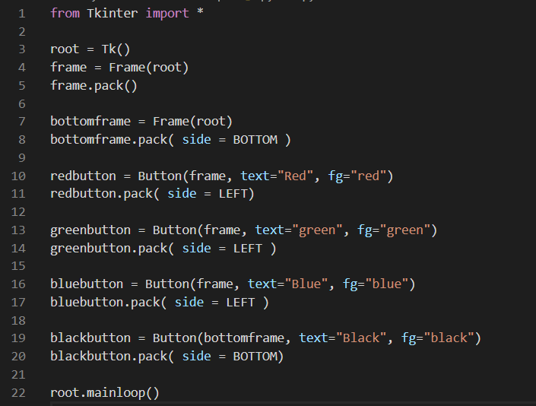

When the above code is executed, it produces the following result −

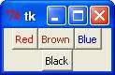

The *grid()* Method:

This geometry manager organizes widgets in a table-like structure in the parent widget.

## Syntax

widget.**grid**( grid_options )

Here is the list of possible options −

* column − The column to put widget in; default 0 (leftmost column).
* columnspan − How many columns widget occupies; default 1.
* ipadx, ipady − How many pixels to pad the widget, horizontally and vertically, inside the widget's borders.
* padx, pady − How many pixels to pad widget, horizontally and vertically, outside v's borders.
* row − The row to put widget in; default the first row that is still empty.
* rowspan − How many rows widget occupies; default 1.
* sticky − What to do if the cell is larger than the widget. By default, with sticky='', the widget is centered in its cell. sticky may be the string concatenation of zero or more of N, E, S, W, NE, NW, SE, and SW, compass directions indicating the sides and corners of the cell to which widget sticks.

## Example

Try the following example by moving cursor on different buttons −

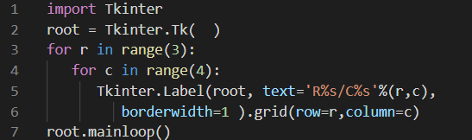

This would produce the following result displaying 12 labels arrayed in a 3 × 4 grid −

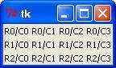

The *place()* Method:

This geometry manager organizes widgets by placing them in a specific position in the parent widget.

## Syntax

widget.**place**( place_options )

Here is the list of possible options −

* anchor − The exact spot of widget other options refer to: may be N, E, S, W, NE, NW, SE, or SW, compass directions indicating the corners and sides of widget; default is NW (the upper left corner of widget)
* bordermode − INSIDE (the default) to indicate that other options refer to the parent's inside (ignoring the parent's border); OUTSIDE otherwise.
* height, width − Height and width in pixels.
* relheight, relwidth − Height and width as a float between 0.0 and 1.0, as a fraction of the height and width of the parent widget.
* relx, rely − Horizontal and vertical offset as a float between 0.0 and 1.0, as a fraction of the height and width of the parent widget.
* x, y − Horizontal and vertical offset in pixels.

## Example

Try the following example by moving cursor on different buttons −

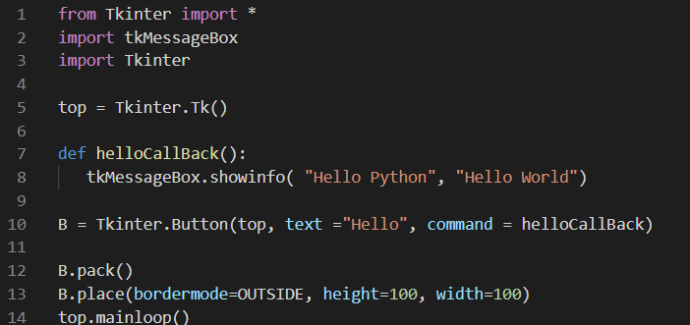

When the above code is executed, it produces the following result −

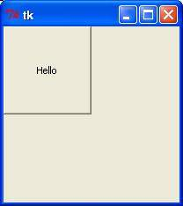

**=>Python - Further Extensions:**

Any code that you write using any compiled language like C, C++, or Java can be integrated or imported into another Python script. This code is considered as an "extension."

A Python extension module is nothing more than a normal C library. On Unix machines, these libraries usually end in .so (for shared objects). On Windows machines, you typically see .dll (for dynamically linked library).

## Prerequisites for Writing Extensions

To start writing your extension, you are going to need the Python header files.

* On Unix machines, this usually requires installing a developer-specific package such as [python2.5-dev](http://packages.debian.org/etch-m68k/python2.5-dev).
* Windows users get these headers as part of the package when they use the binary Python installer.

Additionally, it is assumed that you have good knowledge of C or C++ to write any Python Extension using C programming.

## First look at a Python Extension

For your first look at a Python extension module, you need to group your code into four part −

* The header file *Python.h*.
* The C functions you want to expose as the interface from your module.
* A table mapping the names of your functions as Python developers see them to C functions inside the extension module.
* An initialization function.

## The Header File *Python.h*

You need to include *Python.h* header file in your C source file, which gives you access to the internal Python API used to hook your module into the interpreter.

Make sure to include Python.h before any other headers you might need. You need to follow the includes with the functions you want to call from Python.

## The C Functions

The signatures of the C implementation of your functions always takes one of the following three forms −

**static** PyObject *MyFunction( PyObject *self, PyObject *args );

**static** PyObject *MyFunctionWithKeywords(PyObject *self,

PyObject *args,

PyObject *kw);

**static** PyObject *MyFunctionWithNoArgs( PyObject *self );

Each one of the preceding declarations returns a Python object. There is no such thing as a *void* function in Python as there is in C. If you do not want your functions to return a value, return the C equivalent of Python's None value. The Python headers define a macro, Py_RETURN_NONE, that does this for us.

The names of your C functions can be whatever you like as they are never seen outside of the extension module. They are defined as *static* functions.

Your C functions usually are named by combining the Python module and function names together, as shown here −

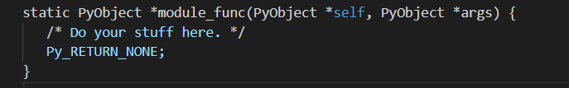

This is a Python function called *func* inside of the module *module*. You will be putting pointers to your C functions into the method table for the module that usually comes next in your source code.

## The Method Mapping Table

This method table is a simple array of PyMethodDef structures. That structure looks something like this −

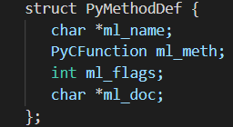

Here is the description of the members of this structure −

* ml_name − This is the name of the function as the Python interpreter presents when it is used in Python programs.
* ml_meth − This must be the address to a function that has any one of the signatures described in the previous section.
* ml_flags − This tells the interpreter which of the three signatures ml_meth is using.
  + This flag usually has a value of METH_VARARGS.
  + This flag can be bitwise OR'ed with METH_KEYWORDS if you want to allow keyword arguments into your function.
  + This can also have a value of METH_NOARGS that indicates you do not want to accept any arguments.
* ml_doc − This is the docstring for the function, which could be NULL if you do not feel like writing one.

This table needs to be terminated with a sentinel that consists of NULL and 0 values for the appropriate members.

### Example

For the above-defined function, we have following method mapping table −

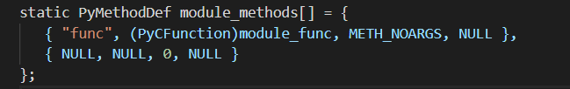

## The Initialization Function

The last part of your extension module is the initialization function. This function is called by the Python interpreter when the module is loaded. It is required that the function be named init*Module*, where *Module* is the name of the module.

The initialization function needs to be exported from the library you will be building. The Python headers define PyMODINIT_FUNC to include the appropriate incantations for that to happen for the particular environment in which we're compiling. All you have to do is use it when defining the function.

Your C initialization function generally has the following overall structure −

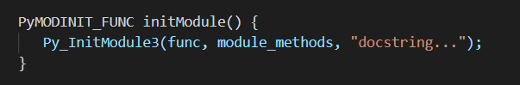

Here is the description of *Py_InitModule3* function −

* func − This is the function to be exported.
* *module*_methods − This is the mapping table name defined above.
* *docstring* − This is the comment you want to give in your extension.

Putting this all together looks like the following −

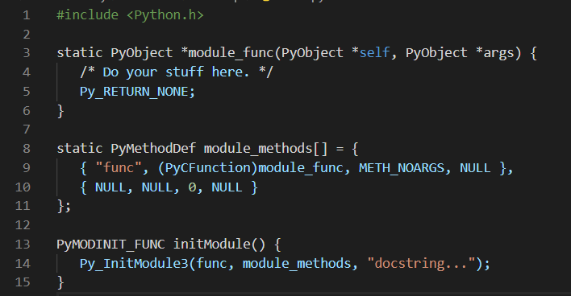

### Example

A simple example that makes use of all the above concepts −

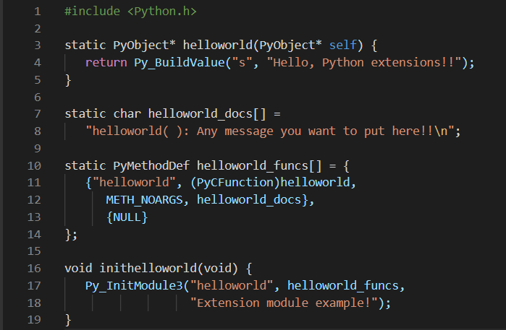

Here the *Py_BuildValue* function is used to build a Python value. Save above code in hello.c file. We would see how to compile and install this module to be called from Python script.

## Building and Installing Extensions

The *distutils* package makes it very easy to distribute Python modules, both pure Python and extension modules, in a standard way. Modules are distributed in source form and built and installed via a setup script usually called *setup.py* as follows.

For the above module, you need to prepare following setup.py script −

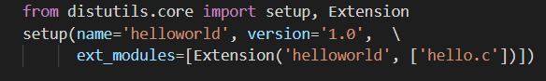

Now, use the following command, which would perform all needed compilation and linking steps, with the right compiler and linker commands and flags, and copies the resulting dynamic library into an appropriate directory −

**$ python setup.py install**

On Unix-based systems, you'll most likely need to run this command as root in order to have permissions to write to the site-packages directory. This usually is not a problem on Windows.

## Importing Extensions

Once you installed your extension, you would be able to import and call that extension in your Python script as follows −



This would produce the following result −



## Passing Function Parameters

As you will most likely want to define functions that accept arguments, you can use one of the other signatures for your C functions. For example, following function, that accepts some number of parameters, would be defined like this −

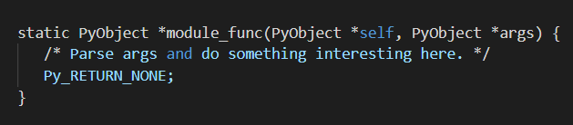

The method table containing an entry for the new function would look like this −

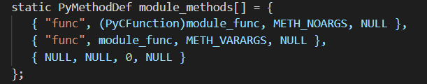

You can use API *PyArg_ParseTuple* function to extract the arguments from the one PyObject pointer passed into your C function.

The first argument to PyArg_ParseTuple is the args argument. This is the object you will be *parsing*. The second argument is a format string describing the arguments as you expect them to appear. Each argument is represented by one or more characters in the format string as follows.

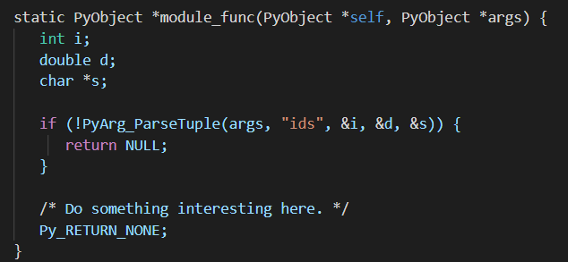

Compiling the new version of your module and importing it enables you to invoke the new function with any number of arguments of any type −

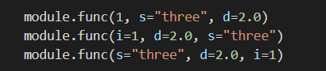

You can probably come up with even more variations.

## The *PyArg_ParseTuple* Function

Here is the standard signature for PyArg_ParseTuple function −



This function returns 0 for errors, and a value not equal to 0 for success. tuple is the PyObject* That was the C function's second argument. Here *format* is a C string that describes mandatory and optional arguments.

Here is a list of format codes for PyArg_ParseTuple function −

|  |  |  |
| --- | --- | --- |
| **Code** | **C type** | **Meaning** |
| c | char | A Python string of length 1 becomes a C char. |
| d | double | A Python float becomes a C double. |
| f | float | A Python float becomes a C float. |
| i | int | A Python int becomes a C int. |
| l | long | A Python int becomes a C long. |
| L | long long | A Python int becomes a C long long |
| O | PyObject* | Gets non-NULL borrowed reference to Python argument. |
| s | char* | Python string without embedded nulls to C char*. |
| s# | char*+int | Any Python string to C address and length. |
| t# | char*+int | Read-only single-segment buffer to C address and length. |
| u | Py_UNICODE* | Python Unicode without embedded nulls to C. |
| u# | Py_UNICODE*+int | Any Python Unicode C address and length. |
| w# | char*+int | Read/write single-segment buffer to C address and length. |
| z | char* | Like s, also accepts None (sets C char* to NULL). |
| z# | char*+int | Like s#, also accepts None (sets C char* to NULL). |
| (...) | as per ... | A Python sequence is treated as one argument per item. |
| | |  | The following arguments are optional. |
| : |  | Format end, followed by function name for error messages. |
| ; |  | Format end, followed by entire error message text. |

## Returning Values

*Py_BuildValue* takes in a format string much like *PyArg_ParseTuple* does. Instead of passing in the addresses of the values you are building, you pass in the actual values. Here's an example showing how to implement an add function −

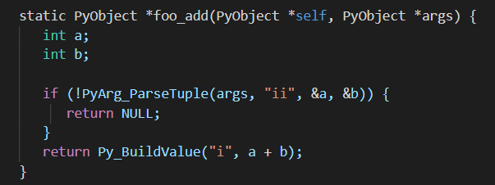

This is what it would look like if implemented in Python −



You can return two values from your function as follows, this would be captured using a list in Python.

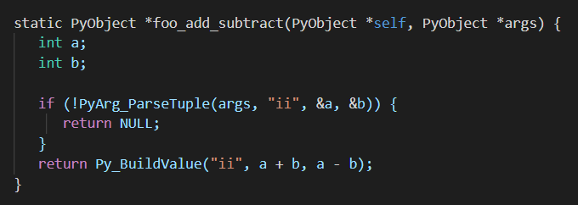

This is what it would look like if implemented in Python −

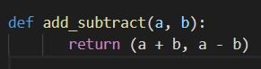

## The *Py_BuildValue* Function

Here is the standard signature for Py_BuildValue function −



Here *format* is a C string that describes the Python object to build. The following arguments of *Py_BuildValue* are C values from which the result is built. The *PyObject\** the result is a new reference.

Following table lists the commonly used code strings, of which zero or more are joined into string format.

|  |  |  |
| --- | --- | --- |
| **Code** | **C type** | **Meaning** |
| c | char | A C char becomes a Python string of length 1. |
| d | double | A C double becomes a Python float. |
| f | float | A C float becomes a Python float. |
| i | int | A C int becomes a Python int. |
| l | long | A C long becomes a Python int. |
| N | PyObject* | Passes a Python object and steals a reference. |
| O | PyObject* | Passes a Python object and INCREFs it as normal. |
| O& | convert+void* | Arbitrary conversion |
| s | char* | C 0-terminated char* to Python string, or NULL to None. |
| s# | char*+int | C char* and length to Python string, or NULL to None. |
| u | Py_UNICODE* | C-wide, null-terminated string to Python Unicode, or NULL to None. |
| u# | Py_UNICODE*+int | C-wide string and length to Python Unicode, or NULL to None. |
| w# | char*+int | Read/write single-segment buffer to C address and length. |
| z | char* | Like s, also accepts None (sets C char* to NULL). |
| z# | char*+int | Like s#, also accepts None (sets C char* to NULL). |
| (...) | as per ... | Builds Python tuple from C values. |
| [...] | as per ... | Builds Python list from C values. |
| {...} | as per ... | Builds Python dictionary from C values, alternating keys and values. |

Code {...} builds dictionaries from an even number of C values, alternately keys and values. For example, Py_BuildValue("{issi}",23,"zig","zag",42) returns a dictionary like Python {23:'zig','zag':42}.

**============================================**

***Python Useful Resources***

**=>Python - Interview Questions and Answers**

Dear readers, these Python Programming Language Interview Questions have been designed specially to get you acquainted with the nature of questions you may encounter during your interview for the subject of Python Programming Language. As per my experience good interviewers hardly plan to ask any particular question during your interview, normally questions start with some basic concept of the subject and later they continue based on further discussion and what you answer −

1. What is Python?

Python is a high-level, interpreted, interactive and object-oriented scripting language. Python is designed to be highly readable. It uses English words frequently whereas other languages use punctuation, and it has fewer syntactic constructions than other languages.

1. Name some of the features of Python.

Following are some of the salient features of python −

* It supports functional and structured programming methods as well as OOP.
* It can be used as a scripting language or can be compiled to byte-code for building large applications.
* It provides very high-level dynamic data types and supports dynamic type checking.
* It supports automatic garbage collection.
* It can be easily integrated with C, C++, COM, ActiveX, CORBA, and Java.

1. What is the purpose of the PYTHONPATH environment variable?

PYTHONPATH - It has a role similar to PATH. This variable tells the Python interpreter where to locate the module files imported into a program. It should include the Python source library directory and the directories containing Python source code. PYTHONPATH is sometimes pre-set by the Python installer.

1. What is the purpose of the PYTHONSTARTUP environment variable?

PYTHONSTARTUP - It contains the path of an initialization file containing Python source code. It is executed every time you start the interpreter. It is named as .pythonrc.py in Unix and it contains commands that load utilities or modify PYTHONPATH.

1. What is the purpose of the PYTHONCASEOK environment variable?

PYTHONCASEOK − It is used in Windows to instruct Python to find the first case-insensitive match in an import statement. Set this variable to any value to activate it.

1. What is the purpose of the PYTHONHOME environment variable?

PYTHONHOME − It is an alternative module search path. It is usually embedded in the PYTHONSTARTUP or PYTHONPATH directories to make switching module libraries easy.

1. Is python a case sensitive language?

Yes! Python is a case sensitive programming language.

1. What are the supported data types in Python?

Python has five standard data types −

* Numbers
* String
* List
* Tuple
* Dictionary

1. What is the output of print str if str = 'Hello World!'?

It will print the complete string. Output would be Hello World!.

1. What is the output of print str[0] if str = 'Hello World!'?

It will print the first character of the string. Output would be H.

1. What is the output of print str[2:5] if str = 'Hello World!'?

It will print characters starting from 3rd to 5th. Output would be llo.

1. What is the output of print str[2:] if str = 'Hello World!'?

It will print characters starting from the 3rd character. Output would be llo World!.

1. What is the output of print str * 2 if str = 'Hello World!'?

It will print the string two times. Output would be Hello World!Hello World!.

1. What is the output of print str + "TEST" if str = 'Hello World!'?

It will print a concatenated string. Output would be Hello World!TEST.

1. What is the output of print list if list = [ 'abcd', 786 , 2.23, 'john', 70.2 ]?

It will print the complete list. Output would be ['abcd', 786, 2.23, 'john', 70.200000000000003].

1. What is the output of print list[0] if list = [ 'abcd', 786 , 2.23, 'john', 70.2 ]?

It will print the first element of the list. Output would be abcd.

1. What is the output of print list[1:3] if list = [ 'abcd', 786 , 2.23, 'john', 70.2 ]?

It will print elements starting from 2nd to 3rd. Output would be [786, 2.23].

1. What is the output of print list[2:] if list = [ 'abcd', 786 , 2.23, 'john', 70.2 ]?

It will print elements starting from the 3rd element. Output would be [2.23, 'john', 70.200000000000003].

1. What is the output of print tinylist * 2 if tinylist = [123, 'john']?

It will print the list two times. Output would be [123, 'john', 123, 'john'].

1. What is the output of print list1 + list2, if list1 = [ 'abcd', 786 , 2.23, 'john', 70.2 ] and ist2 = [123, 'john']?

It will print concatenated lists. Output would be ['abcd', 786, 2.23, 'john', 70.2, 123, 'john']

1. What are tuples in Python?

A tuple is another sequence data type that is similar to the list. A tuple consists of a number of values separated by commas. Unlike lists, however, tuples are enclosed within parentheses.

1. What is the difference between tuples and lists in Python?

The main differences between lists and tuples are − Lists are enclosed in brackets ( [ ] ) and their elements and size can be changed, while tuples are enclosed in parentheses ( ( ) ) and cannot be updated. Tuples can be thought of as read-only lists.

1. What is the output of print tuple if tuple = ( 'abcd', 786 , 2.23, 'john', 70.2 )?

It will print the complete tuple. Output would be ('abcd', 786, 2.23, 'john', 70.200000000000003).

1. What is the output of print tuple[0] if tuple = ( 'abcd', 786 , 2.23, 'john', 70.2 )?

It will print the first element of the tuple. Output would be abcd.

1. What is the output of print tuple[1:3] if tuple = ( 'abcd', 786 , 2.23, 'john', 70.2 )?

It will print elements starting from 2nd to 3rd. Output would be (786, 2.23).

1. What is the output of print tuple[2:] if tuple = ( 'abcd', 786 , 2.23, 'john', 70.2 )?

It will print elements starting from the 3rd element. Output would be (2.23, 'john', 70.200000000000003).

1. What is the output of print tinytuple * 2 if tinytuple = (123, 'john')?

It will print tuples two times. Output would be (123, 'john', 123, 'john').

1. What is the output of print tuple + tinytuple if tuple = ( 'abcd', 786 , 2.23, 'john', 70.2 ) and tinytuple = (123, 'john')?

It will print concatenate tuples. Output would be ('abcd', 786, 2.23, 'john', 70.200000000000003, 123, 'john').

1. What are Python's dictionaries?

Python's dictionaries are kind of hash table type. They work like associative arrays or hashes found in Perl and consist of key-value pairs. A dictionary key can be almost any Python type, but are usually numbers or strings. Values, on the other hand, can be any arbitrary Python object.

1. How will you create a dictionary in python?

Dictionaries are enclosed by curly braces ({ }) and values can be assigned and accessed using square braces ([]).

dict = {}

dict['one'] = "This is one"

dict[2] = "This is two"

tinydict = {'name': 'john','code':6734, 'dept': 'sales'}

1. How will you get all the keys from the dictionary?

Using dictionary.keys() function, we can get all the keys from the dictionary object.

print dict.keys() # Prints all the keys

1. How will you get all the values from the dictionary?

Using dictionary.values() function, we can get all the values from the dictionary object.

print dict.values() # Prints all the values

1. How will you convert a string to an int in python?

int(x [,base]) - Converts x to an integer. base specifies the base if x is a string.

1. How will you convert a string to a long in python?

long(x [,base] ) - Converts x to a long integer. base specifies the base if x is a string.

1. How will you convert a string to a float in python?

float(x) − Converts x to a floating-point number.

1. How will you convert an object to a string in python?

str(x) − Converts object x to a string representation.

1. How will you convert an object to a regular expression in python?

repr(x) − Converts object x to an expression string.

1. How will you convert a String to an object in python?

eval(str) − Evaluates a string and returns an object.

1. How will you convert a string to a tuple in python?

tuple(s) − Converts s to a tuple.

1. How will you convert a string to a list in python?

list(s) − Converts s to a list.

1. How will you convert a string to a set in python?

set(s) − Converts s to a set.

1. How will you create a dictionary using tuples in python?

dict(d) − Creates a dictionary. d must be a sequence of (key,value) tuples.

1. How will you convert a string to a frozen set in python?

frozenset(s) − Converts s to a frozen set.

1. How will you convert an integer to a character in python?

chr(x) − Converts an integer to a character.

1. How will you convert an integer to an unicode character in python?

unichr(x) − Converts an integer to a Unicode character.

1. How will you convert a single character to its integer value in python?

ord(x) − Converts a single character to its integer value.

1. How will you convert an integer to hexadecimal string in python?

hex(x) − Converts an integer to a hexadecimal string.

1. How will you convert an integer to octal string in python?

oct(x) − Converts an integer to an octal string.

1. What is the purpose of ** operator?

** Exponent − Performs exponential (power) calculation on operators. a**b = 10 to the power 20 if a = 10 and b = 20.

1. What is the purpose of // operator?

// Floor Division − The division of operands where the result is the quotient in which the digits after the decimal point are removed.

1. What is the purpose of is operator?

is − Evaluates to true if the variables on either side of the operator point to the same object and false otherwise. x is y, here it results in 1 if id(x) equals id(y).

1. What is the purpose of not in operator?

not in − Evaluates to true if it does not find a variable in the specified sequence and false otherwise. x not in y, here not in results in a 1 if x is not a member of sequence y.

1. What is the purpose break statement in python?

break statement − Terminates the loop statement and transfers execution to the statement immediately following the loop.

1. What is the purpose of the continue statement in python?

continue statement − Causes the loop to skip the remainder of its body and immediately retest its condition prior to reiterating.

1. What is the purpose pass statement in python?

pass statement − The pass statement in Python is used when a statement is required syntactically but you do not want any command or code to execute.

1. How can you pick a random item from a list or tuple?

choice(seq) − Returns a random item from a list, tuple, or string.

1. How can you pick a random item from a range?

randrange ([start,] stop [,step]) − returns a randomly selected element from range(start, stop, step).

1. How can you get a random number in python?

random() − returns a random float r, such that 0 is less than or equal to r and r is less than 1.

1. How will you set the starting value in generating random numbers?

seed([x]) − Sets the integer starting value used in generating random numbers. Call this function before calling any other random module function. Returns None.

1. How will you randomize the items of a list in place?

shuffle(lst) − Randomizes the items of a list in place. Returns None.

1. How will you capitalize the first letter of string?

capitalize() − Capitalizes first letter of string.

1. How will you check in a string that all characters are alphanumeric?

isalnum() − Returns true if string has at least 1 character and all characters are alphanumeric and false otherwise.

1. How will you check in a string that all characters are digits?

isdigit() − Returns true if string contains only digits and false otherwise.

1. How will you check in a string that all characters are in lowercase?

islower() − Returns true if string has at least 1 cased character and all cased characters are in lowercase and false otherwise.

1. How will you check in a string that all characters are numerics?

isnumeric() − Returns true if a unicode string contains only numeric characters and false otherwise.

1. How will you check in a string that all characters are whitespaces?

isspace() − Returns true if string contains only whitespace characters and false otherwise.

1. How will you check in a string that it is properly titlecased?

istitle() − Returns true if string is properly "titlecased" and false otherwise.

1. How will you check in a string that all characters are in uppercase?

isupper() − Returns true if string has at least one cased character and all cased characters are in uppercase and false otherwise.

1. How will you merge elements in a sequence?

join(seq) − Merges (concatenates) the string representations of elements in sequence seq into a string, with separator string.

1. How will you get the length of the string?

len(string) − Returns the length of the string.

1. How will you get a space-padded string with the original string left-justified to a total of width columns?

ljust(width[, fillchar]) − Returns a space-padded string with the original string left-justified to a total of width columns.

1. How will you convert a string to all lowercase?

lower() − Converts all uppercase letters in string to lowercase.

1. How will you remove all leading whitespace in string?

lstrip() − Removes all leading whitespace in string.

1. How will you get the max alphabetical character from the string?

max(str) − Returns the max alphabetical character from the string str.

1. How will you get the min alphabetical character from the string?

min(str) − Returns the min alphabetical character from the string str.

1. How will you replace all occurrences of old substring in string with new string?

replace(old, new [, max]) − Replaces all occurrences of old in string with new or at most max occurrences if max given.

1. How will you remove all leading and trailing whitespace in string?

strip([chars]) − Performs both lstrip() and rstrip() on string.

1. How will you change the case for all letters in string?

swapcase() − Inverts case for all letters in string.

1. How will you get the title cased version of string?

title() − Returns "titlecased" version of string, that is, all words begin with uppercase and the rest are lowercase.

1. How will you convert a string to all uppercase?

upper() − Converts all lowercase letters in string to uppercase.

1. How will you check in a string that all characters are decimal?

isdecimal() − Returns true if a unicode string contains only decimal characters and false otherwise.

1. What is the difference between del() and remove() methods of list?

To remove a list element, you can use either the del statement if you know exactly which element(s) you are deleting or the remove() method if you do not know.

1. What is the output of len([1, 2, 3])?

3.

1. What is the output of [1, 2, 3] + [4, 5, 6]?

[1, 2, 3, 4, 5, 6]

1. What is the output of ['Hi!'] * 4?

['Hi!', 'Hi!', 'Hi!', 'Hi!']

1. What is the output of 3 in [1, 2, 3]?

True

1. What is the output of for x in [1, 2, 3]: print x?

1

2

3

1. What is the output of L[2] if L = [1,2,3]?

3, Offsets start at zero.

1. What is the output of L[-2] if L = [1,2,3]?

1, Negative: count from the right.

1. What is the output of L[1:] if L = [1,2,3]?

2, 3, Slicing fetches sections.

1. How will you compare two lists?

cmp(list1, list2) − Compares elements of both lists.

1. How will you get the length of a list?

len(list) − Gives the total length of the list.

1. How will you get the max valued item of a list?

max(list) − Returns item from the list with max value.

1. How will you get the min valued item of a list?

min(list) − Returns item from the list with min value.

1. How will you get the index of an object in a list?

list.index(obj) − Returns the lowest index in the list that obj appears.

1. How will you insert an object at a given index in a list?

list.insert(index, obj) − Inserts object obj into list at offset index.

1. How will you remove the last object from a list?

list.pop(obj=list[-1]) − Removes and returns last object or obj from list.

1. How will you remove an object from a list?

list.remove(obj) − Removes object obj from list.

1. How will you reverse a list?

list.reverse() − Reverses objects of list in place.

1. How will you sort a list?

list.sort([func]) − Sorts objects of list, use compare func if given.

1. What is the lambda function in python?

‘lambda’ is a keyword in python which creates an anonymous function. Lambda does not contain a block of statements. It does not contain return statements.

1. What do we call a function which is an incomplete version of a function?

Stub.

1. When a function is defined then the system stores parameters and local variables in an area of memory. What is this memory known as?

Stack.

1. A canvas can have a foreground color? (Yes/No)

Yes.

1. Is Python platform independent?

No

There are some modules and functions in python that can only run on certain platforms.

1. Do you think Python has a compiler?

Yes

Yes it has a compiler which works automatically so we don’t notice the compiler of python.

1. What are the applications of Python?

Django (Web framework of Python).

2. Micro Framework such as Flask and Bottle.

3. Plone and Django CMS for advanced content Management.

1. What is the basic difference between Python version 2 and Python version 3?

Table below explains the difference between Python version 2 and Python version 3.

|  |  |  |  |
| --- | --- | --- | --- |
| S.No | Section | Python Version2 | Python Version3 |
| 1. | Print Function | Print command can be used without parentheses. | Python 3 needs parentheses to print any string. It will raise errors without parentheses. |
| 2. | Unicode | ASCII str() types and separate Unicode() but there is no byte type code in Python 2. | Unicode (utf-8) and it has two byte classes −   * Byte * Bytearray S. |
| 3. | Exceptions | Python 2 accepts both new and old notations of syntax. | Python 3 raises a SyntaxError in turn when we don’t enclose the exception argument in parentheses. |
| 4. | Comparing Unorderable | It does not raise any error. | It raises ‘TypeError’ as a warning if we try to compare unorderable types. |

1. Which programming Language is an implementation of Python programming language designed to run on Java Platform?

Jython

(Jython is the successor of Jpython.)

1. Is there any double data type in Python?

No

1. Is String in Python immutable? (Yes/No)

Yes.

1. Can True = False be possible in Python?

No.

1. Which module of python is used to apply the methods related to OS.?

OS.

1. When does a new block begin in python?

A block begins when the line is intended by 4 spaces.

1. Write a function in python which detects whether the given two strings are anagrams or not.

def check(a,b):

if(len(a)!=len(b)):

return False

else:

if(sorted(list(a)) == sorted(list(b))):

return True

else:

return False

1. Name the python Library used for Machine learning.

Scikit-learn python Library used for Machine learning

1. What does pass operation do?

Pass indicates that nothing is to be done i.e. it signifies a no operation.

1. Name the tools which python uses to find bugs (if any).

Pylint and pychecker.

1. Write a function to give the sum of all the numbers in list?

Sample list − (100, 200, 300, 400, 0, 500)

Expected output − 1500

Program for sum of all the numbers in list is −

def sum(numbers):

total = 0

for num in numbers:

total += num

print(''Sum of the numbers: '', total)

sum((100, 200, 300, 400, 0, 500))

We define a function ‘sum’ with numbers as parameters. In the for loop we store the sum of all the values of the list.

1. Write a program in Python to reverse a string without using inbuilt function reverse string?

Program to reverse a string in given below −

def string_reverse(str1):

rev_str = ' '

index = len(str1) #defining index as length of string.

while(index>0):

rev_str = rev_str + str1[index-1]

index = index-1

return(rev_str)

print(string_reverse('1tniop'))

First we declare a variable to store the reverse string. Then using while loop and indexing of string (index is calculated by string length) we reverse the string. While loop starts when index is greater than zero. Index is reduced to value 1 each time. When index reaches zero we obtain the reverse of string.

1. Write a program to test whether the number is in the defined range or not?

Program is −

def test_range(num):

if num in range(0, 101):

print(''%s is in range''%str(num))

else:

print(''%s is not in range''%str(num))

Output −

test_range(101)

101 is not in the range

To test any number in a particular range we make use of the method ‘if..in’ and else condition.

1. Write a program to calculate the number of uppercase letters and number of lowercase letters?

Test on String: ''Tutorials POINT''

Program is −

def string_test(s):

a = { ''Lower_Case'':0 , ''Upper_Case'':0} #intiail count of lower and upper

for ch in s: #for loop

if(ch.islower()): #if-elif-else condition

a[''Lower_Case''] = a[''Lower_Case''] + 1

elif(ch.isupper()):

a[''Upper_Case''] = a [''Upper_Case''] + 1

else:

pass

print(''String in testing is: '',s) #printing the statements.

print(''Number of LowerCase characters in String: '',a[''Lower_Case''])

print(''Number of UpperCase characters in String: '',a[''Upper_Case''])

Output −

string_test(''Tutorials POINT'')

String in testing is: Tutorials POINT

Number of LowerCase characters in String: 8

Number of UpperCase characters in String: 6

We make use of the methods .islower() and .isupper(). We initialise the count for lower and upper. Using if and else condition we calculate the total number of lower and upper case characters.