**Form Creation**

**Elements like <input>,<select>,<textarea> they can be styled with form-control class.**

**<div>**

**<input class="form-control form-control-lg" type="text"**

**placeholder="Large text box">**

**<br><br>**

**<input class="form-control" type="text"**

**placeholder="Default text box">**

**<br><br>**

**<input class="form-control form-control-sm" type="text"**

**placeholder="Small text box">**

**</div>**

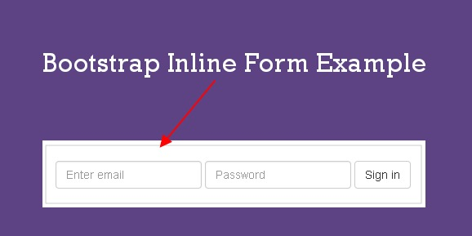

<html lang="en" dir="ltr">

<head>

<link rel="stylesheet"

href="https://cdn.jsdelivr.net/npm/bootstrap@5.1.1/dist/css/bootstrap.min.css" integrity="sha384-F3w7mX95PdgyTmZZMECAngseQB83DfGTowi0iMjiWaeVhAn4FJkqJByhZMI3AhiU" crossorigin="anonymous">

<style>

.btn-success{

background: green;

color: white;

}

</style>

</head>

<body>

<center>

<form>

<div class="form-group">

<label for="exampleInputEmail1">Email address</label>

<input type="email" class="form-control" id="exampleInputEmail1" aria-describedby="emailHelp" placeholder="Enter email">

<small id="emailHelp" class="form-text text-muted">We'll never share your email with anyone else.</small>

</div>

<div class="form-group">

<label for="exampleInputPassword1">Password</label>

<input type="password" class="form-control" id="exampleInputPassword1" placeholder="Password">

</div>

<div class="form-check">

<input type="checkbox" class="form-check-input" id="exampleCheck1">

<label class="form-check-label" for="exampleCheck1">Check me out</label>

</div>

<button type="submit" class="btn btn-primary">Submit</button>

</form>

<div>

<input class="form-control form-control-lg" type="text"

placeholder="Large text box">

<br><br>

<input class="form-control" type="text"

placeholder="Default text box">

<br><br>

<input class="form-control form-control-sm" type="text"

placeholder="Small text box">

</div>

<br><br>

<input class="form-control" type="text" placeholder="Readonly box" readonly>

<br><br>

<div class="form-check">

<input class="form-check-input" type="checkbox" value="" id="default checkbox1">

<label class="form-check-label" for="default checkbox1">

Default Checkbox</label>

</div>

<br><br>

<div class="form-check">

<input class="form-check-input" type="radio" name="ExampleRadioBtn" id="rdbtn1" value="option1" checked>

<label class="form-check-label" for="rdbtn1">Default Radio Btn

</label>

</div>

<br><br>

<div class="form-check">

<input class="form-check-input" type="radio" name="ExampleRadioBtn" id="rdbtn2" value="option2">

<label class="form-check-label" for="rdbtn2">Default Radio Btn

</label>

</div>

<br><br>

<div class="form-check disabled">

<input class="form-check-input" type="radio" name="ExampleRadioBtn" id="rdbtn3" value="option3" disabled>

<label class="form-check-label" for="rdbtn3">Disabled Radio Btn

</label>

</div>

<br><br>

<div class="form-check form-check-inline">

<input class="form-check-input" type="checkbox" id="ch1" value="v1">

<label class="form-check-label" for="ch1">1</label>

</div>

<div class="form-check form-check-inline">

<input class="form-check-input" type="checkbox" id="ch2" value="v2">

<label class="form-check-label" for="ch2">2</label>

</div>

<div class="form-check form-check-inline">

<input class="form-check-input" type="checkbox" id="ch3" value="v3" disabled>

<label class="form-check-label" for="ch3" >3(disabled)</label>

</div>

<br><br>

<div class="form-check form-check-inline">

<input class="form-check-input" type="radio" id="ch1" value="v1">

<label class="form-check-label" for="ch1">1</label>

</div>

<div class="form-check form-check-inline">

<input class="form-check-input" type="radio" id="ch2" value="v2">

<label class="form-check-label" for="ch2">2</label>

</div>

<div class="form-check form-check-inline">

<input class="form-check-input" type="radio" id="ch3" value="v3" disabled>

<label class="form-check-label" for="ch3" >3(disabled)</label>

</div>

</center>

</body>

</html>

Nav bars in bootstrap

A std navigation bar is created with

<nav class=”navbar navbar-default”>

.navbar-inverse🡺Black colored nav-bar

.navbar-brand🡪for your company or product or project names

.navbar-nav🡪Full height and light weight navigation

.navbar-toggler🡪Use with **collapse plugin** and for toggling behaviors

.navbar-text🡪for adding vertically centered text.

.collapse.navbar-collapse🡪Collapse for grouping and hiding navbar

Collapse- for space saving of large content.it is hidden and shows the content when user clicks on a particular element.

Collapsible content-the content that will be shown or hidden with a click of a button.

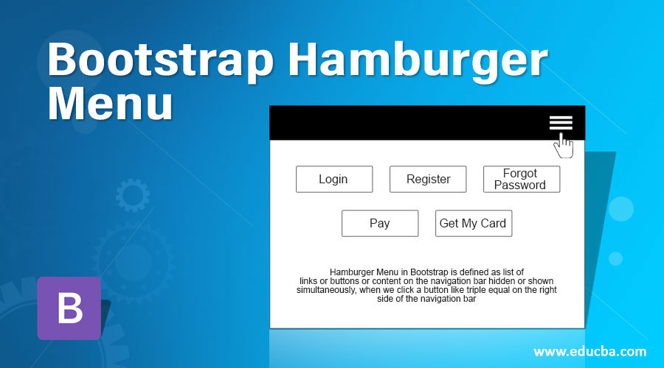

Note:

<!DOCTYPE html>

<html>

<head>

<title>

Data Toggle - Collapse example

</title>

<meta name="viewport" content="width=device-width, initial-scale=1">

<link rel="stylesheet" href=

"https://maxcdn.bootstrapcdn.com/bootstrap/3.4.1/css/bootstrap.min.css">

<script src=

"https://ajax.googleapis.com/ajax/libs/jquery/3.5.1/jquery.min.js">

</script>

<script src=

"https://maxcdn.bootstrapcdn.com/bootstrap/3.4.1/js/bootstrap.min.js">

</script>

</head>

<body>

<h2>Welcome To Pentagon Space</h2>

<button type="button"

class="btn btn-primary"

data-toggle="collapse"

data-target="#learnMore">

Learn More

</button>

<div id="learnMore" class="collapse">

welcome to python/java full stack

</div>

</body>

/* div tag conatins collapsible element */

</html>

1.Learn more is a toggle menu

2.toggle menu is associated with collapse class

the content that will be shown or hidden with a click of a button.

data-tag is a property which maps to collapse value

3.data-target contains an id Ex:#learnMore

data-target binds to collapsible element in our ex,<div>

That is

div class now contains

id==>data-toggle in button

class==>data-target in button

mapped by the button that is meant for toggling

<!DOCTYPE html>

<html lang="en" dir="ltr">

<head>

<!-- Latest compiled and minified CSS -->

<link rel="stylesheet" href="https://maxcdn.bootstrapcdn.com/bootstrap/3.3.7/css/bootstrap.min.css" integrity="sha384-BVYiiSIFeK1dGmJRAkycuHAHRg32OmUcww7on3RYdg4Va+PmSTsz/K68vbdEjh4u" crossorigin="anonymous">

<script src="https://code.jquery.com/jquery-3.4.1.slim.min.js" integrity="sha384-J6qa4849blE2+poT4WnyKhv5vZF5SrPo0iEjwBvKU7imGFAV0wwj1yYfoRSJoZ+n" crossorigin="anonymous"></script>

<script src="https://cdn.jsdelivr.net/npm/popper.js@1.16.0/dist/umd/popper.min.js" integrity="sha384-Q6E9RHvbIyZFJoft+2mJbHaEWldlvI9IOYy5n3zV9zzTtmI3UksdQRVvoxMfooAo" crossorigin="anonymous"></script>

<script src="https://stackpath.bootstrapcdn.com/bootstrap/4.4.1/js/bootstrap.min.js" integrity="sha384-wfSDF2E50Y2D1uUdj0O3uMBJnjuUD4Ih7YwaYd1iqfktj0Uod8GCExl3Og8ifwB6" crossorigin="anonymous"></script>

<title></title>

</head>

<body>

<nav class="navbar navbar-default navbar-fixed-top navbar-inverse">

<div class="container">

<div class="navbar-header">

<button type="button"

class="navbar-toggle collapsed"

data toggle="collapse" data-target="#id1">

</button>

<a href="https://pentagonspace.in/" class="navbar-brand" >Pentagon Space</a>

</div>

<div class="collapse navbar-collapse" id="id1">

<ul class="nav navbar-nav">

<li><a href="#">Home</a></li>

<li><a href="#">About Us</a></li>

<li><a href="#">Java</a></li>

<li><a href="#">Python</a></li>

<li><a href="#">Others</a></li>

</ul>

<ul class="nav navbar-nav navbar-right">

<li><a href="#">Contact Us</a></li>

<li><a href="#">Logout</a></li>

</ul>

</div>

</div>

</nav>

</body>

</html>