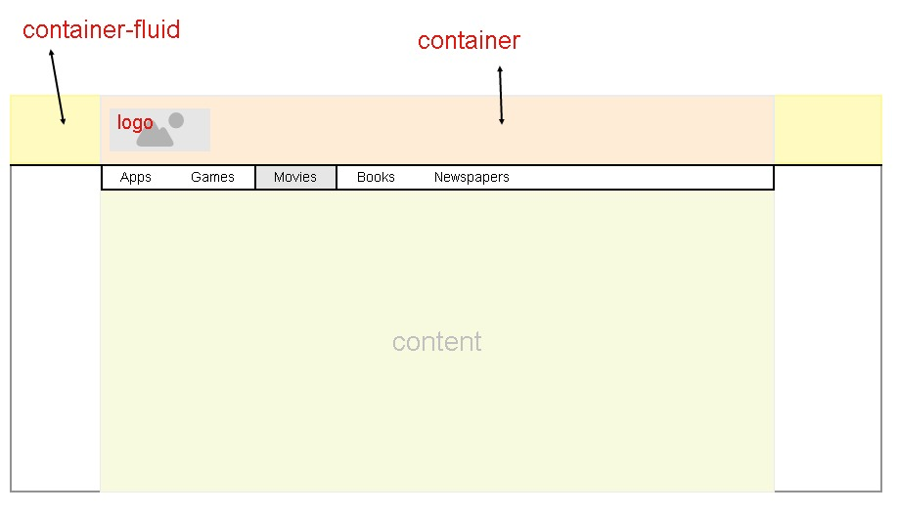

COMPLETE NAV BAR APPLICATION

<!DOCTYPE html> <html lang="en" dir="ltr"> <head> <!-- Latest compiled and

minified CSS --> <link rel="stylesheet"

href="https://maxcdn.bootstrapcdn.com/bootstrap/3.3.7/css/bootstrap.min.css"

integrity="sha384-BVYiiSIFeK1dGmJRAkycuHAHRg32OmUcww7on3RYdg4Va+PmSTsz/K68vbdEjh4u"

crossorigin="anonymous"> <script

src="https://code.jquery.com/jquery-3.4.1.slim.min.js"

integrity="sha384-J6qa4849blE2+poT4WnyKhv5vZF5SrPo0iEjwBvKU7imGFAV0wwj1yYfoRSJoZ+n"

crossorigin="anonymous"></script> <script

src="https://cdn.jsdelivr.net/npm/popper.js@1.16.0/dist/umd/popper.min.js"

integrity="sha384-Q6E9RHvbIyZFJoft+2mJbHaEWldlvI9IOYy5n3zV9zzTtmI3UksdQRVvoxMfooAo"

crossorigin="anonymous"></script> <script

src="https://stackpath.bootstrapcdn.com/bootstrap/4.4.1/js/bootstrap.min.js"

integrity="sha384-wfSDF2E50Y2D1uUdj0O3uMBJnjuUD4Ih7YwaYd1iqfktj0Uod8GCExl3Og8ifwB6"

crossorigin="anonymous"></script> <title></title>

</head> <body>

<nav

class="navbar navbar-default navbar-fixed-top navbar-inverse"> <div

class="container"> <div class="navbar-header">

<button type="button" class="navbar-toggle collapsed" data toggle="collapse" data-target="#id1">

<span>Toggle navigation</span> <span class="icon-bar">

</span>

<span

class="icon-bar"></span> <span class="icon-bar"></span>

<span class="icon-bar"></span>

</button>

<a href="https://pentagonspace.in/"

class="navbar-brand" >Pentagon Space</a> </div>

<div class="collapse navbar-collapse" id="id1">

<ul class="nav navbar-nav"> <li><a href="#">Home</a>

</li>

<li><a href="#">About Us</a></li>

<li><a href="#">Java</a></li>

<li><a href="#">Python</a></li>

<li><a href="#">Others</a></li></ul>

<ul class="nav navbar-nav navbar-right">

<li><a href="#">Contact Us</a></li>

<li><a href="#">Logout</a></li>

</ul>

</div>

</div>

</nav>

<br><br><br><br>

<nav class="nav navbar-default">

<div class="container-fluid">

<div class="navbar-header">

<button class="navbar-toggle collapsed" data-toggle="collapse"

data-target="#id2">

</button>

</div>

</div>

<div class="collapse navbar-collapse" id="id2">

<ul class="nav navbar-nav">

<li class="active"><a href="#">Link</a></li>

<li class="dropdown">

<a href="#" class="dropdown-toggle" data-toggle="dropdown"

role="button">Dropdown</a>

<ul class="dropdown-menu">

<li> <a href="#">Read an Article</a></li>

<li> <a href="#">Enroll</a></li>

<li> <a href="#">Avail offers</a></li>

<li role="separator" class="divider"></li>

</ul>

</li>

</ul>

<form class="navbar-form navbar-left">

<div class="form-group">

<input type="text" class="form-control" placeholder="Search">

</div>

<button type="submit" class="btn btn-primary">Submit</button>

</form>

<ul class="nav navbar-nav navbar-right">

<li><a href="#">Link</a></li>

<li class="dropdown">

<a href="#" class="dropdown-toggle" data-toggle="dropdown"

role="button">Dropdown</a>

<ul class="dropdown-menu">

<li><a href="#">Action1</a></li>

<li><a href="#">Action2</a></li>

<li><a href="#">Action3</a></li>

<li role="separator" class="divider">

</li>

</ul>

</li>

</ul>

</div>

</nav>

</body>

</html>

1.How to add brand to navbar?

navbar-brand

2.How to create a std navbar?

navbar navbar-default

3.How to create nav bar header?

navbar-header

4.Which class is associated with list entry?

nav navbar-nav

5.How to add items to the right hand side?

nav navbar-nav navbar-right

6.How to position navbar elemets properly?

<nav class=”navbar navbar-default”>

<div class=”container”>…. </div>></nav>

7.How to fix navbar always at top position?

Class=”navbar navbar-default navbar-fixed-top”

8.How to get black colored navbar?

Class=”navbar navbar-default navbar-inverse

9.How to implement hamburger?

<div class=” collapse navbar-collapse” id=”id1”>

<ul class=”nav navbar-nav”>

….

…

</ul>

</div>

10.Which class to use toggle navigation?

class="navbar-toggle collapsed"

