Ref cdn links

<link rel="stylesheet" href="https://stackpath.bootstrapcdn.com/bootstrap/4.3.1/css/bootstrap.min.css">

<script src="https://code.jquery.com/jquery-3.4.1.min.js"></script>

<script src="https://cdnjs.cloudflare.com/ajax/libs/popper.js/1.14.7/umd/popper.min.js">

</script>

<script src="https://stackpath.bootstrapcdn.com/bootstrap/4.3.1/js/bootstrap.min.js">

</script>

=============================================

<link rel="stylesheet" href="https://maxcdn.bootstrapcdn.com/bootstrap/3.3.7/css/bootstrap.min.css" integrity="sha384-BVYiiSIFeK1dGmJRAkycuHAHRg32OmUcww7on3RYdg4Va+PmSTsz/K68vbdEjh4u" crossorigin="anonymous">

<!-- Optional theme -->

<link rel="stylesheet" href="https://maxcdn.bootstrapcdn.com/bootstrap/3.3.7/css/bootstrap-theme.min.css" integrity="sha384-rHyoN1iRsVXV4nD0JutlnGaslCJuC7uwjduW9SVrLvRYooPp2bWYgmgJQIXwl/Sp" crossorigin="anonymous">

<!-- Latest compiled and minified JavaScript -->

<script src="https://maxcdn.bootstrapcdn.com/bootstrap/3.3.7/js/bootstrap.min.js" integrity="sha384-Tc5IQib027qvyjSMfHjOMaLkfuWVxZxUPnCJA7l2mCWNIpG9mGCD8wGNIcPD7Txa" crossorigin="anonymous"></script>

========================================

File Attachment

<body>

<center>

<h1>Attach your file here</h1>

<div class="container">

<input type="file" name="file" class="form-control-file">

</div>

</center>

</body>

Jumbotron class

Jumbotron indicates a big box for extra attention to a special content.It is displayed as a grey box with rounded corner

<body>

<div class="comntainer">

<p>For the first time ever, Bootstrap has its own open source SVG icon library, designed to work best with our components and documentation.</p>

</div>

<div class="jumbotron">

<h1>Bootrap classes</h1>

<p>

Quickly design and customize responsive mobile-first sites with Bootstrap, the world’s most popular front-end open source toolkit, featuring Sass variables and mixins, responsive grid system, extensive prebuilt components, and powerful JavaScript plugins.

</p>

</div>

</body>

Bootstrap images

<body>

<center>

<h1>Rounded image</h1>

<img src="lion1.jfif" class="img-rounded" alt="not available" height="500" width="500"/>

<br><br>

<h1> image circle</h1>

<img src="lion1.jfif" class="img-circle" alt="not available" height="500" width="500"/>

<br><br>

<h1> image thumbnail</h1>

<img src="lion1.jfif" class="img-thumbnail" alt="not available" height="500" width="500"/>

<br><br>

<h1> image responsive</h1>

<img src="lion1.jfif" class="img-responsive" alt="not available" height="500" width="500"/>

</center>

</body>

Breadcrumb class

Indicates current page’s location within a navigation hierarchy

<body>

<div class="container">

<h2>Breadcrumbs</h2>

<ul class="breadcrumb" >

<li class="active">Home</li>

<li><a href="#">Subjects</a></li>

<li><a href="#">Test</a></li>

</ul>

</div>

</body>

**Pagination**

<body>

<center>

<h1>Pagination Example</h1>

<hr>

<h2>Pagination large</h2>

<ul class="pagination pagination-lg">

<li><a href="#">Java</a></li>

<li><a href="#">Python</a></li>

<li><a href="#">C#</a></li>

</ul>

<br><br>

<h2>Pagination small</h2>

<ul class="pagination pagination-sm">

<li><a href="#">Java</a></li>

<li><a href="#">Python</a></li>

<li><a href="#">C#</a></li>

</ul>

<br><br>

<h2>Pagination default</h2>

<ul class="pagination pagination-default">

<li><a href="#">Java</a></li>

<li><a href="#">Python</a></li>

<li><a href="#">C#</a></li>

</ul>

</center>

</body>

Bootstrap Grid System

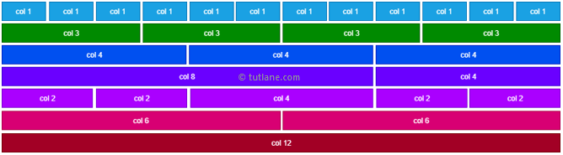

Grid system is useful to build quick web page layout that are responsive to the different devises based onn screen size.

It shows up to 12 columns.

It uses series of containers,rows and colums to define a layout to align the content properly based on the devise.

By defining 12 columns individually or by grouping the columns to create wider columns we can create responsive web pages.

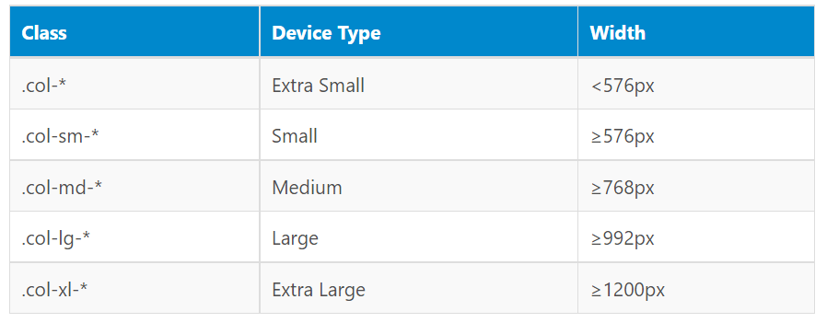

Bootstrap defines 5 grid classes

.col-*

.col-sm-*

.col-md-*

.col-lg-*

.col-xl-*

Start symbol means span width of the col from 1-12

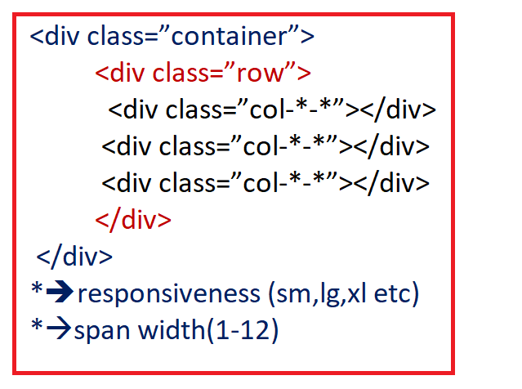

<html>

<head>

<link rel="stylesheet" href="https://stackpath.bootstrapcdn.com/bootstrap/4.3.1/css/bootstrap.min.css">

<script src="https://code.jquery.com/jquery-3.4.1.min.js"></script>

<script src="https://cdnjs.cloudflare.com/ajax/libs/popper.js/1.14.7/umd/popper.min.js">

</script>

<script src="https://stackpath.bootstrapcdn.com/bootstrap/4.3.1/js/bootstrap.min.js">

</script>

</head>

<body>

<center>

<div class="container">

<div class="row" style="background-color:yellow;">

<div class="col-sm-4">col-sm-4</div>

<div class="col-sm-4">col-sm-4</div>

<div class="col-sm-4">col-sm-4</div>

</div>

<div class="row" style="background-color:green";>

<div class="col-sm-2">col-sm-2</div>

<div class="col-sm-4">col-sm-4</div>

<div class="col-sm-6">col-sm-6</div>

</div>

<div class="row" style="background-color:blue;">

<div class="col-sm-5">col-sm-5</div>

<div class="col-sm-5">col-sm-5</div>

<div class="col-sm-2">col-sm-2</div>

</div>

</div>

</center>

</body>

</html>

Bootstrap Tables

|  |  |
| --- | --- |
| Class | Explanation |
| .active | Applies hover color to the table row |
| .success | Indicates a positive action |
| .info | Indicates a neutral action |
| .warning | Indicates an attention |
| .danger | Indicates negative action |

<html>

<head>

<link rel="stylesheet" href="https://maxcdn.bootstrapcdn.com/bootstrap/3.3.7/css/bootstrap.min.css" integrity="sha384-BVYiiSIFeK1dGmJRAkycuHAHRg32OmUcww7on3RYdg4Va+PmSTsz/K68vbdEjh4u" crossorigin="anonymous">

<!-- Optional theme -->

<link rel="stylesheet" href="https://maxcdn.bootstrapcdn.com/bootstrap/3.3.7/css/bootstrap-theme.min.css" integrity="sha384-rHyoN1iRsVXV4nD0JutlnGaslCJuC7uwjduW9SVrLvRYooPp2bWYgmgJQIXwl/Sp" crossorigin="anonymous">

<!-- Latest compiled and minified JavaScript -->

<script src="https://maxcdn.bootstrapcdn.com/bootstrap/3.3.7/js/bootstrap.min.js" integrity="sha384-Tc5IQib027qvyjSMfHjOMaLkfuWVxZxUPnCJA7l2mCWNIpG9mGCD8wGNIcPD7Txa" crossorigin="anonymous"></script>

</head>

<body>

<center>

<table class="table">

<tr>

<td>Name</td>

<td>Id</td>

<td>Marks</td>

<td>Place</td>

</tr>

<tr class="success">

<td>Shreenath</td>

<td>100</td>

<td>9.3</td>

<td>B'lore</td>

</tr>

<tr class="warning">

<td>Shreeram</td>

<td>101</td>

<td>9.4</td>

<td>Mumbai</td>

</tr>

<tr class="info">

<td>Shreya</td>

<td>102</td>

<td>9.3</td>

<td>Hyderabad</td>

</tr>

<tr class="active">

<td>Shreekanth</td>

<td>103</td>

<td>9.3</td>

<td>Delhi</td>

</tr>

<tr class="danger">

<td>Shreekar</td>

<td>104</td>

<td>8.3</td>

<td>Chennai</td>

</tr>

</table>

</center>

</body>

</html>

Table classes-

.table table-bordered

.table table-hover

.table table-condensed-to create compact table

. table table-striped

<html>

<head>

<link rel="stylesheet" href="https://stackpath.bootstrapcdn.com/bootstrap/4.3.1/css/bootstrap.min.css">

<script src="https://code.jquery.com/jquery-3.4.1.min.js"></script>

<script src="https://cdnjs.cloudflare.com/ajax/libs/popper.js/1.14.7/umd/popper.min.js">

</script>

<script src="https://stackpath.bootstrapcdn.com/bootstrap/4.3.1/js/bootstrap.min.js">

</script>

</head>

<body>

<center>

<table class="table table-striped" >

<tr>

<td>Name</td>

<td>Id</td>

<td>Marks</td>

<td>Place</td>

</tr>

<tr class="success">

<td>Shreenath</td>

<td>100</td>

<td>9.3</td>

<td>B'lore</td>

</tr>

<tr class="warning">

<td>Shreeram</td>

<td>101</td>

<td>9.4</td>

<td>Mumbai</td>

</tr>

<tr class="info">

<td>Shreya</td>

<td>102</td>

<td>9.3</td>

<td>Hyderabad</td>

</tr>

<tr class="active">

<td>Shreekanth</td>

<td>103</td>

<td>9.3</td>

<td>Delhi</td>

</tr>

<tr class="danger">

<td>Shreekar</td>

<td>104</td>

<td>8.3</td>

<td>Chennai</td>

</tr>

</table>

</center>

</body>

</html>

Progress Bars

<html>

<head>

<link rel="stylesheet" href="https://maxcdn.bootstrapcdn.com/bootstrap/3.3.7/css/bootstrap.min.css" integrity="sha384-BVYiiSIFeK1dGmJRAkycuHAHRg32OmUcww7on3RYdg4Va+PmSTsz/K68vbdEjh4u" crossorigin="anonymous">

<!-- Optional theme -->

<link rel="stylesheet" href="https://maxcdn.bootstrapcdn.com/bootstrap/3.3.7/css/bootstrap-theme.min.css" integrity="sha384-rHyoN1iRsVXV4nD0JutlnGaslCJuC7uwjduW9SVrLvRYooPp2bWYgmgJQIXwl/Sp" crossorigin="anonymous">

<!-- Latest compiled and minified JavaScript -->

<script src="https://maxcdn.bootstrapcdn.com/bootstrap/3.3.7/js/bootstrap.min.js" integrity="sha384-Tc5IQib027qvyjSMfHjOMaLkfuWVxZxUPnCJA7l2mCWNIpG9mGCD8wGNIcPD7Txa" crossorigin="anonymous"></script>

</head>

<body>

<div class="progress">

<div class="progress progress-bar-success" aria-valuenow="40" aria-valuemin="0" aria-valuemax="100" style="width:40%">40% complete

</div>

</div>

<div class="progress">

<div class="progress progress-bar-warning" aria-valuenow="60" aria-valuemin="0" aria-valuemax="100" style="width:60%">60% complete

</div>

</div>

<div class="progress">

<div class="progress progress-bar-danger" role="progressbar"aria-valuenow="70" aria-valuemin="0" aria-valuemax="100" style="width:70%">70% complete

</div>

</div>

<div class="progress">

<div class="progress progress-bar-info" aria-valuenow="50" aria-valuemin="0" aria-valuemax="100" style="width:50%">50% complete

</div>

</div>

<div class="progress">

<div class="progress progress-bar-warning" aria-valuenow="80" aria-valuemin="0" aria-valuemax="100" style="width:80%">80% complete

</div>

</div>

</body>

</html>