CDR-Based Cognitive Impairment Classification Using the OASIS-1 Dataset
Anshu Yadav

A statistical machine learning project that classifies whether a subject's Clinical Dementia Rating (CDR) is zero or positive, using demographic, cognitive (MMSE) and structural-MRI measures from the OASIS-1 cross-sectional dataset. Three models are compared: logistic regression, random forest and XGBoost.
Scope. The target is a label derived from CDR (CDR = 0 vs CDR > 0). This is a classification study, not a diagnostic tool, and it does not establish that anyone has Alzheimer's disease.

Summary of Results
Model | Test ROC-AUC | 95% bootstrap CI | 5-fold CV ROC-AUC (SD)
Logistic regression | 0.906 | 0.808 – 0.973 | 0.903 (0.035)
Random forest | 0.930 | 0.849 – 0.983 | 0.906 (0.034)
XGBoost | 0.933 | 0.855 – 0.985 | 0.907 (0.030)

- The three models are statistically indistinguishable at this sample size: the bootstrap intervals overlap almost entirely and CV AUCs differ by 0.004.
- MMSE is the dominant predictor in both tree models (39% and 44% of importance), followed by normalised whole-brain volume (nWBV) and age.
- The test set has only 47 subjects, so every test metric is coarse.

1. Dataset and audit
The spreadsheet has 436 rows and 12 columns (ID, M/F, Hand, Age, Educ, SES, MMSE, CDR, eTIV, nWBV, ASF, Delay) from 416 unique subjects; 20 subjects have a second scan. There are no duplicate rows. All subjects are right-handed, and Delay is recorded for only 20 rows.
CDR is missing for 201 rows (46.1%), and not at random. Rows with a CDR have a mean age of 72.3 (range 33–96); rows without have a mean age of 26.8 (range 18–58). The unlabeled rows are essentially the young adults, so the conclusions here apply to middle-aged and older adults only.
CDR | Rows | Share of 436
0 | 135 | 31.0%
0.5 | 70 | 16.1%
1 | 28 | 6.4%
2 | 2 | 0.5%
Missing | 201 | 46.1%

Among the 235 labeled rows, Educ, MMSE, eTIV, nWBV and ASF are complete and SES is missing for 19 (8.1%). SES missingness is concentrated in the impaired group (17.0% vs 1.5%), so median imputation is a simplification. All 235 labeled rows belong to distinct subjects.
Variable | Meaning
M/F | Sex (F = 0, M = 1 in the models)
Age | Age in years
Educ | Education level, coded 1–5
SES | Socioeconomic status, coded 1–5
MMSE | Mini-Mental State Examination score (0–30)
eTIV | Estimated total intracranial volume
nWBV | Normalised whole-brain volume
ASF | Atlas scaling factor (inversely related to head size)

2. Methodology
Target. Dementia = 1 if CDR > 0, else 0, on the 235 labeled rows: 135 negatives (57.45%) and 100 positives (42.55%). The two CDR = 2 cases are pooled with the positive class.
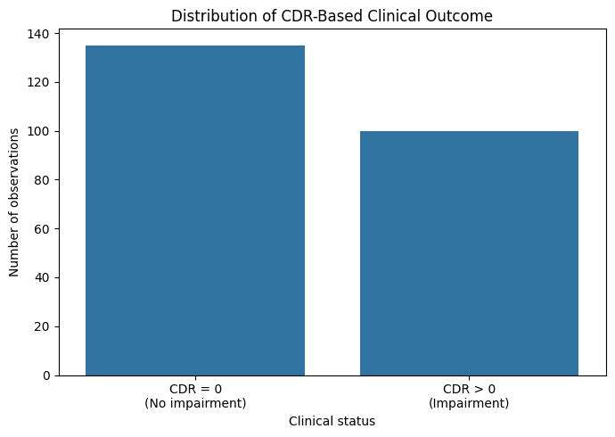
Class distribution
Predictors and leakage control. Eight predictors: M/F, Age, Educ, SES, MMSE, eTIV, nWBV, ASF. Excluded: CDR (defines the target), ID and Subject_ID (identifiers), Hand (constant), Delay (missing for every labeled row).
Subject-level split. An 80/20 split stratified on the outcome (random_state = 42) was made on unique subjects: 188 train (108 / 80) and 47 test (27 / 20), with zero subject overlap verified in code.
Preprocessing. SES is median-imputed inside each model pipeline (fitted on training data only). Logistic regression also standardises predictors.
Model | Configuration
Logistic regression | Median imputation, standard scaling, max_iter=1000
Random forest | 500 trees, min_samples_split=5, min_samples_leaf=2, class_weight="balanced"
XGBoost | 300 trees, max_depth=3, learning_rate=0.03, min_child_weight=3, subsample=0.8, colsample_bytree=0.8, reg_alpha=0.1, reg_lambda=1.0

Evaluation. Test metrics at the default 0.5 threshold; stratified 5-fold CV (shuffled, seed 42, imputation inside each fold) on all 235 labeled rows; and a 5,000-resample percentile bootstrap of the test set for ROC-AUC (rows resampled, which is valid here because the test subjects are distinct).

3. Exploratory analysis
Groups were compared with two-sided Mann–Whitney U tests.
Variable | CDR = 0 mean (SD) | CDR > 0 mean (SD) | p-value
Age | 69.07 (13.88) | 76.76 (7.12) | < 0.0001
Educ | 3.44 (1.26) | 2.82 (1.30) | 0.0003
SES | 2.33 (1.06) | 2.75 (1.17) | 0.0094
MMSE | 29.10 (1.13) | 24.32 (4.17) | < 0.0001
eTIV | 1441.5 (152.4) | 1483.8 (168.3) | 0.0518
nWBV | 0.769 (0.046) | 0.722 (0.036) | < 0.0001
ASF | 1.231 (0.127) | 1.197 (0.131) | 0.0516

By sex, 59 of 156 women (37.8%) and 41 of 79 men (51.9%) have CDR > 0. Differences are associations in a convenience sample, not causal effects.
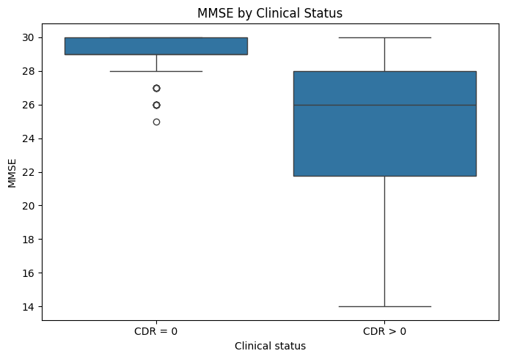
MMSE by status
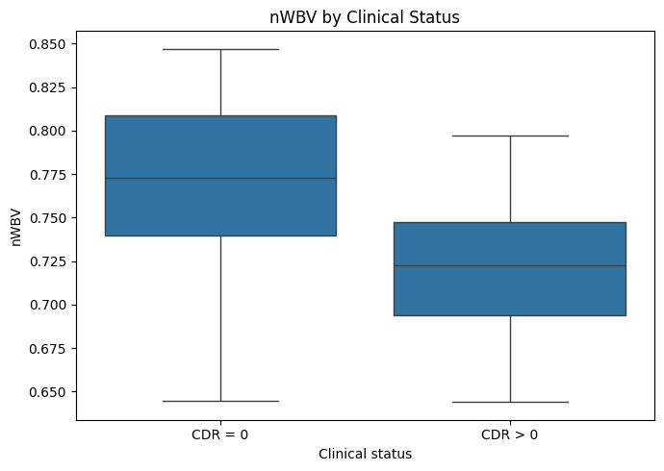
nWBV by status
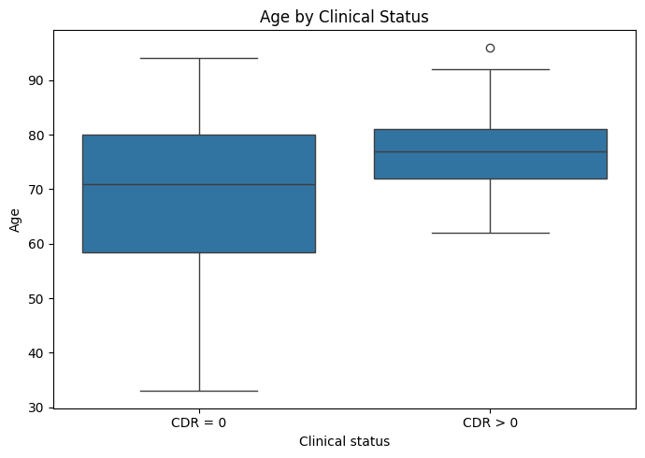
Age by status
eTIV and ASF are almost perfectly negatively correlated (r ≈ −0.99), which makes their individual model coefficients unstable.
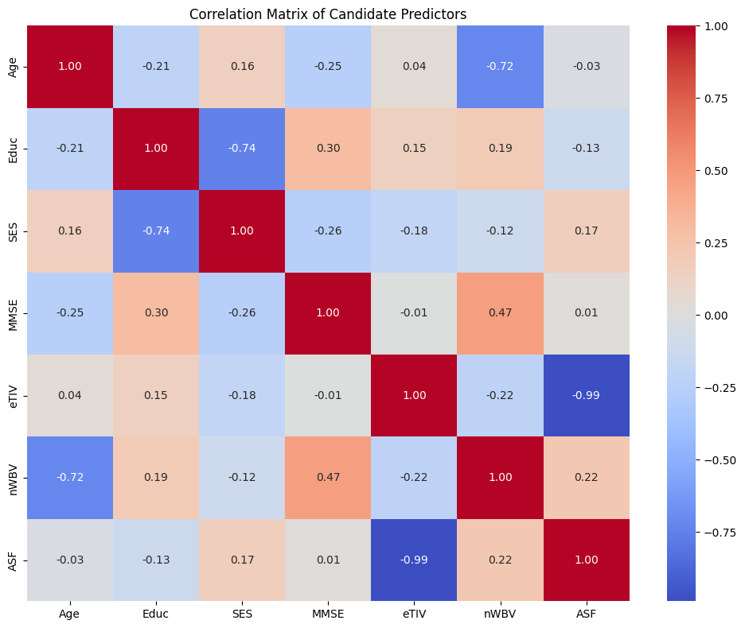
Predictor correlation

4. Results

4.1 Test-set performance
Model | Accuracy | Precision | Sensitivity | F1 | ROC-AUC
Logistic regression | 0.7872 | 0.7778 | 0.7000 | 0.7368 | 0.9056
Random forest | 0.8085 | 0.7895 | 0.7500 | 0.7692 | 0.9296
XGBoost | 0.8085 | 0.7895 | 0.7500 | 0.7692 | 0.9333

Confusion matrices (rows = actual, columns = predicted, class order 0 then 1): logistic [[23, 4], [6, 14]]; random forest and XGBoost [[23, 4], [5, 15]]. Specificity is 85.2% for all three; the tree ensembles gain one extra correctly identified impaired subject.
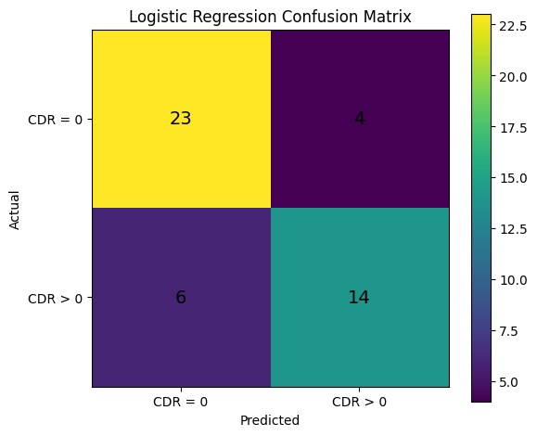
Logistic regression
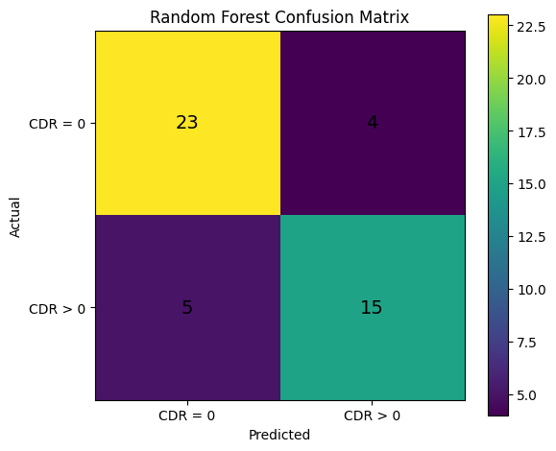
Random forest
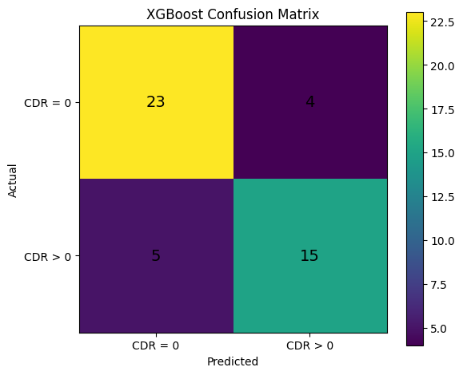
XGBoost
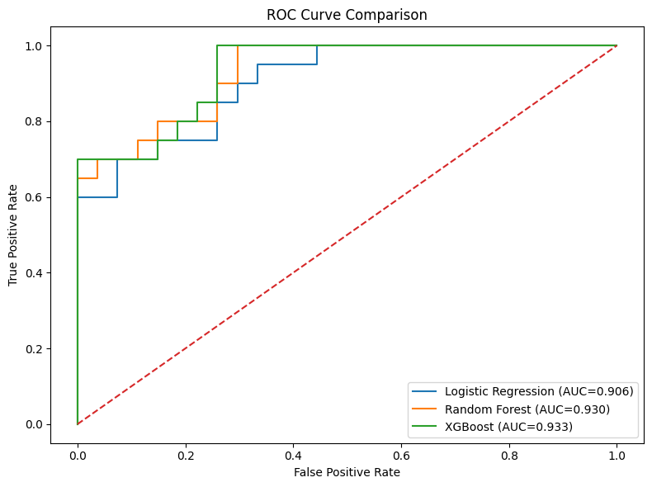
ROC comparison

4.2 Logistic regression coefficients
Predictors are standardised, so each odds ratio is per one-SD increase with the others held fixed.
Predictor | Coefficient | Odds ratio
MMSE | −2.605 | 0.074
nWBV | −0.749 | 0.473
Educ | −0.198 | 0.820
Age | −0.174 | 0.841
SES | −0.024 | 0.976
ASF | 0.066 | 1.068
M/F (male) | 0.133 | 1.143
eTIV | 0.191 | 1.211

Age's negative sign should not be read as protective: given MMSE and nWBV it adds little and shares variance with them. No standard errors were computed.

4.3 Feature importance
Predictor | Random forest | XGBoost
MMSE | 0.389 | 0.439
nWBV | 0.184 | 0.123
Age | 0.155 | 0.101
eTIV | 0.084 | 0.064
ASF | 0.084 | 0.062
Educ | 0.052 | 0.071
SES | 0.031 | 0.066
M/F | 0.022 | 0.075

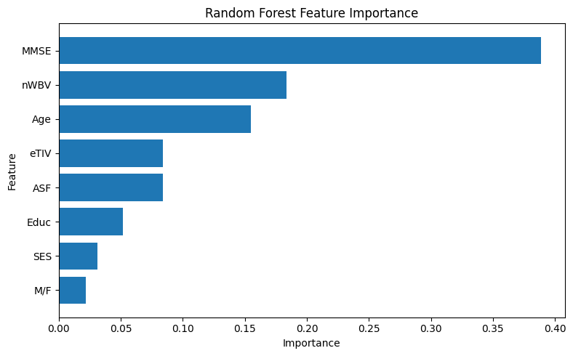
Random forest
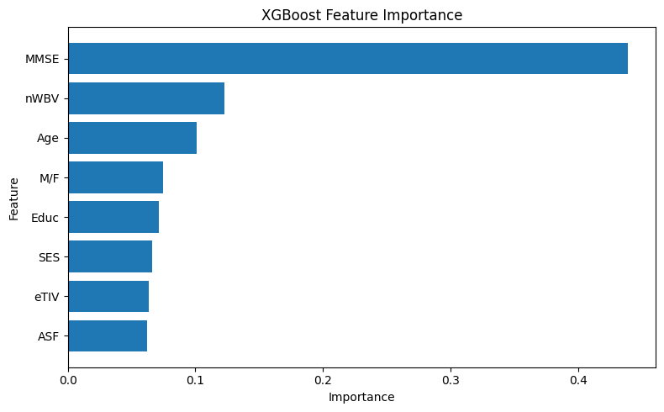
XGBoost

4.4 Five-fold cross-validation (all 235 labeled rows)
Model | Accuracy (SD) | Precision | Sensitivity | F1 | ROC-AUC (SD)
Logistic regression | 0.817 (0.055) | 0.824 | 0.730 | 0.767 | 0.903 (0.035)
Random forest | 0.826 (0.043) | 0.829 | 0.770 | 0.789 | 0.906 (0.034)
XGBoost | 0.813 (0.068) | 0.798 | 0.760 | 0.774 | 0.907 (0.030)

Fold | Logistic AUC | Random forest AUC | XGBoost AUC
1 | 0.9315 | 0.9167 | 0.9019
2 | 0.8778 | 0.8741 | 0.8870
3 | 0.9444 | 0.9389 | 0.9593
4 | 0.8500 | 0.8593 | 0.8704
5 | 0.9111 | 0.9426 | 0.9185

4.5 Bootstrap confidence intervals (test ROC-AUC, 5,000 resamples)
Model | Observed AUC | Bootstrap mean | 95% CI | SD
Logistic regression | 0.9056 | 0.9060 | 0.8084 – 0.9732 | 0.0425
Random forest | 0.9296 | 0.9298 | 0.8485 – 0.9827 | 0.0349
XGBoost | 0.9333 | 0.9333 | 0.8549 – 0.9852 | 0.0340

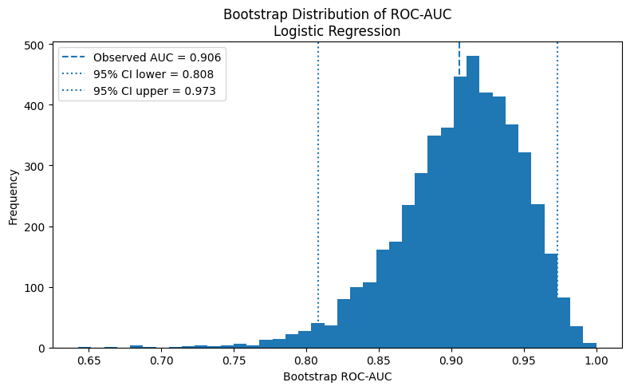
Logistic regression
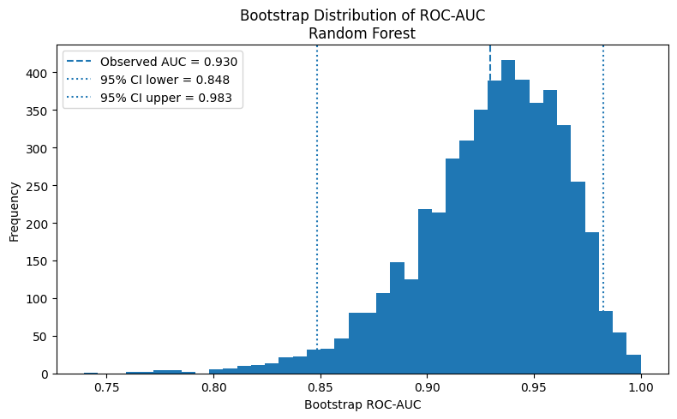
Random forest
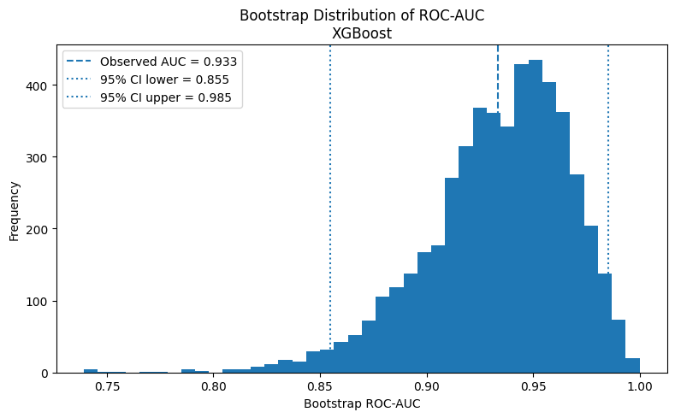
XGBoost

5. Discussion
Model choice matters less than the predictors. The ensembles correctly identified one more impaired test subject than logistic regression, and cross-validated AUCs agree to the third decimal. With 235 subjects and eight predictors, a regularised linear model captures nearly all the signal and is the easiest to interpret.
MMSE dominates, with a caveat. MMSE is a cognitive test closely tied to the clinical picture that CDR summarises, so predicting CDR from MMSE is partly predicting one cognitive measure from another. High AUC is therefore not independent evidence that these models could screen for dementia. An MMSE-free ablation (MRI + demographics only) would show how much the other variables contribute on their own.

6. Limitations
- Small test set. 47 subjects (20 positive); one subject moves accuracy by 2.1 points and the AUC intervals span 0.13 to 0.17.
- Age-restricted labels. CDR exists almost only for adults aged 33 and over.
- Imputation. SES missingness is higher in the impaired group; median imputation ignores that.
- Pooled outcome. CDR 0.5, 1 and 2 are merged; CDR 2 has only two cases.
- No tuning protocol. Hyperparameters were set by hand, not by nested CV, and the threshold stayed at 0.5. Sensitivity (0.70–0.75) is below specificity (0.85).
- Cross-sectional data. No progression or causal claims; importance scores are associations.
- No external validation.

7. Future work
MMSE-free ablation; nested cross-validation with threshold tuning; calibration curves; ordinal or multiclass CDR modelling; external validation on a longitudinal cohort such as OASIS-2.

References
- Marcus, D. S., et al. (2007). Open Access Series of Imaging Studies (OASIS): Cross-sectional MRI data in young, middle aged, nondemented, and demented older adults. Journal of Cognitive Neuroscience, 19(9), 1498–1507.
- Morris, J. C. (1993). The Clinical Dementia Rating (CDR): Current version and scoring rules. Neurology, 43(11), 2412–2414.
- Folstein, M. F., Folstein, S. E., & McHugh, P. R. (1975). "Mini-mental state": A practical method for grading the cognitive state of patients for the clinician. Journal of Psychiatric Research, 12(3), 189–198.
- Breiman, L. (2001). Random forests. Machine Learning, 45(1), 5–32.
- Chen, T., & Guestrin, C. (2016). XGBoost: A scalable tree boosting system. Proceedings of the 22nd ACM SIGKDD Conference, 785–794.
- Efron, B. (1979). Bootstrap methods: Another look at the jackknife. The Annals of Statistics, 7(1), 1–26.
- Mann, H. B., & Whitney, D. R. (1947). On a test of whether one of two random variables is stochastically larger than the other. The Annals of Mathematical Statistics, 18(1), 50–60.
- Pedregosa, F., et al. (2011). Scikit-learn: Machine learning in Python. Journal of Machine Learning Research, 12, 2825–2830.

