STATISTICS PROJECT REPORT
Neural Networks for Survival Analysis
A Simulation Study and Two Breast Cancer Applications Comparing Cox Proportional Hazards, DeepSurv and Random Survival Forests
Anshu Yadav
M.Sc. Statistics and Computing
DST Centre for Interdisciplinary Mathematical Sciences (DST CIMS)
Banaras Hindu University
November 2026

Abstract
Neural networks are increasingly proposed as alternatives to the Cox proportional hazards (PH) model for predicting time-to-event outcomes, but it is rarely clear when they actually help. This report studies that question first in a controlled simulation with known ground truth and then on two real breast cancer data sets. Right-censored data (30% censoring, six covariates, two of them pure noise) were generated under four scenarios that cross two factors: whether the log-risk is linear or contains interactions and non-linear terms, and whether the proportional hazards assumption holds (Weibull PH) or fails (log-normal accelerated failure time). Three models were implemented from scratch and compared: a linear Cox model, DeepSurv (a neural network trained on the Cox partial likelihood), and a discrete-time neural model that does not assume proportional hazards. Performance was measured by Harrell's C-index and the integrated Brier score on large independent test sets, over 200 replications per scenario, with paired bootstrap intervals and Wilcoxon tests.
When the true log-risk is linear, the Cox model is essentially optimal (C-index 0.697 against an oracle 0.699) and the neural models are slightly but significantly worse. When the log-risk is non-linear, the linear Cox model fails badly (C-index 0.55 and 0.56), whereas DeepSurv recovers most of the available signal (0.71 and 0.77). Violating proportional hazards cost little for ranking, and the PH-free neural model gained a clear (but small) advantage over DeepSurv only at n = 3000 and only when both factors were present. At n = 300 the neural models were unreliable.
The same comparison was then repeated on two real breast cancer data sets distributed with pycox, with a random survival forest added: GBSG (2,232 patients, seven covariates) and METABRIC (1,904 patients, nine covariates), in each case with 5-fold cross-validation repeated three times. The C-indices of Cox PH, DeepSurv and the forest were 0.662, 0.670 and 0.674 in GBSG and 0.636, 0.626 and 0.645 in METABRIC; none of the differences was statistically significant (corrected resampled t-test; smallest unadjusted p = 0.101). The forest had the best mean on every metric in both data sets and a significantly lower integrated Brier score than Cox PH (GBSG: 0.1679 against 0.1749, Holm-adjusted p = 0.012; METABRIC: 0.1785 against 0.1831, Holm-adjusted p = 0.013). DeepSurv improved on Cox PH in the integrated Brier score in GBSG (Holm-adjusted p = 0.037) but not in METABRIC, where it was no better than Cox PH and one of its 15 training runs failed. The proportional hazards test rejected the assumption for several covariates in both data sets without the Cox model losing much ground in ranking. The real-data conclusions rest on two data sets and on fixed, untuned hyper-parameters.

1. Introduction
Survival analysis models the time until an event such as death, relapse or equipment failure, in the presence of censoring: some subjects are observed only up to a certain time, after which their outcome is unknown. The Cox proportional hazards model (Cox, 1972) has been the standard tool for decades because it is semi-parametric, interpretable through hazard ratios, and easy to fit. It has two structural restrictions, however: the log-hazard is assumed to be linear in the covariates unless the analyst adds terms by hand, and the effect of a covariate is assumed constant over time (proportional hazards).
Neural networks relax the first restriction automatically by learning non-linear effects and interactions. DeepSurv (Katzman et al., 2018) keeps the Cox likelihood but replaces the linear predictor with a neural network, so it relaxes linearity but keeps proportional hazards. Discrete-time neural models (for example Gensheimer and Narasimhan, 2019; Kvamme and Borgan, 2021) model the hazard in each time interval directly and therefore relax both restrictions, at the price of many more parameters. Published comparisons on real data often show small or inconsistent gains, and real data cannot reveal why, because the true data-generating mechanism is unknown.
This project therefore combines a simulation, where the truth is known, with applications to two real data sets, to answer five questions:
- RQ1. What does a neural network cost when the Cox model is correctly specified?
- RQ2. How much does it gain when the log-risk is non-linear?
- RQ3. Does a model that drops proportional hazards help when PH is violated?
- RQ4. How does the answer depend on the training sample size?
- RQ5. On two real breast cancer data sets, do Cox PH, DeepSurv and a random survival forest differ in discrimination, in the accuracy of predicted survival and in calibration, is the size of the differences in line with the simulation, and does the pattern agree between the two data sets?

2. Models

2.1 Setting and notation
For subject i let Tᵢ be the event time, Cᵢ the censoring time and xᵢ ∈ ℝᵖ the covariates. We observe tᵢ = min(Tᵢ, Cᵢ) and δᵢ = I(Tᵢ ≤ Cᵢ). Censoring is independent of the event time given the covariates. The goal is to predict the survival function S(t | x) = P(T > t | x), or at least to rank subjects by risk.

2.2 Cox proportional hazards
The Cox model specifies the hazard as h(t | x) = h₀(t) exp(β′x), with an unspecified baseline hazard h₀. The coefficients maximise the partial likelihood
L(β) = ∏ᵢ [ exp(β′xᵢ) / Σⱼ∈R(tᵢ) exp(β′xⱼ) ]^δᵢ
where R(tᵢ) is the set of subjects still at risk at tᵢ. Here the maximisation uses Newton–Raphson with a very small ridge penalty (0.5 on standardised covariates) for numerical stability. The baseline cumulative hazard is estimated with the Breslow estimator, giving S(t | x) = exp(−H₀(t) exp(β′x)).

2.3 DeepSurv
DeepSurv replaces the linear predictor β′x by the output gθ(x) of a feed-forward network and minimises the negative log partial likelihood, normalised by the number of events. The network has two hidden layers of 32 ReLU units. Training uses the Adam optimiser (learning rate 0.003) with L2 weight decay 0.001, full-batch gradients, and early stopping on the partial likelihood of a 20% validation split (patience 30 epochs, at most 800). The Breslow estimator then supplies the survival curves. Because the hazard ratio between two subjects is still exp(gθ(x₁) − gθ(x₂)), independent of time, DeepSurv keeps the PH assumption.

2.4 Discrete-time neural model (logistic hazard)
Follow-up time is cut into K = 20 intervals at quantiles of the training times. A network with the same hidden layers outputs K logits, giving the discrete hazard hₖ(x) = P(event in interval k | survived to interval k, x). The likelihood of a subject observed in interval kᵢ is a product of Bernoulli terms: survival through intervals before kᵢ, and an event (if δᵢ = 1) or survival (if δᵢ = 0) in interval kᵢ. Survival is S(tₖ | x) = ∏ⱼ≤ₖ (1 − hⱼ(x)), linearly interpolated between interval boundaries. The hazards of different subjects are free to cross, so PH is not assumed, but the output layer has K parameters per hidden unit rather than one. Training settings are identical to DeepSurv.

2.5 Random survival forest
A random survival forest (Ishwaran et al., 2008) grows many survival trees on bootstrap samples of the data. Each tree splits the covariate space with a survival-specific criterion (here the log-rank statistic) and estimates a cumulative hazard in each terminal node; the forest averages these estimates over the trees. Survival curves follow from the averaged cumulative hazard, and the ensemble mortality (the cumulative hazard summed over event times) serves as the risk score. Because the splits are chosen from the data, the forest captures non-linear effects and interactions without being told about them and does not assume proportional hazards; in exchange it gives no hazard ratios. It was used only in the real-data applications (Sections 6 and 7).

2.6 Implementation
For the simulation, all three models (Cox PH, DeepSurv and the logistic-hazard model), including the neural networks with hand-derived back-propagation, the Cox and logistic-hazard losses, the Breslow estimator and all metrics, were implemented in NumPy because deep-learning and survival packages could not be installed in the analysis environment. The code was verified before use: analytic gradients matched finite differences (maximum error 5.5×10⁻⁸ for the Cox loss, 2.8×10⁻⁹ for the logistic-hazard loss); on a sample of 40,000 the Cox fit recovered the true coefficients (0.592, −0.503, 0.395, 0.306, 0.004, 0.001 against 0.6, −0.5, 0.4, 0.3, 0, 0); and the empirical censoring fraction was 30% in every scenario. No hyper-parameter was tuned on test data; all settings were fixed in advance.
In the real-data applications (Sections 6 and 7) standard software was used instead: Cox PH from the lifelines package (Davidson-Pilon, 2019) with a small ridge penalty of 0.01, the random survival forest from scikit-survival (Pölsterl, 2020), and DeepSurv from pycox (Kvamme et al., 2019) on PyTorch. DeepSurv there has two hidden layers of 32 units with batch normalisation and dropout 0.1, is trained with Adam (learning rate 0.005, batch size 64, at most 200 epochs) and stops early when the partial likelihood on a 20% validation subset of the training fold stops improving (patience 20). The forest uses 300 trees, at least 15 patients per leaf and the square root of the number of covariates at each split. These settings were fixed in advance and not tuned. The analysis was run in Google Colab.

3. Simulation design
Six covariates were drawn from a multivariate normal distribution with unit variances and correlation 0.3^|i−j| between xᵢ and xⱼ. Only x₁–x₄ influence survival; x₅ and x₆ are noise. Event times follow the four scenarios in Table 1, which cross the functional form of the log-risk η(x) with the validity of PH. In the PH scenarios, S(t | x) = exp(−t¹·⁵ exp(η(x))). In the AFT scenarios, log T = −η(x) + 0.8ε with ε standard normal; this model has non-proportional hazards but, as in the PH case, survival curves of different subjects never cross.
Table 1. Data-generating mechanisms. In every scenario higher η means higher risk.
Scenario | Event-time model | Log-risk η(x)
A | Weibull PH, shape 1.5 | 0.6x₁ − 0.5x₂ + 0.4x₃ + 0.3x₄
B | Weibull PH, shape 1.5 | 0.8x₁x₂ + 0.5(x₃² − 1) + 0.6·I(x₄ > 0) − 0.3
C | Log-normal AFT, σ = 0.8: log T = −η(x) + σε | same η as A
D | Log-normal AFT, σ = 0.8: log T = −η(x) + σε | same η as B

Censoring times are exponential and independent of covariates, with the rate calibrated so that 30% of observations are censored in each scenario. Each replication draws a fresh training set (n = 1000, about 700 events) and an independent test set of 3000 subjects from the same mechanism. The main experiment uses R = 200 replications per scenario. A sample-size experiment repeats the study with n = 300 and n = 3000 training observations (R = 60 each). All random seeds are fixed, so every number can be reproduced.

4. Evaluation (simulation study)
- Harrell's C-index measures discrimination: the probability that, among comparable pairs, the subject with the higher risk score fails first. For Cox and DeepSurv the risk score is the linear predictor; for the logistic-hazard model it is minus the restricted mean survival time up to the 90th percentile of training event times.
- Integrated Brier score (IBS) measures the accuracy of predicted survival probabilities, weighted by the inverse probability of censoring (Graf et al., 1999), integrated over 20 time points between the 10th and 80th percentiles of observed test times. The censoring distribution is estimated by Kaplan–Meier on the test set. Lower is better.
- Reference points. An oracle that uses the true η(x) and true survival function shows the best attainable value. A Kaplan–Meier model without covariates (C-index 0.5) shows the no-information value.
- Comparing models. Within each replication the models see the same data, so differences are paired. We report the mean paired difference with a 95% percentile bootstrap interval (10,000 resamples) and a Wilcoxon signed-rank test (Morris et al., 2019, on simulation reporting).
- PH diagnostic. For the Cox fit on each training set, Schoenfeld residuals of each covariate were correlated with the rank of event time (a simplified version of the test of Grambsch and Therneau, 1994); PH was rejected if the smallest p-value was below 0.05/6 (Bonferroni).
- Calibration. For one replication, predicted survival at the median event time was plotted against the true value for 400 test subjects.

5. Simulation results

5.1 Overall performance (n = 1000)
Table 2 and Figure 1 summarise 200 replications per scenario. Three patterns stand out.
Table 2. Mean (SD over 200 replications) of test-set C-index and integrated Brier score, training size n = 1000.
Scenario | Model | C-index | IBS
A: PH, linear | Oracle (true model) | 0.699 (0.006) | 0.166 (0.002)
 | Kaplan–Meier (no covariates) | 0.500 (0) | 0.207 (0.001)
 | Cox PH | 0.697 (0.006) | 0.167 (0.002)
 | DeepSurv | 0.684 (0.008) | 0.173 (0.003)
 | Neural logistic hazard | 0.655 (0.014) | 0.191 (0.006)
B: PH, non-linear | Oracle (true model) | 0.737 (0.007) | 0.153 (0.002)
 | Kaplan–Meier (no covariates) | 0.500 (0) | 0.211 (0.001)
 | Cox PH | 0.547 (0.009) | 0.209 (0.002)
 | DeepSurv | 0.710 (0.009) | 0.167 (0.004)
 | Neural logistic hazard | 0.678 (0.028) | 0.181 (0.010)
C: non-PH, linear | Oracle (true model) | 0.770 (0.005) | 0.144 (0.002)
 | Kaplan–Meier (no covariates) | 0.500 (0) | 0.215 (0.001)
 | Cox PH | 0.769 (0.005) | 0.146 (0.002)
 | DeepSurv | 0.754 (0.008) | 0.153 (0.004)
 | Neural logistic hazard | 0.738 (0.010) | 0.162 (0.005)
D: non-PH, non-linear | Oracle (true model) | 0.807 (0.005) | 0.131 (0.002)
 | Kaplan–Meier (no covariates) | 0.500 (0) | 0.216 (0.001)
 | Cox PH | 0.563 (0.008) | 0.213 (0.002)
 | DeepSurv | 0.775 (0.008) | 0.149 (0.004)
 | Neural logistic hazard | 0.762 (0.014) | 0.154 (0.006)

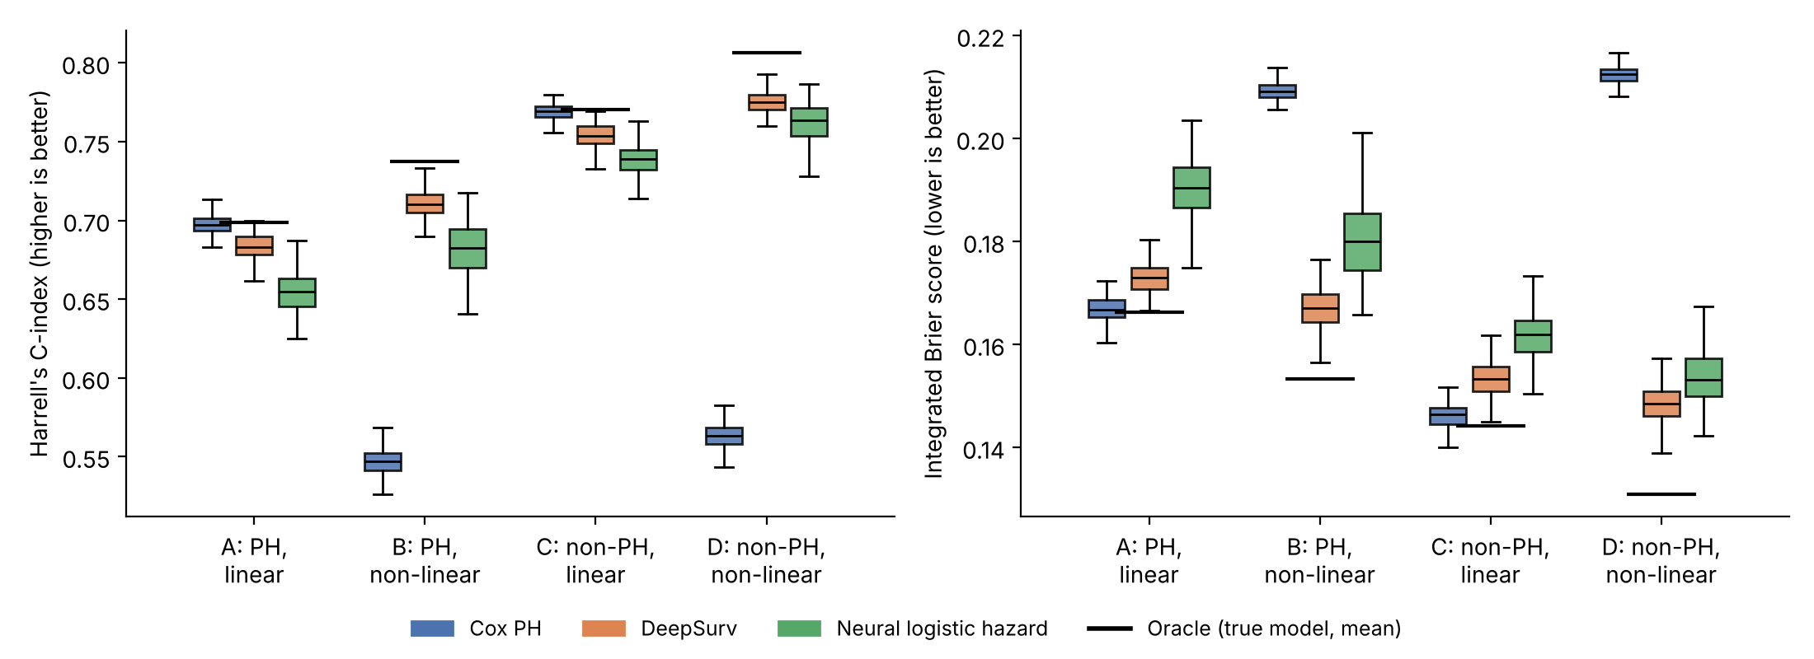
Figure 1. Distribution over 200 replications of the C-index (left) and integrated Brier score (right). Black bars mark the oracle mean. Boxes show quartiles; whiskers extend to 1.5 × IQR.
1. When Cox is correctly specified, it is nearly optimal. In scenario A the Cox model reaches a C-index of 0.6975, within 0.002 of the oracle (0.6986), and an IBS of 0.1670 against 0.1663. DeepSurv is lower by 0.014 in C-index and the logistic-hazard model by 0.043. The extra flexibility is paid for as estimation variance (RQ1).
2. When the log-risk is non-linear, the linear Cox model fails. In scenarios B and D its C-index (0.547 and 0.563) is close to chance, and its IBS (0.2092 and 0.2125) is barely better than the covariate-free Kaplan–Meier benchmark (0.2111 and 0.2164). DeepSurv reaches 0.710 and 0.775, gains of 0.163 and 0.212 (RQ2). It still falls short of the oracle (0.737 and 0.807) because 1000 observations are not enough to learn the interactions exactly.
3. Violating proportional hazards cost little at n = 1000. In scenario C, where PH is violated but the effect is linear, the Cox model still attains 0.7690 against an oracle of 0.7704, and the IBS gap to the oracle is only 0.0019. The PH-free logistic-hazard model did not improve on DeepSurv in either non-PH scenario at this sample size (RQ3).

5.2 Paired comparisons
Table 3 confirms that these differences are not simulation noise. Every comparison has a Wilcoxon p-value below 0.001 and a bootstrap interval that excludes zero. Statistical significance is easy to achieve with 200 replications and 3000 test subjects, so the size of the differences matters more than the p-values: the neural-versus-Cox gaps in B and D are 0.13–0.21 in C-index, while the gaps in A and C are 0.014–0.043.
Table 3. Paired differences (first model minus second), mean and 95% bootstrap interval, n = 1000, R = 200. For the C-index a positive difference favours the first model; for the IBS a negative difference favours it. “Neural LH” = neural logistic hazard.
Sc. | Comparison | Δ C-index [95% CI] | p | Δ IBS [95% CI] | p
A | DeepSurv − Cox PH | −0.014 [−0.015, −0.013] | <0.001 | +0.006 [+0.006, +0.006] | <0.001
 | Neural LH − Cox PH | −0.043 [−0.045, −0.041] | <0.001 | +0.024 [+0.023, +0.024] | <0.001
 | Neural LH − DeepSurv | −0.029 [−0.031, −0.027] | <0.001 | +0.018 [+0.017, +0.018] | <0.001
B | DeepSurv − Cox PH | +0.163 [+0.161, +0.165] | <0.001 | −0.042 [−0.042, −0.041] | <0.001
 | Neural LH − Cox PH | +0.131 [+0.127, +0.135] | <0.001 | −0.028 [−0.029, −0.026] | <0.001
 | Neural LH − DeepSurv | −0.032 [−0.036, −0.028] | <0.001 | +0.014 [+0.013, +0.016] | <0.001
C | DeepSurv − Cox PH | −0.015 [−0.016, −0.014] | <0.001 | +0.007 [+0.007, +0.008] | <0.001
 | Neural LH − Cox PH | −0.031 [−0.032, −0.030] | <0.001 | +0.016 [+0.015, +0.016] | <0.001
 | Neural LH − DeepSurv | −0.016 [−0.017, −0.014] | <0.001 | +0.009 [+0.008, +0.009] | <0.001
D | DeepSurv − Cox PH | +0.212 [+0.210, +0.214] | <0.001 | −0.064 [−0.064, −0.063] | <0.001
 | Neural LH − Cox PH | +0.199 [+0.196, +0.201] | <0.001 | −0.059 [−0.059, −0.058] | <0.001
 | Neural LH − DeepSurv | −0.013 [−0.015, −0.011] | <0.001 | +0.005 [+0.004, +0.006] | <0.001

5.3 Does the PH test detect the violation?
The Schoenfeld-based test rejected PH in 93% of replications in scenario C but in only 12.5% in scenario D, although PH is equally violated there (Table 4). In the PH scenarios A and B the rejection rate was 3.0%, consistent with the nominal 5% level (the Bonferroni correction makes the test conservative). A plausible explanation for the low power in D is that the linear Cox model is badly misspecified, which distorts the residuals the test relies on; this was not investigated further. The practical lesson is that a non-significant PH test should not be read as evidence that PH holds when the covariate effects are poorly modelled.
Table 4. Proportion of replications (n = 1000) in which the PH test rejected, and median smallest p-value, by scenario.
Scenario | Rejection rate | Median min. p-value
A: PH, linear | 3.0% | 0.104
B: PH, non-linear | 3.0% | 0.129
C: non-PH, linear | 93.0% | <0.001
D: non-PH, non-linear | 12.5% | 0.068

5.4 Calibration of predicted survival
Figure 2 compares predicted and true survival probabilities at the median event time in one replication of scenarios B and D. The Cox predictions are almost flat, with nearly all subjects receiving a probability between about 0.5 and 0.75 whatever their true risk. DeepSurv follows the diagonal closely (root mean square error 0.103 in B and 0.108 in D, against 0.242 and 0.316 for Cox). The logistic-hazard model is noisier (0.190 and 0.133). These are single-replication values and are illustrative only.
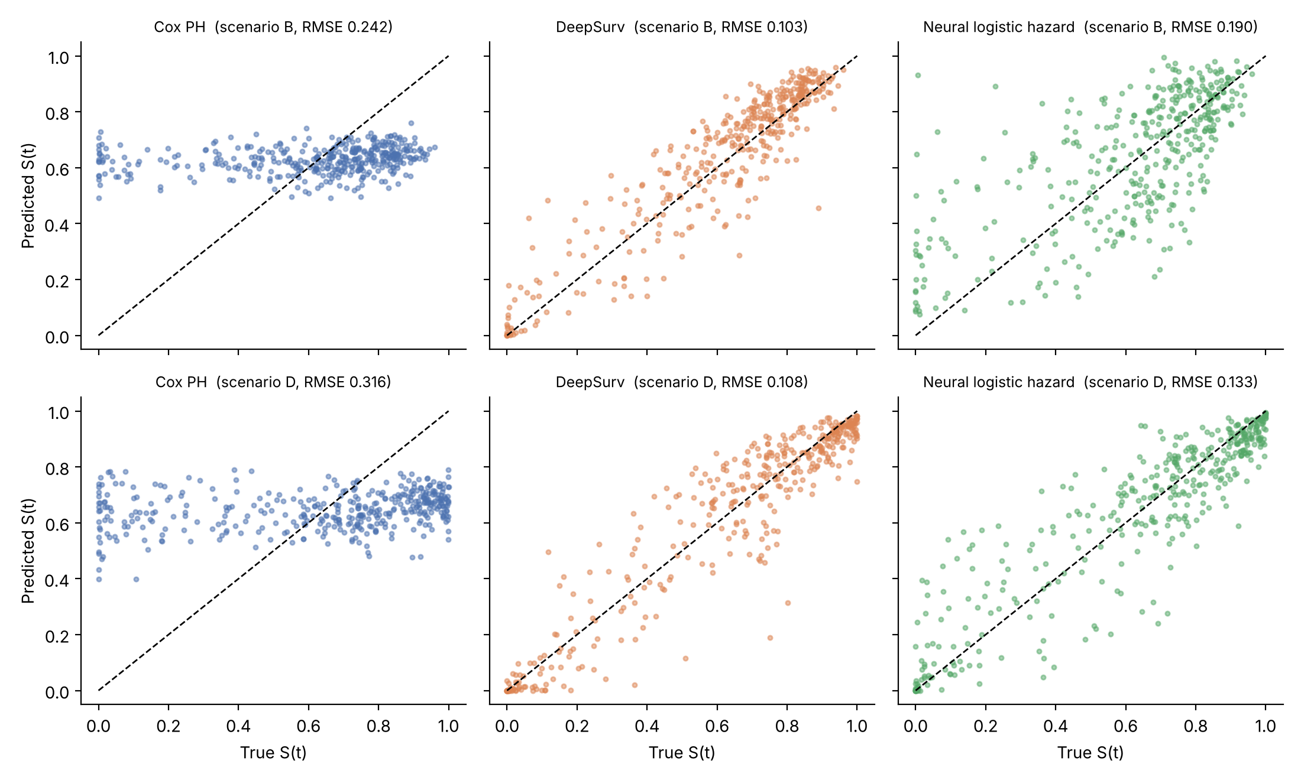
Figure 2. Predicted versus true survival probability at the median event time for 400 test subjects (one replication, n = 1000). The dashed line is perfect calibration.

5.5 Effect of the training sample size
Table 5 and Figure 3 show how the results change with n (RQ4). The Cox model is almost insensitive to n because it has only six parameters. The neural models improve steadily with n. At n = 300 the logistic-hazard model is unreliable: in scenarios B and D its mean C-index (0.478 and 0.514) is at the level of random ranking, and in 77% of the replications of scenario D it fell below 0.55. DeepSurv still beat Cox in the non-linear scenarios at n = 300 (0.675 against 0.537 in B). A plausible reason for the logistic-hazard failure is that 20 output units and a validation set of about 60 subjects give too little information to learn non-linear structure, but this was not tested directly.
At n = 3000 the two neural models are nearly equal. The logistic-hazard model was clearly ahead only in scenario D, the only scenario with both a non-linear log-risk and non-proportional hazards (it was also marginally ahead on IBS in scenario C: −0.0007, Wilcoxon p = 0.013). In scenario D the paired difference to DeepSurv was +0.0036 in C-index (95% CI +0.0026 to +0.0046) and −0.0028 in IBS (−0.0033 to −0.0023). This is a small effect. In scenario A DeepSurv remained marginally better, and in B the two were indistinguishable.
Table 5. Mean test C-index and IBS by training size (n = 300 and 3000: R = 60; n = 1000: R = 200).
Sc. | Model | C 300 | C 1000 | C 3000 | IBS 300 | IBS 1000 | IBS 3000
A | Cox PH | 0.695 | 0.697 | 0.697 | 0.169 | 0.167 | 0.167
 | DeepSurv | 0.664 | 0.684 | 0.689 | 0.183 | 0.173 | 0.171
 | Neural logistic hazard | 0.620 | 0.655 | 0.688 | 0.207 | 0.191 | 0.172
 | Oracle (true model) | 0.699 | 0.699 | 0.697 | 0.166 | 0.166 | 0.167
B | Cox PH | 0.537 | 0.547 | 0.553 | 0.212 | 0.209 | 0.208
 | DeepSurv | 0.675 | 0.710 | 0.721 | 0.183 | 0.167 | 0.161
 | Neural logistic hazard | 0.478 | 0.678 | 0.721 | 0.260 | 0.181 | 0.162
 | Oracle (true model) | 0.739 | 0.737 | 0.738 | 0.153 | 0.153 | 0.153
C | Cox PH | 0.767 | 0.769 | 0.769 | 0.148 | 0.146 | 0.146
 | DeepSurv | 0.740 | 0.754 | 0.761 | 0.161 | 0.153 | 0.150
 | Neural logistic hazard | 0.693 | 0.738 | 0.762 | 0.183 | 0.162 | 0.149
 | Oracle (true model) | 0.772 | 0.770 | 0.770 | 0.144 | 0.144 | 0.145
D | Cox PH | 0.551 | 0.563 | 0.568 | 0.216 | 0.213 | 0.212
 | DeepSurv | 0.737 | 0.775 | 0.785 | 0.167 | 0.149 | 0.143
 | Neural logistic hazard | 0.514 | 0.762 | 0.789 | 0.253 | 0.154 | 0.140
 | Oracle (true model) | 0.807 | 0.807 | 0.806 | 0.131 | 0.131 | 0.131

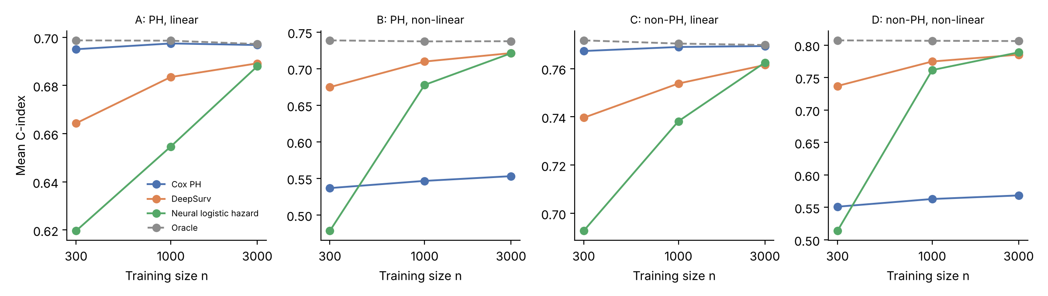
Figure 3. Mean C-index against training size for each scenario. The dashed line is the oracle.

6. Application to real data: breast cancer (GBSG)
The simulation shows how the models behave when the truth is known. This section asks how they behave on a real prognostic data set. A random survival forest (Section 2.5), which assumes neither linearity nor proportional hazards, is added to the comparison. A second data set, METABRIC, is analysed in the same way in Section 7.

6.1 Data
The data are the file named gbsg in the pycox package (Kvamme et al., 2019), which combines patients from the Rotterdam tumour bank and from the German Breast Cancer Study Group (GBSG) trial and is the breast cancer data set that Katzman et al. (2018) used to evaluate DeepSurv; it is called GBSG here after the name of the file. It contains 2,232 patients, of whom 1,267 had an event (43.2% censored), seven covariates and a right-censored survival time. The file anonymises the covariates as x0–x6; their clinical meaning was not used here, and any clinical reading of individual covariates should be taken from the documentation of the data set. Time is on the scale stored in the file. The Kaplan–Meier estimate of overall survival (Figure 4) falls steadily to about 0.37 by the end of follow-up. All covariates were standardised with the mean and standard deviation of the training part of each split.
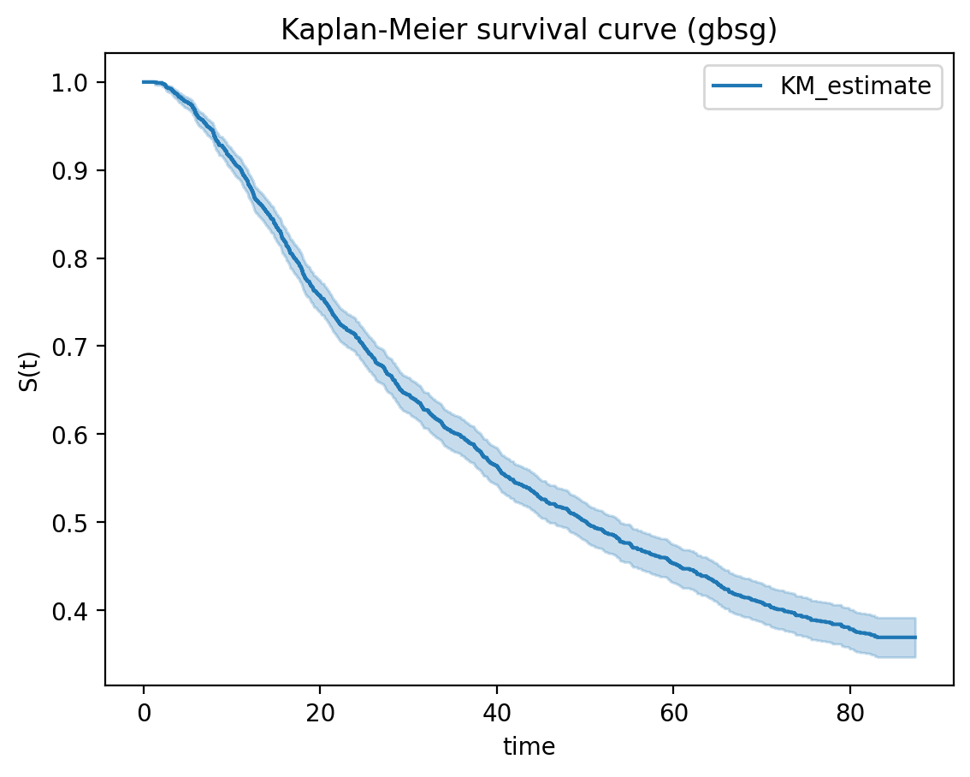
Figure 4. Kaplan–Meier estimate of overall survival with 95% confidence band, GBSG data (all patients).

6.2 Design
Cox PH, the random survival forest and DeepSurv were compared with 5-fold cross-validation repeated 3 times (15 train/test splits), stratified by the event indicator, so that each split trains on about 1,786 patients and tests on about 446. All three models see identical splits, so comparisons are paired. The metrics are those of Section 4: Harrell's C-index, the time-dependent AUC (cumulative/dynamic; Uno et al., 2007; the mean over the evaluation grid, as returned by scikit-survival) and the integrated Brier score. The evaluation grid has 20 time points between the 10th and 80th percentiles of the event times in the test fold, restricted to the range of training event times. Hyper-parameters were fixed in advance and not tuned (Section 2.6).
Because the 15 splits share training data, the usual paired t-test is too optimistic. Differences were therefore tested with the corrected resampled t-test of Nadeau and Bengio (2003), which inflates the variance of the mean difference by the factor 1/J + n_test/n_train = 0.317, with J = 15 splits and 14 degrees of freedom. For the six comparisons of C-index and IBS, Holm (1979) adjusted p-values are also reported; the time-dependent AUC comparisons are secondary and unadjusted.

6.3 Cox model on all data and the proportional hazards assumption
Table 6 shows the Cox model fitted to all patients, with hazard ratios per one-unit increase of the raw covariates (so they are not comparable between covariates), and the Schoenfeld-residual test of proportional hazards for each covariate (Section 4). The covariates x0, x1, x2, x4 and x5 have effects significant at the 5% level. The hazard ratios of x5 and x6 are 1.000 to three decimals, consistent with covariates measured on a wide scale, where a one-unit change is tiny.
The proportional hazards assumption is not supported for every covariate: the test is significant at the 5% level for x0, x1, x2, x5 and x6, and for x1, x5 and x6 even after a Bonferroni correction for seven tests (threshold 0.05/7 = 0.0071). The Cox model is therefore a reasonable but imperfect description of these data. The test cannot say whether the cause is truly time-varying effects or non-linear covariate effects, since both can trigger it (Section 5.3).
Table 6. Cox PH fitted to all patients: hazard ratio per one-unit increase (95% CI, Wald p-value) and Schoenfeld-residual test of proportional hazards (χ² on 1 degree of freedom, rank-transformed time). * Below the Bonferroni threshold 0.05/7.
Covariate | Hazard ratio | 95% CI | p | PH test χ² | PH test p
x0 | 0.704 | [0.614, 0.807] | <0.001 | 5.85 | 0.015
x1 | 1.377 | [1.260, 1.505] | <0.001 | 7.41 | 0.006 *
x2 | 1.235 | [1.027, 1.484] | 0.025 | 4.20 | 0.041
x3 | 1.003 | [0.996, 1.010] | 0.427 | 2.45 | 0.118
x4 | 1.054 | [1.045, 1.063] | <0.001 | 0.06 | 0.813
x5 | 1.000 | [0.999, 1.000] | 0.001 | 8.33 | 0.004 *
x6 | 1.000 | [1.000, 1.000] | 0.086 | 16.25 | <0.001 *

6.4 Predictive performance
Table 7 and Figure 5 summarise the 15 splits. The ordering is the same on all three metrics: Cox PH is lowest, DeepSurv is in the middle, and the random survival forest is highest in discrimination (C-index and AUC) and lowest in IBS. All differences are small compared with the split-to-split variation: the SD of the C-index across splits is about 0.02 for every model, larger than the difference between any two model means (at most 0.012). Paired differences, which compare the models on the same splits, are therefore more informative than the overlapping boxes of Figure 5.
Table 7. Mean (SD over 15 splits) of the C-index, time-dependent AUC and integrated Brier score on the test folds, GBSG data.
Model | C-index | Time-dep. AUC | IBS (lower is better)
Cox PH | 0.662 (0.020) | 0.721 (0.026) | 0.1749 (0.0058)
DeepSurv | 0.670 (0.018) | 0.730 (0.024) | 0.1705 (0.0065)
Random survival forest | 0.674 (0.019) | 0.742 (0.022) | 0.1679 (0.0060)

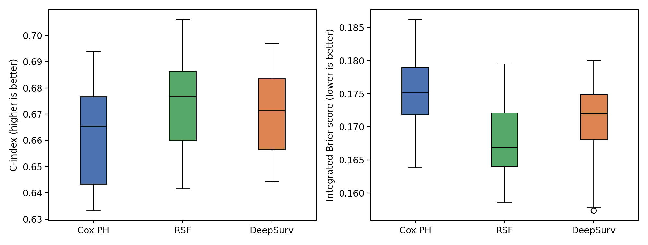
Figure 5. Distribution over the 15 splits of the C-index (left) and the integrated Brier score (right), GBSG data. Boxes show quartiles; whiskers extend to 1.5 × IQR.
Table 8 gives the paired differences.
Table 8. Paired differences between models (first minus second), mean with corrected 95% interval. A positive C-index or AUC difference and a negative IBS difference favour the first model. p: corrected resampled t-test; Holm: Holm-adjusted over the six C-index and IBS tests; last column: number of the 15 splits in which the first model was better.
Comparison | Metric | Mean difference [95% CI] | p | Holm p | Splits won
DeepSurv − Cox PH | C-index | +0.0080 [−0.0024, +0.0183] | 0.120 | 0.403 | 13/15
 | AUC | +0.0099 [−0.0051, +0.0248] | 0.178 | — | 10/15
 | IBS | −0.0044 [−0.0074, −0.0014] | 0.007 | 0.037 | 14/15
RSF − Cox PH | C-index | +0.0125 [−0.0027, +0.0277] | 0.101 | 0.403 | 13/15
 | AUC | +0.0215 [+0.0013, +0.0417] | 0.038 | — | 12/15
 | IBS | −0.0071 [−0.0111, −0.0030] | 0.002 | 0.012 | 14/15
DeepSurv − RSF | C-index | −0.0045 [−0.0143, +0.0054] | 0.345 | 0.403 | 7/15
 | AUC | −0.0117 [−0.0259, +0.0026] | 0.101 | — | 3/15
 | IBS | +0.0027 [−0.0007, +0.0061] | 0.115 | 0.403 | 2/15

Discrimination. DeepSurv and the forest had a higher C-index than Cox PH by 0.008 and 0.012 on average, and were ahead of it in 13 of the 15 splits each. The corrected 95% intervals include zero, though (p = 0.120 and 0.101), so a difference in ranking ability is not established. In relative terms the largest gain, that of the forest, is 1.9% of the Cox C-index.
Accuracy of predicted survival. Both flexible models have a lower IBS than Cox PH: by 0.0044 (95% CI 0.0014 to 0.0074; Holm-adjusted p = 0.037) for DeepSurv and by 0.0071 (0.0030 to 0.0111; Holm-adjusted p = 0.012) for the forest. Both were better than Cox in 14 of the 15 splits each. These two differences remain significant at the 5% level after adjustment for six tests, but they are small in absolute terms: the IBS of Cox PH is 0.1749 and that of the forest 0.1679.
Time-dependent AUC. The forest's mean AUC is higher than that of Cox PH by 0.0215 (95% CI 0.0013 to 0.0417, unadjusted p = 0.038). This is the only AUC comparison below 0.05 and it was not part of the adjusted family. For DeepSurv the difference to Cox PH is +0.0099 (p = 0.178).
DeepSurv against the forest. No difference is significant (p = 0.345 for the C-index, 0.101 for the AUC and 0.115 for the IBS), although the forest had the lower IBS in 13 of the 15 splits and the higher AUC in 12. With 15 overlapping splits the corrected test has limited power, so the data do not show that either of the two is better.

6.5 Calibration
Figure 6 compares predicted and observed survival at t₀ = 24, the median event time, using out-of-fold predictions from the first repeat. Patients were grouped into five groups by predicted survival and observed survival in each group was estimated by Kaplan–Meier. All three models are close to the diagonal. Reading the figure, the predictions of Cox PH span a narrower range (roughly 0.53 to 0.83) than those of the forest (0.47 to 0.90) and DeepSurv (0.48 to 0.87), and the Cox curve is steeper than the diagonal: observed survival is lower than predicted in the highest-risk group and higher than predicted in the lowest-risk group, which suggests that the Cox risk predictions are slightly too compressed. These deviations are about 0.05 to 0.06, which is of the order of the sampling error of a Kaplan–Meier estimate based on about 446 patients per group; there is only one time point and no confidence band, so the plot is suggestive rather than conclusive.
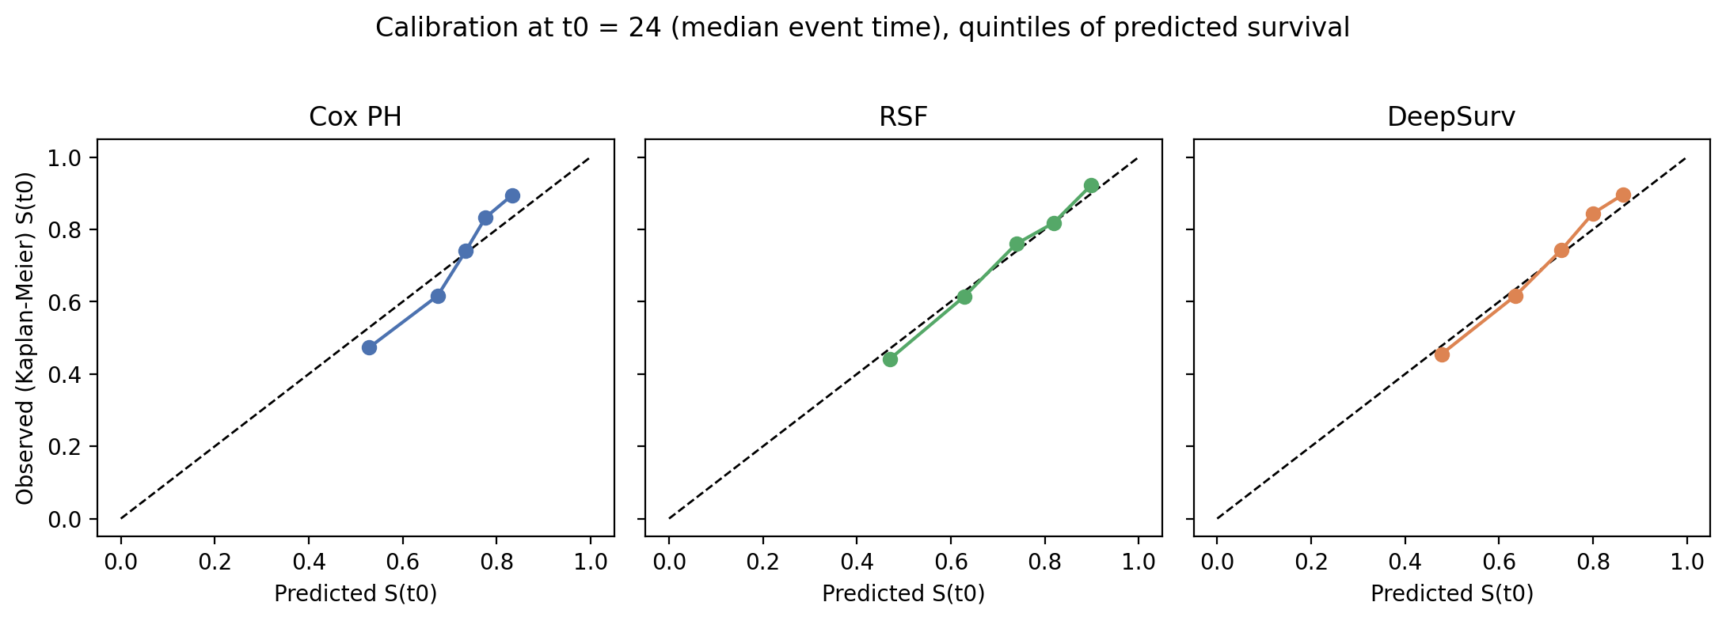
Figure 6. Calibration at the median event time (t₀ = 24): mean predicted survival against Kaplan–Meier observed survival in five groups of predicted survival (out-of-fold predictions, first repeat). The dashed line is perfect calibration.

6.6 Which covariates do the models use?
Figure 7 and Table 9 show how much the C-index drops on the held-out folds when one covariate is randomly permuted, which measures how much each model relies on it. All three models rely most on x4: the C-index drops by 0.074 for Cox PH, 0.097 for the forest and 0.095 for DeepSurv, against at most 0.037 for any other covariate. Beyond that the models differ somewhat. Cox PH relies more than the other two on x0 (0.022 against 0.008 for the forest and 0.019 for DeepSurv) and on x1 (0.037, 0.009 and 0.019), while the forest and DeepSurv both draw more than Cox PH on x3 (0.005 and 0.009 against −0.001) and on x5 (0.014 and 0.010 against 0.009). This is compatible with the flexible models picking up some non-linear effects, but it is only a rough guide: it comes from one repeat of cross-validation, has no uncertainty intervals, and permutation importance is unreliable for correlated covariates.
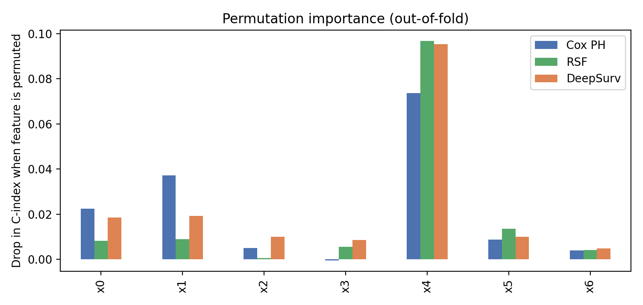
Figure 7. Permutation importance: mean drop in C-index on the held-out folds when a covariate is permuted (first repeat, 5 folds, 5 permutations per covariate).
Table 9. Permutation importance (mean drop in C-index) by covariate and model.
Covariate | Cox PH | Random survival forest | DeepSurv
x0 | 0.0225 | 0.0083 | 0.0186
x1 | 0.0373 | 0.0089 | 0.0192
x2 | 0.0050 | 0.0006 | 0.0099
x3 | −0.0005 | 0.0055 | 0.0085
x4 | 0.0737 | 0.0968 | 0.0953
x5 | 0.0088 | 0.0136 | 0.0101
x6 | 0.0040 | 0.0041 | 0.0048

7. Application to real data: breast cancer (METABRIC)
To see whether the GBSG findings are specific to that data set, the analysis of Section 6 was repeated on a second real data set, METABRIC, with the same models, settings, metrics and tests. Only what differs from Section 6 is described in detail.

7.1 Data and design
METABRIC (Molecular Taxonomy of Breast Cancer International Consortium; Curtis et al., 2012) is used in the preprocessed version distributed with pycox (Kvamme et al., 2019): 1,904 breast cancer patients, of whom 1,103 had an event (42.1% censored), and nine covariates, namely four gene-expression values and five clinical features (age at diagnosis and indicators of hormone therapy, radiotherapy, chemotherapy and oestrogen receptor status). The file labels the covariates x0–x8, and the assignment of labels to names was not verified here, so the report refers to x0–x8 only. The behaviour of x8 (hazard ratio 1.046 per unit and by far the largest permutation importance, Section 7.6) is what one would expect for age at diagnosis in years, but that identification is an inference. Survival times are on the scale stored in the file. The Kaplan–Meier estimate (Figure 8) reaches 0.5 at about 150 time units, and follow-up extends to about 355, where few patients remain at risk and the estimate and its confidence band are unstable.
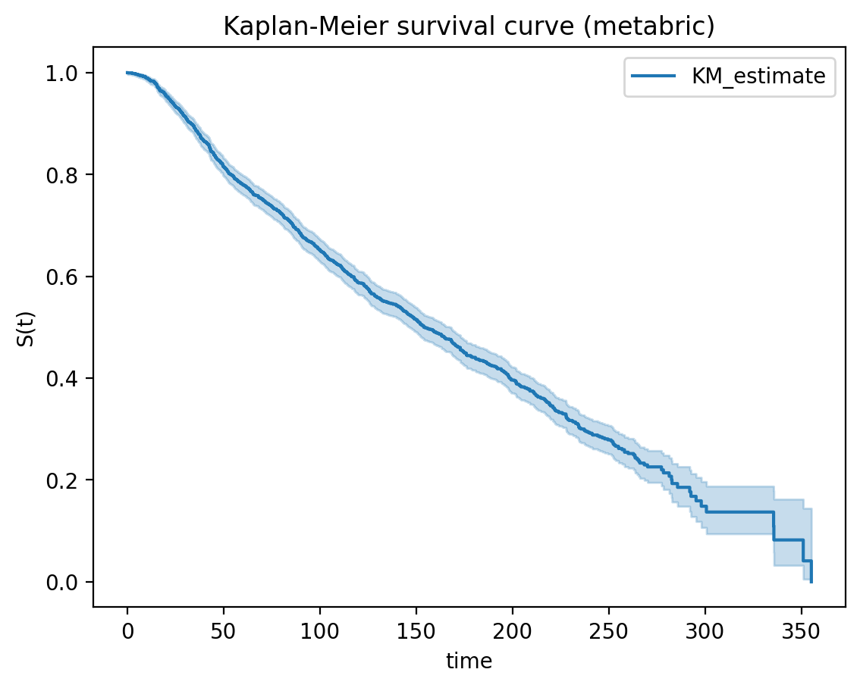
Figure 8. Kaplan–Meier estimate of overall survival with 95% confidence band, METABRIC data (all patients).
The design is that of Section 6: 5-fold cross-validation, stratified by the event indicator and repeated three times (15 splits, about 1,523 training and 381 test patients per split), the same hyper-parameters, and the corrected resampled t-test of Nadeau and Bengio (2003) with variance factor 0.317 for the C-index (J = 15) and 0.333 for the AUC and IBS (J = 12, see below). Holm adjustment covers the six C-index and IBS comparisons.

7.2 Two problems in the cross-validation output
Two features of the METABRIC run need to be stated before the results. (i) Missing AUC and IBS. The AUC and the IBS could not be computed in 3 of the 15 splits (the second fold of the first repeat, the fourth fold of the second repeat and the third fold of the third repeat). The notebook suppresses the error message and stores a missing value; it did so for all three models in the same splits, so the cause lies in the metric calculation for those splits (probably the evaluation time grid or the censoring weights), not in a model fit. It was not diagnosed. The AUC and IBS comparisons below therefore use the remaining 12 splits; the C-index uses all 15.
(ii) A failed DeepSurv fit. One DeepSurv fit, in the first fold of the second repeat, ended with a C-index of 0.442, below 0.5 (a reversed ranking), and with the worst IBS of all fits (0.220); the other fourteen DeepSurv fits had C-indices between 0.612 and 0.669. This looks like a failed training run, for example early stopping at a poor point of the optimisation, but it was not investigated. The primary analysis keeps this split, because instability of this kind is part of how the method behaves under the fixed protocol; a sensitivity analysis (Table 13) excludes it for all three models.

7.3 Cox model on all data and the proportional hazards assumption
Table 10 shows the Cox model fitted to all patients (hazard ratios per one-unit increase of the raw covariates) and the Schoenfeld-residual test of proportional hazards for each covariate. Seven of the nine covariates have effects significant at the 5% level (x1, x2, x3, x4, x5, x6 and x8). The test rejects proportional hazards at the 5% level for 5 covariates (x1, x3, x4, x7 and x8), and for x1 and x8 even after a Bonferroni correction for nine tests (threshold 0.05/9 = 0.0056). The covariate with by far the largest permutation importance, x8, is among them, so, as in GBSG, the Cox model is a reasonable but imperfect description of the data. The test cannot say whether time-varying effects or non-linear covariate effects are responsible (Section 5.3).
Table 10. Cox PH fitted to all patients (METABRIC): hazard ratio per one-unit increase (95% CI, Wald p-value) and Schoenfeld-residual test of proportional hazards (χ² on 1 degree of freedom, rank-transformed time). * Below the Bonferroni threshold 0.05/9.
Covariate | Hazard ratio | 95% CI | p | PH test χ² | PH test p
x0 | 1.056 | [0.972, 1.148] | 0.196 | 2.36 | 0.124
x1 | 0.928 | [0.867, 0.993] | 0.031 | 17.07 | <0.001 *
x2 | 1.093 | [1.044, 1.144] | <0.001 | 0.04 | 0.840
x3 | 1.377 | [1.147, 1.653] | 0.001 | 6.39 | 0.011
x4 | 1.160 | [1.012, 1.331] | 0.033 | 7.11 | 0.008
x5 | 0.832 | [0.735, 0.943] | 0.004 | 0.01 | 0.943
x6 | 2.174 | [1.785, 2.649] | <0.001 | 0.81 | 0.368
x7 | 1.075 | [0.877, 1.319] | 0.485 | 4.73 | 0.030
x8 | 1.046 | [1.040, 1.053] | <0.001 | 22.72 | <0.001 *

7.4 Predictive performance
Table 11 and Figure 9 summarise the results. The random survival forest has the best mean on every metric. Cox PH is the most stable model across splits (SD of the C-index 0.008, against 0.018 for the forest) and DeepSurv the least stable (0.053), mainly because of the failed split: without it the SD of the DeepSurv C-index is 0.016 and its mean rises from 0.626 to 0.639, close to the Cox value (0.637) in the same splits. The three C-index means lie within 0.019 of each other, which is small compared with the split-to-split variation, so the paired differences (Table 12) are more informative than the means.
Table 11. Mean (SD) of the C-index (over 15 splits), time-dependent AUC and integrated Brier score (over the 12 splits with valid values) on the test folds, METABRIC data.
Model | C-index | Time-dep. AUC | IBS (lower is better)
Cox PH | 0.636 (0.008) | 0.655 (0.017) | 0.1831 (0.0031)
DeepSurv | 0.626 (0.053) | 0.641 (0.072) | 0.1857 (0.0117)
Random survival forest | 0.645 (0.018) | 0.682 (0.017) | 0.1785 (0.0041)

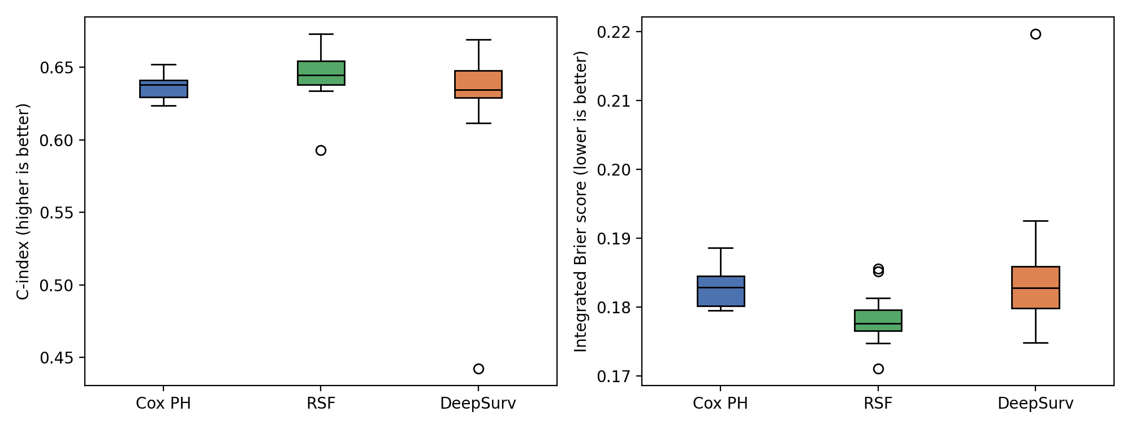
Figure 9. Distribution over the splits of the C-index (left, 15 splits) and the integrated Brier score (right, 12 splits with a valid IBS), METABRIC data. Boxes show quartiles; whiskers extend to 1.5 × IQR; circles are splits outside the whiskers (for DeepSurv, the failed split).
Table 12 gives the paired differences.
Table 12. Paired differences between models, METABRIC (first minus second), mean with corrected 95% interval. A positive C-index or AUC difference and a negative IBS difference favour the first model. p: corrected resampled t-test; Holm: Holm-adjusted over the six C-index and IBS tests; last column: number of splits in which the first model was better (out of 15 for the C-index, 12 for the AUC and IBS).
Comparison | Metric | Mean difference [95% CI] | p | Holm p | Splits won
DeepSurv − Cox PH | C-index | −0.0100 [−0.0706, +0.0507] | 0.730 | 1.000 | 7/15
 | AUC | −0.0139 [−0.0985, +0.0707] | 0.725 | — | 6/12
 | IBS | +0.0026 [−0.0095, +0.0147] | 0.644 | 1.000 | 3/12
RSF − Cox PH | C-index | +0.0091 [−0.0116, +0.0298] | 0.363 | 1.000 | 14/15
 | AUC | +0.0265 [+0.0138, +0.0392] | <0.001 | — | 12/12
 | IBS | −0.0046 [−0.0072, −0.0021] | 0.002 | 0.013 | 12/12
DeepSurv − RSF | C-index | −0.0190 [−0.0797, +0.0416] | 0.512 | 1.000 | 4/15
 | AUC | −0.0404 [−0.1237, +0.0430] | 0.309 | — | 2/12
 | IBS | +0.0072 [−0.0041, +0.0185] | 0.187 | 0.937 | 1/12

Discrimination. The forest's C-index is higher than that of Cox PH by 0.009 on average and in 14 of the 15 splits, but the corrected interval includes zero (p = 0.363), so a difference in ranking ability is not established. DeepSurv is lower than Cox PH by 0.010 on average (p = 0.730), which is due to the failed split (Table 13).
Accuracy of predicted survival. The forest has a lower IBS than Cox PH by 0.0046 (95% CI 0.0021 to 0.0072; Holm-adjusted p = 0.013) and was better in all 12 splits with a valid IBS. DeepSurv's IBS is 0.0026 higher than that of Cox PH on average (p = 0.644), that is, no better. The forest's IBS advantage is of the same order as in GBSG (0.0071).
Time-dependent AUC. The forest's mean AUC is higher than that of Cox PH by 0.0265 (95% CI 0.0138 to 0.0392, unadjusted p <0.001), in all 12 splits. This comparison was not part of the adjusted family. For DeepSurv the difference to Cox PH is −0.0139 (p = 0.725).
DeepSurv against the forest. No difference is significant in the primary analysis (p = 0.512 for the C-index, 0.309 for the AUC and 0.187 for the IBS), although the forest had the lower IBS in 11 of 12 splits and the higher AUC in 10 of 12.
Sensitivity analysis. Table 13 repeats the C-index and IBS comparisons without the split in which DeepSurv failed, for all three models (14 splits for the C-index, 11 for the IBS). DeepSurv is then indistinguishable from Cox PH (C-index +0.0025, IBS +0.0000), and the forest remains better than Cox PH in IBS (−0.0048; Holm-adjusted p = 0.015). The IBS comparison of DeepSurv with the forest becomes +0.0048 (95% CI 0.0010 to 0.0086; unadjusted p = 0.018, Holm-adjusted p = 0.090), which suggests that the forest is more accurate than DeepSurv in this data set but is not significant after adjustment for the six tests.
Table 13. Sensitivity analysis, METABRIC: paired differences without the split in which DeepSurv failed (14 splits for the C-index, 11 for the IBS). Same conventions as Table 12; the Holm adjustment covers these six tests.
Comparison | Metric | Mean difference [95% CI] | p | Holm p | Splits won
DeepSurv − Cox PH | C-index | +0.0025 [−0.0155, +0.0205] | 0.771 | 1.000 | 7/14
 | IBS | +0.0000 [−0.0043, +0.0043] | 0.991 | 1.000 | 3/11
RSF − Cox PH | C-index | +0.0090 [−0.0128, +0.0308] | 0.388 | 1.000 | 13/14
 | IBS | −0.0048 [−0.0074, −0.0021] | 0.003 | 0.015 | 11/11
DeepSurv − RSF | C-index | −0.0065 [−0.0235, +0.0104] | 0.420 | 1.000 | 4/14
 | IBS | +0.0048 [+0.0010, +0.0086] | 0.018 | 0.090 | 1/11

7.5 Calibration
Figure 10 compares predicted and observed survival at t₀ = 86, the median event time, using out-of-fold predictions from the first repeat, in the same way as in Section 6.5 (five groups of about 381 patients each). Reading from the figure, the forest and DeepSurv are close to the diagonal in all five groups (deviations of roughly 0.03 to 0.04 at most), whereas the Cox PH curve deviates more: observed survival is roughly 0.06 above the prediction in the second-lowest group and roughly 0.06 below it in the highest group, that is, the highest predicted survival probabilities are too optimistic. For scale, the binomial standard error of an observed survival probability of 0.7 in a group of 381 patients is about 0.023 even without censoring, so deviations of 0.03 are within noise and those of 0.06 are about two and a half standard errors. There is only one time point and no confidence band, so the plot is suggestive rather than conclusive.
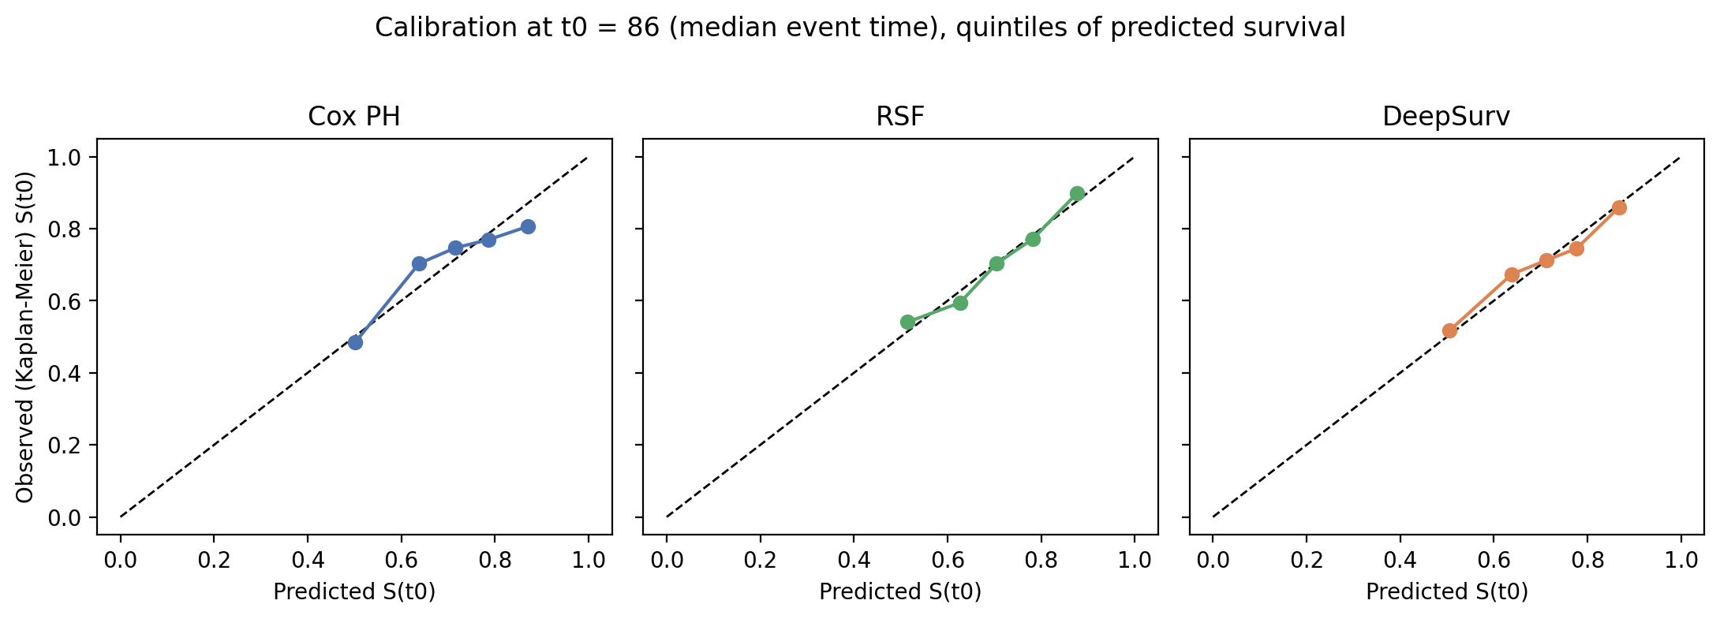
Figure 10. Calibration at the median event time (t₀ = 86), METABRIC: mean predicted survival against Kaplan–Meier observed survival in five groups of predicted survival (out-of-fold predictions, first repeat). The dashed line is perfect calibration.

7.6 Which covariates do the models use?
Figure 11 and Table 14 show the permutation importance in the same way as in Section 6.6. All three models rely overwhelmingly on x8: permuting it lowers the C-index by 0.092 for Cox PH, 0.092 for the forest and 0.091 for DeepSurv, against at most 0.037 for any other covariate. After x8 the models differ: Cox PH relies next on x6 (0.037), DeepSurv on x6 (0.021) and x3 (0.015), and the forest on x1 (0.016) and x3 (0.011); x6 matters much less to the forest (0.009). The remaining covariates (x0, x2, x4, x5, x7) have importances of at most 0.008 for every model. The same caveats apply as in GBSG: one repeat of cross-validation, no uncertainty intervals, and the known unreliability of permutation importance for correlated covariates.
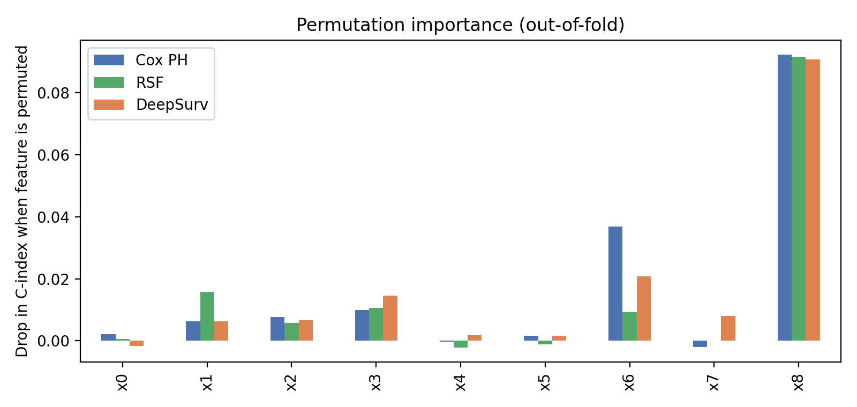
Figure 11. Permutation importance, METABRIC: mean drop in C-index on the held-out folds when a covariate is permuted (first repeat, 5 folds, 5 permutations per covariate).
Table 14. Permutation importance (mean drop in C-index) by covariate and model, METABRIC.
Covariate | Cox PH | Random survival forest | DeepSurv
x0 | 0.0022 | 0.0006 | −0.0016
x1 | 0.0064 | 0.0157 | 0.0062
x2 | 0.0076 | 0.0057 | 0.0066
x3 | 0.0099 | 0.0106 | 0.0145
x4 | −0.0002 | −0.0022 | 0.0017
x5 | 0.0016 | −0.0011 | 0.0016
x6 | 0.0369 | 0.0093 | 0.0208
x7 | −0.0020 | 0.0001 | 0.0081
x8 | 0.0923 | 0.0917 | 0.0907

7.7 Summary across the two data sets
Table 15 sets the two real data sets side by side. For the forest the picture is the same in both: the best mean on every metric, a C-index gain over Cox PH of 0.012 and 0.009 that is not significant, and an IBS gain of 0.0071 and 0.0046 that is significant after Holm adjustment in both (Holm-adjusted p = 0.012 and 0.013). For DeepSurv it differs: its IBS improved on Cox PH in GBSG (−0.0044, Holm-adjusted p = 0.037) but not in METABRIC (+0.0026), where it was also less stable. The data cannot say why; the hyper-parameters were fixed in advance and not tuned for either data set. The C-index of all three models is lower in METABRIC (0.626 to 0.645) than in GBSG (0.662 to 0.674).
Table 15. Differences from Cox PH in the two real data sets: mean paired difference in C-index with its unadjusted p-value, and in IBS with its Holm-adjusted p-value (METABRIC: C-index over 15 splits, IBS over 12). A positive C-index difference and a negative IBS difference favour the model named.
Data set | Model | Δ C-index | Δ IBS
GBSG | DeepSurv | +0.0080 (p = 0.120) | −0.0044 (Holm p = 0.037)
 | Random survival forest | +0.0125 (p = 0.101) | −0.0071 (Holm p = 0.012)
METABRIC | DeepSurv | −0.0100 (p = 0.730) | +0.0026 (Holm p = 1.000)
 | Random survival forest | +0.0091 (p = 0.363) | −0.0046 (Holm p = 0.013)

8. Discussion
Functional form matters more than proportional hazards. The largest effects in this study come from whether the log-risk is linear, not from whether PH holds. A key reason is that in all four scenarios the survival curves of different subjects do not cross, so a single risk score already ranks subjects correctly at every time point. Cox and DeepSurv can therefore achieve a near-oracle C-index even when PH is violated (scenario C); the violation shows up mainly in the calibration of the survival curves (the IBS), where the gap to the oracle is small at this effect size. This is a property of the chosen simulation design. Real data with crossing survival curves, for example when a treatment helps early and harms later, would penalise a single-index model much more, and the discrete-time model could then be expected to gain more; this was not simulated.
A neural network is not a free upgrade. In scenarios A and C, where the linear Cox model is adequate, every neural model was significantly worse than Cox, and the more flexible discrete-time model was worse than DeepSurv. The cost shrinks with n but is still visible at n = 3000 for DeepSurv in A and C (Table 5).
Where neural networks help. They help when the structure is non-linear or interactive and n is at least about 1000. With n = 300 the logistic-hazard model was unusable, while DeepSurv still helped, probably because it has a single output and is therefore easier to estimate.
What the real data add. On both real data sets the flexible models gained little in ranking: the C-index differences from Cox PH were +0.008 (DeepSurv) and +0.012 (forest) in GBSG and −0.010 and +0.009 in METABRIC, none of them significant and all far smaller than the gains of 0.16 to 0.21 in the strongly non-linear simulation scenarios B and D. The clearer gains were in the accuracy of predicted survival (IBS) and were largest for the forest, which was significantly better than Cox PH in both data sets (Holm-adjusted p = 0.012 in GBSG and 0.013 in METABRIC); DeepSurv was significantly better only in GBSG (Holm-adjusted p = 0.037). In both data sets the PH test rejected the assumption for several covariates (after Bonferroni correction: x1, x5 and x6 in GBSG; x1 and x8 in METABRIC), yet the Cox model still ranked patients almost as well as the other models, as in scenario C. This is what one would expect if the Cox model is a reasonable but imperfect description of the data, with mild non-linearity or non-proportional effects, rather than one in which it fails. With two data sets it is not possible to tell whether the forest's advantage comes from non-linearity or from departures from proportional hazards. The forest, which relaxes both, had a better mean than DeepSurv, which relaxes only linearity, on every metric in both data sets, but none of these differences was significant after adjustment. The network was also less stable than the other two models: one of its 15 METABRIC fits failed, and without that fit it matched Cox PH rather than improving on it. In both data sets all models rely most on the same covariate (x4 in GBSG, x8 in METABRIC; Figures 7 and 11).
A fair caveat on the baseline. The Cox model in this study is deliberately the plain linear model. An analyst who suspected an interaction between x₁ and x₂ could add the product term, or fit splines, and the Cox model would then recover much of its loss in scenarios B and D. The comparison therefore shows what a network gives automatically, not what it gives beyond a well-engineered Cox model. Testing this directly is a natural extension. The real data point the same way: the hazard ratios of x5 and x6 are 1.000 per unit, which suggests covariates measured on a wide scale, possibly with skewed distributions, and a log transformation or a spline might help the Cox model; this was not tried.
Practical guidance suggested by these results. (i) Begin with a Cox model and examine linearity and PH diagnostics, remembering that the PH test can have low power when effects are misspecified (Section 5.3). (ii) Use DeepSurv when non-linearity or interactions are suspected and several hundred to a thousand events are available. (iii) Reserve PH-free discrete-time networks for large samples or for settings where crossing survival curves are expected. (iv) Compare models on held-out data with paired differences rather than on a single split, and when cross-validation is used, account for the overlap between training sets (for example with the corrected resampled t-test), because the split-to-split spread of the C-index (about 0.02 in the real data) is larger than the differences between models. (v) Check the stability of a network across splits and seeds: in METABRIC one of 15 DeepSurv fits failed, which a single split would not reveal.

9. Limitations and next steps
- Two real data sets. The real-data applications use two data sets (the GBSG and METABRIC files distributed with pycox), whose covariates are anonymised; SUPPORT was not analysed. The real-data findings are an illustration, not a general statement about neural networks in survival analysis.
- Failures in the METABRIC run. The AUC and IBS were missing in 3 of 15 METABRIC splits (for all models) and one DeepSurv fit failed. The causes were not diagnosed, the METABRIC comparisons of AUC and IBS rest on 12 splits, and the results of the network for that data set are less reliable than those of the other two models.
- Four scenarios, one set of effect sizes. Results depend on the chosen coefficients, the Weibull shape, σ = 0.8, 30% censoring and six covariates. Crossing survival curves, time-varying effects and high-dimensional covariates were not studied.
- Fixed hyper-parameters. Network depth, width, regularisation and learning rate, and the forest settings, were fixed in advance and not tuned in either part; tuning might narrow or widen the gaps, particularly in the small-sample simulation runs. In the simulation, random survival forests and Cox models with splines were not included, and in the real data the Cox model used the covariates as given, without transformations or interactions.
- Independent censoring only, and censoring weights estimated from the test sample.
- Approximate inference in cross-validation. The corrected resampled t-test is an approximation based on overlapping splits of one data set (15 per data set; 12 for the AUC and IBS in METABRIC), so p-values near 0.05 should not be over-interpreted. Holm's adjustment covered the six C-index and IBS comparisons within each data set, not across data sets; the AUC comparisons were not adjusted.
Next steps. (1) Add stronger Cox baselines: log-transformed or spline terms for skewed covariates, interactions, and a stratified or time-varying-coefficient model for the covariates that violate proportional hazards. (2) Tune the hyper-parameters of DeepSurv and the forest by nested cross-validation, and run the network with several seeds. (3) Find the cause of the missing AUC and IBS values in three METABRIC splits and of the failed DeepSurv fit, then repeat the real-data comparison on SUPPORT (the DATASET setting in the notebook) and on further data sets. (4) Add simulation scenarios with crossing hazards. (5) Add SHAP-based interpretation and compare it with the hazard ratios.

10. Conclusion
In a controlled simulation, a neural network is neither always better nor always worse than the Cox model: its value depends on the structure of the data and on the sample size. The linear Cox model was essentially optimal when its assumptions held, and a modest but statistically clear loss was the price of using a network in that case. When the log-risk was non-linear, the Cox model collapsed to near-chance discrimination while DeepSurv recovered most of the signal. Dropping proportional hazards brought only a small benefit and only at n = 3000, and the discrete-time model was unreliable at n = 300. On the two real breast cancer data sets the picture was more modest. A random survival forest had the best mean on every metric in both data sets; its C-index gain over the Cox model (0.012 in GBSG, 0.009 in METABRIC) was not significant, but its gain in integrated Brier score (0.0071 and 0.0046) remained significant after adjustment for multiple testing in both. DeepSurv improved on the Cox model in GBSG (C-index +0.008, not significant; integrated Brier score −0.0044, significant after adjustment) but not in METABRIC, where it was no better than the Cox model and one of its 15 training runs failed. Taken together, the results support a pragmatic workflow: fit a Cox model first, diagnose it, and move to a flexible model when there is evidence of non-linear structure and enough data to support it, judging any gain with paired comparisons that respect the overlap between cross-validation folds and checking the stability of the network across splits. Whether the small real-data gains justify the added complexity depends on the application; this study, based on two real data sets, cannot settle that.

References
Breslow, N. E. (1972). Discussion of “Regression models and life-tables” by D. R. Cox. Journal of the Royal Statistical Society, Series B, 34, 216–217.
Cox, D. R. (1972). Regression models and life-tables. Journal of the Royal Statistical Society, Series B, 34(2), 187–220.
Curtis, C., Shah, S. P., Chin, S.-F., Turashvili, G., Rueda, O. M., Dunning, M. J. et al. (2012). The genomic and transcriptomic architecture of 2,000 breast tumours reveals novel subgroups. Nature, 486, 346–352.
Davidson-Pilon, C. (2019). lifelines: survival analysis in Python. Journal of Open Source Software, 4(40), 1317.
Gensheimer, M. F. and Narasimhan, B. (2019). A scalable discrete-time survival model for neural networks. PeerJ, 7, e6257.
Graf, E., Schmoor, C., Sauerbrei, W. and Schumacher, M. (1999). Assessment and comparison of prognostic classification schemes for survival data. Statistics in Medicine, 18, 2529–2545.
Grambsch, P. M. and Therneau, T. M. (1994). Proportional hazards tests and diagnostics based on weighted residuals. Biometrika, 81(3), 515–526.
Harrell, F. E., Califf, R. M., Pryor, D. B., Lee, K. L. and Rosati, R. A. (1982). Evaluating the yield of medical tests. JAMA, 247(18), 2543–2546.
Holm, S. (1979). A simple sequentially rejective multiple test procedure. Scandinavian Journal of Statistics, 6(2), 65–70.
Ishwaran, H., Kogalur, U. B., Blackstone, E. H. and Lauer, M. S. (2008). Random survival forests. The Annals of Applied Statistics, 2(3), 841–860.
Katzman, J. L., Shaham, U., Cloninger, A., Bates, J., Jiang, T. and Kluger, Y. (2018). DeepSurv: personalized treatment recommender system using a Cox proportional hazards deep neural network. BMC Medical Research Methodology, 18, 24.
Kingma, D. P. and Ba, J. (2015). Adam: a method for stochastic optimization. International Conference on Learning Representations.
Kvamme, H. and Borgan, Ø. (2021). Continuous and discrete-time survival prediction with neural networks. Lifetime Data Analysis, 27, 710–736.
Kvamme, H., Borgan, Ø. and Scheel, I. (2019). Time-to-event prediction with neural networks and Cox regression. Journal of Machine Learning Research, 20(129), 1–30.
Morris, T. P., White, I. R. and Crowther, M. J. (2019). Using simulation studies to evaluate statistical methods. Statistics in Medicine, 38(11), 2074–2102.
Nadeau, C. and Bengio, Y. (2003). Inference for the generalization error. Machine Learning, 52, 239–281.
Pölsterl, S. (2020). scikit-survival: a library for time-to-event analysis built on top of scikit-learn. Journal of Machine Learning Research, 21(212), 1–6.
Uno, H., Cai, T., Tian, L. and Wei, L. J. (2007). Evaluating prediction rules for t-year survivors with censored regression models. Journal of the American Statistical Association, 102(478), 527–537.

Appendix A. Reproducibility
The simulation study is reproducible from two Python files that need only NumPy, SciPy, pandas and Matplotlib:
- survival_sim.py 200 — main experiment (n = 1000, 200 replications per scenario; about 3.5 minutes on two CPU cores). Setting the environment variable SIM_N to 300 or 3000 with 60 replications gives the sample-size runs.
- analysis.py — builds all tables, paired tests and figures from the saved result files.
Fixed hyper-parameters of the simulation: hidden layers 32–32 (ReLU), Adam with learning rate 0.003, L2 weight decay 0.001, full-batch training, validation fraction 0.2, early-stopping patience 30, maximum 800 epochs, K = 20 time intervals, Cox ridge 0.5. Test sets contain 3000 subjects and are generated independently in each replication.
The real-data applications are run with the notebook Survival_RealData_Colab.ipynb. It needs pycox, lifelines, scikit-survival and torchtuples, downloads the data file automatically, and writes the tables and figures of Sections 6 and 7 as CSV and PNG files; the GBSG results use DATASET = gbsg and the METABRIC results DATASET = metabric. The cross-validation seed is 42. In the METABRIC run the notebook returned missing values for the AUC and IBS in three splits without printing the error (Section 7.2); these values were left as they were and the splits excluded from the AUC and IBS comparisons.

