Least Tour Trip

Steps to run the project

1 . Download and Open the Zip folder

2. Open the project_prototype_v3.0 folder in VS code

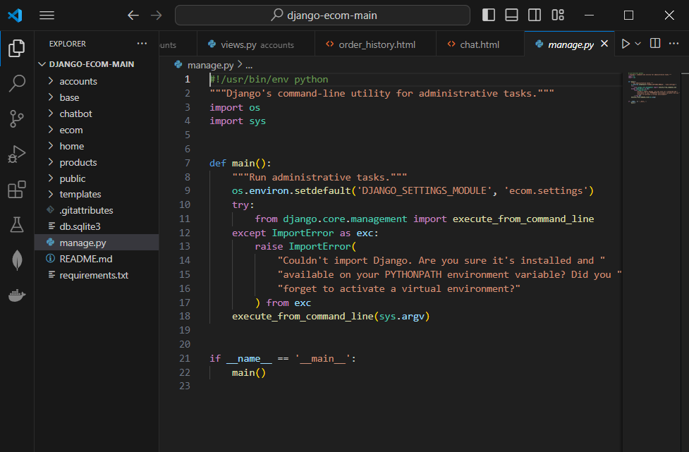

3. requirement.txt

Command to run: pip install -r requirements.txt this will install all the required libraries that is needed to run this file.

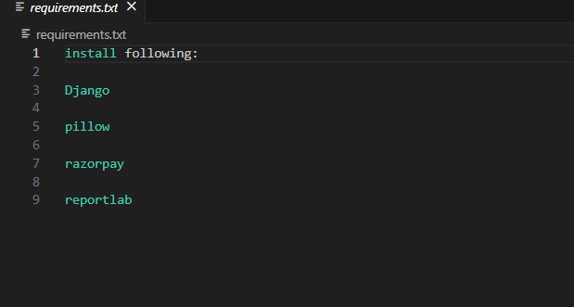

4. now to the cmd path where your project is saved and enter this command



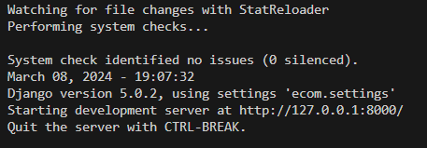

5. copy the server IP and run it on Browser

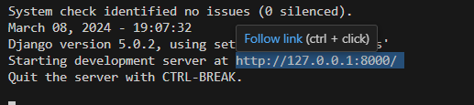

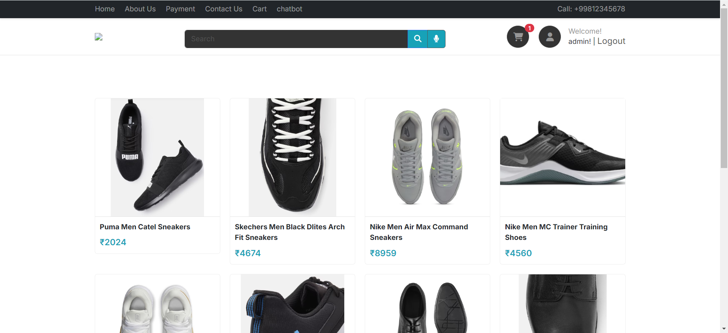

6 . Enter the cities of which you want the optimal path and choose the paths as land or water

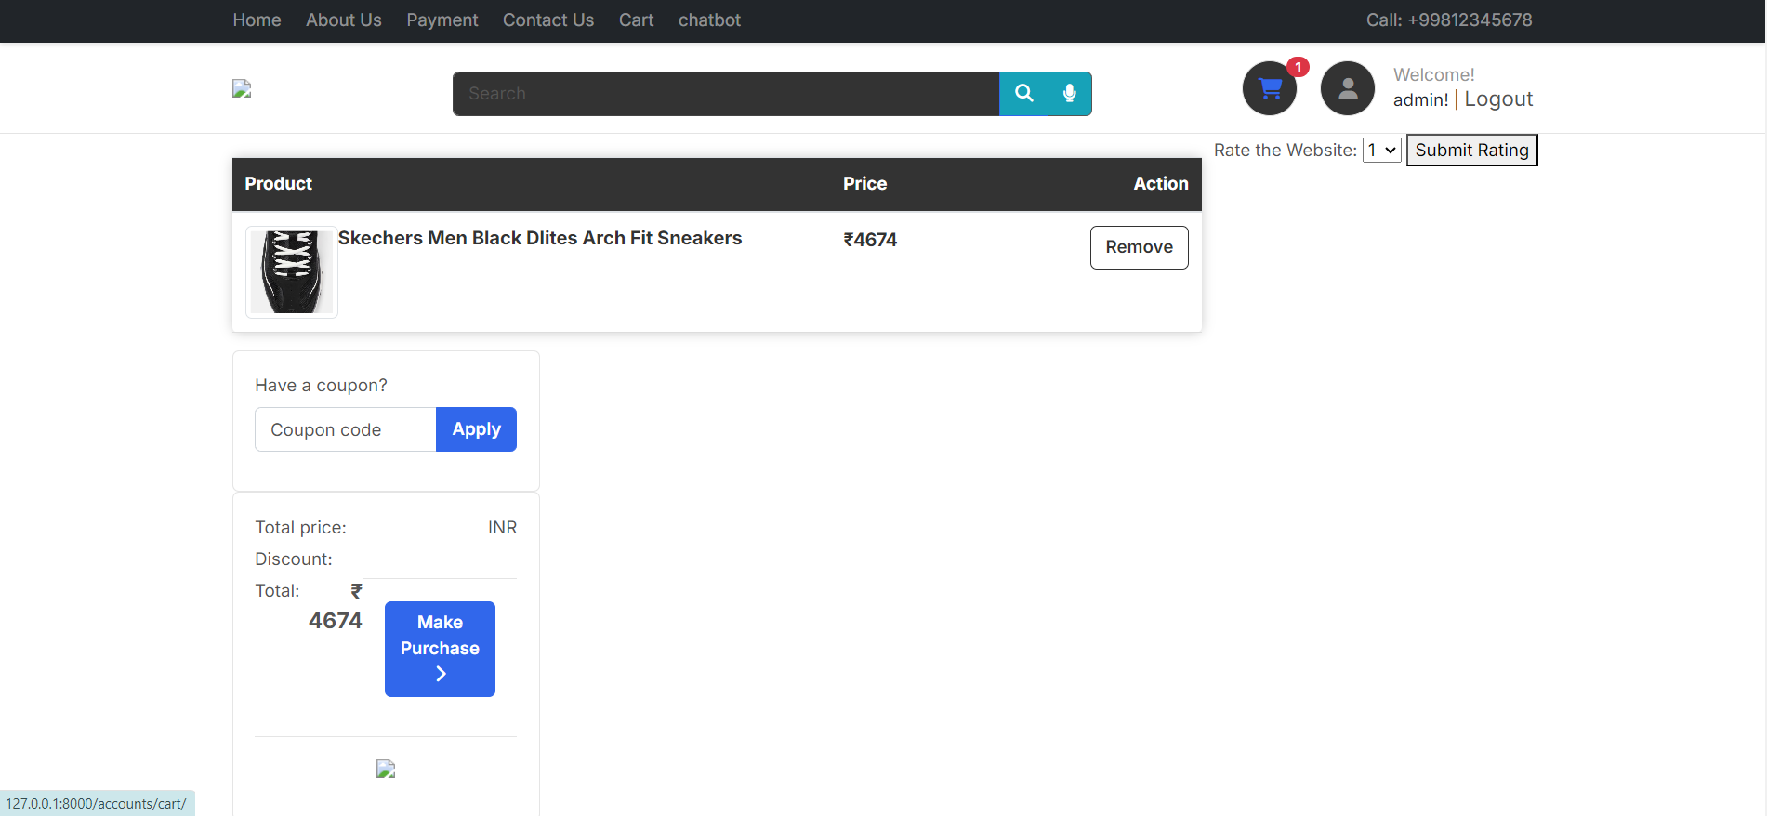

7. now click on submit



8. it will give you an optimal path of trip with distances calculated using genetic algorithms and also the path points are plotted on the map

