Qlyraxis Technical Report
Design implementation and measured performance

Smart India Hackathon Problem Statement 26169
Indian Space Research Organisation
Theme Smart Automation
Qlyraxis SIH Team
September 2026

AI assisted virtual camera tracking for coarse alignment of mobile free space optical communication terminals

Executive Summary
Qlyraxis implements the coarse pointing acquisition and tracking stage required before a fine optical steering mechanism can establish a mobile FSOC link. The application creates a repeatable virtual world, renders narrow optical beacons through configurable disturbances, detects and verifies candidates from pixels, predicts target motion, and commands a constrained virtual pan tilt camera. It also accepts recorded MP4 files and image sequences without using simulator state.
Five 60 second benchmark runs met the supplied thresholds. Every scenario acquired within 2 seconds, every maximum centroid error stayed below 3.1 pixels, throughput remained above 24 FPS, and the timed dropout run reacquired in 0.633 seconds with 1.07 percent target loss. The results are generated from saved seeds and configuration files rather than manually entered claims.

Problem Understanding
An FSOC beam has a narrow angular footprint. Small errors caused by platform movement, vibration, turbulence, low contrast, or sensor noise can move the remote terminal outside the camera field of view. Coarse alignment must search the available field, distinguish a beacon from artifacts, estimate its image position, and keep it visible long enough for fine alignment to take over.

Implemented Scope
- Deterministic 2000 by 2000 virtual world and 640 by 480 camera viewport
- Four target trajectories and bounded pan tilt dynamics
- Hybrid computer vision detection with AI candidate verification
- Kalman estimation PID control and explicit loss recovery states
- Sensor atmosphere platform and beacon dropout disturbances
- Desktop operation recorded media analysis and automatic reports

Requirements and Success Criteria
The software converts the problem statement into testable contracts. The tracker sees only rendered or decoded pixels. Ground truth is carried on a separate evaluation channel and is used only to calculate accuracy. This separation prevents an unrealistically easy solution that reads target coordinates directly from the simulator.
Requirement | Configured value | Acceptance threshold
World and camera | 2000 by 2000 world 640 by 480 viewport | Configurable
Field of view | 4 by 3 degrees | Configurable
Camera update | 30 Hz | At least 30 Hz
Control update | 30 Hz | At least 20 Hz
Pan and tilt speed | 5 to 10 degrees per second | Within stated range
Acquisition | Measured per scenario | At most 2 seconds
Reacquisition | Measured after target loss | At most 1 second
Tracking error | Centroid distance from truth | At most 10 pixels
Target loss | Post acquisition unlocked frames | Below 5 percent
Processing | Wall clock frame processing | At least 20 FPS

Each scenario stores its random seed, target motion, camera limits, disturbance values, duration, and log formats. Invalid values such as excessive jitter or camera speed are rejected before a run begins.

System Architecture
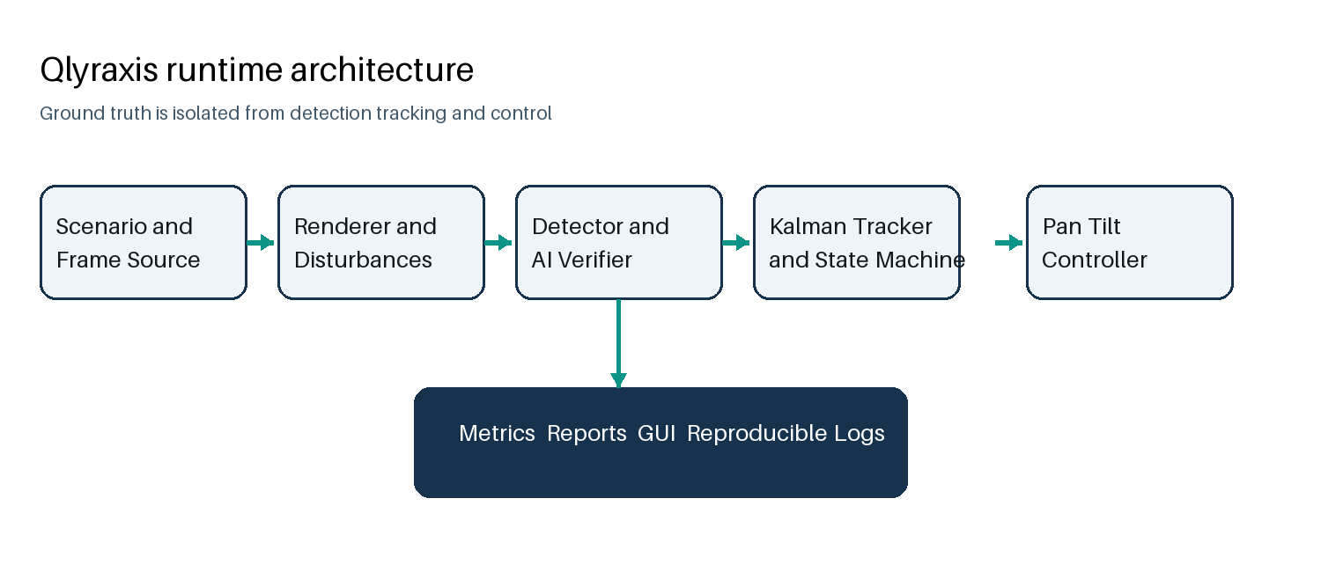
Figure 1 Runtime modules and information boundaries
Frame sources normalize simulation, video, and image sequences into an index, timestamp, and image. The detector produces candidate centroids and confidence values. The optional ONNX verifier rejects candidate patches that do not resemble an optical beacon. A stateful Kalman tracker then associates measurements, predicts motion through short gaps, and selects search or tracking behavior.
The controller converts filtered image error into pan and tilt rates. The virtual camera applies acceleration, speed, and world boundary limits before the next frame is rendered. Metrics subscribe to the resulting frame state, command, timing, and optional truth without feeding evaluation data back into the tracker.

Virtual Environment and Camera
The simulator derives time from the integer frame index. Two runs with the same scenario and seed therefore produce identical images and disturbances regardless of host speed. This makes failures replayable and lets teams compare algorithms against the same conditions.

Target Motion
Trajectory | Parameters | Purpose
Straight line | Speed and heading with boundary reflection | Baseline and dropout tests
Circular | Radius and period | Continuous curved motion
Figure eight | Width height and period | Direction reversal and changing velocity
Random | Maximum speed and turn interval | Unpredictable mobile platform motion

Camera Model
The camera maps angular commands to viewport movement through pixels per degree. It clamps requested pan and tilt rates, limits acceleration to avoid instant reversals, and constrains the viewport to the world. The raster search begins with a fast survey of likely regions and then covers the remaining angular limits in overlapping bands.

Detection Acquisition and Tracking

Pixel Processing
Frames are converted to monochrome, contrast enhanced, and filtered at two spatial scales. A robust median and median absolute deviation threshold isolates bright compact regions without normalizing background fog into thousands of false components. Connected components are filtered by area, diameter, aspect ratio, compactness, peak brightness, and local contrast. Intensity weighted moments provide subpixel centroids.

Temporal Confirmation
A single bright region does not immediately establish lock. Initial acquisition requires three spatially consistent frames. Reacquisition requires two confirmations. Association gates account for image motion caused by the search camera and the specified frame jitter.

State Machine
State | Behavior | Exit condition
SEARCH | Run the global camera survey | A credible candidate appears
ACQUIRE | Confirm temporal and spatial consistency | Required confirmations or rejection
TRACK | Correct the filter and command the camera | Measurement is missed
COAST | Use short term prediction | Detection returns or timeout expires
REACQUIRE | Search near prediction then expand globally | Candidate is confirmed

AI Verification and Recorded Media
The candidate verifier uses a small convolutional network designed for CPU deployment. Its eight 3 by 3 filters represent compact brightness, center surround response, and several edge orientations. ReLU activation and 2 by 2 max pooling feed a learned logistic head. The network contains 2049 trainable output parameters and is exported as an 8.8 KB ONNX model.
Training patches are created without simulator coordinates. Positive patches contain square or circular beacons with varied size, intensity, blur, attenuation, haze, gradient, and noise. Negative patches contain impulses, streaks, broad glows, elongated regions, multiple isolated pixels, and off center blobs. The committed model reached 97.20 percent accuracy on a separately seeded synthetic validation set.

Recorded Input
OpenCV decodes MP4 and other common video containers. Image directories accept PNG, JPEG, BMP, and TIFF files with natural numeric ordering. Timestamps remain strictly increasing even when a container does not provide reliable presentation times. Recorded analysis runs detection, ONNX verification, and the same tracker without importing simulation modules or ground truth.

Deployment
- OpenCV DNN provides the default ONNX CPU backend
- ONNX Runtime is available as an optional backend
- NumPy weights and the deterministic training command are included
- The classical detector remains available for comparison

Disturbance Model
Disturbances are deterministic functions of scenario seed and frame index. The application can compare a clean render with the corresponding sensor frame while carrying transformed truth coordinates to the metrics channel.
Disturbance | Implementation | Configured range
Gaussian noise | Additive zero mean samples | Sigma 0 to 20
Poisson noise | Signal dependent photon count model | Selectable
Salt and pepper | Random black and white pixels | Fraction 0 to 0.1
Haze and fog | Contrast attenuation background lift and blur | Strength 0 to 1
Rain | Attenuation and seeded diagonal streaks | Strength 0 to 1
Low light | Intensity attenuation | Strength 0 to 1
Turbulence | Time varying two dimensional remap | 0 to 20 pixels
Camera jitter | Per frame random translation | 0 to 20 pixels
Platform motion | Linear circular figure eight spiral or random offset | 0 to 20 pixels
Dropout | Timed beacon suppression before sensor effects | Start and duration

Control and Reacquisition
A constant velocity Kalman filter estimates horizontal and vertical image position and velocity. Measurement corrections reduce noise while predictions bridge short interruptions. The pan tilt controller converts image displacement from the viewport center into angular error using the camera field of view. Independent proportional integral derivative axes generate rate commands.
Every command is clipped to the configured speed limit, and the virtual camera applies its own acceleration and position limits. This double boundary ensures that a controller defect cannot request physically invalid motion. A small deadband prevents unnecessary movement when the filtered centroid is already centered.

Loss Recovery
- The tracker enters COAST after the first missed measurement and continues with the Kalman prediction.
- After the configured coast window it enters REACQUIRE and searches within a local prediction gate.
- If the local timeout expires the camera resumes a global survey.
- Two consistent measurements restore TRACK and reset the loss counters.
In the 0.75 second synthetic dropout, the measured recovery interval from REACQUIRE to TRACK was 0.633 seconds. Post acquisition target loss over the full 60 second run was 1.07 percent.

Desktop Application and Reporting
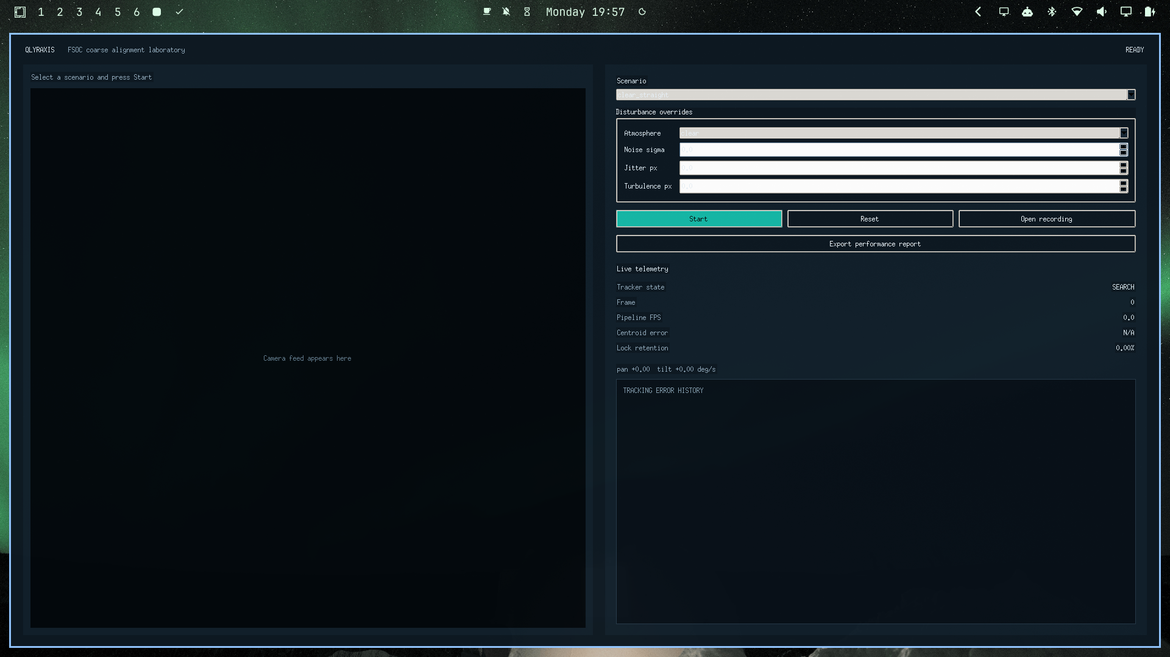
Figure 2 Qlyraxis desktop dashboard
The desktop application exposes scenario selection, atmosphere and disturbance overrides, start pause reset controls, recorded input, and report export. The camera view overlays detections, the filtered estimate, tracker state, search scope, and control command. A telemetry panel updates processing speed, centroid error, lock retention, and recent error history.
The benchmark command and the desktop export action write a per frame CSV, a JSON file containing summary configuration and raw frames, and a self contained HTML report with an error chart. This preserves both judge friendly summaries and detailed evidence for later analysis.

Test Methodology
Automated tests cover configuration, trajectories, camera constraints, rendering, disturbance determinism, preprocessing, detection, acquisition, Kalman behavior, state transitions, control signs and limits, recorded sources, AI training and inference, metrics, and GUI chart calculations. The suite also executes closed loop scenarios to catch interactions that isolated unit tests cannot reveal.
Layer | Representative check | Evidence
Configuration | Reject out of range camera and disturbance values | Unit tests
Simulation | Same seed produces identical frames | Pixel equality
Vision | Centroid accuracy under clear and noisy frames | Ground truth distance
Tracking | State transitions and bounded association | State sequence assertions
Control | Correct pan tilt signs speed and acceleration | Command assertions
AI | Held out data and ONNX numerical agreement | Accuracy and tolerance checks
Recorded media | MP4 timestamp reset and end of stream | Frame source tests
Integration | Acquisition retention dropout recovery | Closed loop runs
Packaging | Executable help validation benchmark and GUI launch | Built artifact smoke test

The final test run contains 71 automated tests. Official benchmark runs use 1800 frames at 30 Hz, which represents 59.97 seconds from the first timestamp to the last. Processing FPS is calculated from measured per frame wall clock time on the development host.

Performance Results
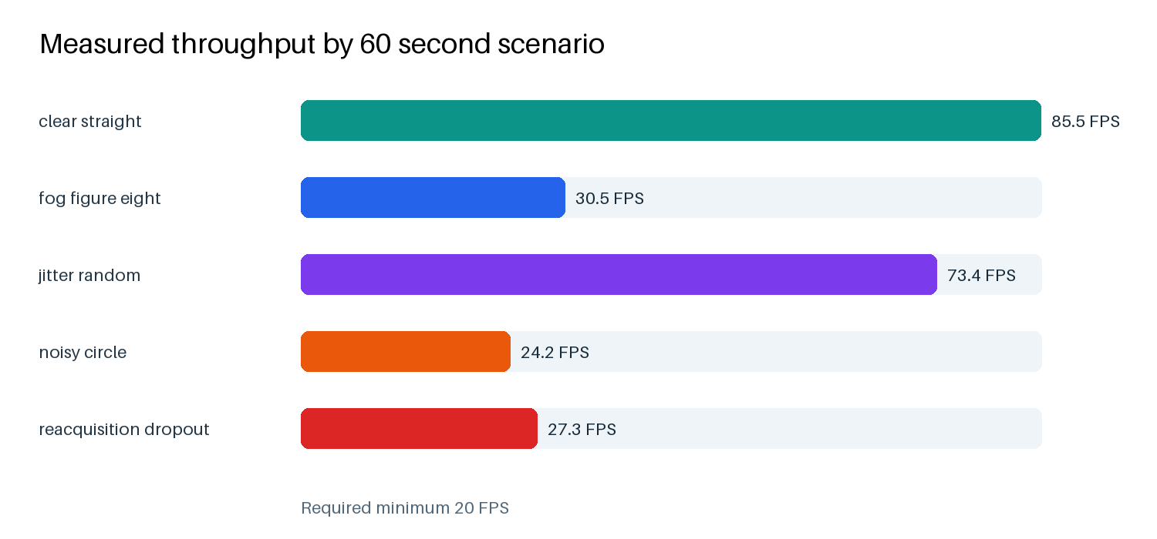
Figure 3 Processing throughput across five 60 second runs
Scenario | Acquire s | Max error px | Lock percent | FPS
clear straight | 0.067 | 2.890 | 100.00 | 85.5
fog figure eight | 1.867 | 0.828 | 100.00 | 30.5
jitter random | 1.600 | 1.315 | 100.00 | 73.4
noisy circle | 1.600 | 0.806 | 100.00 | 24.2
reacquisition dropout | 0.633 | 3.043 | 98.93 | 27.3

All measured scenarios satisfy the supplied thresholds. The lowest throughput is 24.2 FPS in the mixed Gaussian and Poisson profile, leaving 21 percent headroom above the 20 FPS minimum. The highest maximum centroid error is 3.043 pixels during the dropout profile, less than one third of the 10 pixel limit.

Limitations Future Work and Conclusion

Current Limitations
- The current world is two dimensional and does not model full orbital geometry or optical link budget.
- The AI verifier is trained on generated patches and requires real beacon footage for domain calibration.
- Recorded video analysis estimates image motion but cannot command the camera that produced an existing file.
- The packaged artifact is built for the current Linux architecture and should be rebuilt for Windows submission machines.

Recommended Extensions
- Add three dimensional platform attitude and ephemeris driven trajectories
- Introduce measured turbulence and background datasets supplied by the evaluator
- Calibrate camera intrinsics and convert pixel error into line of sight uncertainty
- Connect the command interface to a hardware in the loop pan tilt unit
- Train and compare an end to end compact CNN when representative labeled footage is available

Conclusion
Qlyraxis provides a complete software laboratory for developing and evaluating coarse FSOC alignment without specialized optical hardware. Its modules preserve the boundary between pixels and truth, its disturbances replay exactly, and its reports expose the measurements behind each result. The five final benchmark profiles meet the acquisition, accuracy, loss, recovery, and processing targets supplied for PS 26169.

