Qlyraxis User Manual
Installation operation configuration and reporting

Smart India Hackathon Problem Statement 26169
Indian Space Research Organisation
Theme Smart Automation
Qlyraxis SIH Team
September 2026

AI assisted virtual camera tracking for coarse alignment of mobile free space optical communication terminals

Purpose and Quick Start
This manual explains how to install, launch, configure, test, and package Qlyraxis. The application supports deterministic simulations and recorded camera feeds. Use the desktop interface for demonstrations and the command line for repeatable benchmark runs.

Fastest Local Start
1. Open a terminal in the Qlyraxis repository.
2. Create and activate a Python virtual environment.
3. Install the project with python -m pip install -e .
4. Run qlyraxis gui.
5. Select a scenario and press Start.
6. Press Export performance report after collecting frames.

System Requirements
Component | Requirement
Operating system | Linux Windows or macOS for source execution
Python | Version 3.11 or newer
Display | Recommended 1280 by 720 or larger
Core libraries | NumPy OpenCV and Tk
Model training | Optional ONNX package
Packaging | Optional PyInstaller package

Installation and Launch

Source Installation
python -m venv .venv
source .venv/bin/activate
python -m pip install -e .
qlyraxis gui
On Windows activate the environment with .venv\Scripts\activate and use the same install and launch commands. The committed ONNX model runs through OpenCV, so ONNX Runtime is not required.

Packaged Linux Application
1. Install the packaging extra with python -m pip install -e .[packaging].
2. Run scripts/build_executable.sh from the repository root.
3. Launch dist/Qlyraxis/Qlyraxis gui.
4. Keep the complete dist/Qlyraxis folder together when copying it to another machine.
PyInstaller bundles Python, OpenCV, NumPy, Tcl Tk, scenario files, documentation, and the ONNX model. Build separately on each target operating system because PyInstaller does not cross compile.

Desktop Interface
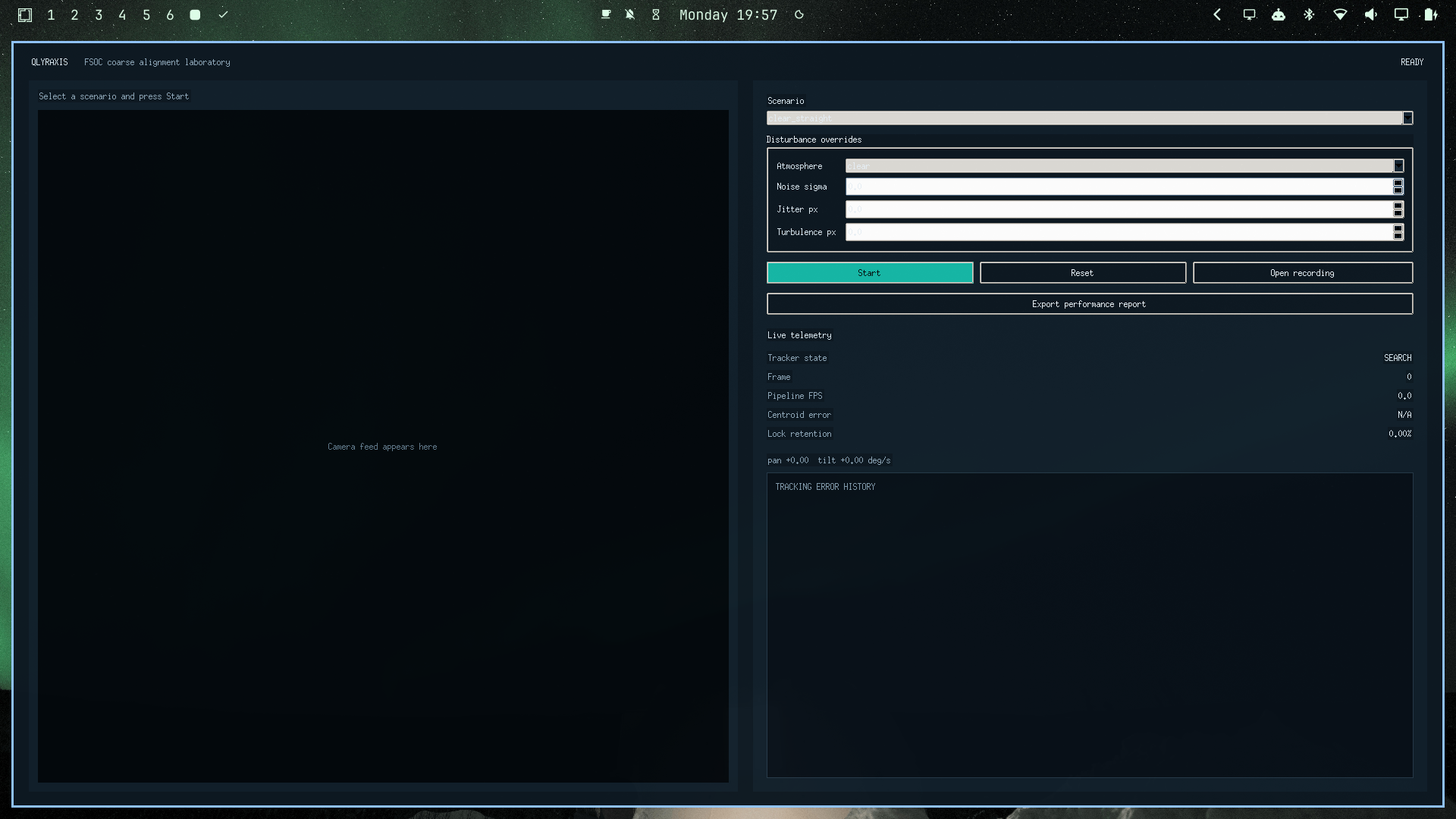
Figure 1 Main desktop window
Control | Action
Scenario | Select one of the five reproducible configurations
Disturbance overrides | Adjust atmosphere noise jitter and turbulence before starting
Start Pause | Begin or temporarily stop frame processing
Reset | Clear state metrics and the current source
Open recording | Choose a video or still image for ground truth free analysis
Export performance report | Write CSV JSON and HTML to a chosen directory

Running Simulations
1. Choose clear straight for the simplest smoke test or another scenario for disturbances.
2. Optionally change the atmosphere noise sigma jitter or turbulence fields.
3. Press Start and observe the tracker state change from SEARCH to ACQUIRE to TRACK.
4. Confirm that the magenta estimate circle and yellow detection box remain on the beacon.
5. Watch pipeline FPS centroid error lock retention and the error history plot.
6. Pause when needed or reset to replay from frame zero with the same seed.

Scenario Guide
Scenario | Primary test
clear straight | Baseline acquisition tracking and camera control
noisy circle | Gaussian and Poisson noise under curved motion
fog figure eight | Low contrast blur turbulence and direction reversal
jitter random | Maximum jitter salt and pepper noise and random motion
reacquisition dropout | Timed beacon loss prediction and recovery

Recorded Media and AI
Use Open recording in the desktop application or the analyze command for MP4 AVI MOV MKV PNG JPEG and image directories. Recorded media has no simulator truth, so centroid error is shown as N A while detection state and lock retention remain available.

Command Line Analysis
qlyraxis record configs/scenarios/fog_figure_eight.json work/fog.mp4 --frames 240
qlyraxis analyze work/fog.mp4 --model models/beacon_verifier.onnx
qlyraxis analyze path/to/frames --fps 30 --max-frames 300
qlyraxis analyze work/fog.mp4 --no-ai
The AI verifier is enabled by default. Use no ai only when comparing it with the classical detector. To retrain, install the training extra and run qlyraxis train-ai. The command writes NumPy weights and an ONNX model and reports held out accuracy.
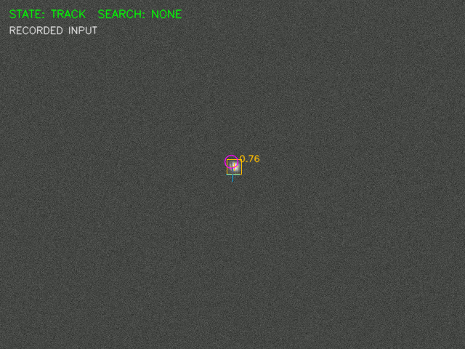
Figure 2 AI verified recorded frame

Reports and Benchmarking
A performance export contains three matching files. CSV is suitable for spreadsheets, JSON preserves configuration summary state counts and every frame, and HTML presents a readable summary with a tracking error chart.

Full Scenario Benchmark
qlyraxis benchmark configs/scenarios/clear_straight.json --output-dir reports/clear
qlyraxis benchmark configs/scenarios/reacquisition_dropout.json --output-dir reports/dropout
python scripts/summarize_benchmarks.py
Metric | Interpretation
Acquisition time | First simulation timestamp in TRACK
Tracking error | Distance between measured centroid and transformed truth
Lock retention | TRACK or COAST frames after initial acquisition
Target loss | One hundred minus lock retention
Reacquisition time | Elapsed time from REACQUIRE to restored TRACK
Processing FPS | Inverse of average measured frame processing time

Troubleshooting and Submission Checklist
Symptom | Resolution
GUI does not open | Confirm a desktop display is available and Tk is installed
Model not found | Run from the repository root or pass model with an absolute path
Video does not decode | Convert it to MP4 with H264 or MPEG4 and retry
No beacon is detected | Check contrast target size and detector thresholds then compare no ai
FPS is below target | Close other workloads reduce frame size or use the classical comparison mode
Training export fails | Install the training extra which provides ONNX
Packaged GUI cannot load Tk | Rebuild with the supplied spec so Tcl Tk libraries are included

Submission Contents
- Source repository with modular documented code
- Packaged application folder for the target operating system
- Technical report and this user manual
- Five scenario performance logs and compact benchmark summary
- Optional demonstration video and presentation deck
Before submission run the full automated test suite, repeat the benchmark command on the submission computer, open each HTML report, and launch the packaged GUI once from a copied folder.

