Online Grocery Delivery System
Microservices Mini Project Report - Team 8
Team members: ____________________ (5 students)
Table of Contents

1. Problem Statement
Customers of a grocery store want to browse products, place an order, pay online and have it delivered. A single monolithic application is hard to scale and one failure (for example the payment module) can bring the whole shop down. This project builds the system as independent microservices that communicate through REST APIs, each owning its own database, with an API Gateway, service discovery, circuit breakers and a Saga for the distributed order transaction. All data is fake; no real personal or payment data is used.

2. System Architecture
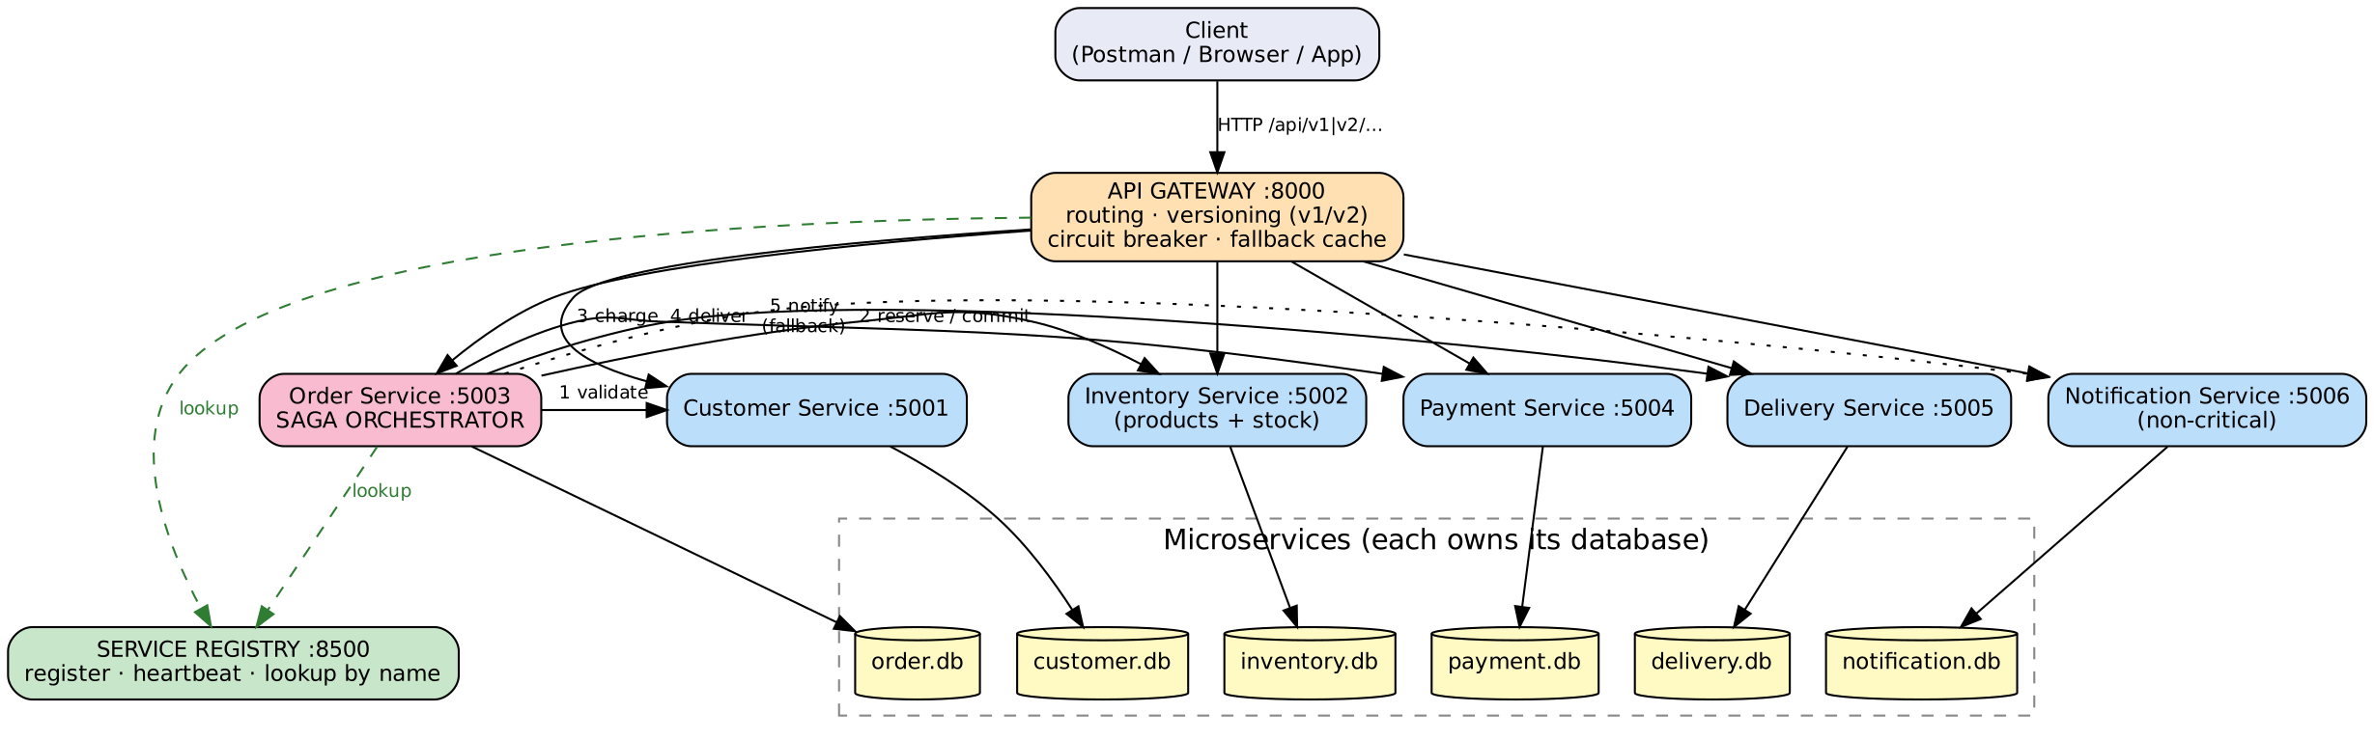
Architecture
Client -> API Gateway -> microservices -> individual databases; every service registers with the Service Registry and looks others up by name; calls are protected by circuit breakers; the Order service orchestrates the Saga.

3. Microservices and Responsibilities
Service | Port | Database | Responsibility
Service Registry | 8500 | in-memory | register, heartbeat, lookup by name
API Gateway | 8000 | - | single entry point, routing, version check, fallback
Customer | 5001 | customer.db | customer profiles
Inventory | 5002 | inventory.db | products, stock, reservations
Order | 5003 | order.db | orders, Saga orchestration, v1/v2 APIs
Payment | 5004 | payment.db | simulated payments and refunds
Delivery | 5005 | delivery.db | delivery agents, delivery assignment
Notification | 5006 | notification.db | customer messages (non-critical)

4. REST API List
See API_DOCUMENTATION.md and Postman_Collection.json. All four methods (GET, POST, PUT, DELETE) are used with proper status codes (200, 201, 400, 402, 404, 409, 424, 503).

5. API Versioning
/api/v1/orders returns a flat order. /api/v2/orders returns {data, meta} with nested customer, payment, delivery, items, saga steps and links, plus paging and filtering. The gateway rejects unsupported versions with a 404 listing supported versions.

6. Service Discovery
Each service registers its name and URL with the Registry at start-up and sends a heartbeat every 3 s. The Registry removes an instance after 9 s without heartbeat. Callers use discovery.resolve("payment-service"); no service URL is hard-coded. A restarted service re-registers automatically.

7. Circuit Breaker and Failure Demonstration
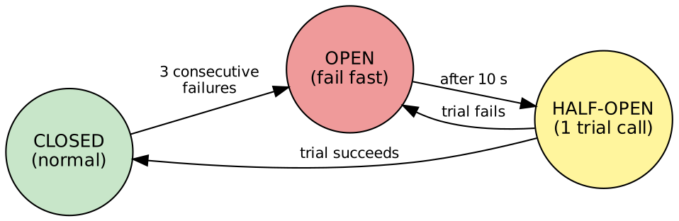
Circuit breaker states
Implementation: common/circuit_breaker.py, used by every inter-service call. Threshold 3 consecutive failures, recovery timeout 10 s. Connection errors, timeouts and HTTP 5xx count as failures; business errors (4xx) do not. Real demo (tests/demo_circuit_breaker.py, output in CIRCUIT_BREAKER_DEMO.txt): payment-service was killed; attempts 1-3 failed with “connection refused” and the circuit went CLOSED -> OPEN; attempts 4-5 were rejected instantly (fail fast); the gateway returned a clean 503 and opened its own circuit; products and customers kept working; after restart the circuit moved OPEN -> HALF_OPEN -> CLOSED on the first trial order. With notification-service down, orders were still confirmed (fallback).

8. Database per Service and Data Isolation
Each service has its own SQLite file in its own folder. The Order database stores only customer_id, product_id, payment_id and delivery_id as plain references (no foreign keys across databases). Customer name, prices, etc. are obtained through the other services’ REST APIs. Automated checks confirm six separate DB files, no duplicated tables, and that no service code opens another service’s .db file (DATA_ISOLATION_DEMO.txt).

9. API Gateway
Implemented in services/gateway/app.py. Routes /api/<version>/<resource> to the right service via discovery, adds X-Request-ID and X-Routed-To, checks versions, converts failures to JSON 503 and serves stale cached product lists if inventory is down.

10. Saga Workflow and Compensating Action
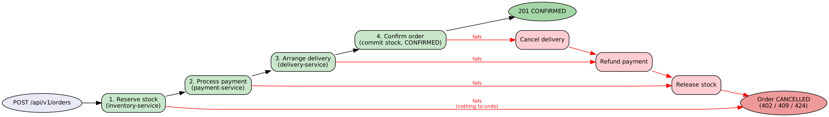
Saga
Orchestrated Saga in the Order service: Reserve stock (Inventory) -> Process payment (Payment) -> Arrange delivery (Delivery) -> Confirm order. Compensations run in reverse order: cancel delivery, refund payment, release stock. Tested scenarios: payment declined (stock released), unserviceable pincode after payment (payment refunded then stock released), insufficient stock, dependency down (424), and customer cancellation of a confirmed order. Every step is written to saga_log.

11. Source Code and Database Schema
Source: folder services/ and common/. Schemas are in each service’s init_db(): customers; products, reservations; orders, order_items, saga_log; payments; agents, deliveries; notifications.

12. API Testing Results
Automated suite tests/run_tests.py: 54/54 checks passed (details in TEST_RESULTS.md). Add your own Postman screenshots here.

13. Conclusion and Future Work
The system demonstrates REST, versioning, discovery, inter-service calls, circuit breaker, database per service, gateway, Saga and fault tolerance. Future work: PostgreSQL, message broker, Docker, authentication, automatic saga recovery, distributed tracing.

