**Experiment No. 1**

*import* java**.**util**.***\****;**

class **ProductCipher** {

*public* *static* *void* main(String **args**[]) {

        Scanner scanner **=** **new** Scanner(System**.***in*)**;**

*// Input for substitution encryption*

        System**.***out***.**println("Enter the input to be encrypted:")**;**

        String substitutionInput **=** scanner**.**nextLine()**;**

*// Input for transposition encryption*

        System**.***out***.**println("Enter a number for transposition:")**;**

*int* n **=** scanner**.**nextInt()**;**

*// Substitution encryption*

        StringBuffer substitutionOutput **=** **new** StringBuffer()**;**

**for** (*int* i **=** 0**;** i **<** substitutionInput**.**length()**;** i**++**) {

*char* c **=** substitutionInput**.**charAt(i)**;**

            substitutionOutput**.**append((*char*) (c **+** 5))**;** *// Shift each character by 5*

        }

        System**.***out***.**println("\nSubstituted text:")**;**

        System**.***out***.**println(substitutionOutput)**;**

*// Transposition encryption*

        String transpositionInput **=** substitutionOutput**.**toString()**;**

*int* modulus **=** transpositionInput**.**length() **%** n**;**

**if** (modulus **!=** 0) {

            modulus **=** n **-** modulus**;** *// Calculate padding needed*

**for** (**;** modulus **!=** 0**;** modulus**--**) {

                transpositionInput **+=** "X"**;** *// Add padding character 'X'*

            }

        }

        StringBuffer transpositionOutput **=** **new** StringBuffer()**;**

        System**.***out***.**println("\nTransposition Matrix:")**;**

**for** (*int* i **=** 0**;** i **<** n**;** i**++**) {

**for** (*int* j **=** 0**;** j **<** transpositionInput**.**length() **/** n**;** j**++**) {

*char* c **=** transpositionInput**.**charAt(i **+** (j **\*** n))**;**

                System**.***out***.**print(c)**;** *// Print matrix row-wise*

                transpositionOutput**.**append(c)**;**

            }

            System**.***out***.**println()**;**

        }

        System**.***out***.**println("\nFinal encrypted text:")**;**

        System**.***out***.**println(transpositionOutput)**;**

*// Transposition decryption*

        String transpositionEncrypted **=** transpositionOutput**.**toString()**;**

*int* rows **=** transpositionEncrypted**.**length() **/** n**;**

        StringBuffer transpositionPlaintext **=** **new** StringBuffer()**;**

**for** (*int* i **=** 0**;** i **<** rows**;** i**++**) {

**for** (*int* j **=** 0**;** j **<** n**;** j**++**) {

*char* c **=** transpositionEncrypted**.**charAt(i **+** (j **\*** rows))**;**

                transpositionPlaintext**.**append(c)**;**

            }

        }

*// Remove padding*

**while** (transpositionPlaintext**.**charAt(transpositionPlaintext**.**length() **-** 1) **==** 'X') {

            transpositionPlaintext**.**deleteCharAt(transpositionPlaintext**.**length() **-** 1)**;**

        }

*// Substitution decryption*

        StringBuffer plaintext **=** **new** StringBuffer()**;**

**for** (*int* i **=** 0**;** i **<** transpositionPlaintext**.**length()**;** i**++**) {

*char* c **=** transpositionPlaintext**.**charAt(i)**;**

            plaintext**.**append((*char*) (c **-** 5))**;** *// Reverse shift by 5*

        }

        System**.***out***.**println("\nDecrypted Plaintext:")**;**

        System**.***out***.**println(plaintext)**;**

        scanner**.**close()**;**

    }

}

**Output:**

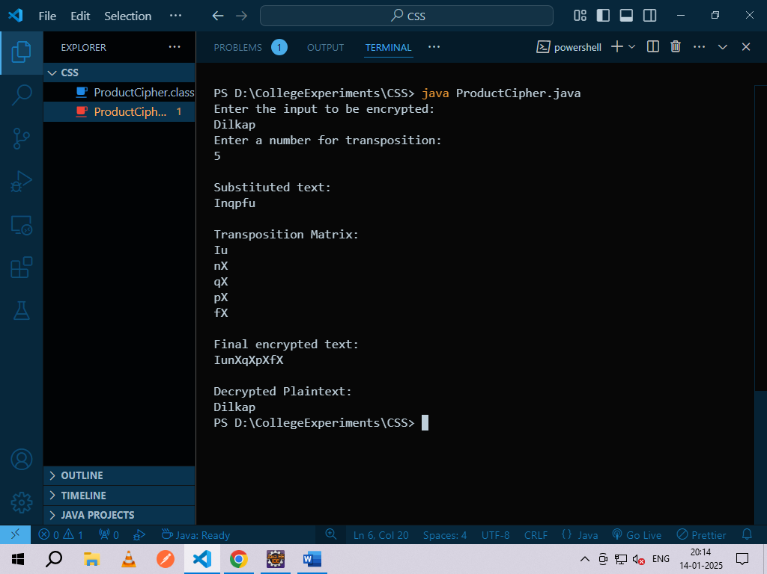

**Experiment No. 2**

*import* java.util.*\**;

class Expl {

*public* *static* *void* main(String args[]) {

        Scanner sc = new Scanner(System.*in*);

*int* d = 0;

        System.*out*.println("Enter two prime numbers");

*int* p = sc.nextInt();

*int* q = sc.nextInt();

*int* n = p * q;

        System.*out*.println("n = " + n);

*int* pn = (p - 1) * (q - 1);

*int* e = 0;

        search:

        for (*int* i = 2; i <= pn; i++) {

*int* j = i;

*int* k = pn;

            while (k != j) {

                if (k > j)

                    k = k - j;

                else

                    j = j - k;

            }

            if (k == 1) {

                e = i;

                break search;

            }

        }

        System.*out*.println("e = " + e);

        go:

        for (*int* i = 1; i < pn; i++) {

*int* x = (e * i) % pn;

            if (x == 1) {

                System.*out*.println("d = " + i);

                System.*out*.println("The private key is (d) " + i);

                d = i;

                break go;

            }

        }

        System.*out*.println("The public key is (n, e) " + n + "," + e);

        System.*out*.println("Enter plaintext");

        String t = sc.next();

*int* c, m = 0;

        for (*int* i = 0; i < t.length(); i++) {

            m += (*int*) t.charAt(i);

        }

        c = (m * e) % n;

        System.*out*.println("The Encrypted message is " + c);

        m = (c * d) % n;

        System.*out*.println("The decrypted message is " + m);

    }

}

**Output:**

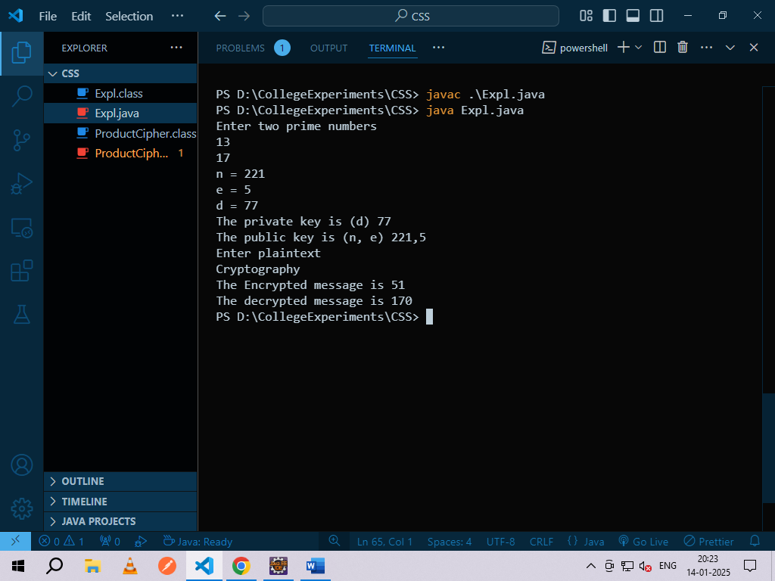

**Experiment No. 3**

*import* java**.**util**.***\****;**

*import* java**.**math**.**BigInteger**;**

*public* class **DiffieHellman** {

*final* *static* BigInteger one **=** **new** BigInteger("1")**;**

*public* *static* *void* main(String **args**[]) {

        Scanner stdin **=** **new** Scanner(System**.***in*)**;**

        BigInteger n**;**

*// Get a start spot to pick a prime from the user.*

        System**.***out***.**println("Enter the first prime no:")**;**

        String ans **=** stdin**.**next()**;**

        n **=** getNextPrime(ans)**;**

        System**.***out***.**println("First prime is: " **+** n **+** ".")**;**

*// Get the base for exponentiation from the user.*

        System**.***out***.**println("Enter the second prime no(between 2 and n-1):")**;**

        BigInteger g **=** **new** BigInteger(stdin**.**next())**;**

*// Get A’s secret number.*

        System**.***out***.**println("Person A: enter your secret number now i.e any random no(x):")**;**

        BigInteger a **=** **new** BigInteger(stdin**.**next())**;**

*// Make A’s calculation.*

        BigInteger resulta **=** g**.**modPow(a**,** n)**;**

*// This is the value that will get sent from A to B.*

*// This value does NOT compromise the value of a easily.*

        System**.***out***.**println("Person A sends " **+** resulta **+** " to person B.")**;**

*// Get B’s secret number.*

        System**.***out***.**println("Person B: enter your secret number now i.e any random no(y):")**;**

        BigInteger b **=** **new** BigInteger(stdin**.**next())**;**

*// Make B’s calculation.*

        BigInteger resultb **=** g**.**modPow(b**,** n)**;**

        System**.***out***.**println("Person B sends " **+** resultb **+** " to person A.")**;**

*// Key A calculates*

        BigInteger KeyACalculates **=** resultb**.**modPow(a**,** n)**;**

*// Key B calculates*

        BigInteger KeyBCalculates **=** resulta**.**modPow(b**,** n)**;**

*// Print out the Key A calculates.*

        System**.***out***.**println("A takes " **+** resultb **+** " raises it to the power " **+** a **+** " mod " **+** n **+** ".")**;**

        System**.***out***.**println("The Key A calculates is " **+** KeyACalculates **+** ".")**;**

*// Print out the Key B calculates.*

        System**.***out***.**println("B takes " **+** resulta **+** " raises it to the power " **+** b **+** " mod " **+** n **+** ".")**;**

        System**.***out***.**println("The Key B calculates is " **+** KeyBCalculates **+** ".")**;**

    }

*public* *static* BigInteger getNextPrime(String **ans**) {

        BigInteger test **=** **new** BigInteger(ans)**;**

**while** (**!**test**.**isProbablePrime(99))

            test **=** test**.**add(one)**;**

**return** test**;**

    }

}

**Output:**

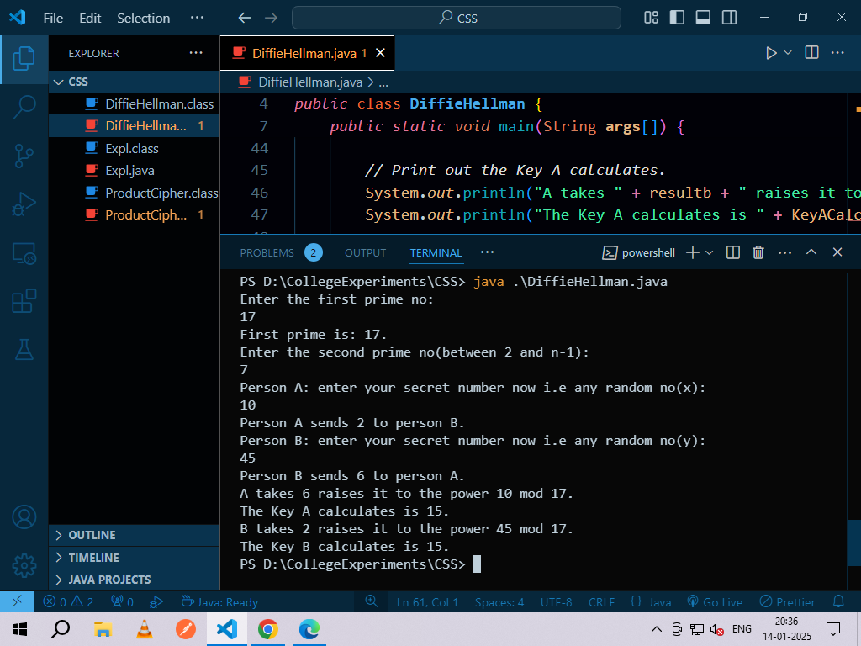

**Experiment No. 4**

*import* java**.**security**.**MessageDigest**;**

*import* java**.**security**.**NoSuchAlgorithmException**;**

*import* java**.**security**.**SecureRandom**;**

*public* class **SimpleMD5Example** {

*public* *static* *void* main(String[] **args**) {

        String passwordToHash **=** "password"**;**

        String generatedPassword **=** null**;**

**try** {

*// Create MessageDigest instance for MD5*

*// For hashing using MD5 can be replaced by SHA1 in the following line*

            MessageDigest md **=** MessageDigest**.**getInstance("MD5")**;**

*// Add password bytes to digest*

            md**.**update(passwordToHash**.**getBytes())**;**

*// Get the hash's bytes*

*byte*[] bytes **=** md**.**digest()**;**

*// This bytes[] has bytes in decimal format;*

*// Convert it to hexadecimal format*

            StringBuilder sb **=** **new** StringBuilder()**;**

**for** (*int* i **=** 0**;** i **<** bytes**.***length***;** i**++**) {

                sb**.**append(Integer**.**toString((bytes[i] **&** 0xff) **+** 0x100**,** 16)**.**substring(1))**;**

            }

*// Get complete hashed password in hex format*

            generatedPassword **=** sb**.**toString()**;**

        } **catch** (NoSuchAlgorithmException **e**) {

            e**.**printStackTrace()**;**

        }

        System**.***out***.**println(generatedPassword)**;**

    }

}

**Output:**

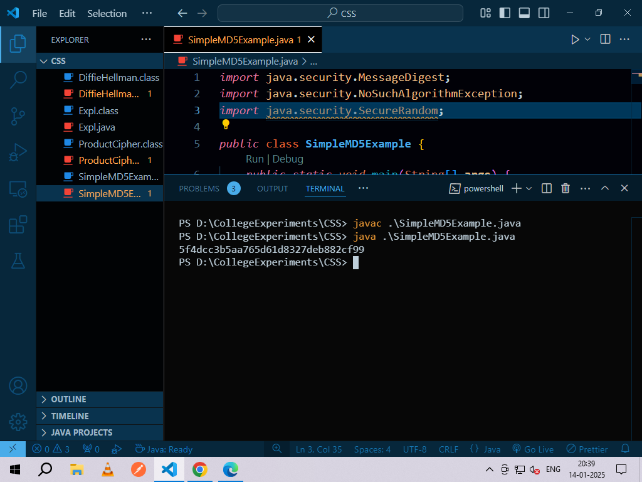

**Experiment No. 5**

1. **Whois Command**

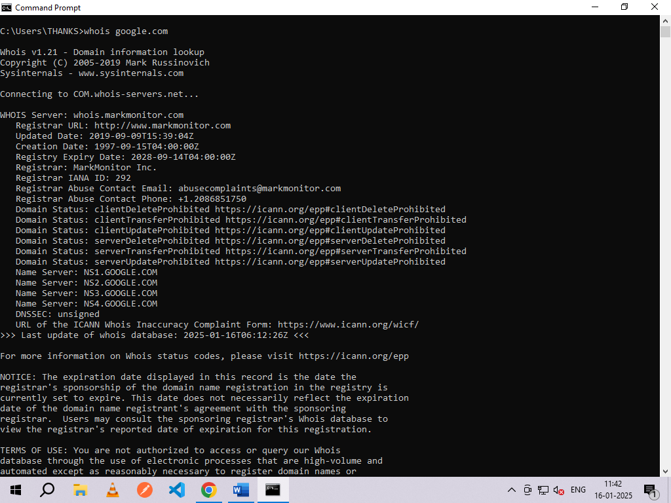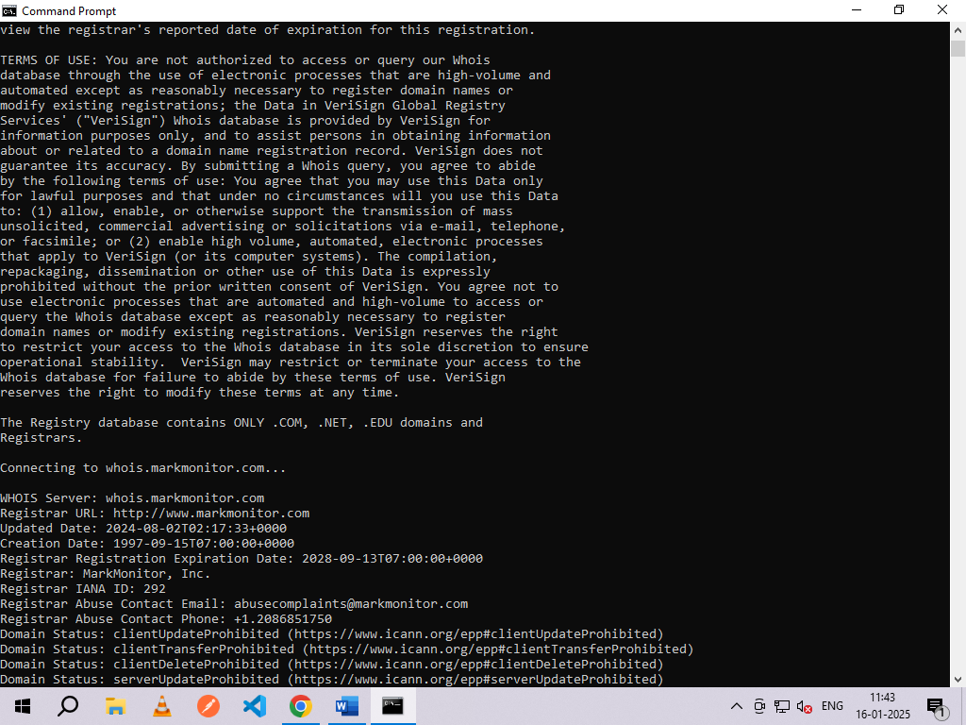

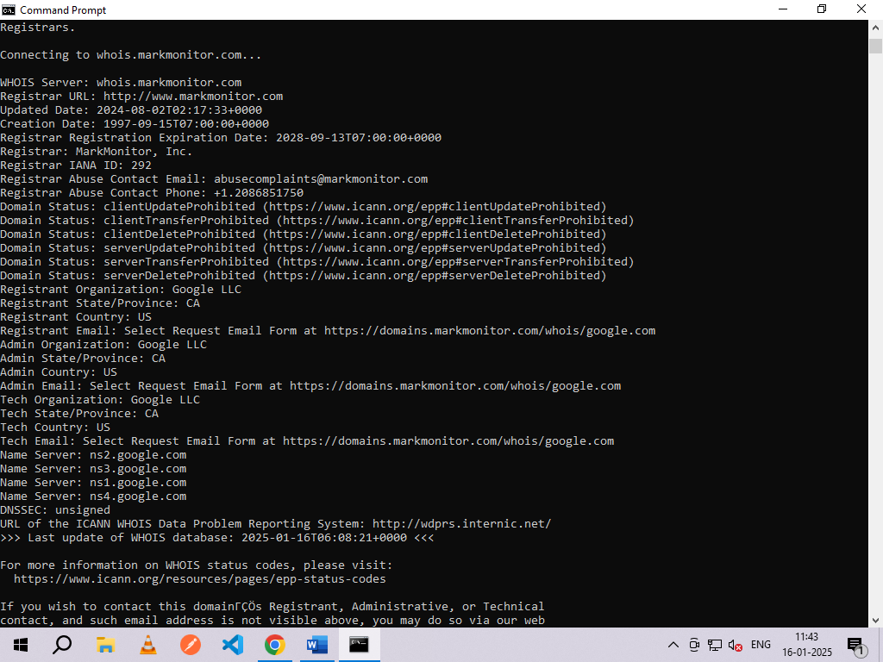

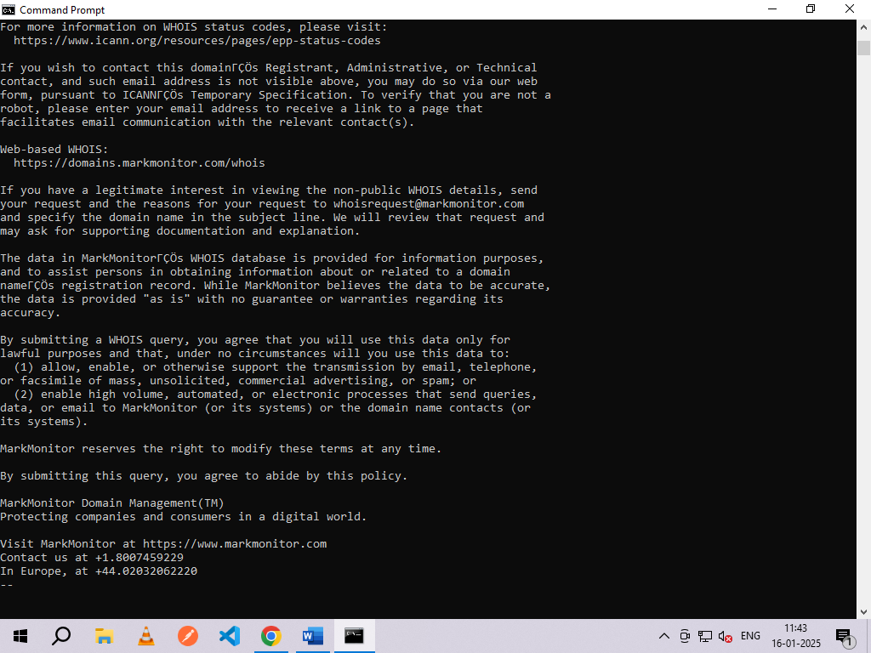

1. **Nslookup**

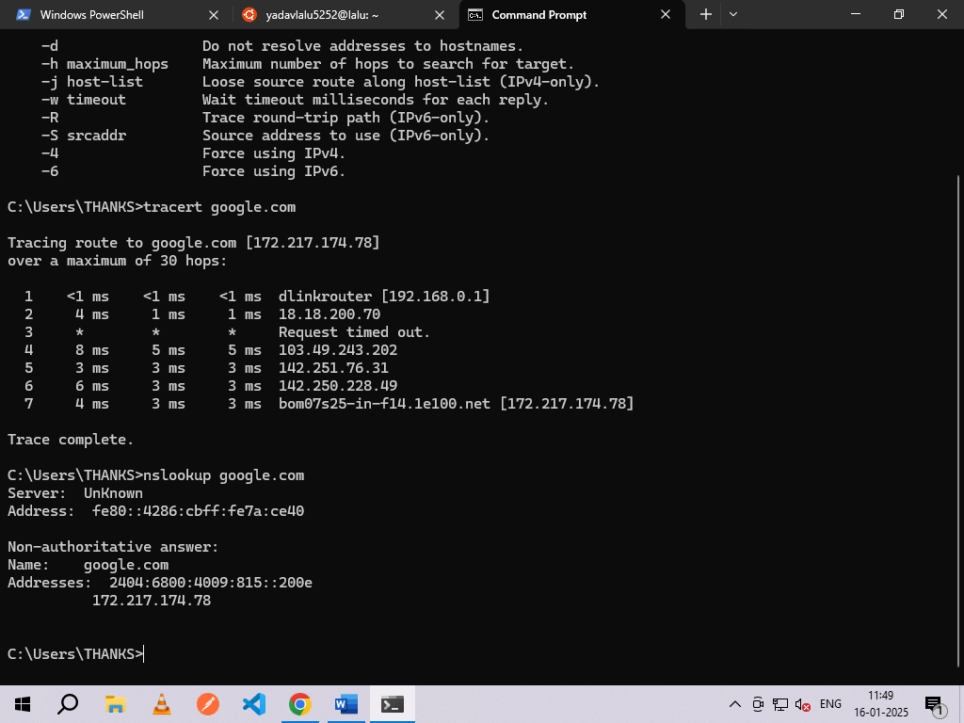

1. **Dig**

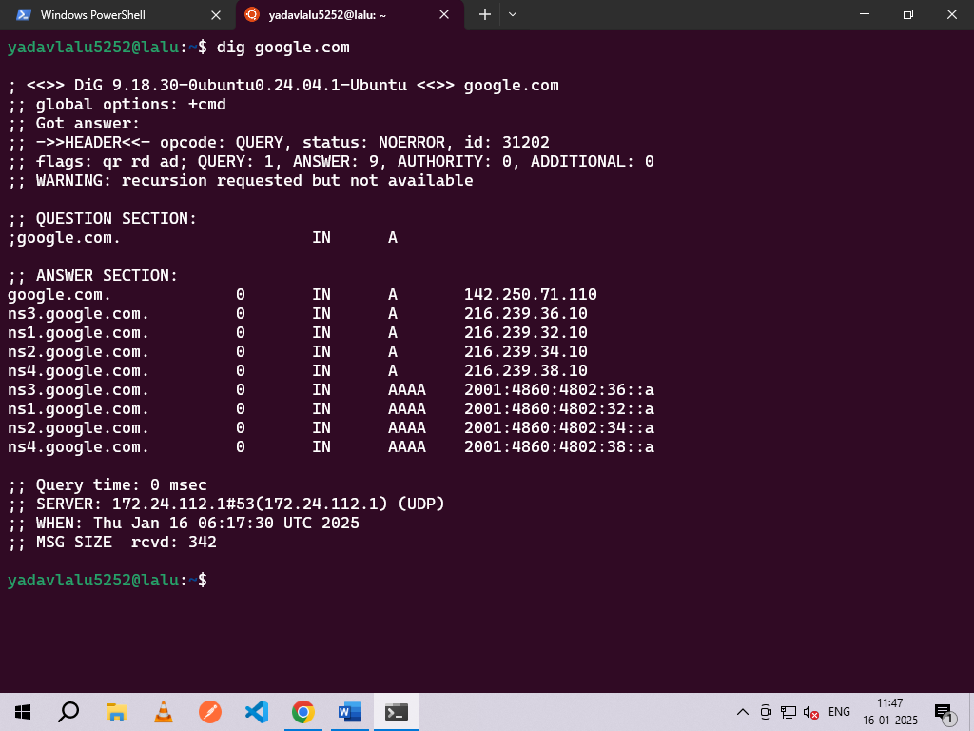

1. **Traceroute**

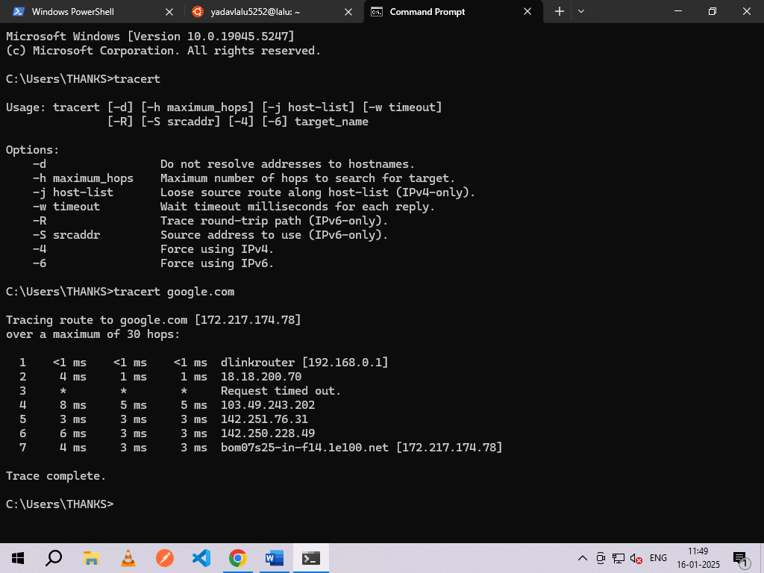

**Experiment No. 6**

**Output:**







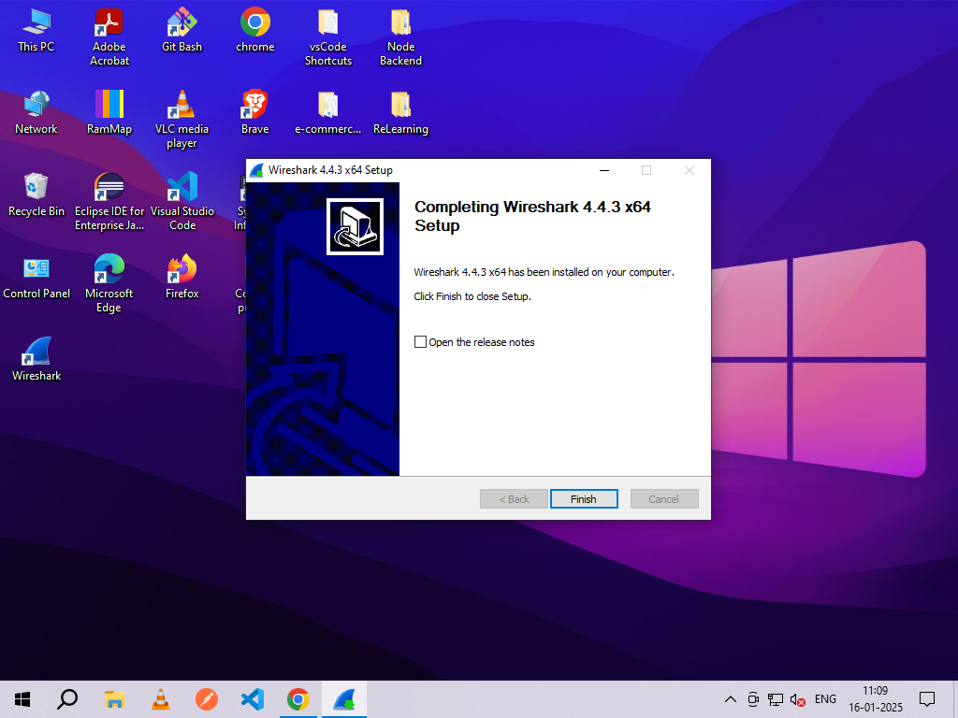

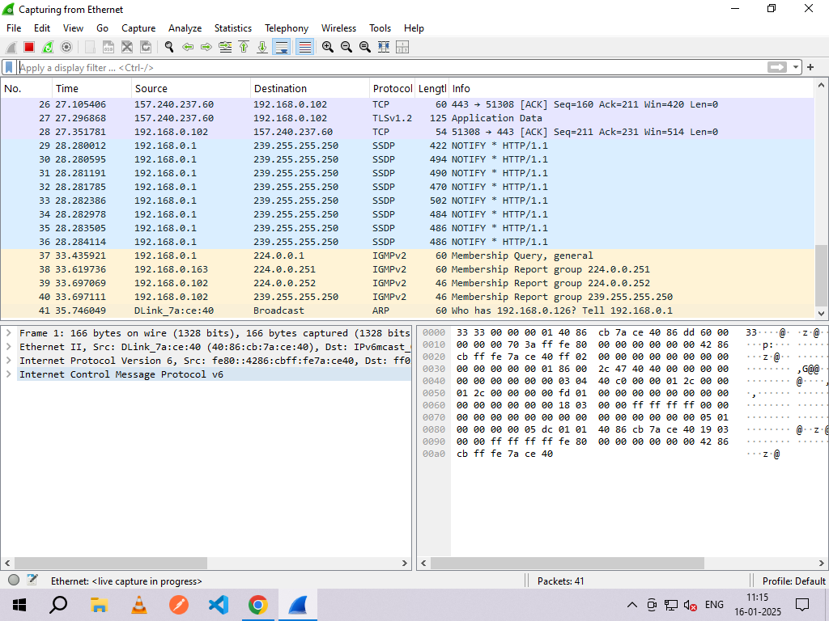

**Icmp:-**

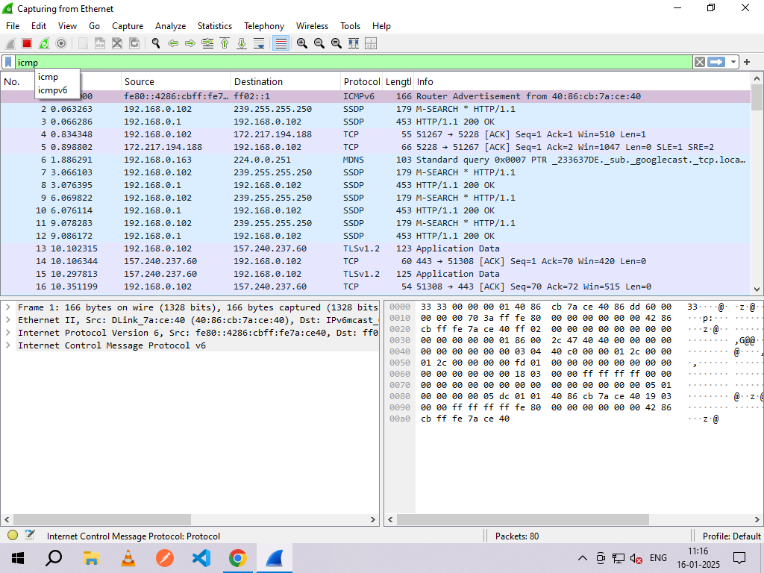

**Udp:-**

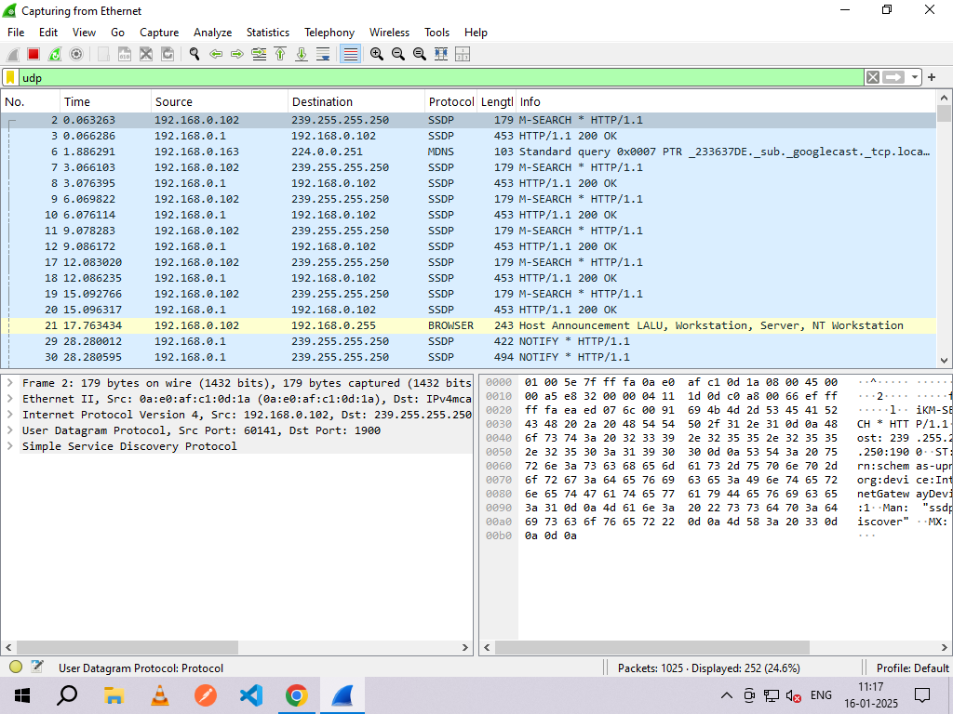

**Dns:-**

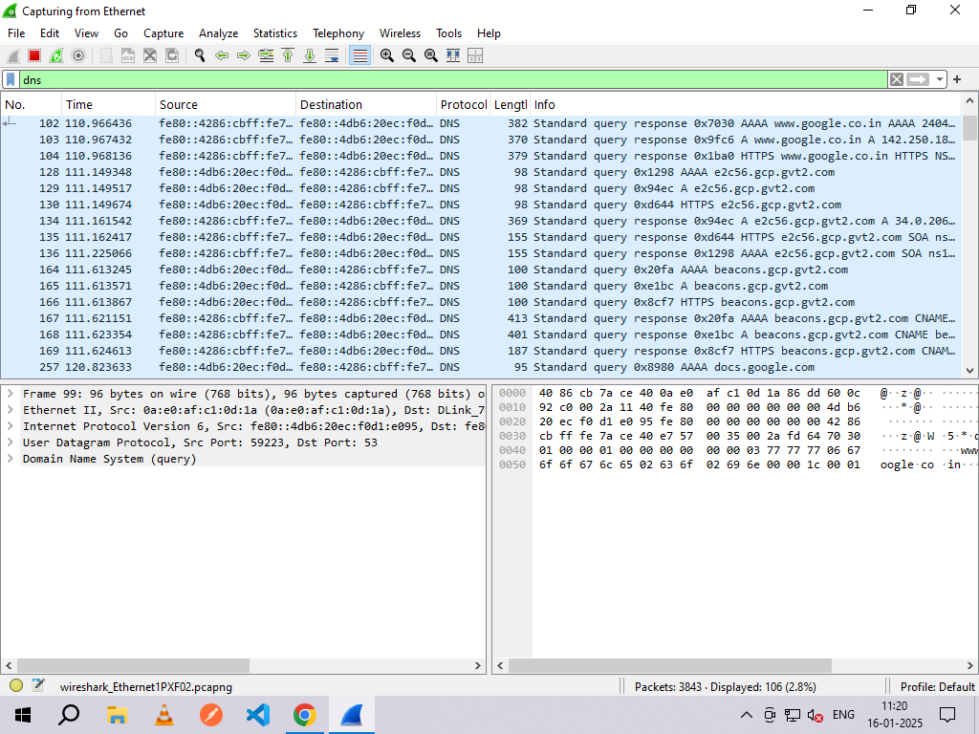

**Tcp:-**

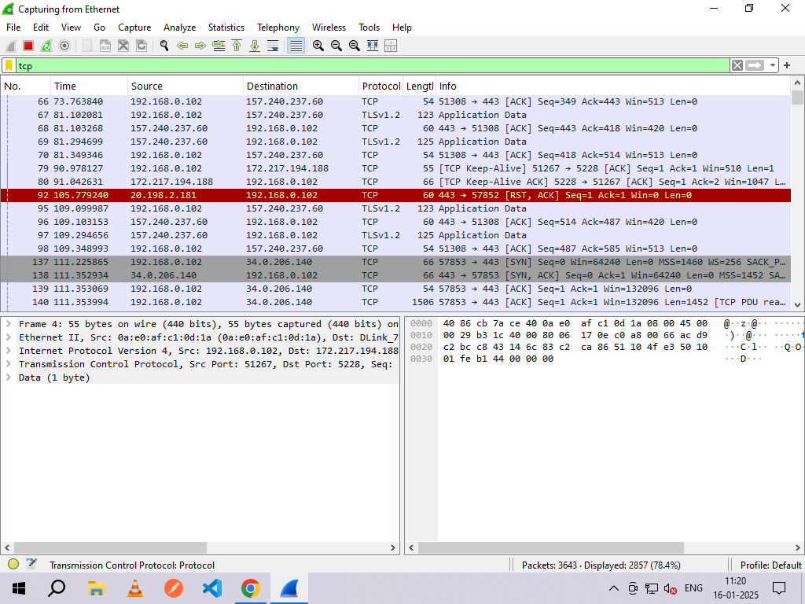

**Experiment No. 7**

1. **Nmap -Sp**

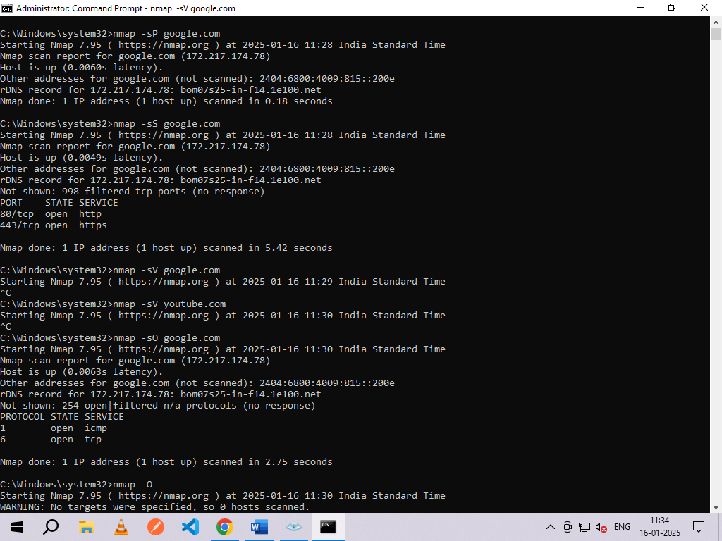

1. **FIN scan (-sF)**

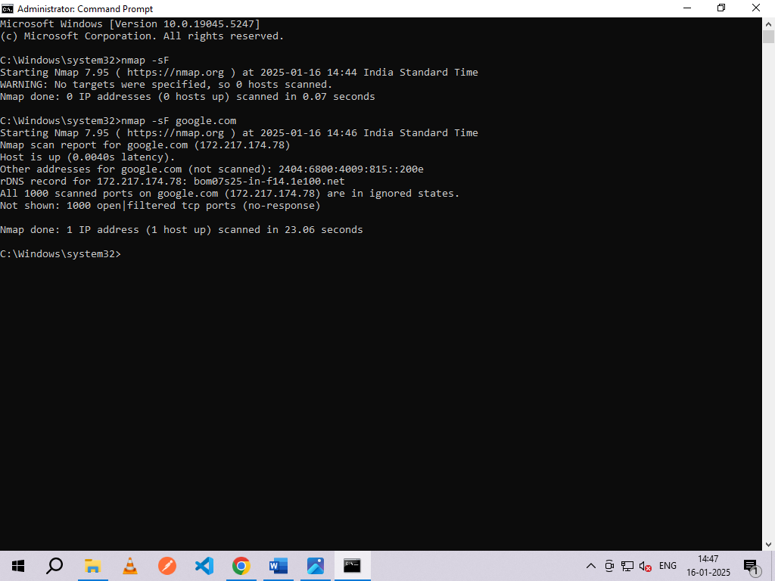

1. **-sV**



1. **-sO**



1. **-O**

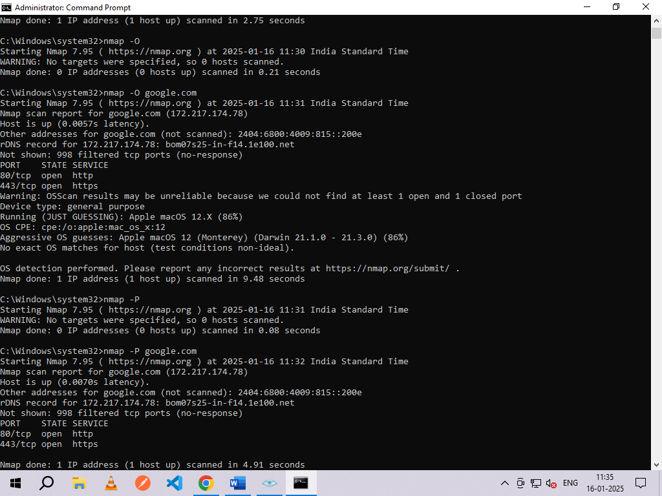

1. **-P port ranges**



1. **Nmap -iflist**

