PIZZA SALE ANALYSIS – SQL QUERIES
A: KPI Requirements:
- Total Revenue
select sum(total_price) as Total_Revenue from pizza_sales

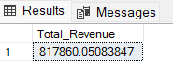

- Average Order Value
select sum(total_price)/count(distinct order_id) as Avg_Order_Value from pizza_sales

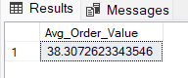

- Total Pizza Sold
select sum(quantity) as total_pizza_sold from pizza_sales

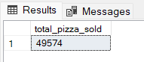

- Total Orders Placed
select count(distinct order_id) as Total_Orders from pizza_sales
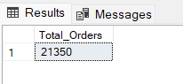

- Average Pizzas Per Order:
select cast(cast(sum(quantity) as decimal(10,2)) /
cast(count(distinct order_id) as decimal(10,2)) as decimal(10,2)) as Avg_Pizza_Per_Order from pizza_sales

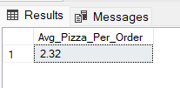

B: Chart Requirements:
- Daily Trend For Total Orders :
select datename(DW, order_date) as Order_Day, count(distinct order_id) as Total_Orders from pizza_sales
group by datename(DW, order_date)

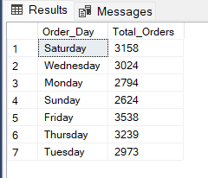

- Hourly Trend for Total Orders:

select datepart(hour, order_time) as Order_hours, count(distinct order_id) as Total_Orders
from pizza_sales
group by datepart(hour, order_time)
order by datepart(hour, order_time)

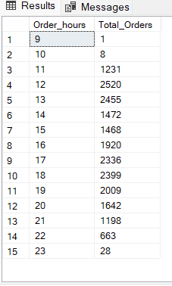

3: Percentage of sales by Pizza Category:

select pizza_category, sum(total_price) as total_sales, sum(total_price) * 100 /
(select sum(total_price) from pizza_sales where month(order_date)=1) as PCT from pizza_sales
where month(order_date)=1
group by pizza_category

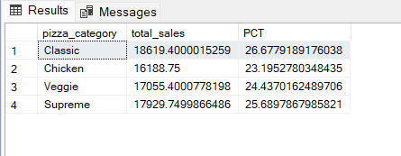

4: Percentage of Sales by Pizza Size:

select pizza_size, sum(total_price) as total_sales,cast( sum(total_price)*100 /
(select sum(total_price) from pizza_sales) as decimal(10,2)) as PCT from pizza_sales
group by pizza_size
order by PCT DESC

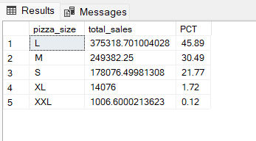

5: Total Pizzas Sold By Pizza Category:

select pizza_category,sum(quantity) as Total_Pizzas_Sold from pizza_sales
group by pizza_category

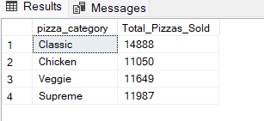

6: Top 5 Best Sellers by Total Pizzas Sold

select top 5 pizza_name, sum(quantity) as Total_Pizzas_Sold from pizza_sales
group by pizza_name
order by sum(quantity) DESC

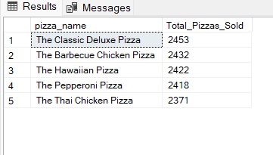

7: Bottom 5 Worst Seller by Total Pizzas Sold:

select top 5 pizza_name, sum(quantity) as Total_Pizzas_Sold from pizza_sales
group by pizza_name
order by sum(quantity)
