Question 4(a) — Read the CSV and inspect the DataFrame
Question: Read students_scores.csv into a pandas DataFrame and display the first five rows, column names and data types.
Python programming-based problem — Question 4 carries 10 marks. The code blocks in parts (a)–(f) form one program when run in order. Save the supplied dataset as students_scores.csv in the same folder. Python requires pandas and matplotlib.
import pandas as pd
import matplotlib.pyplot as plt
df = pd.read_csv("students_scores.csv")
subjects = ["Physics", "Chemistry", "Maths", "English"]
colors = ["#26756c", "#d38b38", "#476f9d", "#a25777"]
print("FIRST FIVE ROWS")
print(df.head(5).to_string(index=False))
print("\nCOLUMN NAMES:", list(df.columns))
print("\nDATA TYPES")
print(df.dtypes)
The data have 10 rows and six source columns. Student_ID and Student_Name are text/object columns; the four subject columns contain whole-number marks. The original identifiers and subject names are retained.
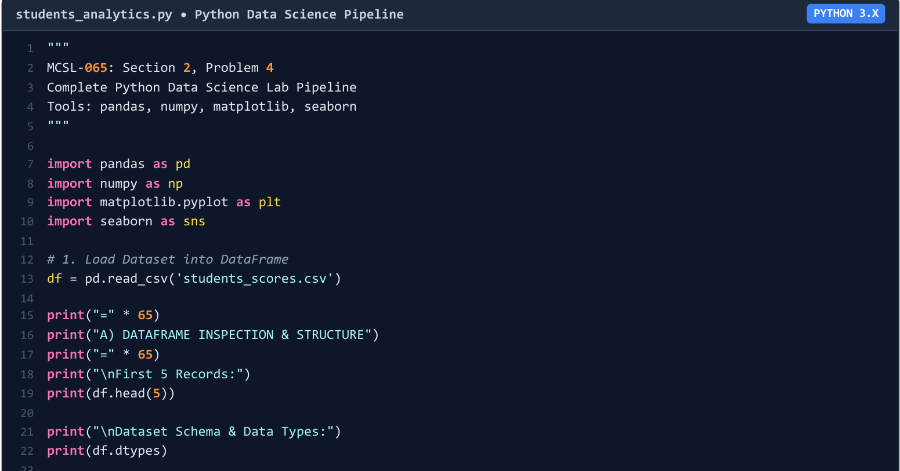
Figure 4(a)-1. Relevant region of the supplied Python source screenshot (solution PDF, page 7).
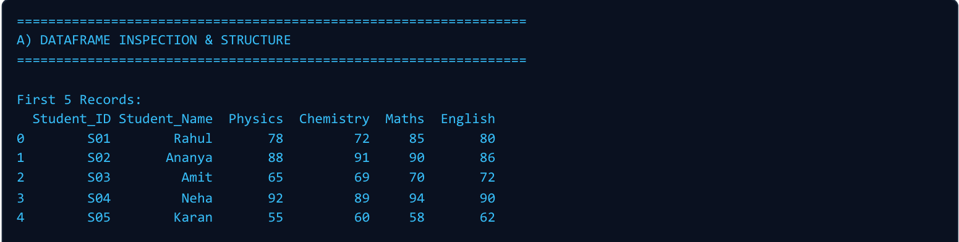
Figure 4(a)-2. Supplied Python output showing the first five records (solution PDF, page 8).
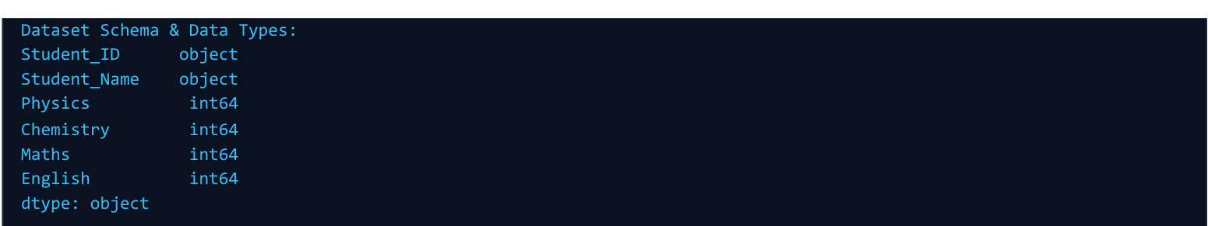
Figure 4(a)-3. Supplied Python data-type output (solution PDF, page 9).

Question 4(b) — Subject-wise descriptive statistics
Question: For each subject calculate mean, median, mode, minimum, maximum, range, variance and standard deviation.
Use pandas mean(), median(), min() and max(). Range is maximum − minimum. Sample variance and standard deviation use ddof=1. The mode helper returns all repeated modal values, or No mode when every observed score is distinct.
def statistical_mode(series):
counts = series.value_counts()
if counts.max() == 1:
return "No mode"
modes = sorted(counts[counts == counts.max()].index)
return ", ".join(str(value) for value in modes)
records = []
for subject in subjects:
s = df[subject]
records.append({
"Subject": subject,
"Mean": s.mean(), "Median": s.median(),
"Mode": statistical_mode(s),
"Minimum": s.min(), "Maximum": s.max(),
"Range": s.max() - s.min(),
"Variance": s.var(ddof=1),
"Std_Dev": s.std(ddof=1)
})
stats_df = pd.DataFrame(records)
print("\nSUBJECT-WISE DESCRIPTIVE STATISTICS")
print(stats_df.round(4).to_string(index=False))
stats_df.to_csv("python_descriptive_statistics.csv", index=False)
Subject | Mean | Median | Mode | Min | Max | Range | Variance | SD
Physics | 76.40 | 79.50 | No mode | 55 | 92 | 37 | 173.1556 | 13.1589
Chemistry | 77.90 | 78.50 | No mode | 60 | 92 | 32 | 149.4333 | 12.2243
Maths | 80.20 | 86.50 | 90 | 58 | 94 | 36 | 162.6222 | 12.7523
English | 79.20 | 82.00 | No mode | 62 | 91 | 29 | 102.4000 | 10.1193

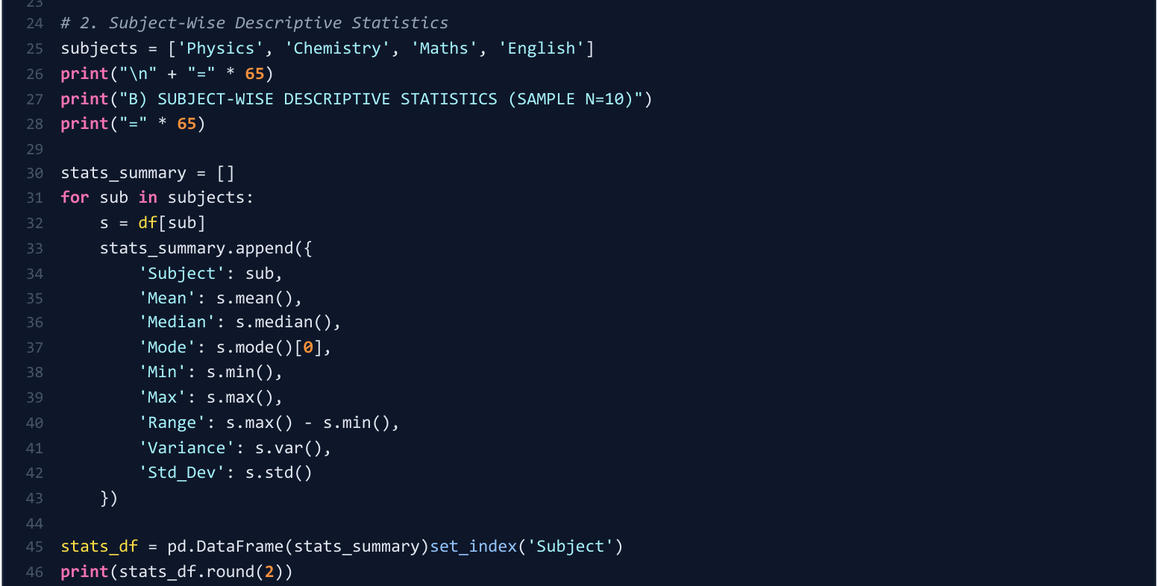
Figure 4(b)-1. Supplied reference statistics-code region (solution PDF, page 7).
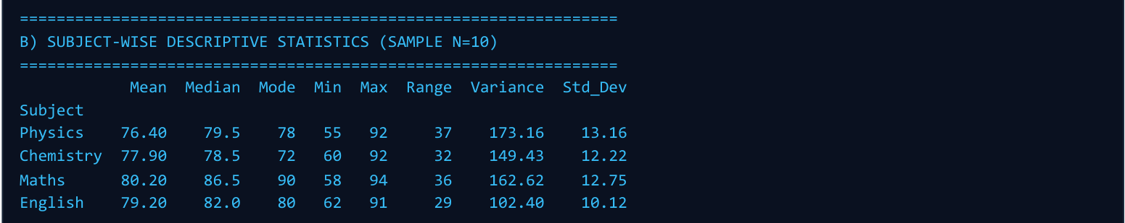
Figure 4(b)-2. Original supplied statistics screenshot, reproduced unchanged (solution PDF, page 9).
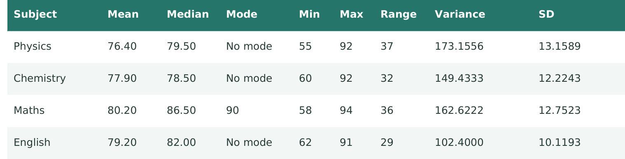
Figure 4(b)-3. Corrected statistics supplied in the review PDF, page 5.
The original screenshot lists single values as modes for Physics, Chemistry and English, although all ten scores in each of those subjects are distinct. The answer and runnable code follow the corrected review: No mode for those subjects; Maths has mode 90.

Question 4(c) — Totals, percentages and highest/lowest scorers
Question: Create Total and Percentage = (Total / 400) × 100; identify the topper and the lowest scorer.
Add the four subject columns row by row. Each subject is out of 100, so the total is out of 400. The equality filters below retain all students if a maximum or minimum is tied.
df["Total"] = df[subjects].sum(axis=1)
df["Percentage"] = (df["Total"] / 400) * 100
columns = ["Student_ID", "Student_Name", "Total", "Percentage"]
print("\nTOTALS AND PERCENTAGES")
print(df[columns].to_string(index=False))
topper = df.loc[df["Total"] == df["Total"].max(), columns]
lowest = df.loc[df["Total"] == df["Total"].min(), columns]
print("\nTOPPER\n", topper.to_string(index=False))
print("\nLOWEST SCORER\n", lowest.to_string(index=False))
df.to_csv("python_scores_with_totals.csv", index=False)
Student ID | Name | Total / 400 | Percentage
S01 | Rahul | 315 | 78.75%
S02 | Ananya | 355 | 88.75%
S03 | Amit | 276 | 69.00%
S04 | Neha | 365 | 91.25%
S05 | Karan | 235 | 58.75%
S06 | Priya | 338 | 84.50%
S07 | Rohit | 286 | 71.50%
S08 | Simran | 362 | 90.50%
S09 | Arjun | 255 | 63.75%
S10 | Pooja | 350 | 87.50%

Topper: Neha (S04), 365/400, 91.25%. Lowest scorer: Karan (S05), 235/400, 58.75%.
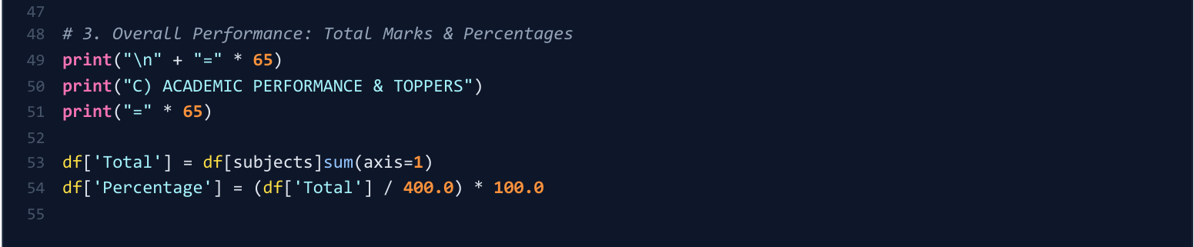
Figure 4(c)-1. Supplied source code for Total and Percentage (solution PDF, page 7).
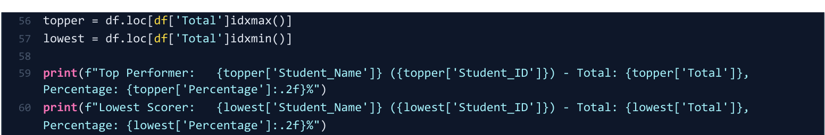
Figure 4(c)-2. Supplied continuation identifying the top and lowest scorers (solution PDF, page 8).
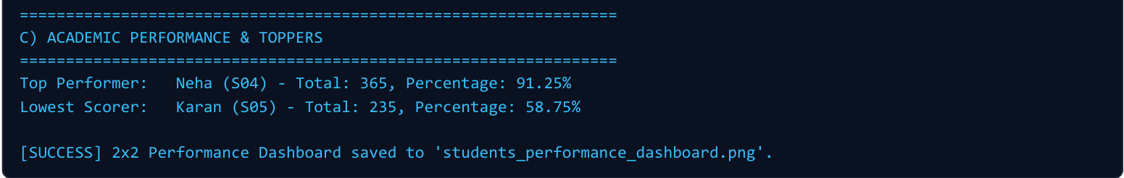
Figure 4(c)-3. Supplied Python output confirming Neha and Karan (solution PDF, page 9).

Question 4(d) — Maths scatter diagram and histogram
Question: Plot a scatter diagram and histogram of Maths scores and interpret whether they are concentrated or spread out.
Use Student_ID as the categorical position in the scatter plot. For the histogram use 10-mark intervals with boundaries 50, 60, 70, 80, 90 and 100. The expected counts are 1, 1, 2, 3 and 3.
plt.figure(figsize=(8, 4))
plt.scatter(df["Student_ID"], df["Maths"], color=colors[2], s=65)
plt.axhline(df["Maths"].mean(), color=colors[0], linestyle="--",
label=f"Mean = {df['Maths'].mean():.1f}")
plt.xlabel("Student ID (category)")
plt.ylabel("Maths marks / 100")
plt.title("Maths scores by student")
plt.ylim(50, 100)
plt.legend()
plt.tight_layout()
plt.savefig("python_maths_scatter.png", dpi=180)
plt.show()
plt.close()
plt.figure(figsize=(8, 4))
counts, edges, bars = plt.hist(df["Maths"],
bins=[50, 60, 70, 80, 90, 100], color=colors[2], edgecolor="white")
for count, bar in zip(counts, bars):
plt.text(bar.get_x() + bar.get_width()/2, count + .05,
str(int(count)), ha="center")
plt.xlabel("Maths marks (10-mark intervals)")
plt.ylabel("Number of students")
plt.title("Distribution of Maths scores")
plt.xticks([50, 60, 70, 80, 90, 100])
plt.yticks(range(5))
plt.ylim(0, 4)
plt.tight_layout()
plt.savefig("python_maths_histogram.png", dpi=180)
plt.show()
plt.close()
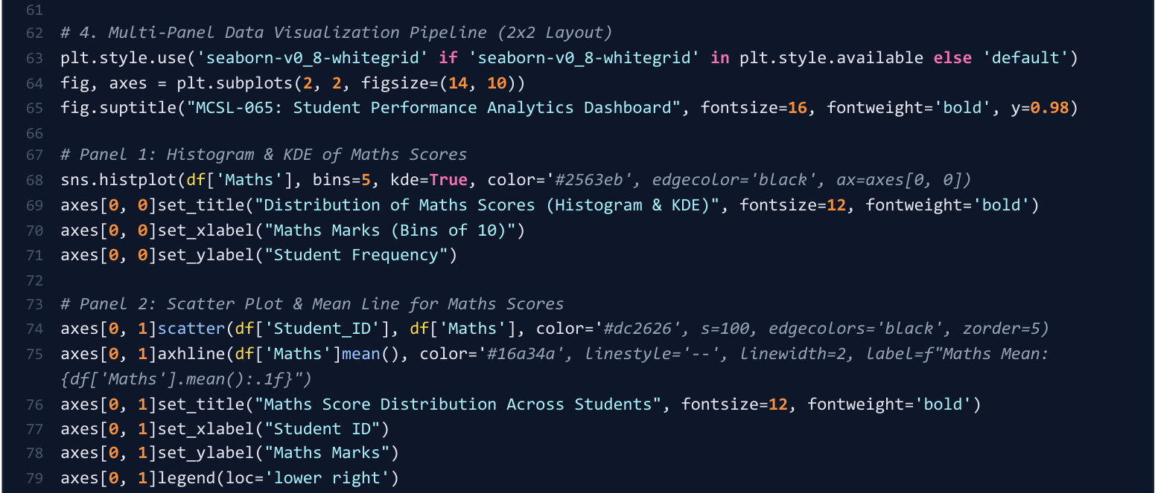
Figure 4(d)-1. Supplied reference plotting code for the Maths histogram and scatter view (solution PDF, page 8).
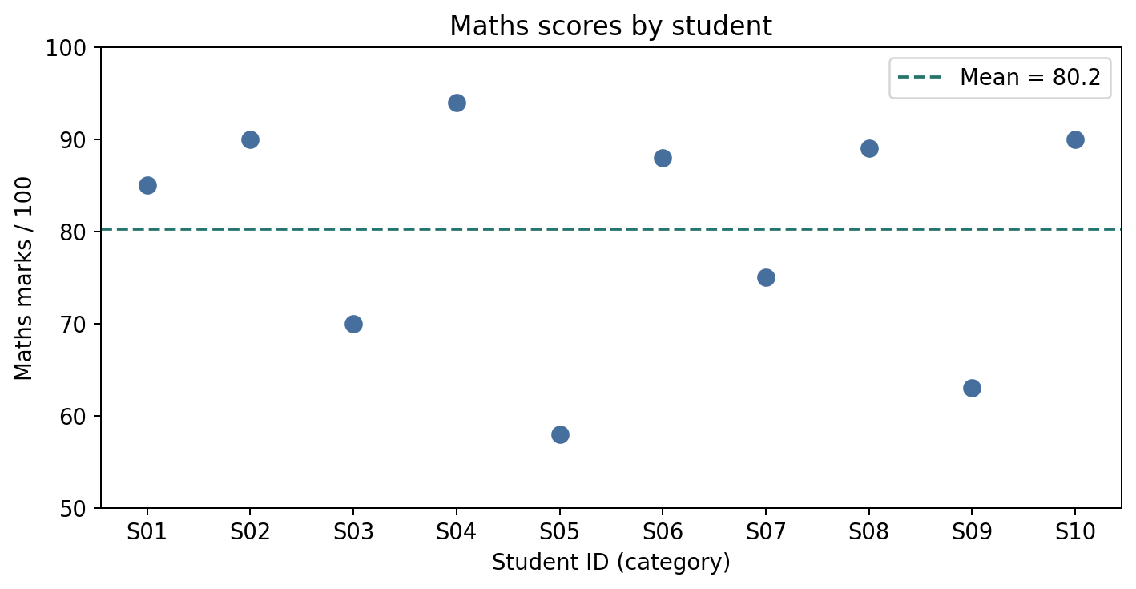
Figure 4(d)-2. Supplied Python scatter diagram, corresponding to review PDF page 19.
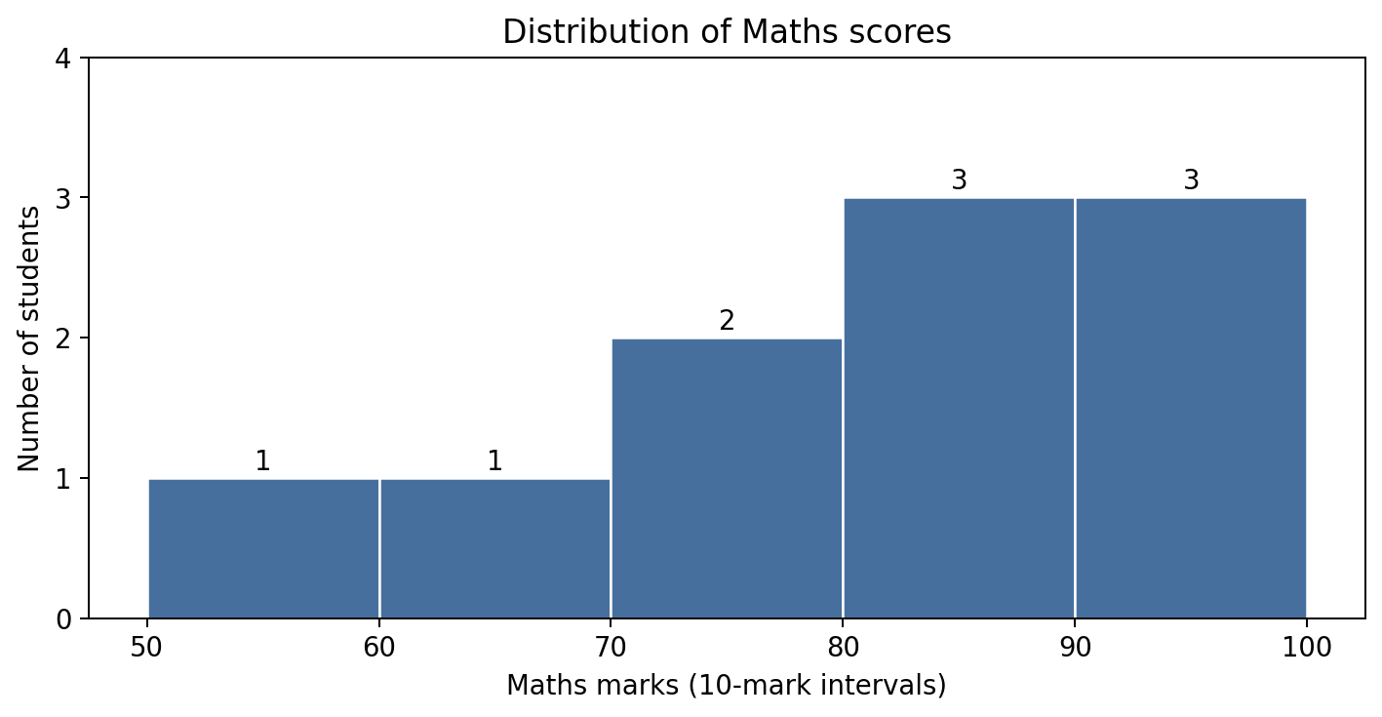
Figure 4(d)-3. Supplied Python Maths histogram, corresponding to review PDF page 19.
Maths scores range from 58 to 94, a range of 36, with sample SD 12.7523 and mean 80.20. Six students score at least 80, showing a greater concentration in the upper two intervals, while the overall set still has appreciable spread.
The reference uses a 2 × 2 plotting layout. The runnable code above saves separate figures to match the supplied individual plot screenshots. Student IDs distinguish people; their order is not a time variable.

Question 4(e) — Bar chart of subject averages
Question: Compute each subject average and plot a bar chart of the subject-wise averages.
averages = df[subjects].mean()
print("\nSUBJECT AVERAGES\n", averages)
plt.figure(figsize=(8, 4))
bars = plt.bar(averages.index, averages.values, color=colors)
plt.bar_label(bars, fmt="%.2f", padding=4)
plt.xlabel("Subject")
plt.ylabel("Average marks / 100")
plt.title("Subject-wise average scores")
plt.ylim(0, 100)
plt.tight_layout()
plt.savefig("python_subject_averages.png", dpi=180)
plt.show()
plt.close()
The averages are Physics 76.40, Chemistry 77.90, Maths 80.20 and English 79.20. Maths has the highest average and Physics the lowest; the gap is 3.80 marks.
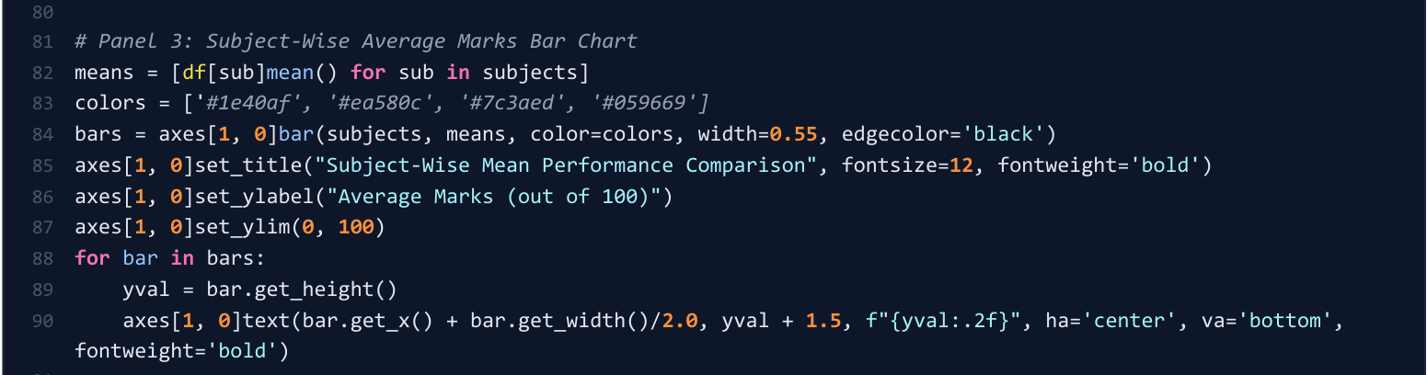
Figure 4(e)-1. Supplied Python source region for the average bar chart (solution PDF, page 8).
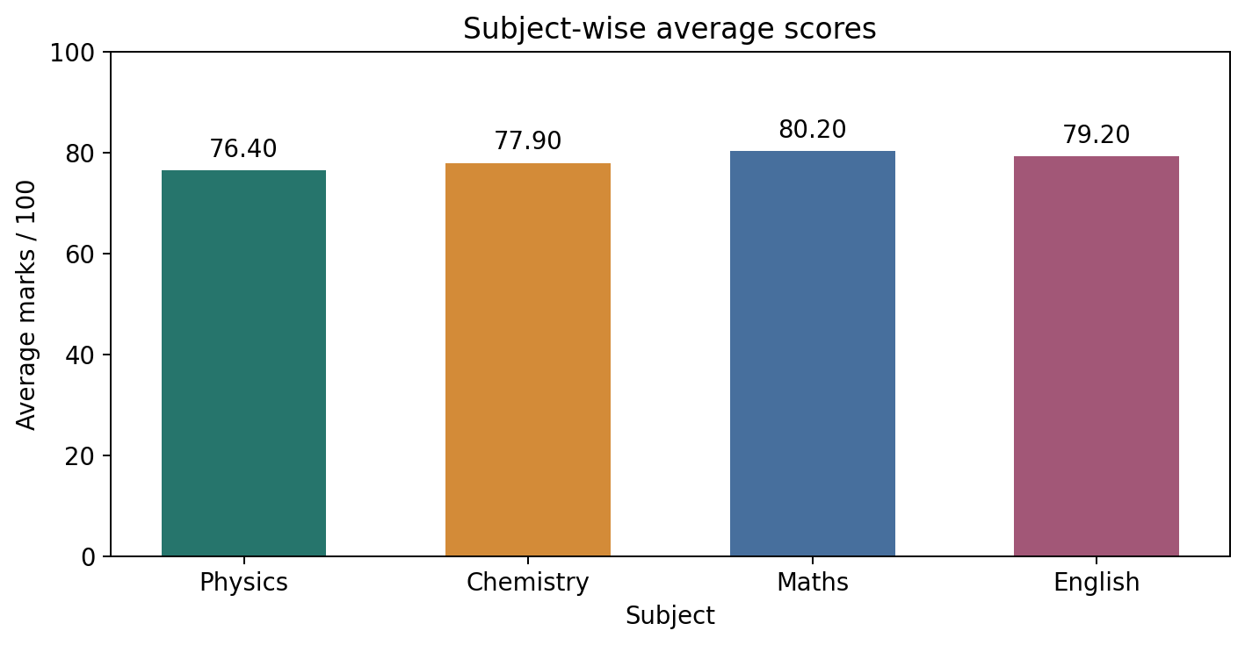
Figure 4(e)-2. Supplied Python subject-average chart, corresponding to review PDF page 20.

Question 4(f) — Total marks by student and performance variation
Question: Plot Total marks against Student_ID and identify the rises and falls.
plt.figure(figsize=(8, 4))
plt.plot(df["Student_ID"], df["Total"], marker="o", color=colors[0])
plt.axhline(df["Total"].mean(), color="grey", linestyle="--",
label=f"Mean total = {df['Total'].mean():.1f}")
plt.xlabel("Student ID (category)")
plt.ylabel("Total marks / 400")
plt.title("Total marks across students")
plt.ylim(200, 400)
plt.legend()
plt.tight_layout()
plt.savefig("python_total_trend.png", dpi=180)
plt.show()
plt.close()
print("\nCHANGES BETWEEN ADJACENT STUDENT IDS")
for i in range(1, len(df)):
change = df["Total"].iloc[i] - df["Total"].iloc[i-1]
print(f"{df['Student_ID'].iloc[i-1]} to "
f"{df['Student_ID'].iloc[i]}: {change:+d}")
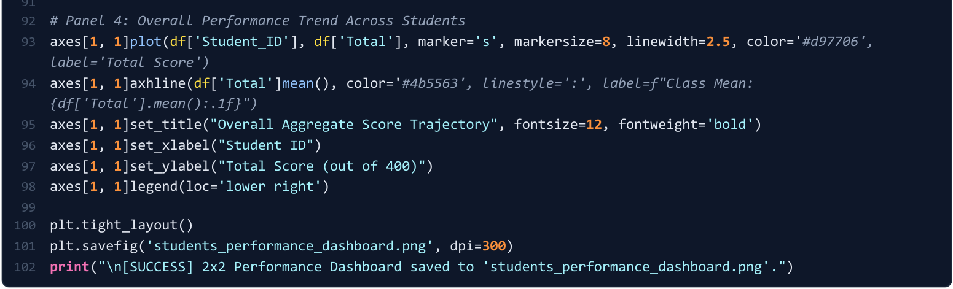
Figure 4(f)-1. Supplied Python source region for the total-marks chart (solution PDF, page 8).
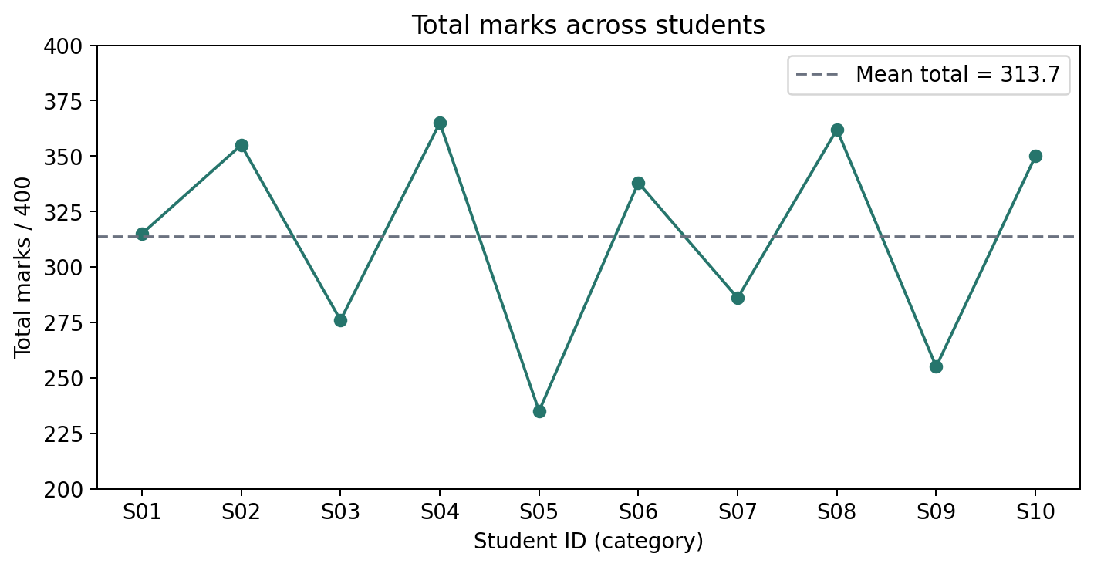
Figure 4(f)-2. Supplied Python total-marks line chart, corresponding to review PDF page 20.
Transition | Change in total marks
S01 → S02 | +40
S02 → S03 | −79
S03 → S04 | +89
S04 → S05 | −130
S05 → S06 | +103
S06 → S07 | −52
S07 → S08 | +76
S08 → S09 | −107
S09 → S10 | +95

The greatest drop is S04 → S05 (365 → 235, −130), and the greatest rise is S05 → S06 (235 → 338, +103). Mean total marks are 313.70; totals span 235–365. These are differences between students, not improvement or decline over time.

Question 5(a) — Read the CSV and inspect the data frame
Question: Read students_scores.csv into an R data frame and display the first five rows, structure and summary.
R programming-based problem — Question 5 carries 10 marks. Run the code blocks (a)–(f) in order as one R script. Base R is sufficient; use the same students_scores.csv as in Question 4.
students_data <- read.csv("students_scores.csv",
stringsAsFactors = FALSE)
subjects <- c("Physics", "Chemistry", "Maths", "English")
colours <- c("#26756c", "#d38b38", "#476f9d", "#a25777")
cat("FIRST FIVE ROWS\n")
print(head(students_data, 5), row.names = FALSE)
cat("\nSTRUCTURE OF DATASET\n")
str(students_data)
cat("\nSUMMARY OF DATASET\n")
print(summary(students_data))
The data frame contains 10 observations and six variables. The identifier/name columns are character data; the subject columns are integers. summary() gives the numeric summaries for marks and descriptive information for the character columns.
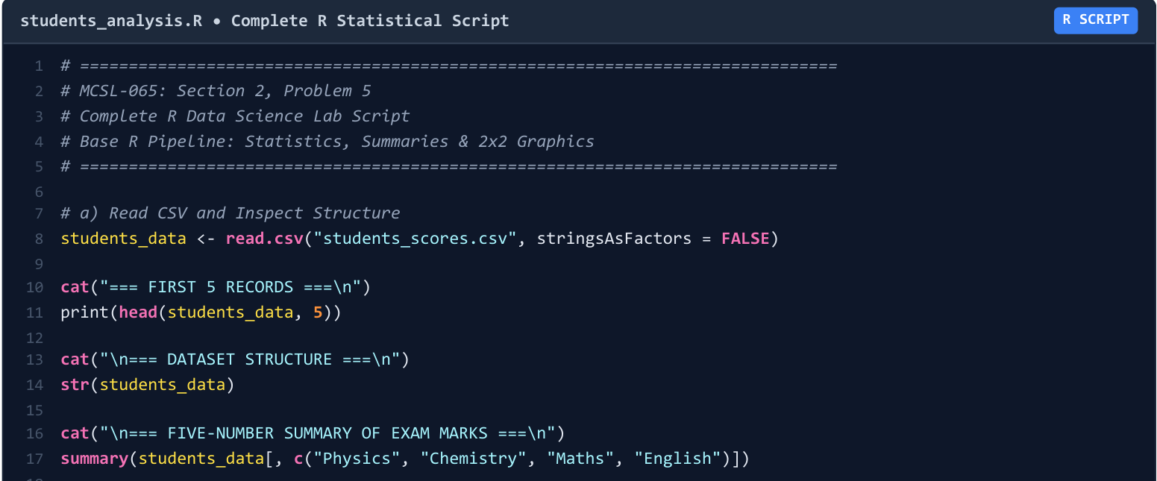
Figure 5(a)-1. Supplied R reading and inspection code region (solution PDF, page 10).
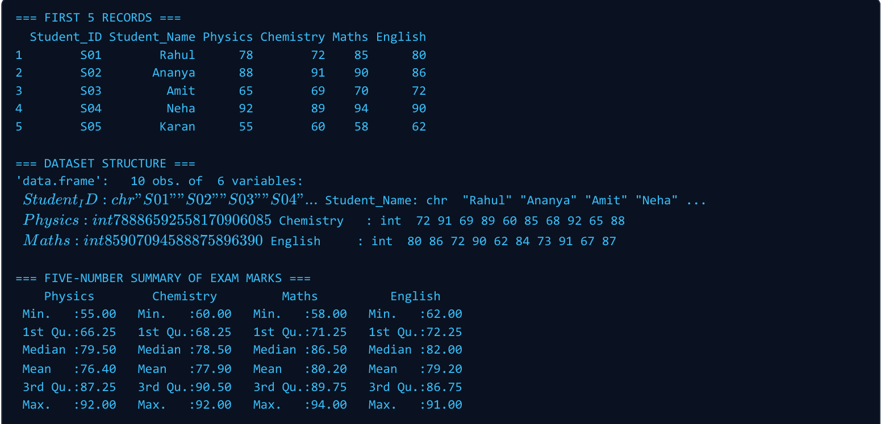
Figure 5(a)-2. Supplied first-five-rows, structure and summary output (solution PDF, page 11).
Statistic | Physics | Chemistry | Maths | English
Minimum | 55.00 | 60.00 | 58.00 | 62.00
First quartile | 66.25 | 68.25 | 71.25 | 72.25
Median | 79.50 | 78.50 | 86.50 | 82.00
Mean | 76.40 | 77.90 | 80.20 | 79.20
Third quartile | 87.25 | 88.75 | 89.75 | 86.75
Maximum | 92.00 | 92.00 | 94.00 | 91.00

The original screenshot’s structure text is visually crowded, and its Chemistry third quartile is printed as 90.50. The correct R default third quartile is 88.75, as in the corrected review and the typed table above.

Question 5(b) — Subject-wise descriptive statistics
Question: Calculate mean, median, mode, minimum, maximum, range, variance and standard deviation for every subject.
R mean(), median(), min(), max(), var() and sd() provide the numeric statistics. var() and sd() use n − 1. R mode() describes an object’s storage mode, so a frequency-based helper is needed for the statistical mode.
statistical_mode <- function(x) {
counts <- table(x)
if (max(counts) == 1) return("No mode")
paste(names(counts)[counts == max(counts)], collapse = ", ")
}
stats_df <- do.call(rbind, lapply(subjects, function(subject) {
x <- students_data[[subject]]
data.frame(Subject = subject,
Mean = mean(x), Median = median(x),
Mode = statistical_mode(x),
Minimum = min(x), Maximum = max(x),
Range = max(x) - min(x),
Variance = var(x), Std_Dev = sd(x))
}))
cat("\nSUBJECT-WISE DESCRIPTIVE STATISTICS\n")
print(stats_df, row.names = FALSE, digits = 6)
write.csv(stats_df, "r_descriptive_statistics.csv", row.names = FALSE)
Subject | Mean | Median | Mode | Min | Max | Range | Variance | SD
Physics | 76.40 | 79.50 | No mode | 55 | 92 | 37 | 173.1556 | 13.1589
Chemistry | 77.90 | 78.50 | No mode | 60 | 92 | 32 | 149.4333 | 12.2243
Maths | 80.20 | 86.50 | 90 | 58 | 94 | 36 | 162.6222 | 12.7523
English | 79.20 | 82.00 | No mode | 62 | 91 | 29 | 102.4000 | 10.1193

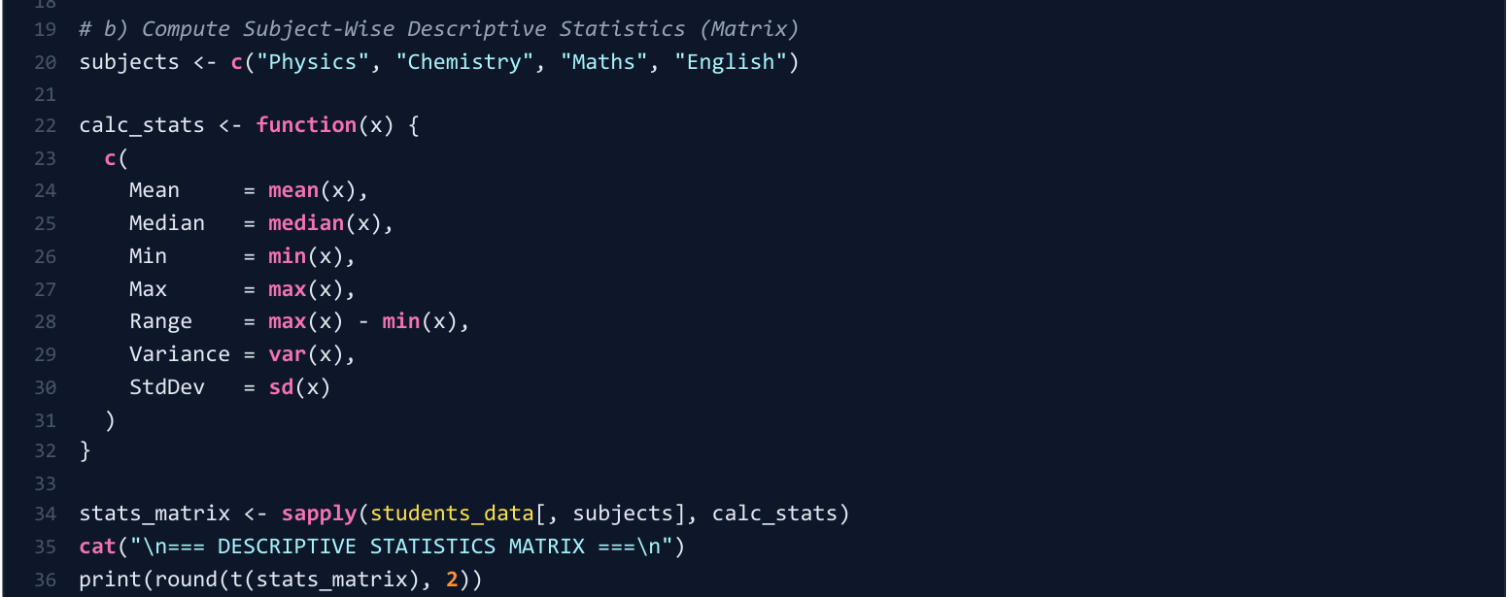
Figure 5(b)-1. Supplied R statistics-code region; its original version omits mode (solution PDF, page 10).
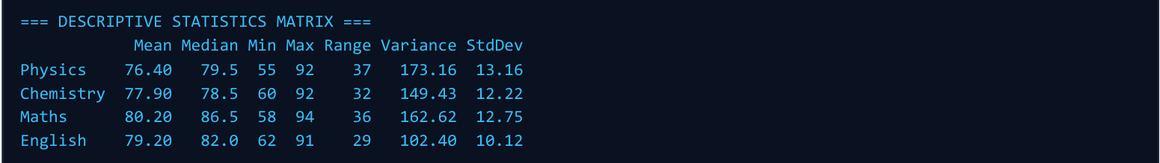
Figure 5(b)-2. Supplied R statistics matrix (solution PDF, page 11).
Figure 5(b)-3. Corrected all-statistic summary from the review PDF, page 5, including modes.
The runnable code completes the missing Mode column using the corrected review approach. Physics, Chemistry and English have no mode; Maths has mode 90. All numeric values agree with the Python answer.

Question 5(c) — Totals, percentages and highest/lowest scorers
Question: Add Total and Percentage and identify the topper and lowest scorer.
students_data$Total <- rowSums(students_data[subjects])
students_data$Percentage <- (students_data$Total / 400) * 100
columns <- c("Student_ID", "Student_Name", "Total", "Percentage")
cat("\nTOTALS AND PERCENTAGES\n")
print(students_data[columns], row.names = FALSE)
cat("\nTOPPER\n")
print(students_data[students_data$Total == max(students_data$Total),
columns], row.names = FALSE)
cat("\nLOWEST SCORER\n")
print(students_data[students_data$Total == min(students_data$Total),
columns], row.names = FALSE)
write.csv(students_data, "r_scores_with_totals.csv", row.names = FALSE)
Student ID | Name | Total / 400 | Percentage
S01 | Rahul | 315 | 78.75%
S02 | Ananya | 355 | 88.75%
S03 | Amit | 276 | 69.00%
S04 | Neha | 365 | 91.25%
S05 | Karan | 235 | 58.75%
S06 | Priya | 338 | 84.50%
S07 | Rohit | 286 | 71.50%
S08 | Simran | 362 | 90.50%
S09 | Arjun | 255 | 63.75%
S10 | Pooja | 350 | 87.50%

Neha (S04) is highest at 365/400 (91.25%); Karan (S05) is lowest at 235/400 (58.75%). The equality conditions include every tied highest/lowest student if ties occur.
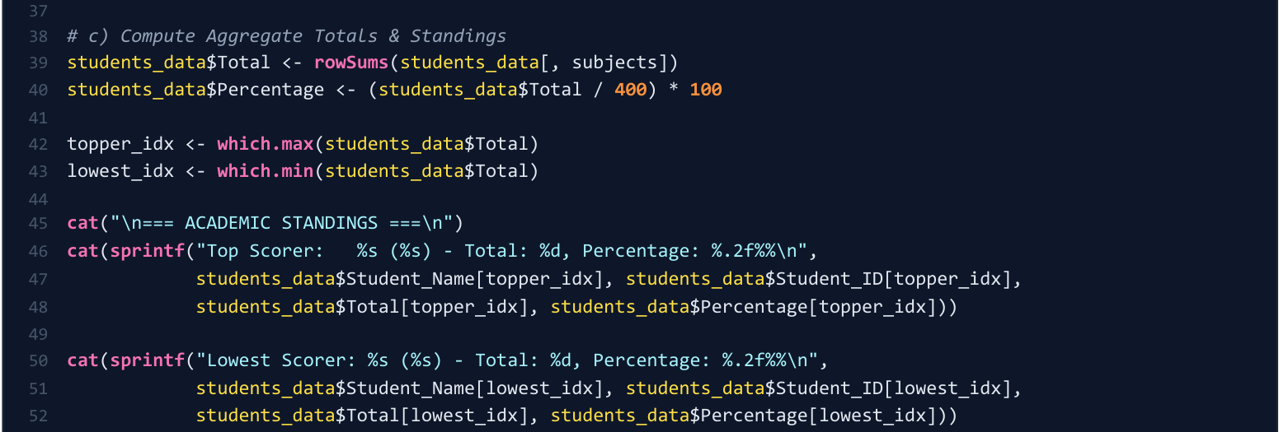
Figure 5(c)-1. Supplied R total, percentage and scorer-selection code (solution PDF, page 10).
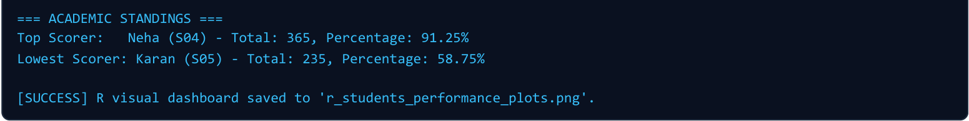
Figure 5(c)-2. Supplied R output confirming the top and lowest scorers (solution PDF, page 11).

Question 5(d) — Maths scatter diagram and histogram
Question: Plot the Maths scatter diagram and histogram and interpret the score distribution.
png("r_maths_scatter.png", width = 1100, height = 850, res = 150)
plot(seq_len(nrow(students_data)), students_data$Maths,
pch = 19, col = colours[3], xaxt = "n", ylim = c(50, 100),
xlab = "Student ID (category)", ylab = "Maths marks / 100",
main = "Maths scores by student")
axis(1, at = seq_len(nrow(students_data)),
labels = students_data$Student_ID, las = 2)
abline(h = mean(students_data$Maths), col = colours[1], lty = 2)
invisible(dev.off())
png("r_maths_histogram.png", width = 1100, height = 850, res = 150)
hist(students_data$Maths, breaks = seq(50, 100, 10),
right = FALSE, include.lowest = TRUE,
col = colours[3], border = "white", labels = TRUE,
xlab = "Maths marks (10-mark intervals)",
ylab = "Number of students", ylim = c(0, 4),
main = "Distribution of Maths scores")
invisible(dev.off())
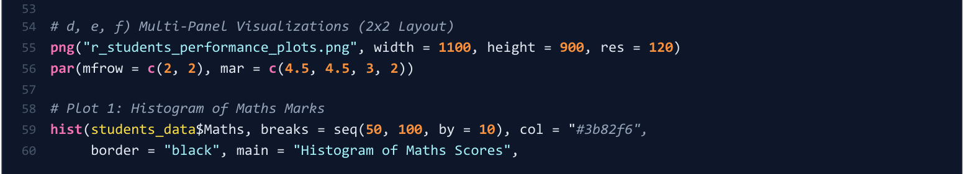
Figure 5(d)-1. Start of the supplied R plotting-code region (solution PDF, page 10).
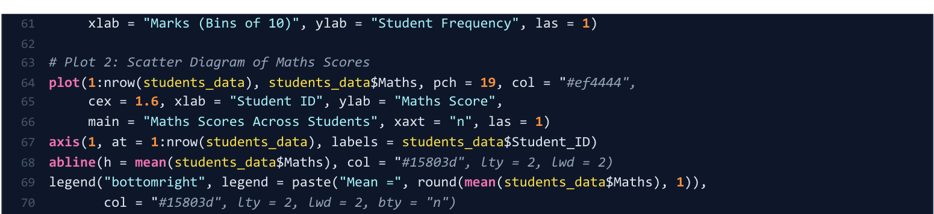
Figure 5(d)-2. Supplied continuation containing the Maths scatter code (solution PDF, page 11).
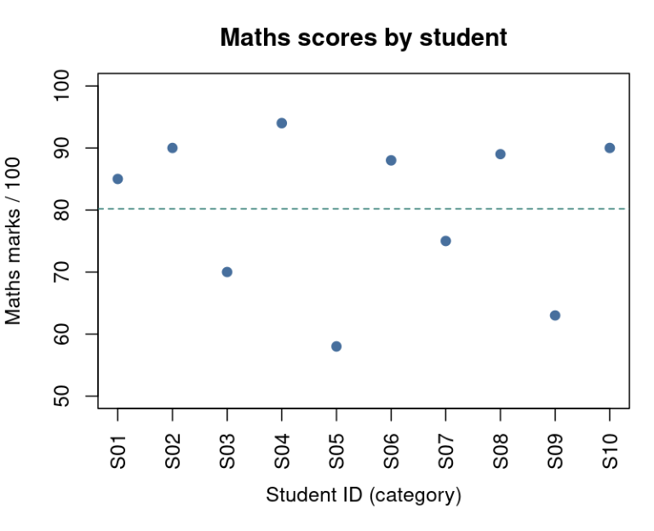
Figure 5(d)-3. Supplied R Maths scatter view; corresponding review figure is on page 26.
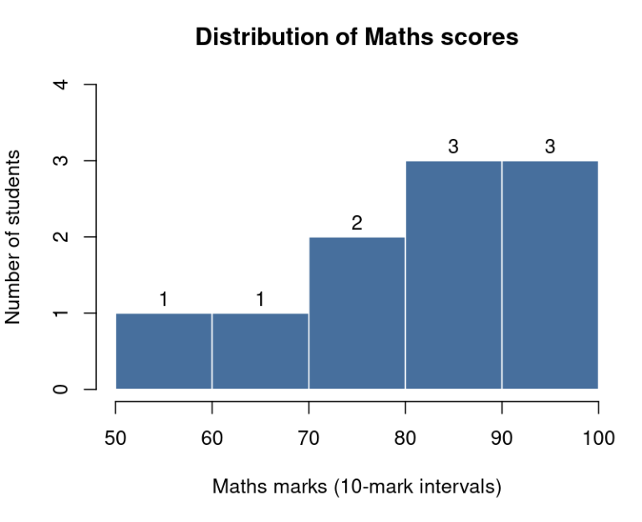
Figure 5(d)-4. Supplied R histogram with frequencies 1, 1, 2, 3 and 3.
The mean is 80.20 and scores span 58–94. The higher-frequency intervals are 80–89 and 90–100, together containing six students. The sample standard deviation of 12.7523 shows that the marks are not tightly grouped at one value.
The corrected hist() call explicitly uses right = FALSE so marks such as 70 and 90 enter the same intervals as the supplied plot and Python histogram. Student IDs are categorical positions, not time points.

Question 5(e) — Bar chart of subject averages
Question: Compute average marks for each subject and plot a bar chart of the subject-wise averages.
averages <- colMeans(students_data[subjects])
cat("\nSUBJECT AVERAGES\n")
print(averages)
png("r_subject_averages.png", width = 1100, height = 850, res = 150)
positions <- barplot(averages, col = colours, ylim = c(0, 100),
xlab = "Subject", ylab = "Average marks / 100",
main = "Subject-wise average scores")
text(positions, averages + 4, sprintf("%.2f", averages))
invisible(dev.off())
colMeans() returns Physics 76.40, Chemistry 77.90, Maths 80.20 and English 79.20. The bars show a small 3.80-mark difference between the highest and lowest subject means.
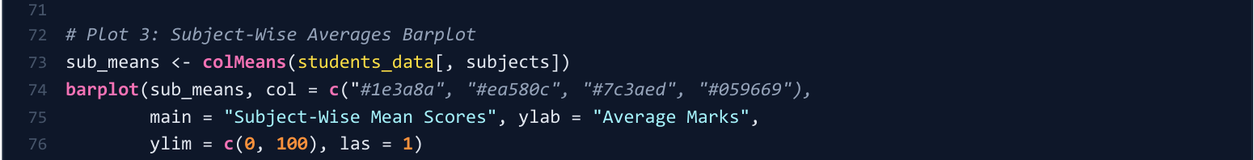
Figure 5(e)-1. Supplied R subject-average barplot code (solution PDF, page 11).
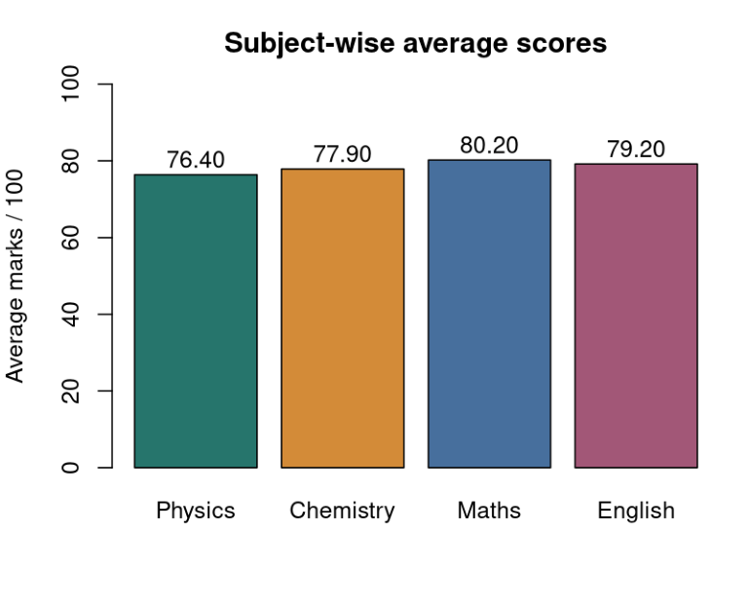
Figure 5(e)-2. Supplied R subject-average chart; corresponding review figure is on page 26.

Question 5(f) — Total marks by student and performance variation
Question: Plot total marks against Student_ID and identify rises and falls in performance.
png("r_total_trend.png", width = 1100, height = 850, res = 150)
plot(seq_len(nrow(students_data)), students_data$Total,
type = "b", pch = 19, col = colours[1], xaxt = "n",
ylim = c(200, 400), xlab = "Student ID (category)",
ylab = "Total marks / 400", main = "Total marks across students")
axis(1, at = seq_len(nrow(students_data)),
labels = students_data$Student_ID, las = 2)
abline(h = mean(students_data$Total), col = "grey50", lty = 2)
invisible(dev.off())
cat("\nCHANGES BETWEEN ADJACENT STUDENT IDS\n")
print(diff(students_data$Total))
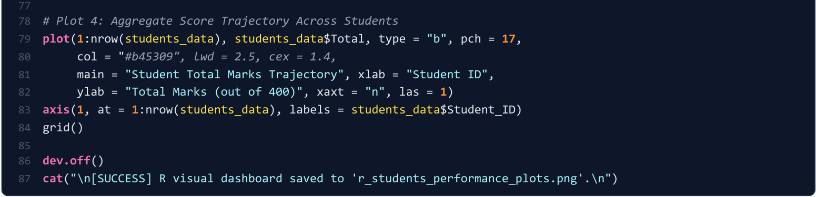
Figure 5(f)-1. Supplied R total-marks line-chart code (solution PDF, page 11).
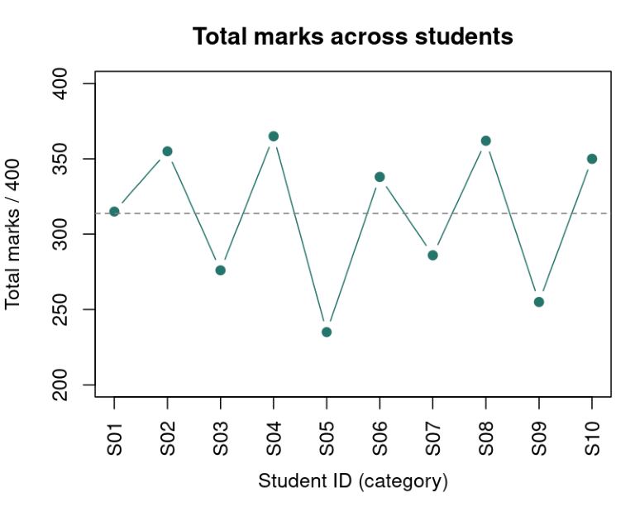
Figure 5(f)-2. Supplied R total-marks chart; corresponding review figure is on page 26.
Transition | Change in total marks
S01 → S02 | +40
S02 → S03 | −79
S03 → S04 | +89
S04 → S05 | −130
S05 → S06 | +103
S06 → S07 | −52
S07 → S08 | +76
S08 → S09 | −107
S09 → S10 | +95

R confirms the Python result: the largest drop is −130 between S04 and S05, and the largest rise is +103 between S05 and S06. The class mean total is 313.70, with Neha highest and Karan lowest. This line compares different students in ID order and should not be interpreted as change over time.

Dataset file for Questions 4 and 5
Save these contents as students_scores.csv. Keep the header names and all ten records exactly as shown. Place the file in the working folder used for both scripts.
Student_ID,Student_Name,Physics,Chemistry,Maths,English
S01,Rahul,78,72,85,80
S02,Ananya,88,91,90,86
S03,Amit,65,69,70,72
S04,Neha,92,89,94,90
S05,Karan,55,60,58,62
S06,Priya,81,85,88,84
S07,Rohit,70,68,75,73
S08,Simran,90,92,89,91
S09,Arjun,60,65,63,67
S10,Pooja,85,88,90,87

Source record
Question wording and dataset: MSCDSA-MCSL-065-2026.pdf. Reference code/output screenshots: MCSL-065_Data_Science_Lab_Solutions.pdf, pages 7–11. Corrected statistics and plot figures: MCSL-065_Assignment_REVIEW.pdf, pages 5 and 13–26. The Markdown solution file was also used for the written code structure.
Source screenshot regions have been placed beneath their corresponding question parts. The selectable code corrects the omitted/incorrect statistical modes, missing punctuation in extracted reference text, and histogram interval settings; the original reference screenshots remain unchanged. There is no front page.

