MCSL-065
Data Science Lab
Scope: SECTION 1 · GUI TOOLS · 20 MARKS
Course information | Details
Programme | Master of Science (Data Science and Analytics) — MSCDSA
Assignment number | MSCDSA(I)/L-065/Lab_Assignment/2026
Session | July 2026
Question 1 | Excel: parts (a)–(e), including (e)(i)–(iv) — 6 marks
Question 2 | Tableau: parts (a)–(f) — 7 marks
Question 3 | Power BI: parts (a)–(g) — 7 marks

About the answers and figures
The answers are organized using the question numbers and part letters in the supplied assignment paper. They are based on the two supplied solution PDFs and the Markdown solution file. The screenshots supplied in the chat are reproduced from their corresponding PDF regions and matched to the relevant parts.
The statistical summary follows the corrected review PDF. Sample variance and standard deviation use n − 1. The Power BI answer includes the complete set of 16 subject measures requested in Question 3(e).
Figure provenance: the chart images are supplied workbook renderings; reused figures illustrate the corresponding Tableau and Power BI views. The dashboard picture is a layout blueprint. These illustrations do not establish that the native desktop applications were newly run for this document.

Dataset — Students’ Exam Scores
Use the ten records given in the assignment. Save the six source columns as students_scores.csv. Total and percentage columns shown in the supplied screenshot are derived values and are not required for the original import.
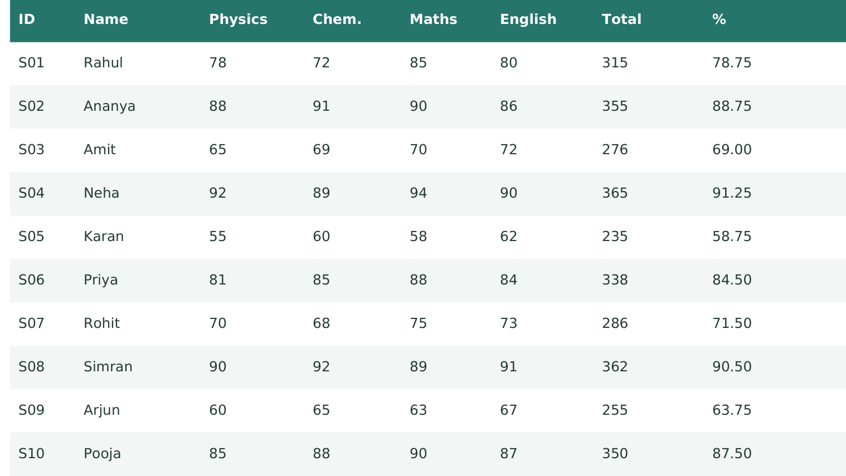
Dataset figure. Supplied student-score table, reproduced from the review PDF, page 3.
Field | Data type / role
Student_ID | Text / string identifier; S01 through S10
Student_Name | Text / string
Physics, Chemistry, Maths, English | Whole-number marks, each out of 100

There are 10 students, four subject-score columns, and no missing marks. In all tools, use the same source values so the chart labels and statistics can be compared directly.

Question 1 — Excel-based problem
Total marks for Question 1: 6.

Question 1(a) — Histogram for Maths marks
Question: Create a histogram for Maths marks.
1. Enter the source data with headers in A1:F11. The Maths marks are in E2:E11.
2. Use Data → Data Analysis → Histogram. Set Input Range to E2:E11 and Bin Range to cells containing upper limits 59, 69, 79, 89 and 99. Select Chart Output. A chart with adjacent bars represents the grouped distribution.
3. Label the horizontal axis Maths marks and the vertical axis Number of students. The five frequencies are 1, 1, 2, 3 and 3.
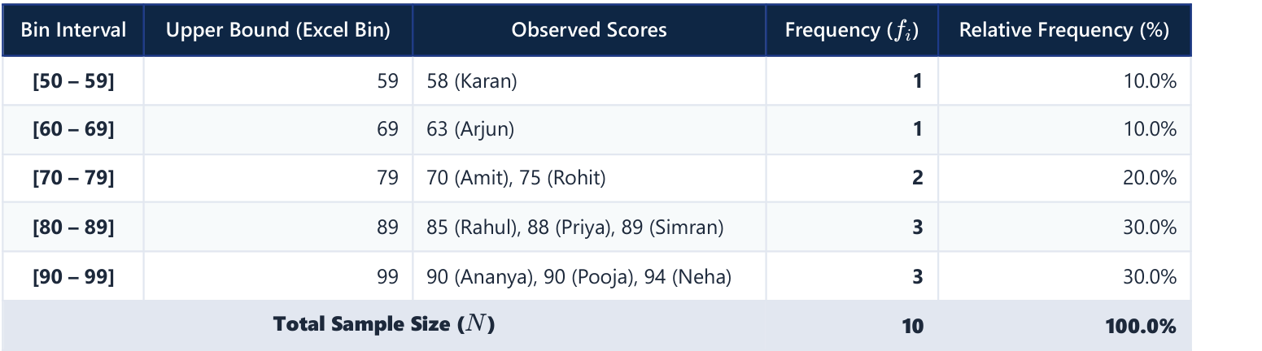
Figure 1(a)-1. Supplied frequency table for Maths marks (solution PDF, page 2).
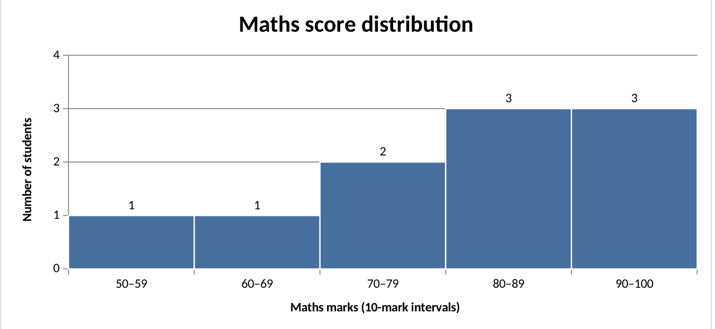
Figure 1(a)-2. Supplied Maths histogram; the five frequencies total 10.
The histogram screenshot labels the final interval 90–100; the reference frequency table uses 90–99. The largest observed score is 94, so both labels give the same frequency for this dataset.

Question 1(b) — Line chart for Maths scores
Question: Plot a line chart for Maths scores against Student_ID.
1. Select Student_ID (A1:A11) and Maths (E1:E11). Use Insert → Line → Line with Markers.
2. Keep Student_ID in ascending order on the horizontal axis and Maths marks on the vertical axis. Add the title Maths scores across students.
The sequence is 85, 90, 70, 94, 58, 88, 75, 89, 63 and 90. S04 has the highest Maths mark, 94; S05 has the lowest, 58.
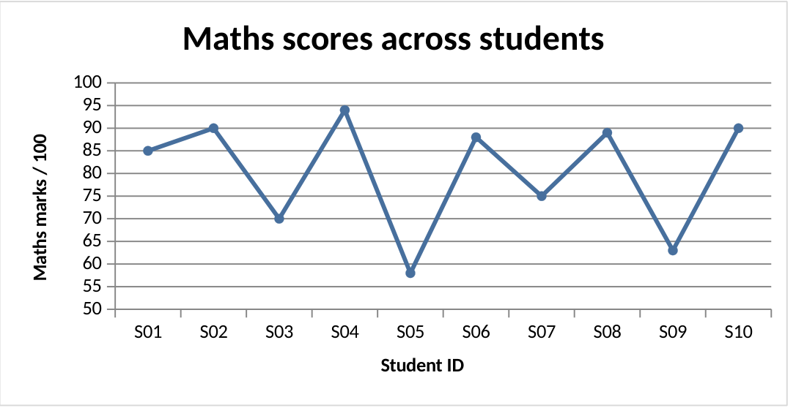
Figure 1(b). Supplied line chart of Maths marks against Student_ID.

Question 1(c) — Subject-wise average bar chart
Question: Calculate each subject average and create a bar chart comparing them.
Use AVERAGE(C2:C11), AVERAGE(D2:D11), AVERAGE(E2:E11) and AVERAGE(F2:F11). Select the subject labels and four averages, then insert a clustered column/bar chart with a 0–100 marks axis.
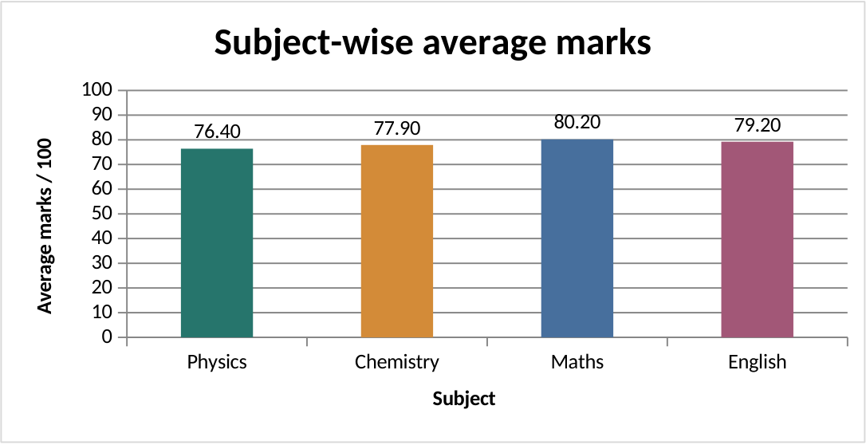
Figure 1(c). Subject means: Physics 76.40, Chemistry 77.90, Maths 80.20 and English 79.20.

Question 1(d) — Pie chart of subject contributions
Question: Using average marks, create a pie chart showing each subject’s percentage contribution.
The sum of subject averages is 313.70. Percentage contribution = (subject average ÷ 313.70) × 100. Select the subject labels and averages, insert a 2-D Pie chart, and enable category and percentage labels.
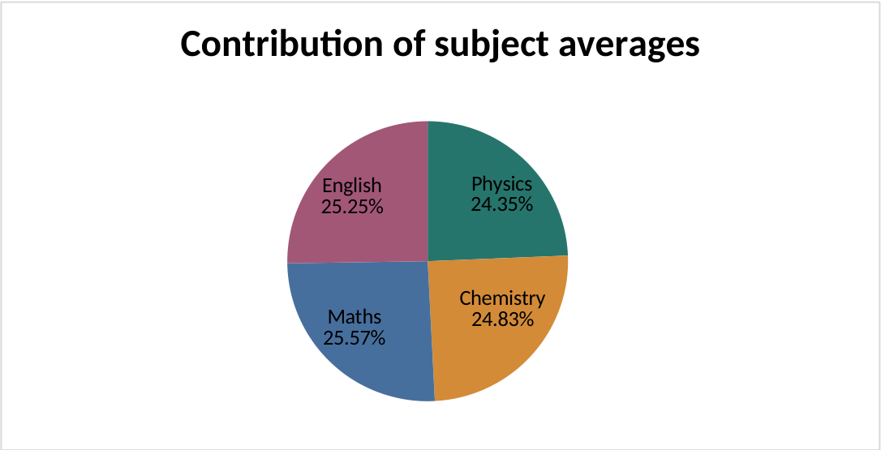
Figure 1(d). Supplied pie chart based on the four subject averages.
Physics contributes 24.35%, Chemistry 24.83%, Maths 25.57% and English 25.25%. These are shares of the sum of subject averages, not student pass percentages.

Question 1(e) — Analysis ToolPak
Question: Use the Data Analysis ToolPak for descriptive statistics, a two-sample t-test, an F-test and Pearson correlations.
Enable File → Options → Add-ins → Manage Excel Add-ins → Go → Analysis ToolPak. The Data Analysis command then appears on the Data tab.

Question 1(e)(i) — Descriptive statistics
Question: Generate descriptive statistics.
Select Data → Data Analysis → Descriptive Statistics. Use C1:F11, grouped by Columns, with Labels in first row and Summary statistics checked. Use VAR.S and STDEV.S when checking the sample statistics with formulas.
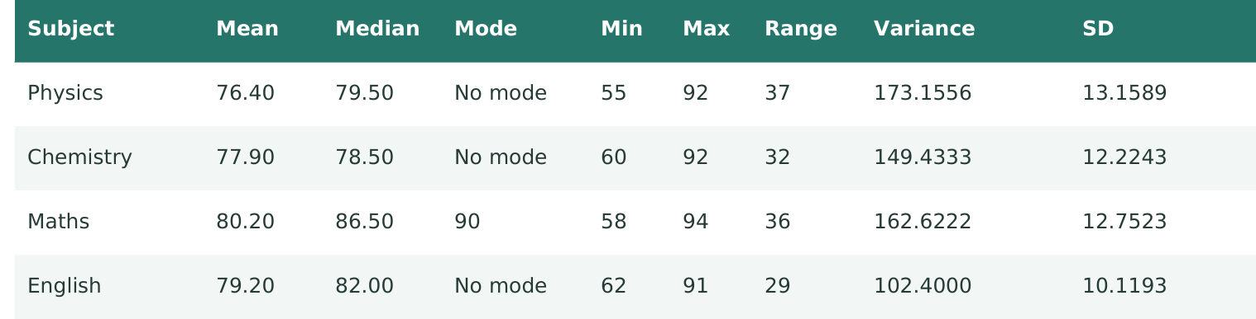
Figure 1(e)(i). Corrected descriptive summary supplied in the review PDF, page 5.
Maths has mode 90. The other subjects have no repeated value and are reported as No mode. Excel MODE.SNGL returns #N/A for such subjects; IFERROR can display No mode instead.

Question 1(e)(ii) — Two-sample t-test
Question: Check whether Physics and Chemistry marks have significantly different means.
Null hypothesis H₀: μPhysics = μChemistry. Alternative H₁: μPhysics ≠ μChemistry. Use a two-sided test with α = 0.05.
1. Choose t-Test: Two-Sample Assuming Equal Variances in the Analysis ToolPak.
2. Use Physics C1:C11 as Variable 1 and Chemistry D1:D11 as Variable 2. Check Labels; set Hypothesized Mean Difference to 0 and Alpha to 0.05.
3. Read t Stat, P(T≤t) two-tail and t Critical two-tail. A formula check is =T.TEST(C2:C11,D2:D11,2,2).
Quantity | Value
Physics mean / Chemistry mean | 76.40 / 77.90
Pooled sample variance | 161.294444
t statistic / degrees of freedom | −0.264099 / 18
Two-sided p-value | 0.794704
Critical |t| at 5% | 2.100922

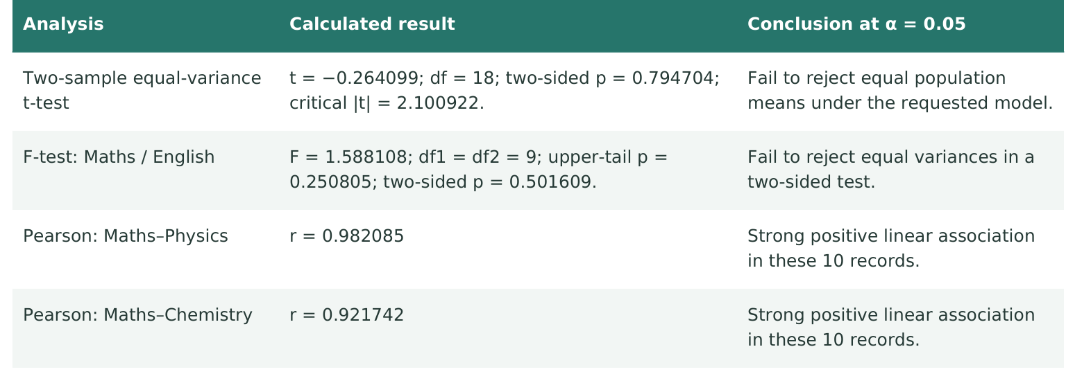
Figure 1(e)(ii). Supplied corrected inference table; the first row contains the requested t-test.
Because p = 0.794704 > 0.05, fail to reject H₀ under the requested independent two-sample model. The data do not show a statistically significant mean difference in that model.
Both subjects are measured for the same students. A paired comparison would be more natural for within-student inference; the independent two-sample result is included because it is the test requested by the assignment. Failure to reject is not proof that the means are equal.

Question 1(e)(iii) — F-test for Maths and English variances
Question: Perform an F-test to compare the variances of Maths and English marks.
H₀: σ²Maths = σ²English; H₁: σ²Maths ≠ σ²English. In Data → Data Analysis → F-Test Two-Sample for Variances, select Maths E1:E11 and English F1:F11, check Labels and use α = 0.05.
The sample variances are 162.622222 and 102.400000. Their ratio is F = 1.588108, with numerator and denominator degrees of freedom both equal to 9.
Figure 1(e)(iii)-1. Corrected F-test row from the review PDF: upper-tail p = 0.250805 and two-sided p = 0.501609.
For the two-sided question of any variance difference, use =F.TEST(E2:E11,F2:F11). Since 0.501609 > 0.05, fail to reject equal variances. The test does not establish that the variances are identical.
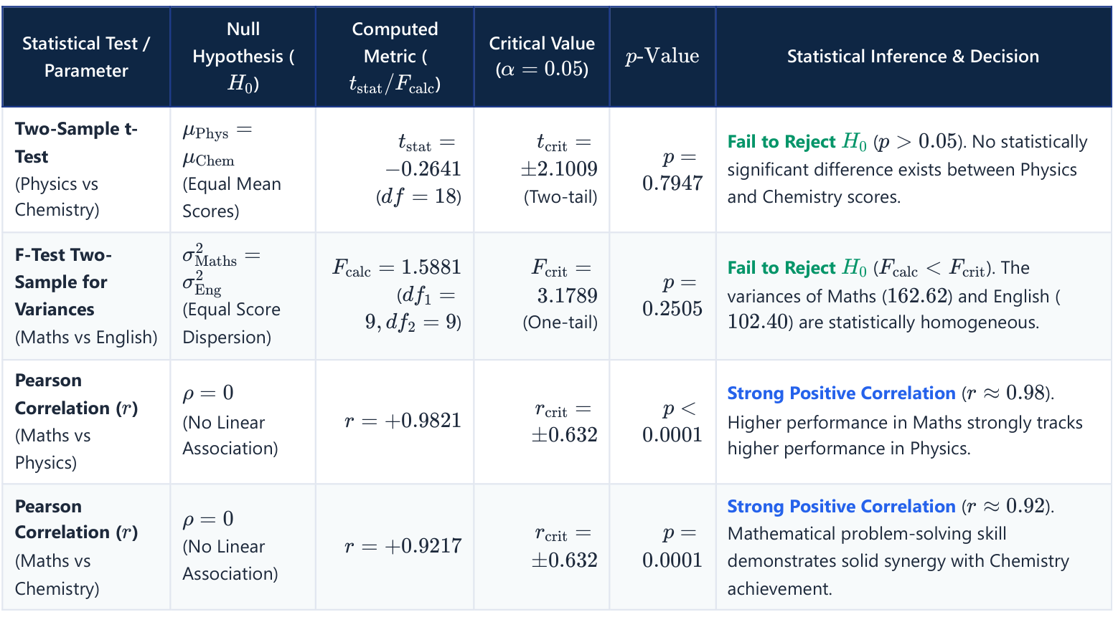
Figure 1(e)(iii)-2. Original supplied reference table (solution PDF, page 3), reproduced as provided.
The original screenshot uses a one-tail critical F of 3.1789 and rounds its upper-tail p-value to 0.2505. The more precise value is 0.250805. The two-sided p-value used in the answer is 0.501609, as shown in the corrected review. The F-test assumes independent, normally distributed observations; this paired student dataset is an instructional example.

Question 1(e)(iv) — Pearson correlation coefficients
Question: Calculate Pearson correlations for Maths–Physics and Maths–Chemistry.
1. Use =CORREL(E2:E11,C2:C11) for Maths and Physics.
2. Use =CORREL(E2:E11,D2:D11) for Maths and Chemistry. The ToolPak Correlation option can also produce the matrix from the numeric score columns.
Pair | Pearson r | Interpretation
Maths and Physics | 0.982085 | Strong positive linear association
Maths and Chemistry | 0.921742 | Strong positive linear association

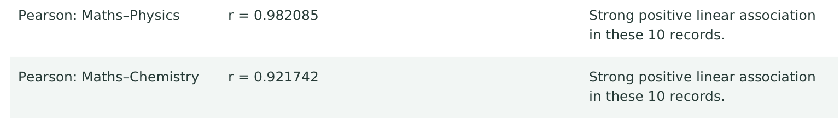
Figure 1(e)(iv). Supplied correlation results from the corrected review table.
Students with higher Maths scores tend to have higher Physics and Chemistry scores in these ten records. The Maths–Physics relationship is stronger. Correlation alone does not demonstrate a causal relationship.

Question 2 — Tableau-based problem
Total marks for Question 2: 7.

Question 2(a) — Import, verify and rename fields
Question: Save the dataset as Excel/CSV, import it into Tableau, verify data types, and rename fields if required.
1. Save the six original fields as students_scores.csv. In Tableau, choose Connect → Text File and select the CSV.
2. Confirm ten records. Student_ID and Student_Name must be String. Physics, Chemistry, Maths and English must be Number (whole). Keep the four subject fields as numeric measures.
3. Keep the original field names because they already describe the data. For the common Subject/Score layout below, select the four subject columns and Pivot; rename Pivot Field Names to Subject and Pivot Field Values to Score. This produces 40 student–subject records.
Figure 2(a). Supplied source-data table used for the Tableau import; this is a data illustration, not an import-screen capture.
Continuous/discrete display roles in Tableau are separate from the underlying number/string data types. After pivoting, keep Subject as a string dimension and Score as a numeric measure.

Question 2(b) — Average marks bar chart
Question: Create a bar chart showing the four subject averages, with labelled axes and a title.
In a worksheet, put Subject on Columns and AVG(Score) on Rows. Choose Bar marks, put Subject on Colour, and show AVG(Score) on Label. Set the vertical axis to 0–100, label it Average marks / 100, and add the title Subject-wise average marks.
Figure 2(b). Supplied chart illustrating the required Tableau average-marks view.
Expected averages are Physics 76.40, Chemistry 77.90, Maths 80.20 and English 79.20.

Question 2(c) — Maths line chart
Question: Create a line chart of Maths scores across students, with Student_ID on the X-axis.
On a new worksheet, filter Subject to Maths for this sheet only. Put Student_ID on Columns and AVG(Score) on Rows. Select Line marks with markers, sort Student_ID ascending and label the axes Student ID and Maths marks / 100.
Figure 2(c). Supplied chart illustrating the required Tableau Maths trend view.

Question 2(d) — Subject-contribution pie chart
Question: Create a pie chart from the subject averages and display percentage labels.
Use a new worksheet without the Maths-only filter. Choose Pie marks, put Subject on Colour and AVG(Score) on Angle. Add AVG(Score) to Label and apply Quick Table Calculation → Percent of Total, computed across Subject. Display the subject names and percentages.
Figure 2(d). Supplied pie chart illustrating the required Tableau contribution view.
The labels should be Physics 24.35%, Chemistry 24.83%, Maths 25.57% and English 25.25%.

Question 2(e) — Summary statistics table
Question: Display Average, Minimum, Maximum and Standard Deviation for all four subjects.
Create aggregate calculated fields AVG([Score]), MIN([Score]), MAX([Score]) and STDEV([Score]). Put Subject on Rows, Measure Names on Columns and Measure Values on Text; retain these four statistics. Format the average and sample standard deviation to two decimal places.
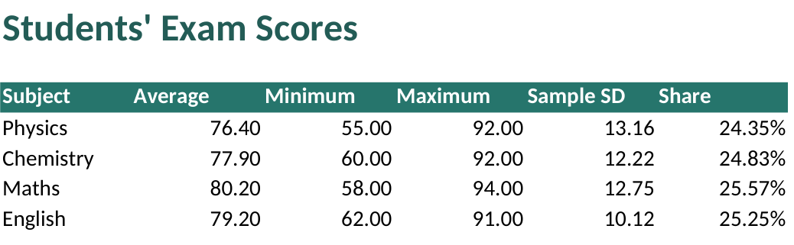
Figure 2(e). Supplied summary table; Average, Minimum, Maximum and Sample SD are the four requested statistics. Share is an additional reference column.
Use STDEV rather than STDEVP to match the sample statistic in the solution. The Maths row must show 80.20, 58, 94 and 12.75.

Question 2(f) — Single Tableau dashboard
Question: Combine the average bar chart, Maths line chart, contribution pie and summary statistics table.
1. Create a dashboard, for example with a fixed size of 1200 × 800, titled Students’ Exam Scores.
2. Place the average bar chart and Maths line across the top, then the pie chart and statistics table below. Fit each worksheet to its container and keep subject colours consistent.
3. Keep all four subjects in the bar, pie and summary sheets. The Subject = Maths filter must remain scoped to the Maths line worksheet. An optional student filter can be applied consistently to the dashboard.
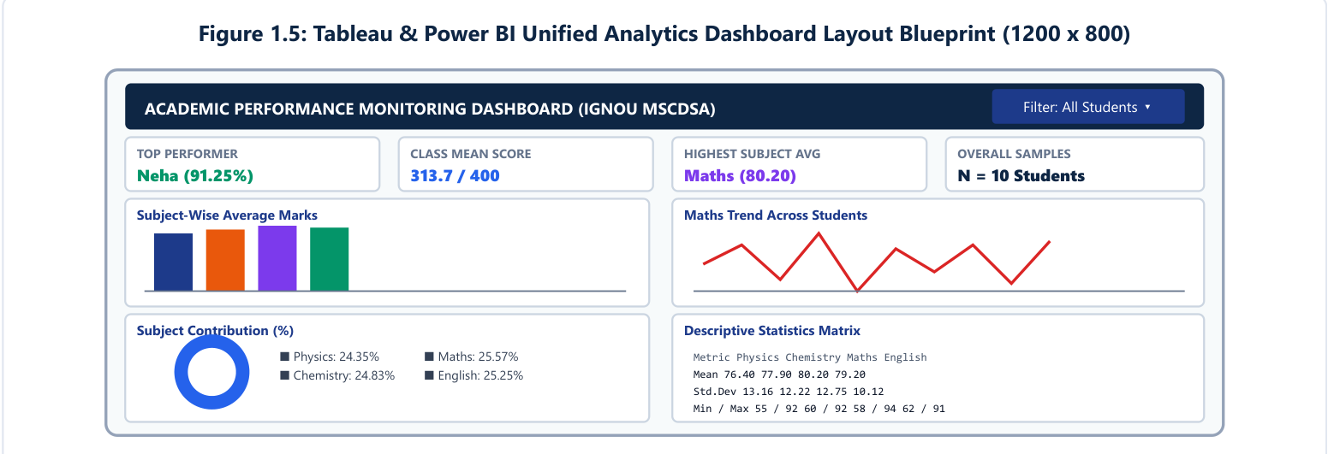
Figure 2(f)-1. Supplied Tableau/Power BI dashboard layout blueprint (solution PDF, page 6).
Figure 2(f)-2. The four supplied view screenshots arranged for comparison. This arrangement is an illustration, not a native Tableau dashboard capture.
The required four views are present in the proposed arrangement. Save the workbook with its source data and check each value against the tables before capturing the final dashboard in Tableau.

Question 3 — Power BI-based problem
Total marks for Question 3: 7.

Question 3(a) — Import and verify the dataset
Question: Save the dataset as Excel/CSV, import it into Power BI, verify data types, and rename fields where required.
1. Use Home → Get Data → Text/CSV, select students_scores.csv and choose Transform Data. Name the query StudentsScores.
2. In Power Query, set Student_ID and Student_Name to Text, and the four subject fields to Whole Number. Confirm 10 rows and the original six source columns, then Close & Apply.
3. Retain the descriptive source names. Optional Total/Percentage columns shown in the reference are not necessary for the required subject measures.
Figure 3(a). Supplied student-score table used for the Power BI import; this is the source table, not a Power Query interface capture.
The original wide StudentsScores table supports the 16 measures in Question 3(e). A small disconnected Subjects table, described in Question 3(f), supplies the subject labels for the four-row visuals.

Question 3(b) — Subject-average bar chart
Question: Plot the four subject averages and identify the highest and lowest average score.
Use a Clustered column/bar chart with Subjects[Subject] as the category and the Average display measure from Question 3(f) as the value. The subject measures are defined in Question 3(e). Show data labels to two decimals and use an axis from 0 to 100.
Figure 3(b). Supplied average chart illustrating the required Power BI view.
Maths has the highest mean, 80.20. Physics has the lowest mean, 76.40. Chemistry is 77.90 and English is 79.20; the highest–lowest gap is 3.80 marks.

Question 3(c) — Maths line chart
Question: Plot Maths scores across students, using Student_ID on the X-axis.
Add a Line chart. Use StudentsScores[Student_ID] on the X-axis and Avg_Maths on the Y-axis. Sort the text IDs in ascending order, use a categorical X-axis, enable markers and label the Y-axis Maths marks / 100.
Figure 3(c). Supplied Maths chart illustrating the required Power BI line view.

Question 3(d) — Subject-contribution pie chart
Question: Create a pie chart from the subject averages and display percentage labels.
Choose a Pie chart. Put Subjects[Subject] in Legend and the Average display measure in Values. Enable the subject name and percent-of-total labels, formatted to two decimal places. Use the four averages as values, so the visual calculates each share of their sum.
Figure 3(d). Supplied pie chart illustrating the required Power BI contribution view.
Subject | Average | Percentage of 313.70
Physics | 76.40 | 24.35%
Chemistry | 77.90 | 24.83%
Maths | 80.20 | 25.57%
English | 79.20 | 25.25%

The four slices sum to 100% after rounding. The assignment asks for a pie chart; use that visual even where the supplied dashboard sketch represents contribution as a ring.

Question 3(e) — DAX measures
Question: Create Average, Minimum, Maximum and Standard Deviation measures for all four subjects.
Create each formula separately using Modeling → New measure. The table name is StudentsScores. Use AVERAGE, MIN, MAX and STDEV.S; the last function returns the sample standard deviation.
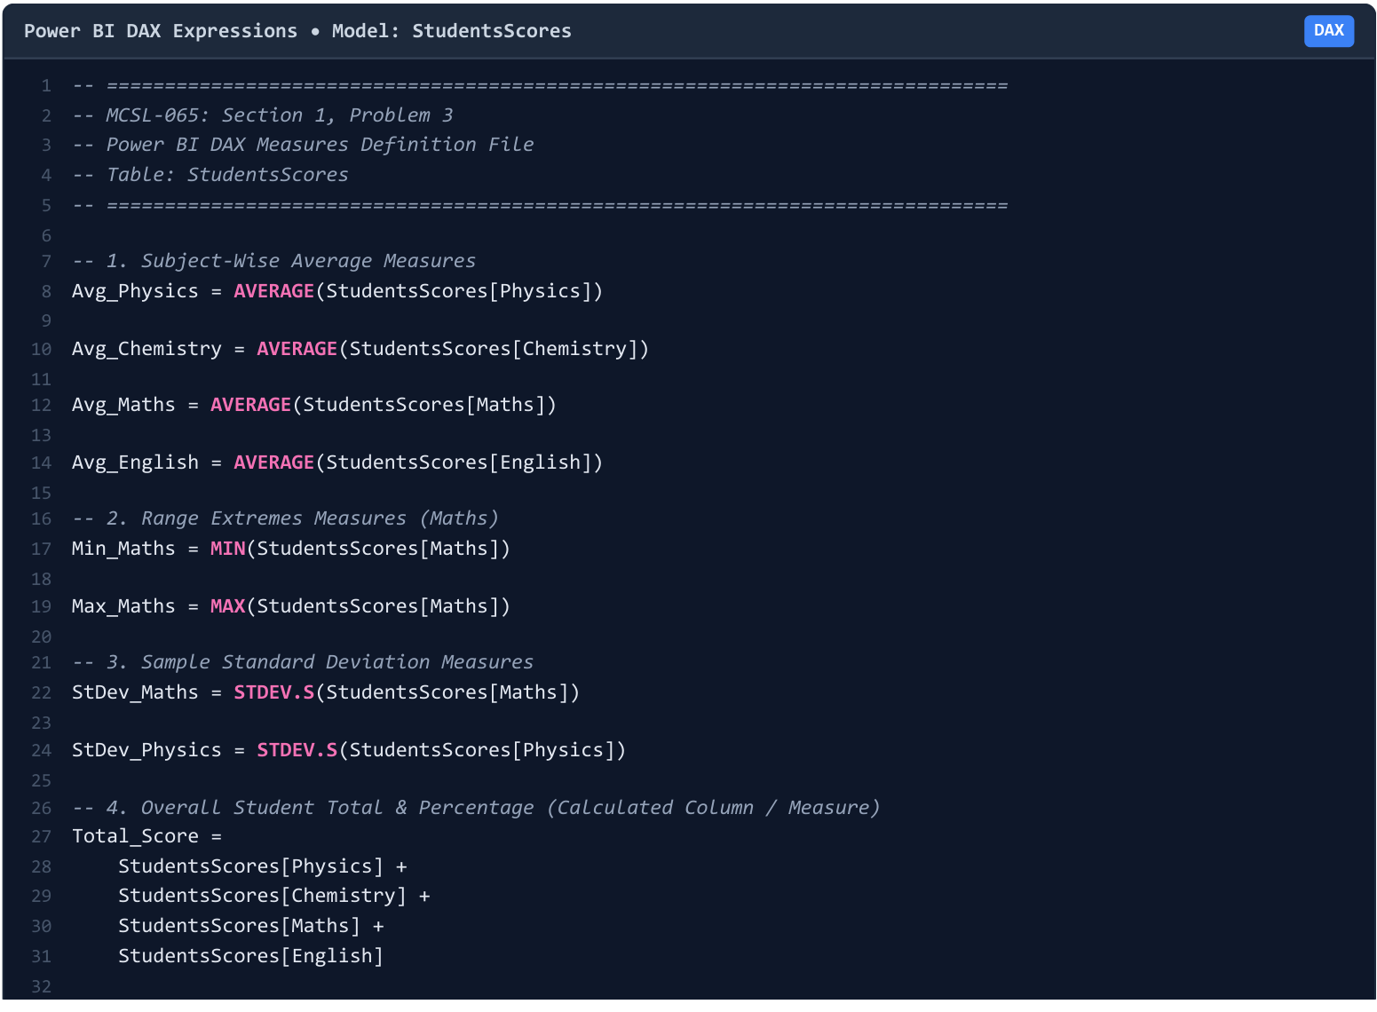
Figure 3(e)-1. Supplied DAX screenshot from the solution PDF, page 5.
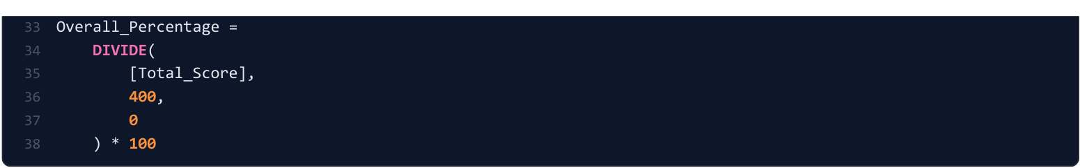
Figure 3(e)-2. Continuation of the supplied DAX screenshot, solution PDF, page 6.
The screenshot provides eight of the sixteen required subject measures. The next page completes the same pattern for every subject using the review PDF. Total_Score and Overall_Percentage in the screenshots are optional calculated columns; they do not replace the subject measures.

Question 3(e) — Complete set of 16 measures
Group: Average measures
Avg_Physics = AVERAGE(StudentsScores[Physics])
Avg_Chemistry = AVERAGE(StudentsScores[Chemistry])
Avg_Maths = AVERAGE(StudentsScores[Maths])
Avg_English = AVERAGE(StudentsScores[English])
Group: Minimum measures
Min_Physics = MIN(StudentsScores[Physics])
Min_Chemistry = MIN(StudentsScores[Chemistry])
Min_Maths = MIN(StudentsScores[Maths])
Min_English = MIN(StudentsScores[English])
Group: Maximum measures
Max_Physics = MAX(StudentsScores[Physics])
Max_Chemistry = MAX(StudentsScores[Chemistry])
Max_Maths = MAX(StudentsScores[Maths])
Max_English = MAX(StudentsScores[English])
Group: Sample standard deviation measures
StDev_Physics = STDEV.S(StudentsScores[Physics])
StDev_Chemistry = STDEV.S(StudentsScores[Chemistry])
StDev_Maths = STDEV.S(StudentsScores[Maths])
StDev_English = STDEV.S(StudentsScores[English])
Format the average and standard deviation measures to two decimal places; minimum and maximum may be shown as whole numbers. The expected values are listed in Question 3(f). Each line above is a separate measure definition.
The completed definitions follow the supplied reference syntax and the complete measure set in the review PDF. They are document source definitions, not evidence of a new execution in Power BI Desktop.

Question 3(f) — Summary statistics table
Question: Create a table view with Average, Minimum, Maximum and Standard Deviation for all four subjects.
1. Use the four subject measures from Question 3(e). To display one row per subject, create the small disconnected Subjects table and four display measures on the next page.
2. Add a Table visual containing Subjects[Subject], Average, Minimum, Maximum and Standard Deviation. Sort Subject by SortOrder and disable the total row.
3. Use two decimal places for Average and Standard Deviation. Check all four rows against the supplied summary screenshot.
Figure 3(f). Supplied four-subject summary; the first five columns provide the required Power BI table.
Subject | Average | Minimum | Maximum | Sample SD
Physics | 76.40 | 55 | 92 | 13.16
Chemistry | 77.90 | 60 | 92 | 12.22
Maths | 80.20 | 58 | 94 | 12.75
English | 79.20 | 62 | 91 | 10.12

The additional Share column in the supplied screenshot belongs to the pie-chart calculation; it can be omitted from the four-statistic table requested here.

Question 3(f) — Subject labels and display measures
Create this as a New table. Do not create a relationship between Subjects and StudentsScores. Select Subjects[Subject] → Sort by column → SortOrder.
Subjects =
DATATABLE("Subject", STRING, "SortOrder", INTEGER,
{{"Physics", 1}, {"Chemistry", 2},
{"Maths", 3}, {"English", 4}})
Create the following as four separate New measure definitions. These SWITCH expressions select the relevant subject measure for each row; the same Average display measure can be used for the bar and pie charts.
Average =
SWITCH(SELECTEDVALUE(Subjects[Subject]),
"Physics", [Avg_Physics],
"Chemistry", [Avg_Chemistry],
"Maths", [Avg_Maths],
"English", [Avg_English],
BLANK())
Minimum =
SWITCH(SELECTEDVALUE(Subjects[Subject]),
"Physics", [Min_Physics],
"Chemistry", [Min_Chemistry],
"Maths", [Min_Maths],
"English", [Min_English],
BLANK())
Maximum =
SWITCH(SELECTEDVALUE(Subjects[Subject]),
"Physics", [Max_Physics],
"Chemistry", [Max_Chemistry],
"Maths", [Max_Maths],
"English", [Max_English],
BLANK())
Standard Deviation =
SWITCH(SELECTEDVALUE(Subjects[Subject]),
"Physics", [StDev_Physics],
"Chemistry", [StDev_Chemistry],
"Maths", [StDev_Maths],
"English", [StDev_English],
BLANK())
This display-table technique follows the model described in the supplied review PDF and keeps the subject rows consistent with the screenshot.

Question 3(g) — Single Power BI dashboard/report page
Question: Combine the average bar chart, Maths line chart, contribution pie and summary statistics table.
1. Create one 16:9 report page titled Students’ Exam Scores. Put the bar chart and Maths trend at the top; place the pie and statistics table below.
2. Keep the four subject colours consistent. Show data labels, readable titles and axes; use the student ID order S01–S10 on the line chart.
3. Verify the four means, all ten Maths marks, pie percentages and the four summary rows. The required dashboard can be arranged as a report page in Desktop; public service publication is not needed for this layout.
Figure 3(g)-1. Supplied dashboard blueprint (solution PDF, page 6), illustrating the four-view layout.
Figure 3(g)-2. Four supplied screenshots arranged as a dashboard illustration. This is not a screenshot of a newly executed Power BI report.
Optional cards in the blueprint show Neha as top scorer (91.25%), the class mean total of 313.70/400, Maths as the highest-average subject (80.20), and N = 10 students. They are additional to the four required views.

Source and screenshot record
Source | Use in this document
MSCDSA-MCSL-065-2026.pdf | Question wording, part letters, marks and the source dataset.
MCSL-065_Assignment_REVIEW.pdf | Corrected statistics and inference; dataset table; complete DAX/model instructions.
MCSL-065_Data_Science_Lab_Solutions.pdf | Reference frequency and test tables, DAX screenshots and dashboard blueprint.
MCSL-065_Data_Science_Lab_Assignment_Solutions.md | Written Excel, Tableau and Power BI procedures and the reference DAX naming pattern.
Screenshots supplied with the request | Summary table, bar, line, pie, histogram, data/statistics/test tables, code and dashboard pictures. Matching regions were reproduced from the corresponding source PDFs.

The same supplied chart is reused under the matching Excel, Tableau and Power BI parts. Captions identify it as an illustration of the required view. A dashboard blueprint or workbook rendering is not a substitute for a native application screenshot if the evaluator requires that specific evidence.
Statistical precision follows the corrected review: t = −0.264099, two-sided p = 0.794704; F = 1.588108, upper-tail p = 0.250805, two-sided p = 0.501609; correlations 0.982085 and 0.921742. No new Python or R solution section is included, because this document covers Section 1 only.

