MCS-063: Python Terminal Outputs
Execution environment: Python 3.12.14 · Linux · Xfce Terminal

Question 1: Exception handling in Python
Explain the process of exception handling in Python with an example.
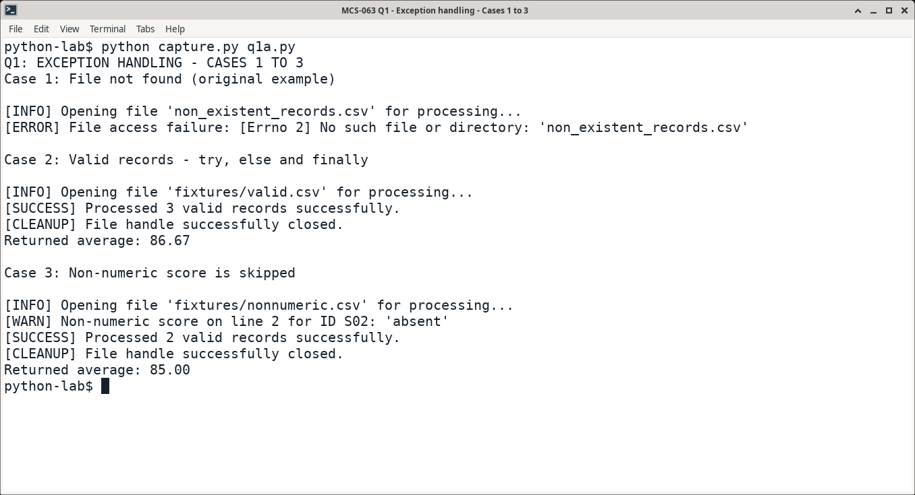
Figure 1. Cases 1–3: file error, successful processing and non-numeric input.
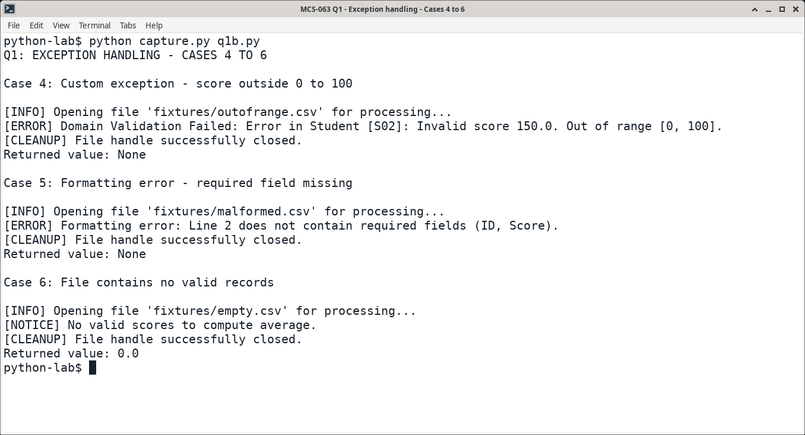
Figure 2. Cases 4–6: custom validation error, missing field and empty input.

Question 2: General tree to binary tree
What is a Tree? How does it differ from a Binary Tree? Explain the process of converting a Tree into a Binary Tree.
The driver builds the A–G example and displays its left-child/right-sibling (LCRS) representation.
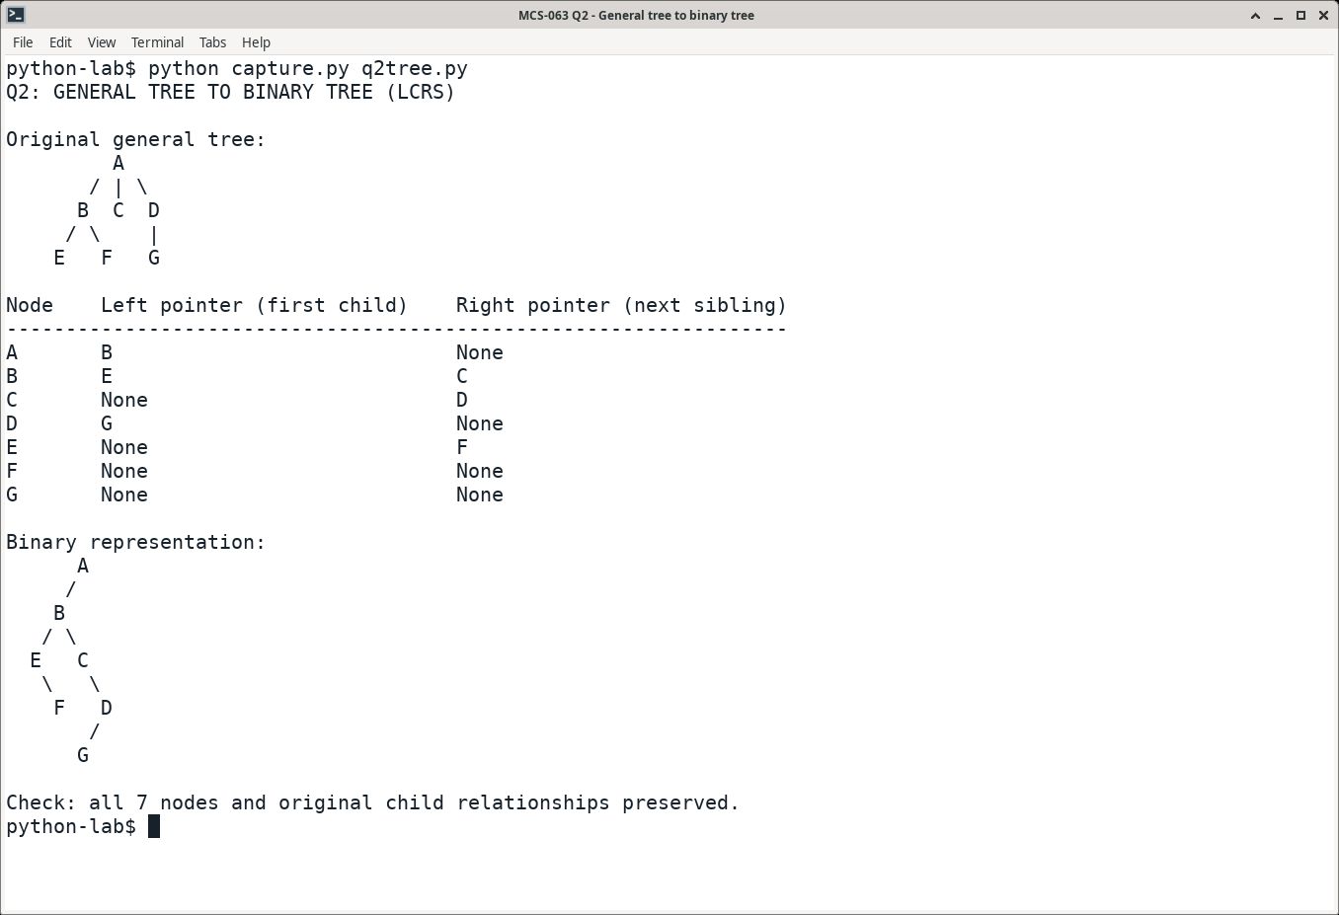
Figure 3. General-tree conversion: each left pointer identifies the first child; each right pointer identifies the next sibling.
Result: all seven nodes and their original child relationships are preserved by the binary representation.

Question 3: Built-in sorting functions
Explain built-in sorting functions of Python with examples.
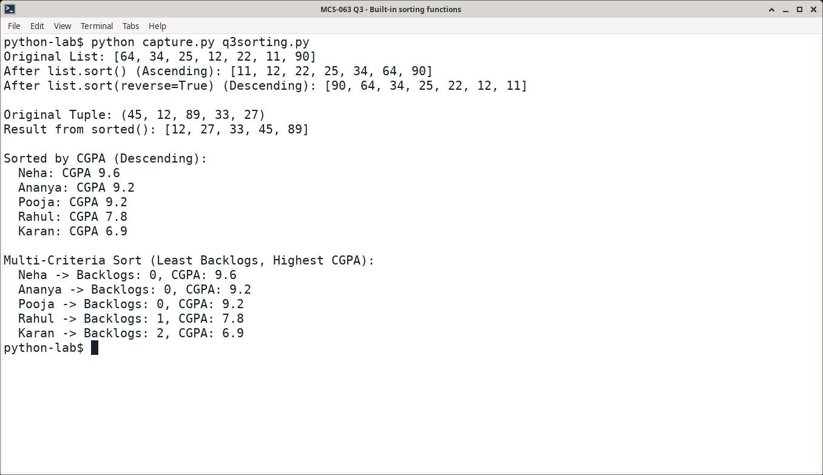
Figure 4. Outputs of list.sort(), sorted(), reverse=True and custom key functions.

Question 4: Minimum cost spanning tree
What is a Minimum Cost Spanning Tree? Explain with an example.
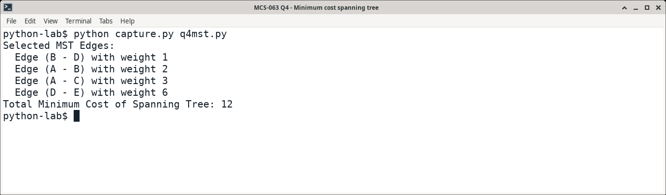
Figure 5. Kruskal’s algorithm selects four edges spanning all five vertices, with total cost 12.
Source: supplied MCS-063_Data_Structures_using_Python_Assignment_Solutions.md; question wording checked against MSCDSA-MCS-063-2026.pdf. Small demonstration drivers were added for Questions 1 and 2; their supplied functions were retained. The supplied programs for Questions 3 and 4 were run unchanged.

