SQL Query Outputs
The supplied SQL executed successfully in SQLite 3.53.1. The screenshots below show the results in an HTML results viewer.
Setup completed: 3 tables; 6 researchers; 6 publications; 13 authorship records.

Query 3: Publications by ResearcherID = 1
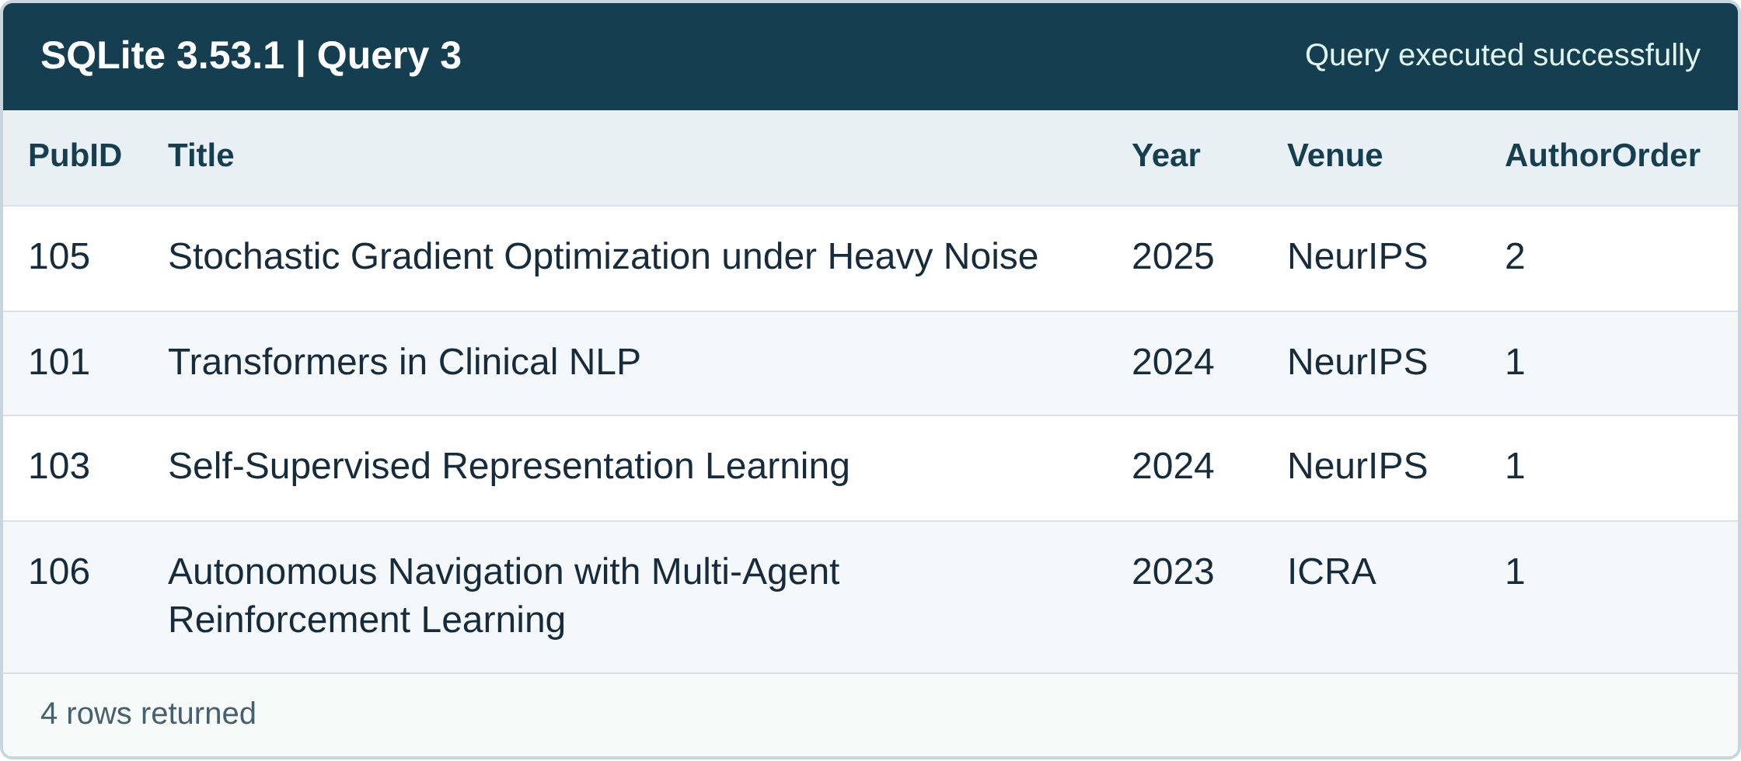

Query 4: Researchers who have not authored any publication
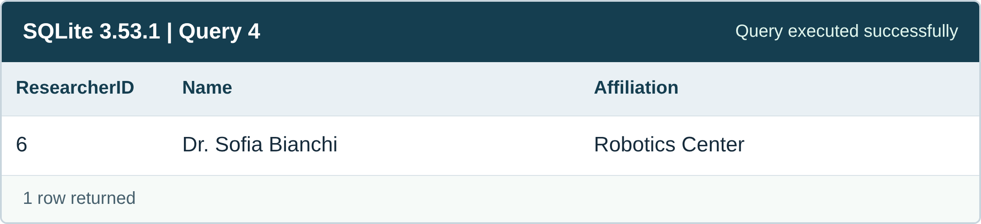

Query 5: Publication with the highest number of authors
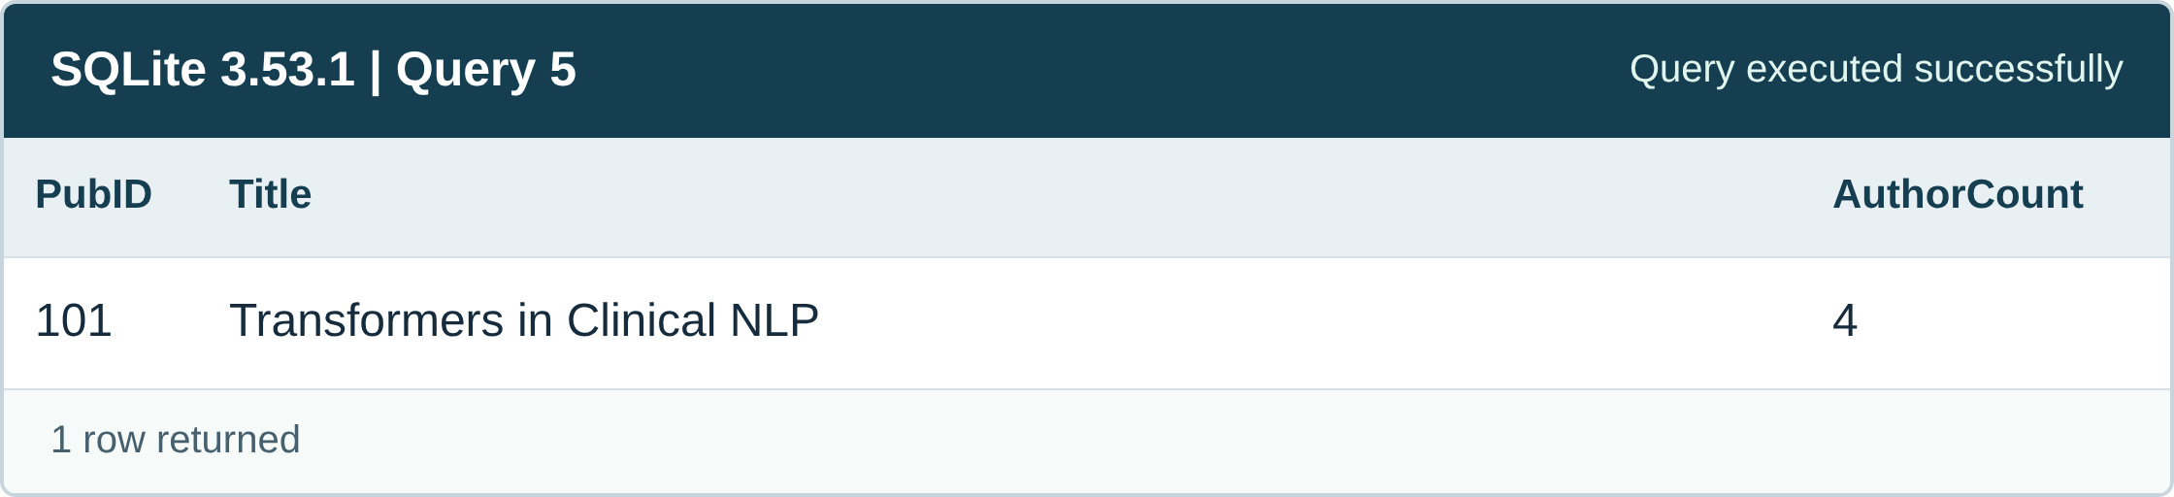

Query 6: Venues with more than two publications
