**Steps for changing the text color and background color on your windows command prompt**

1. Initially, the windows Command Prompt would look like this

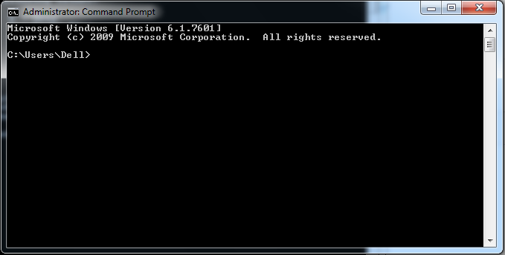

1. Type color /?

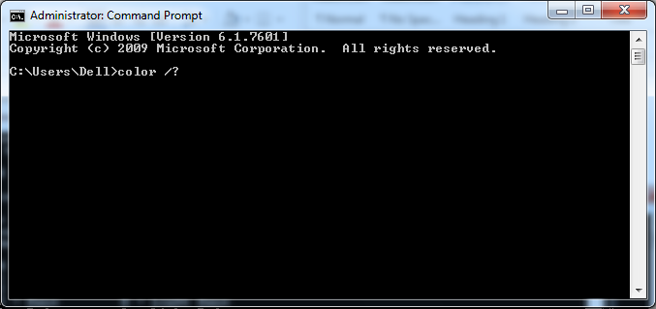

1. Options are displayed on the screen like given below

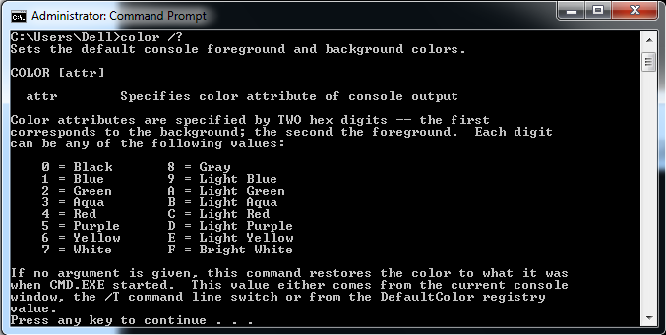

1. Press any key to continue will take you out from the option
2. Now type ‘color 0’ and output is given below (default)

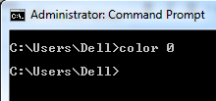

1. Now type ‘color 1’ and output is given below (blue text)

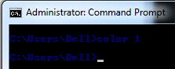

1. Now type ‘color 2’ and output is given below (green text)

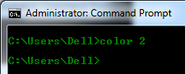

1. Now type ‘color 3’ and output is given below (aqua text)

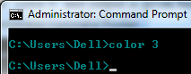

1. Now type ‘color 4’ and output is given below (red text)

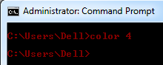

1. Now type ‘color 5’ and output is given below (purple text)

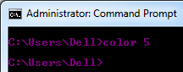

1. Now type ‘color 6’ and output is given below (yellow text)

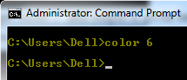

1. Now type ‘color 7’ and output is given below (green text)

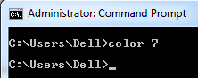

1. Now type ‘color 8’ and output is given below (gray text)

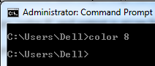

1. Now type ‘color 9’ and output is given below (light blue text)

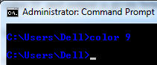

1. Now type ‘color A’ and output is given below (light green text)

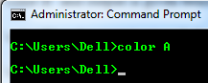

1. Now type ‘color B’ and output is given below (light aqua text)

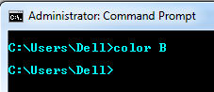

1. Now type ‘color C’ and output is given below (light red text)

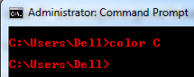

1. Now type ‘color D’ and output is given below (light purple text)

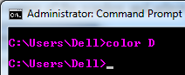

1. Now type ‘color E’ and output is given below (light yellow text)

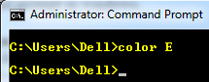

1. Now type ‘color F’ and output is given below (bright white text)

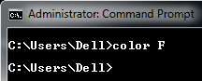

1. To come back to original state i.e. black color back ground and white color font type ‘color’ in command prompt in windows.

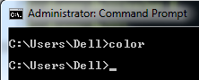

**Personalize Command Prompt without Commands**

If you’d prefer to change the color without entering commands, just click on the Command Prompt icon in the top left corner of the window and select Properties.

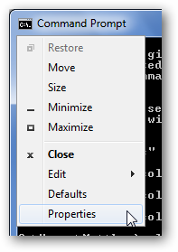

Select the Colors tab, and then choose the color you want for the screen text and background.  You can also enter your own RGB color combination if you want.

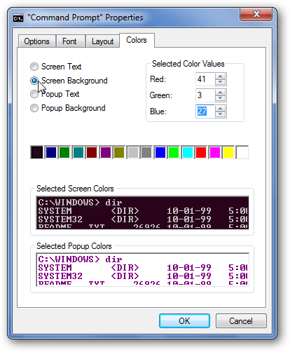

Here we entered the RGB values to get a purple background color like Ubuntu 10.04.

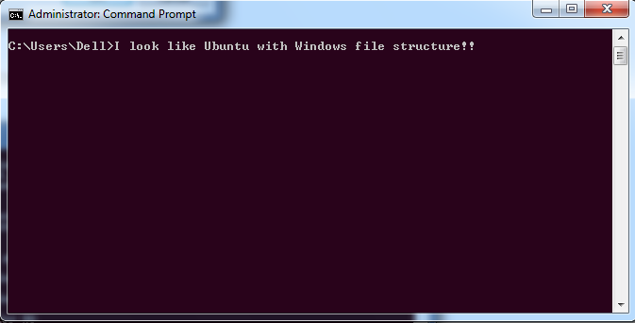

Back in the Properties dialog, you can also change your Command Prompt font from the font tab.  Choose any font you want as long as the one you want is one of the three listed here.

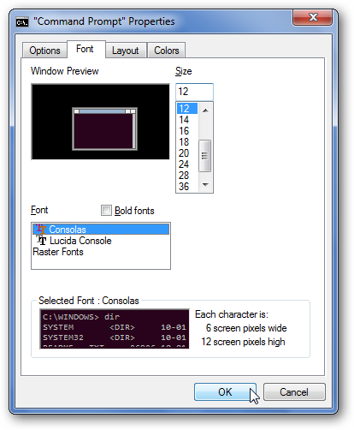

Customizations you make via the Properties dialog are saved and will be used any time you open Command Prompt, but any customizations you make with the Color command are only for that session.

**Conclusion**

You can make your command prompt much more attractive by trying out above mentioned color options. So that your Command Prompt is bright and more unique.