# Application architecture

# AWS architecture

A single page web application built with frameworks such as Angular or React. Both these frameworks load all required files such as html, CSS and Javascript file with a single page. To approach a SPA in AWS I would be using following services:

**Amazon CloudFront** to deliver webapp to different edge locations near to the users location.

**DynamoDB**: A serverless no SQL database. It’s a fully managed database with built-in security which can handle heavy traffic.

**AWS Lambda** is a service that allows you to run functions upon certain events, for example, when data is inserted in a DynamoDB table or when a file is uploaded to S3.

**S3 bucket** to store all the files and host the website.

**Amazon API gateway** as a front door to access data, functionality from backend services.

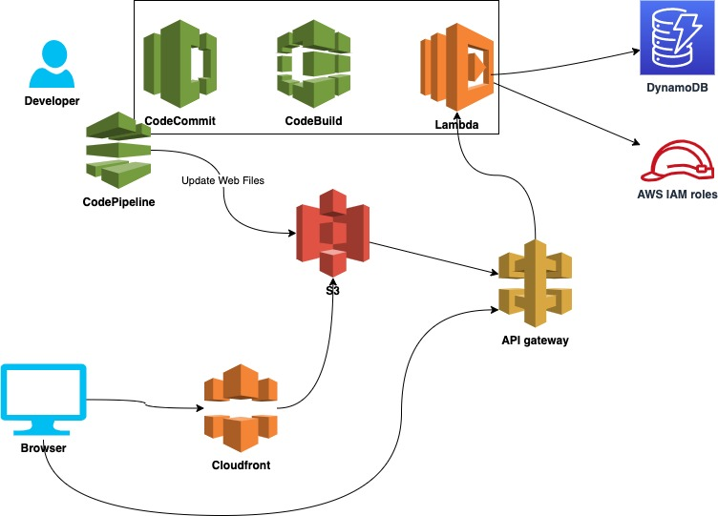

## Scalability

To manage the capacity of the environment AWS provides CloudFront solution which is a CDN service and very scalable with built-in security and will copy our app to different edge locations around the world to improve the speed in different locations.

Describe, how would you scale your application components like

* Lambda (function concurrency)
* DynamoDB (you can use autoscaling)
* S3 (it scales automatically)

## Security

Creating IAM roles in AWS account and then assigning them permissions to allow or deny access to other AWS services eg: Lambda can have Read/Write access to DynamoDB tables.

**IAM Users**

**Access keys**: The secret key portion must be secured by the AWS account holder or the IAM user to whom they are assigned. Users can have two sets of active access keys at any one time. As a best practice, users should rotate their access keys on a regular basis.

**MFA**: Multi-factor authentication (MFA)-protected API access requires IAM users to enter a valid MFA code before they can use certain functions, which are APIs.

**IAM Roles:** Developer/Admin IAM users will be assigned IAM roles to manage resources and deployments based on the required access level eg: Only authorised person should have access to the production environment.

## Continuous deployment

To make any changes in the app and update the code with new features or removing bugs. We can use CodePipeline to commit new code into the existing file and make changes to our application’s source code. It’s fast and reliable which allows us to deliver features and updates. It should also show updates to S3 bucket as the static files are hosted there.