EMAIL Analysis

Spam score: -0.10
Sender Address: notifications@pod.ai
Receiver Add: 4534125@mitacsc.edu.in
Email Header:
authentication-results:
dkim=pass
spf=pass
dmarc=pass

Count of Url: 8 (clean)
Attachment: No
Count of Domain: 6 (clean)
Sandbox run demo
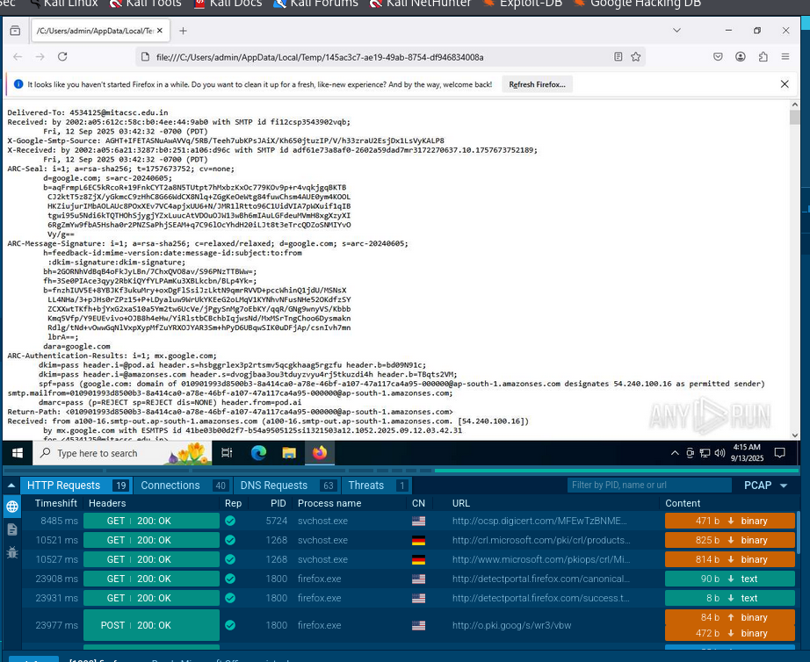

Final conclusion: The email message has successfully passed all authentication checks (SPF, DKIM, DMARC) and shows no signs of spoofing. Sandbox analysis revealed no malicious behavior, with URLs and domains marked as clean. Overall, the email can be considered legitimate and non-malicious.

