What is Threat Analysis?
Threat analysis is a cybersecurity strategy that aims to assess an organization’s security protocols, processes and procedures to identify threats, vulnerabilities, and even gather knowledge of a potential attack before they happen.

Cyber threat analysis is the process of assessing the cyber activities and capabilities of unknown intelligence entities or criminals.
A cybersecurity threat or “cyber threat” can be defined as a malicious act that seeks to disrupt digital life. This act could be the disruption of a communication pathway, the damage of data, or stealing data.

A threat analysis is a process used to determine which components of the system need to be protected and the types of security risks (threats) they should be protected from
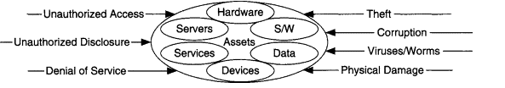
By studying various threats staged against one’s organization in detail, security teams can gain a better understanding of the level of sophistication of threats staged against the organization, the exploitation strategies, and identify areas in the organization’s security posture that may be vulnerable to these threats.

A threat analysis typically consists of identifying the assets to be protected, as well as identifying and evaluating possible threats. Assets may include, but are not restricted to:

User hardware (workstations/PCs)

Servers

Specialized devices

Network devices (hubs, switches, routers, OAM&P)

Software (OS, utilities, client programs)

Services (applications, IP services)

Data (local/remo te, stored, archived, databases, data in-transit)
And threats may include, but are not restricted to:

Unauthorized access to data/services/software/hardware

Unauthorized disclosure of information

Denial of service

Theft of data/services/software/hardware

Corruption of data/services/software/hardware

Viruses, worms, Trojan horses

Physical damage

Hackers target enterprises, governments, institutions, or even individuals with valuable information. Threats posed by cyber-attacks include denial of service attacks (DoS), computer viruses, malware, phishing emails, and others. The attacks target anyone with an online presence. Cyber-attacks can lead to electrical blackouts, breaches of government security details, failure of military equipment, disruption of computer networks, paralyzation of phone networks, unavailability of confidential data and it may affect the functioning of human life

The main objective of cyber threat analysis is to produce findings used to aid in initialization or support of counter-intelligence investigations. Then action is taken to eliminate the threat from the given organizations, business, or government system. In cyber threat analysis, the know-how on external and internal information vulnerabilities relating to a particular business model is matched against the actual or real-world cyber-attacks. This type of approach to countering cyber-attack is a desirable transition from a reactive security state to an efficient, proactive state.
The final output from a threat assessment should provide the best practices on how to utilize the protective controls to promote integrity, availability, and confidentiality, without affecting the functionality and usability conditions.
A successful threat analysis strategy can uncover various types of threats within an organization. Some of the categorization of threats is as follows:
- Accidental Threats
Whether it’s a misconfiguration of a security process, or an accident that leaves an organization exposed, one of today’s leading causes of cyberattacks, is unfortunately an exploitation facilitated through human error. By performing a threat analysis, organizations can identify and remediate accidental errors before bad actors have the chance to exploit them.
- Intentional Threats
The threat that every organization is worried about is the intentional threat. Intentional threats are those conducted by malicious entities to gain access and exploit sensitive data within an organization for profit.
- Internal Threats
One of the most worrisome threats is not actually what you’d expect. Often, organizations worry about external threats and build sophisticated security architectures to keep bad actors out, however, the real concern resides inside the security perimeter of the organization. Unfortunately, when an employee decides to act in a malicious way it can be catastrophic as they may have easier access to sensitive information.

Components of the Cyber Threat Analysis Process

1. Scope
The first step in any cyber threat analysis should be to identify every susceptible item that must be protected from access by malicious third parties. After this, the level of sensitivity and the desired degree of protection of the item is drafted and extensively defined by the analysis drafters.

2. Collection of Data
In the Collection of Data stage, the first step is to collect information about the actual cyber-attack or threat incidents. Examples could be phishing email header and content, uncovered hostile command and control infrastructure of IP addresses and domain names, URLs to malicious links, and so on. One must distinguish between real potential attacks and threats that are not real but are perceived threats. The scope should help filter out percieved threats in order to ensure that the focus is on the targeted threats that exist in reality.

3. Vulnerability Analysis of Acceptable Risks
In this phase, the analysts test what has already been gathered in order to determine the extent of current exposure. The existing security defense is tested to determine whether it has the capability to neutralize information threats in terms of integrity, availability and confidentiality. This stage should double check whether the current policies, security measures and policies are adequate protective measures. Penetration tests are also done as part of vulnerability analysis in an attempt to identify vunerabillites.

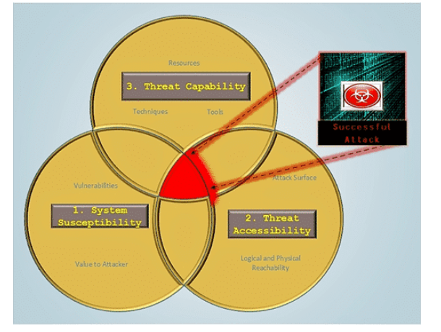

4. Mitigation and Anticipation
After completion of all other previous steps, a highly qualified analyst can then use the corpus of threat data identified to determine preventive measures. The analyst has the task to catigorize the threat data into groups, allocate each pattern to specific threat actors, and implement mitigation measures. Subsiquently, the analyst must anticipate the occurrence of similar attack in the future.

Threatcrowd.org
Threat Crowd is part of an open Threat Intelligence community which permits global collaboration and sharing of cyber threats. Users share IP addresses or websites from which attacks have originated, or, look up specific threats to see if anyone in the intelligence community has provided information about them and determined them to be malicious.
Query ThreatCrowd for Malware, Passive DNS and historical Whois data.

Benefits
- Enrich domains and IPs to historical dns resolutions and connecting malware
- Enrich MD5 hashes of malware to command and control domains and IP addresses
- Enrich the names of malware detections to the MD5 hashes of malware samples
he ThreatCrowd API allows you to quickly identify related infrastructure and malware.

Objects
With the ThreatCrowd API you can search for:
- Domains
- IP Addreses
- E-mail adddresses
- Filehashes
- Antivirus detections
The request and response format is similiar to that of the VirusTotal API - this is to allow for code reuse. HTTP GET requests are used to return JSON objects, for example:
- https://www.threatcrowd.org/searchApi/v2/email/report/?email=william19770319@yahoo.com
- https://www.threatcrowd.org/searchApi/v2/domain/report/?domain=aoldaily.com
- https://www.threatcrowd.org/searchApi/v2/ip/report/?ip=188.40.75.132
- https://www.threatcrowd.org/searchApi/v2/antivirus/report/?antivirus=plugx
- https://www.threatcrowd.org/searchApi/v2/file/report/?resource=ec8c89aa5e521572c74e2dd02a4daf78

• Netcraft
Netcraft’s online brand protection operates 24/7 to discover phishing, fraud, scams, and cyber attacks through extensive automation, AI, machine learning, and human insight. Our disruption & takedown service ensures that malicious content is blocked and removed quickly and efficiently—typically within hours.
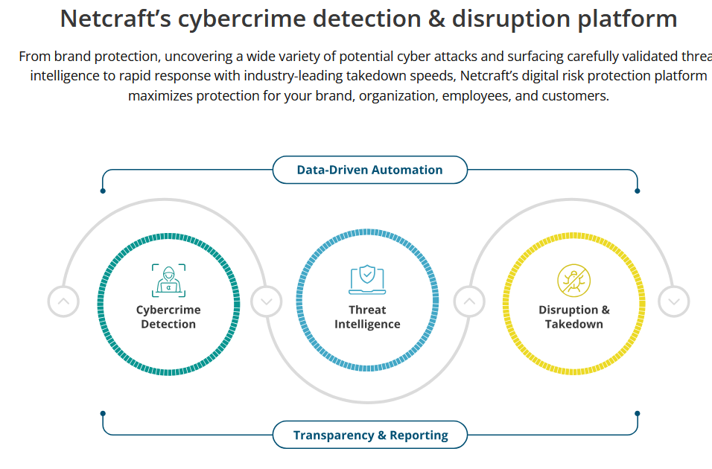

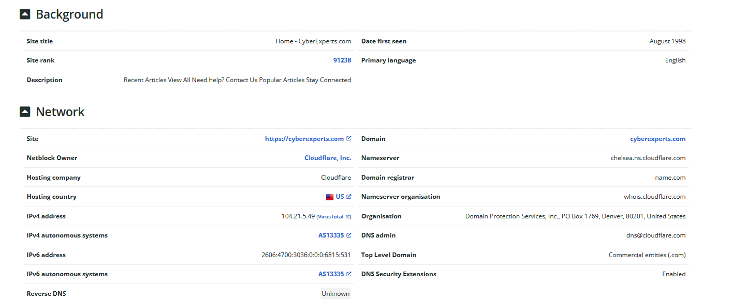
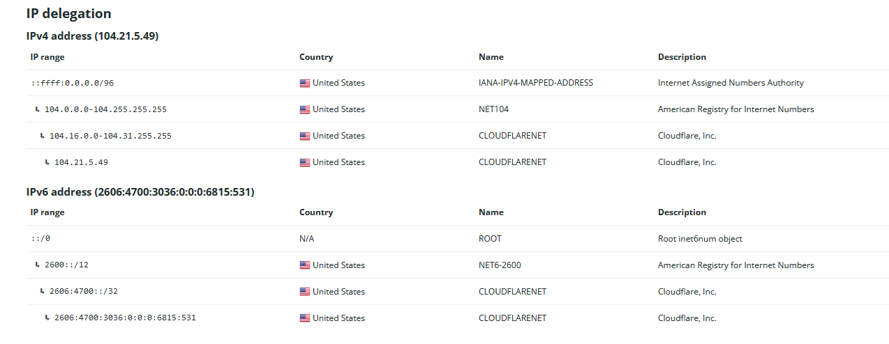
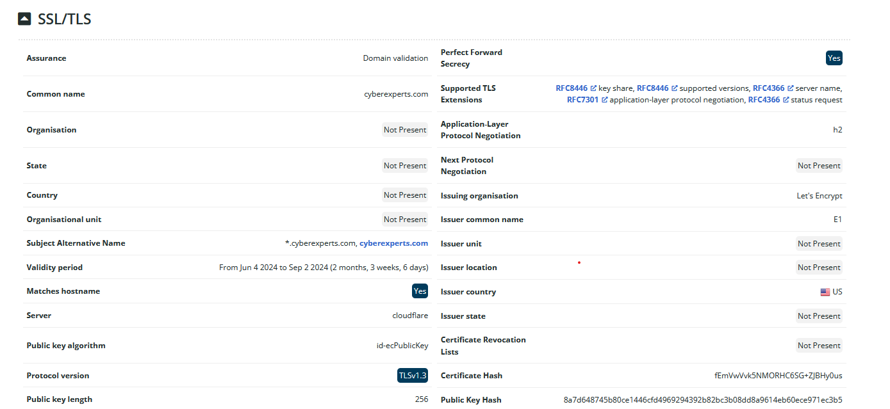
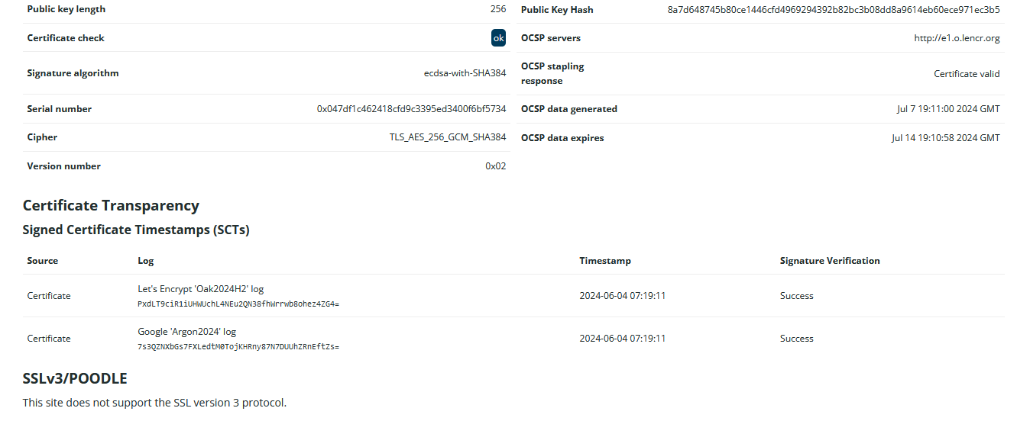

Most Visited Websites

View the top 50,000 sites as determined by users of the Netcraft extensions, filtered by country.

